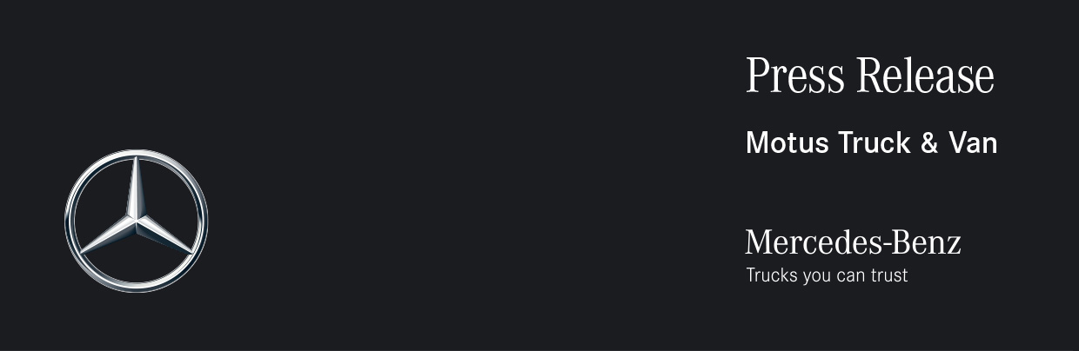

Date: 26 August 2021

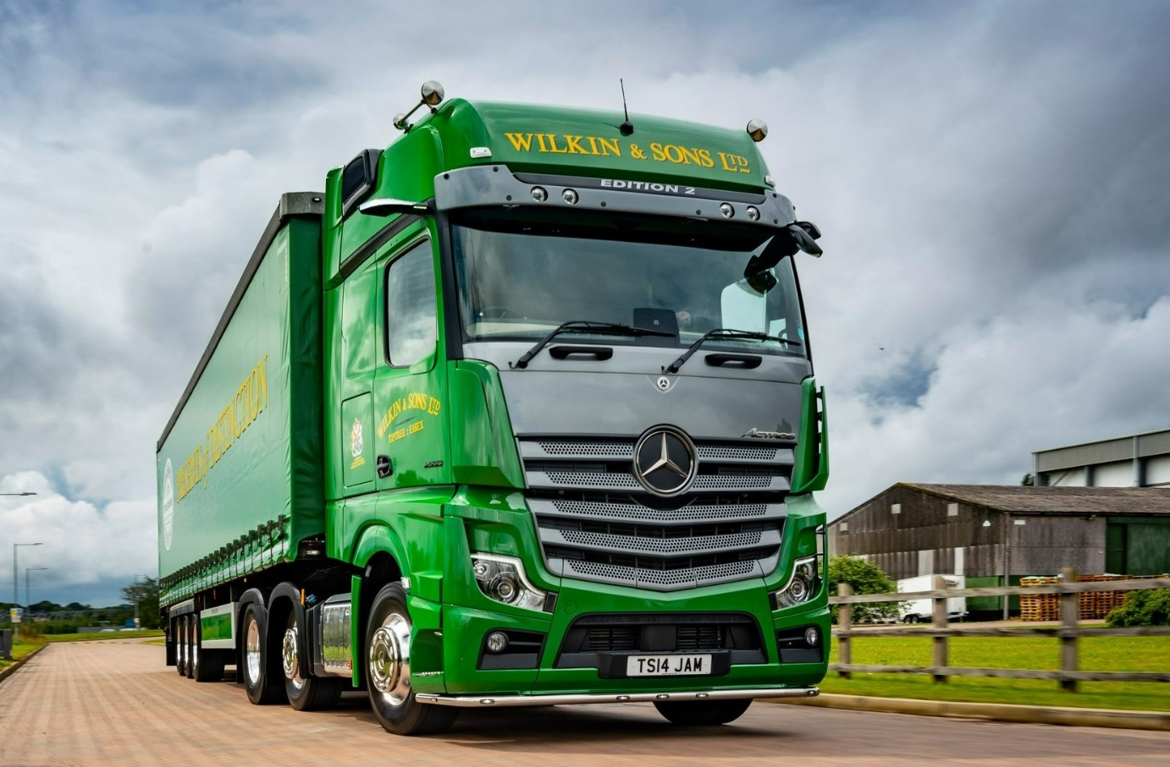

It’s ‘jam today’ for Tiptree driver Tim, as UK’s first exclusive Mercedes-Benz Actros Edition 2 hits the road

The world-renowned producer of Tiptree jam is running the country’s first, stunning Actros Edition 2 from Mercedes-Benz Trucks – and this most desirable of tractor units has been assigned to a driver who passed his Class 1 test less than a month before it arrived!

The Edition 2 represents a new dimension in comfort, safety and design. Just 400 are being built, with a dozen going to UK operators.

Wilkin & Sons’ latest flagship was supplied by Orwell Truck & Van – following its formal pairing with fellow Dealer S & B Commercials on Tuesday (24 August), the manufacturer’s representative for East Anglia is now trading as Motus Truck & Van.

The new Actros is based at the operator’s main warehouse in Maldon, north Essex, five miles from its headquarters in Tiptree, where the Wilkin family began farming in the early 1700s.

It wears Wilkin & Sons’ traditional green and gold livery, complete with the coat of arms the company is entitled to use as the holder of a Royal Warrant from Her Majesty The Queen. However, the truck is easily identified as one of the most exclusive on the road, thanks to its Moonstone Grey grille and sun visor – this incorporating four additional LED headlights – above which is a deep black panel with EDITION 2 lettering.

Other external highlights include an illuminated Mercedes-Benz three-pointed star in dark chrome, with a black closed cover, gloss black trim, stainless steel entrance steps, three more LED headlights behind the cab, and – for tractor units – a chassis frame cover.

Tim Sharp came out of a 26-tonne curtainsider after passing – with no minors – the HGV test that allows him to drive tractor units. His Edition 2 has lined up alongside another limited-edition Mercedes-Benz ‘special’ – Bradley Scott has been piloting his Actros Edition 1 since it was delivered in January 2020.

The two drivers are obsessive about the appearance of their vehicles and have won numerous awards at truck shows. They are now looking forward to presenting their limited edition Actros tractor units for the first time together at Truckfest Peterborough this weekend (28-30 August).

Edition 2s are being built as rigids as well as tractor units, in 4x2, 6x2 or 6x4 configurations, and with range-topping GigaSpace or BigSpace cabs. Customers have chosen from 15.6- or 12.8-litre in-line six-cylinder engines with a combined total of eight outputs. Like its Edition 1 stablemate, Wilkin & Sons’ Edition 2 has a GigaSpace cab and, at 390 kW (530 hp), the most powerful of the 12.8-litre engines.

As well as the jams and marmalades for which it is best known, the company’s portfolio now includes everything from savouries, sauces and Christmas puddings, to fruit-flavoured gins and teas. Transport Manager Kevin King explained: “We’d been relying on two tractors for some time but decided to replace a 10-year-old 26-tonner with a third because we’re so busy, and because the loads we’re delivering, particularly to supermarket RDCs, keep getting bigger.”

He enthused: “Both Actros are very exclusive and look amazing. It’s only just entered service but we’ve had a lot of positive feedback already from people who’ve seen Tim’s Edition 2 out and about. We’re a high-profile company so image is very important to us. That’s why we actively encourage our drivers to take care of their vehicles and participate in truck shows.

Mr King continued: “We were running Mercedes-Benz products when I joined this company 31 years ago, and we’ve remained loyal to the brand ever since. Mercedes-Benz trucks have always been reliable and cost-effective to operate, of course, but in recent years the manufacturer has really raised its game in terms of driver appeal too.

“We like to look after the lads and provide them with the first-class equipment they deserve as ambassadors for our business. That’s never been more important than in these current times of acute driver shortages – if we can put smiles on their faces by giving them vehicles they enjoy driving, then they’ll want to keep coming to work for Wilkin & Sons.”

The Edition 2’s cab interior is every bit as eye-catching inside as its exterior. An abundance of stitched black Nappa leather contrasts with dashboard components in carbon. There is a sliding and tilting sunroof, eight colours of ambient lighting, and a driver’s suspension seat that incorporates climate and massage functions, while at 900 mm-wide and with its own, cosy topper, the comfort mattress is a dream for any driver. A brushed and polished aluminium badge on the co-driver’s side hails this Edition 2 as “One of 400”.

The truck also comes with a full complement of high-tech aids for increased safety, efficiency and comfort. MirrorCam, Mercedes-Benz Trucks’ pioneering alternative to conventional mirrors, is fitted as standard on all Actros. So, too, is the latest version of Predictive Powertrain Control, which manages gear changes to optimise fuel economy, and Active Brake Assist 5, the emergency braking system that outperforms its rivals, particularly in its responses to pedestrians stepping into the vehicle’s path.

Edition 2 drivers also benefit from the upgraded interactive version of the radical, twin-screen Multimedia Cockpit, which boasts a larger, 12in instrument panel and comes with extra functionality, including satellite navigation, together with Proximity Control Assist, Bi-xenon headlamps with a cleaning system, and LED tail lights.

All of this equipment, and much else besides, is bundled into the Edition 2’s Driving, Comfort, Media, Stowage, Safety and Sight Packages, and ExtraLine design, to create a vehicle with an unmistakable “Wow!” factor.

Most drivers would pass an entire career without ever finding themselves behind the wheel of a truck as special as the Edition 2. “I do realise how incredibly lucky I am,” insisted Tim Sharp. “In fact, I’m still pinching myself. The Edition 2 is fantastic to drive and has the looks to match; it’s just awesome.”

He recalled: “I parked up at a truckstop the other day, alongside a very smart, black Swedish unit. Within no time at all I had other drivers all over my truck – obviously, they’d never seen an Edition 2 before, so they were asking all sorts of questions and taking pictures on their phones. The Swedish truck didn’t get a look in; they weren’t interested.”

Like its Edition 1, Wilkin & Sons’ Actros Edition 2 is the subject of a Mercedes-Benz Finance contract hire agreement. “We have great relationships with the Dealer’s Truck Sales Executive Ben Sheldrake and with the workshop team at its Colchester depot, who are very responsive and provide an excellent service,” added Kevin King.

www.tiptree.com

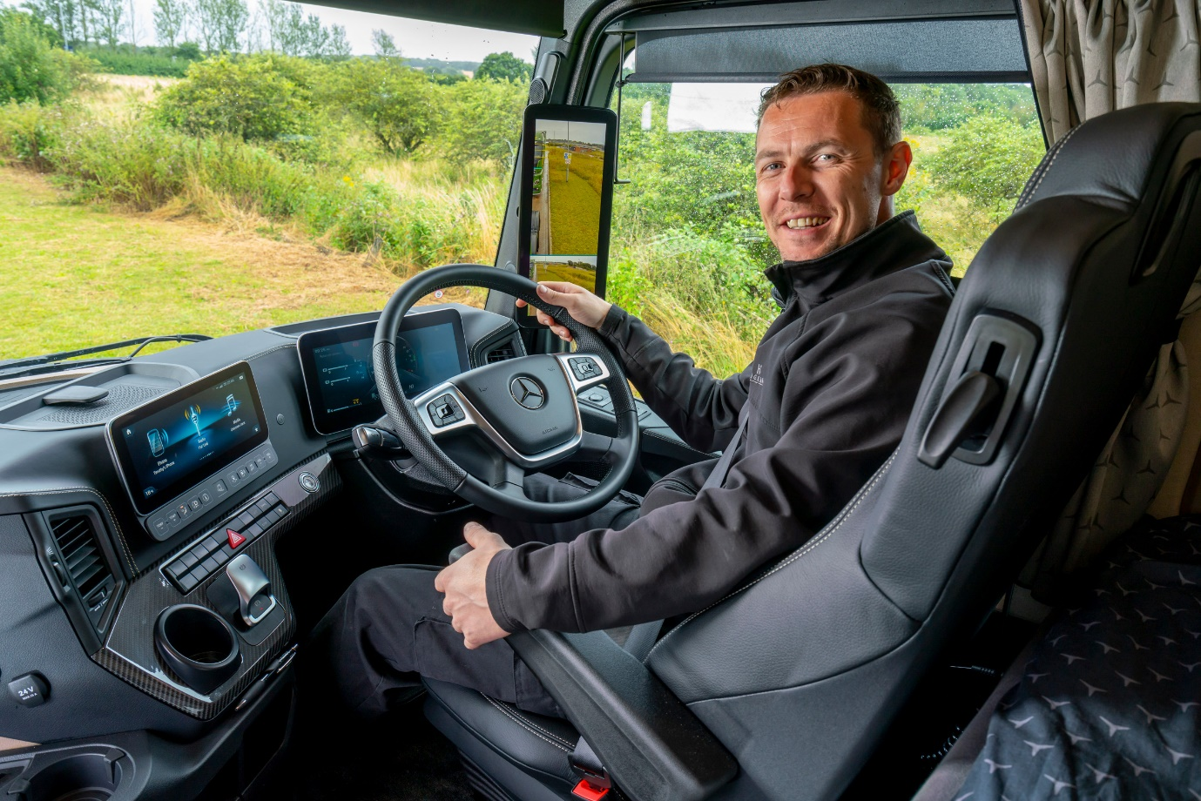

Sharp styling: Driver Tim’s Multimedia Cockpit, interactive dashboard combines stitched black Nappa leather with carbon trim

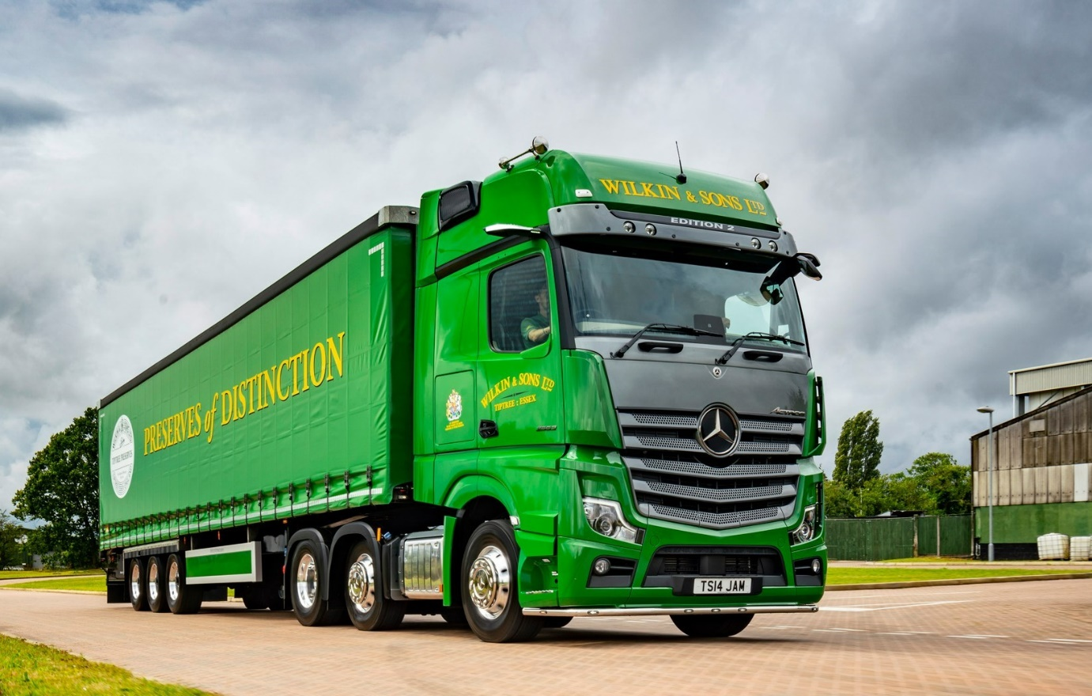

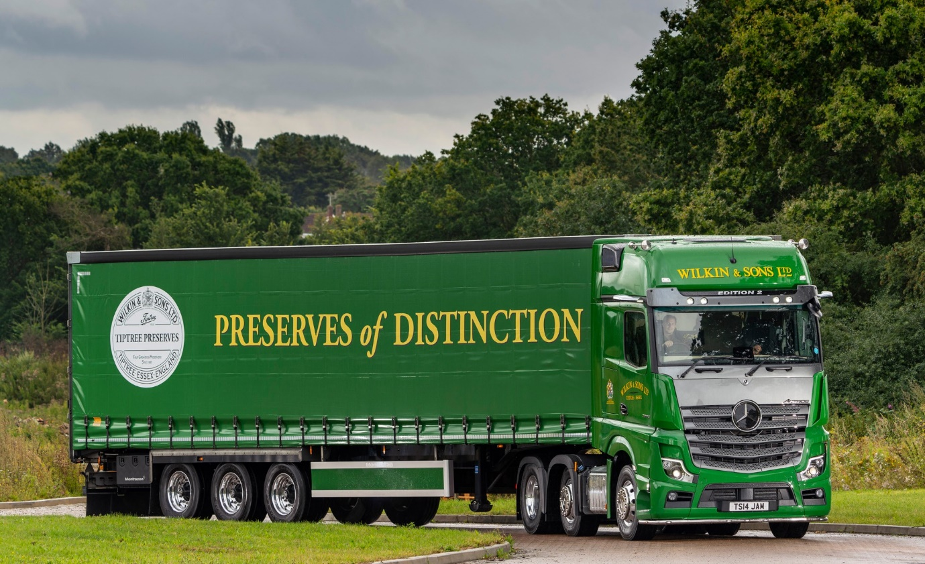

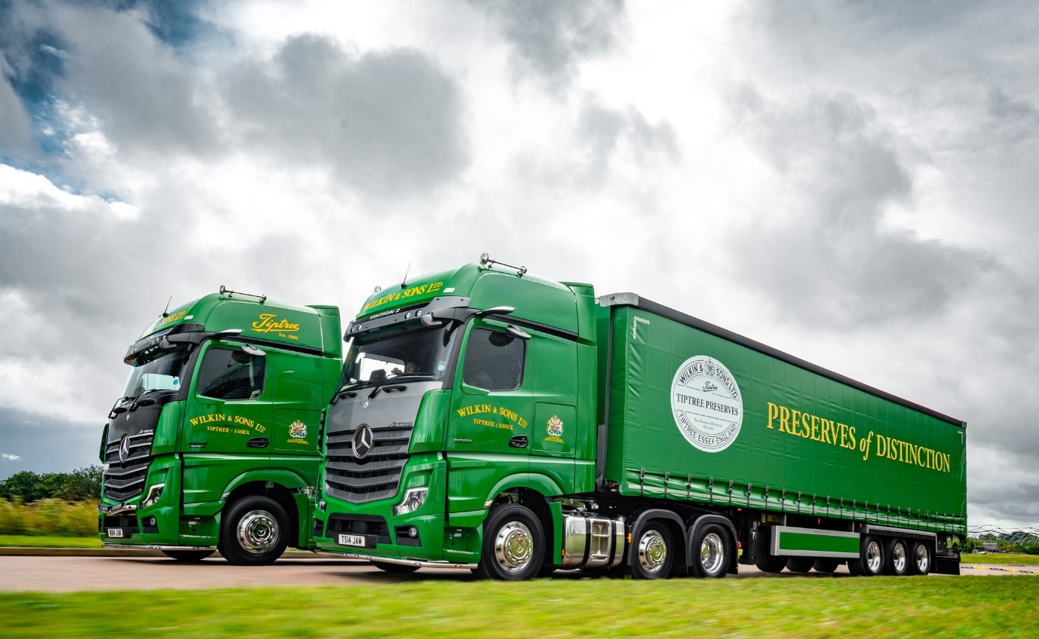

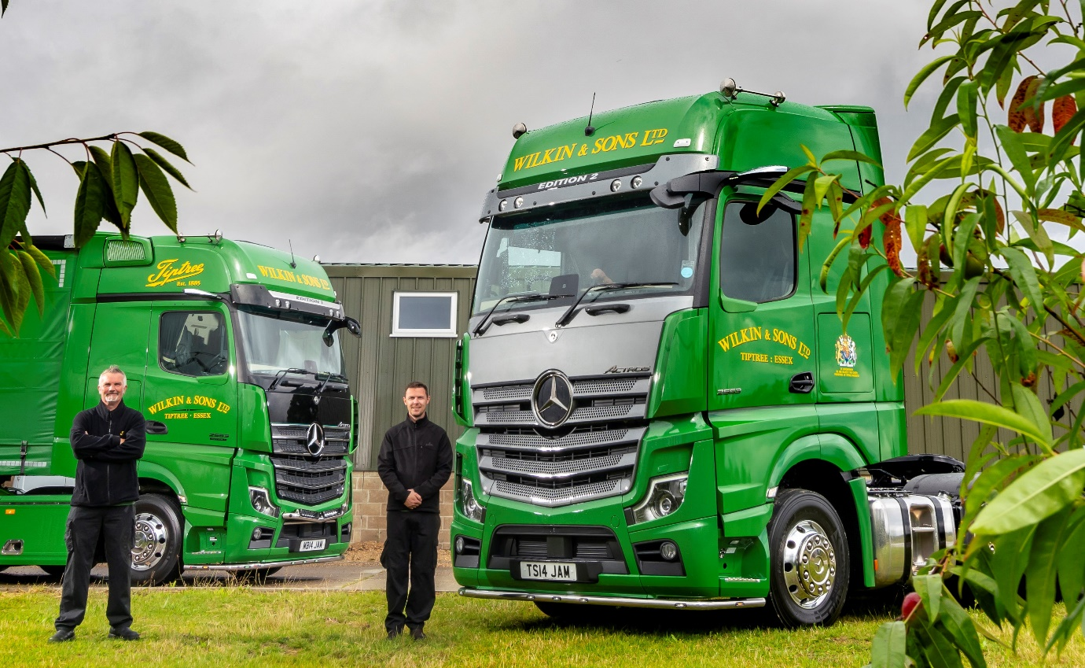

Driving force: Bradley Scott, left, and Tim Sharp are pictured with their Actros Edition 1 and Edition 2, right

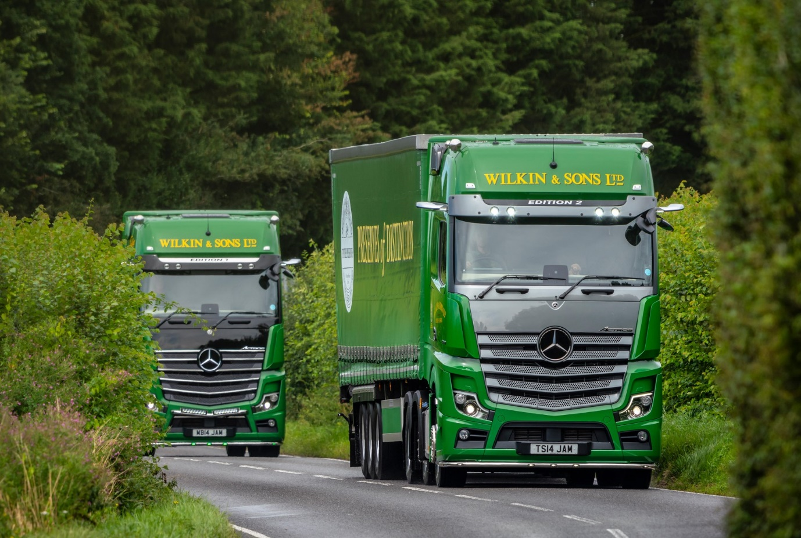

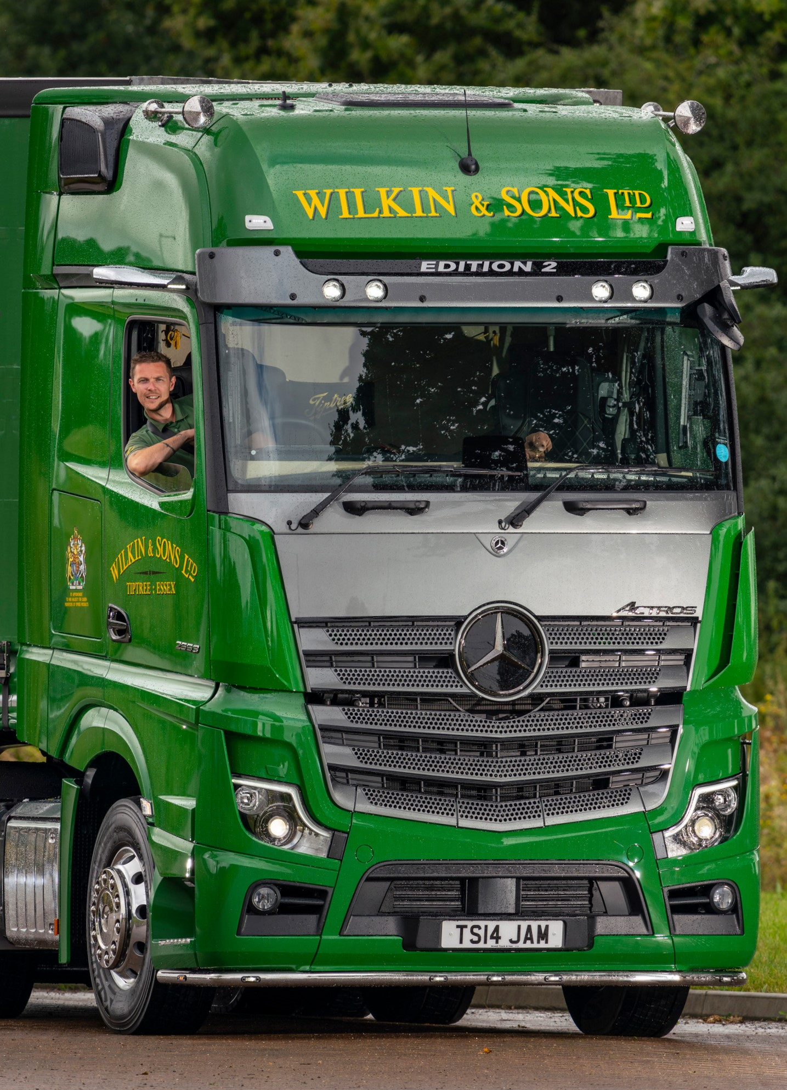

ends

For more information, or to request bigger/higher-res image files, please contact:
Steve Warren or John Ripley
Impact Communications, 01926 842126
Steve: 07770 470251, steve@impactcom.co.uk
John: 07771 484595, john@impactcom.co.uk

