

Date: 17 May 2023

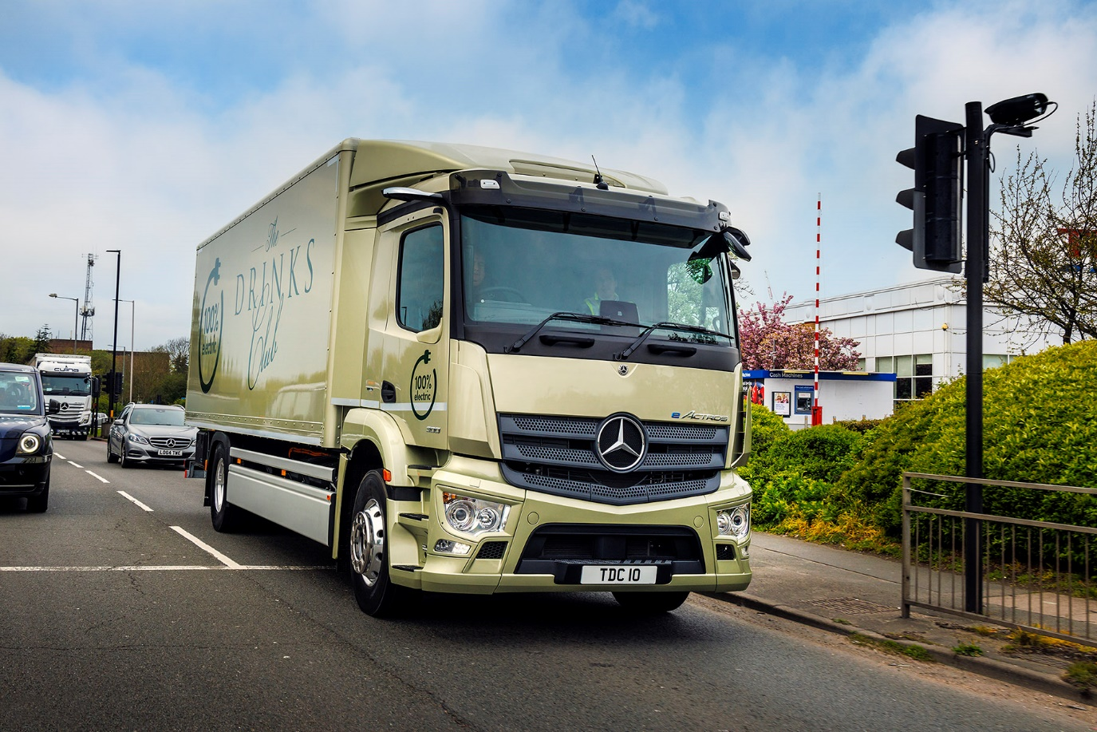

The Drinks Club raises a toast to its first electric Mercedes-Benz eActros

One of the first all-electric Mercedes-Benz heavy trucks to take to the UK’s roads is now in service with London-based premium beverage supplier The Drinks Club.

The 4x2 eActros 300 is now hard at work making daily deliveries of a wide range of alcoholic and soft drinks to some of the capital’s best-known venues including the Ritz, Dorchester and Hoxton Hotels.

It joins a fleet of 12 delivery vehicles, comprising trucks plated at 18 and 7.2 tonnes GVW, as well as 5.0- and 3.5-tonne vans, but is the operator’s first battery-powered model.

The Drinks Club founder and Managing Director Stuart Randall said: “Like all responsible operators we at The Drinks Club are keen to minimise the effects of our activities on the environment and have been considering our options carefully. Clearly, electrified transport is the future of the industry and we’d rather be a leader than a follower.

“Our clients and their customers are also delighted to see us taking this proactive step towards removing exhaust emissions from the streets in which we work.

“For our first electric vehicle we decided the maximum operational benefit would come from replacing one of our biggest trucks, so this eActros is a direct substitute for a diesel-powered 18-tonner. Assuming it works well – and all the early indications are that it will – we’ll be looking to swap the rest of our fleet for battery-powered vehicles at the earliest opportunity.”

The truck is based on a 4x2 eActros 300. Fitted with three battery packs, for a total installed capacity of 336kWh, it boasts a range of up to 330km (205 miles). The batteries can be recharged from 20 to 80% in 75 minutes, using a 400A 160kW charger.

The eActros is designed from the ground up as an electric truck. Its twin electric motors are located within the rear eAxle. With no need for a prop shaft energy efficiency is maximised, while chassis space can be freed up for the batteries to be set across the full width of the vehicle. This helps to create a low centre of gravity which, in turn, translates into improved driving dynamics. The motors drive through a special transmission with two forward and two reverse gears, allowing the truck to cruise at up to 89 km/h (55 mph).

The absence of a combustion engine under the ClassicSpace cab means there’s much less noise and vibration than in a traditional diesel-powered truck. Standard features include the innovative Multimedia Cockpit with twin display screens, MirrorCam, Active Brake Assist 5 and an Acoustic Vehicle Alerting System.

The Drinks Club’s eActros was supplied by Dealer Rygor Commercials and is fitted with a rigid box body by Solent Bodybuilders, of Fareham, which also mounted a 2,000 kg Dhollandia cantilever tail lift.

The vehicle was handed over at The Drinks Club’s Southall headquarters by Mercedes-Benz Trucks Head of Future Sustainability James Venables, who also assisted the operator with acquisition of a T-Series mobile charging system, supplied by Coventry-based Vital EV Solutions. Senior TruckTRAINER Alistair Colquhoun attended, giving Drinks Club team members a thorough introduction to the new vehicle and taking them out on the road to pass on expert tips on how to get the very best out of the electric drivetrain.

James Venables said: “We’re delighted to support The Drinks Club by supplying this innovative Mercedes-Benz eActros and I’m thrilled to see it out on the road. Interest in electric vehicles has never been higher, from small and medium-sized operators as well as the biggest names in the transport sector.

“We continue to work with fleets of all sizes to find the best solutions for our customers and their business. From initial sales enquiry to purchase, and throughout their ownership of the vehicle, our team eConsultants and our eTruck-ready National Dealer Network stand ready to help.”

Following delivery, Stuart Randall confirmed: “Our drivers certainly benefited from their TruckTRAINING input and now report that the eActros is far more pleasant to drive than a diesel truck. It’s quiet and smooth but also has excellent and immediate power delivery, so is very easy to pilot among city-centre traffic.

“Energy efficiency is highly impressive too. The team reports that, on our typical 45-mile daily run, we’re only using around 10-15% of a full charge to complete the route.”

“The truck has already proved itself in terms of performance and our experience of running other Mercedes-Benz Trucks suggests that reliability will be of the high standards we’ve come to expect. We’ll now be monitoring the vehicle’s whole-life operating costs closely, to gain a true picture of the economic reality of electric transport.”

Rygor Commercials Commercial Director Rish Channa added: “We at Rygor Commercials share The Drinks Club’s commitment to a sustainable future and we’re working with external consultants to enable us to make beneficial changes across our whole business. Going forward, we’re keen to work with and support more businesses that share our commitment to being greener, and we continue to work with our customer to find the best EV solutions.”

As well as a 19-tonne 4x2 chassis the eActros is also available as a 6x2, with 27-tonne GVW and a body-and-payload allowance of 16.6 tonnes, and as an eActros 400 with four batteries allowing up to 400 km (249 miles) of range.

www.thedrinksclub.com

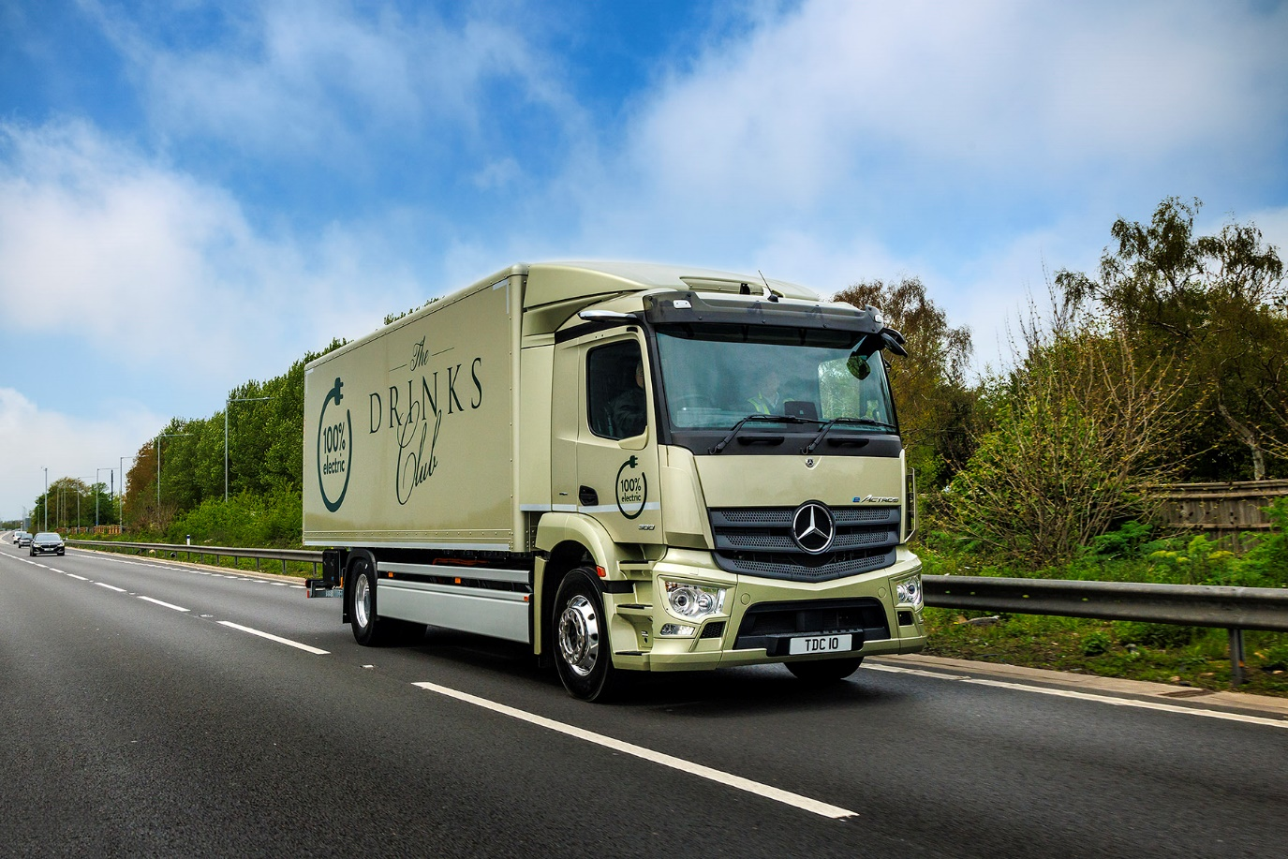

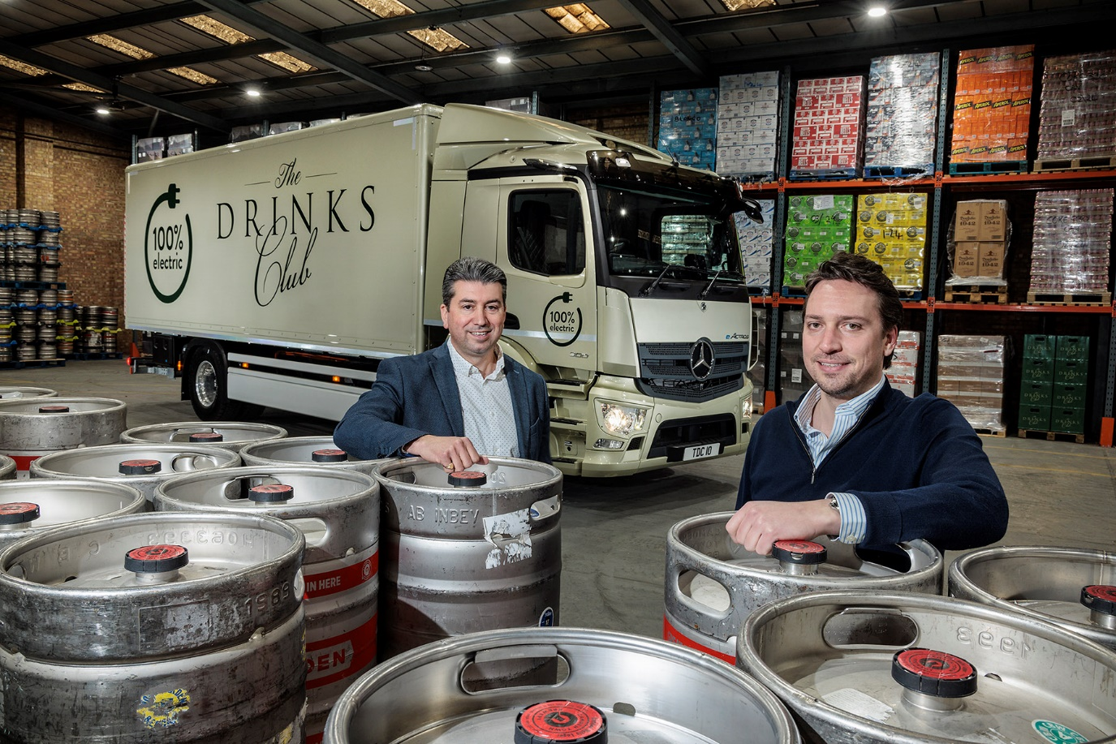

Sustainable partnership: The Drinks Club Managing Director Stuart Randall, right, with James Venables of Mercedes-Benz Trucks UK

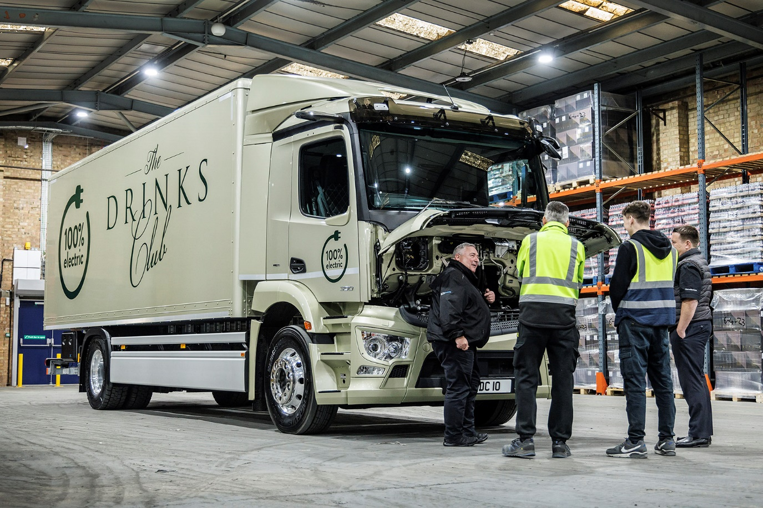

Benefit of experience: Mercedes-Benz Senior TruckTRAINER Alistair Colquhoun gives The Drinks Club colleagues an introduction to the eActros

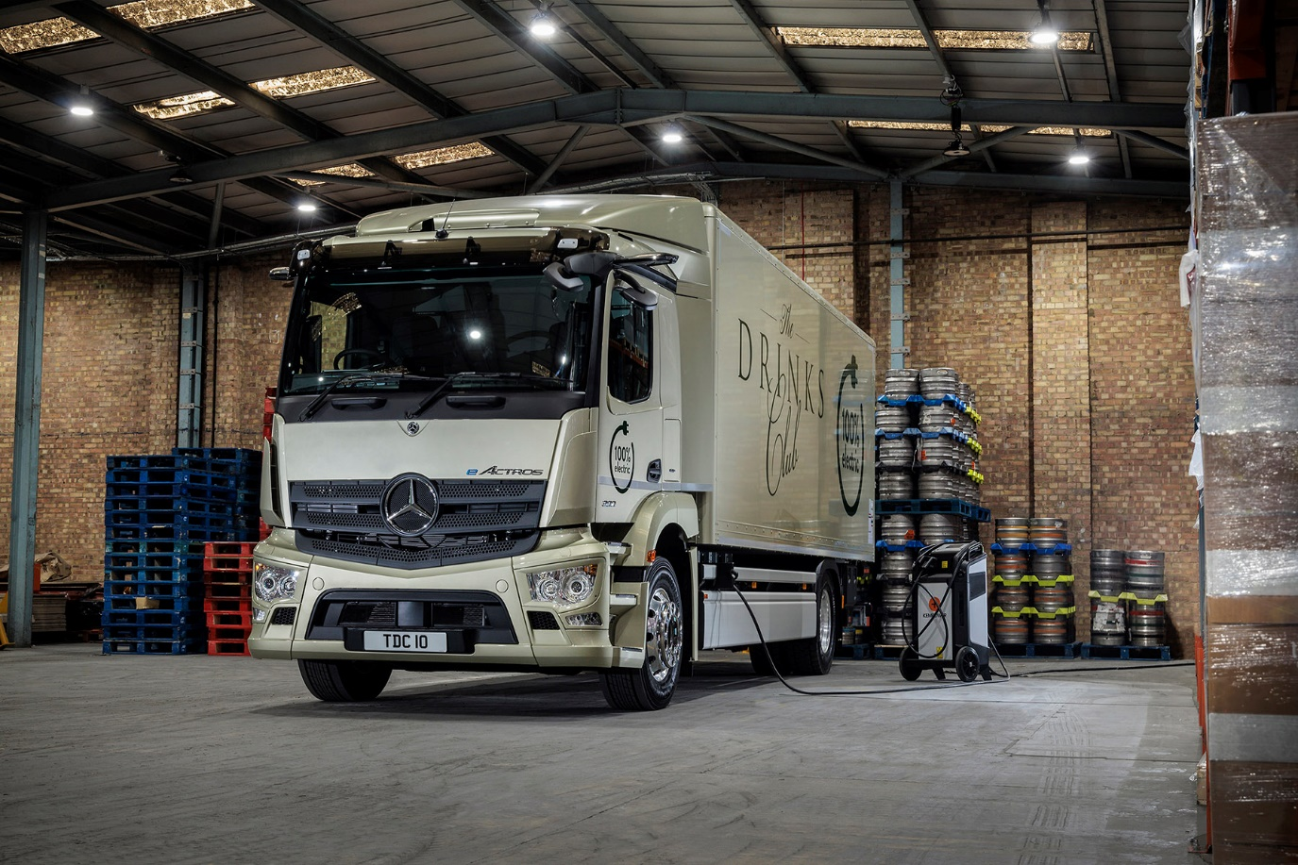

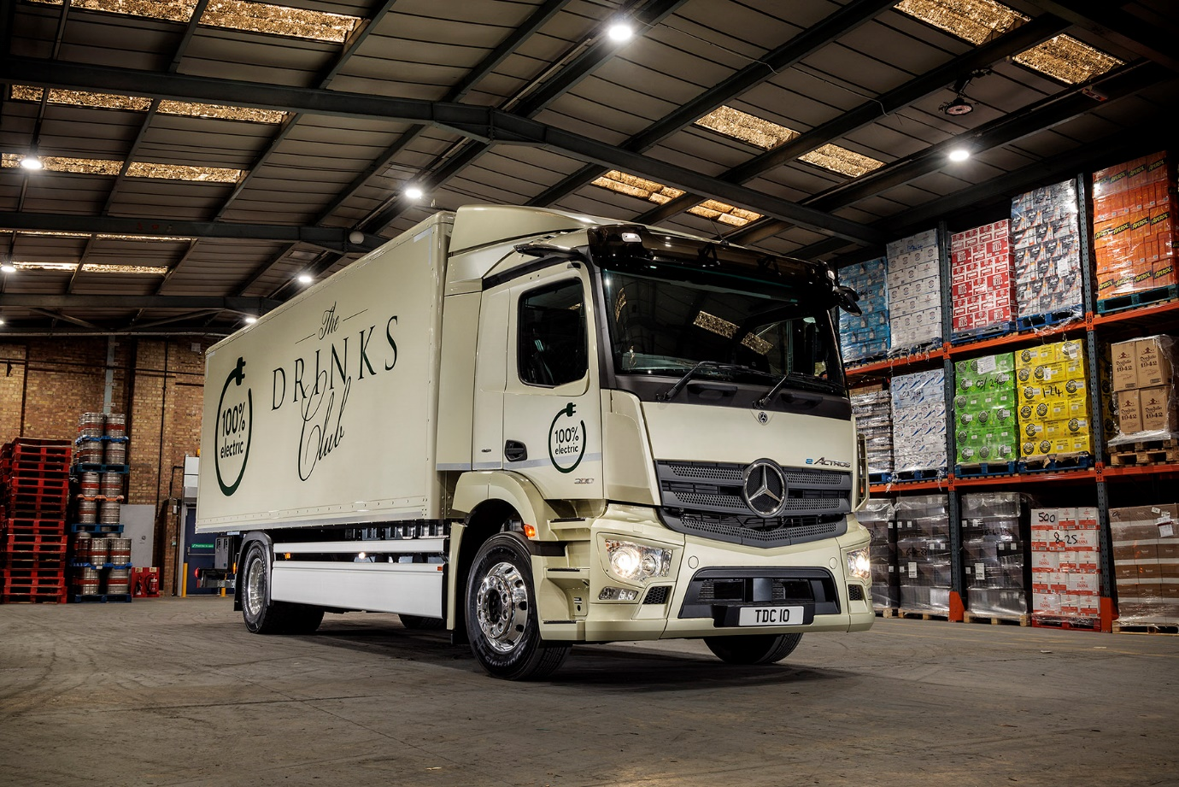

ends

For more information, or to request higher-res image files, please contact:

Jamie Fretwell at Mercedes-Benz Trucks UK Ltd
07712 519230, jamie.fretwell@daimler.com

or

John Ripley: 07771 484595, john.ripley@loopagency.co.uk

