

Date: 12 June 2020

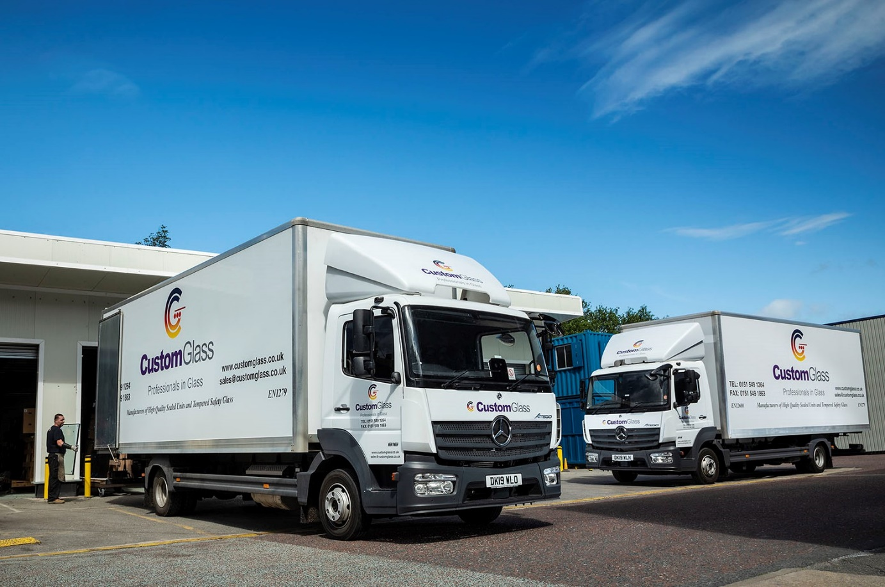

Mercedes-Benz Atego reliability and back-up from Roanza make an open and shut case for Custom Glass

Custom Glass is fighting back after a series of setbacks, thanks to the dedication of staff and the tried-and-tested reliability of its Mercedes-Benz Atego fleet.

The Covid-19 pandemic has presented severe challenges for many businesses. It was just the latest blow for Custom Glass, though. In the 12 months leading up to the outbreak the company had already suffered a devastating fire at its premises in Liverpool. Then, through no fault of its own, one of its new trucks was badly damaged in a site accident during the rebuilding.

Now repaired and hard at work, that vehicle was one of two 7.5-tonne Atego 816s supplied by Dealer Roanza Truck & Van. Both have ClassicSpace S-Cabs and 5.1-litre engines that produce 115 kW (156 hp). Their box bodies, which feature fixed internal glass-carrying frails, were designed and manufactured to Custom Glass’s own specification by Alloy Bodies, of Manchester. Other trucks on the fleet have removable frails, so they can also carry glass panes loaded onto stillages.

For Managing Director Jeff Hooson, Roanza offers the two things he needs most for his fleet – tough, reliable vehicles that are rarely off the road, and dependable, flexible back-up that ensures his distribution operation runs smoothly.

“We’ve been relying on Mercedes-Benz trucks for years now, and they’ve always been fantastic workhorses,” he confirmed. “A purpose-built glass-carrying vehicle is a very specialised piece of kit, and the bodywork quite expensive, so we tend to run ours for a long time. Our oldest Atego was registered in 2002 and has over 600,000 km on the clock, yet it’s still going strong.”

Mr Hooson continued: “The fact that our trucks have bespoke bodies means that if one breaks down it’s very difficult to hire or buy a replacement at short notice. That’s why we depend on the reliability of the Atego, and Roanza’s excellent support.

“Sales Executive Richie Rainford understands our business well and always delivers our vehicles on time and in top condition, while his workshop colleagues do their best to get them in for any routine maintenance work through the night or at weekends, so downtime is never an issue.”

Like so many other businesses, Custom Glass closed down completely in the early stages of the lockdown. “However, most of our customers are in the construction industry, which was one of the first sectors to get back to work,” said Mr Hooson. “As demand took off, we quickly came under pressure to resume deliveries again.”

Social distancing restrictions meant working practices had to be heavily adapted. Only 25 members of the company’s 110-strong workforce can be on site at any one time, with just four of its 18 Mercedes-Benz trucks running in and out of the depot. “We’re doing everything we can to serve our customers, while keeping our employees as safe as possible,” Mr Hooson added.

Established in 1982, Custom Glass now boasts an annual turnover of £10 million, and produces 2,500 double-glazed units every day. The firm supplies window fabricators and installers, builders and home improvers, throughout the North and Midlands. It also offers toughened and decorative glass, high-performance roof glass and ‘Low E’ thermal panels, painted glass splashbacks and ancillaries such as silicone sealant and integral blinds.

To cater for a wide-ranging customer base, Custom Glass’s fleet extends from Sprinter vans to a 44-tonne articulated tractor and semi-trailer combination. The mainstay of the operation, though, are its 14 Mercedes-Benz Atego 7.5-tonners.

The Atego range from 7.5-16 tonnes GVW is purpose-designed for light- and medium-duty distribution applications. It offers outstanding dynamics, comfort and manoeuvrability, as well as the durability necessary for intensive, multi-drop delivery work.

www.customglass.co.uk

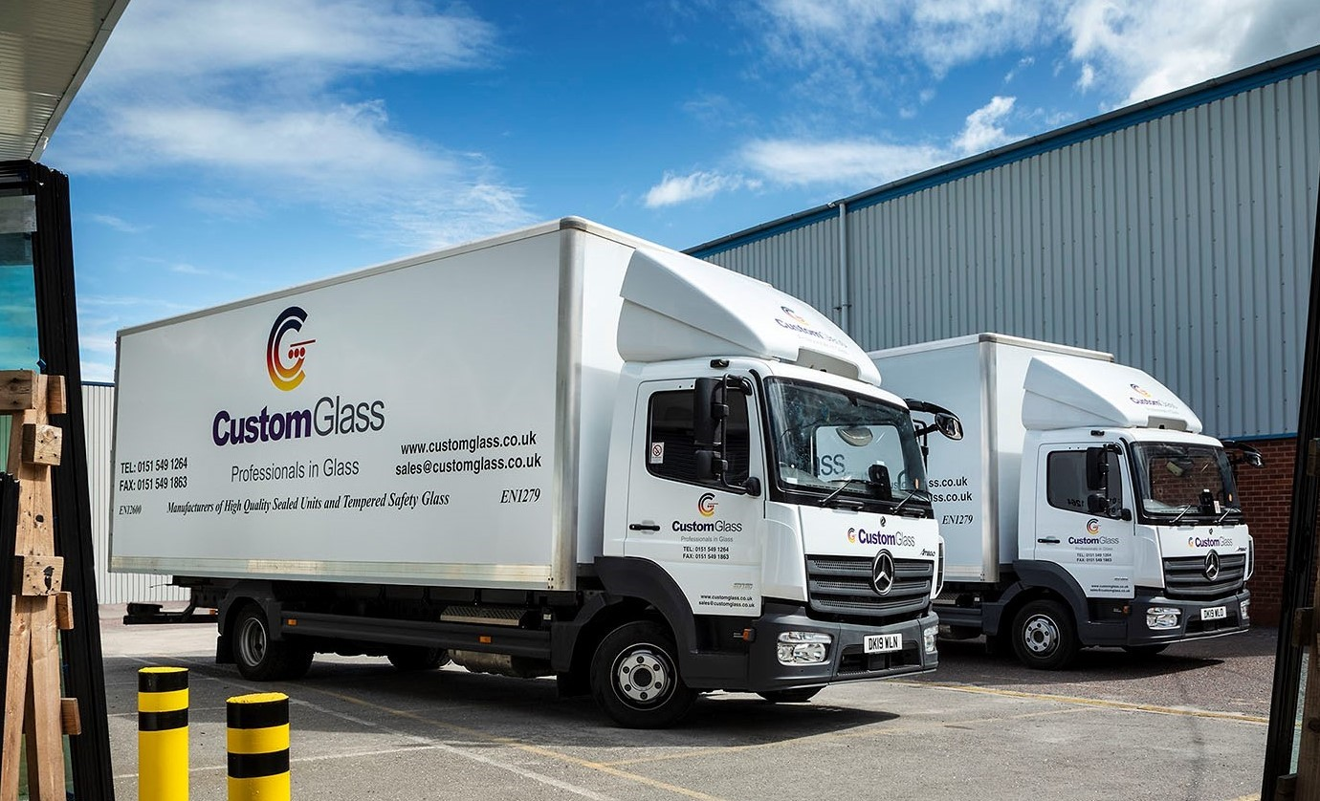

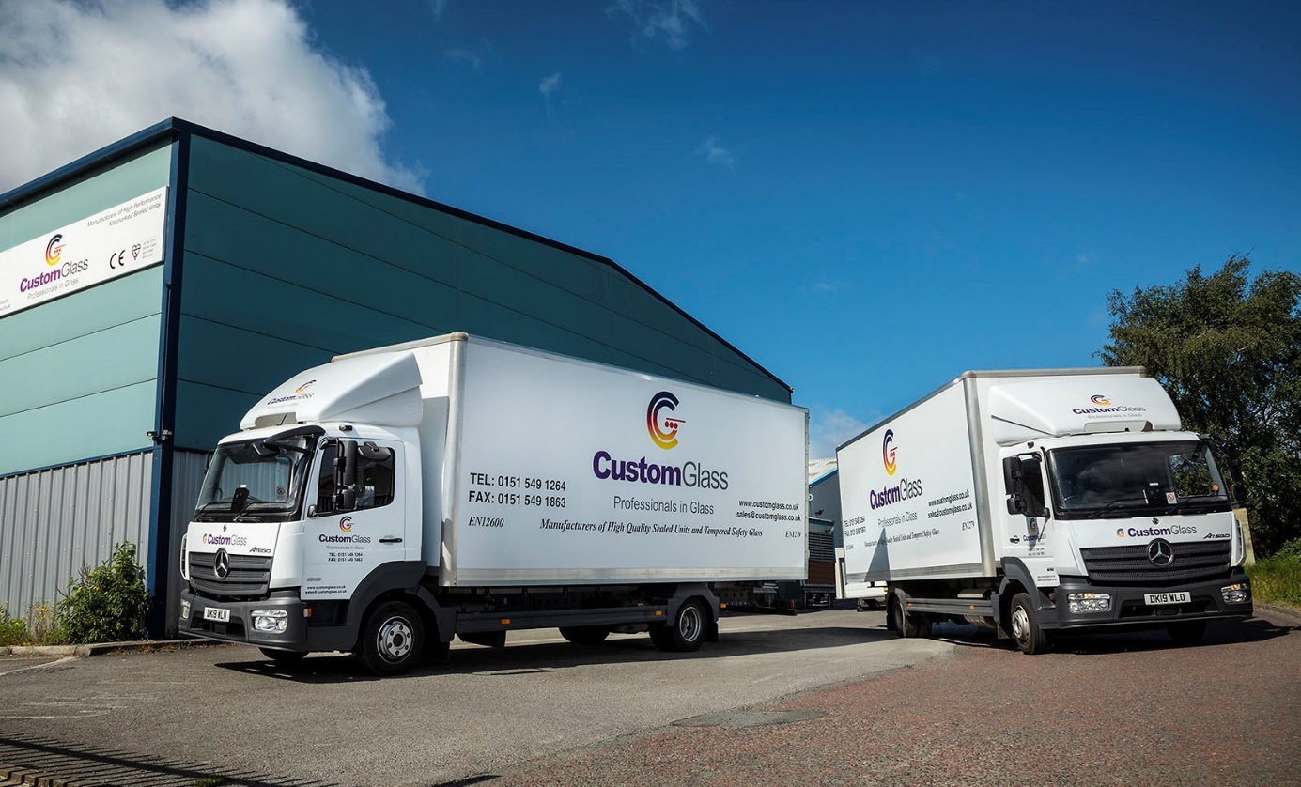

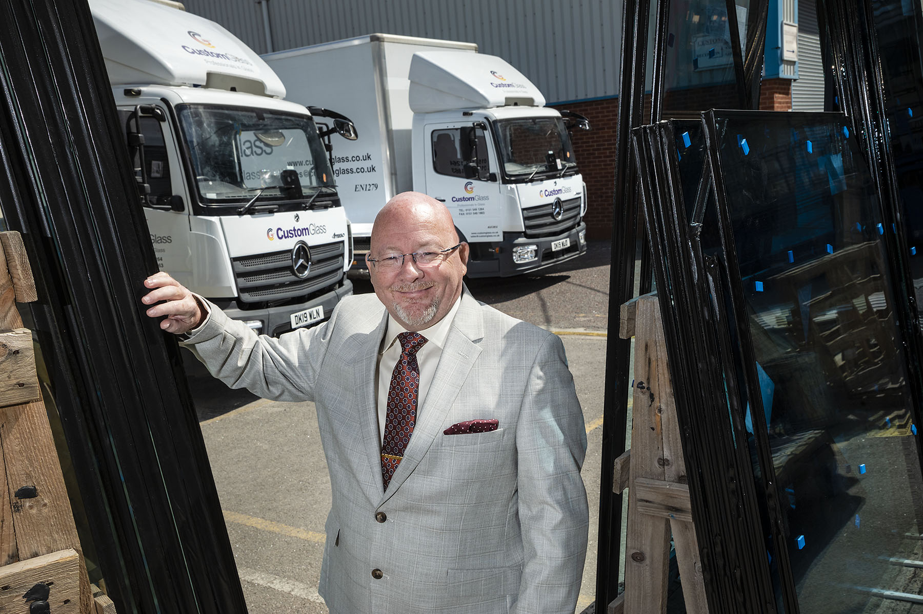

Clear winners: Jeff Hooson, with Custom Glass’s latest Mercedes-Benz Atego 7.5-tonners

ends

For more information, or to request bigger/higher-res image files, please contact:
John Ripley or Steve Warren
Impact Communications, 01926 842126
John: 07771 484595, john@impactcom.co.uk
Steve: 07770 470251, steve@impactcom.co.uk

