

Date: 22 October 2021
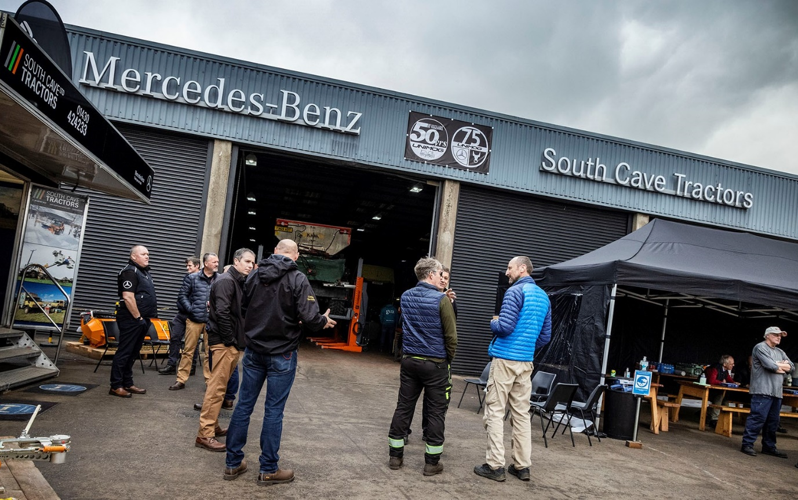

Mercedes-Benz Unimog specialist South Cave Tractors
marks twin anniversaries with a day to remember

Established and prospective Mercedes-Benz Unimog customers joined staff from the only UK Dealer that’s fully dedicated to the iconic 4x4 in a memorable double celebration.

South Cave Tractors, of Brough, East Yorkshire, has been selling and supporting Unimogs for 50 years, while Mercedes-Benz Trucks is currently marking the legendary vehicle’s 75th anniversary.

Reflecting the significance of the two anniversaries for their own business and the brand they are proud to represent, South Cave Tractors proprietor Tony Levitt and his team staged a special event at which some 75 invited guests were able to exchange their own knowledge and experience with other like-minded enthusiasts and professionals.

The Dealer presented a comprehensive line-up of Unimogs in many different specifications, including evocative classic models from years gone by. There were opportunities to put a pair of vehicles through their hugely impressive paces on an adjacent field, and learn how to operate an array of mowers, cranes and hitches. Owners who brought their own ’Mogs along could also benefit from a free professional inspection and report, while a specialist technician from Germany was available in the workshop to dispense expert advice.

The Mercedes-Benz Unimog is unique. Neither a truck, nor a tractor, it nevertheless offers many of the attributes of both. The vehicle’s unrivalled reputation as the ultimate off-roader has been earned in some of the world’s harshest operating conditions. Unimogs are chosen for the most arduous applications by a broad spectrum of operators, including those engaged in the agriculture, utilities, municipal and emergency services sectors, as well as for highly specialised roles such as maintenance of the railway infrastructure – the vehicle can even be adapted to run on rails.

All Unimogs have single rear wheels that follow the track created by the front wheels. Today’s range encompasses gross weights from 7.5 to 16 tonnes and is built around two core variants: a UGE implement carrier and a UHE extreme off-roader that can be fitted with many different types of body.

The birthplace of the ‘universally applicable motorised device’, as the Unimog was originally known, was Schwäbisch Gmünd, near Stuttgart, where the earliest prototype underwent off-road testing in 1946. Five years later, the first Unimog to bear a three-pointed star rolled off a Mercedes-Benz production line. The factory in Gaggenau is now home to the Unimog Museum.
Fast forward another two decades to 1971, and in the small town of Brough on the north bank of the Humber Estuary Simon Legard was establishing his agricultural contracting business. Initially, South Cave Tractors was an operator of Mercedes-Benz Unimogs but before long it was also maintaining and then selling them.

By the time engineer Tony Levitt joined South Cave Tractors in 1987, its contracting days were long behind it and the company was a well-established member of the Mercedes-Benz Dealer network.

Then, when the founder retired 15 years ago, it was Tony who took up the reins. “I jokingly asked Simon if he’d sell me the business,” recalled Tony. “I had no intention of going through with it at the time, but he agreed and that’s what we ended up doing.”

Under the stewardship of Tony and his wife and co-Director Tracey, South Cave Tractors has gone from strength to strength. It is now one of the world’s leading specialist Mercedes-Benz Unimog Dealers, and serves customers nationwide.

“I’ve spent most of my career working on and with Unimogs, and I’m as passionate about the product today as I’ve ever been,” he said. “The same is true of my team; we’re all enthusiasts at heart.”

Business is buoyant for South Cave Tractors, and while Tracey manages the accounts and other ‘back office’ functions, Tony and his sales colleagues are busy visiting potential customers to demonstrate the Unimog’s capabilities at first hand. “You’re not so much selling a vehicle as a concept,” he explained. “Operators need to experience the Unimog at first hand, working with equipment, to fully appreciate what it can do.”

Underlining its confidence in the future, South Cave Tractors has just recruited former Mercedes-Benz Trucks man Martin Foster to a fleet sales role that will entail managing accounts with major customers, including rail operators. Martin is now working alongside Sales & Marketing Manager Andy Cooper and Sales Executive Ben Middleton.

Meanwhile, Workshop Manager & Learning Co-ordinator Joe Baines is supported by Workshop Controller Mark Huby, whose son Ashley is a Technician. Other members of the aftersales team are Fabricator/Welders David Cooper – Andy’s brother – and Simon Cossins, Technician Nathan Eade, Parts Specialist Anthony Eate, and Apprentice Technician Max Waslin.

“Our special anniversary event was a great success, and it was very gratifying that so many customers took time out from their busy schedules to support us,” said Tony. “Tracey and I took a leap of faith when we bought South Cave Tractors, but we’ve never regretted it. Nor have I forgotten my own shopfloor background. Our people have always been the single most important factor behind the success of this business and I’m very proud of the fact that no-one has ever left us. You can’t buy loyalty like that.”

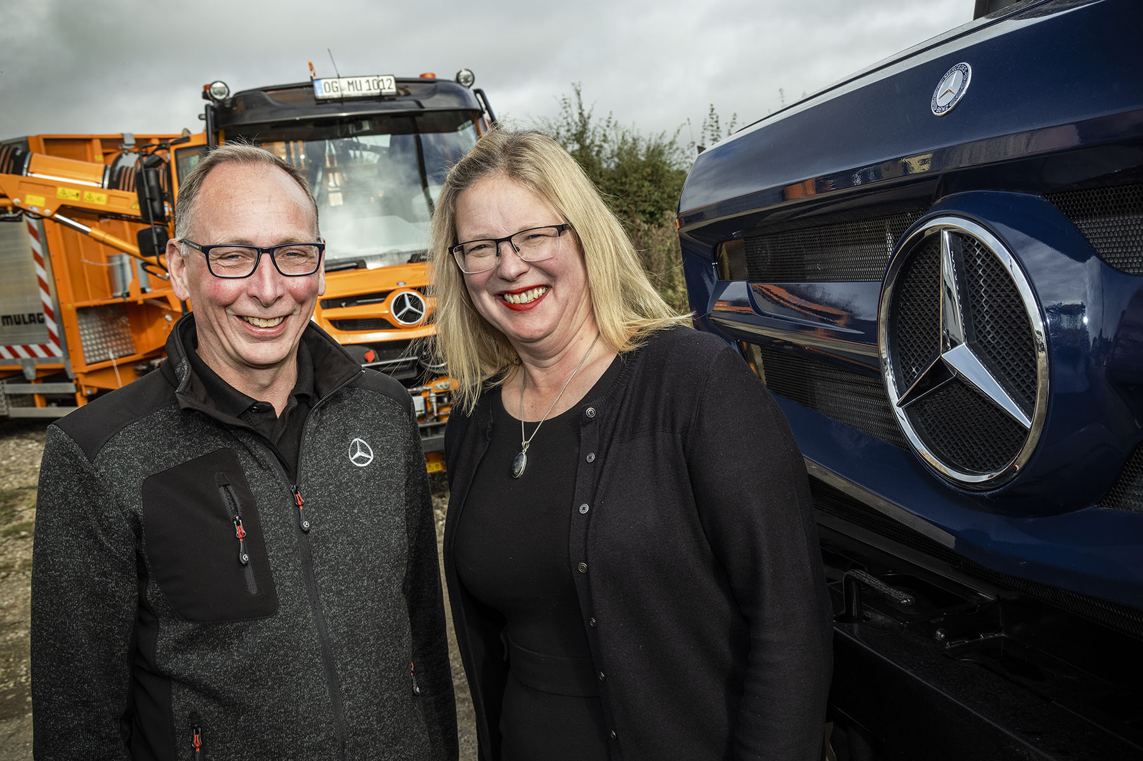

Celebrating their ‘other anniversary’: South Cave Tractors owners Tony and Tracey Levitt, whose company has been trading for 50 years

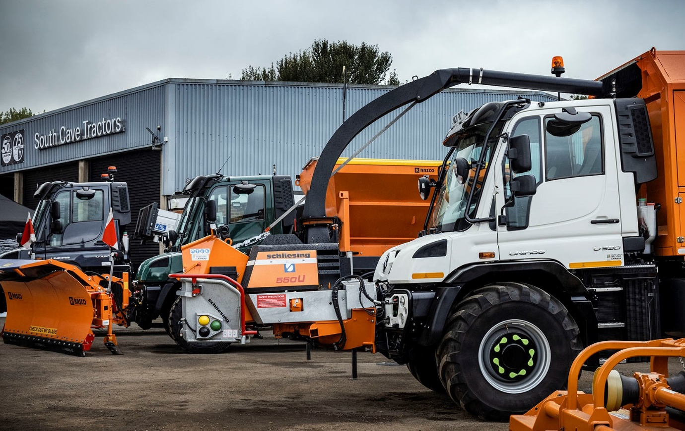

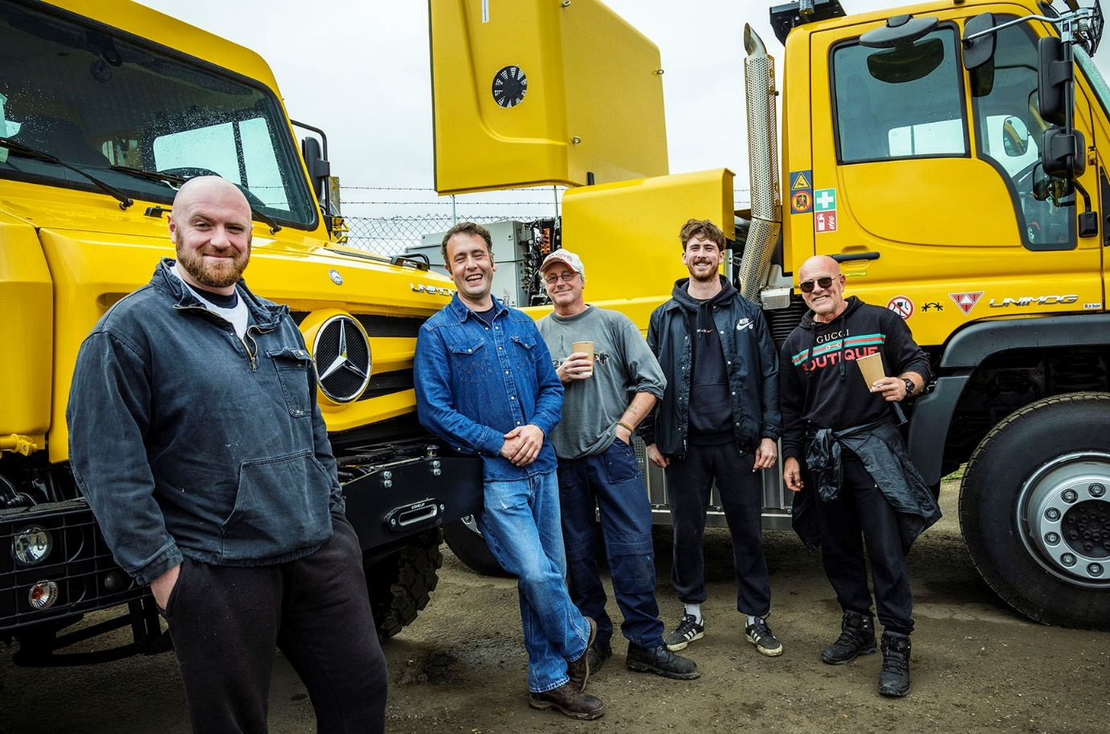

The ‘bees knees’: Colleagues from Bridlington-based Woldgate Honey, which uses its Unimogs to access hives in remote locations on the North York Moors, were among the guests at South Cave Tractors’ anniversary event

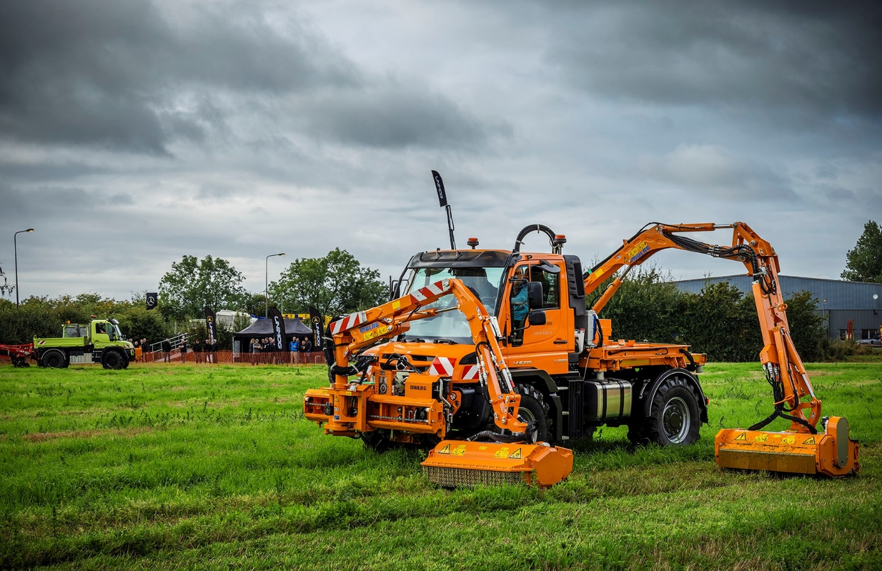

Field of dreams: Attractions included live demonstrations and ‘ride ’n’ drive’ opportunities

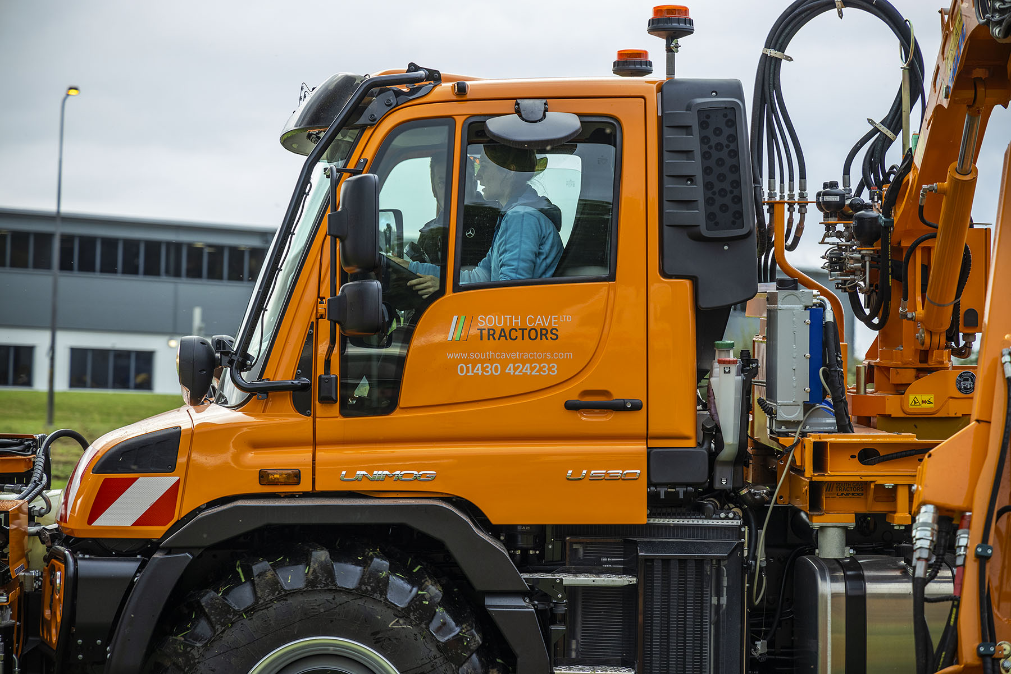

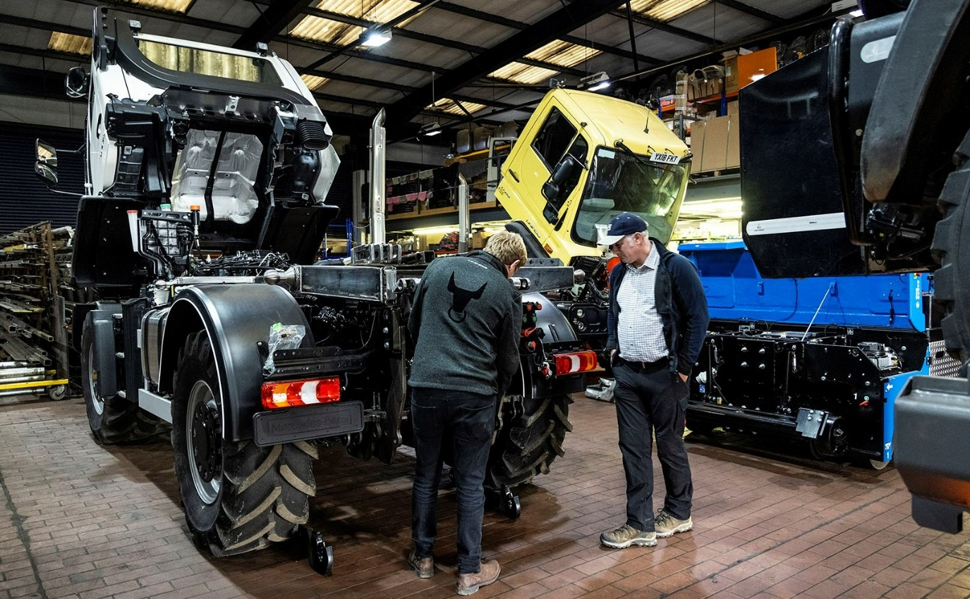

Work in progress: Lincolnshire Pig Company proprietor Ian Chick, right, from Sleaford, Lincolnshire, will shortly be taking delivery of his first Unimog, a U430 variant

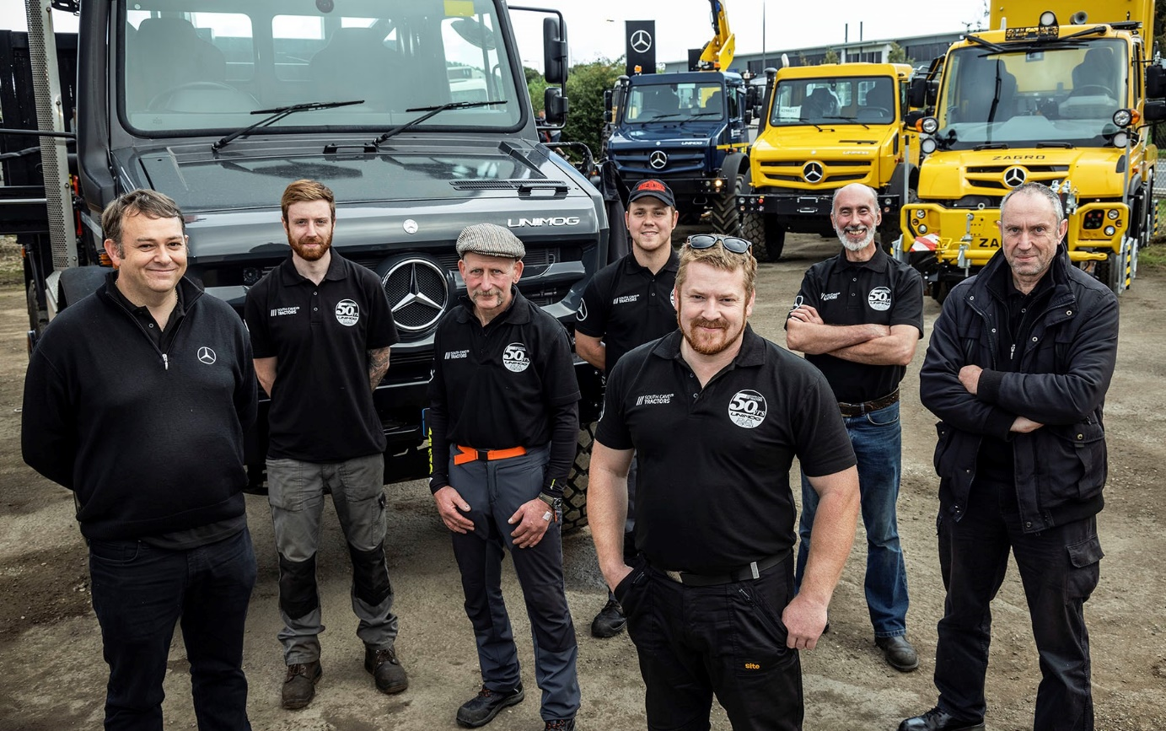

At your service: Workshop Manager & Learning Co-ordinator Joe Baines, third from right, is pictured with colleagues, from left, Anthony Eate, Ashley Huby, Simon Cossins, Nathan Eade, David Cooper and Mark Huby

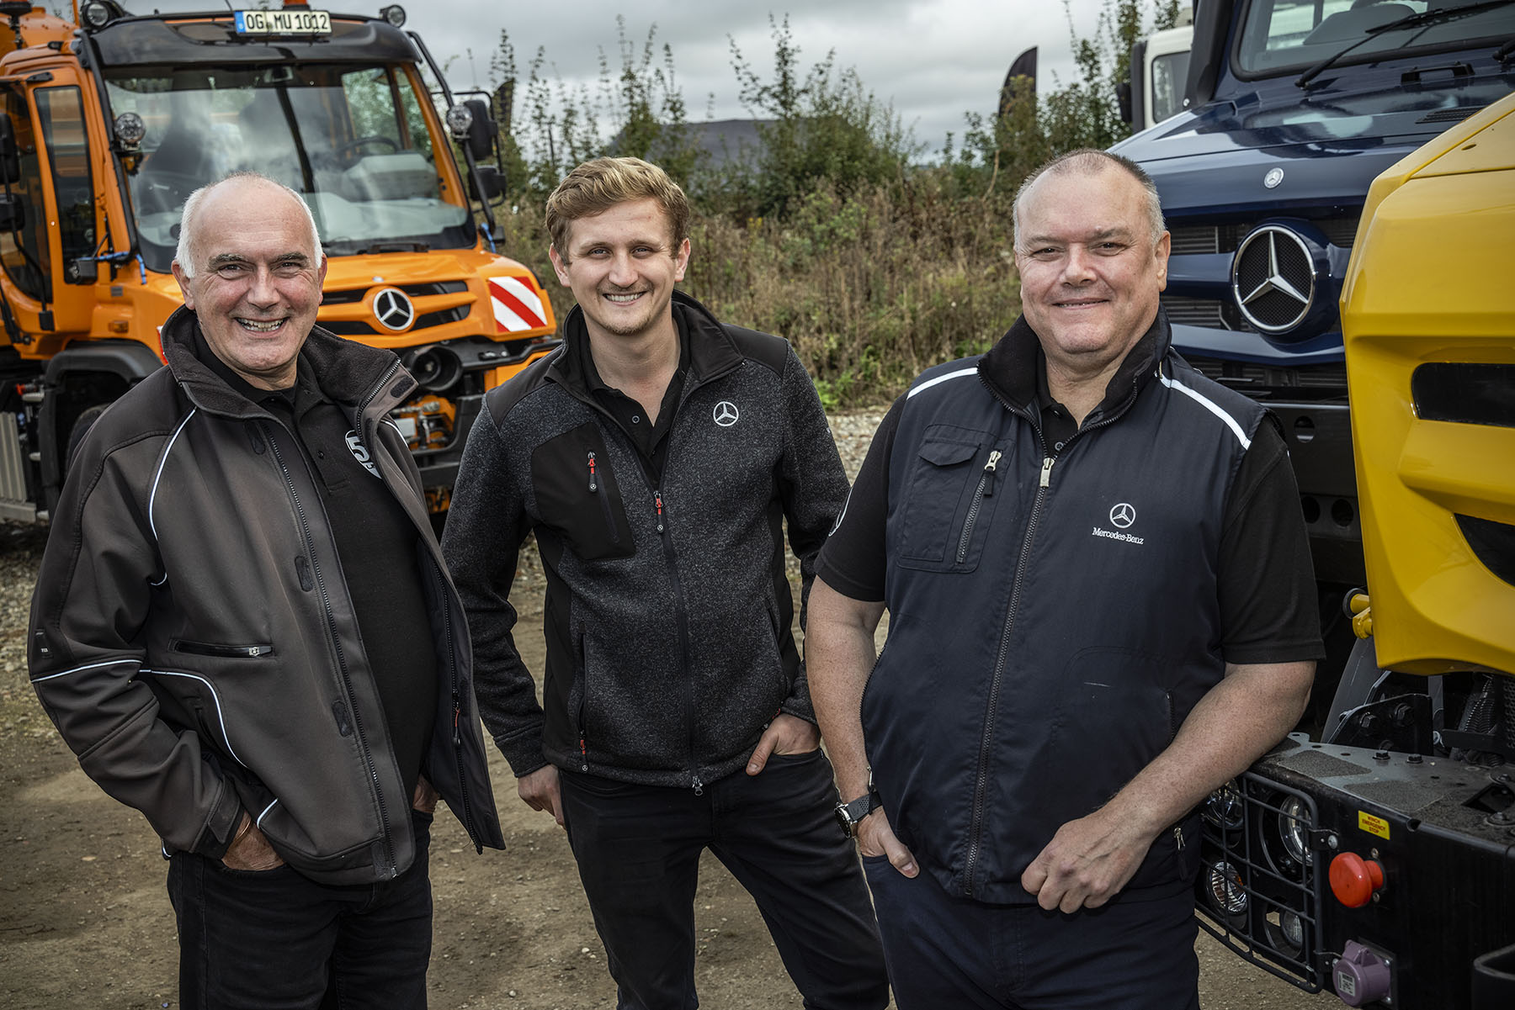

Welcome aboard! Martin Foster, right, is a new addition to the South Cave Tractors Sales team; he is pictured with colleagues Andy Cooper, left, and Ben Middleton

ends

For more information, or to request higher-res image files, please contact:

Jamie Fretwell at Mercedes-Benz Trucks UK Ltd
07712 519230, jamie.fretwell@daimler.com

or

Steve Warren or John Ripley
Impact Communications
Steve: 07770 470251, steve@impactcom.co.uk
John: 07771 484595, john@impactcom.co.uk



