

Date: 12 March 2020

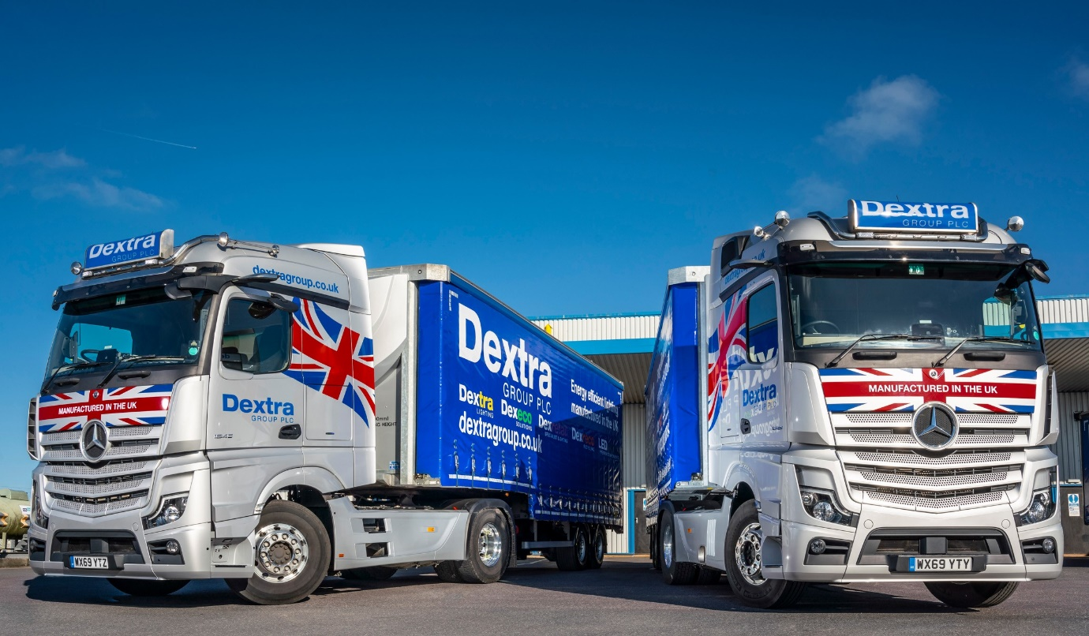

Flying the flag for new technology: With Active Drive Assist as well as Active Brake Assist 5 emergency braking systems, Dextra’s new Actros set the standard for safety

Dextra Group plc shines a light on Active Drive Assist from Mercedes-Benz Trucks

The UK’s largest privately-owned lighting manufacturer has commissioned two of the first right-hand drive Mercedes-Benz trucks to be equipped with ground-breaking Active Drive Assist technology.

Dorset-based Dextra Group plc turned once again to established supplier Rygor Commercials for its latest 4x2 tractor units. Both are 1845 models with flat-floored StreamSpace cabs and 330 kW (450 hp) ‘straight six’ engines.

The first level 2 autonomous driving system to enter series production, Active Drive Assist manages the vehicle’s speed to keep it a safe distance from traffic ahead, and steers it to keep its position in the centre of the lane. The driver always retains overall control, though, and must keep hands on the steering wheel at all times – if the sensor in the steering column detects a lack of human interaction, it sounds audible alerts, and disengages after a minute.

Active Drive Assist encourages a more relaxed and fuel-efficient driving style, thereby increasing safety. A study by Mercedes-Benz Trucks parent Daimler Trucks concluded that highly automated driving technologies such as Active Drive Assist can reduce sleepiness in drivers by as much as 25%.

The manufacturer contends that its state-of-the-art, high-tech trucks will help to attract youngsters to the industry, but Dextra’s longest-serving driver was also quickly won over by the benefits of Active Drive Assist. Having worked previously for its contractor, Martin Farrell joined the company in 1995 when it brought the transport operation in-house. He has now driven tractors from all five Actros generations.

“I always use Active Drive Assist when I’m out on the open road and it’s lovely,” enthused Martin. “Rygor’s Truck Training Manager Chris Moore gave us a clear and thorough overview during the handover, and I find the system very simple to operate. It’s another tool in the box that helps to make the job that bit easier and less stressful.”

Active Drive Assist is currently available as an option on 4x2 and 6x2 tag axle Actros tractor units and rigid models, but not yet on standard 6x2 mid-lift or mid-steer tractor units.

Martin is equally enthusiastic about MirrorCam, the revolutionary, camera-based system fitted as standard on new Actros models. Gone are the main and wide-angle mirrors outside the truck; instead the cameras relay images to a pair of 15-inch screens mounted on the A-pillars.

“In most trucks you get a massive blind spot in which another vehicle might be hidden, particularly at roundabouts,” continued Martin. “You can be right on top of it and not see it, so I’d always be trying to look around the mirror to reassure myself that nothing was there.

“That blind spot is eliminated by MirrorCam. I very quickly got used to the way the system pans the camera image to follow the vehicle’s movements when manoeuvring, turning off or lane charging, a feature that also contributes to the greatly improved all-round visibility.

“There’s no glare from the high-quality cameras either, and because the screens are inside the cab you don’t have to keep getting out to clean the windows. Having put some 10,000 km on my new Actros I can’t see a downside to MirrorCam; it’s a brilliant innovation in which I already have full confidence.”

The truck’s Multimedia Cockpit wins enthusiastic approval too – “It’s beautiful,” declared Martin. “There are fewer buttons and switches, and I love the new twin screens, which are intuitive and easy to use.”

Likewise, the technology that contributes to the truck’s increased fuel-efficiency. Although new Actros employs the same powerplants as the previous model generation, economy is enhanced by a much-improved version of the established Predictive Powertrain Control system, which offers 5% savings on regional roads. The compact and streamlined MirrorCam housings also help by reducing wind resistance.

“I’ve always tried to maximise economy by maintaining momentum and staying off the brakes as much as possible,” said Martin. “My new Actros is definitely ahead of its predecessor on fuel. I collected a new trailer the other day and on the outward journey she returned 16.5 mpg. Fully loaded I’m averaging 11-12 mpg, but sometimes touching 13.”

Dextra Group plc is the largest and most successful privately-owned lighting manufacturer in the UK. Founded more than 40 years ago by the current owner, the company boasts the most up to date and largest array of specialist equipment to service its client base of installing contractors and direct corporate accounts. Its wholly-owned, liveried fleet is integral to the company’s industry-leading service.

Every one of Dextra’s trucks wears a three-pointed star. Like the two new Actros, most are 4x2 tractor units plated for operation at 32 tonnes GCW, which pull double-deck trailers restricted to a height of 4.0 metres for operation on the Continent.

Operations Director Tim Pickford confirmed: “We’ve been a 100% Mercedes-Benz fleet since 2002, and have been using the manufacturer’s Fleetboard telematics hardware for nearly 15 years. We’re big believers in technology, and the benefits it offers in terms of safety, reliability and efficiency – that’s why our latest twin-decks from Tiger Trailers are equipped with automatic tyre pressure monitoring systems.

“Driver retention is crucial too. Guys like Martin are away for two, three and sometimes four nights a week – the truck is their home, so we’re committed to providing them with top-quality equipment. The new Actros cab interior looks and feels more like a premium-quality Mercedes-Benz car than a truck.”

Dextra maintains its trucks in a two-bay workshop on its headquarters site in Gillingham. “We rely on Rygor’s excellent technical and parts back-up,” he continued. “We’re in a very rural, outlying location, but the Dealer will make two parts deliveries per day if we need them.”

Rygor’s Dextra account is managed by Truck Sales Executive Marcus Cahalin, while the comprehensive handover delivered by Chris Moore included in-cab familiarisation and a practical drive with the truck hitched to a trailer.

“Our customers invest a lot of money in their new trucks, so it’s essential that drivers fully understand how to use all of the technology on their vehicles to best effect,” said Chris Moore. “I’ll spend as long as it takes to make sure a driver is comfortable with their new truck, and am always happy to take follow-up calls or return to provide further instruction if necessary.”
www.dextragroup.co.uk

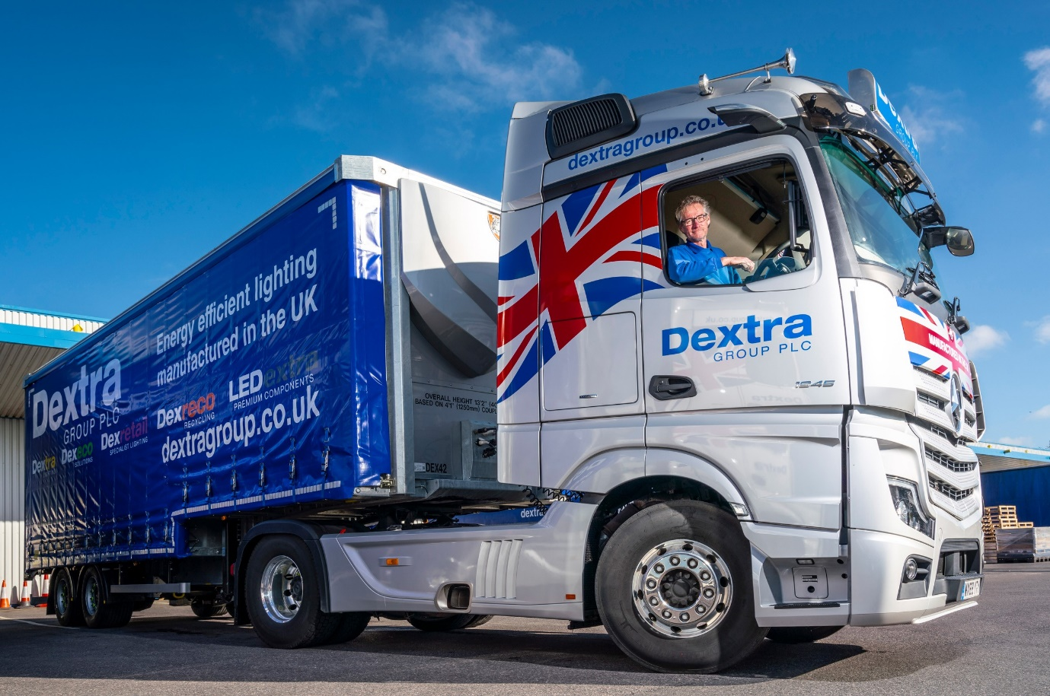

Fit for purpose: A keen cyclist and youth football coach, Martin Farrell believes in looking after himself and says Active Drive Assist makes life at the wheel less tiring and stressful

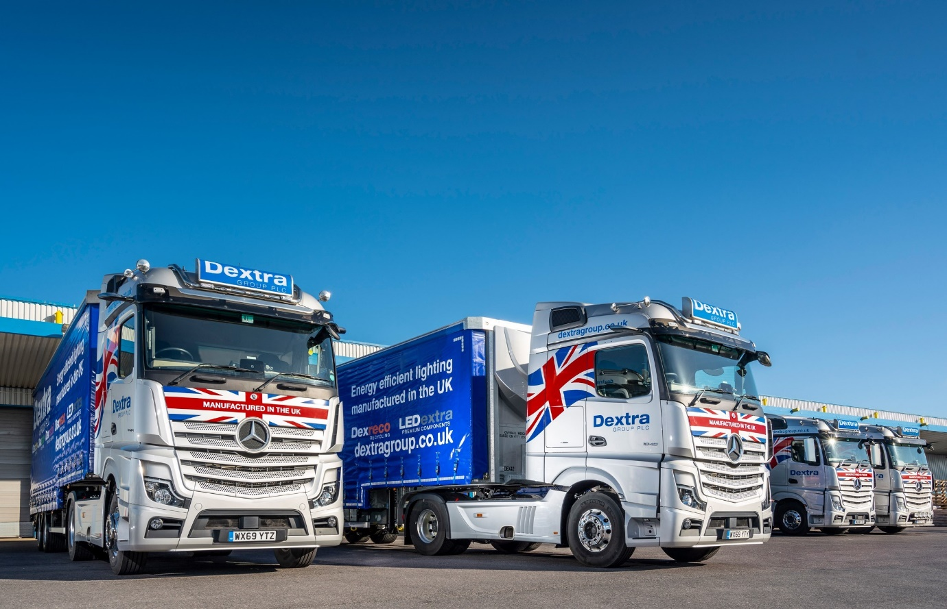

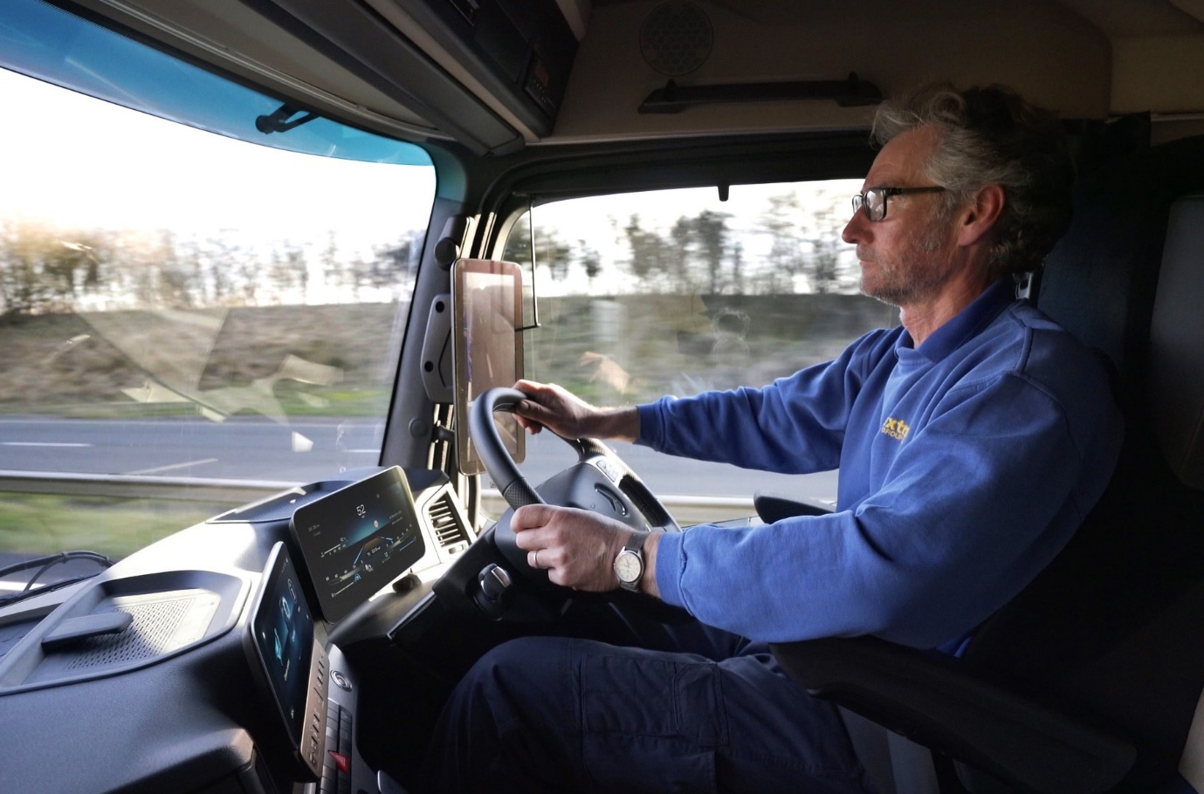

Always in control: Drivers must keep hands on the wheel when using Active Drive Assist

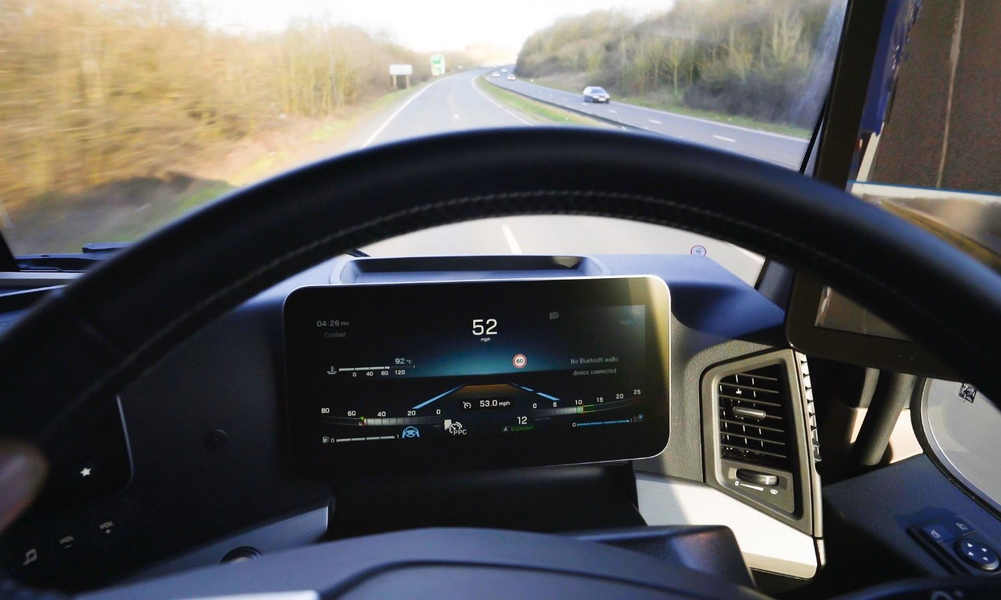

Sign of the times: The blue steering wheel and lane markers confirm that Active Drive Assist is in operation

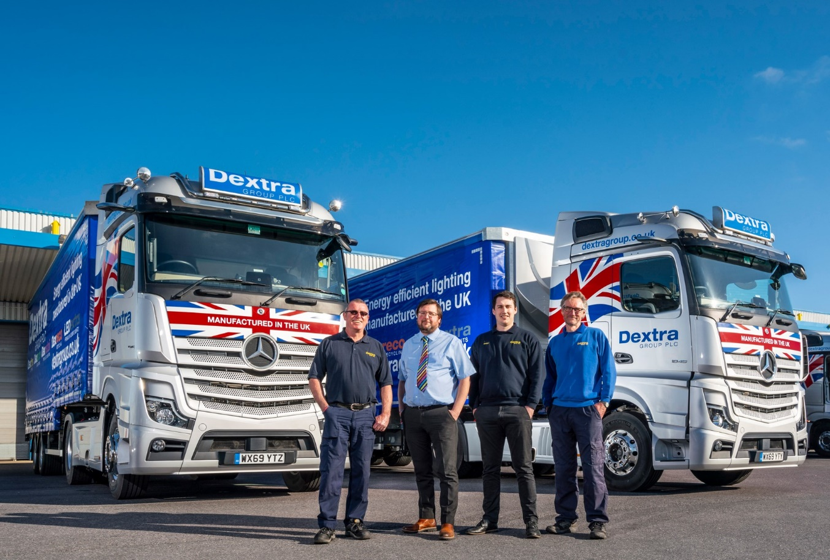

Dextra’s driving force: New Actros drivers Martin Farrell, right, and Rob Perrett, left, are pictured with Operations Director Tim Pickford, second from left, and Transport Manager Ben Chant

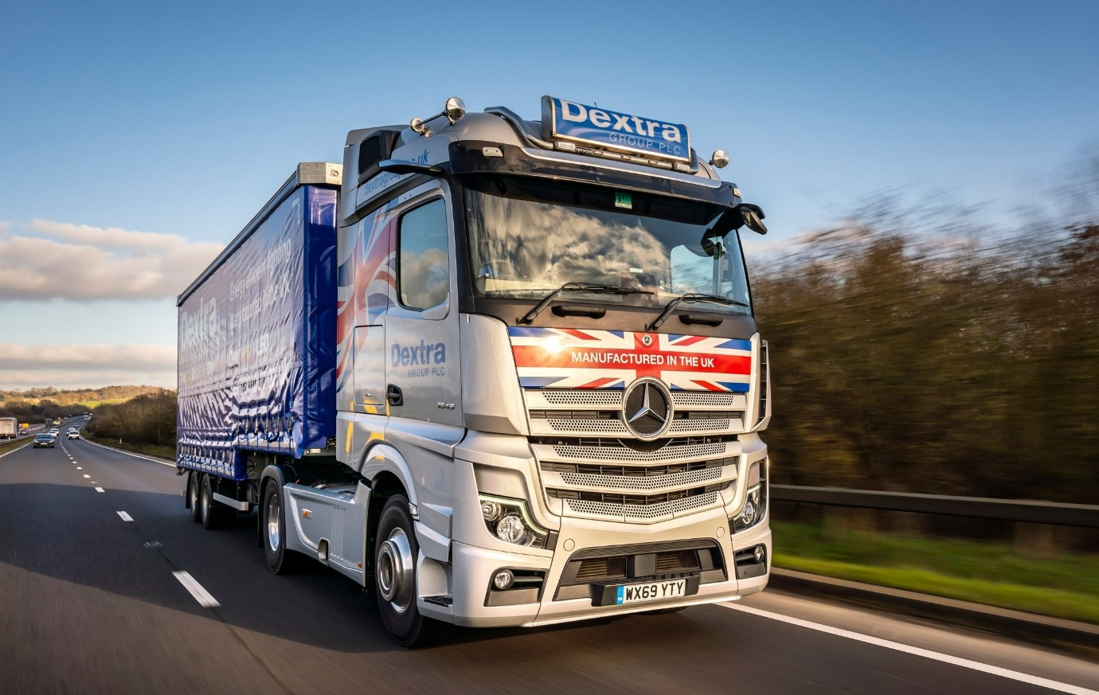

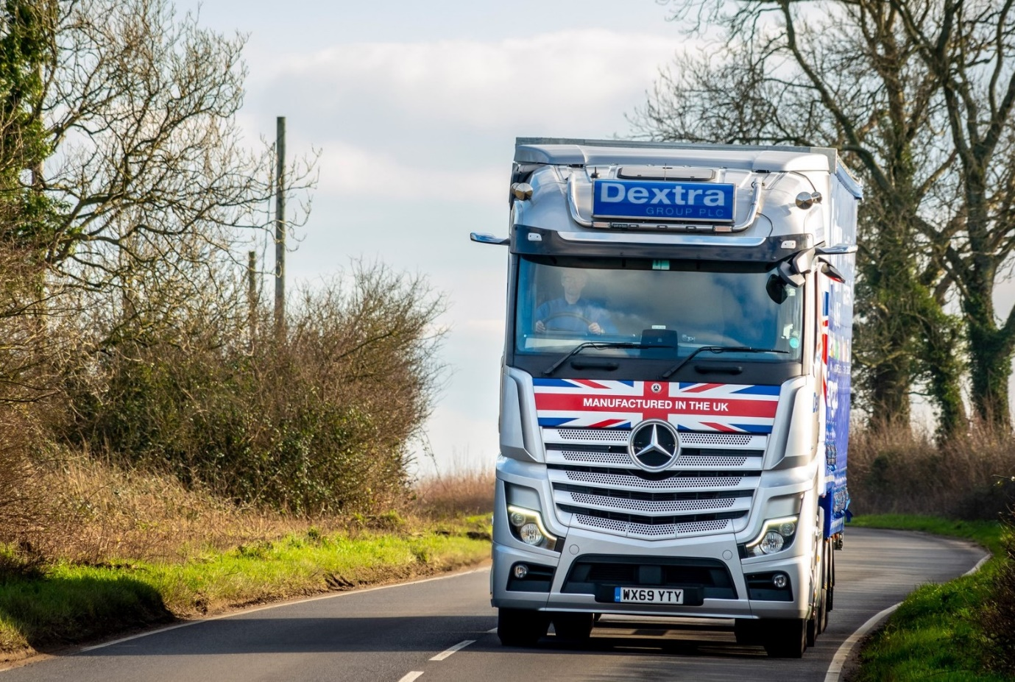

High, less wide, and handsome: Operations Director Tim Pickford believes the MirrorCam housings will prove less susceptible than conventional mirrors to damage from oncoming tippers on the rural roads around its Dorset base

ends

For more information, or to request bigger/higher-res image files, please contact:
Steve Warren or John Ripley
Impact Communications, 01926 842126
Steve: 07770 470251, steve@impactcom.co.uk
John: 07771 484595, john@impactcom.co.uk

Notes to Editors: Rygor Commercials

Award-winning Mercedes-Benz Commercial Vehicle Dealer group, Rygor, has branches throughout Berkshire, Gloucestershire, Oxfordshire, Somerset, West London, Warwickshire, Wiltshire and Worcestershire, offering extensive coverage for customers throughout the M5, M4 and M42 corridors.

The Rygor business has expanded and gone from strength to strength in recent years, launching its flagship Gloucester branch in late 2016 (which won Showroom of the Year at the 2018 Commercial Motor Awards) and undergoing a significant refurbishment of its Oxford branch in 2018. Rygor was delighted to be announced as winner of the ‘Best Sales Team’ award at the 2019 AM Awards, demonstrating our continued commitment to our customers and dedication to providing exceptional customer service.

With a proven track record, Rygor is proud to be selling and supporting the most prestigious name in commercial vehicles.

For more information, in the first instance please contact Kate Ruberry-Shoemack, Head of People and Communications at Rygor – kateruberry-shoemack@rygor.co.uk

