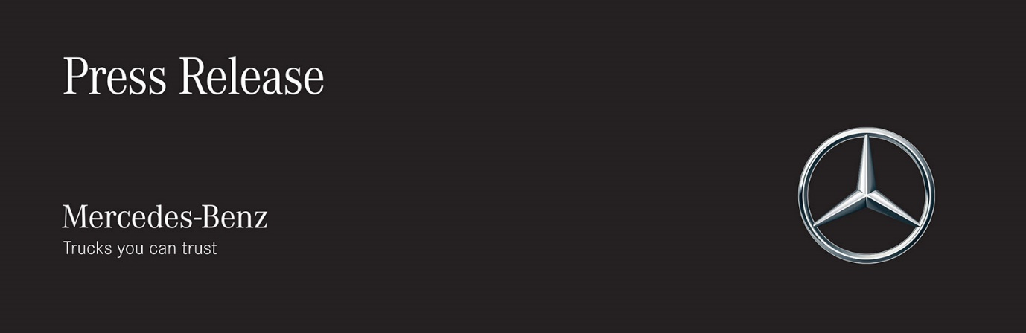

Date: 2 January 2019

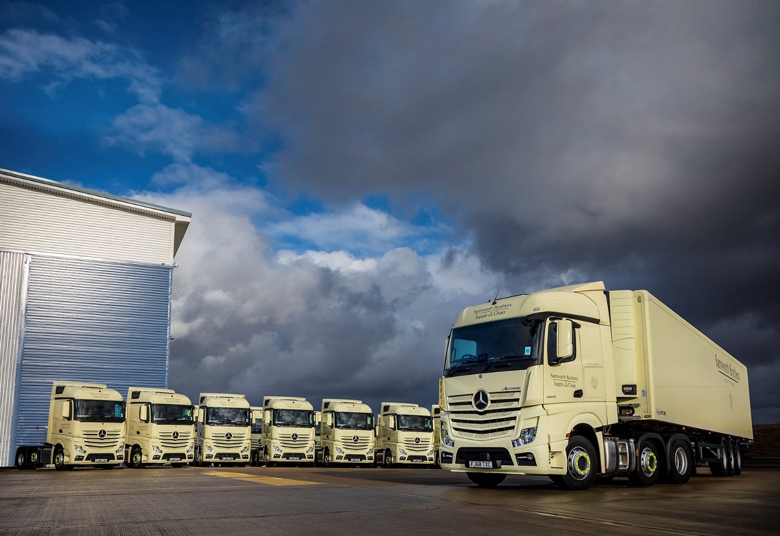

Samworth Brothers enters 2019 with breakthrough fleet of 18 Mercedes-Benz Actros

Industry-leading safety technology coupled with impressive fuel-efficiency and strong residual values persuaded high-profile temperature-controlled distribution specialist Samworth Brothers to place a prestigious fleet order with Mercedes-Benz.

The Leicester-based operator’s 18 new tractor units were supplied by East Midlands Dealer Mertrux Truck & Van. All are Actros 2545 models with flat-floored StreamSpace cabs, Safety Packs, and optional, fuel-saving Predictive Powertrain Control (PPC) systems.

Samworth Brothers trialled a variety of demonstration units, including Actros models powered by 330 kW (450 hp) and 350 kW (480 hp) versions of the state-of-the-art, second-generation OM 471 12.8-litre straight-six. Both performed well, returning in excess of 10 mpg when pulling single-deck trailers, and only marginally less with twin-deck trailers – the 330 kW (450 hp) unit was slightly ahead, however, so it is this engine that powers the operator’s new fleet.

Though fuel-efficiency was crucial given the high-mileage nature of the operation, an even higher priority for Samworth Brothers was the protection of its drivers and other road users. The Mercedes-Benz Safety Pack bundles together the ground-breaking Active Brake Assist 4 emergency braking system – which incorporates a world ‘first’ in the shape of pedestrian recognition – as well as Proximity Control Assist and a driver’s airbag.

The Actros are the subject of a buyback agreement under which each unit will cover 250,000 km per year. Key to the attractive package put together by Mertrux Fleet Truck Sales Manager Bob Holt, were their high, guaranteed residual values at the end of the term.

A fourth-generation family business, Samworth Brothers operates more than 120 of its own trucks, as well as some 230 semi-trailers of various configurations – it also supplements the fleet with rental vehicles.

Although this is its first multiple-unit order for Mercedes-Benz trucks, Samworth Brothers has been running a single Actros tractor for the last four years. Having clocked-up one million km and proved both reliable and economical, this vehicle was recently withdrawn from front-line duties.

It has now been refurbished and converted for use under a sponsorship deal with Mertrux, by the operator’s acclaimed Supply Chain Academy – Samworth Brothers’ drivers and instructors have won a string of industry awards, including the Freight Transport Association’s prestigious ‘Driver of the Year’ accolade for the last two years running.

A programme of driver training is being delivered at Mercedes-Benz Trucks’ Wentworth Park complex in South Yorkshire, and at the operator’s own locations. Meanwhile, Mertrux has installed an imprest parts stock at Samworth Brothers’ Leicester workshop and will be providing support with any warranty or other technical issues.

www.samworthbrothers.co.uk

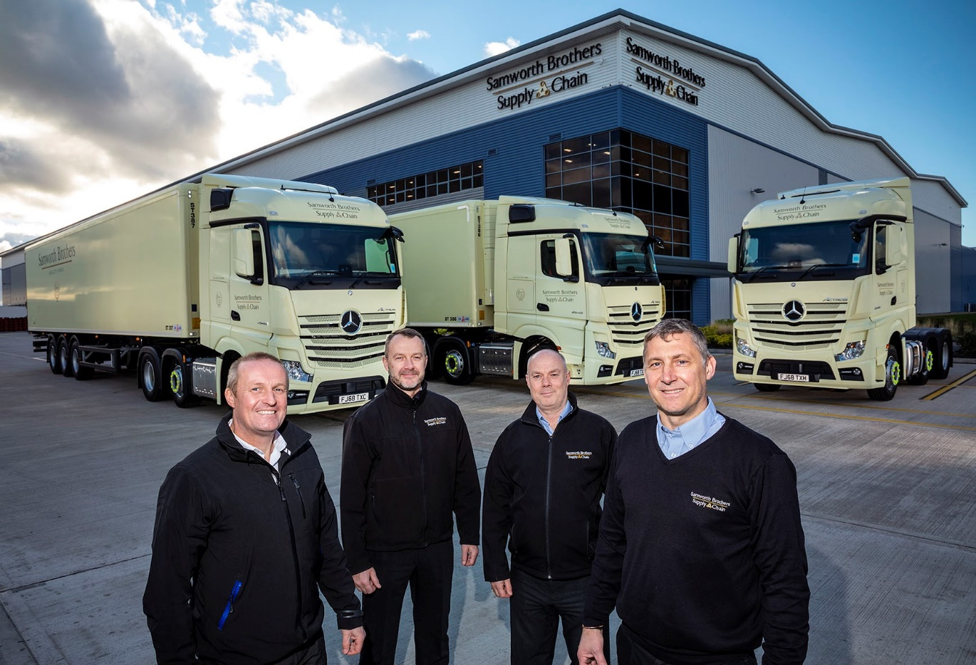

Forging a new partnership: Samworth Brothers Operations Director Paul Marrow, second from, left, is pictured with colleagues David Alexander and Ian Cooper, right, and Mertrux Fleet Truck Sales Manager Bob Holt, left

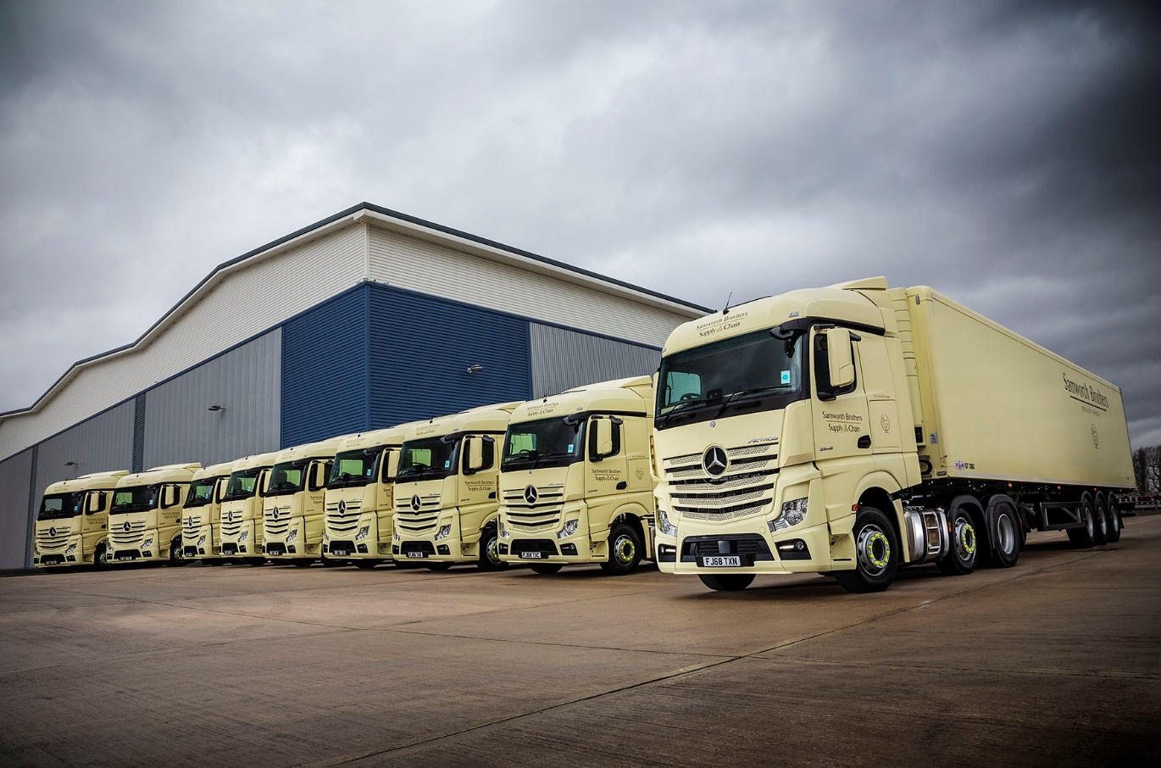

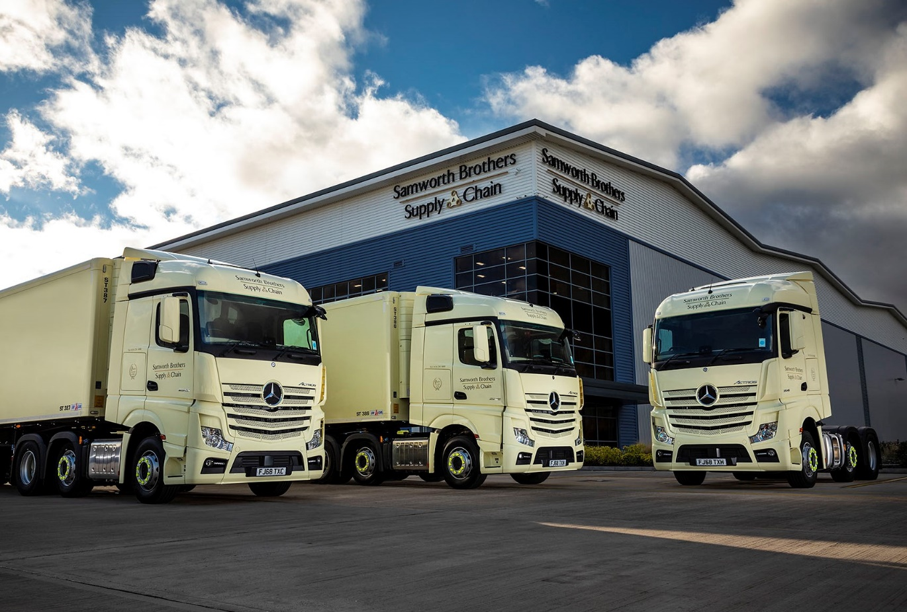

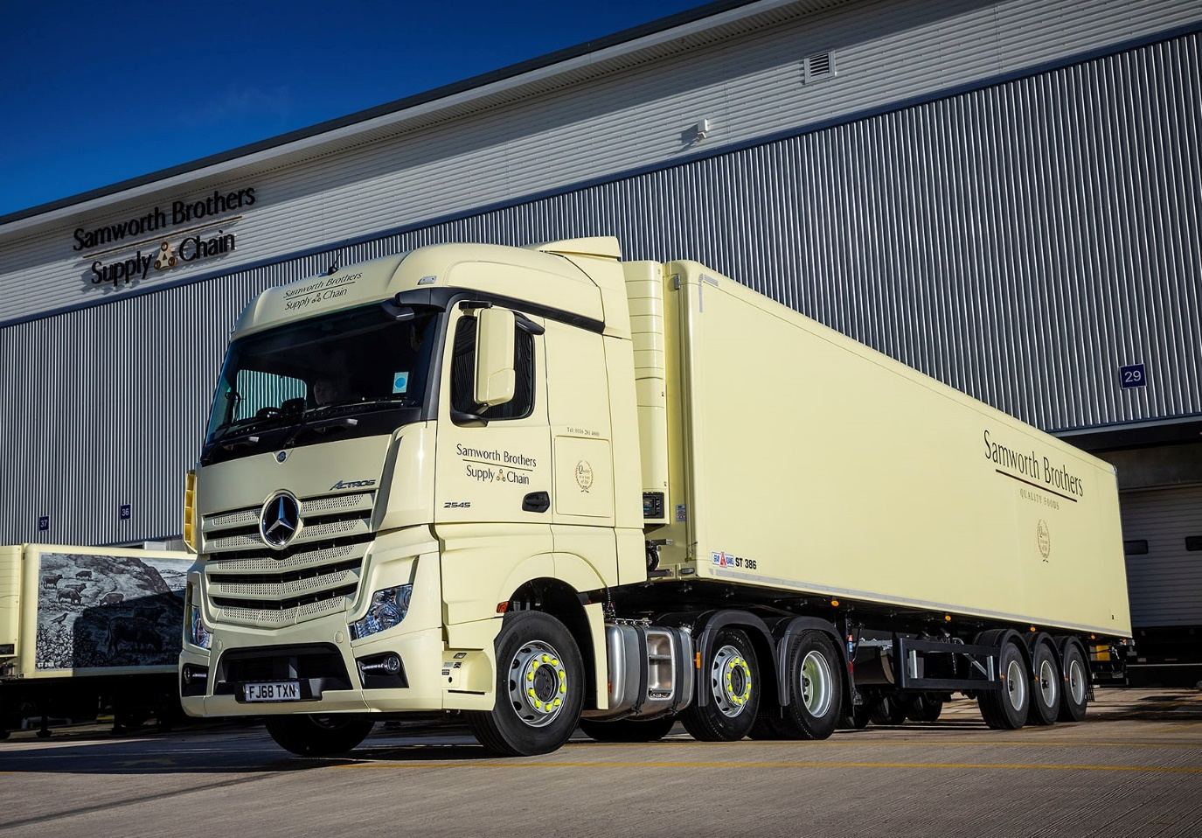

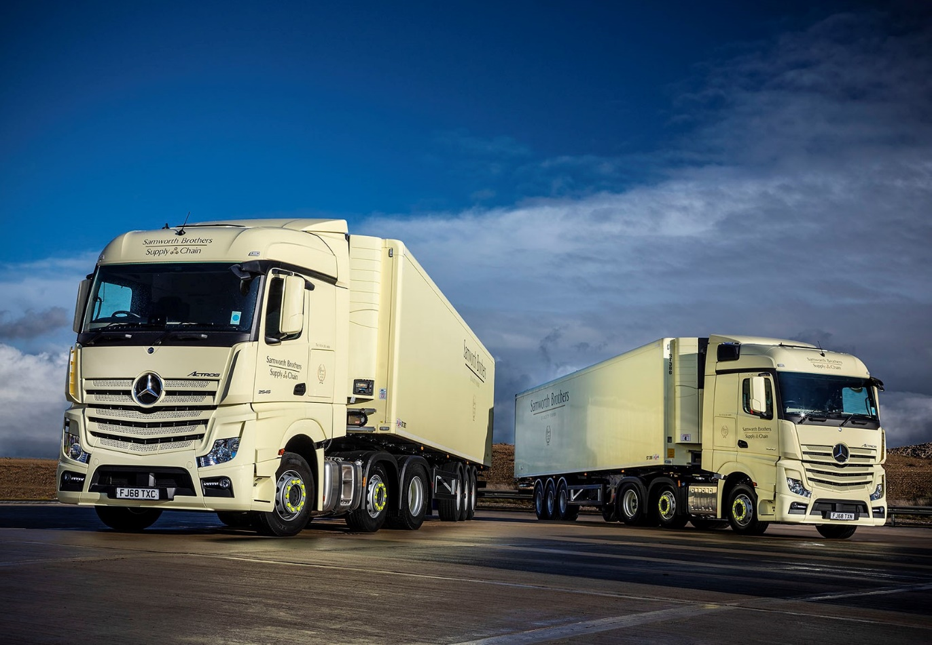

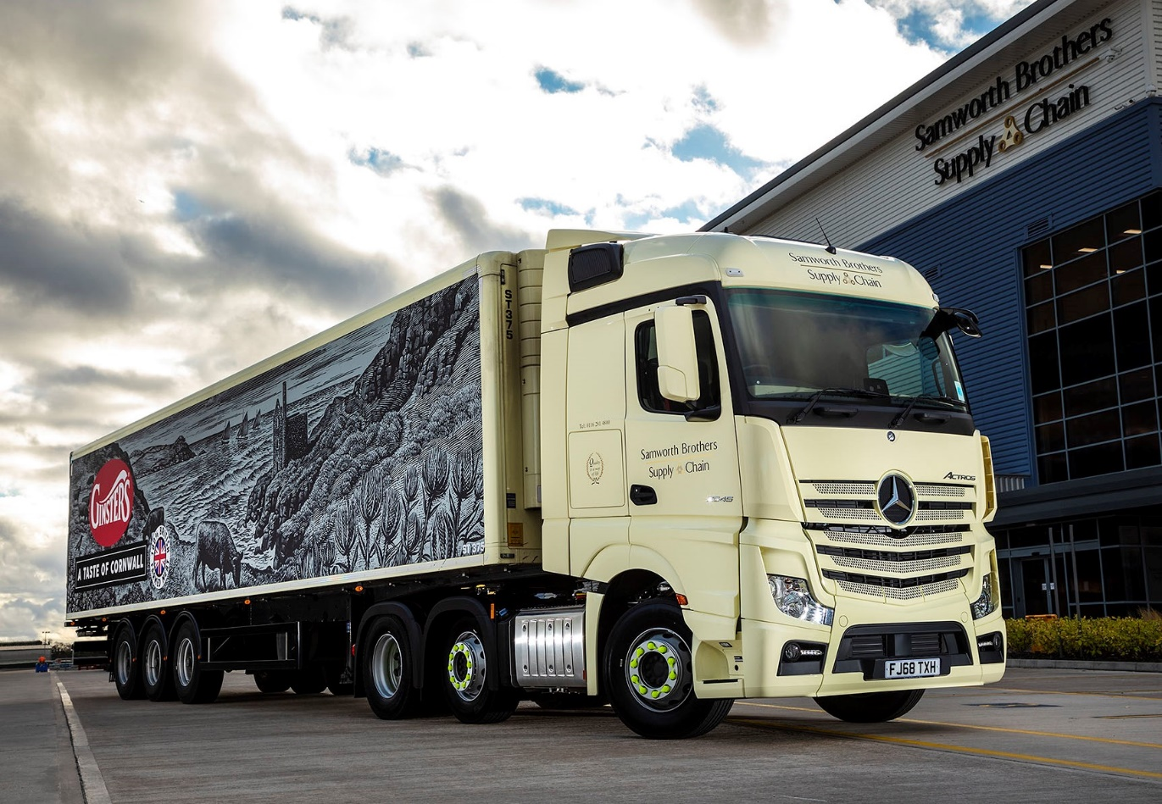

ends

For hi-res image files, please visit:
media.mbtrucks.co.uk

For further information, please contact:
Jamie Fretwell, PR & Internal Communications
Mercedes-Benz Trucks
07712 519230, Jamie.Fretwell@daimler.com
or

Steve Warren or John Ripley
Impact Communications, 01926 842126
Steve: 07770 470251, steve@impactcom.co.uk
John: 07771 484595, john@impactcom.co.uk

About Mercedes-Benz Trucks UK Ltd

Mercedes-Benz Trucks UK Ltd is the sales and marketing organisation responsible for all Mercedes-Benz truck products in the UK, including FUSO Canter.

In 2017, Mercedes-Benz Trucks UK Ltd registered 8,385 new trucks. Mercedes-Benz registrations grew by 9% year-on-year, totalling 7,561 trucks. The company’s total market share for 2017 was 18.6% – making Mercedes-Benz the second-biggest truck brand in the UK.

For more than 125 years, Mercedes-Benz has stood for innovative vehicles that meet exceptionally high standards of quality. Our claim to perfection, sustainability and avant-garde design is now embodied in the next generation of trucks: Actros, Antos, Arocs, Atego, Econic and Unimog.

www.mbtrucks.co.uk

