

Date: 5 March 2020

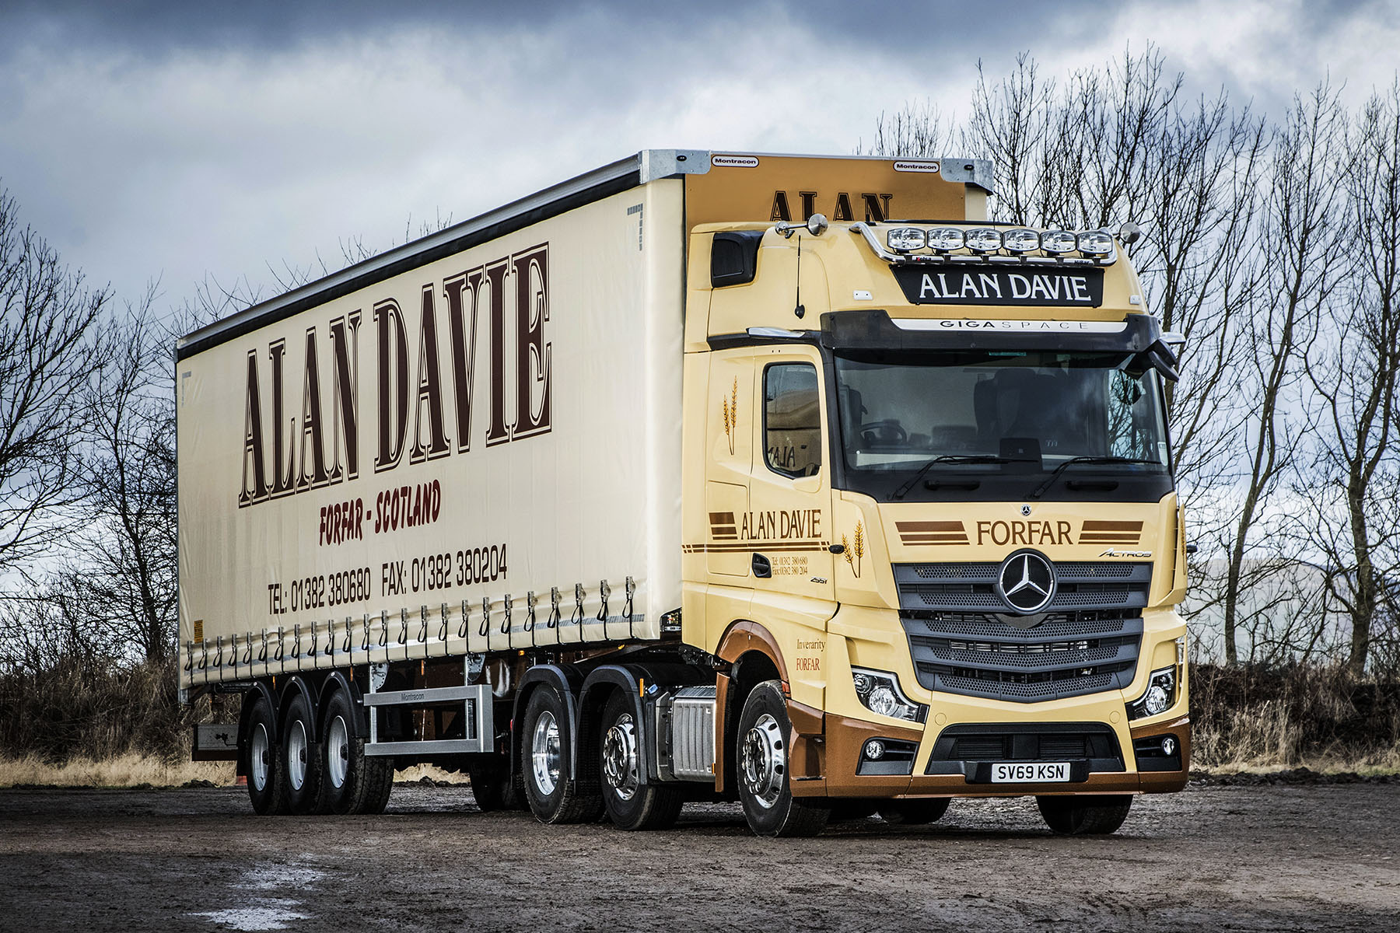

Safety-focused Alan Davie doubles up with first new-generation Mercedes-Benz Actros

Safety was uppermost in the mind of haulier Alan Davie when he ordered his latest two tractor units from Mercedes-Benz Dealer BLS Truck & Van.

Both are new Actros 2551 models with range-topping GigaSpace cabs and 12.8-litre in-line six-cylinder engines which produce 375 kW (510 hp). One hit the road on 1st March, while the second is scheduled to arrive in April.

Mr Davie was farming with his father when he bought his first truck in 1978. Today, the transport business that bears his name operates from depots in Dundee and Forfar, and runs a mixed-marque fleet of 53 trucks, the overwhelming majority of them tractor units.

The line-up includes eight other Mercedes-Benz Actros, one an 18-tonner. Three of those vehicles, all tractor units, were supplied by Aberdeen-based BLS Truck & Van last year. The two new trucks, however, are Alan Davie’s first from the fifth-generation Actros range launched in the summer of 2019.

They represent extensions to the operator’s fleet, reflecting continued growth in demand for its services. A member of TPN – THE Pallet Network, and the Road Haulage Association, Alan Davie is proud to be the stable employer of a 65-strong workforce, and to couple modern efficiency with the values of a traditional family firm. While Mr Davie remains at the helm as Managing Director, sons Ian and Euan also work for the business and so, occasionally do his grandchildren.

Alan Davie’s established Actros tractor units return between 8.5 and 9.5 mpg depending on the route, the load and the prevailing weather conditions. “We’re very happy indeed with those fuel figures,” confirmed Mr Davie, “but we’ll be looking for even better from our latest trucks.”

Crowned International Truck of the Year 2020, the latest Actros is equipped as standard with a host of innovative features. Well-proven Predictive Powertrain Control technology scans the road ahead, then manages the vehicle’s driveline to restrict diesel consumption and cut emissions.

The new model’s enhanced version makes an even more substantial contribution to economy by covering virtually all A roads, as well as many B roads, and taking account not only of topography but also of corners, roundabouts, junctions and traffic signs.

Meanwhile MirrorCam, the much-publicised replacement for conventional mirrors, helps to cut fuel costs by up to 1.5%, thanks to the compact, streamlined profile of the camera housings.

Welcome though further cost savings will be, however, it is the ground-breaking safety advances made by Mercedes-Benz that most excite Mr Davie. The biggest advantage of MirrorCam is the greatly improved all-round visibility it offers, particularly at roundabouts and junctions, or in congested town and city centres, where cars and vulnerable road users can be ‘lost’ in blind spots.

A potential life-saver in the form of Active Brake Assist 5 is also standard equipment on new Actros. Whereas the previous version of Mercedes-Benz Trucks’ emergency braking system relied solely on radar, its successor employs a combination of radar and cameras. The result, at speeds of up to 50 kph, is a dramatically improved response to moving pedestrians. Active Brake Assist 5 employs full braking – as opposed to the 50% achieved previously – when encountering pedestrians crossing its path.

The state-of-the-art Multimedia Cockpit contributes to safety too, along with aids such as Proximity Control Assist, Lane Keeping Assist and Attention Assist, by making life at the wheel easier and less stressful for drivers.

“We’re very conscious at Alan Davie of our Duty of Care to colleagues and, indeed, the general public,” continued Mr Davie. “Mercedes-Benz is very good when it comes to safety technology, and is clearly ahead of the competition in this respect.”

Director Ian Davie added: “We’ve been out in a truck with MirrorCam and were very impressed. A relaxed driver is also a safer driver, so we’re very much looking forward to getting our new Actros on the road and seeing whether the system lives up to its promise.”

www.alandavietransport.co.uk

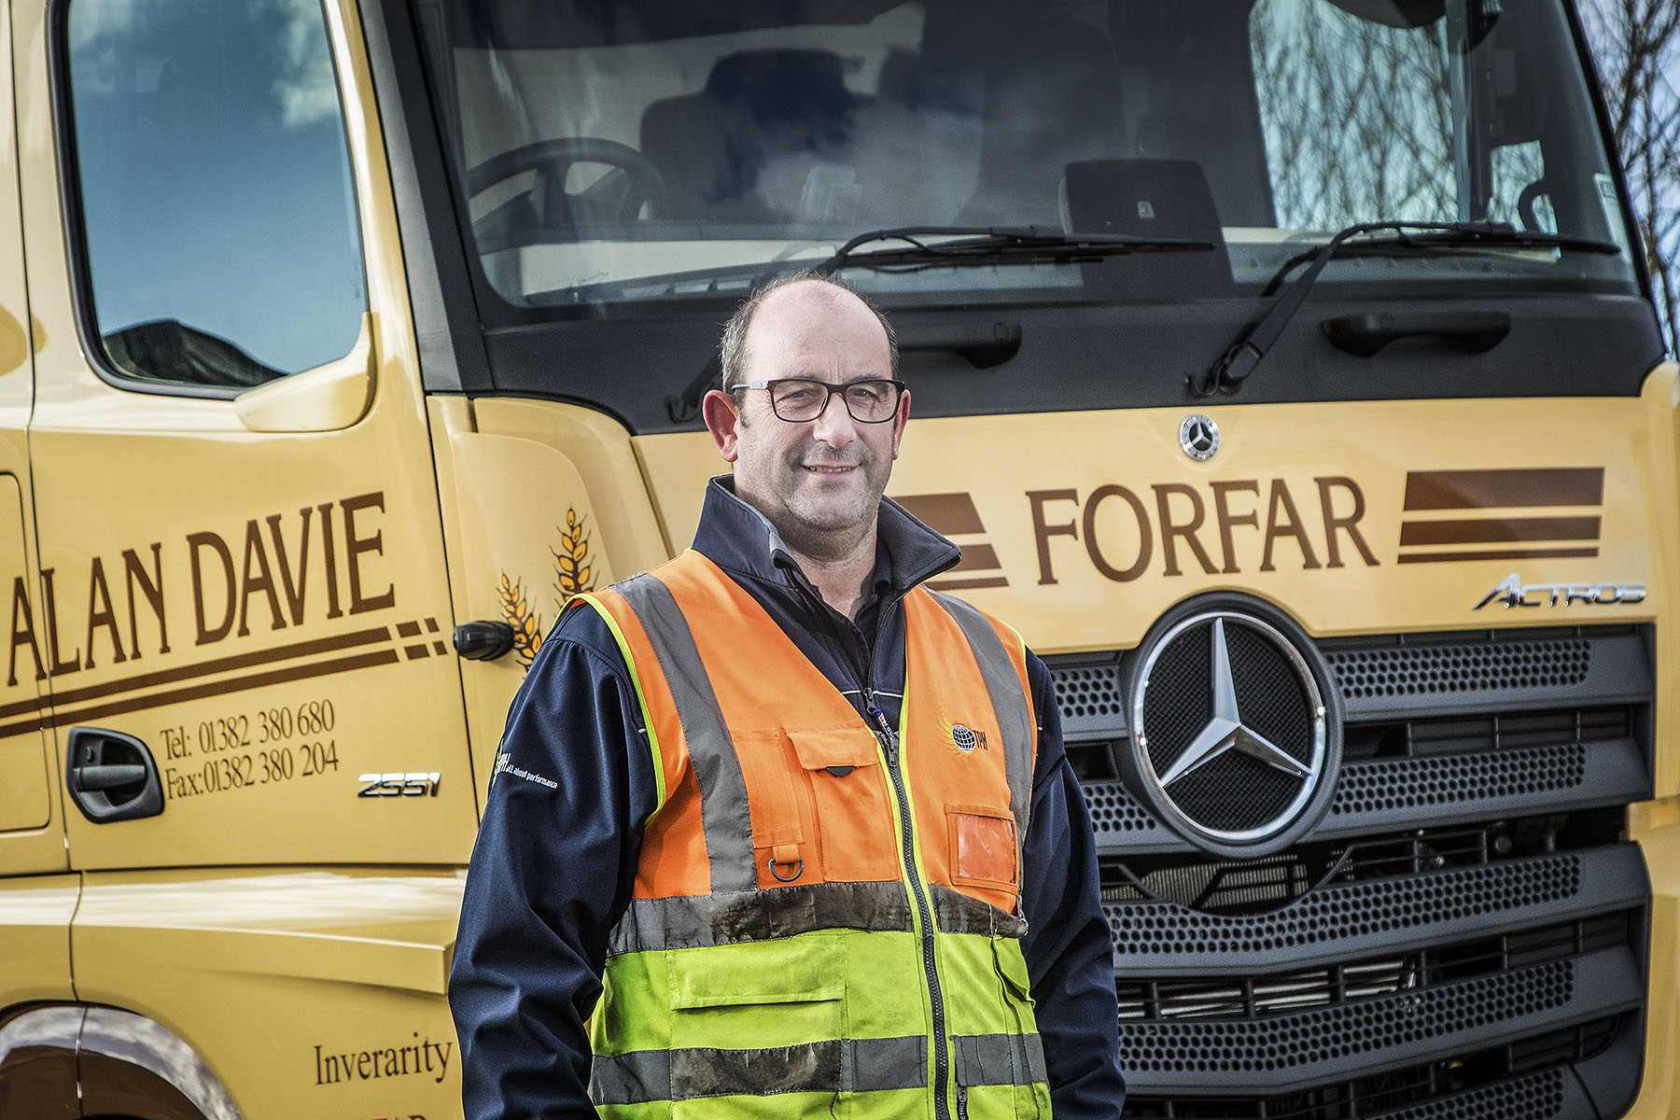

Advancing with Actros: Director Ian Davie, with the first of Alan Davie’s two new Mercedes-Benz tractor units
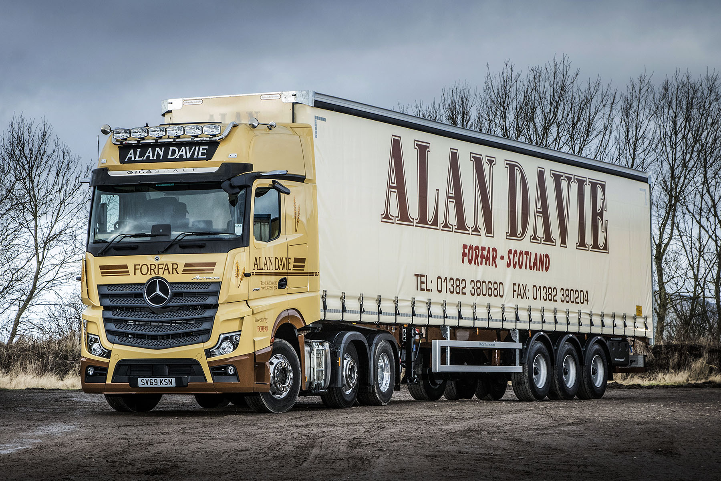

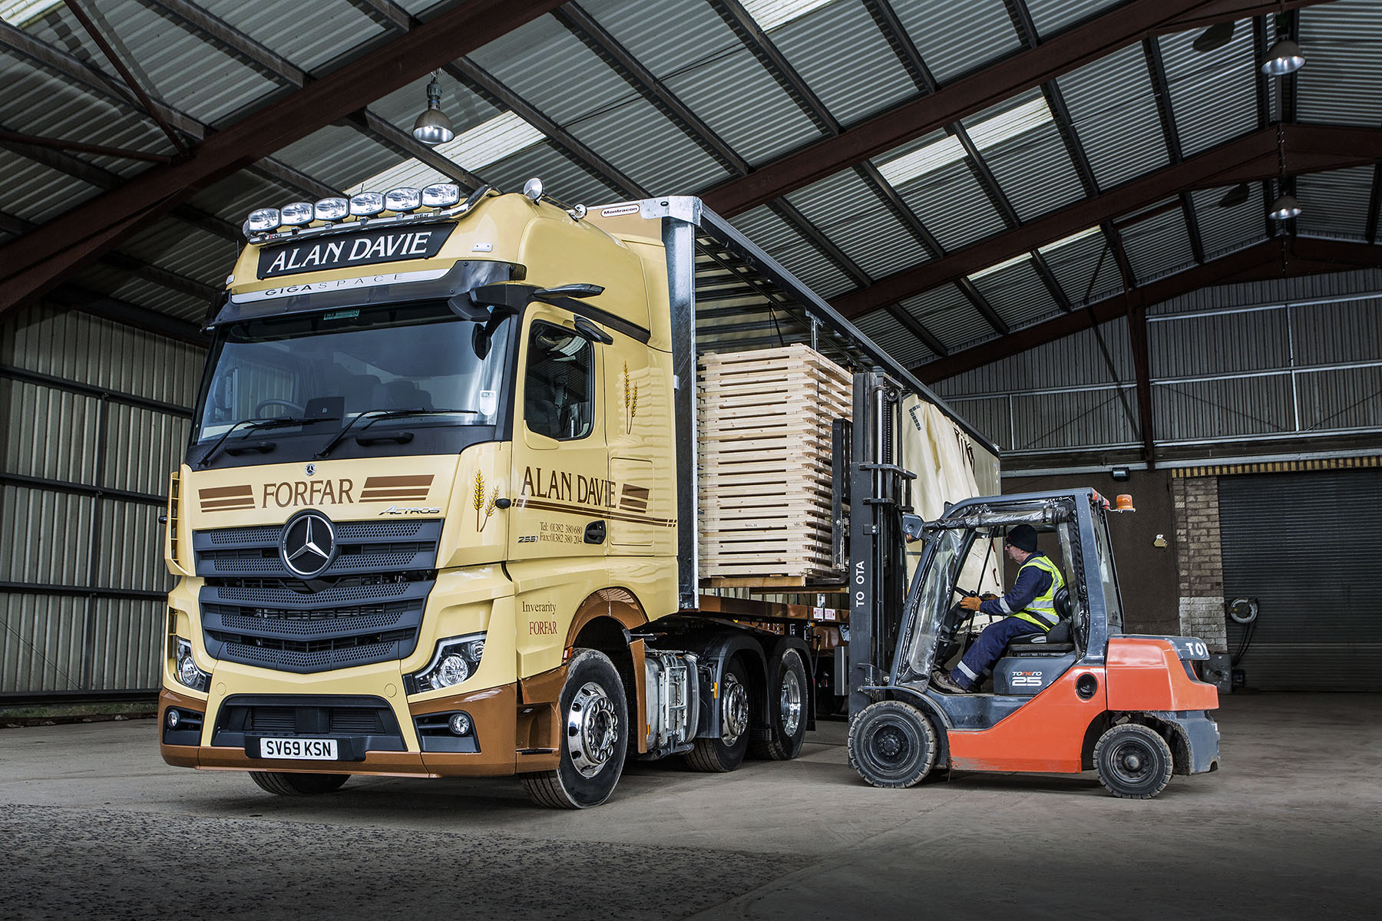

ends

For more information, or to request bigger versions of image files, please contact:
Steve Warren or John Ripley
Impact Communications, 01926 842126
Steve: 07770 470251, steve@impactcom.co.uk
John: 07771 484595, john@impactcom.co.uk



