

Date: 18 May 2021

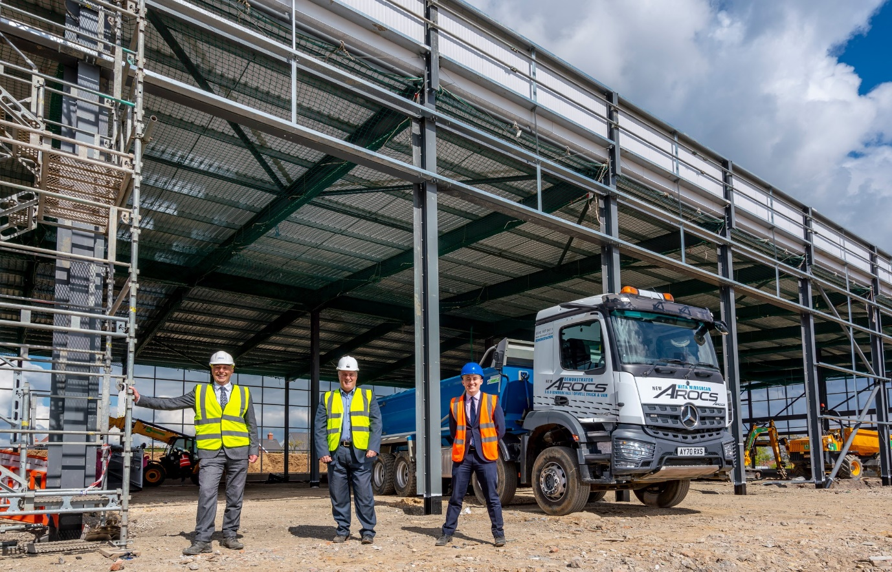
Site inspection: Orwell Truck & Van and S & B Commercials Managing Director Lee Seward, centre, with Head of Aftersales Paul Smith, left, and Truck Sales Manager Sam Setterfield

Dealers Orwell Truck & Van and S & B Commercials double-up on the development of £4m Mercedes-Benz service and parts facility

Operators of Mercedes-Benz and FUSO commercial vehicles are today offered an exciting glimpse of the future, in the form of a state-of-the-art truck and van aftersales centre which is now taking shape in the Essex town of Witham.

The project represents an investment of nearly £4 million by Motus (UK), the owner of two long-established Mercedes-Benz Dealers – between them, Orwell Truck & Van and S & B Commercials represent the three-pointed star from eight branches in Norfolk, Suffolk, Essex and Hertfordshire. Like other members of the manufacturer’s franchised network, they also sell and support the FUSO Canter light truck range.

The flagship development is perfectly located alongside a stretch of the A12 trunk road that runs between Chelmsford and Colchester. This is the primary route by which trucks working in and out of the docks at Felixstowe and Harwich, reach London and the M25.

Scheduled for completion before the end of the year, the new centre will be open round-the-clock, six days a week. Crucially, the three-acre site offers ample space for drivers to manoeuvre and park their trucks.

At the heart of the 2,500 sq m building will be a comprehensively equipped workshop with nine full-length truck and trailer bays. Two of these will have 22-metre pits, as will a third which is being kitted out as an Authorised Testing Facility so that inspectors from the Driver and Vehicle Standards Agency can carry out on-site truck MOT tests.

A further eight bays will be set aside for van maintenance and repairs, and for MOT tests in the Class 4, 5 and 7 categories. These will be carried out by the Dealer’s own technicians, and at times of the day or night that are most convenient to customers.

Truck wash facilities are also being installed, while the 700 sq m Parts department will carry broader and deeper stocks of Mercedes-Benz GenuineParts than has previously been possible. Not only will the team serve their workshop colleagues and over-the-counter customers, but as the company’s new trade hub they will also make urgent and other deliveries to own account and independent maintenance facilities, garages, mechanics and others throughout Essex, Suffolk, and parts of Hertfordshire.

Meanwhile, shortly before construction work began at Witham, S & B Commercials embarked on a £1.2-million redevelopment of its truck-dedicated workshop in West Thurrock, which is open from 6am on Mondays and remains so until 1pm on Saturdays.

This scheme, which should be completed before the end of March 2022, increases capacity by 50% and reflects huge demand from locally based operators for the Dealer’s maintenance and repair support.

It adds another three full-length truck and trailer bays to the six already in place. Two of the new bays will be the first at this location with pits – one is being fitted out as an ATF, the other will be fully equipped for ADR and pet reg work – and the Parts department is also being extended.

S & B Commercials is now recruiting for the additional technicians it needs to deliver on Mercedes-Benz Trucks’ ‘Zero Tolerance on Downtime’ pledge.

Lee Seward, the Managing Director of Orwell Truck & Van and S & B Commercials, declared: “The very substantial investments we are making at Witham and West Thurrock reflect our determination to provide customers with an experience and a level of service that matches the reputations of the brands and the quality of the products we are proud to represent.

“The Witham project has been a long time in the planning and it’s tremendously exciting now that it’s finally a reality. Given its fantastic location, the new aftersales centre is going to play a big part in our growth strategy, as we strive to restrict vehicle downtime to an absolute minimum for our customers.”

The South African-owned, multi-marque Motus Group (UK) acquired Orwell Truck & Van in 2013 and S & B Commercials the following year. Today, they have a combined workforce of more than 400 professional, motivated colleagues.

Lee Seward added: “We’ve put in a great deal of time and effort over the last few years, on bringing the two Dealer groups together, introducing new systems, capitalising on synergies and developing strategies to bring all of our sites up to the standards that we, and most importantly our customers, expect.

“That process is now virtually complete so that we’re now on a much stronger footing and working as one, unified team. The new aftersales centre reveals the direction in which we’re travelling. Watch this space!”

Mercedes-Benz Trucks UK Managing Director Wolfgang Theissen enthused: “When you see the work now underway at Witham and West Thurrock, it really underlines the long-term commitment of Motus Group. These investments prove to operators of Mercedes-Benz and FUSO trucks that they can continue to rely on us for the timely, efficient back-up to which they are entitled.

“Witham represents a particularly welcome development because it will provide us with brand representation in an area – and alongside a busy trunk road – where this was previously lacking. We thank them for this investment, and we are very much looking forward to the opening of these fantastic new facilities.”

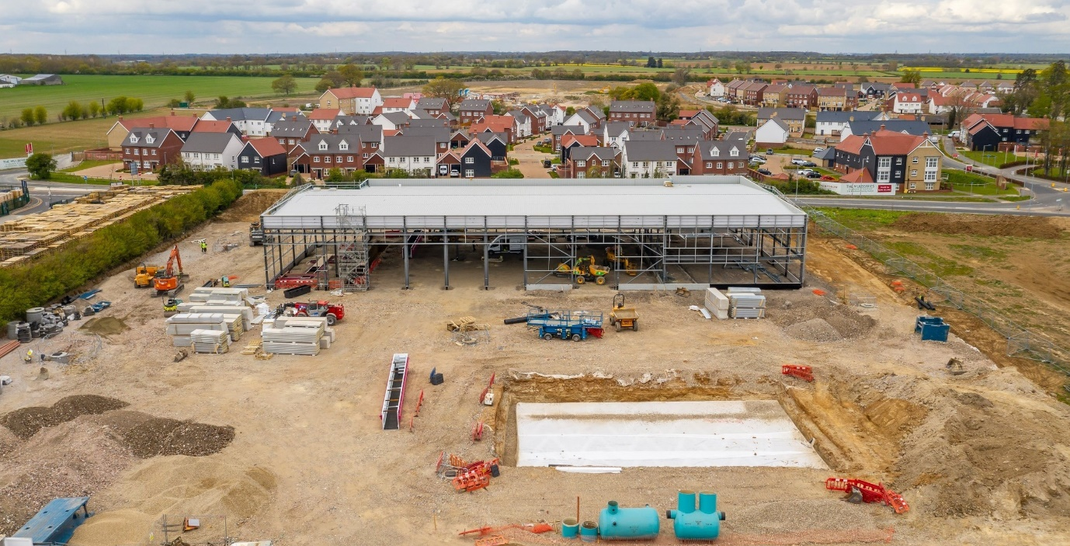

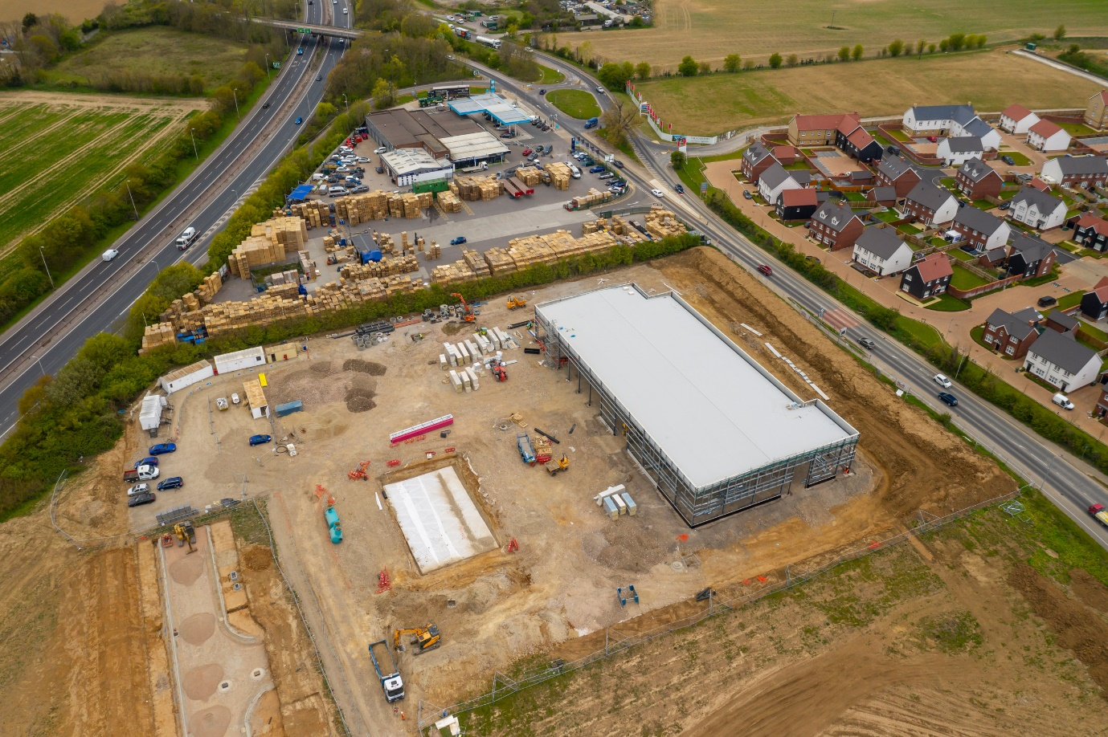

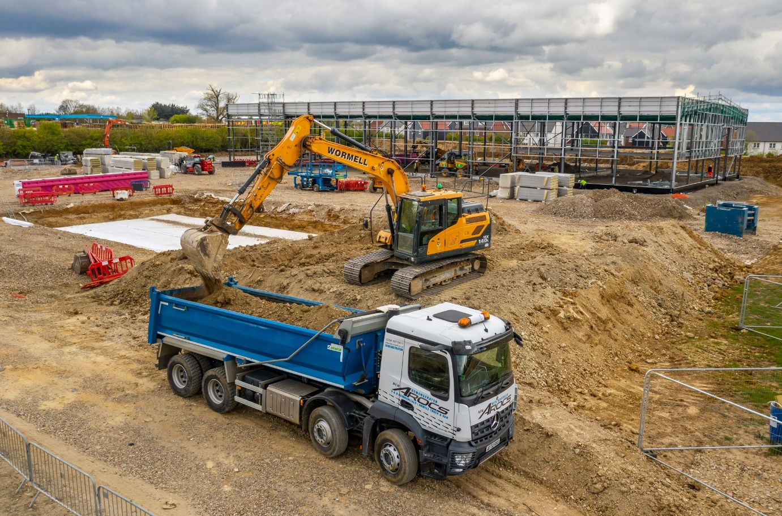

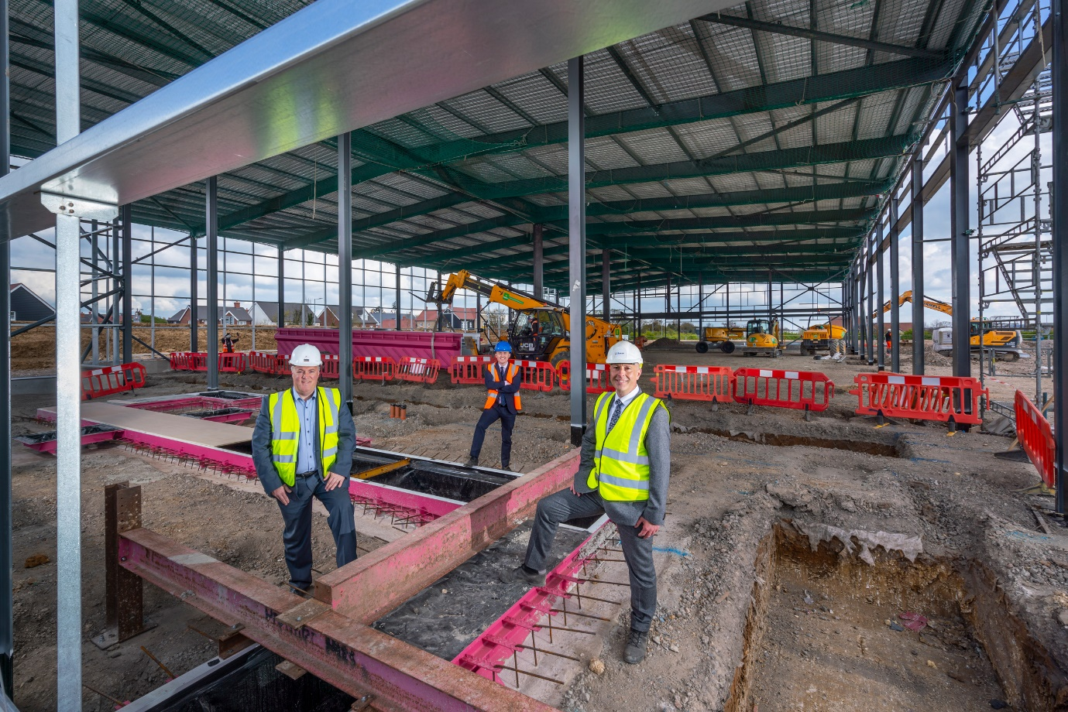

Laying firm foundations for the future: Managing Director Lee Seward, left, is pictured with Head of Aftersales Paul Smith, right, and Truck Sales Manager Sam Setterfield

ends

For more information, or to request higher-res image files, please contact:
Jamie Fretwell at Mercedes-Benz Trucks UK Ltd
07712 519230, jamie.fretwell@daimler.com

About Mercedes-Benz Trucks UK Ltd
Mercedes-Benz Trucks UK Ltd is the sales and marketing organisation responsible for all Daimler truck products in the UK, including FUSO Canter.

In 2019, the company registered 6,963 new trucks. Mercedes-Benz accounted for 6,188 new trucks registered in 2019, making it the third-biggest truck brand in the UK. Meanwhile, FUSO registrations hit 775 – including 580 new trucks over 6.0-tonnes.

The flagship new Mercedes-Benz Actros which won the 2020 International Truck of the Year award, features seven core innovations including MirrorCam, Multimedia Cockpit and Active Brake Assist 5. Our premium range of innovative trucks – Actros, Arocs, Atego, Econic and Unimog – draw upon more than 125 years of exceptionally high standards of quality, backed up by our promise of Trucks You Can Trust.

www.mbtrucks.co.uk

