

Date: 13 August 2025

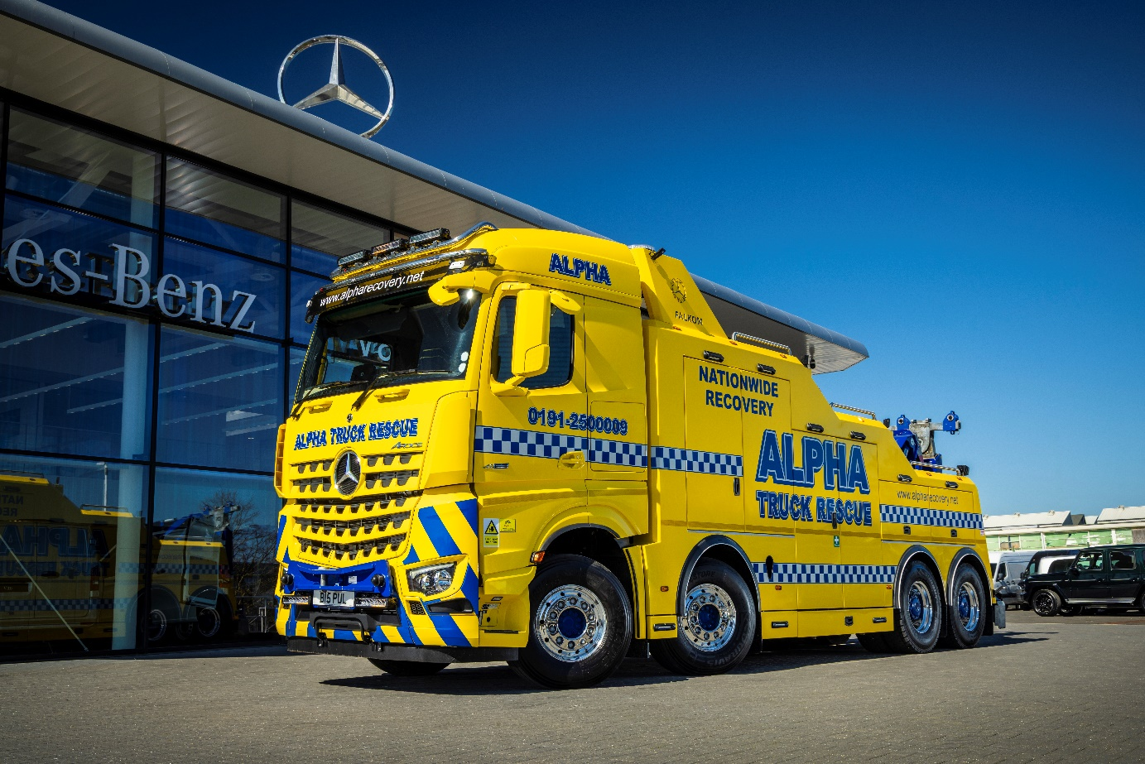

Heavy lifting: Mercedes-Benz 630hp Arocs supplied by Bell Truck and Van for Alpha Recovery is equipped with a Falkom FAW25000 wrecker system

Alpha Recovery expands fleet with first Mercedes-Benz Arocs from Bell Truck and Van

Outstanding performance, technology, driver comfort and engine braking were all part of the national breakdown and recovery specialist Alpha Recovery’s decision to take delivery of its first-ever Mercedes-Benz Arocs truck through Bell Truck and Van.

Alpha Recovery is a UK-based vehicle recovery specialist offering a wide range of breakdown, transport, and heavy recovery services mainly in Northumberland, Tyneside, Wearside, County Durham, Teesside and North Yorkshire. Operating from multiple depots, Alpha provides 24/7 solutions to private and commercial clients across the country. With a growing fleet and focus on service excellence, the company continues to set industry standards in rapid response and technical recovery capability.

It has more than 36 diverse vehicles offering breakdown services including heavy recovery and rescue, air-cushion recovery for trucks that have tipped over, specialist off-road, bus and coach, and rescue for vans and light vans. Alpha also offers plant winching and has a number of contraflow roadworks contracts.

The high-spec Arocs will be the cornerstone of Alpha’s operations and already the recovery company is considering adding another Arocs as part of its expanding fleet.

A long-time Mercedes-Benz operator, Alpha Recovery has previously purchased two Unimogs and four Ategos (three 16 tonnes and one 7.5 tonnes), but the Arocs is its first heavy vehicle from Mercedes-Benz Trucks.

The Mercedes-Benz Arocs truck features a 15.6-litre 627bhp engine that delivers 3000Nm of torque, with an 8x4 configuration with steel suspension. It is equipped with the Mercedes-Benz PowerShift automated gearbox, featuring 12 speeds and selectable driving modes (including rocking mode and fast reverse). The truck has a maximum gross train weight of 180 tonnes which is just the job for recovering big trucks with trailers.

Alpha’s vehicle is also equipped with a Falkom FAW25000 wrecker system, was chosen for its proven capability to meet the rigorous demands of modern heavy recovery work.

“We chose the Arocs because of our excellent past experiences with Mercedes vehicles,” said Michael Burke of Alpha Recovery. “This truck had to meet serious demands — and it’s exceeded expectations. The performance, technology, driver comfort, and engine braking are outstanding. Plus, it offers a fuel return we’ve not seen from other manufacturers.”

The sale was facilitated by Alex Wordsworth, Group Head of Truck Sales at Bell Truck and Van, who worked closely with Adam Green of Rydam Universal to ensure a smooth chassis-to-wrecker conversion process. The vehicle was custom-specified in collaboration with the Mercedes-Benz technical team to match Alpha’s exact operational requirements.

“One of the biggest reasons we went with Bell was the level of service,” Michael added. “Alex took all the stress out of the build and conversion. Knowing any query will be dealt with quickly and competently is invaluable. The process was seamless.”

With recovery operations covering demanding terrain and high-pressure scenarios, Alpha required a reliable heavy-duty solution that could stand up to daily challenges — and the Arocs delivered.

“Our first ‘heavy’ was a Mercedes-Benz years ago, and this new Arocs takes it to the next level,” said Michael. “Our driver was blown away by the ease of use, comfort, and sheer capability of the truck.”

Alex Wordsworth said: “Michael, Simon, and the Team at Alpha have been a trusted and reliable partner of Bell Truck and Van for many years.

“Alpha fulfils much of our recovery requirements both on the van and truck side of the business. When we started talking about building a heavy wrecker I was really excited as it’s something very different and I knew it would be a great project and be unmissable on the road.

“Working with the guys at Alpha, Rydam, Falkom and Daimler Truck Technical we managed to put together the perfect spec to suit the job down to a T. It’s great to see the finished result on the road and the superb feedback from the driver.”

www.alpharecovery.net
Ends

For more information, or to request bigger/higher-res image files, please contact:
Tim Bowdler: 07434 940162, tim.bowdler@loopagency.co.uk

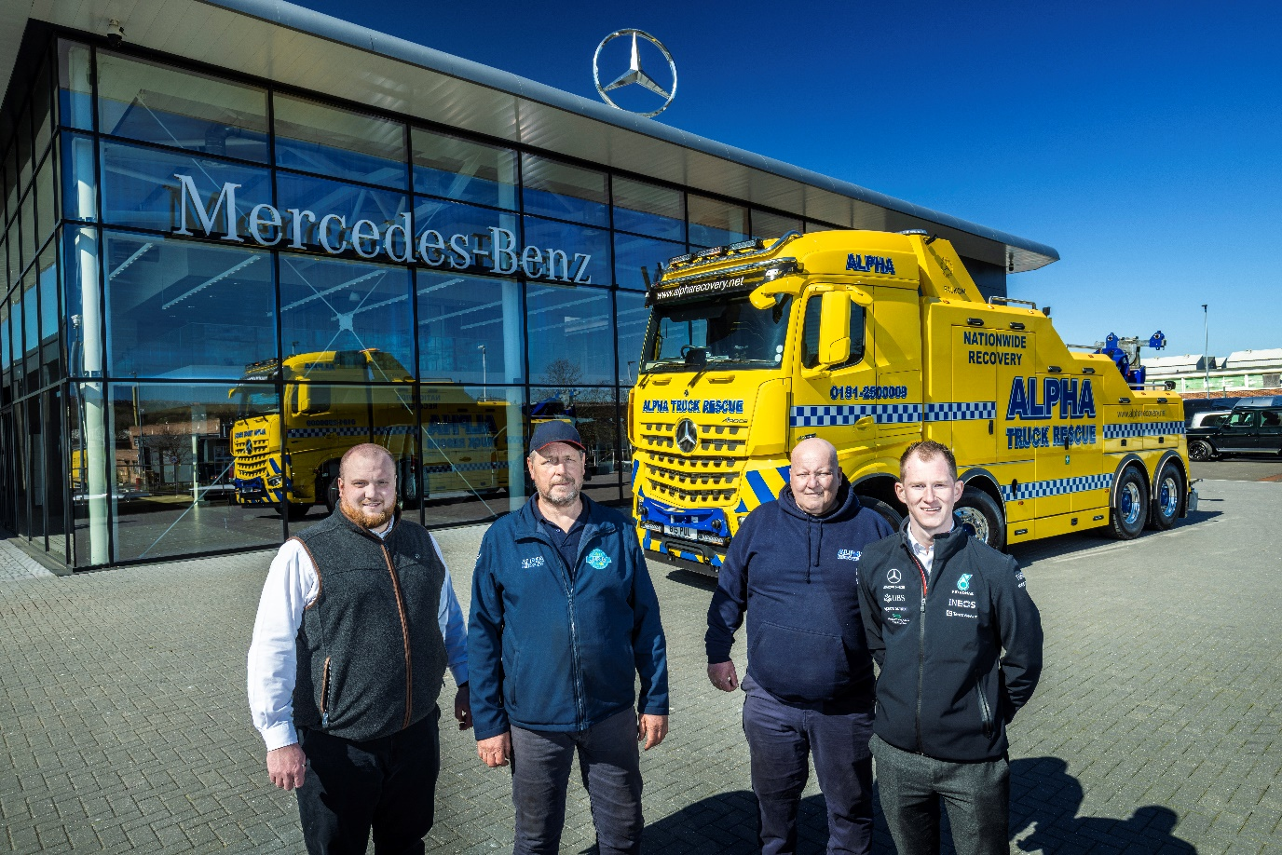

Rescuers: Daniel Peck, Bell Truck and Van, Managing Director; Micheal Burke, Managing Director, Alpha Recovery; Simon Narey, Alpha Recovery Operations Director; Alex Wordsworth, Group Head of Sales at Bell Truck and Van.
