

Date: 8 August 2022

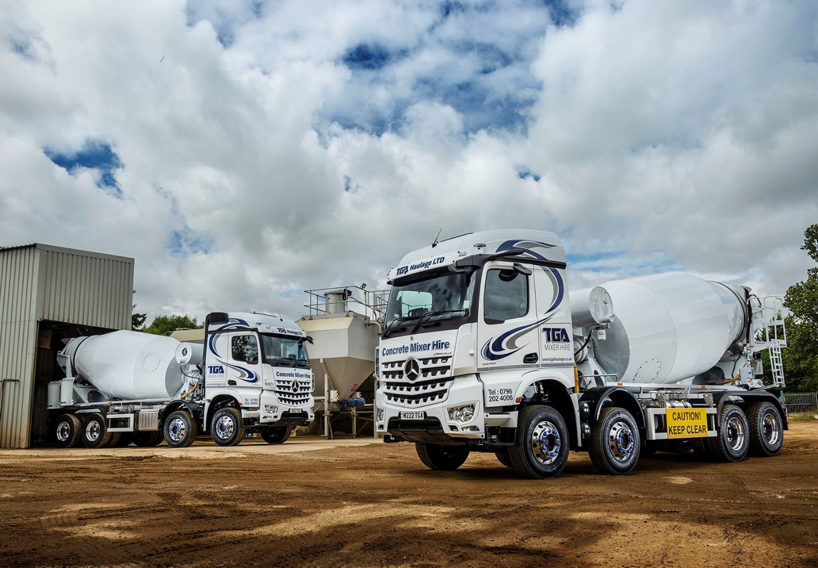

Concrete operator TGA settles on the perfect mix – Mercedes-Benz Arocs backed by Intercounty Truck & Van

Highly competitive running costs and “amazing” aftersales support led mixer hire specialist TGA Haulage back to Intercounty Truck & Van for another pair of Mercedes-Benz eight-wheelers.

The Peterborough-based company was established by Tom Allen in 2014, shortly after he and his father – who were then working in partnership under a different name – purchased one of the first vehicles from the purpose-designed Arocs construction range to be supplied by the Dealer.

While TGA Haulage’s business has evolved over the last eight years, from ready-mix and floor screed work undertaken directly for locally-based customers, to nationwide vehicle and driver rental services, so, too, has its fleet profile.

Having initially favoured a Swedish truck brand, Mr Allen has gradually phased out these vehicles and replaced them with more by Mercedes-Benz. Today, TGA runs seven Arocs – most are standard 32-tonne 8x4s, although the line-up also includes an ENA model with single front steer axle, double-drive bogie and rear-steer axle, and a 6x4 26-tonner.

Like the single vehicle it purchased from Intercounty Truck & Van last year, the company’s latest mixers are both 3243 variants and came with a full complement of advanced technology including MirrorCam, the manufacturer’s ground-breaking replacement for conventional mirrors.

Other standard-fit equipment includes Active Brake Assist 5 emergency braking with industry-leading pedestrian-recognition capability, and the enhanced Predictive Powertrain Control system, which manages gear changes and ensures that full use is made of the Mercedes PowerShift 3 transmission’s Eco Roll function to reduce fuel consumption and emissions.

Meanwhile, Multimedia Cockpit, interactive, the optionally upgraded version of Mercedes-Benz Trucks’ radical, twin screen dashboard, boasts a larger, 12in instrument panel, and comes with extra functionality, including satellite navigation.

TGA’s new Arocs have StreamSpace sleeper cabs which, at 2.3m, are in the narrower of the two widths available. They are smartly finished with colour-coded bumpers and grilles, while Dura-Bright alloy wheels add an extra dash of style, as well as saving weight.

The trucks’10.7-litre in-line six-cylinder engines produce 315 kW (428 hp) and drive through 12-speed Mercedes PowerShift 3 automated manual transmissions. Their 7.5m³ drums are by Motherwell-based McPhee Mixers, Mr Allen’s preferred bodybuilder.

Tom Allen explained: “I like the idea of uniformity within the fleet, and the Arocs is now firmly established in my mind as the best vehicle for our kind of work. It’s beautifully put together and a real pleasure to drive, particularly the latest examples, which are loaded with technology that makes life safer and more comfortable for the individual at the wheel.

“I’m a big fan of MirrorCam, which provides much improved visibility. The images from the roof-mounted cameras remain crisp and clear, even when it’s raining, which means you no longer have the hassle of wiping the water and road debris from standard wing mirrors.”

He continued: “Factor in the Mercedes-Benz truck’s fuel-efficiency and attractive overall running costs, and the high ground clearance that gives it a big advantage when working on rough terrain, and it all adds up to a very compelling proposition.”

Even the best trucks, however, are only as good as the support behind them. Here, too, Tom Allen knows he is onto a winner. “Truck Sales Executive Paul Hind looks after me really well, while his colleagues at Intercounty Truck & Van’s workshop here in Peterborough are nothing short of amazing,” declared Mr Allen.

“The Arocs is supremely reliable but you’ll always get the occasional breakdown. Crucially, the Dealer’s team understand how important it is for a small-scale operator like me, to avert the crisis that can result from unplanned vehicle downtime.

“They’ve been a lifeline on more than one occasion, providing fast, efficient roadside assistance and coming up with temporary fixes that have kept me on the road until issues could be fully resolved.

“Great customer service is all about the personal touch, and in my experience nobody does it better than Intercounty Truck & Van.”

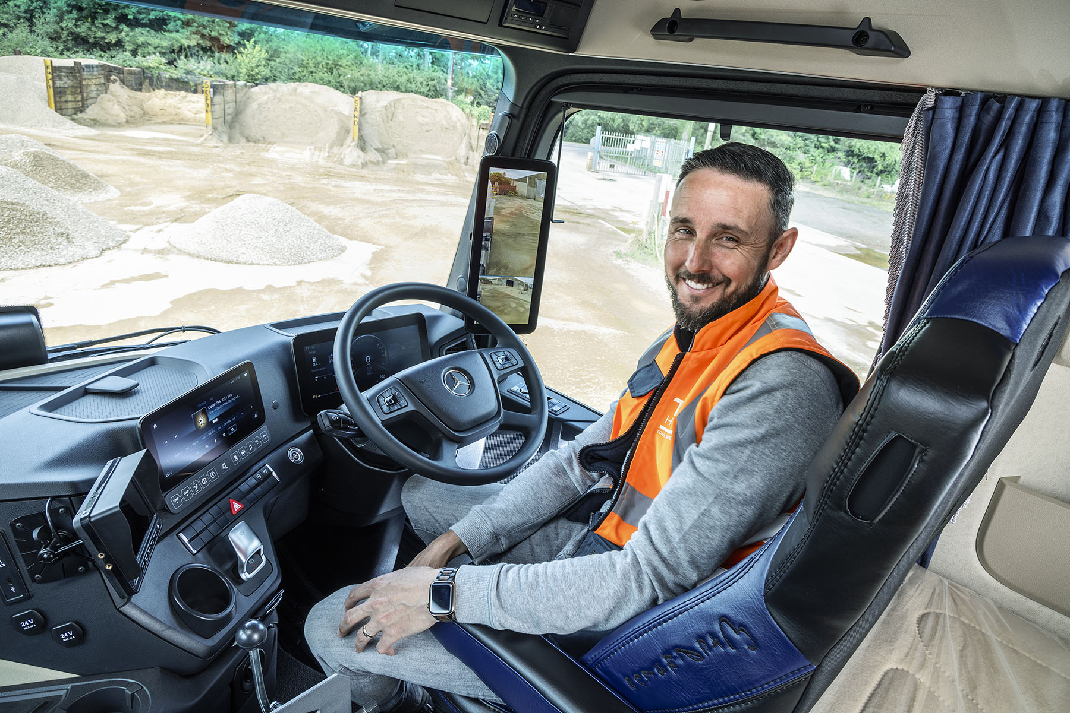

Allen’s key to success: TGA’s Tom at the wheel of one of his latest Mercedes-Benz Arocs truck mixers, which have Streamspace sleeper cabs with 170mm engine tunnels, and fridges and drawers beneath the beds

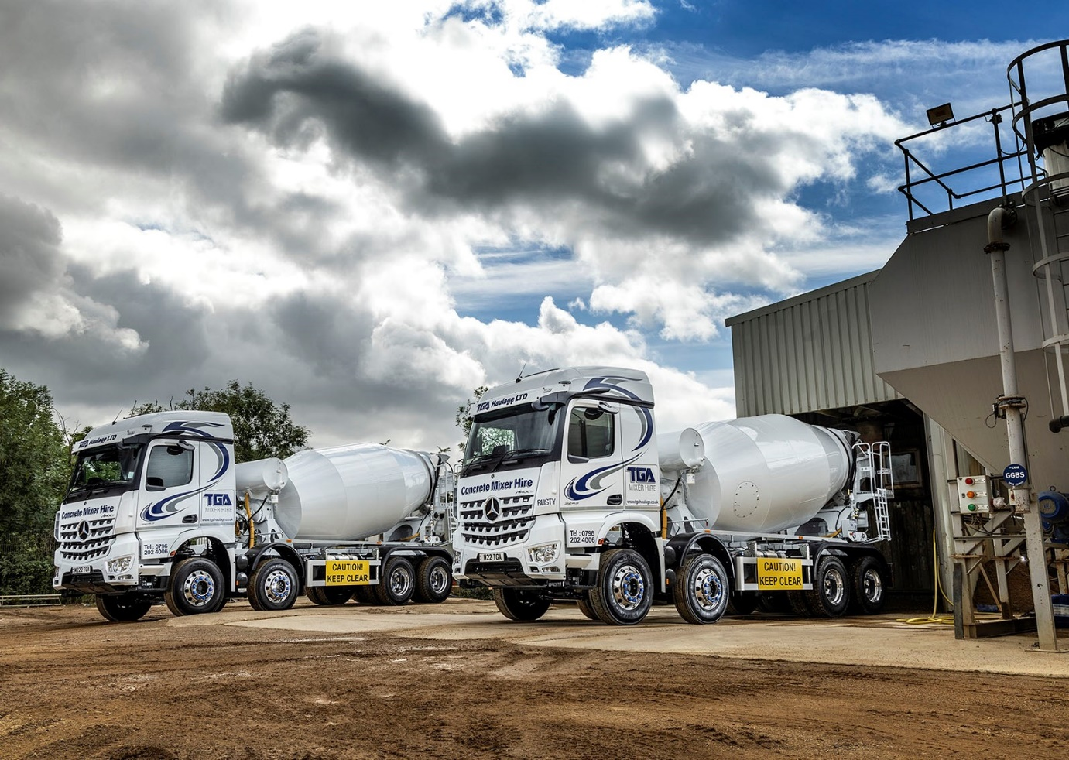

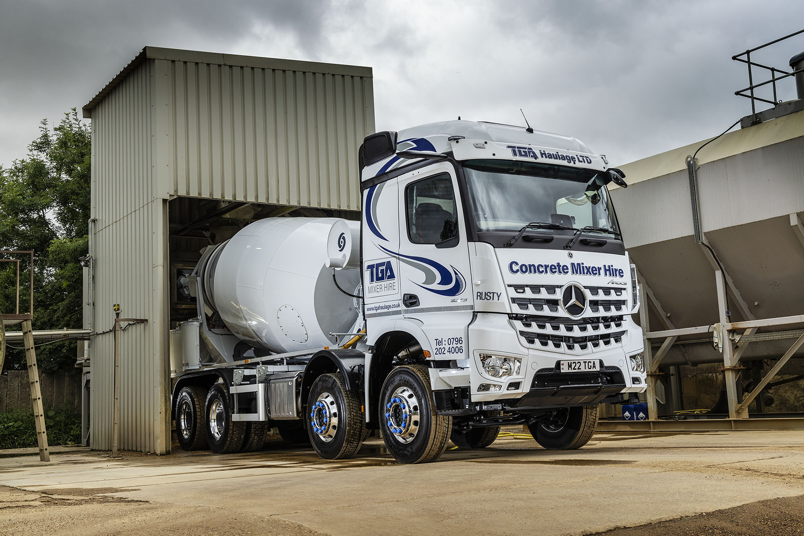

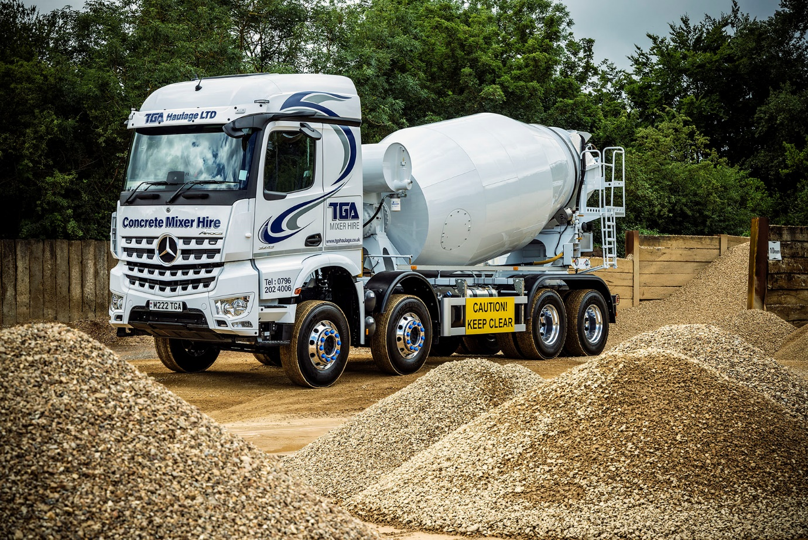

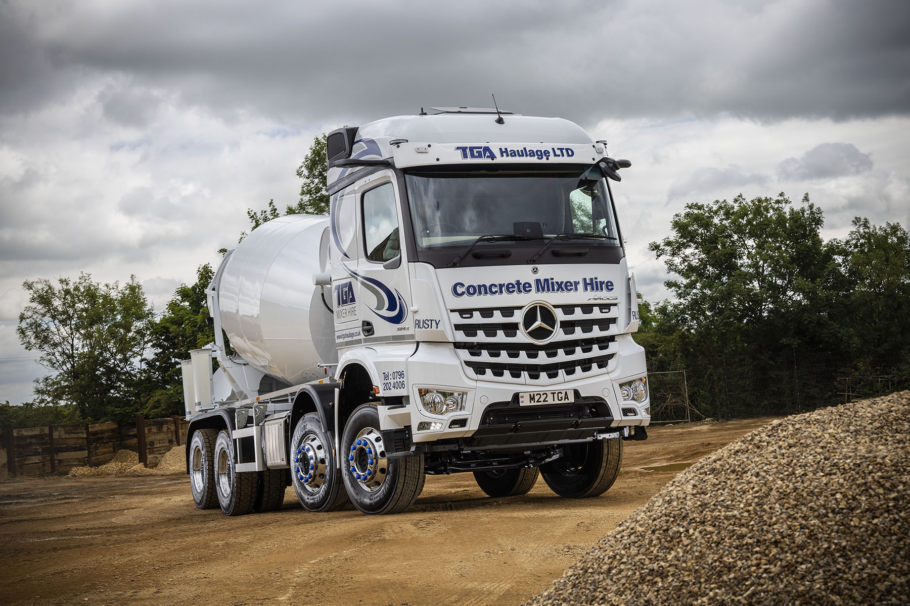

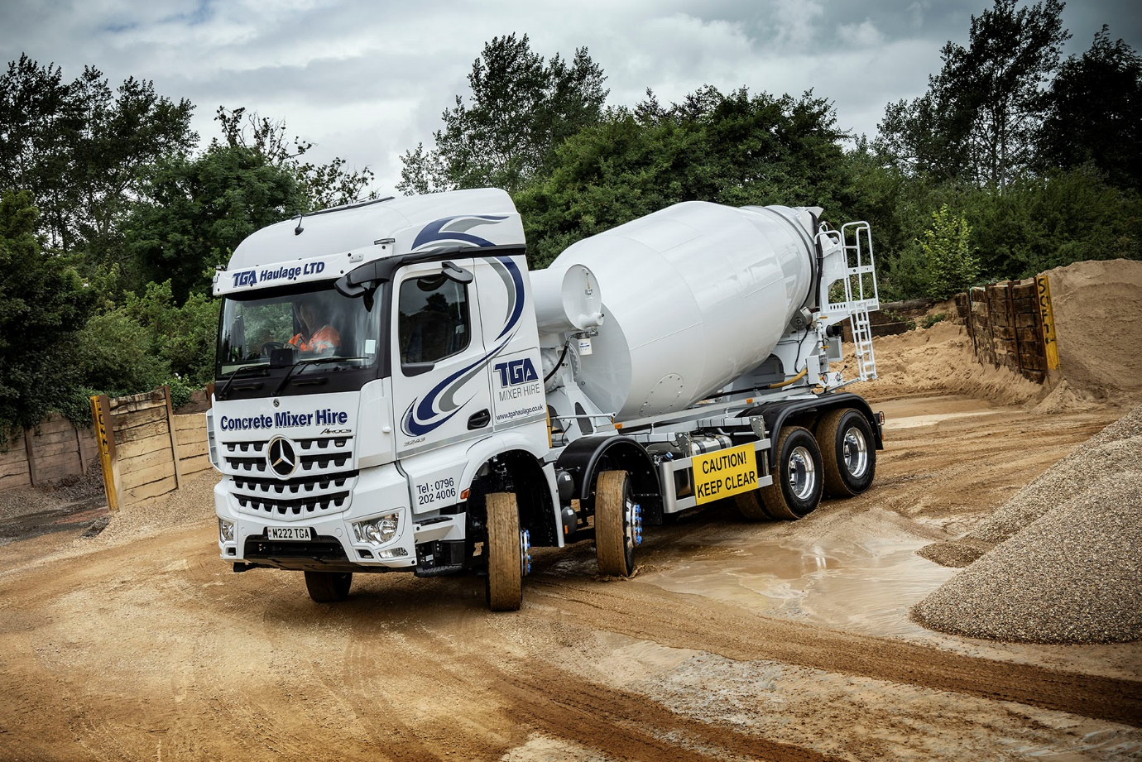

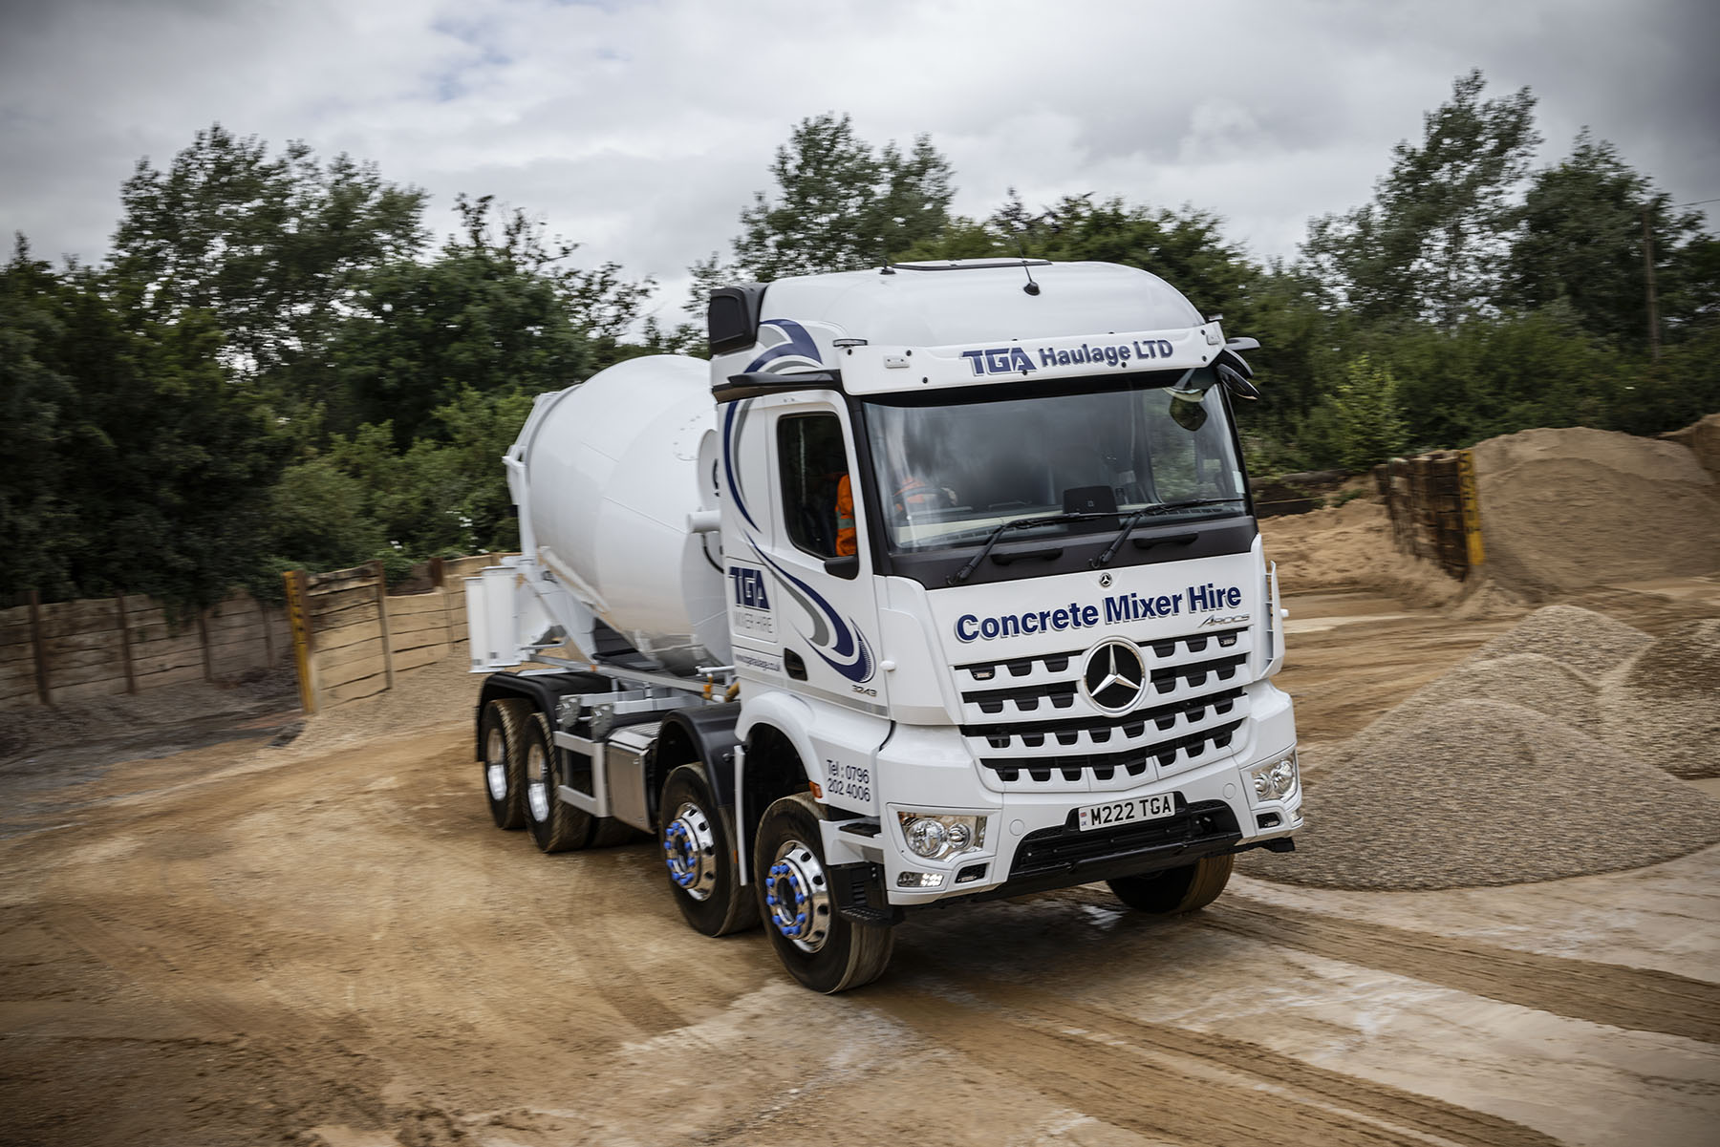

ends

For more information, or to request bigger/higher-res image files, please contact:
Steve Warren or John Ripley
Impact Communications
Steve: 07770 470251, steve@impactcom.co.uk
John: 07771 484595, john@impactcom.co.uk

