

Date: 27 October 2022

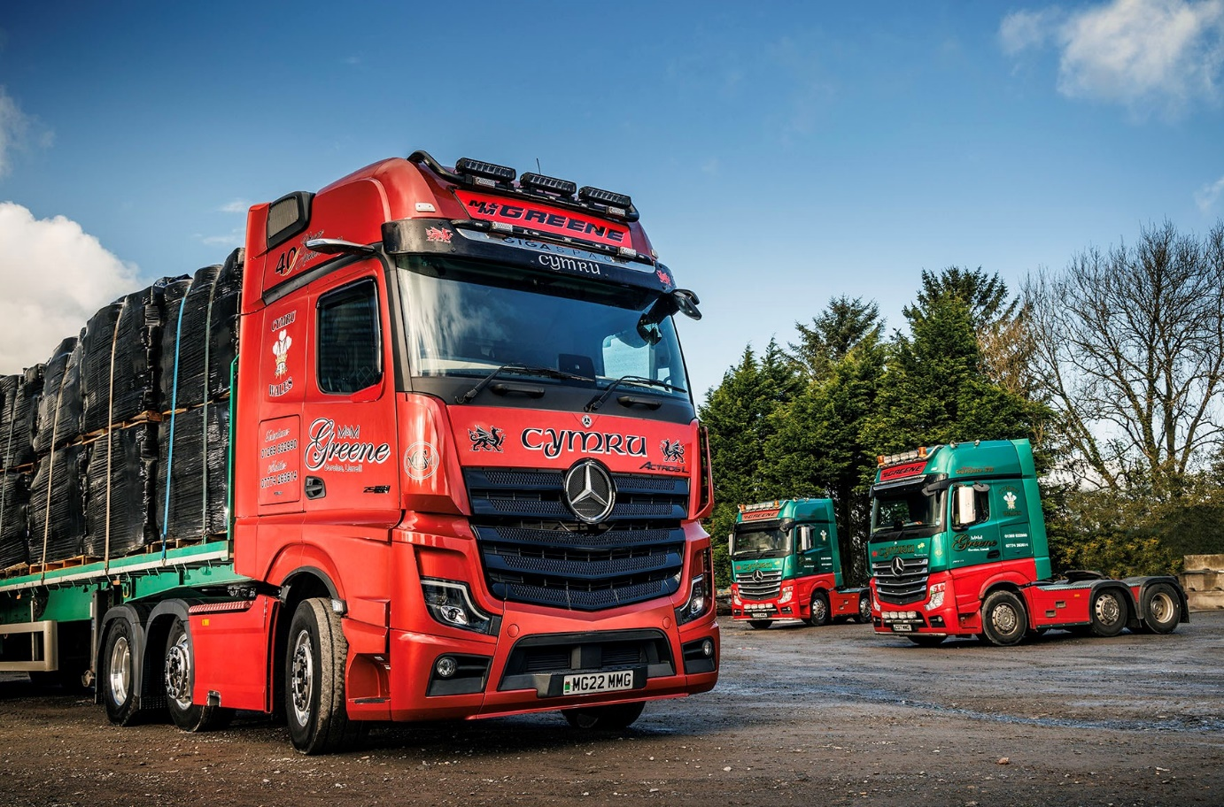

M&M Greene celebrates a ‘red letter day’ with stunning
Mercedes-Benz Actros L from Euro Commercials

Carmarthenshire haulier M&M Greene has marked its 40th anniversary by commissioning a very special Mercedes-Benz flagship.

Euro Commercials was proposing to use the Actros L for demonstration purposes… until it took the highly-specified tractor unit to the Convoy Cymru truck show, which was held in May at the Pembrey Circuit, near Llanelli. So impressed were M&M Greene Managing Director Mike Greene and his brother Mark, also a Director, when they saw the vehicle on the Dealer’s stand, that they agreed there and then to buy it.

The 2563 variant has a GigaSpace cab, the biggest available, and is powered by a range-topping 460 kW (625 hp), 15.6-litre in-line six-cylinder engine. Standard-fit technology includes MirrorCam, Mercedes-Benz Trucks’ camera-based replacement for conventional mirrors, the Active Brake Assist 5 emergency braking aid, with its market-leading pedestrian-recognition capability, and the latest version of the fuel-saving Predictive Powertrain Control system.

Its exhaustive list of optional features, meanwhile, include the interactive version of the radical, twin-screen Multimedia Cockpit dashboard, a smart StyleLine interior with aluminium-effect and chrome trim, automatic climate control, a sliding and tilting electric sunroof, leather-covered seats and steering wheel, and a luxury top bunk with levelling control. The driver also gets a TV and DVD player, a pull-out fridge and a microwave oven, as well as numerous other items of specification bundled within the Comfort, Driver and Media packages.

The Actros L is a real head-turner, too. While M&M Greene’s predominantly green vehicles are a common sight at truck shows and on the roads of South Wales, the operator’s new flagship is immaculate in a metallic red paint scheme, with colour-coded bumpers and aluminium side skirts. A distinctive, black-painted grille, sun visor, twin, roof-mounted light bars and Alcoa Dura-Bright alloy wheels, as well as a painted and polished full catwalk infill, further enhance the truck’s appearance.

M&M Greene is based in Gorslas, near Cross Hands, and heavily engaged in the delivery of jumbo bags of sand and gravel for long-term customer Llanelli Sand Dredging, while also providing general haulage services.

It was established by the Greene brothers and their father Alan, who passed away seven years ago. Representing the third generation, Mike Greene’s son Carwyn also works for the family concern as a driver.

Like Alan before them, Mike, Mark and Carwyn are all proud Welshmen. Not only do the nation’s heraldic dragon symbol, the ‘three ostrich feathers’ motif of the Prince of Wales, and the Cymru name (which is Welsh for ‘Wales’) appear prominently on the anniversary Actros L, but so, too, on the unit’s back wall, does the legend ‘Yma O Hyd’, the title of a patriotic song that translates as ‘Still Here’.

Acquired with competitive funding support from Daimler Truck Financial Services UK, the landmark Actros L was delivered by Euro Commercials’ Swansea-based Truck Sales Executive Steve Bastin; the Dealer took back a vehicle by another manufacturer in part-exchange. Steve also supplied the operator’s first Mercedes-Benz truck in 2005, and every one it has purchased since, including, in 2012, the first fourth-generation 375 kW (510 hp) Actros GigaSpace in Wales.

Today, M&M Greene runs seven trucks – five tractors and a pair of rigids. In addition to its latest Mercedes-Benz, the line-up includes 15- and 17-registered Actros units that also have GigaSpace cabs and 460 kW (625 hp) powerplants, and an 8x4 Arocs 3245K tipper which is on a 16-plate. Euro Commercials will also be delivering another Actros L 2563 GigaSpace in the New Year.

“We regularly participate in truck shows and always choose highly-specified equipment,” said Mike Greene. “The latest Actros L has a definite ‘Wow!’ factor, though, even by our own standards. It ticks so many boxes on the options list and looks fantastic.”

The new truck is driven by Mark Greene and is the operator’s first with MirrorCam. Not only does the system boost safety by providing improved rear vision – particularly helpful when reversing with a trailer – but the absence of mirror housings means the driver does not have to contend with forward-facing blind spots either.

“We ran one of Euro Commercials’ demonstrators for a few weeks, before we put our own truck on the road,” recalled Mike Greene. “My brother says the cameras took a little bit of getting used to, but having done so he reckons they’re a huge improvement. It’s definitely the way forward.”

All of M&M Greene’s Mercedes-Benz trucks are maintained under Complete Service Contracts at Euro Commercials’ Swansea branch. “The back-up is excellent,” reported Mr Greene. “It goes a long way towards explaining why, for the last 17 years, most of our trucks have had three-pointed stars on the front.

“Routine inspections and services are carried out at times that suit us, so invariably overnight, and if ever we have an issue the Dealer’s team are very flexible and will always help us out. Steve (Bastin), meanwhile, is more than a salesman and has been a very good friend for a long time now.”

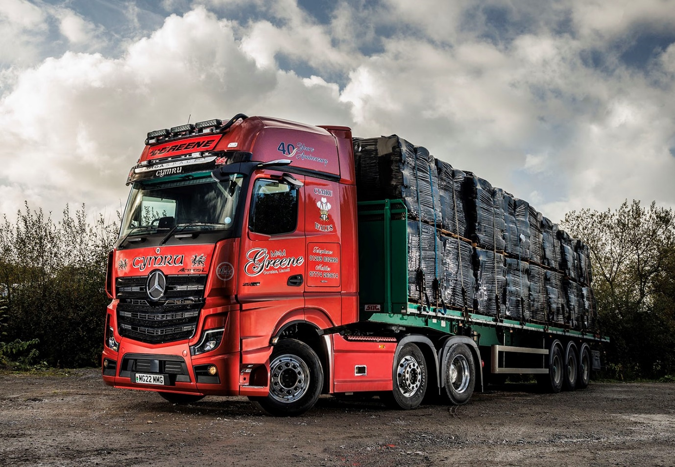

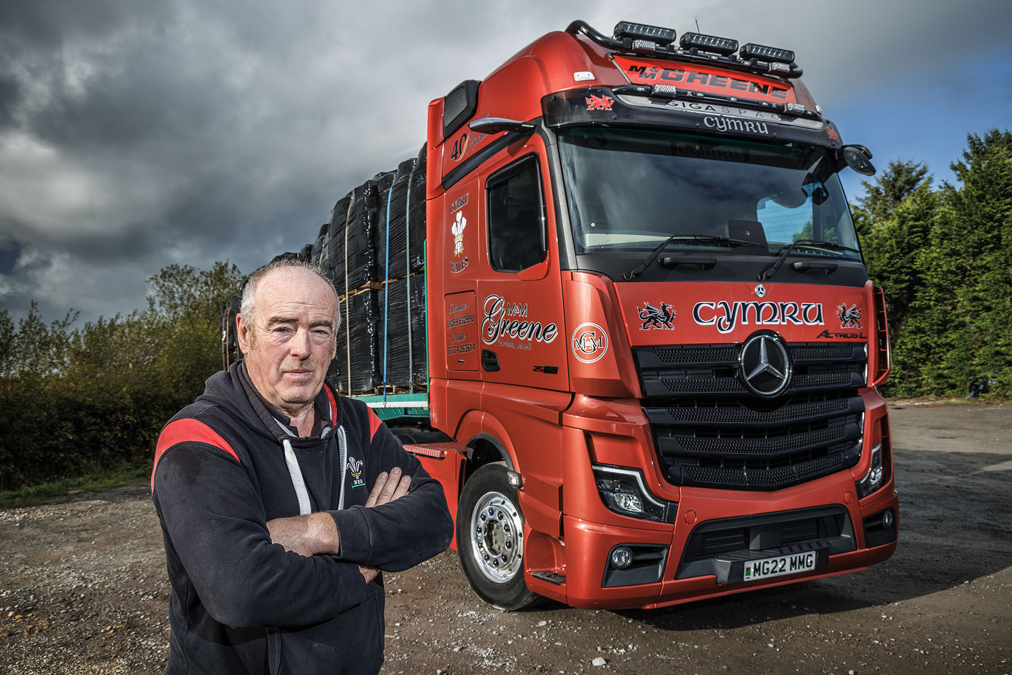

Red alert: Mike Greene, of M&M Greene, with his company’s new Mercedes-Benz Actros L flagship

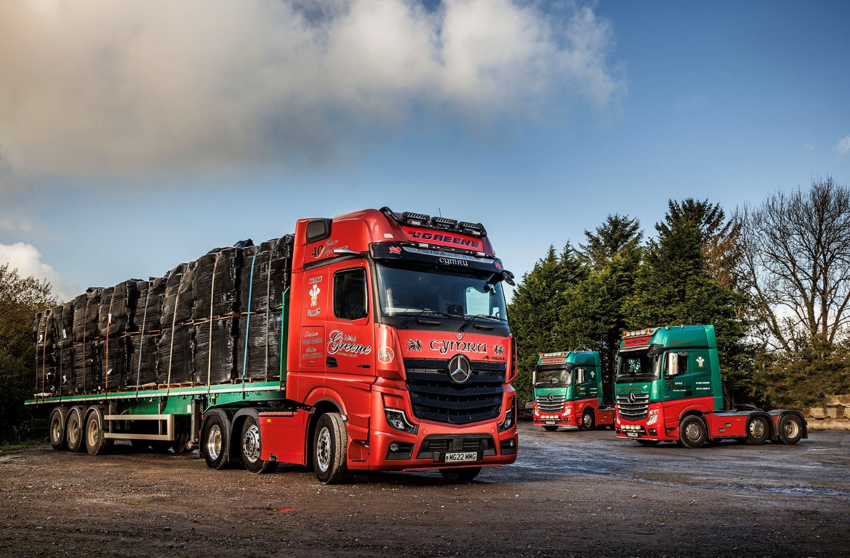

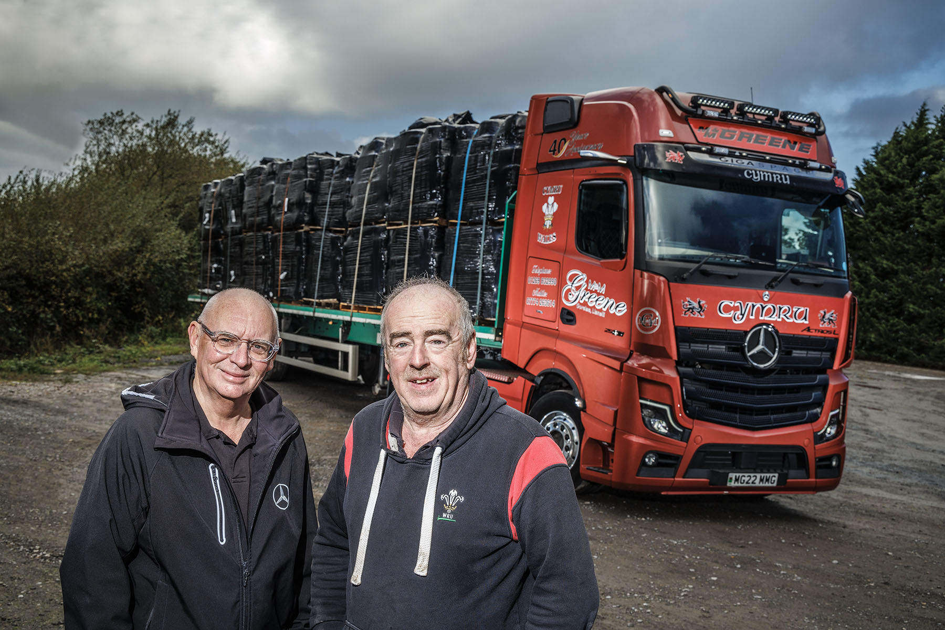

A relationship based on trust and respect: Mike Greene, right, of M&M Greene, is pictured with Euro Commercials’ Truck Sales Executive Steve Bastin

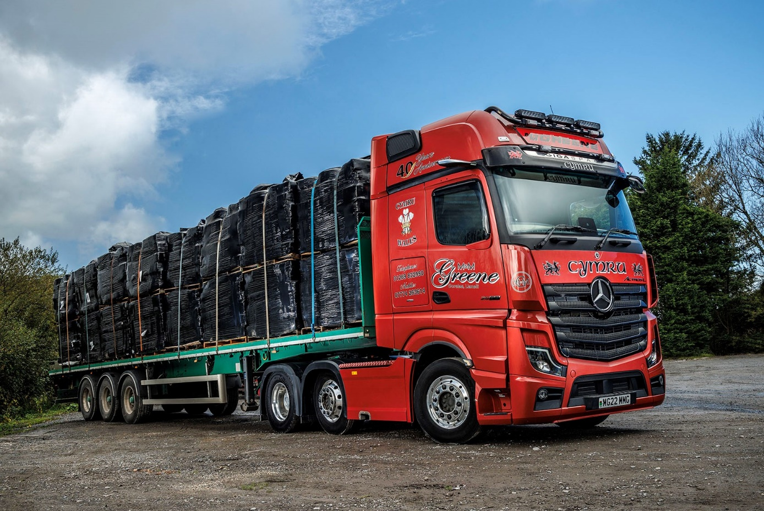

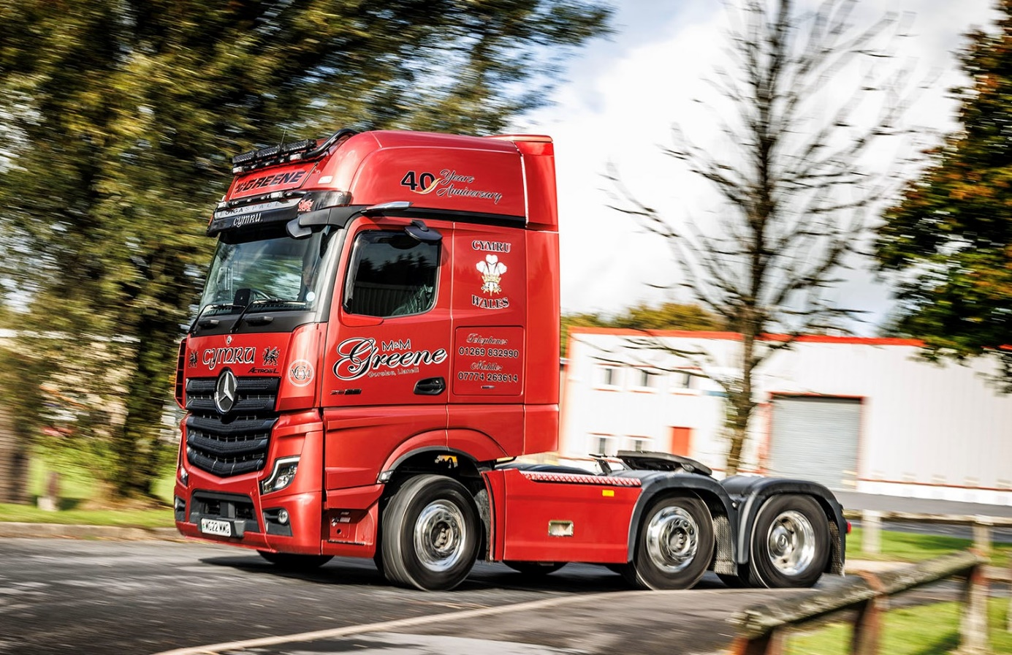

ends

For more information, or to request bigger/higher-res image files, please contact:
Steve Warren or John Ripley
Impact Communications
Steve: 07770 470251, steve@impactcom.co.uk
John: 07771 484595, john@impactcom.co.uk

