

Date: 18 October 2019

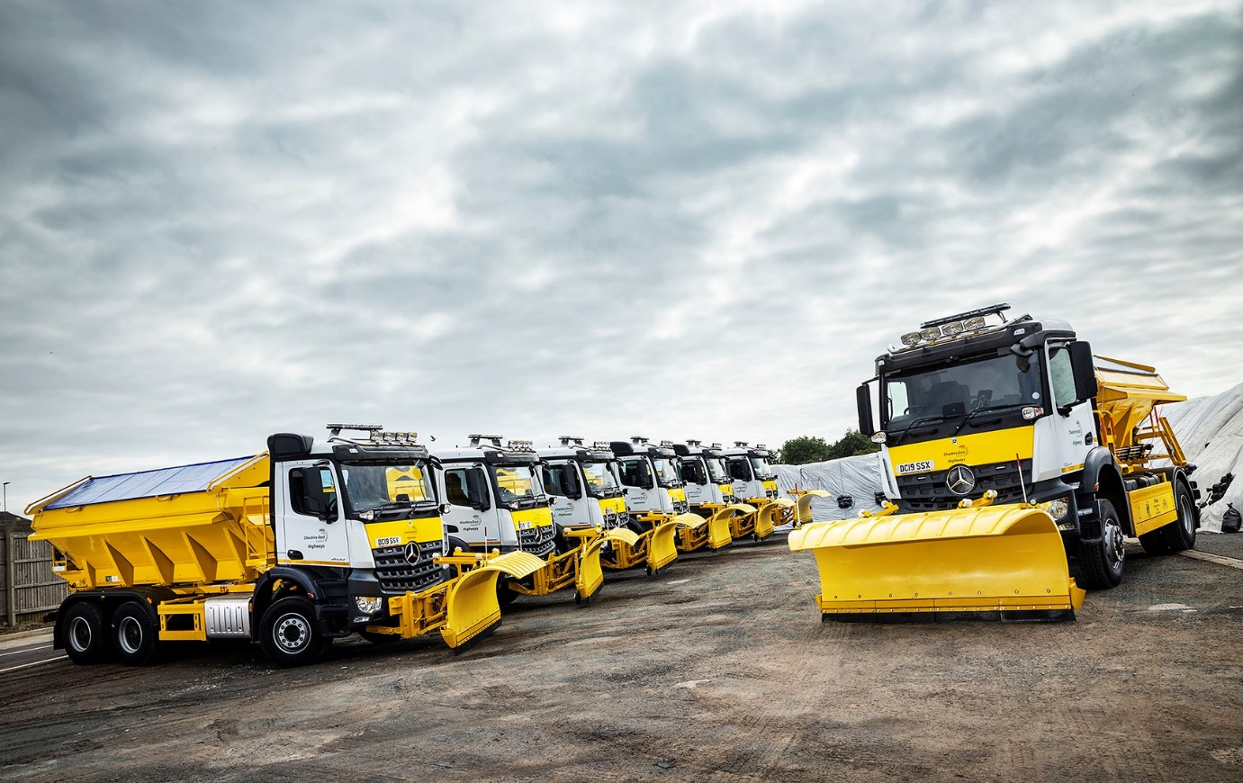

Ringway Jacobs gears up for winter’s worst with eight new Mercedes-Benz Arocs gritters

Ringway Jacobs will be relying on a fleet of new Mercedes-Benz gritters to keep the roads of Cheshire East clear of ice and snow this winter.

The leading highways service provider turned once again to preferred supplier Roanza Truck & Van for the eight new vehicles, all of which are based on muscular Arocs chassis with ClassicSpace S-cabs and Econ Engineering bodywork.

Four are double-drive 2633 26-tonners with 10.7-litre in-line six-cylinder engines producing 240 kW (326 hp). The remainder are 4x4 18-tonne 1824 AK variants with high-torque, 175 kW (238 hp) 7.7-litre straight-sixes.

Econ Engineering’s bodies – the six-wheelers have 9m³ capacities, while the four-wheelers offer up to 6m³ – are purpose-designed to spread de-icing dry rock salt at a width of up to 12 metres. For snow clearance, Econ’s ‘E’ Plough boasts a power angling function which allows the operator to alter the direction in which the snow is ejected without having to make manual adjustments on the move.

The Arocs have also been specified with Econ’s E-Drive route guidance technology. This operates the spreader automatically, allowing the driver to concentrate on the road ahead in challenging driving conditions.

Further underlining Ringway Jacobs’ commitment to safety, the trucks are equipped with recordable five-point camera systems, ‘turning left’ warning alarms, and nearside proximity sensors to protect vulnerable road users, as well as a reverse radar which supplements the standard-fit reverse alarm and camera.

The new gritters have replaced leased vehicles by another manufacturer. Roanza Truck & Van Handover Specialist Ben Clark spent a week at a winter maintenance storage facility in Macclesfield, delivering a comprehensive programme of product familiarisation to 24 of Ringway Jacobs’ drivers.

Following a rigorous procurement exercise, Ringway Jacobs began work on its current contract with the local authority in October 2018. The agreement covers 2,230 km of highway and is worth around £600 million over 15 years.

Theirs is not a new partnership, though, as the company has been serving Cheshire East since 2011. Over the last eight years it has secured more than £150 million of additional funding for the borough’s roads, won industry recognition for collaboration and asset management, and supported the local community by employing 31 apprentices while also putting work the way of local businesses.

Ringway Jacobs’ Head of Fleet David Bonehill commented: “We favour Mercedes-Benz chassis for gritting applications because of their inherent reliability, and for the power they give us for pushing on the plough.

“The ride height of the Arocs is an added bonus, as the truck’s extra ground clearance and relatively elevated seating position makes life that bit easier for drivers when conducting snow clearing and gritting operations.”

He continued: “This significant investment in new vehicles that meet Euro VI emissions regulations reflects our determination to deliver services using the very latest, environmentally-friendly equipment.”

Mr Bonehill is responsible for a fleet of some 250 trucks and 350 vans, in which the three-pointed star features prominently. Other recent truck acquisitions from Roanza include 22 low-entry Econics, 17 Actros at 18- and 26-tonnes GVW, and an Actros tractor unit. Most of the Actros rigids and half of the Econics are impact protection vehicles (IPVs) with crash cushions; the remaining Econics are vacuum tankers for gully emptying.

Mr Bonehill added: “The service we receive from Roanza is second-to-none. Its Truck Fleet Sales Executive Paul Rowley is very open and easy to work with, keeps us regularly updated on the progress of our orders, and invariably delivers on his promises.”

Established in 2005 specifically to provide road network management solutions to local government, Chelmsford-based Ringway Jacobs provides a “best in class” combination of engineering capability, innovation and customer care.

Commenting on its work with Cheshire East Council, Managing Director Mike O’Neill said: “We have delivered an improved, modernised service focused on our customer, localism, effectiveness and efficiency over the last seven years. By re-securing the contract for another 15 years we can continue this legacy and deliver an enhanced, innovative, industry-leading service for the people of Cheshire East.”

www.ringway-jacobs.co.uk

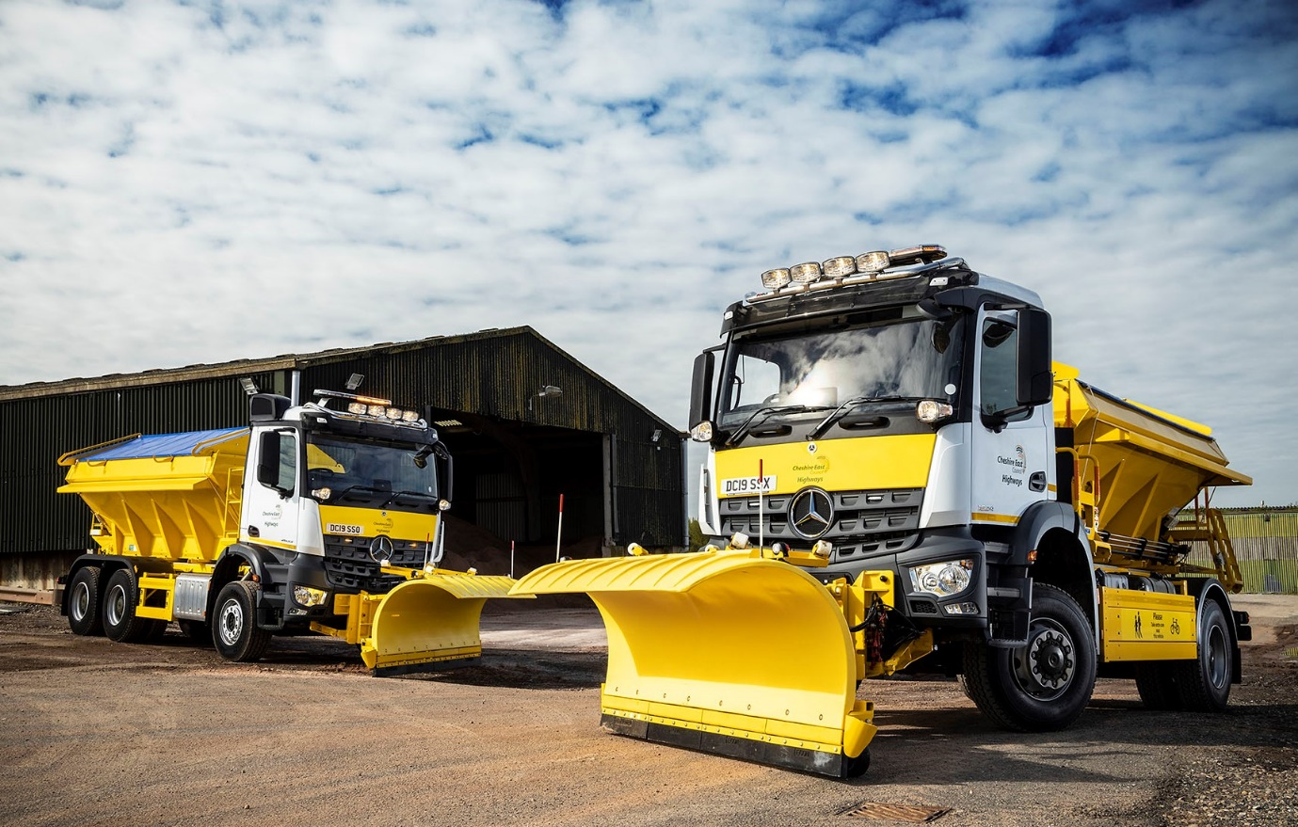

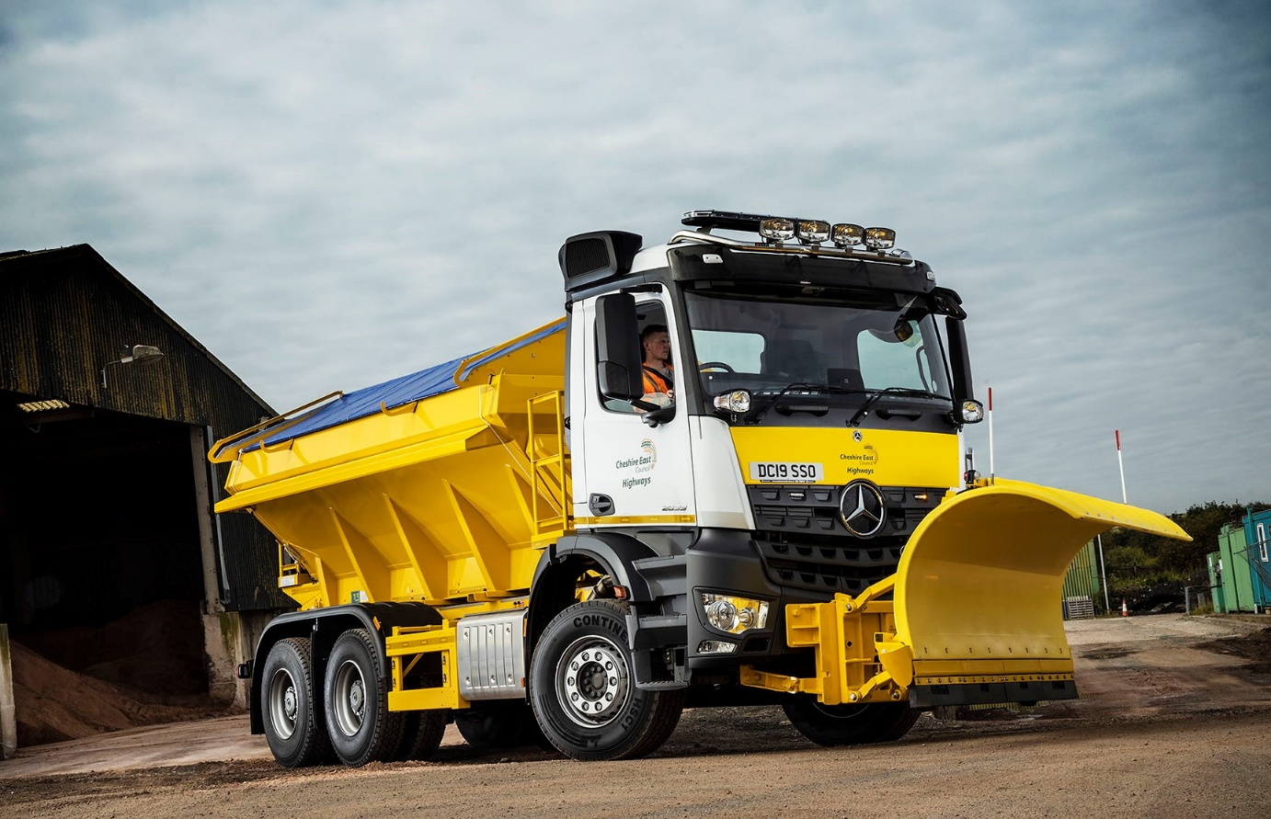

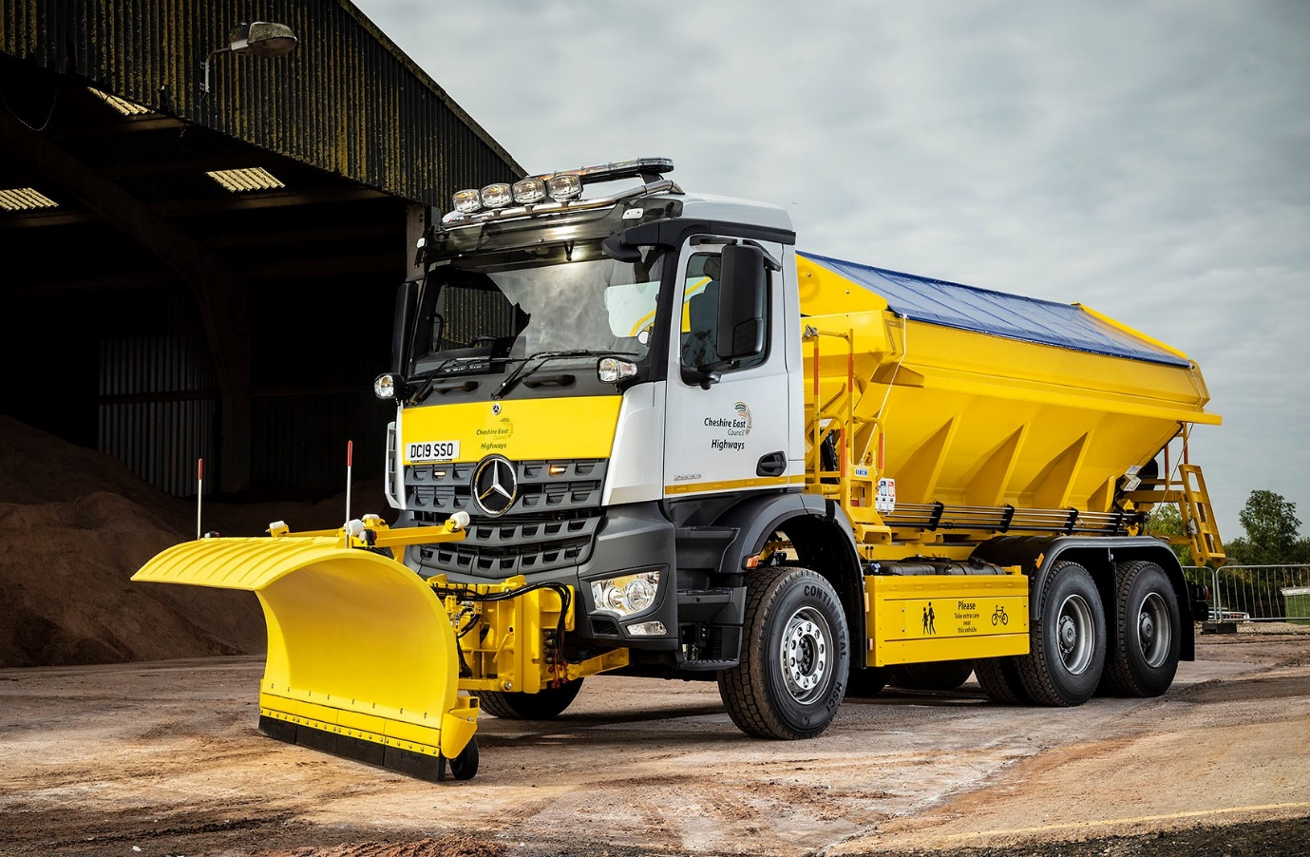

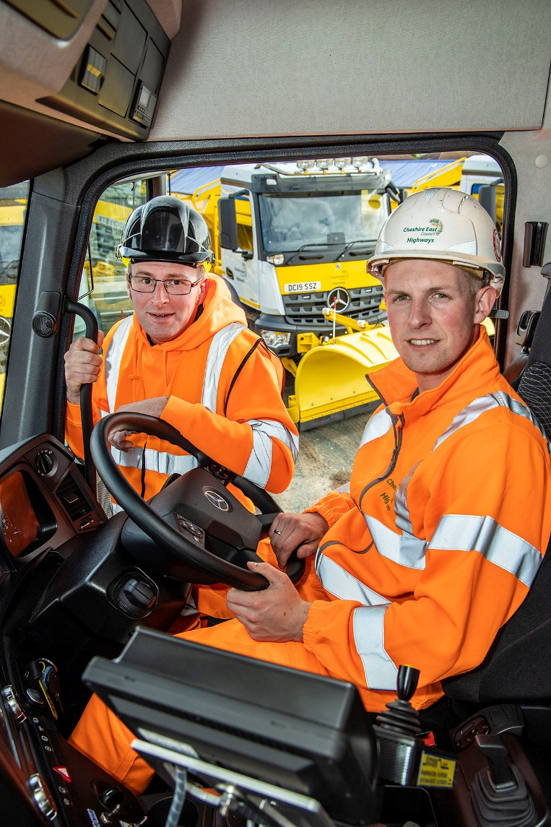

Training gains: Josh Holden, right, a driver on Ringway Jacobs’ Cheshire East contract, is pictured with Roanza Truck & Van Handover Specialist Ben Clark

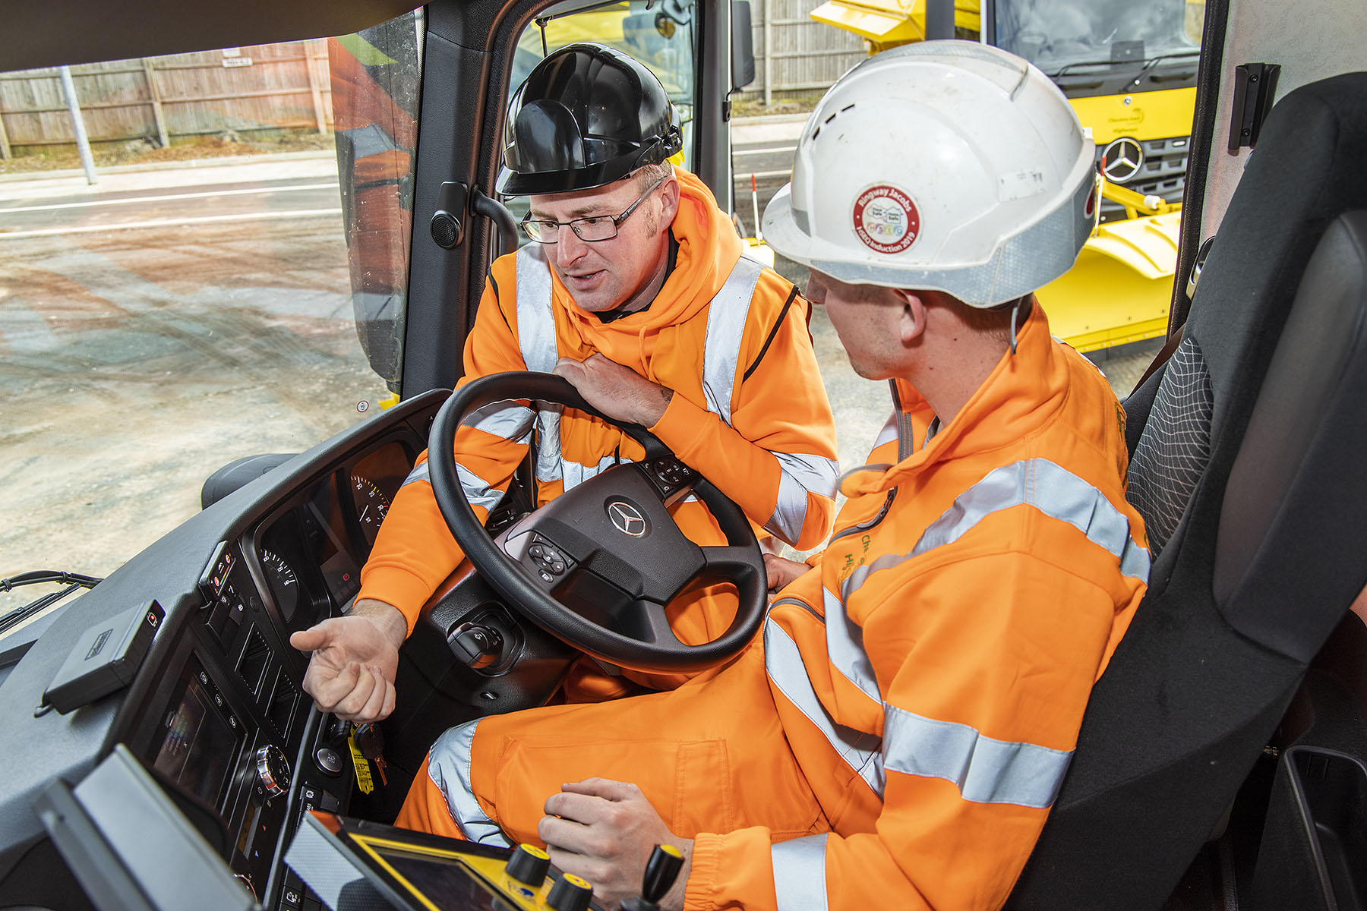

ends

For more information, or to request bigger/higher-res image files, please contact:
Steve Warren or John Ripley
Impact Communications, 01926 842126
Steve: 07770 470251, steve@impactcom.co.uk
John: 07771 484595, john@impactcom.co.uk

