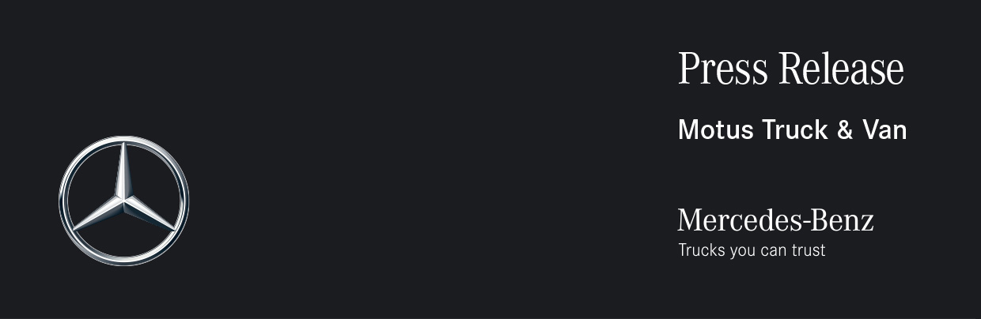

Date: 25 August 2023

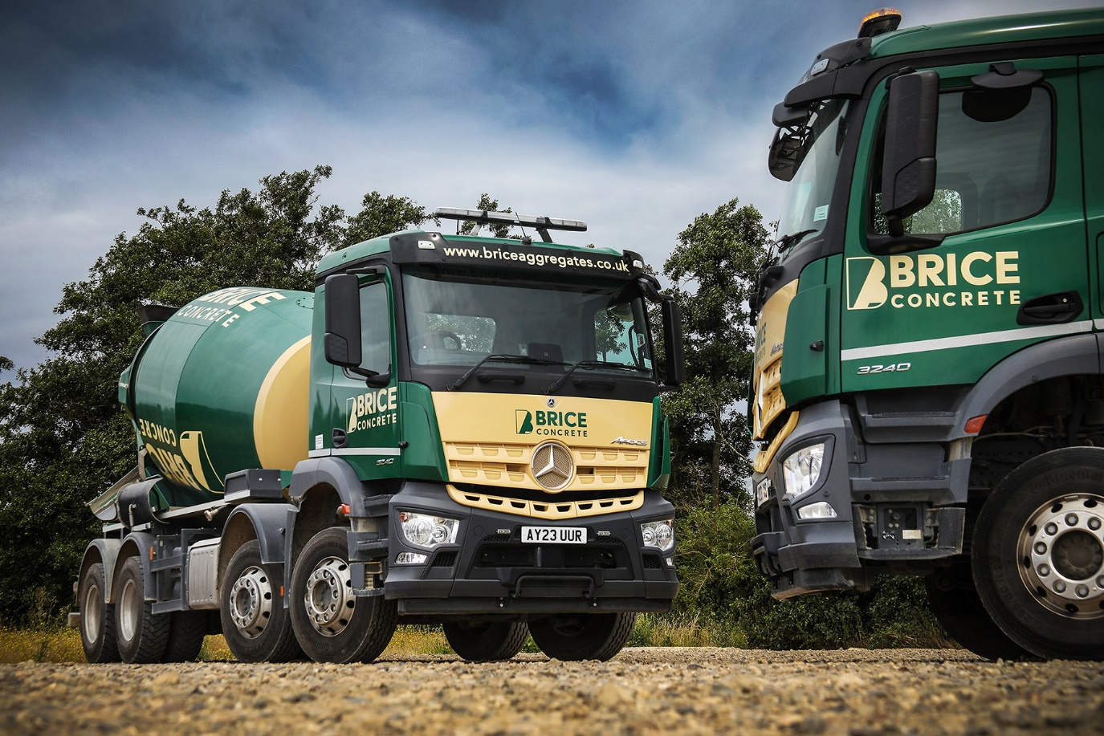

Brice builds for the future with Mercedes-Benz Arocs

Quarrying and construction material supplier Brice Aggregates is laying the foundations for a fleet expansion, with a pair of new Mercedes-Benz Arocs eight-wheelers and more to come.

The Essex-based operator has taken delivery of two Arocs 3240 concrete mixers, with 9m³ Liebherr drums, from Dealer Motus Truck & Van. Another identical mixer and four Arocs 3240 tippers with steel Charlton tipping bodies are on order, for delivery later this year.

Like the trucks already delivered, all will be powered by 290 kW (394 hp) 10.7-litre ‘straight six’ engines, and have ClassicSpace M extended day-cabs. Their 320 mm engine humps allow for a lower seating position than higher-riding variants, which gives the driver a better view of other road users, including pedestrians and cyclists.

All represent expansions to the Brice fleet, which currently stands at 21 but is set to grow to 30 as more vehicles are required to cope with an increasing demand for the company’s range of products and services. The trucks were acquired with funding from Daimler Truck Financial Services and are covered by four-year Mercedes-Benz ServiceContracts.

Managing Director Oliver Brice said: “Since starting this operation in 2017 we have looked to add continuously to our capabilities with the aim of establishing a reputation for reliability, quality and service. Our ready-mixed business has been developed with this in mind and operates the highest capacity plant in Essex. These Arocs will become a familiar sight on the region’s roads delivering quality wet-batched concrete to our customers, from single loads to pours of many hundreds of cubic metres.

The company began by opening its site at Colemans Quarry, Witham, which supplies a range of high-quality aggregate products. Three years later, as trade grew, it started offering construction haulage services. Today Brice also produces and delivers ready-mixed concrete alongside its sand and gravel, and runs a successful muckaway operation. Meanwhile an in-house an inert soil tipping facility and aggregate recycling capabilities have extended its reach still further. The fleet works across Essex, Suffolk, south Cambridgeshire and into East London and eastern parts of Hertfordshire.

In its early days Brice based its fleet on another brand of trucks. The decision to invest in Mercedes-Benz vehicles was sparked when the company began making deliveries to the construction site that was to become Motus Truck & Van’s Witham Dealership, in 2021.

“Motus Sales Executive Ben Sheldrake noticed we were turning up to pour concrete at the site in mixers from a rival brand – so he took the opportunity to start talking to us about the Arocs,” recalled Mr Brice.

“He impressed us with his knowledge of the product and understanding of the requirements of our application, and also made all the right promises regarding the level of back-up Motus could provide. We could see that the Arocs was well suited to a business like ours, and the opening of the Witham Dealership so close to our own operating base was also a significant advantage.

“I’d already been considering adding a second brand to our line-up, and really only Mercedes-Benz and one other manufacturer were in the running. The fact that the Arocs is well proven as a construction chassis, and backed by a Dealer situated just a couple of miles away, was enough to swing us towards the three-pointed star. Motus were also able to quote an impressively short lead time, given the supply problems that still exist in the industry, which sealed the deal in their favour.”

www.briceaggregates.co.uk

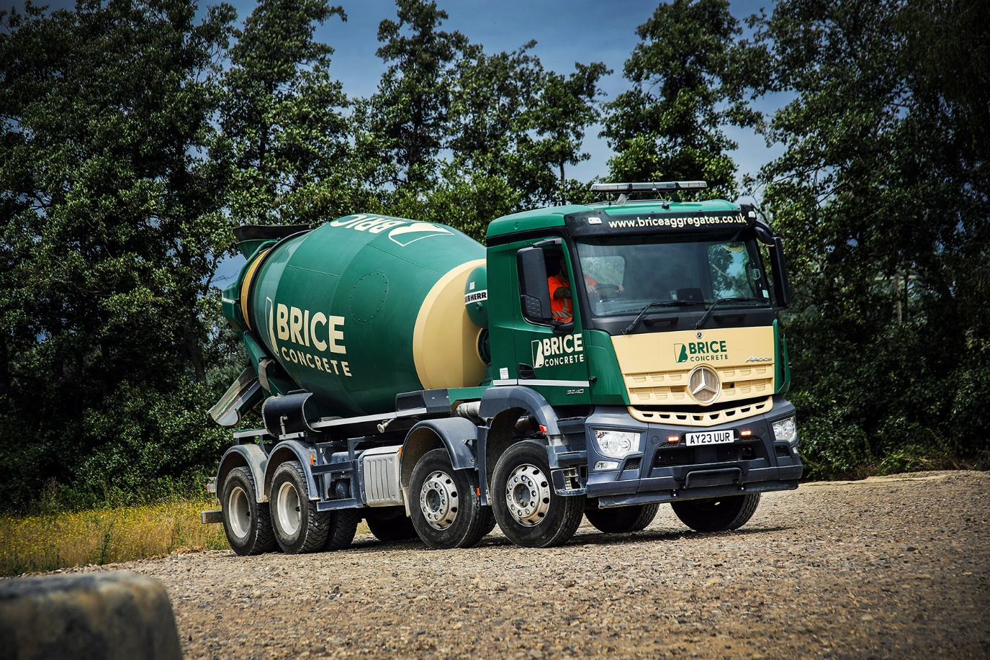

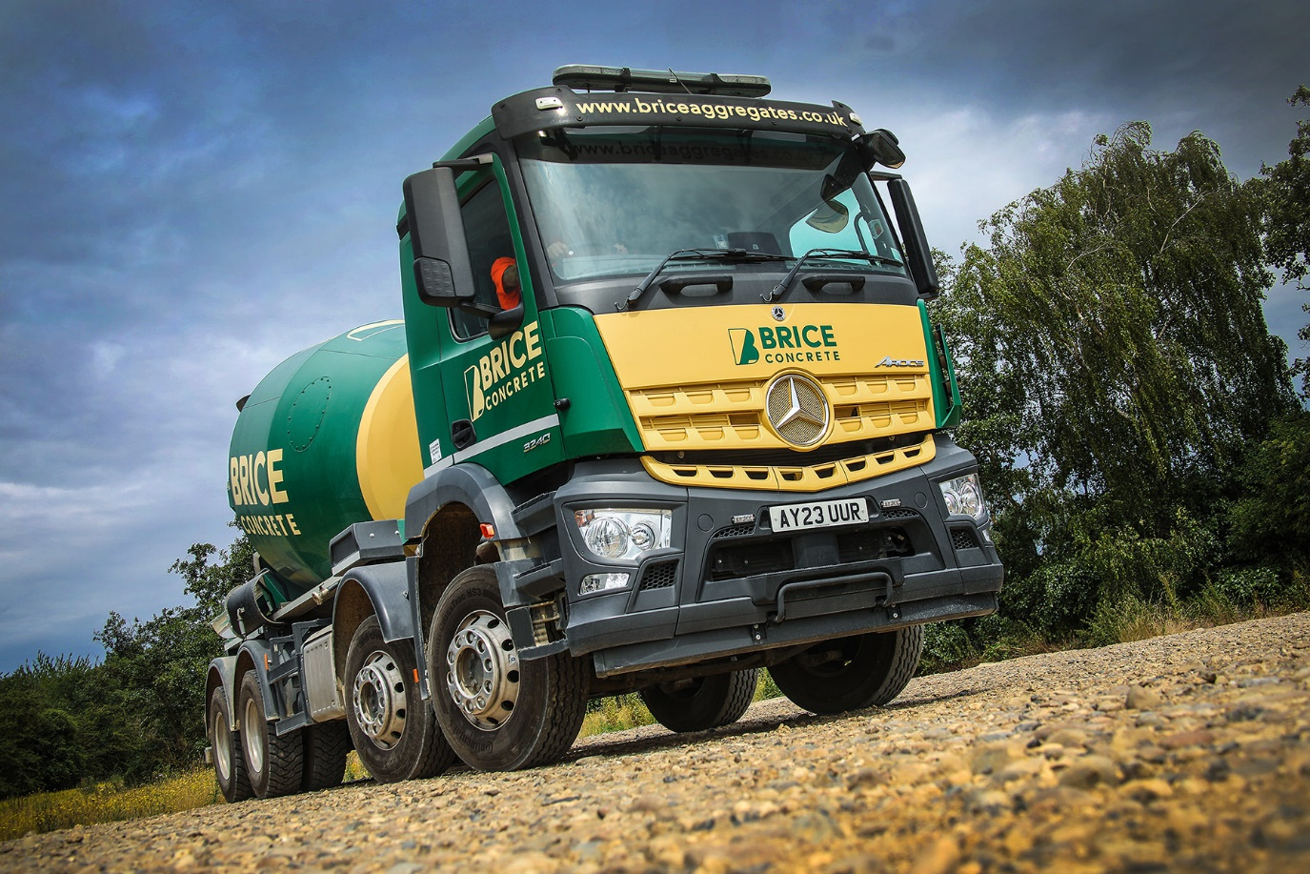

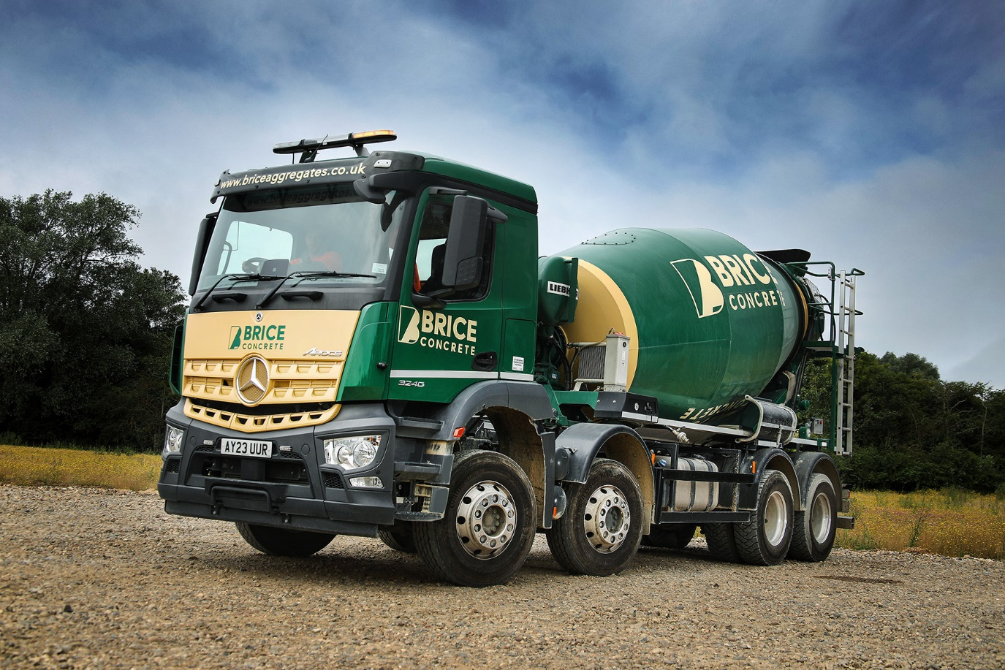

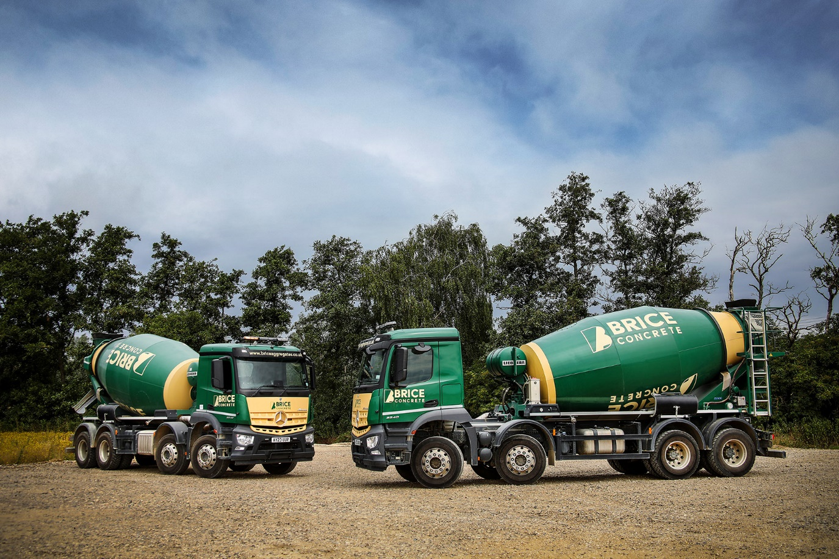

ends

For more information, or to request bigger/higher-res image files, please contact:
John Ripley: 07771 484595, john.ripley@loopagency.co.uk

