

Date: 23 October 2020

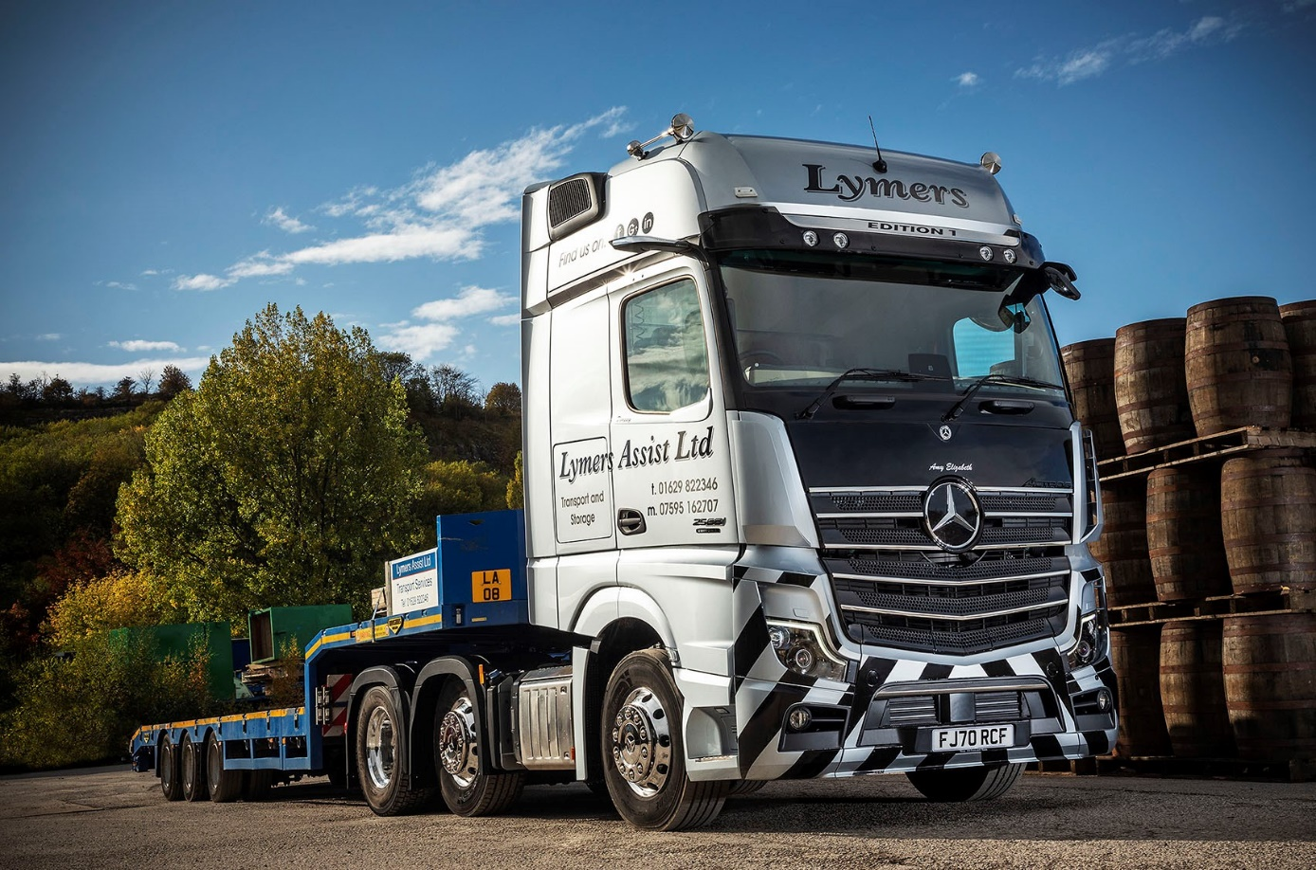

Lymers Assist opens its Mercedes-Benz account with an awesome Actros Edition 1 flagship from Mertrux

Alex Lymer doesn’t do things by halves – which explains why his first Mercedes-Benz truck is a top-of-the-range Actros Edition 1 model that combines ground-breaking technology with the ultimate driver’s ‘wish list’ of comfort and style options.

The Edition 1 is a stunning showcase for the fifth-generation Actros range, winner of the International Truck of the Year 2020 accolade. Just 400 have been built and of these only 35 were made available to UK customers.

Mr Lymer established wide and abnormal loads specialist Lymers Assist, in Croston, Lancashire, in 2014. The following year it moved to its current headquarters in Matlock, Derbyshire, and in July it opened another depot on a three-acre site in Hull.

As well as undertaking movements up to 80 tonnes GCW, Lymers Assist provides Hiab crane, haulage, trailer hire, and storage and distribution services. The company’s new flagship arrived via East Midlands Dealer Mertrux Truck & Van – it is the subject of a Mercedes-Benz Finance contract hire agreement, and has taken its place in a fleet of a dozen tractor units and drawbar rigids.

The Edition 1 is based on the imposing GigaSpace cab and is instantly recognisable thanks to its gloss black grille, darkened headlamp covers and rims, and branded sun visor incorporating four extra LED main-beam headlamps. Like most examples, Lymers Assist’s truck is powered by a range-topping 15.6-litre in-line six-cylinder engine which produces a potent 460 kW (625 hp).

In addition to the many innovations that come as standard in the latest Actros – MirrorCam, Active Brake Assist 5, and enhanced Predictive Powertrain Control technology, for example – the limited-edition model is loaded with additional equipment.

The upgraded interactive version of the revolutionary Multimedia Cockpit incorporates a larger, 12in primary colour display, and the black leather-trimmed cab interior – which includes door handles with contrasting topstitching – features a polished and brushed aluminium dashboard badge that confirms each truck as ‘One of 400’ Edition 1s. Drivers can choose from no fewer than eight colours of ambient ceiling lighting, while the bed is an industry-leading 900 mm wide.

A former driver himself, Alex Lymer explained: “Image is very important to me. I don’t want basic, supermarket-spec trucks, so most of ours are high-end models that really look the part when they turn up on behalf of our customers.
“That’s certainly true of the Edition 1. I’d visited Mertrux, Derby, to talk about an ex-demonstrator they were selling, but as soon as I saw the flagship model in the yard I knew that was the truck for me. I was pleasantly surprised, too, by the competitive contract hire rate the Dealer’s Sales Executive Andrew Bonser was able to offer.”
The Actros bears the name of Mr Lymer’s closest cousin, Amy Elizabeth. “All of our trucks are named after female members of our family,” he said. “Since my wife and I moved away from our home town of Blackpool the business seems to have taken up all of my time, so it’s a nice way to show that at least I’m still thinking of them.”

Christmas has certainly come early for driver Jason Dempsey, who only joined Lymers Assist in June. “My Actros is a beautiful machine, and like Alex I love the way it looks,” he enthused. “It’s supremely comfortable, and someone’s clearly given a lot of thought to the interior lighting – having so many options when it comes to illumination is a real bonus given the dull and dingy cabs of some of the lorries I’ve driven in the past.”

In his 32 years on the road Jason has never had an accident. A self-professed “old school driver”, he admits to having had a certain amount of trepidation about the truck’s MirrorCam system. “It took a little bit of getting used to, but I was soon won over,” he recalled. “The blind side view when I’m reversing with a wide load is truly amazing.”

MirrorCam’s roof-mounted camera relay images to screens mounted inside the cab, on the A-pillars. Not only does this pioneering technology provide much-improved rearward vision, but it also eliminates the blind spots created by conventional mirrors.

“Jason is a very good driver, with a lot of experience of our kind of work,” confirmed Alex Lymer. “I want to retain the best guys, and providing them with top-class equipment like the Actros Edition 1 helps me to do so. It’s an investment I’m very happy to make.”

If the new truck has made a positive first impression on Lymers Assist, so, too, has Mertrux Truck & Van. “Everyone talks about fuel economy and I’ll certainly be looking for double-figure mpg returns from our new Mercedes-Benz,” continued Mr Lymer.

“However, service and back-up are far more important to me in the long run. I like partners with a ‘can do’ attitude, whose people can demonstrate flexibility when I need to get a truck into the workshop in a hurry, and jump straight on it when I call to report an issue.

“These are still very early days, of course, but I’ve been very encouraged by all that I’ve seen and heard from Mertrux so far. The communication from Sales Executive Andrew was excellent, and the Dealer will be providing Jason with a courtesy vehicle while his truck’s in the workshop overnight for inspections and maintenance.

“I also received an introductory call from its Derby Aftersales Manager Jon Burridge, who gave me an overview of the support that Mertrux can provide, then provided me with his number and insisted that if ever I have a problem I should contact him straight away. I liked that… it’s not something I’ve had from any other manufacturer in the past.”

lymersassist.co.uk

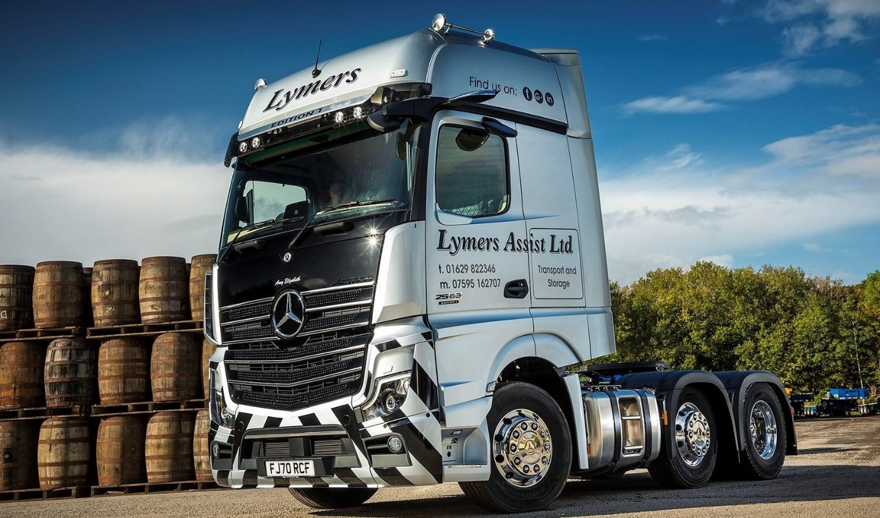
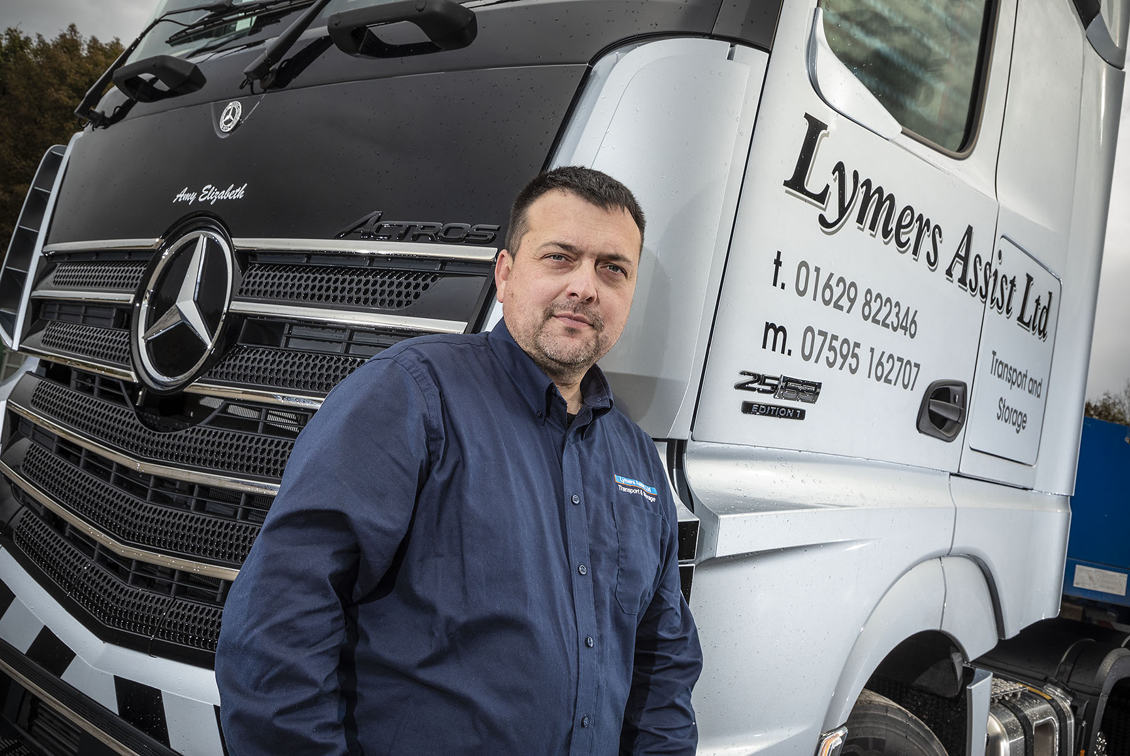

Positive first impressions: Alex Lymer is delighted with his new Actros Edition 1, and encouraged by the early performance of supplying Dealer Mertrux Truck & Van

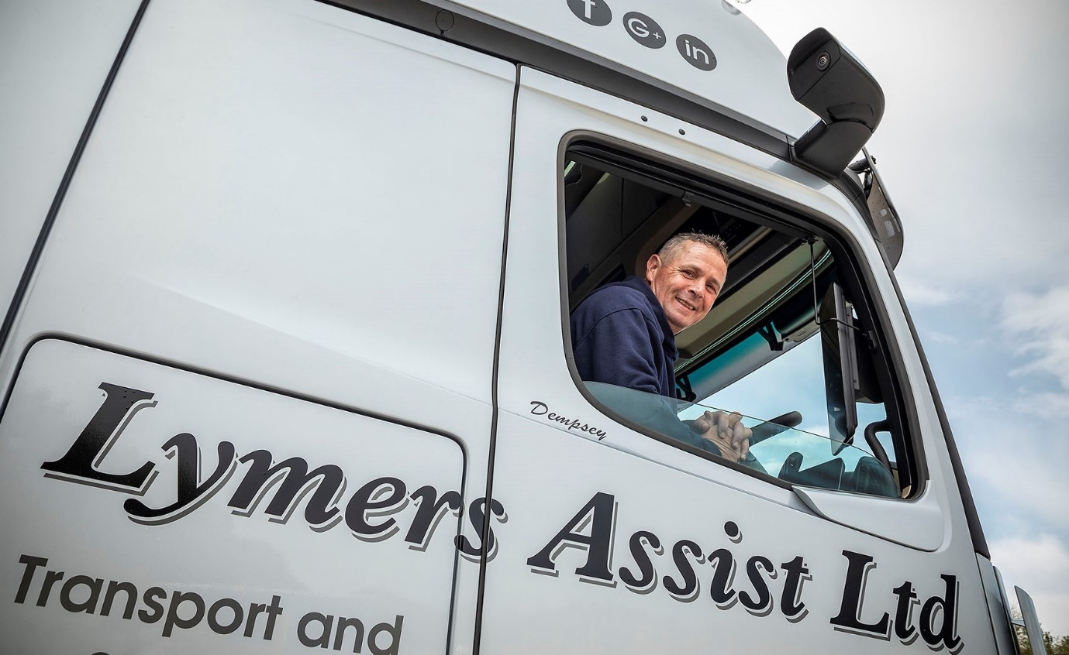

Convert: Despite his initial reservations “old school driver” Jason Dempsey was quickly convinced by the benefits of Mercedes-Benz Trucks’ radical MirrorCam technology
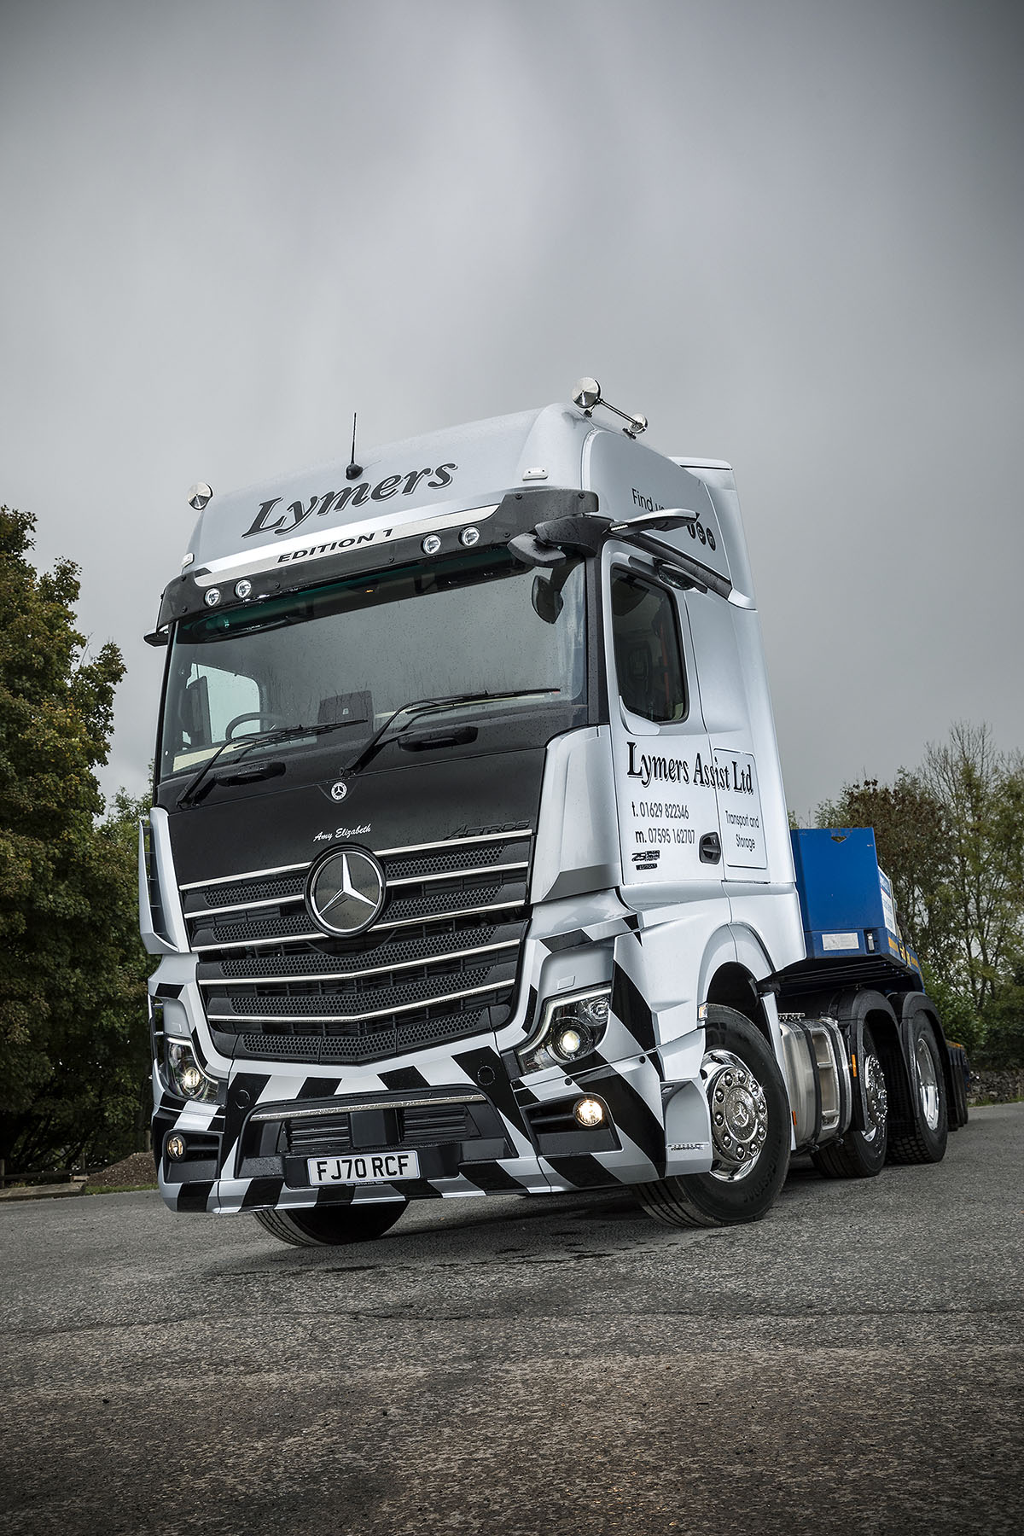

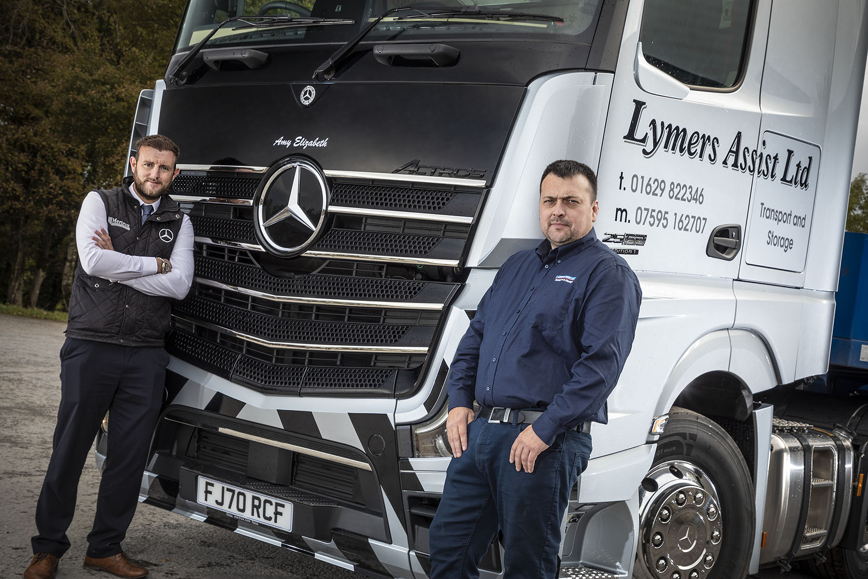

Polishing the star: Alex Lymer, right, was delighted with the service provided by Mertrux Truck Sales Executive Andrew Bonser, who put together an attractively price contract hire package and then kept him fully informed on progress in the lead-up to delivery of the truck

ends

For more information, or to request bigger/higher-res image files, please contact:
Steve Warren or John Ripley
Impact Communications, 01926 842126
Steve: 07770 470251, steve@impactcom.co.uk
John: 07771 484595, john@impactcom.co.uk



