

Date: 28 June 2021

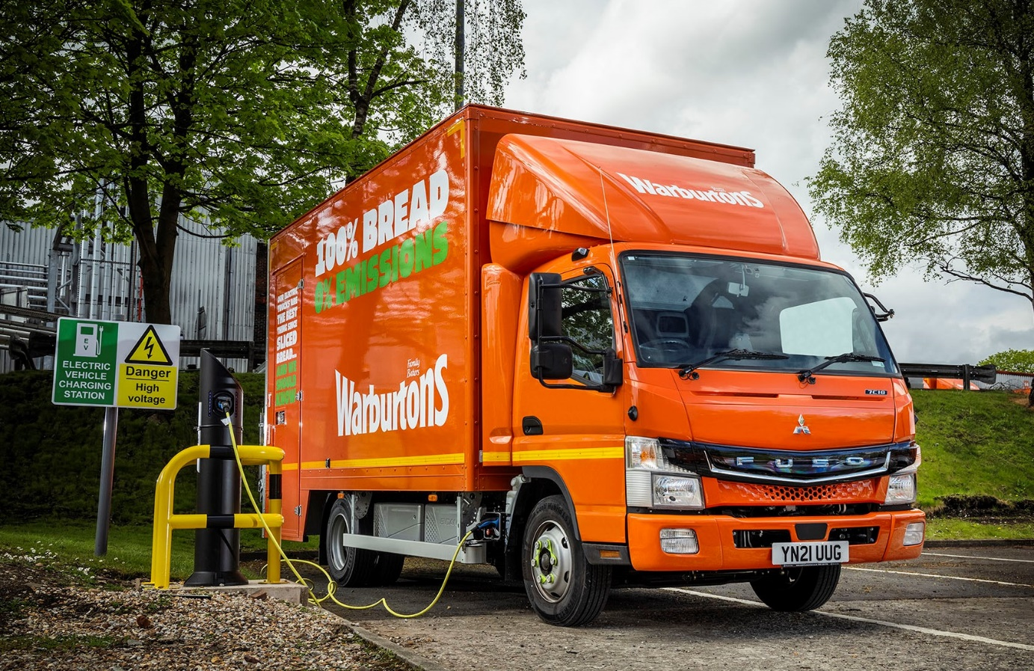

Warburtons grabs another slice of the EV action with zero-emission FUSO eCanter

The UK’s largest bakery brand has underscored its commitment to the rise of battery-powered truck technology by commissioning its first FUSO eCanter.

Family-owned Warburtons is keen to gain early experience of operating electric vehicles, so it will be better placed to exploit opportunities for growth it as they become more mainstream.

The 7.5-tonne FUSO eCanter is the world’s first fully electric light-duty truck to enter series production and represents a major advance in the battle to improve air quality in towns and cities.

Warburtons National Transport Manager Steve Gray explained: “Like all transport operators, we’re conscious of the increasing prevalence of emissions-based restrictions, particularly in city centres, and appreciate that there’s only one direction of travel.

“Zero-emission truck technology is still in its infancy, of course, but the limitations on range which remain the biggest barrier to widespread adoption are not necessarily an issue for Warburtons. This is because many of our trucks are already on low-mileage work. We’ve therefore decided to acquire a FUSO eCanter, as this vehicle aligns perfectly with our operating profile.”

The eCanter’s electric drivetrain employs six 13.8 kWh lithium-ion batteries with a total power output of 82.8 kWh (66 kWh usable). The permanent-magnet motor delivers 129 kW (180 hp) via a single-gear transmission in the rear axle. A single charge gives the truck an effective operating range of more than 62 miles (100 km), which is ample for many urban delivery applications.

Warburtons operates from headquarters in Bolton and is one of the country’s best-loved brands, with roots that date back to 1876. The company’s ‘primary’ fleet of 125 tractor units trunks nightly between a nationwide network of bakeries, each of which specialises in a different product range. The eCanter has joined its ‘secondary fleet’ of 800 rigid trucks, which undertake local deliveries to customers from 23 locations stretching from Aberdeen to Newton Abbot.

The truck is the subject of a five-year Mercedes-Benz Finance contract hire agreement – the manufacturer and its franchised Dealers are also responsible for sales and support of the popular FUSO light truck range in Britain – and fitted with a bespoke box body by PPS Commercials, of Bury, Greater Manchester.

It sets off at 4am each day from Warburtons’ Bolton bakery and delivers fresh bread to as many as 25 different customers, mainly in the central Manchester area. They range from large supermarkets to independent corner shops.

“Our first impressions of the eCanter are certainly positive,” confirmed Steve Gray. “Its range is more than adequate for our needs and it has been well received by our drivers. It’s smaller than a conventional 7.5-tonner and this compact footprint, coupled with an excellent turning circle that makes it highly manoeuvrable, is a definite advantage for city centre work.”

Although Warburtons’ focus is on volume rather than weight-carrying capacity, the eCanter also offers an outstanding body and payload allowance of more than four tonnes, which is not far short of the market-leading figure achieved by its diesel-engined stablemate.

Mr Gray continued: “I’ve been impressed, too, with the support we’ve received from Mercedes-Benz Trucks UK. Our Key Account Manager Darren Bain has been excellent throughout, and arranged for his TRUCKtraining colleagues to deliver familiarisation sessions on the new vehicle to our own driver-trainers.”

The FUSO eCanter is already well proven – the UK’s first 10 examples were delivered to three operators in 2018, with a further six supplied to other customers the following year, and worldwide there are now more than 200 in operation.

www.warburtons.co.uk

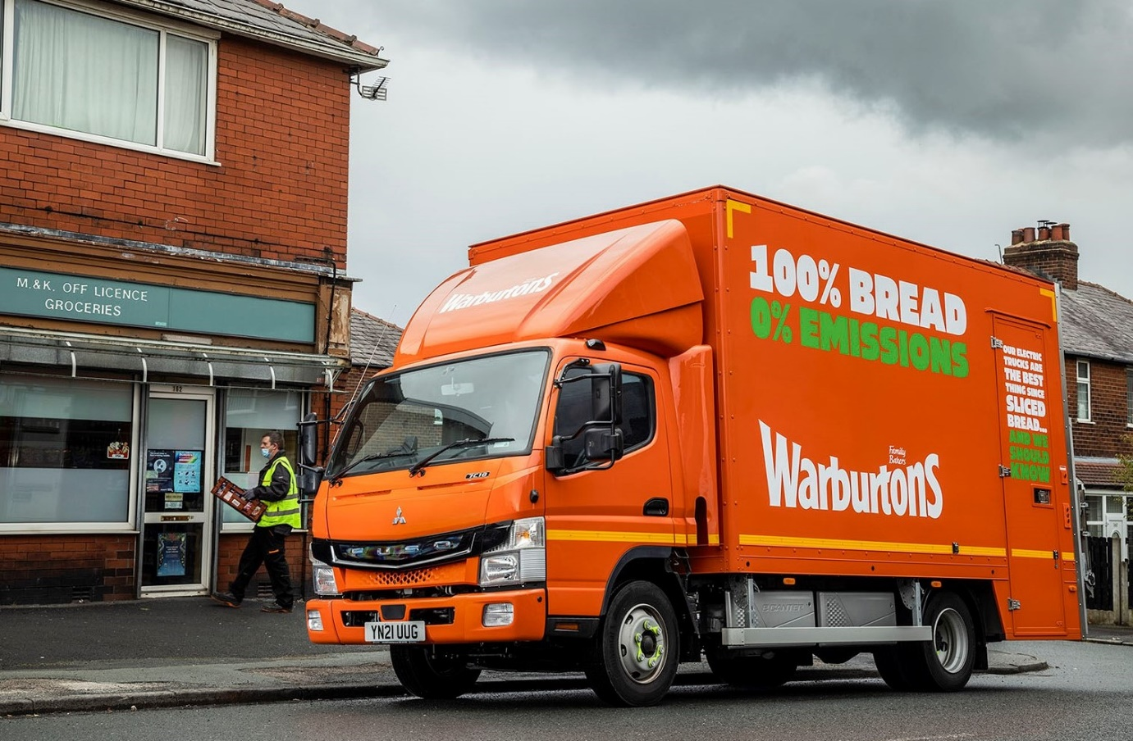

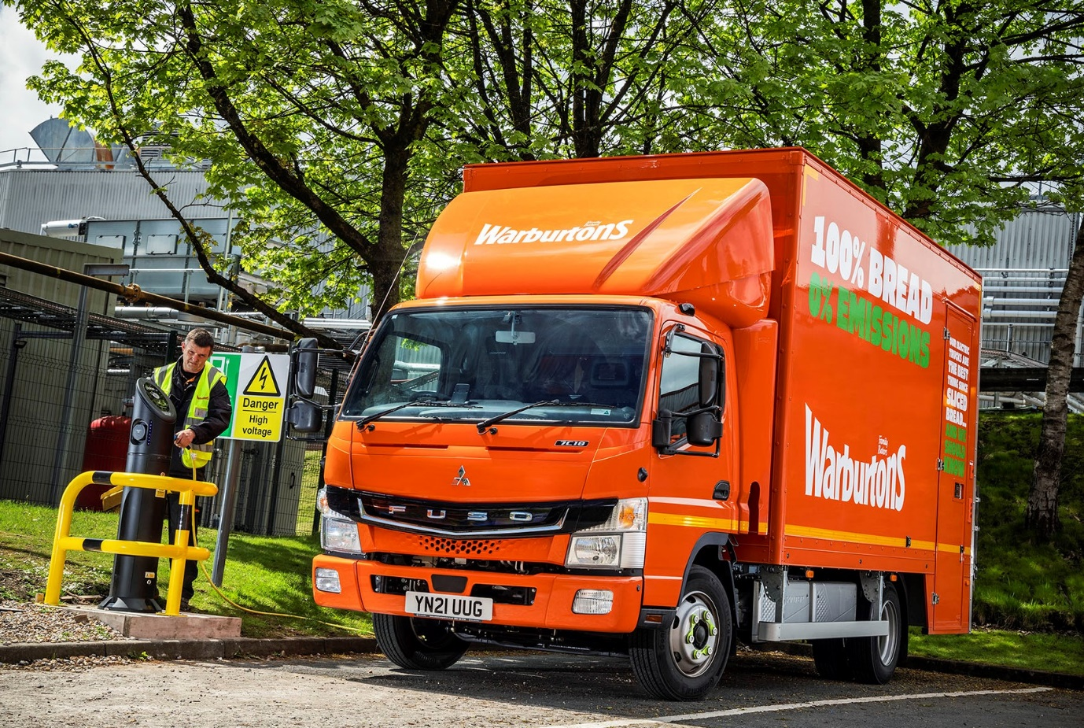

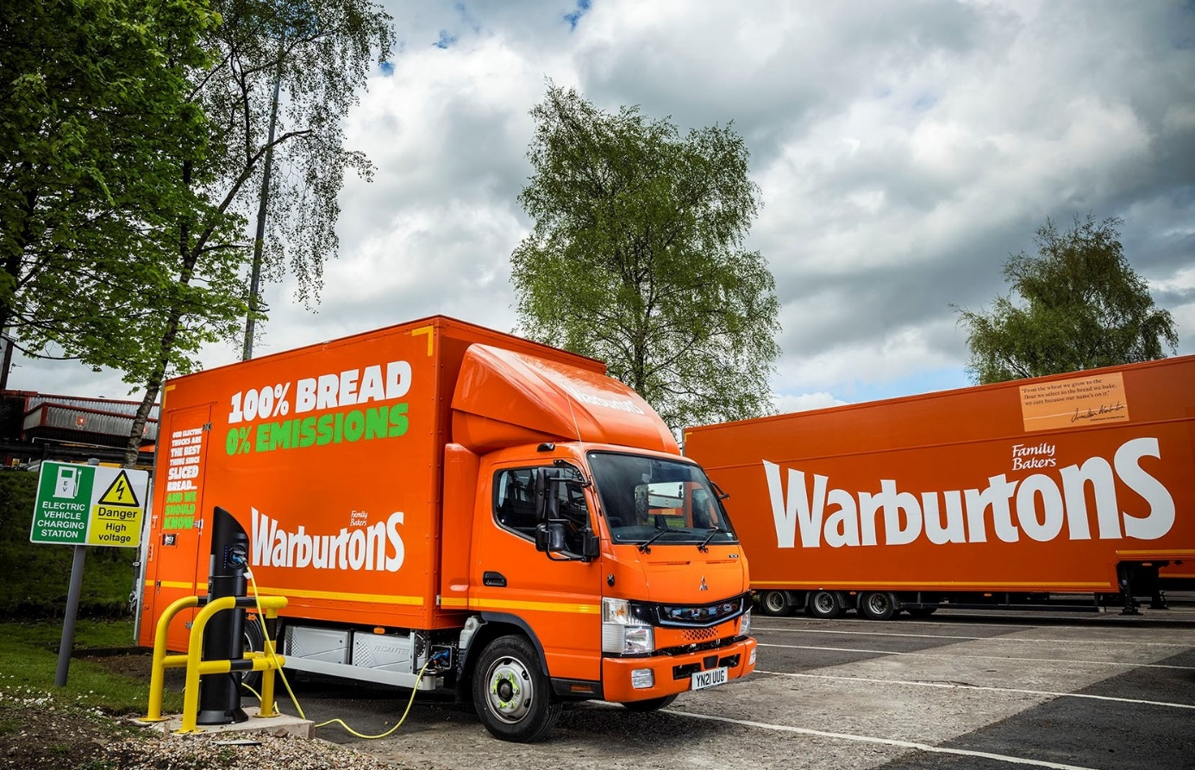

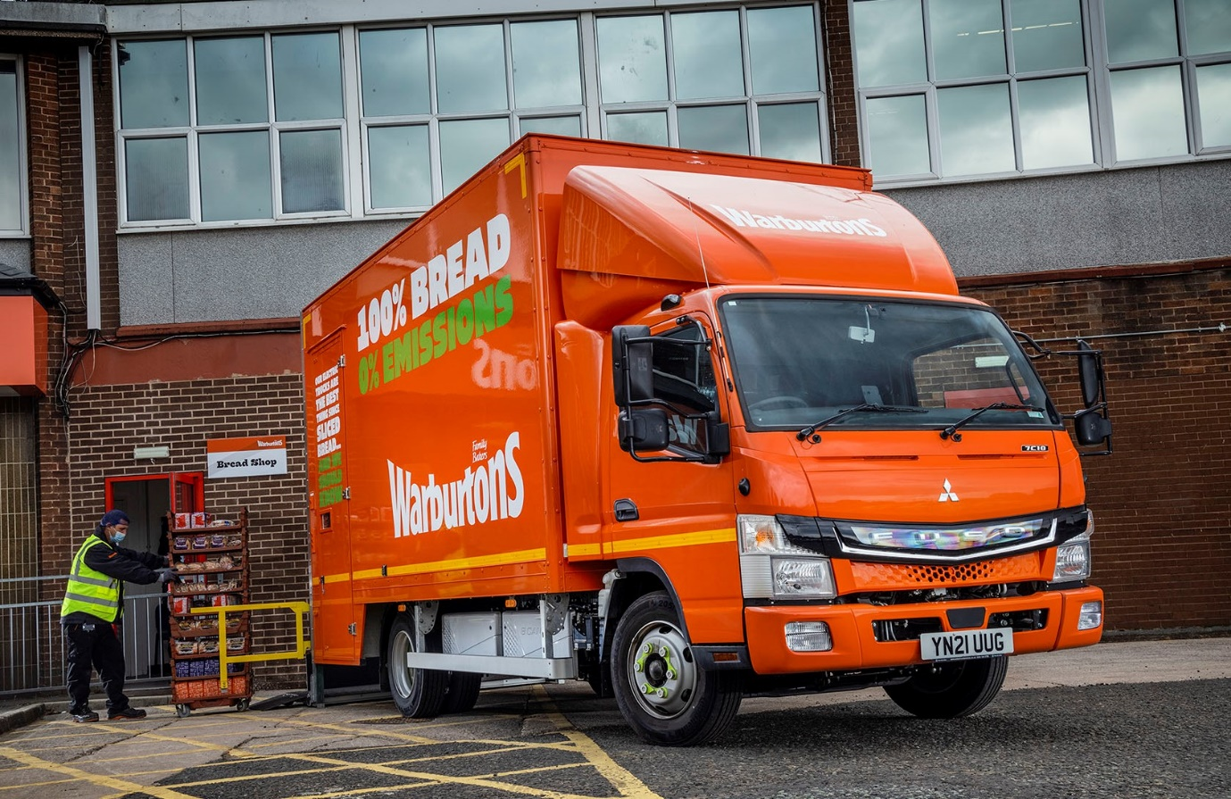

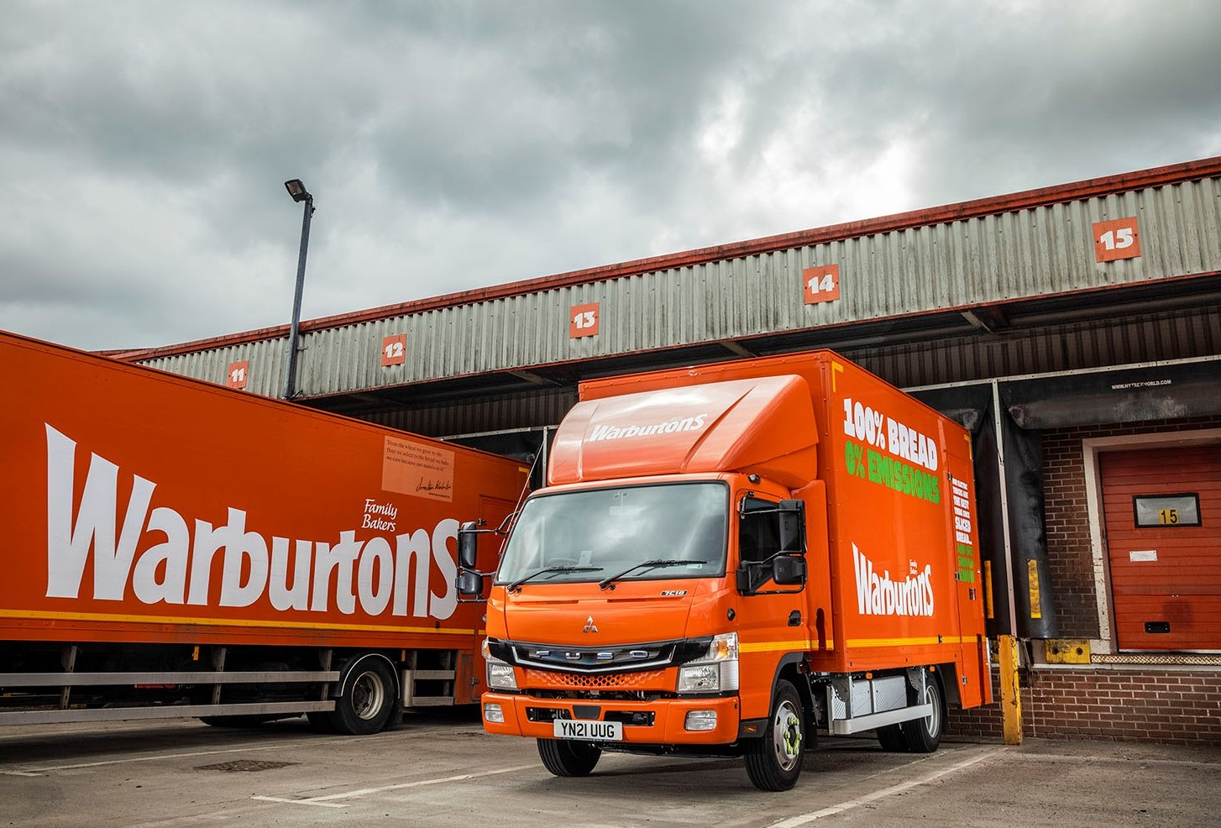

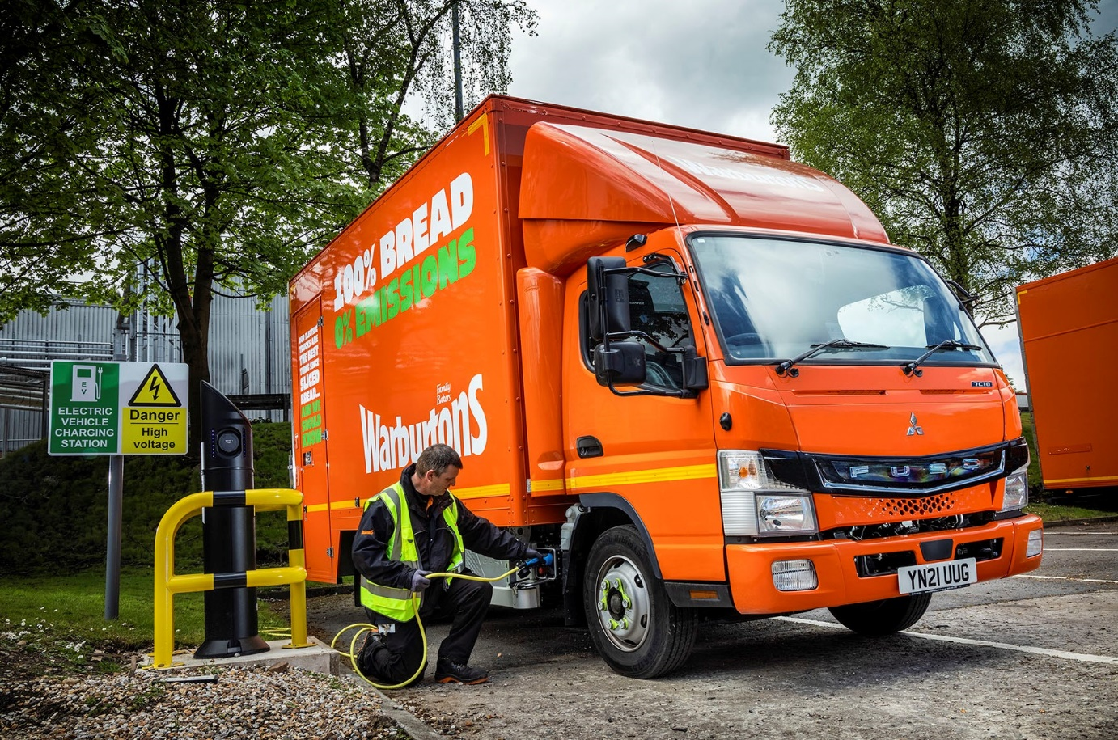

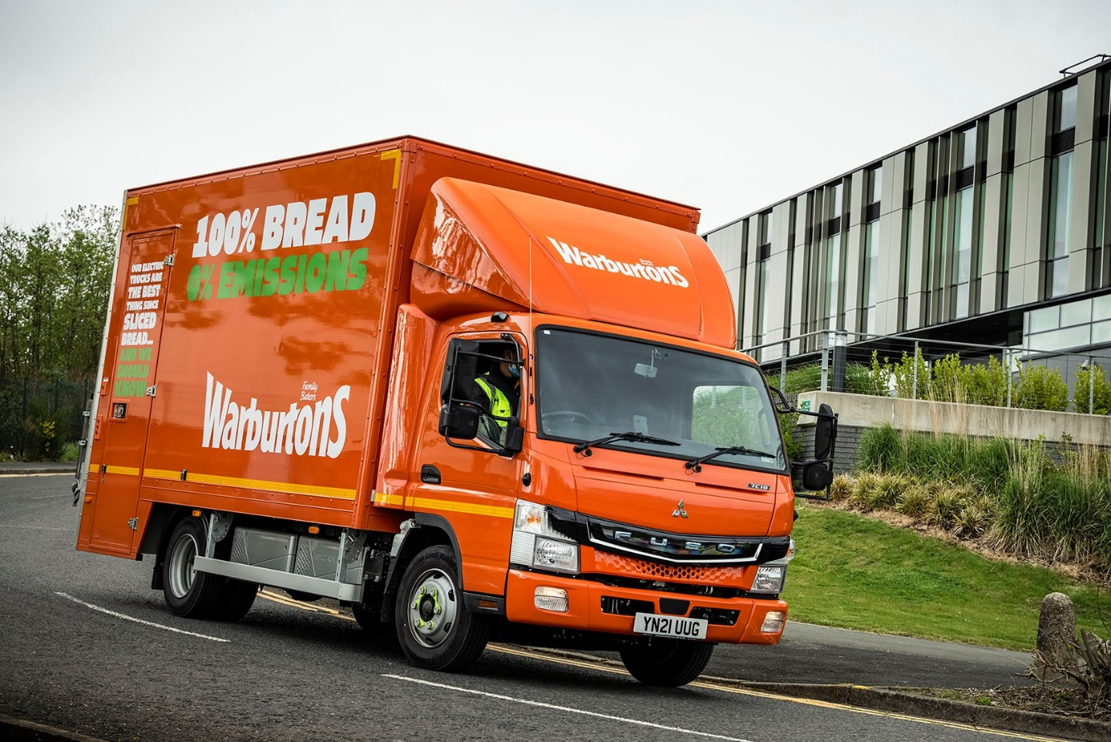

ends

For more information, or to request higher-res image files, please contact:

Jamie Fretwell at Mercedes-Benz Trucks UK Ltd
07712 519230, jamie.fretwell@daimler.com

or

Steve Warren or John Ripley
Impact Communications, 01926 842126
Steve: 07770 470251, steve@impactcom.co.uk
John: 07771 484595, john@impactcom.co.uk

About Mercedes-Benz Trucks UK Ltd
Mercedes-Benz Trucks UK Ltd is the sales and marketing organisation responsible for all Daimler truck products in the UK, including FUSO Canter. In 2019, the company registered 6,963 new trucks. Mercedes-Benz accounted for 6,188 new trucks registered in 2019, making it the third-biggest truck brand in the UK. Meanwhile, FUSO registrations hit 775 – including 580 new trucks over 6.0-tonnes. The flagship new Mercedes-Benz Actros which won the 2020 International Truck of the Year award, features seven core innovations including MirrorCam, Multimedia Cockpit and Active Brake Assist 5. Our premium range of innovative trucks – Actros, Arocs, Atego, Econic and Unimog – draw upon more than 125 years of exceptionally high standards of quality, backed up by our promise of Trucks You Can Trust.
www.mbtrucks.co.uk

