

Date: 21 June 2022

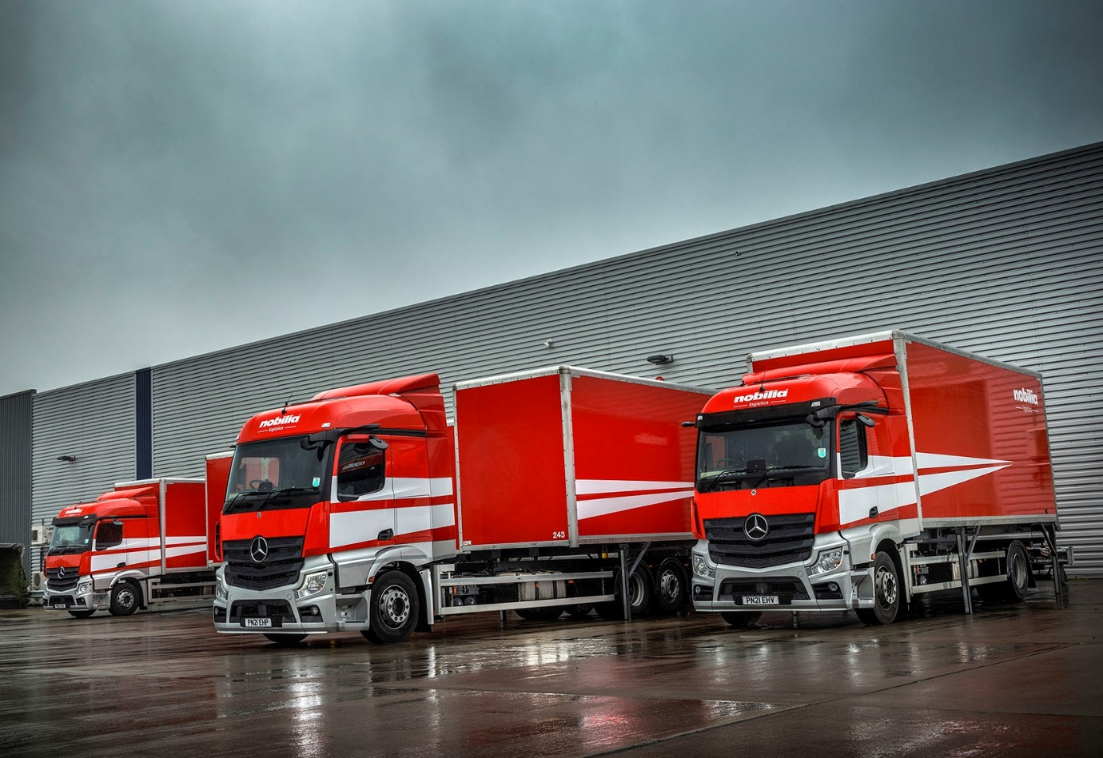

Boxing clever: Nobilia’s eye-catching Mercedes-Benz trucks work with demountable bodies

Nobilia hails its ‘magnificent seven’ Mercedes-Benz Actros from Ciceley Commercials

Nobilia Projects, the fast-growing British contracts division of Europe’s largest kitchen manufacturer, is reaping the benefits of a switch to Mercedes-Benz trucks.

The seven Actros rigids are based at the 55,000 sq ft UK head office and distribution centre that Nobilia GB opened in 2018 on the Kingsway Business Park, Rochdale, a stone’s throw from Junction 21 of the M62.

Supplied by Ciceley Commercials, they are the subject of a Mercedes-Benz Finance contract hire agreement under which routine inspections and maintenance are carried out at the Dealer’s Bolton workshop.

Nobilia Projects, which also has an extensive showroom in Surrey Quays, East London, is committed to providing a comprehensive and seamless kitchen service to housebuilders, developers and other contract clients nationwide.

Its latest trucks – four 26-tonners and three 18-tonners – are the first to wear the company’s smartly updated red and white livery, and work with 14 demountable box bodies built by Wheelbase Engineering, of Darwen.

All have aerodynamic StreamSpace cabs which, at 2.3m, are in the narrower of the two widths available. As 2530 variants the six-wheelers are powered by 7.7-litre engines producing 220 kW (300 hp); their four-wheeled stablemates employ 175 kW (238 hp) versions of the same in-line six-cylinder unit.

The Mercedes-Benz trucks have replaced the mixed-marque fleet of eight trucks that Nobilia Projects was using previously to deliver kitchens. Its former vehicles, among them a single 26-tonne Actros that had been exceptionally reliable, were all fitted with conventional fixed bodies.

Adoption of the demountable concept has brought efficiencies as loading can now take place seven days a week, even when the trucks are out on the road making their deliveries. The 26-tonners carry 18 stillages, six more than the 18-tonners.

Nobilia has been serving the UK contract kitchen sector for nearly 25 years and boasts a ‘blue chip’ client portfolio that includes the likes of Taylor Wimpey and Berkeley Group. Its ‘Logistics in motion’ system uses cutting-edge technology to speed up the process at every step of the delivery chain, ensuring that customers receive a reliable, quality-focused service with regular updates.

Darren Steeles, Nobilia GB’s Transport Manager, said the Actros were proving significantly more fuel-efficient than the vehicles they had replaced. Darren also puts in regular shifts at the wheel and is an enthusiastic advocate for the manufacturer’s ground-breaking, camera-based replacement for conventional mirrors.
“MirrorCam is brilliant, a massive step forward in terms of safety,” he declared. “All-round visibility is so much better. Forward-facing blind spots are no longer an issue because you don’t have huge mirror housings blocking your view, and reversing is easier too. With conventional mirrors you know roughly where your wheels are but you can’t actually see them. MirrorCam allows you to see the edge of your wheel so you don’t hit anything, which saves on tyre damage as well.”

He also lauded the trucks’ Proximity Control Assist systems and radical Multimedia Cockpits, which feature twin, tablet-style screens – one with ‘touch’ functionality – instead of switchgear. “The adaptive cruise control is like nothing we’ve had before and takes a lot of pressure off the driver,” reported Darren, “while we all love the new dashboard, which looks great and is very easy to use.”

Other technological highlights include the latest version of Predictive Powertrain Control, which manages gear changes and ensures that full use is made of the Mercedes PowerShift 3 transmission’s Eco Roll function to reduce fuel consumption and emissions, and the Active Brake Assist 5 emergency braking system with enhanced pedestrian recognition capability.

If the trucks have impressed, so, too, has Ciceley Commercials. Singled out for special praise were Truck Sales Executive Diane Boag, who arranged for Nobilia to undertake week-long trials of Actros at both gross weights prior to placement of the order, and Senior Truck Trainer Gary McMurray, who used a Mercedes-Benz TRUCKTraining vehicle – specially converted with additional bench seat – to deliver a full programme of driver instruction.

“I can’t fault the service we’ve received from Ciceley Commercials, it’s been fantastic,” confirmed Darren Steeles. “Diane did everything we could have asked, liaising with the bodybuilder and managing the fitment of ancillaries such as the 360-degree camera systems, while also putting together a great finance and support package that provides the cover we need, 24 hours a day, seven days a week. If we do ever have an issue, we know we can go to her and she’ll jump on it straight away.

“As for workshop visits, Ciceley’s Bolton team are very flexible and accommodating. Our driver will drop his truck off in the afternoon, go home in one of the Dealer’s courtesy vehicles, then return at four in the morning to pick it up again, all done and ready to work. The arrangement works very smoothly, and is exactly what we need to ensure the efficiency of our own operation.”

Nobilia builds “intelligently engineered kitchens with excellent design and for every taste”. Founded in Germany in 1945, by brothers Johann and Willy Stickling, it now has some 4,000 employees and more than 8,000 trade customers worldwide.

nobiliaprojects.co.uk/

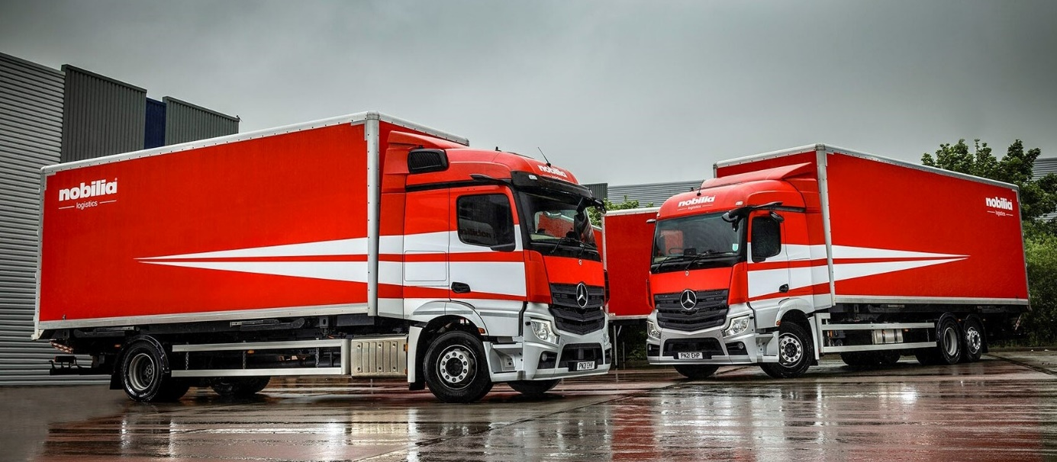

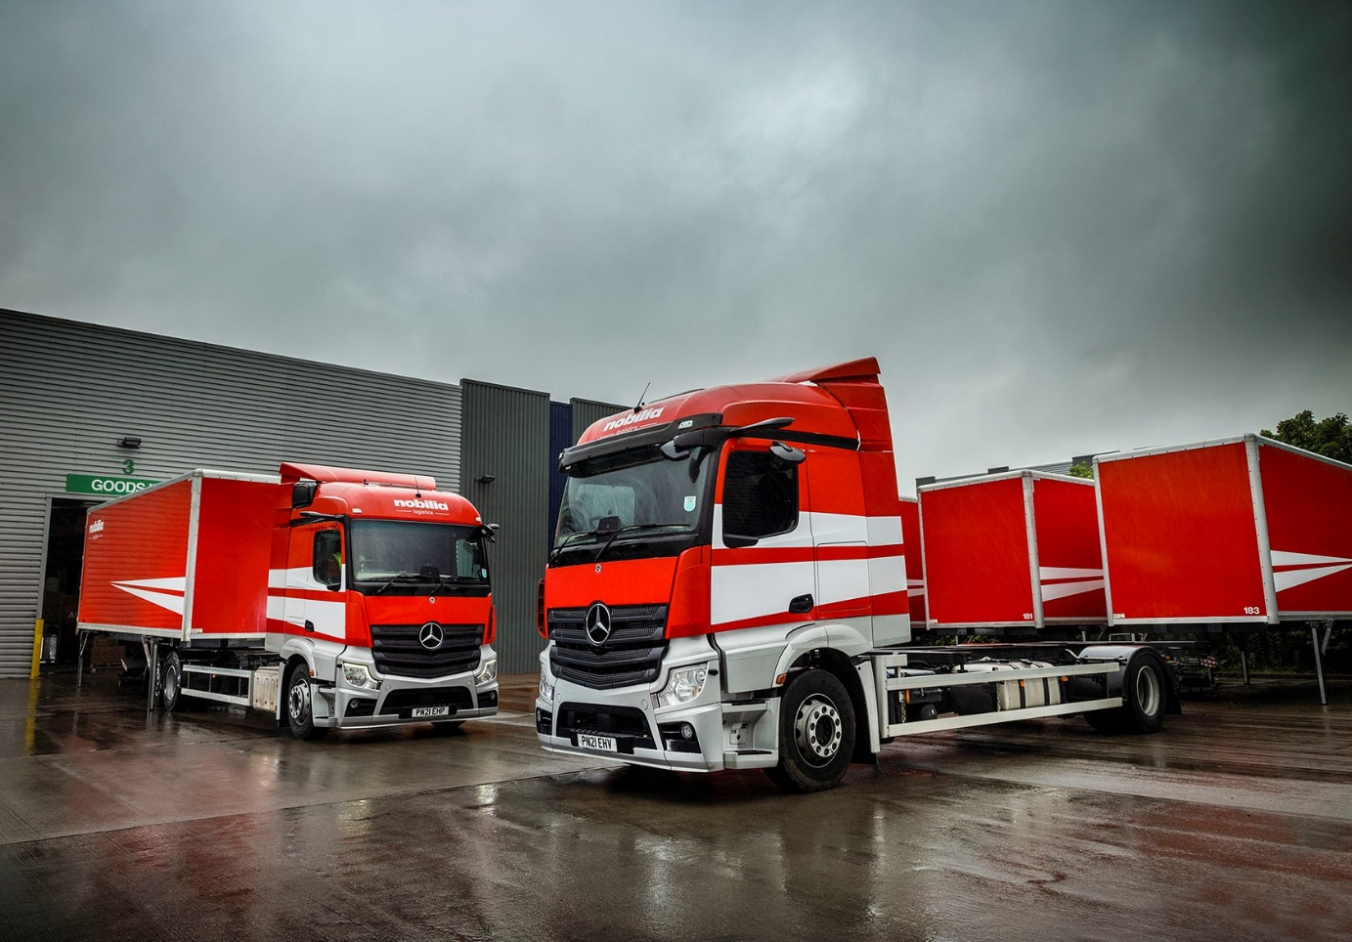

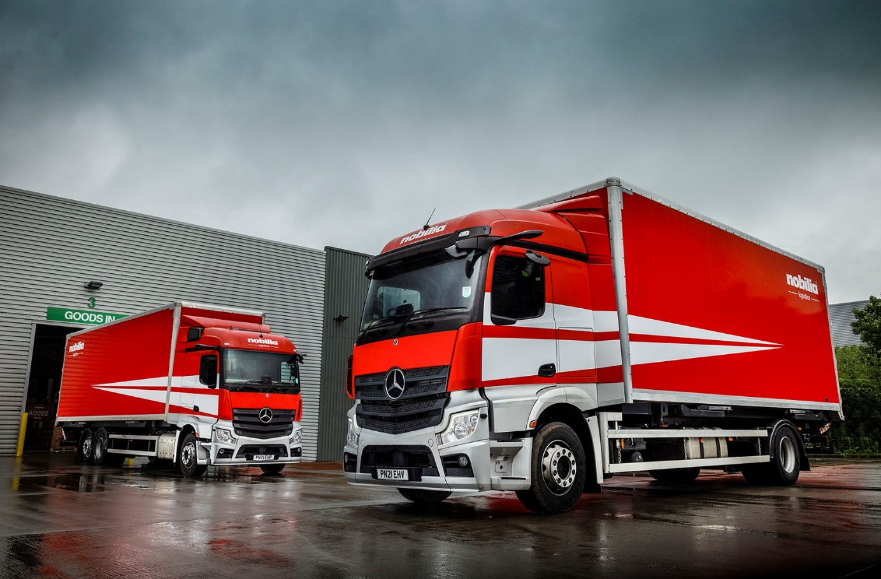

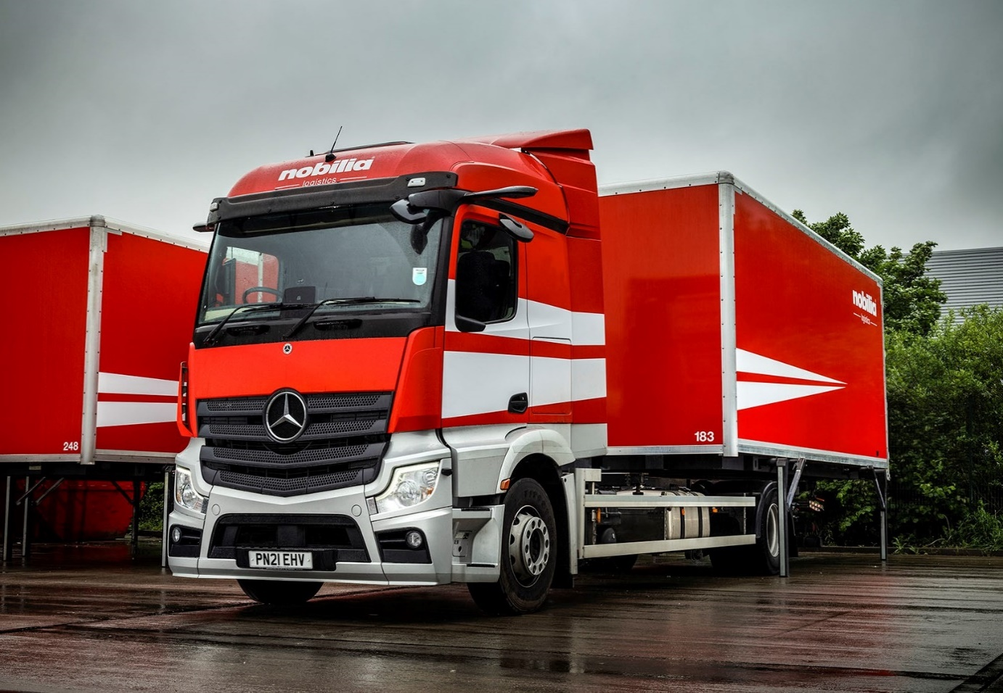

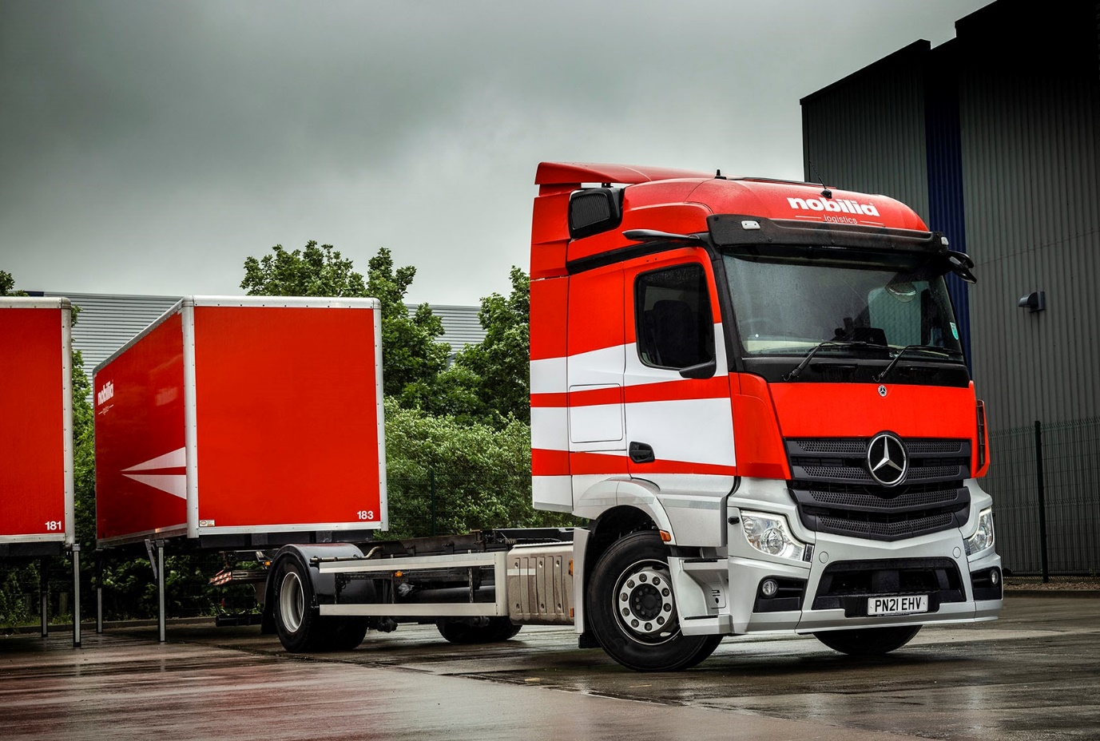

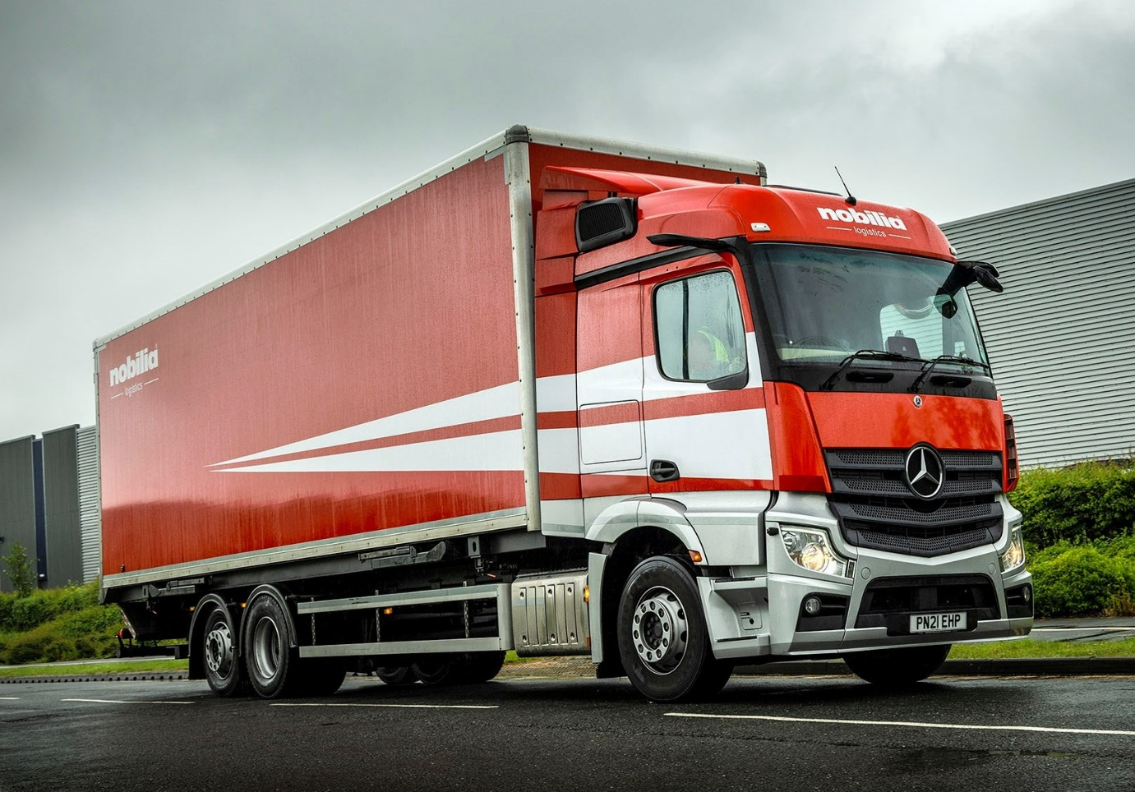

ends

For more information, or to request bigger/higher-res image files, please contact:
Steve Warren or John Ripley
Impact Communications
Steve: 07770 470251, steve@impactcom.co.uk
John: 07771 484595, john@impactcom.co.uk

