

Date: 4 May 2022

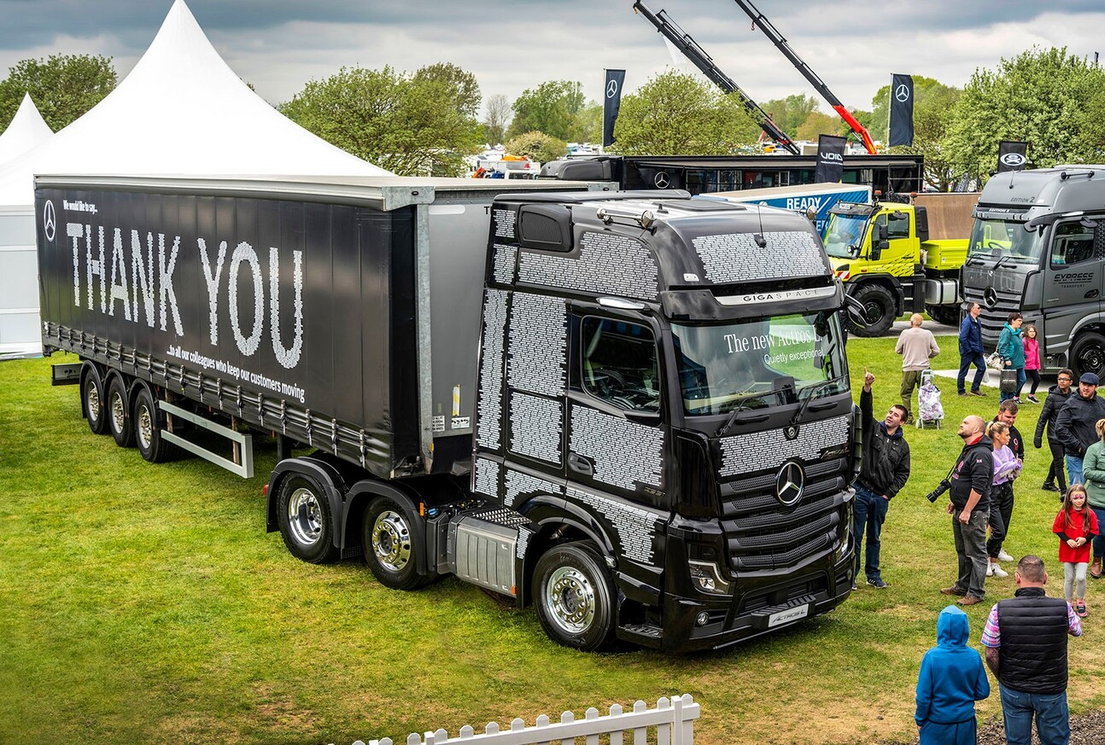

Mercedes-Benz turns up the Truckfest volume as ultra-quiet Actros L makes its UK debut

Mercedes-Benz Trucks made a triumphant return to the haulage industry’s biggest annual festival – and treated the Bank Holiday weekend crowds to a first glimpse of its latest, premium-specification tractor unit.

The stunning Actros L presented at Truckfest 2022 is finished in a special ‘Thank you’ livery commissioned by the manufacturer as a tribute to the 2,300 men and women who pulled together to keep customers moving during the pandemic. The GigaSpace tractor unit and its smart curtainside trailer bear the names of colleagues from across the Mercedes-Benz Trucks UK organisation and its franchised Dealer network.

Aimed at long-distance hauliers and those engaged in heavy-duty distribution, Actros L comes with a host of new features that deliver further improvements in efficiency, safety and comfort.

Key developments include even more sophisticated aerodynamics, quieter cabs with improved heat insulation, and a lower, more comfortable seating position that also provides improved visibility. High-intensity LED headlamps – as fitted to the vehicle showcased at Truckfest – are a new option.

The Actros L badge now applies to all four- and six-wheeled tractor units with single or double drive axles, and 18- and 26-tonne rigid chassis, that have flat-floored GigaSpace, BigSpace or Stream Space cabs in the wider (2.5m) of the two widths available.

Actros L comes as standard with a full complement of innovative Mercedes-Benz technology – MirrorCam, Active Brake Assist 5, the latest version of Predictive Powertrain Control and the Multimedia Cockpit – all of which is now well proven in operation. Tractor units in 4x2 and 6x2 tag axle configuration, and rigid models, can also be specified with Active Drive Assist, the first level 2 autonomous driving system to enter series production.

Other Actros highlights of the Mercedes-Benz Trucks presentation at the Peterborough Showground included exclusive Edition 2 and Edition 1 units in customer colours, and a line-up of four tractors representing each of the previous model generations introduced since the vehicle that tore up the rule book was first seen in 1996.

The manufacturer also underscored the breadth of today’s product offering by presenting examples from its current Arocs, Atego, Econic and Unimog ranges, as well as a FUSO Canter – like Mercedes-Benz, FUSO is part of the Daimler Truck family.

Elsewhere on the stand, Truckfest visitors thrilled to hair-raising performances from Olympic Team GB member James Jones and his fellow Action Sports Tour Freestyle BMX stunt riders, made badges and had their faces painted – children too! – in the Family Activity Marquee, and gave their feet a well-earned rest by chilling out in the Mercedes-Benz Certified Used Trucks Picnic Area.

“It was great to be back at Truckfest, and to share our passion for this industry with the thousands of fellow enthusiasts who visited our stand on each of the three days,” declared Alex Reilly, Head of Marketing at Mercedes-Benz Trucks UK.

“Actros L was a highlight, of course. This fantastic new model combines previously unseen levels of efficiency with a more relaxed driving and living experience, and it certainly impressed many of the drivers who seized the opportunity to climb aboard.”

Alex continued: “Mercedes-Benz Trucks has long been a supporter of Truckfest and our return to this brilliant event represented another very welcome step on the road to recovery after the pandemic. However, while we now have our sights fixed firmly on the future, it’s also important that we don’t forget what everyone has been through.

“That’s why we’ve taken the opportunity presented by the introduction of the Actros L to thank colleagues across all parts of our business for the parts they played in remaining open so the trucks operated by our heroic customers could continue to keep goods moving during lockdowns.”

The specially-liveried tractor unit and trailer combination has now embarked on a tour, during which it will be delivering ‘Thank you’ gifts to team members at Mercedes-Benz Truck Dealerships nationwide.

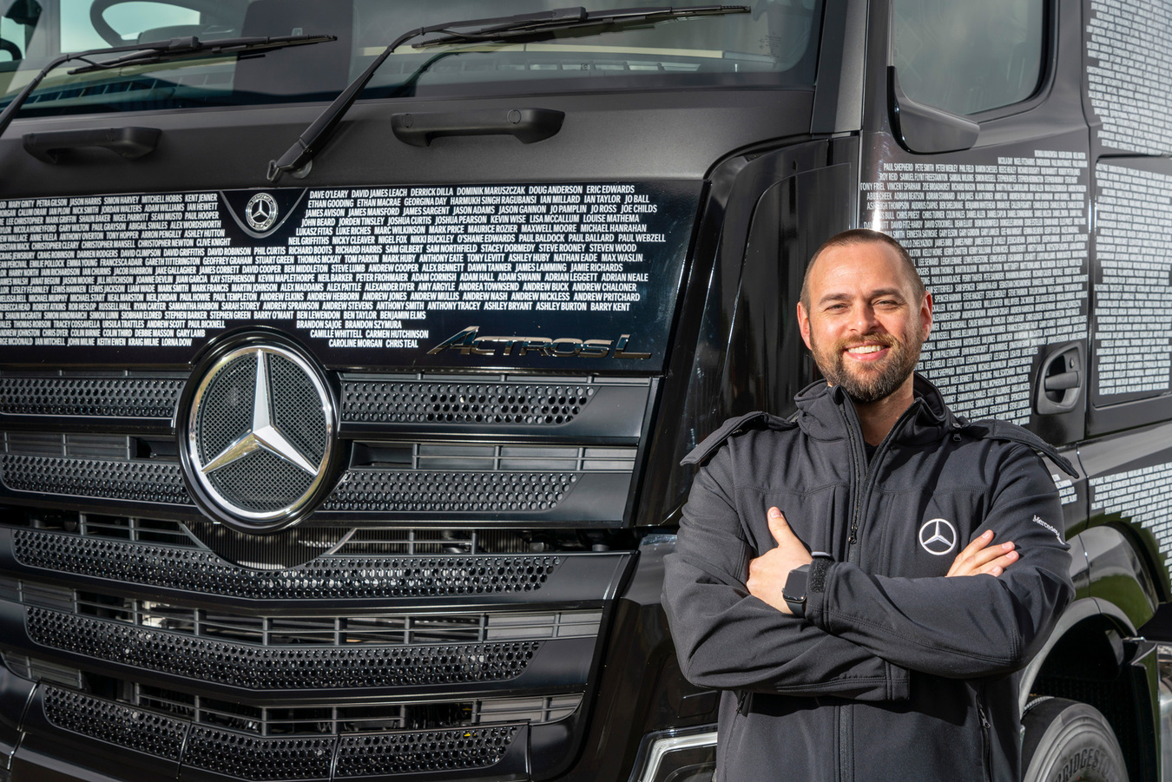

Welcome return: “It was great to be back at Truckfest,” declared Alex Reilly, Head of Marketing at Mercedes-Benz Trucks UK

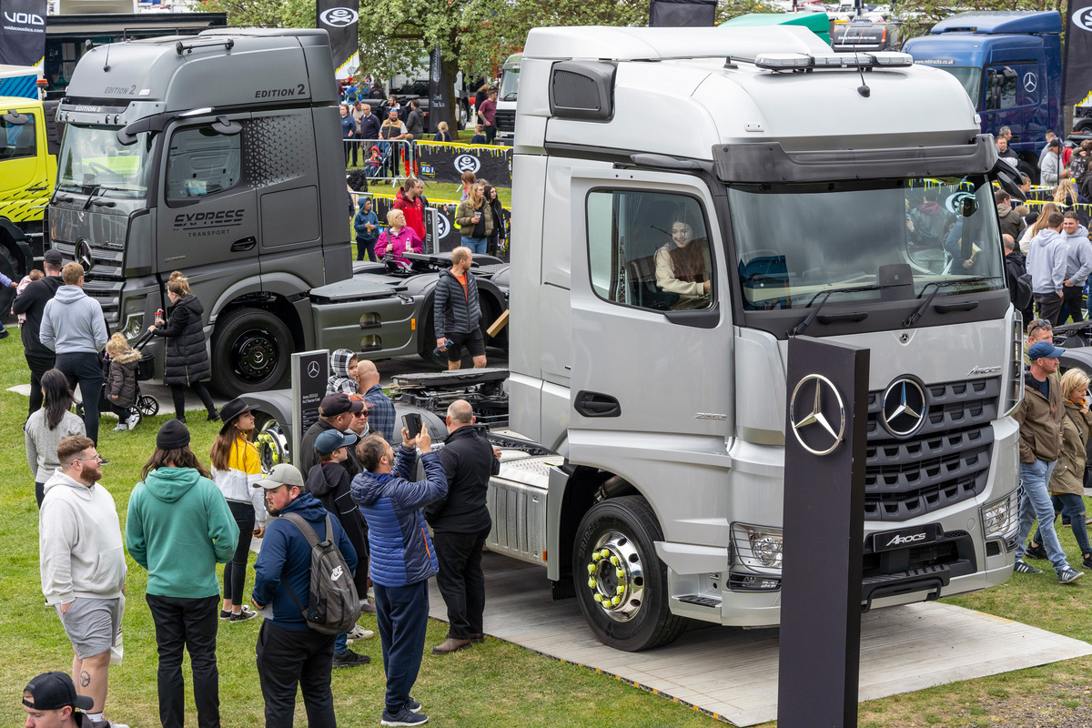

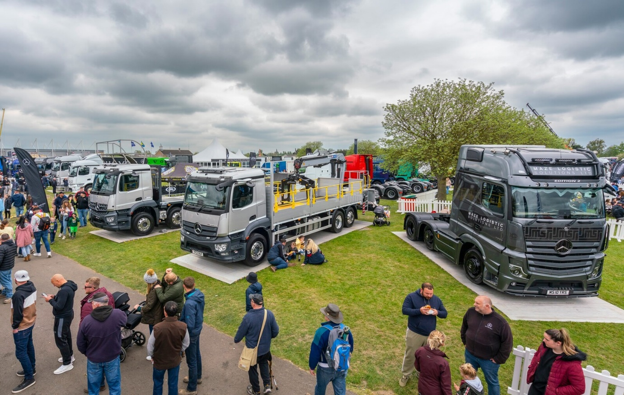

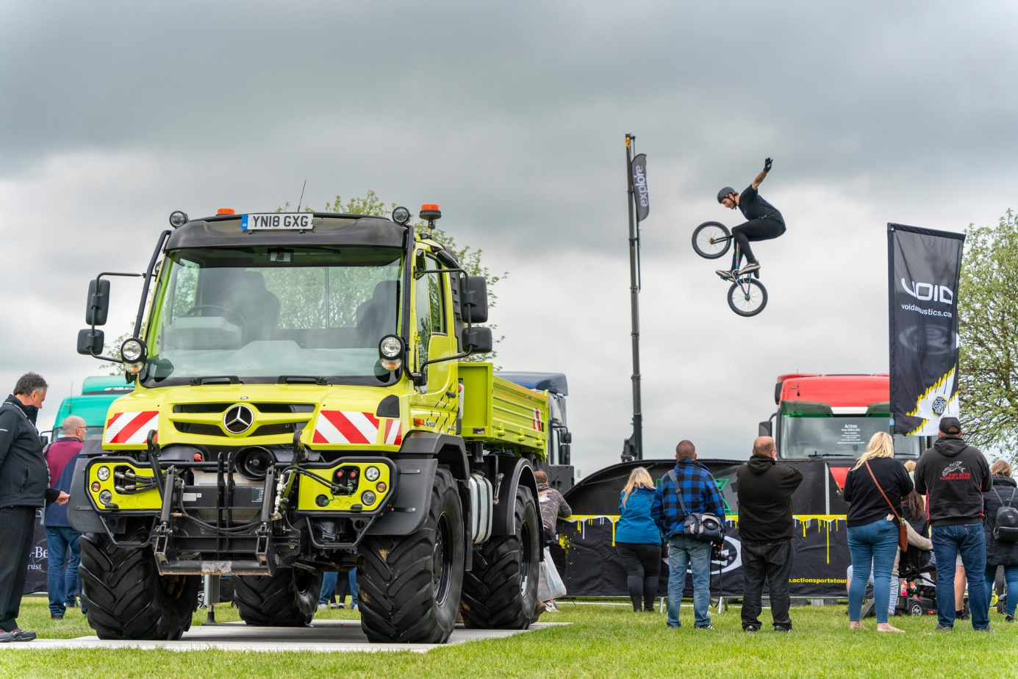

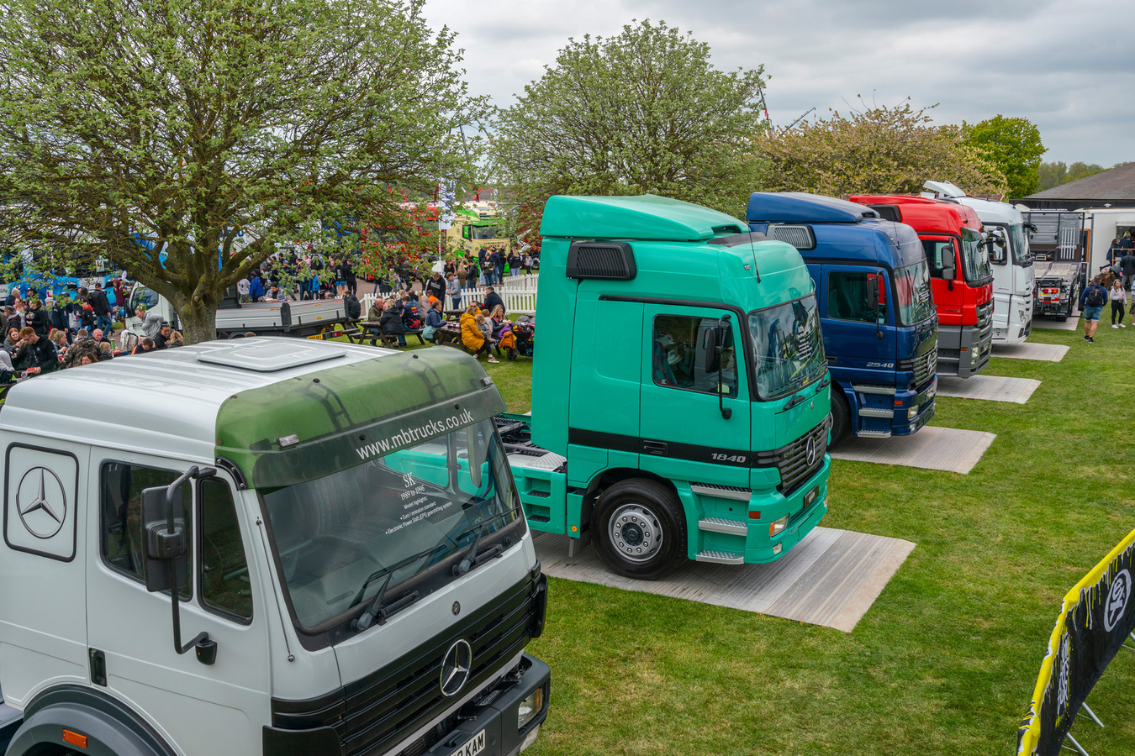

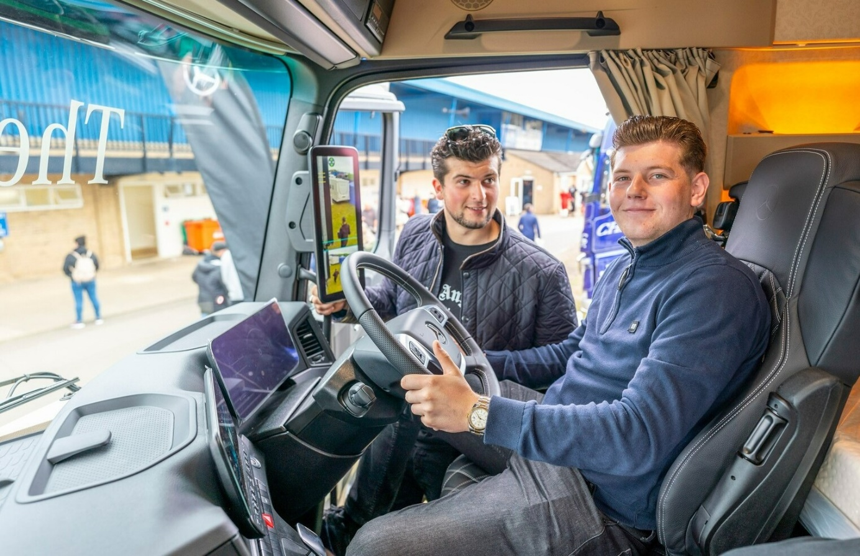

Wheel appeal: Among those taking a seat in the Actros L at Truckfest was Freddy Barr, right, a Director of Telford-based caravan business FB Static Sales. The proud owner of a beautifully finished, low-framed 4x2 Actros tractor unit from 2013, Freddy was visiting the show with his brother Jason, and spoke for many: “Wow! What a fantastic truck. Not too much has changed from the outside and that’s a good thing, but the interior is amazing, it’s on a whole new level. I want one.”

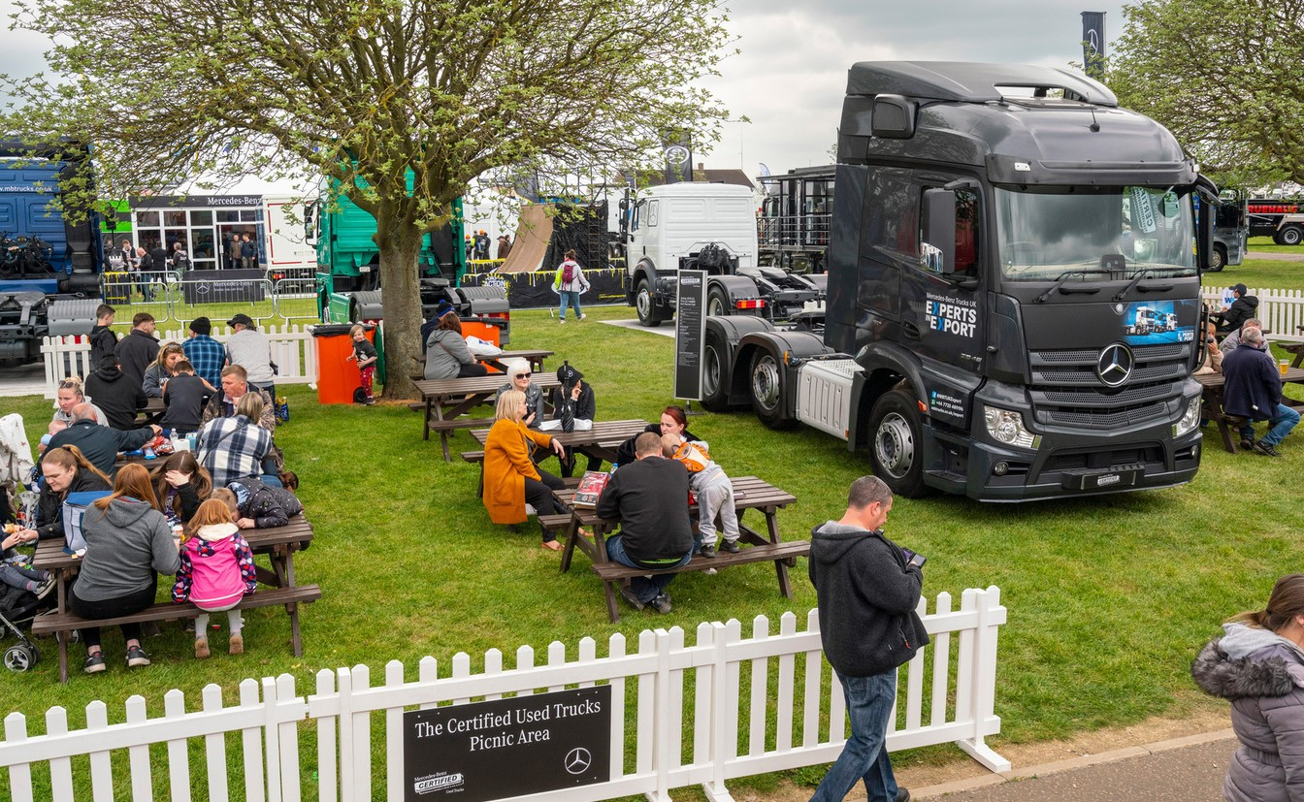

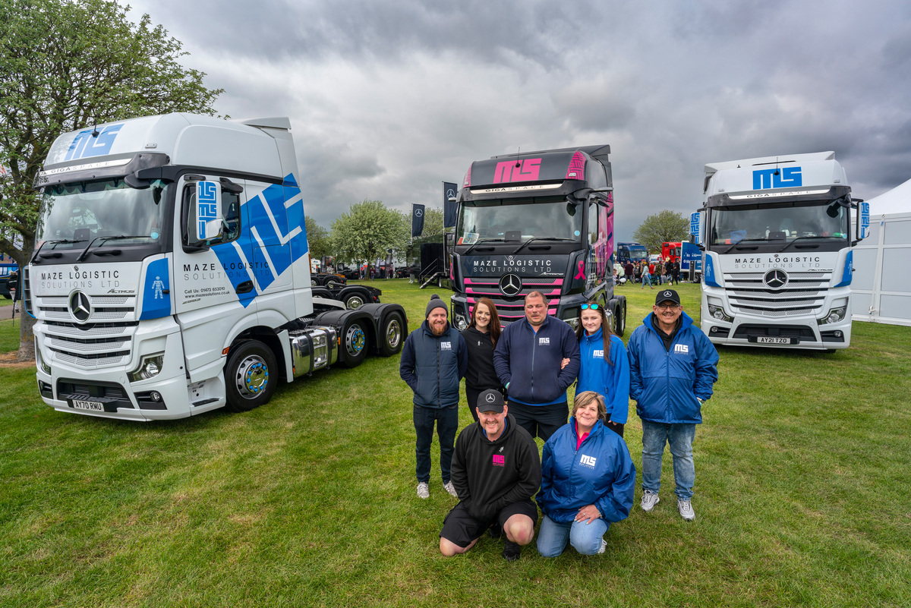

Time out: The team from Maze Logistic Solutions had no difficulty in finding their way to Truckfest; the Ipswich-based operator’s awesome Actros Edition 2 also made an appearance on the Mercedes-Benz Trucks stand

ends

For more information, or to request higher-res image files, please contact:

Jamie Fretwell at Mercedes-Benz Trucks UK Ltd
07712 519230, jamie.fretwell@daimler.com

or

Steve Warren or John Ripley
Impact Communications
Steve: 07770 470251, steve@impactcom.co.uk
John: 07771 484595, john@impactcom.co.uk

