

Date: 18 October 2022

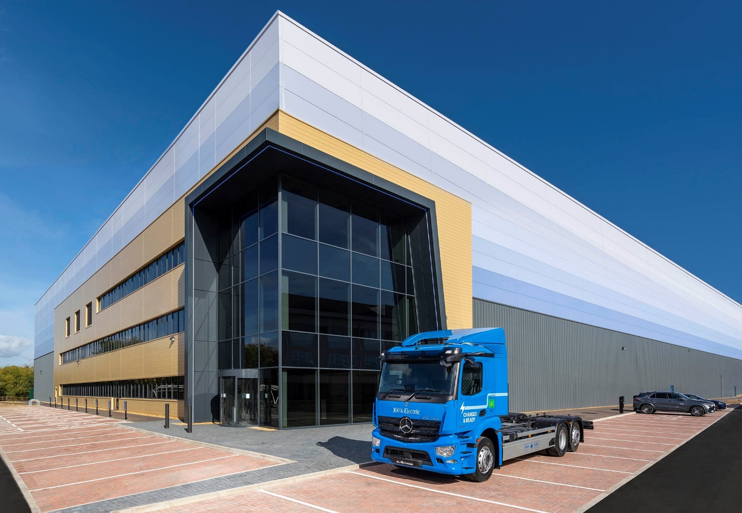

Mercedes-Benz Trucks UK future-proofs its Parts business with state-of-the-art, dedicated distribution hub

Customers can look forward to even slicker, more efficient aftersales support when deliveries from Mercedes-Benz Trucks UK’s impressive new Parts Logistics Centre commence on 3 January.

The facility at Willen, Milton Keynes, will be operated by 3PL partner XPO Logistics, which has been responsible for transporting parts to Mercedes-Benz Dealers since 2020.
Crucially, while the established warehouse in nearby Tongwell is shared with Mercedes-Benz Passenger Cars and Mercedes-Benz Vans, the new hub will only hold parts for trucks bearing the three-pointed star and the three-diamonds badge of FUSO, another Daimler Truck brand.

The 140,000 sq ft facility offers approximately 20% more storage capacity for truck parts than is currently available, so will be able to hold deeper and wider stocks. More importantly, though, truck-dedication will allow Mercedes-Benz Trucks and XPO Logistics to manage the space more flexibly and respond more quickly to changing demand.

Sustainability is a top priority for Mercedes-Benz Trucks and the site chosen by XPO Logistics will contribute significantly to the manufacturer’s carbon reduction targets. The building has secured the highest possible 85% BREEAM (Building Research Establishment Environmental Assessment Method) rating – features include high ceiling clearance with natural light panels that reduce energy consumption and optimise working conditions, and a rain water collection system that feeds the washrooms in the office area. Solar charging infrastructure is also in place, in anticipation of the use in the near future of battery-electric eActros trucks for Dealer deliveries.

Heiko Selzam, Managing Director, Mercedes-Benz Trucks UK, commented: “Together with members of our Dealer network, we are committed to providing operators of Mercedes-Benz and FUSO trucks with the industry’s finest aftersales back-up. This fantastic new centre, coupled with the ground-breaking agreement we have reached with XPO Logistics, provides the perfect platform from which we will be able to provide our customers with the fast, efficient parts support they deserve.”

Dan Myers, Managing Director – UK and Ireland, XPO Logistics, added: “The three-pointed star is an iconic brand which stands for reliability and quality. Working in partnership on this new, state-of-the-art distribution centre, we will embed these essential characteristics in every aspect of the Mercedes-Benz Trucks operation.”

Fit-out of the new centre is now underway, with the first deliveries of parts from Germany due to arrive this week. Small and medium-sized parts will be held in a three-tier, pedestrian-accessible mezzanine system, with main racking used for larger and fast-moving parts. Automated conveyors will carry inbound parts to the mezzanine floors, and completed picks back down to outbound sortation.

Mercedes-Benz Trucks’ Head of Parts Logistics Philip Cross is supported by colleagues, Logistics Operations & Development Manager Gary Lee, Retail/Wholesale Systems Manager Georgina Beecher and Supply Chain & Inventory Manager Keri Marsh. They are already working closely with Glen Brotherton, Regional General Manager at XPO Logistics, whose team of approximately 35 operatives will pick and pack parts ready for delivery.

The centre will be open from 6am until 10pm Monday-Friday, with each Dealer receiving five deliveries per week. A 24-hour call out service for emergency VOR (‘vehicle off road’) cases will also be available.

It is the first time that Mercedes-Benz Trucks has entered into an outsourcing agreement of this kind. “Rather than just moving to a new warehouse, we’re effectively adopting an entirely new supply chain,” said Philip Cross. “As with so many industries, the automotive logistics aftermarket is becoming increasingly specialised, and given our focus on providing the best possible service to customers we felt this was the right move at the right time.”

Explaining the rationale behind its choice of partner, he continued: “XPO Logistics is already in a strong place within the sector and was able to cite persuasive examples of 3PL services it provides to other customers, rather than asking us to make a decision based simply on a sales ‘pitch’.

“Through its work on the transportation of parts from our current logistics centre, XPO is already familiar with our Dealer network. This means that any disruption can be kept to an absolute minimum when we commence operations from our new site in January. Finally, but no less importantly, Dan Myers and his colleagues were also very open to the exciting ideas we have for the future, once the new system is up and running.”

A working group comprising representatives of Mercedes-Benz Trucks and eight members of its franchised network has been engaged in development of the project. “We’ve been entirely open about what we’re doing and the feedback from the working group has been resoundingly positive,” reported Philip. “Dealers see it as a real breath of fresh air.”

In another departure from what has gone before, members of the manufacturer’s head office Parts Logistics team will be gaining first-hand experience in Dealerships. “We’ll now be spending time on the ‘front line’,” said Philip, “picking parts, driving vans… whatever it takes to get a better understanding of the business and the everyday issues that can arise, so we’re best placed to resolve them.”



Partnering on Parts: Mercedes-Benz Trucks Managing Director Heiko Selzam, left, and his XPO Logistics counterpart Dan Myers






Site visit: Dan Myers, Managing Director, XPO Logistics, is pictured, second from right, with Mercedes-Benz Trucks colleagues Can Balaban, Customer Services & Parts Director, right; Philip Cross, Head of Parts Logistics, centre; Gary Lee, Logistics Operations & Development Manager; and Georgina Beecher, Retail/Wholesale Systems Manager



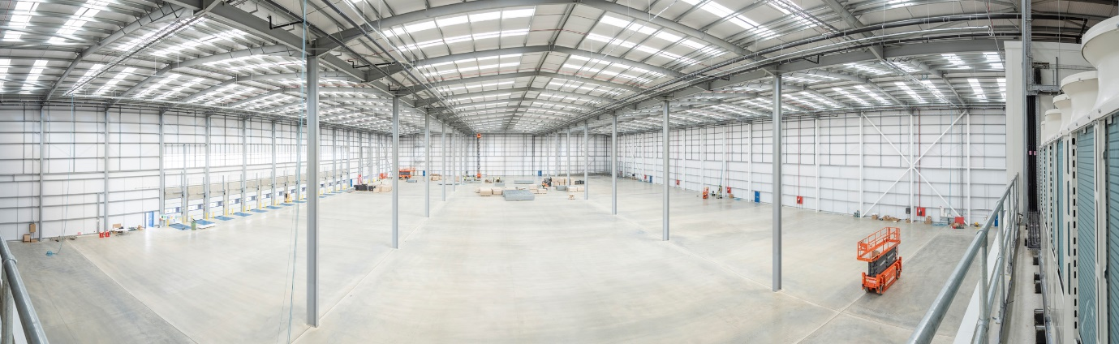



For more information, please contact:

Jamie Fretwell at Mercedes-Benz Trucks UK Ltd
07712 519230, jamie.fretwell@daimler.com

or

Steve Warren or John Ripley
Impact Communications
Steve: 07770 470251, steve@impactcom.co.uk
John: 07771 484595, john@impactcom.co.uk

About XPO Logistics:
XPO Logistics, Inc. (NYSE: XPO) is a leading provider of freight transportation services, primarily less-than-truckload (LTL) and truck brokerage. XPO uses its proprietary technology, including the cutting-edge XPO Connect® automated freight marketplace, to move goods efficiently through supply chains. The company’s global network serves 50,000 shippers with approximately 749 locations and 43,000 employees, and is headquartered in Greenwich, Conn., USA. Visit xpo.com and europe.xpo.com for more information, and connect with XPO on Facebook, Twitter, LinkedIn, Instagram and YouTube.

