

Date: 6 August 2023

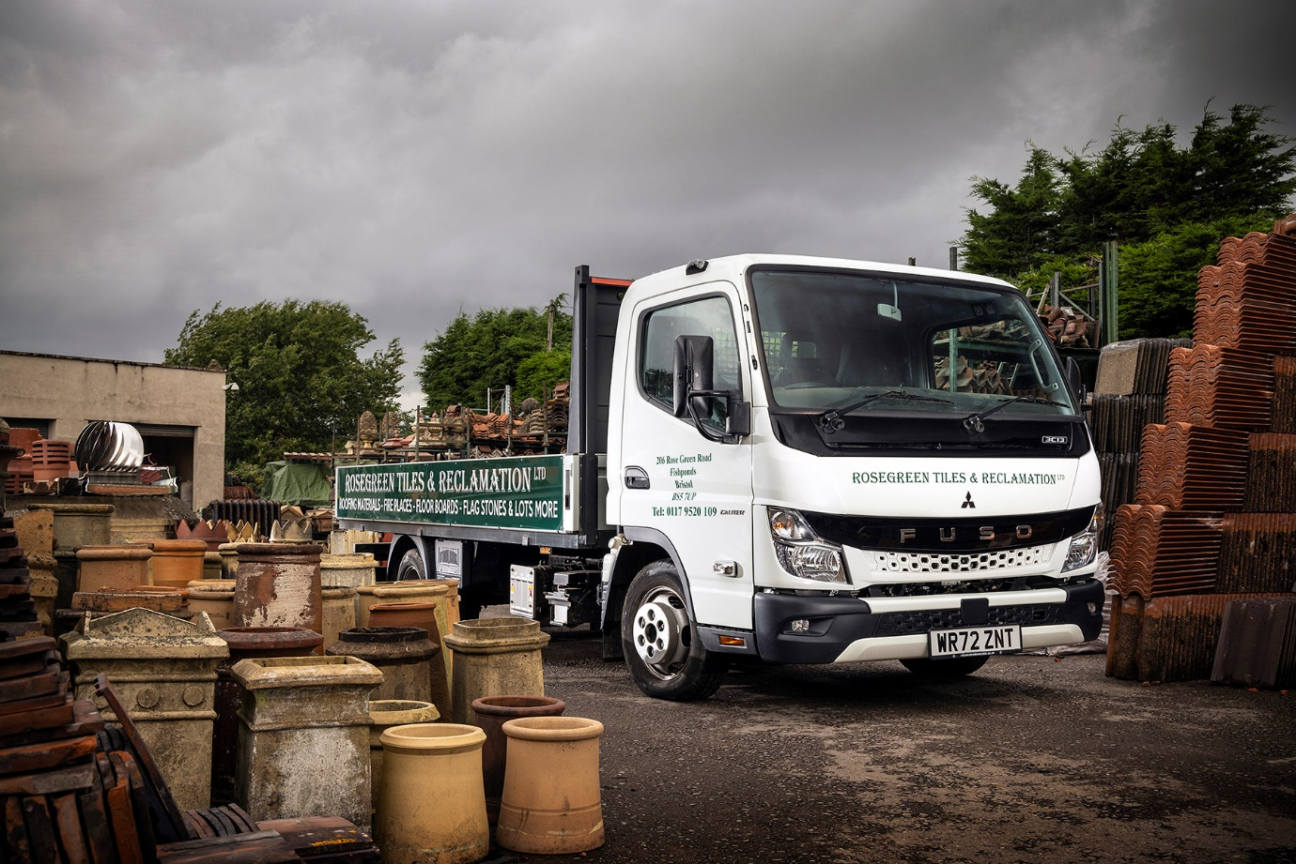

FUSO Canter repeats a pattern of proven reliability for Rose Green Tiles

With a 20-year track record of trouble-free performance from a series of FUSO Canters, Bristol-based Rose Green Tiles & Reclamation only had one vehicle in mind when choosing a new truck.

The company’s new Canter is a 3.5-tonne 3C13 model, supplied – like all its FUSO vehicles since 2007 – by local Dealer City West Commercials.

“We’ve had three 3.5-tonne Canters and a couple of 7.5-tonne variants, with cranes, in the last 20 years,” said proprietor Gerald Selway. “They’ve never let us down. Not once have we had a breakdown, which means that apart from routine maintenance they’ve never been off the road.

“That kind of reliability is invaluable. We work with a lot of people in the building trade, who run all sorts of vehicles, but I’ve never seen one that I’d swap for a Canter.”

Rose Green Tiles specialises in buying and selling a range of traditional and historic construction materials – including tiles and flagstones, chimney-pots, timber, stained glass, and doors – as well as sought-after items like fireplaces and surrounds, or garden statues and planters.

The company collects and delivers across an area covering Bristol, Bath and surrounding towns and villages, to customers including builders, developers and enthusiastic DIY home renovators.

Its new Canter has a Comfort cab and 3,400 mm wheelbase – one of six lengths available – and was fitted with a Scattolini aluminium platform body at the FUSO factory in Tramagal, Portugal.

Power comes from a well-proven, fuel-efficient 3.0-litre turbodiesel engine that produces 96 kW (130 hp) and 350 Nm of torque. The compact exhaust system means the vehicle also meets the EURO VI – STEP E emission standard.

This point was a crucial attraction for Mr Selway – his previous 3.5-tonne Canter, which was built in 2016 to the then-current Euro V standard, would have been subject to a charge every time it entered the Bristol Clean Air Zone which came into force in November last year.

“Honestly, I would have kept that old truck for longer but we did not want to be paying the charge or dealing with all the admin it would involve, so now seemed like the right time to change,” he said. “We make a lot of runs into and out of Bristol so the ability to do so without concern is a real boon.

“The Canter is ideal for this sort of work too. Its compact design and cab-over-engine layout makes it very nimble. It turns on a sixpence, even with a 14-foot body, which makes negotiating the narrow streets of areas like Clifton much easier.”

He had praise for Dealer City West Commercials too. “Sales Executive Matt Gray knows our business and understands what we need, and made sure this vehicle was delivered without any delays. I’m delighted with the whole package.”

salvage-and-reclamation-yards.co.uk
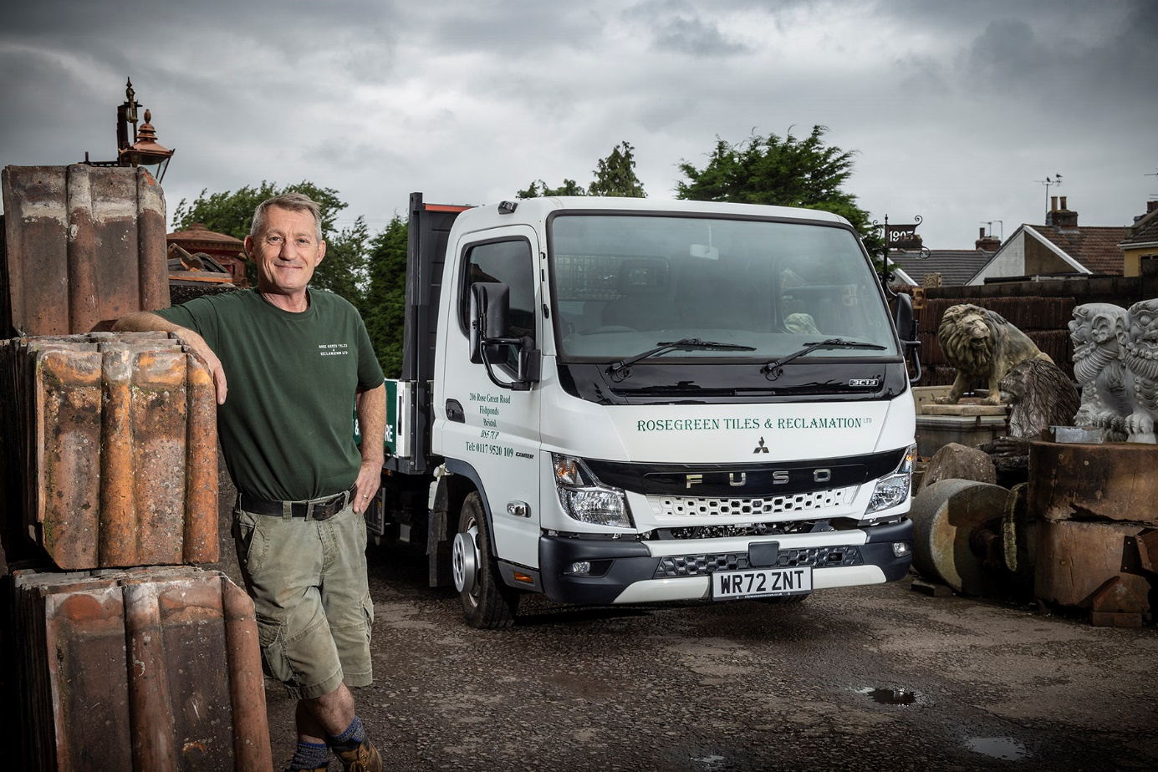

On the tiles: Gerald Selway is delighted with his Euro VI FUSO Canter

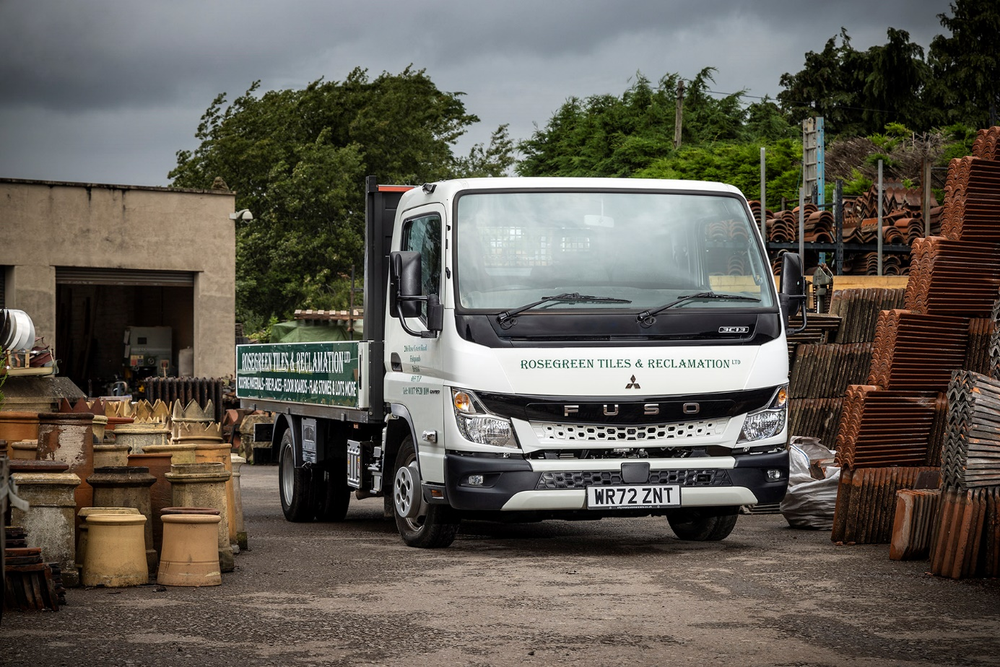

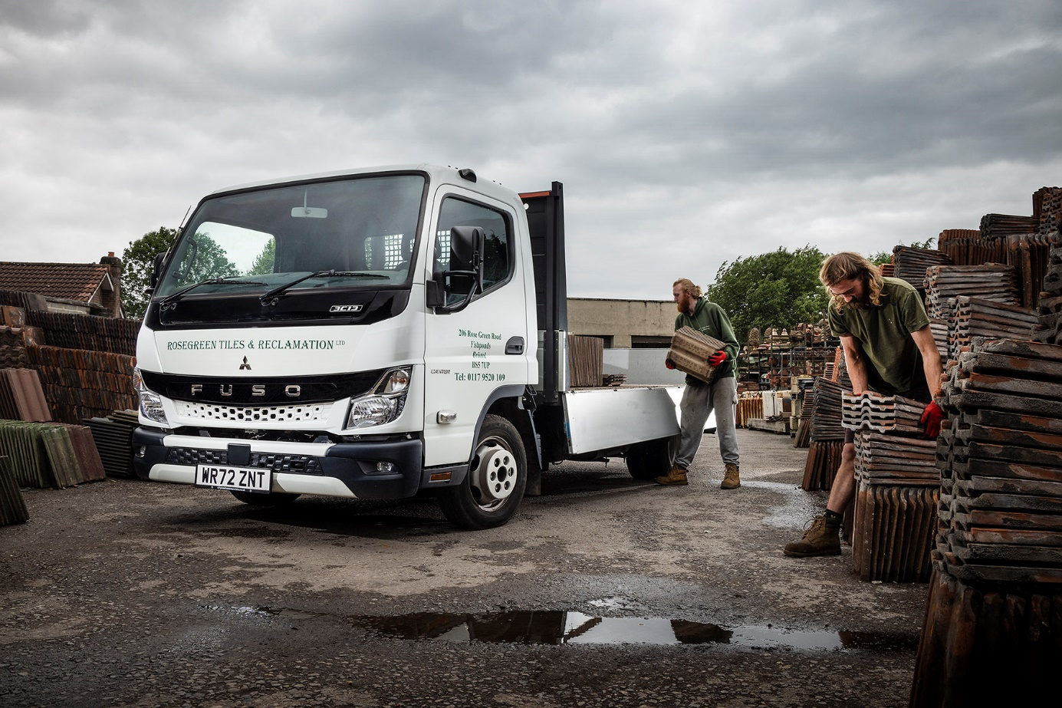

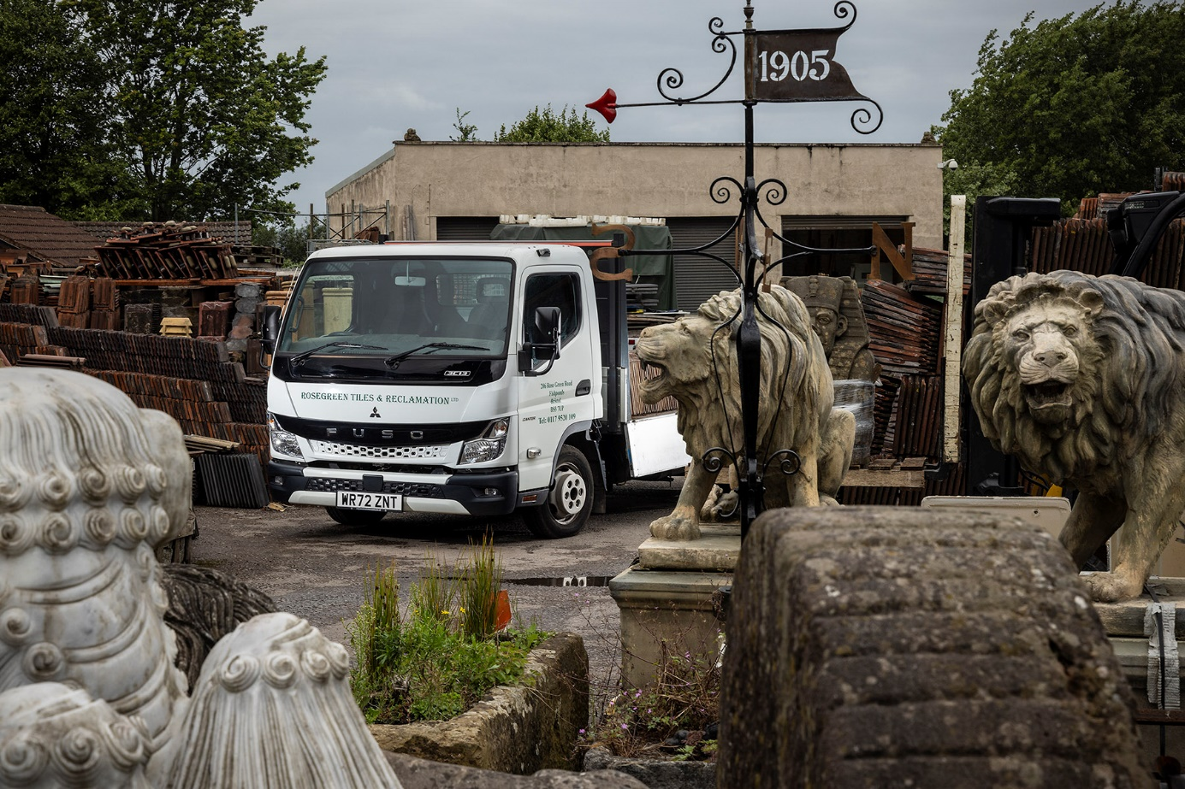

ends

For more information, or to request bigger/higher-res image files, please contact:
John Ripley: 07771 484595, john.ripley@loopagency.co.uk



