

Date: 15 March 2021

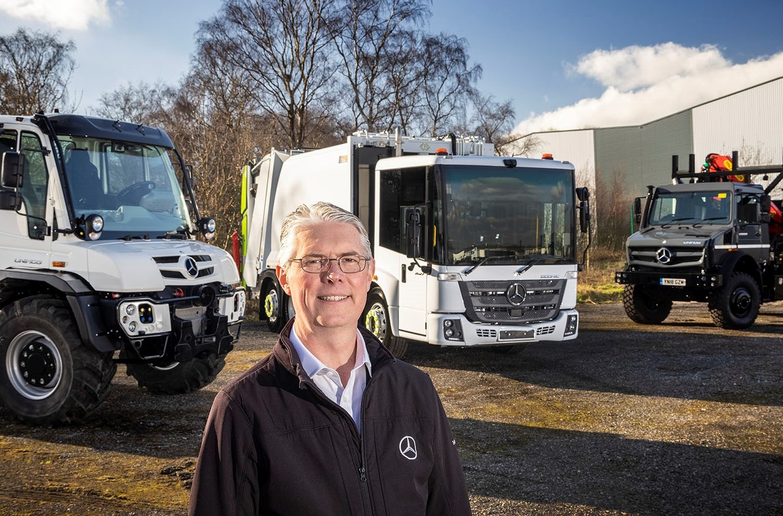

Exciting opportunity: Ross Paterson leads the new Mercedes-Benz Special Trucks team

Econic customers stand to benefit as Mercedes-Benz broadens the scope of its Special Trucks operation

Customers for Mercedes-Benz Econic truck models can look forward to more sharply focused sales support from the manufacturer following a strategic reorganisation at its head office.

Whereas fleet sales of the Econic were previously part of the remit of Mercedes-Benz Trucks UK’s Key Account Management department, responsibility for the product has now been transferred to an expanded Special Trucks team.

The new arrangement mirrors the situation in Germany and better reflects the technical expertise of the team dedicated to providing consultative support to Dealers and operators of the low-entry chassis, which continues to attract new converts due not least to its market-leading safety features.

Simultaneously, a high-level ‘job swap’ has seen former Head of Product & Marketing Ross Paterson take up the position of Head of Special Trucks, while Katie Purcell has moved in the opposite direction.

Special Trucks continues to manage customer and Dealer relationships relating to Unimog variants – for operators of the uniquely capable 4x4 Mercedes-Benz chassis, it is very much ‘business as usual’.

However, in another new development, Special Trucks will also be spearheading the introduction to the UK market of fully electric Mercedes-Benz truck models that produce zero tailpipe emissions.

Waste collection typically entails low overall mileages but relatively high diesel consumption due to the stop-start nature of the work and the energy-intensive body. This sector is therefore expected to be one of the first for which electric vehicles become the norm.

Mercedes-Benz Trucks’ Municipal Sales & Special Application Managers Philip Chance, Ian Bryan and Phil Oakey are now working alongside Dealers to provide consultative support for customers selecting all variants of the Econic.

A byword for ‘five star’ excellence when it comes to Direct Vision, the Econic is also now fitted as standard with the latest Active Brake Assist 5 emergency braking technology, which incorporates enhanced pedestrian recognition and automatic response capability, as well as an Electronic Parking Brake.

Ross Paterson commented: “The decision to bring Econic under the Special Trucks ‘umbrella’ will help us to give this important vehicle the heightened sales focus it deserves.

“Our Municipal Sales & Special Application Managers are more technically orientated than the average truck sales specialist. Given the nature of the product, and the fact that the bodywork with which these chassis are fitted typically represents a very substantial capital investment, this is entirely appropriate. It’s imperative we offer the sales support that customers and our Dealers can rely on to ensure vehicles are 100% suited to their requirements.”

Ross began his career as a 16-year-old apprentice technician with the former Mercedes-Benz truck and van franchisee in Northampton. Over the next nine years he rose to become workshop foreman before leaving in 1997 to join Mercedes-Benz in a technical support role.

Stints as a key account manager in aftersales and then sales followed, before he became Head of Product & Marketing in 2017. Of his latest position Ross said: “This is a very exciting time to be pulling together some of the expertise that exists within our business, refocusing and re-engaging to ensure that we’re making maximum use of the know-how and compatibilities within the team.

“There are huge opportunities to grow our sales of specialised trucks, both now and in the not-too-distant future, as our electric Mercedes-Benz offering starts to come through. Special Trucks is what we’re called, because special is what they are, and that’s a huge source of pride to me and my colleagues.”

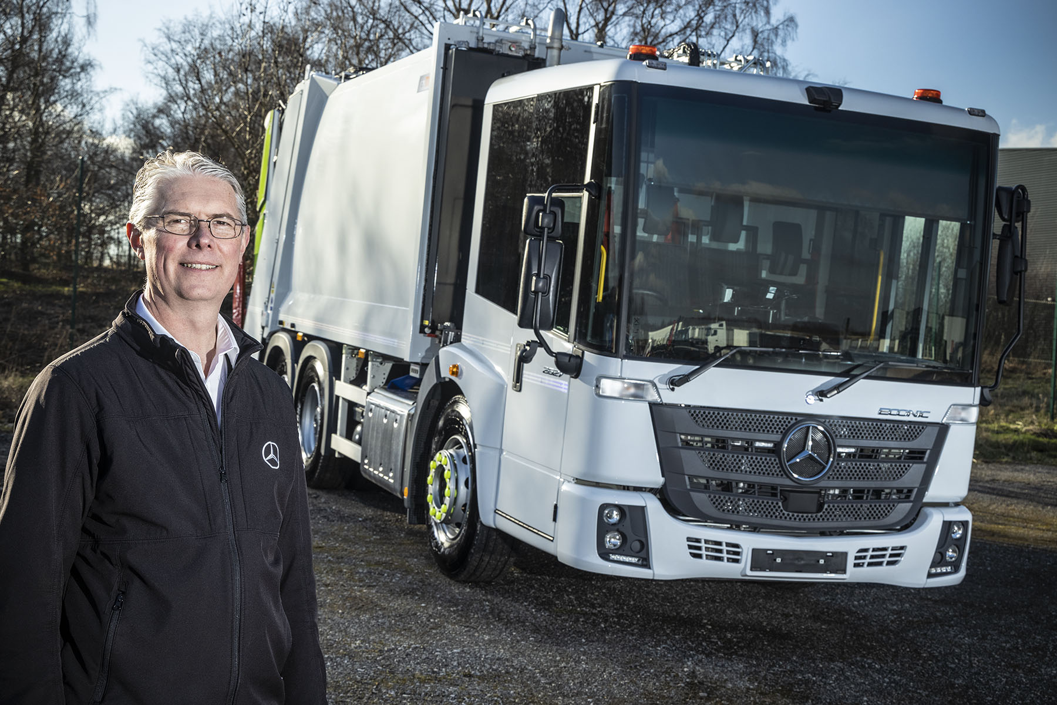

Going for growth: The Econic is already the low-entry chassis of choice for many municipal and other operators, but Ross Paterson believes there remain huge opportunities to convert new customers to diesel-engined versions before mainstream adoption of their electric successors

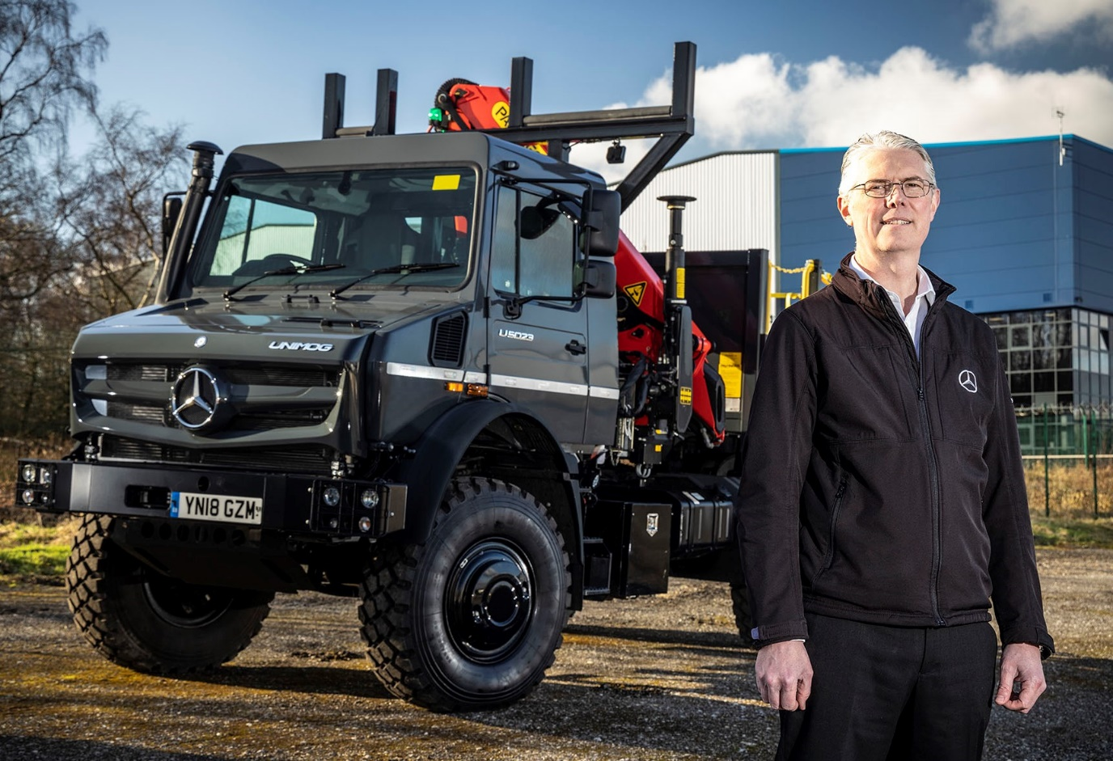

Gaining traction: As Head of Special Trucks Ross Paterson is also responsible for sales and support through the Dealer network of the Mercedes-Benz Unimog, an all-terrain vehicle with an unrivalled range of abilities

For more information, or to request higher-res image files, please contact:

Jamie Fretwell at Mercedes-Benz Trucks UK Ltd
07712 519230, jamie.fretwell@daimler.com

or

Steve Warren or John Ripley
Impact Communications, 01926 842126
Steve: 07770 470251, steve@impactcom.co.uk
John: 07771 484595, john@impactcom.co.uk

About Mercedes-Benz Trucks UK Ltd
Mercedes-Benz Trucks UK Ltd is the sales and marketing organisation responsible for all Daimler truck products in the UK, including FUSO Canter. In 2019, the company registered 6,963 new trucks. Mercedes-Benz accounted for 6,188 new trucks registered in 2019, making it the third-biggest truck brand in the UK. Meanwhile, FUSO registrations hit 775 – including 580 new trucks over 6.0-tonnes. The flagship new Mercedes-Benz Actros which won the 2020 International Truck of the Year award, features seven core innovations including MirrorCam, Multimedia Cockpit and Active Brake Assist 5. Our premium range of innovative trucks – Actros, Arocs, Atego, Econic and Unimog – draw upon more than 125 years of exceptionally high standards of quality, backed up by our promise of Trucks You Can Trust.
www.mbtrucks.co.uk

