

Date: 30 January 2024

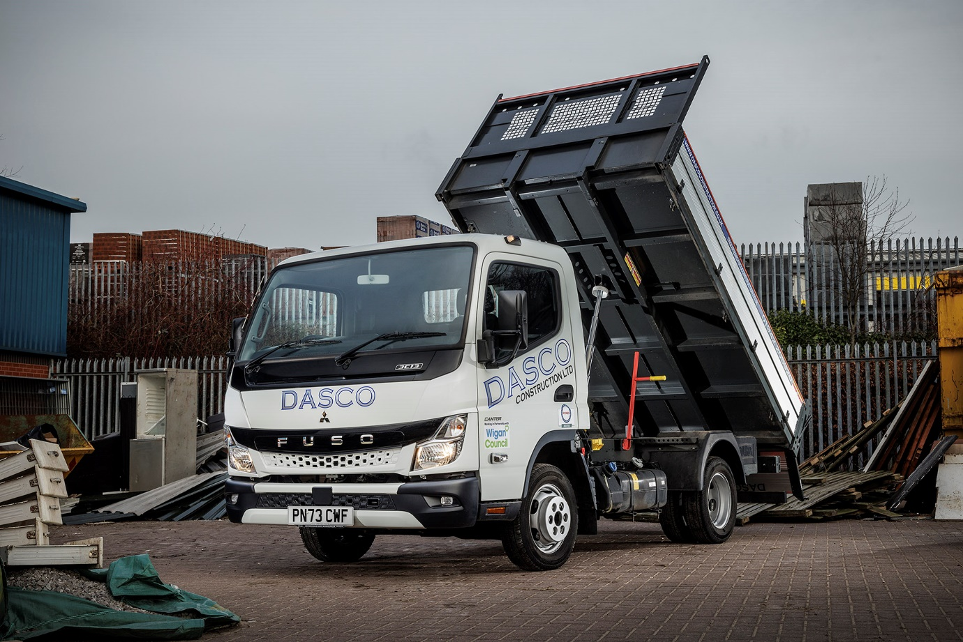

Dasco Construction builds for the future with tough FUSO Canter tippers

When Dasco Construction wanted ‘proper little trucks’ to replace less robust van-based vehicles, the FUSO Canter stood up to the task.

Wigan-based Dasco initially took two Canters then returned with an order for a further three, which were delivered just before Christmas – all were supplied by the Bolton outlet of Dealer Ciceley Commercials.

Dasco Construction will celebrate its tenth anniversary in business this year. In that time its operation has grown rapidly, and the company now runs a fleet of more than 75 small tippers, vans and pickups.

In the past it has chosen van-derived chassis but, said Chairman and founder David Rothwell, this time there was an appetite for something stronger.

“Van conversions are all very well but as time has gone on, and the size of our jobs and the distances we travel has grown, it’s become clear that we need vehicles that are built to deal with a tougher working life,” he said. “The FUSO Canter is a ‘proper truck’ with a rugged ladder-frame chassis, and fits that bill perfectly.

“The cab-over-engine design suits our requirements well too,” he continued. “It allows for a very tight turning circle, which is a big advantage on building sites and in busy town centres, and there’s easy access for any maintenance.”

Dasco’s Canters are all 3.5-tonne 3C13 models, with Comfort cab and 2,500 mm wheelbases – one of six lengths available – and were fitted with Scattolini aluminium tipping bodies at the FUSO factory in Tramagal, Portugal.

Power comes from well-proven, fuel-efficient 3.0-litre turbodiesel engines each producing 96 kW (130 hp) and 350 Nm of torque. The compact exhaust system means the vehicles also meet the EURO VI – STEP E emission standard.

“Although these are our first Canters they’ve already proved themselves to be ideal for the job, while we’ve also been impressed with the professional approach of Sales Executive Simon Fletcher and his colleagues at Ciceley Commercials – it’s very obvious that they’re commercial vehicle specialists who understand the needs of a business like ours. It’s also nice to be able to deal with a supplier who, like us, has strong local family roots,” Mr Rothwell added.

Dasco Construction was established by David Rothwell and his late wife in 2014. Although still actively involved, he has handed over day-to-day running of the company to the next generation – son Scott is now Managing Director, while daughters Charlotte and Colette are Accounts Manager and Contracts Co-ordinator, respectively. The family’s pet dogs Roxy and Ralph look after yard security!

Much of the company’s workload involves carrying out planned and reactive maintenance for social housing providers across the North-West, and undertaking everything from groundworks to station facility construction for the Trans-Pennine Route Upgrade rail infrastructure project.

Dasco is also proud of its Wigan origins and is an enthusiastic supporter of worthy community causes. As well as providing employment for 80 local people – all of whom live and spend their money in the area – the company is a Gold Patron of the Wigan Youth Zone activity centre and has pledged to support the charity with £12,000 per year for the next three years.

dascoconstruction.co.uk

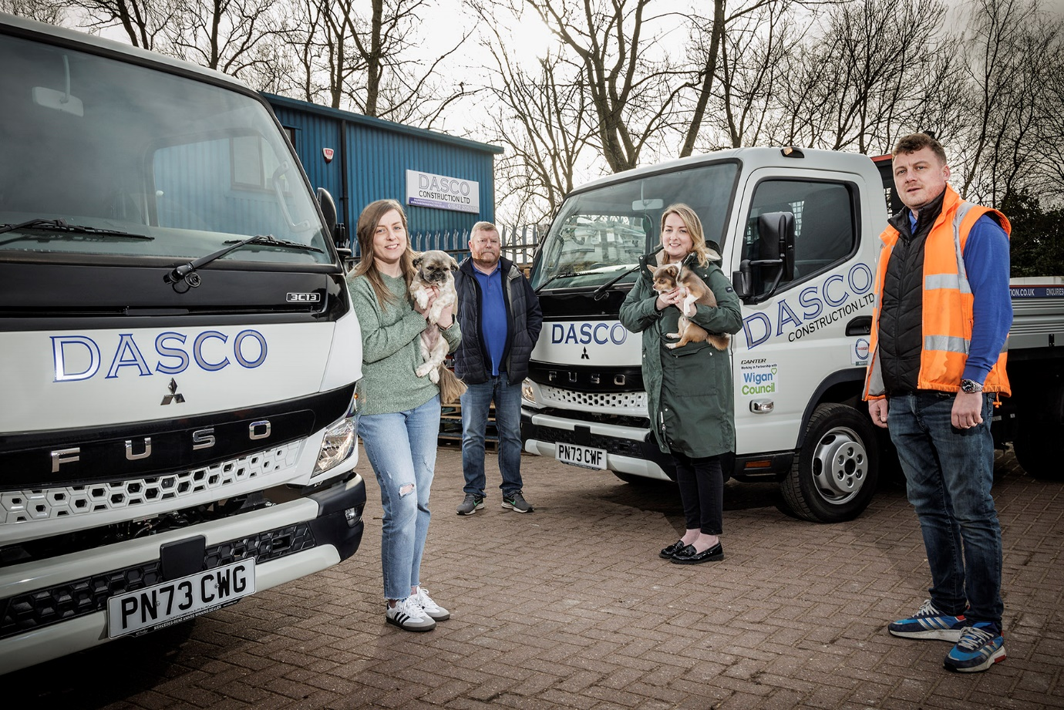

Relative values: The Rothwell family – from left, Charlotte, David, Colette and Scott with two of their new FUSO Canters, and guard dogs Roxy and Ralph!

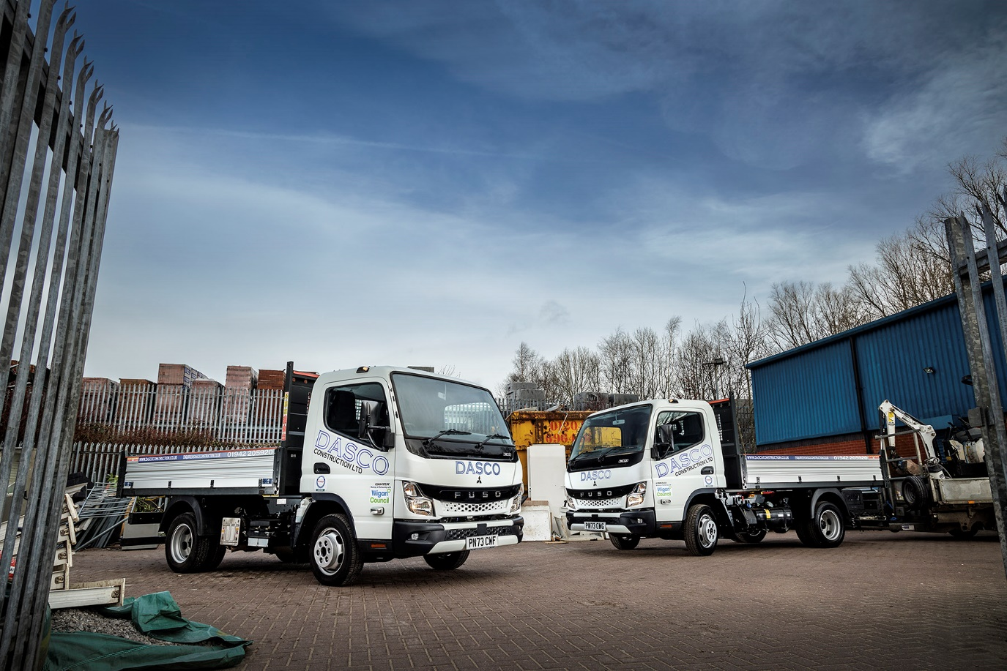

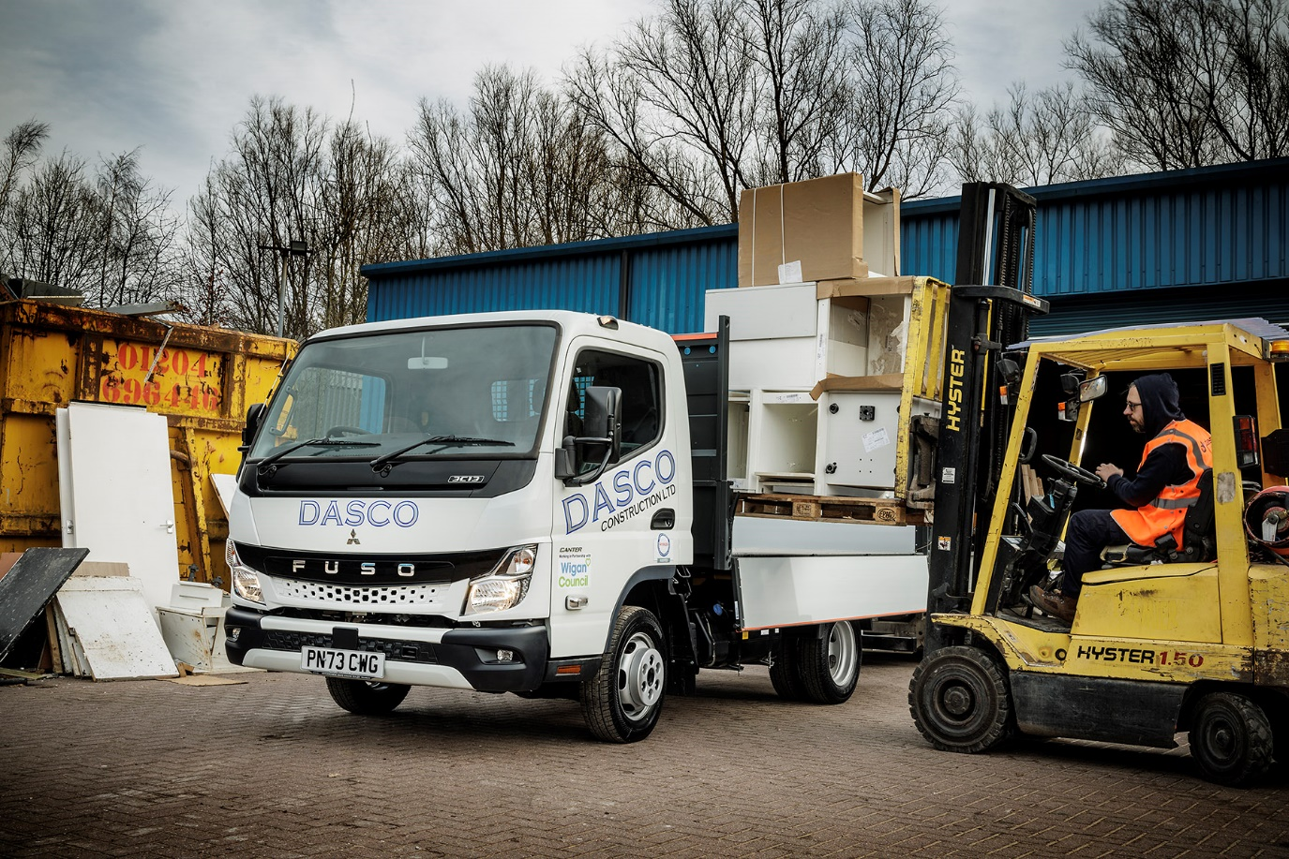

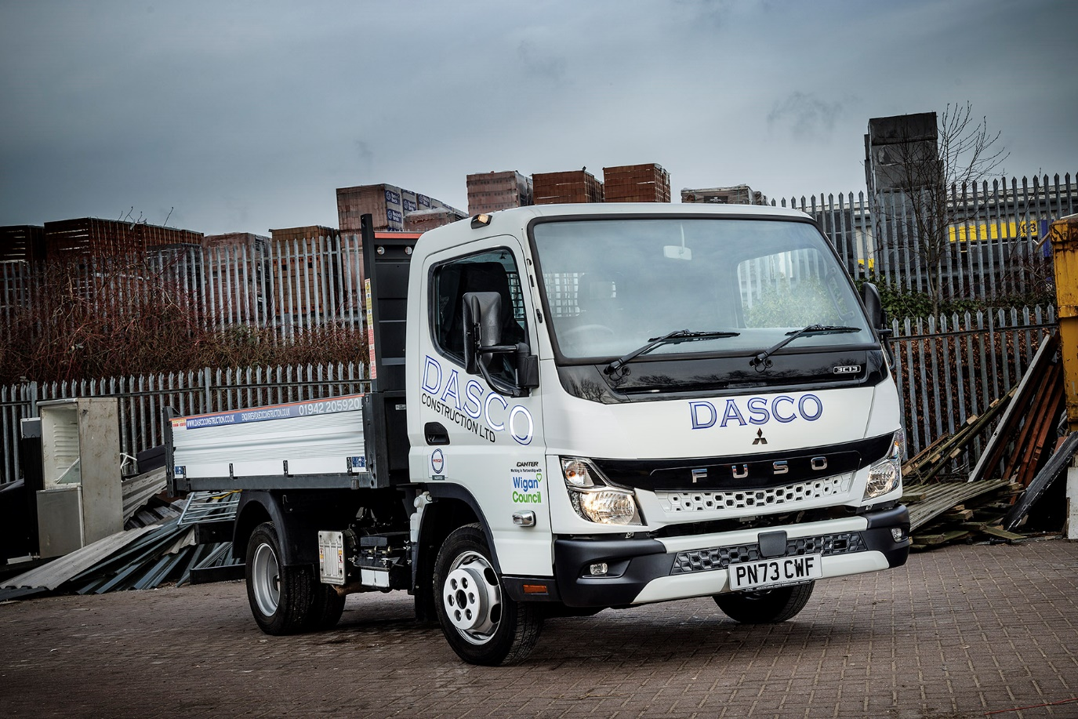

ends

For more information, or to request bigger/higher-res image files, please contact:
John Ripley: 07771 484595, john.ripley@loopagency.co.uk



