

Date: 3 February 2020

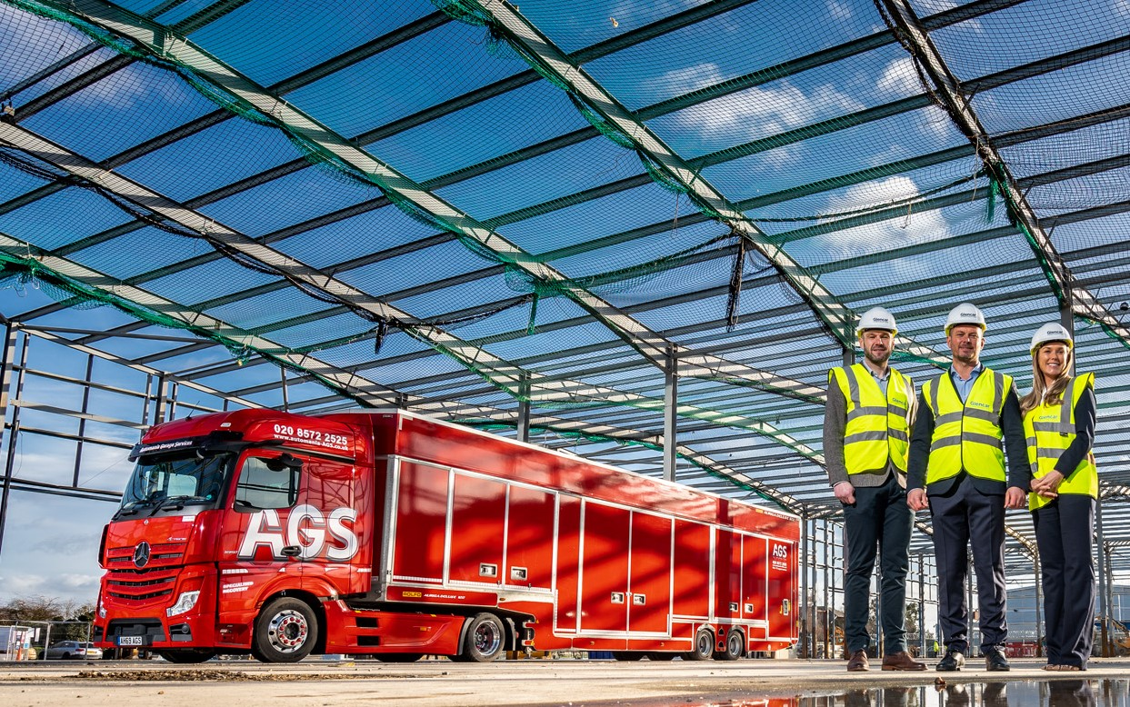

Three-pointed stars of the future: The AGS management team of Richard and Laura Holmes, and Paul Mcgerty, left

AGS takes up new Mercedes-Benz Trucks Authorised Repairer role at Heathrow
The sky’s the limit for commercial vehicle operators located in and around London Heathrow, following the appointment of AGS as Mercedes-Benz Trucks’ latest Authorised Repairer.

Automania Garage Services (AGS) is a leading provider of round-the-clock vehicle maintenance and repair support for the aviation and commercial fleet sectors. The company also offers a full range of recovery, fleet management, and contract hire and ‘spot’ rental services from its headquarters near Heathrow, as well as main depots at Gatwick Airport and Manchester Airport, and smaller facilities at other UK airports.

In June 2020 AGS is due to open for business at a flagship £6-million development which is currently under construction on a two-acre site even closer to Heathrow. At its heart will be a comprehensively equipped 64,000 sq ft workshop with no fewer than 39 bays of varying lengths, 17 with commercial vehicle pits. Two dedicated Authorised Testing Facility (ATF) lanes will be used by inspectors from the Driver and Vehicle Standards Agency (DVSA) to undertake commercial vehicle MoT tests. AGS currently offers a Saturday (ATF) MoT testing service and will continue to do so; however, following discussions with the DVSA, when it moves to its new site it plans to further enhance convenience for operators by introducing MoT testing on three weekday evenings as well.

Key to the appeal of the new partnership for Mercedes-Benz Trucks was AGS’s focus on customer service. This is reflected in its impressive track record for meeting the most demanding performance standards on turnarounds for vehicle servicing and repairs, which will underpin Mercedes-Benz Trucks’ Zero Tolerance on Downtime commitment.

AGS is led by a dynamic management team of Joint Managing Directors Richard Holmes (Operations) and Paul Mcgerty (Finance). Richard has an extensive truck background and history, having spent 12 years within the Mercedes-Benz network prior to buying AGS in 2011 with his wife, Laura. They were advised on the acquisition by Chartered Accountant Paul, who bought into the business in 2016.

Following heavy investment in facilities, vehicles and staff training, group turnover has reached £15 million. The company is now stepping up to the next level by becoming an authorised repairer of Mercedes-Benz trucks.

Mike Belk, Managing Director, Mercedes-Benz Trucks UK, said: “AGS is a fantastic addition to our workshop network. It has a proven track record and we have full confidence in the ability and commitment of Richard, Paul and their colleagues to provide
Mercedes-Benz truck customers with the timely, efficient and cost-effective aftersales support they expect.”

AGS services all makes of truck, but the fact that it has been granted Authorised Repairer status means operators of Mercedes-Benz vehicles that rely on its aftersales support can now benefit from the manufacturer’s cost-effective range of contract maintenance plans. AGS can also apply ground-breaking Mercedes-Benz Uptime predictive maintenance technology, and undertake warranty work for the benefit of its customers.

Richard Holmes recalled: “This exciting opportunity to join the official Mercedes-Benz network came at the same time as we were working on plans for further expansion. AGS recognises the importance of restricting downtime to an absolute minimum. That’s why we provide quick-response services with minimal workshop lead times, collection and delivery of vehicles, and MoT testing at times that suit our customers. We strive to be an exception to the norm.”

Paul Mcgerty is convinced AGS’s appointment will lead to increase sales of Mercedes-Benz trucks. “The product range is brilliant in terms of quality and technology, and comes with attractive ownership costs,” he said. “Back-up is also crucial, though. We’re confident that we’ll now see operators on the airport and beyond, some of which already depend on us for maintenance and repair support, switching in growing numbers to Mercedes-Benz. The flagship facility we open in June is also perfectly located close to the M25 and M4, so our vision is to become a market leader for commercial vehicle servicing.”

Added Richard: “We’re incredibly proud of what we’ve achieved in building AGS up to its current position, an achievement that wouldn’t have been possible without the tremendous support of colleagues throughout the business. We’re now looking forward to this next, exciting phase in the company’s development. We’ve been made to feel very welcome by the team at Mercedes-Benz Trucks UK, and are determined to do our very best for their customers and brand.”

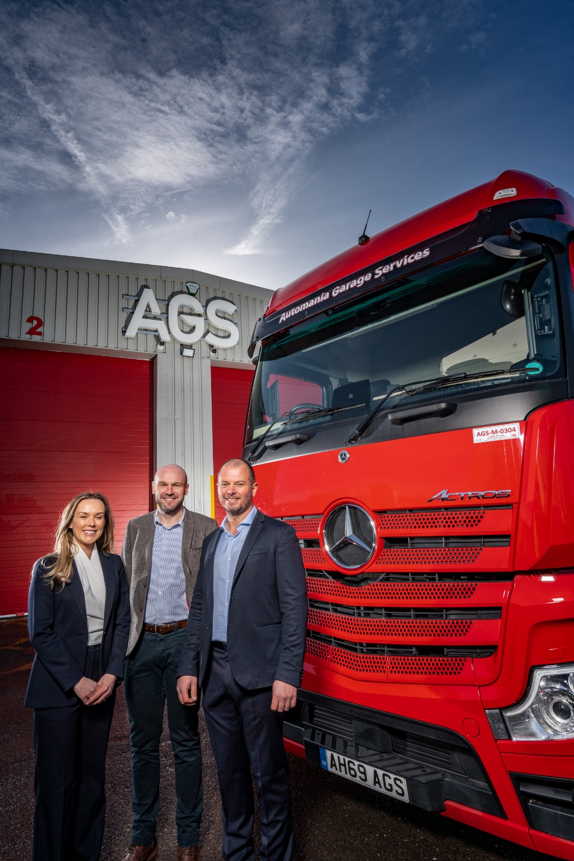

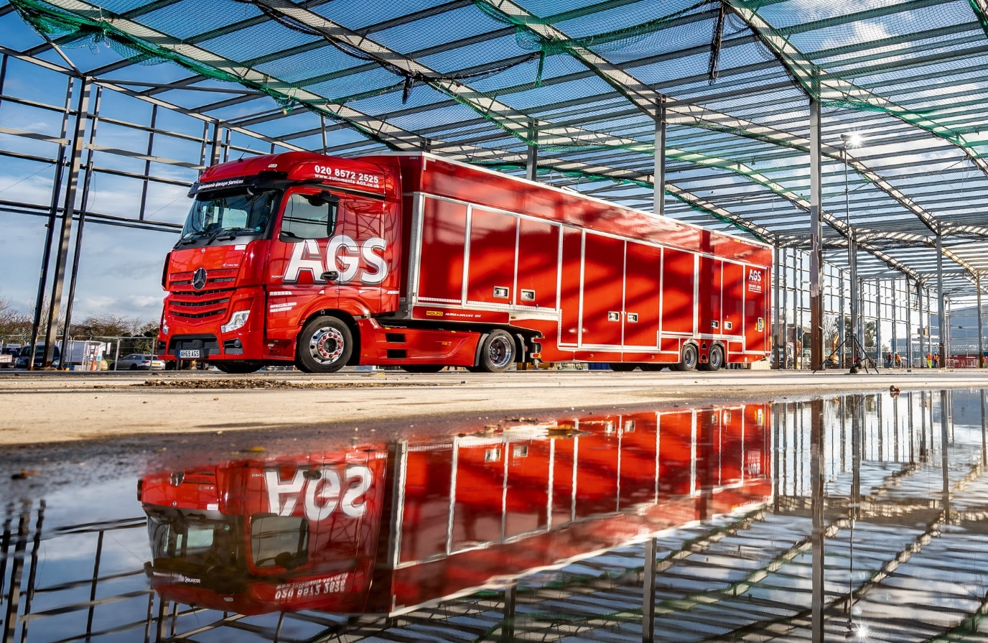

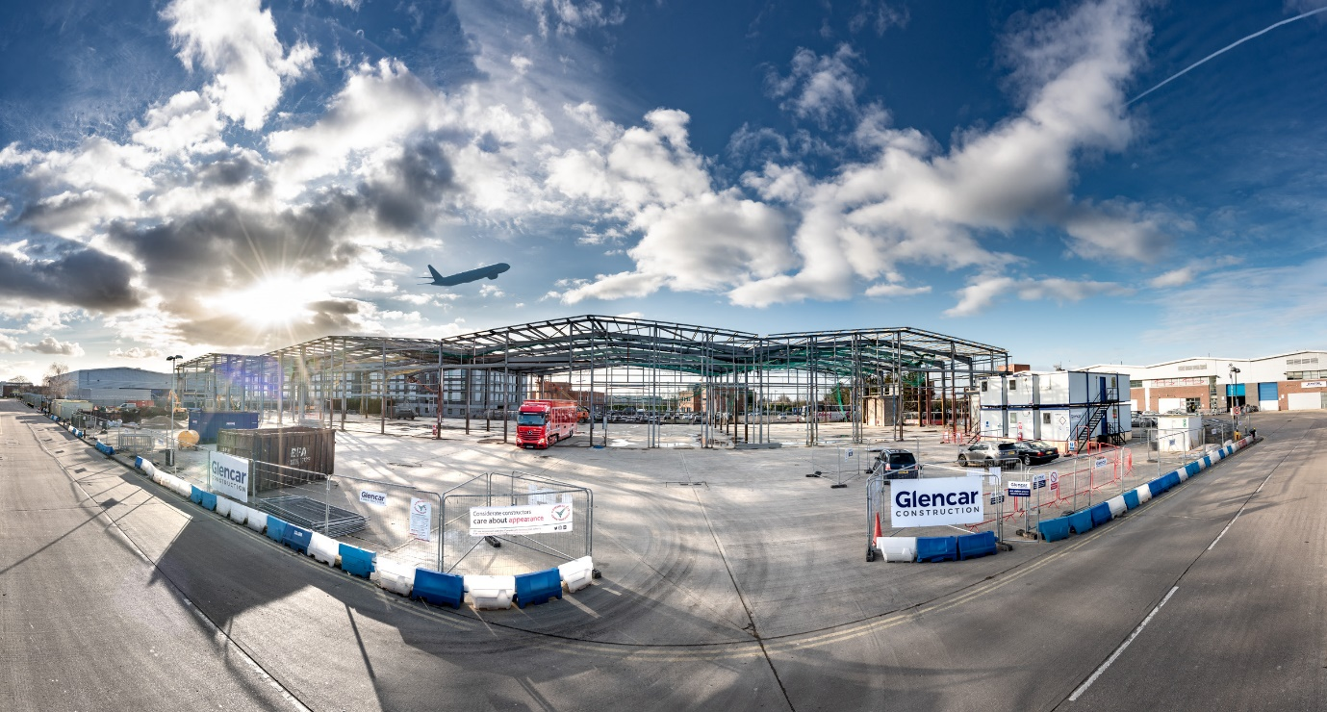

Preparing for take-off: AGS’s new workshop at Heathrow is already under construction and due to open in June

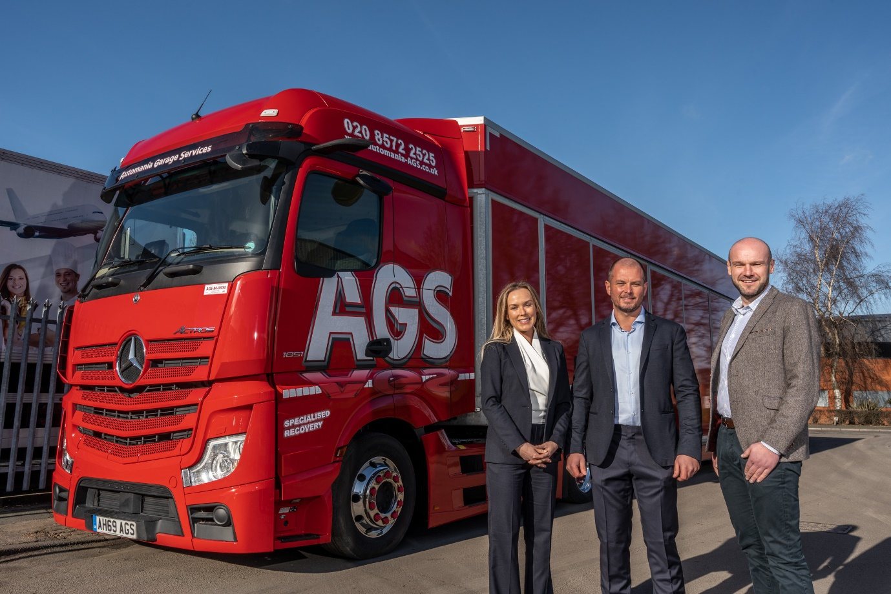

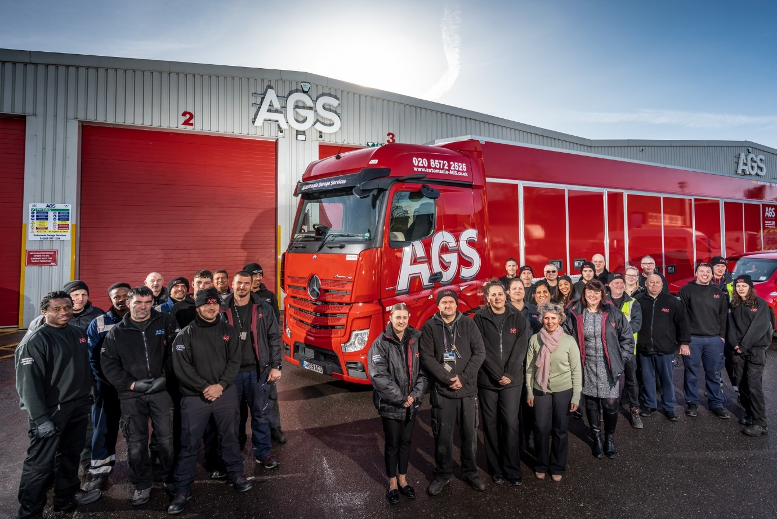

At your service: Pictured at their current premises, AGS colleagues are now supporting operators of vehicles bearing the three-pointed star as Mercedes-Benz Trucks’ latest Authorised Repairer

ends

For more information, or to request higher-res image files, please contact:

Jamie Fretwell at Mercedes-Benz Trucks UK Ltd
07712 519230, jamie.fretwell@daimler.com

or

Steve Warren or John Ripley
Impact Communications, 01926 842126
Steve: 07770 470251, steve@impactcom.co.uk
John: 07771 484595, john@impactcom.co.uk

About Mercedes-Benz Trucks UK Ltd
Mercedes-Benz Trucks UK Ltd is the sales and marketing organisation responsible for all Daimler truck products in the UK, including FUSO Canter.

For more than 125 years, Mercedes-Benz has stood for innovative commercial vehicles that meet exceptionally high standards of quality. Our claim to perfection, sustainability and avant-garde design is now embodied in the next generation of trucks: Actros, Arocs, Atego, Econic and Unimog.
www.mbtrucks.co.uk

