

Date: 7 February 2023

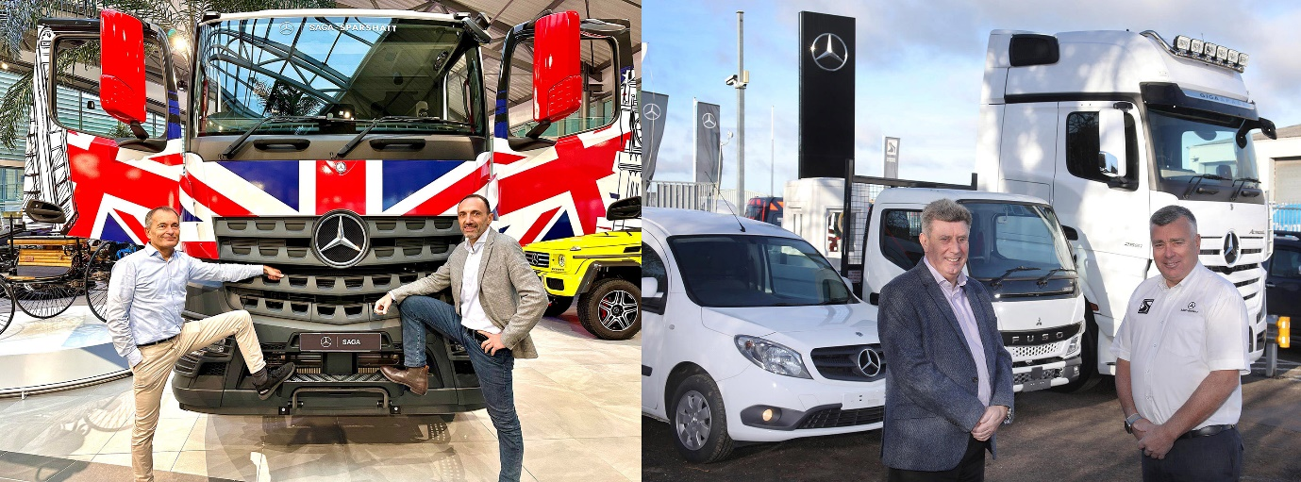

Moving forward together: From left to right: Ronan Chabot, President-Director General of parent company RCM, and Philippe Canetti of SAGA Mercedes-Benz Trucks represent Sparshatt Truck & Van’s new owners. Brothers Steve and Paul Rooney remain in post to help steer the business into a new era

SAGA takeover opens exciting new chapter for Mercedes-Benz Dealer Sparshatt Truck & Van

Kent-based Sparshatt Truck & Van is facing a bright future after acquisition of the company by leading French dealership group SAGA Mercedes-Benz.

Sparshatt will continue to represent Mercedes-Benz Trucks and Mercedes-Benz Vans, under its existing name, with no interruption of service to customers or changes of staff. Previous owners, brothers Paul and Steve Rooney, remain in post to manage the Dealer’s four sites in Ashford, Dartford, Sittingbourne and Tonbridge.

The purchase, for an undisclosed sum, represents SAGA’s first expansion into the UK but the company is no stranger to the commercial vehicle sector or to the three-pointed star – it already operates 14 Mercedes-Benz Truck dealerships and 15 Mercedes-Benz Van outlets across France, Belgium and Switzerland.

SAGA’s parent company RCM, which is based in La Roche-sur-Yon in the Vendee region of France, boasts a portfolio of no fewer than 118 sites representing leading automotive and marine brands, and employs a total of 2,750 people.

Dealer Principal Steve Rooney said: “The vehicle and transport industries are going through a period of rapid change, which is only going to accelerate as electrification becomes more mainstream. Joining the SAGA family secures our long-term future and allows us to plan ahead with full confidence.

“It’s a perfect match – both businesses share a strong ethos of always putting the customer first, and training and developing staff to fulfill their potential, while between us we can point to a total of 100 years of working with Mercedes-Benz. Local operators can be assured it’s very much business as usual at Sparshatt Truck & Van.”

Philippe Canetti, Director at SAGA Mercedes-Benz Trucks, added: “This move into the UK is an important step for us to grow our presence in matured markets across Europe. Sparshatt Truck & Van already follows our philosophy of ‘Respect, Performance and Passion’ and our business cultures align perfectly. We each have a fantastic amount of expertise in the Commercial Vehicle sector, and we are excited to be venturing into the UK during this time of transition towards e-mobility and advanced technology. Taking this first step across the Channel with Mercedes-Benz is the start of an exciting adventure for SAGA.”

The acquisition was welcomed by both Mercedes-Benz Trucks UK and the Van division at Mercedes-Benz UK Ltd, too.

Mercedes-Benz Trucks UK Managing Director Heiko Selzam said: “As well as being great news for both Sparshatt Truck & Van and SAGA, this significant development is proof that our Dealer Network, and the UK transport sector in general, are attractive places for investment. We look forward to building on Sparshatt’s excellent reputation across Kent and beyond, to support our loyal customers and those who are new to the brand alike.”

Robert Veit, Managing Director for the Van division at Mercedes-Benz UK Ltd, added: “We’re delighted that SAGA has seized this opportunity, and welcome them to our national network. As an established player across Europe, SAGA has a proven track record of success in the commercial vehicle industry and this investment will ensure that Sparshatt Truck & Van is perfectly placed to continue its work of keeping local businesses moving.”

Sparshatt Truck & Van employs more than 230 people across its headquarters in Sittingbourne and three more locations, including a dedicated body shop, in Kent. With a history stretching back to the 1970s the business has enjoyed continued growth while holding true to its founding values of personal service and commitment to customers.

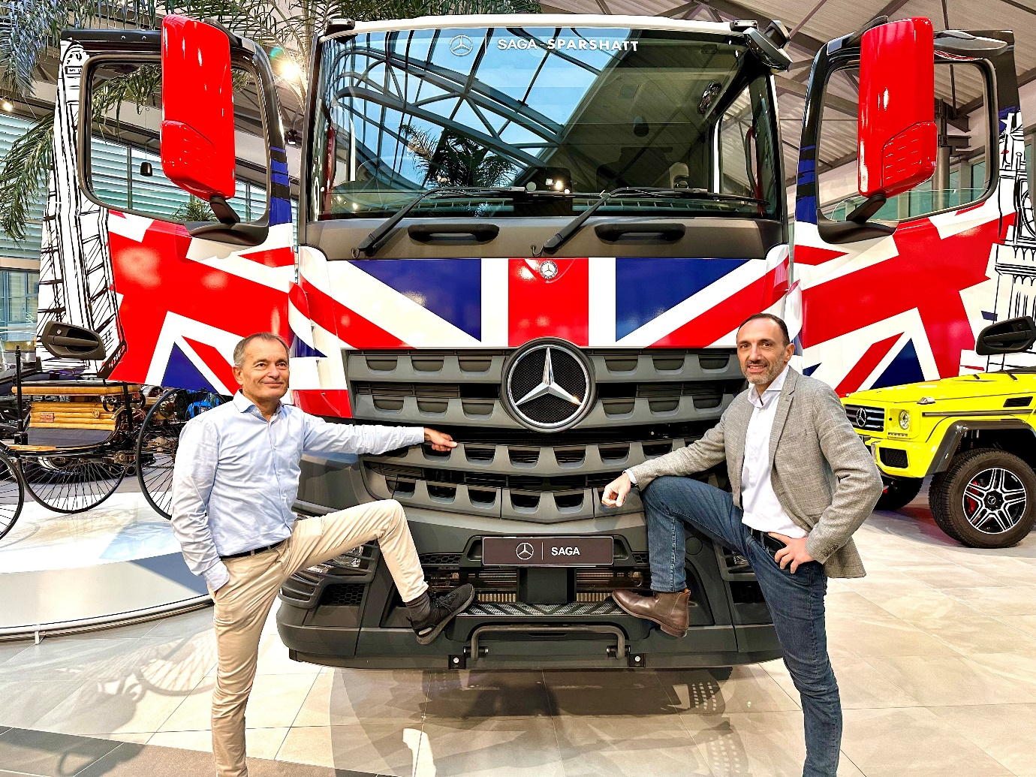

New venture: Ronan Chabot, left, President-Director General of parent company RCM, and Philippe Canetti of SAGA Mercedes-Benz Trucks

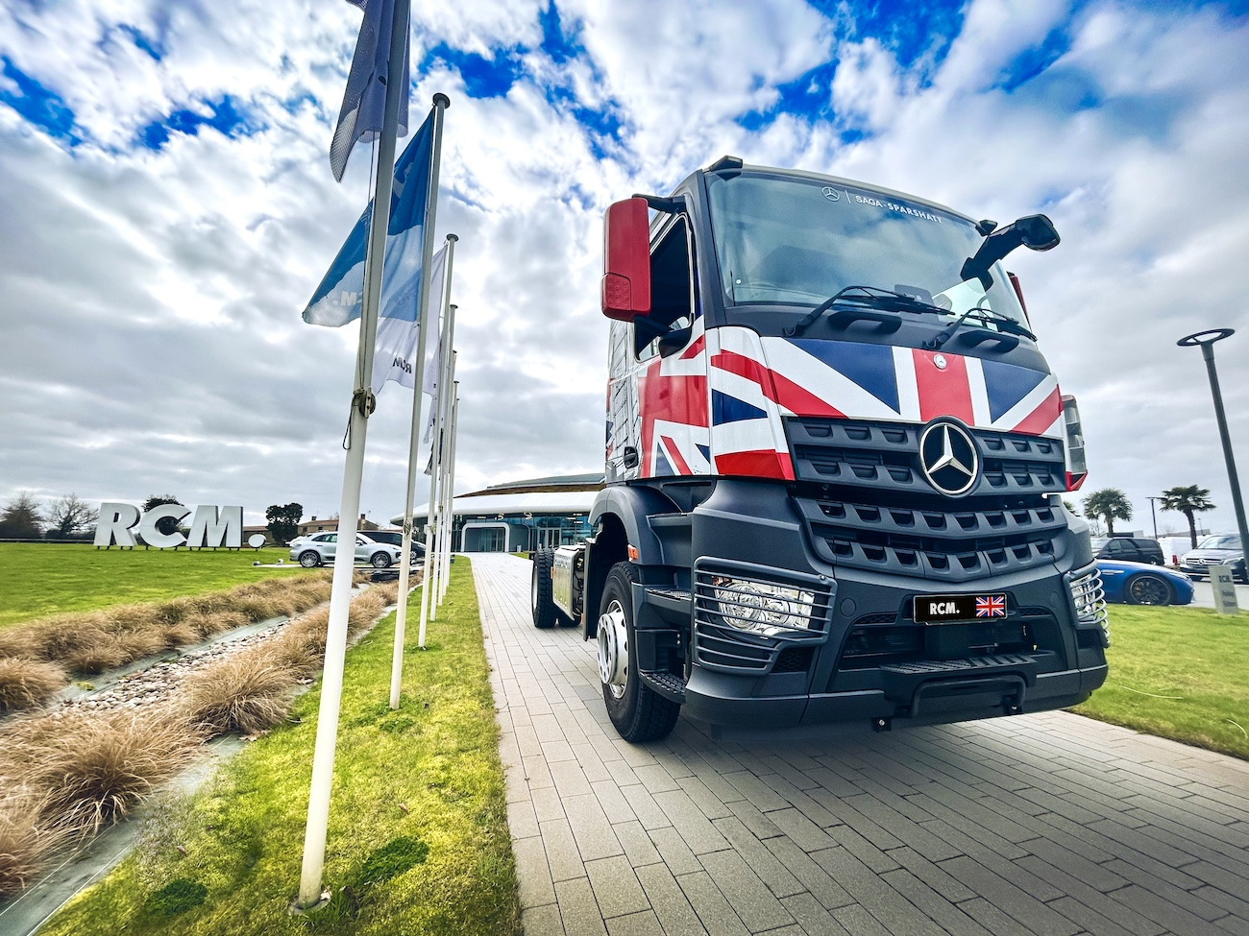

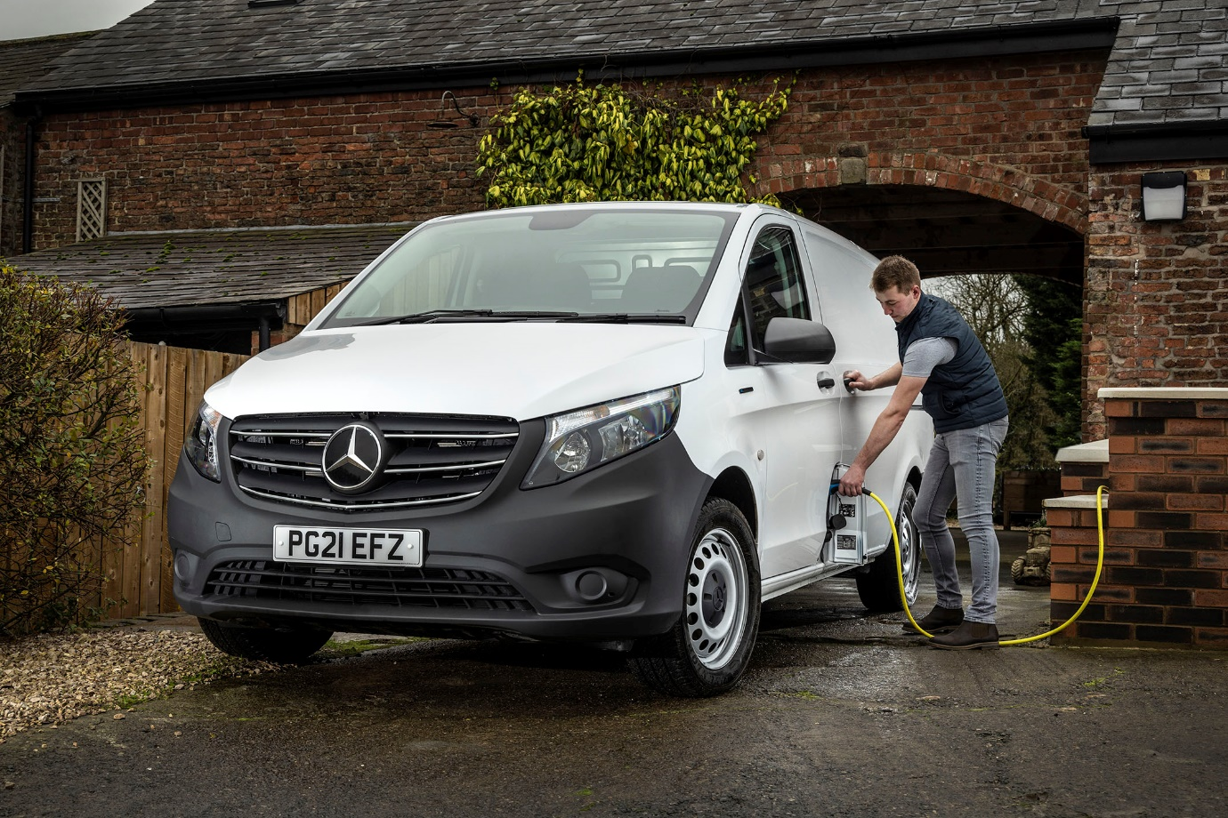

ends

For more information about RCM / SAGA Trucks, please contact:
Clement Gaillard, +33 674666143, clement.gaillard@teamrcm.fr

For more information about Sparshatt Truck & Van, please contact:
Sarah Collyer, 07719 057499, sarah.collyer@sparshattgroup.com

