

Date: 23 December 2021

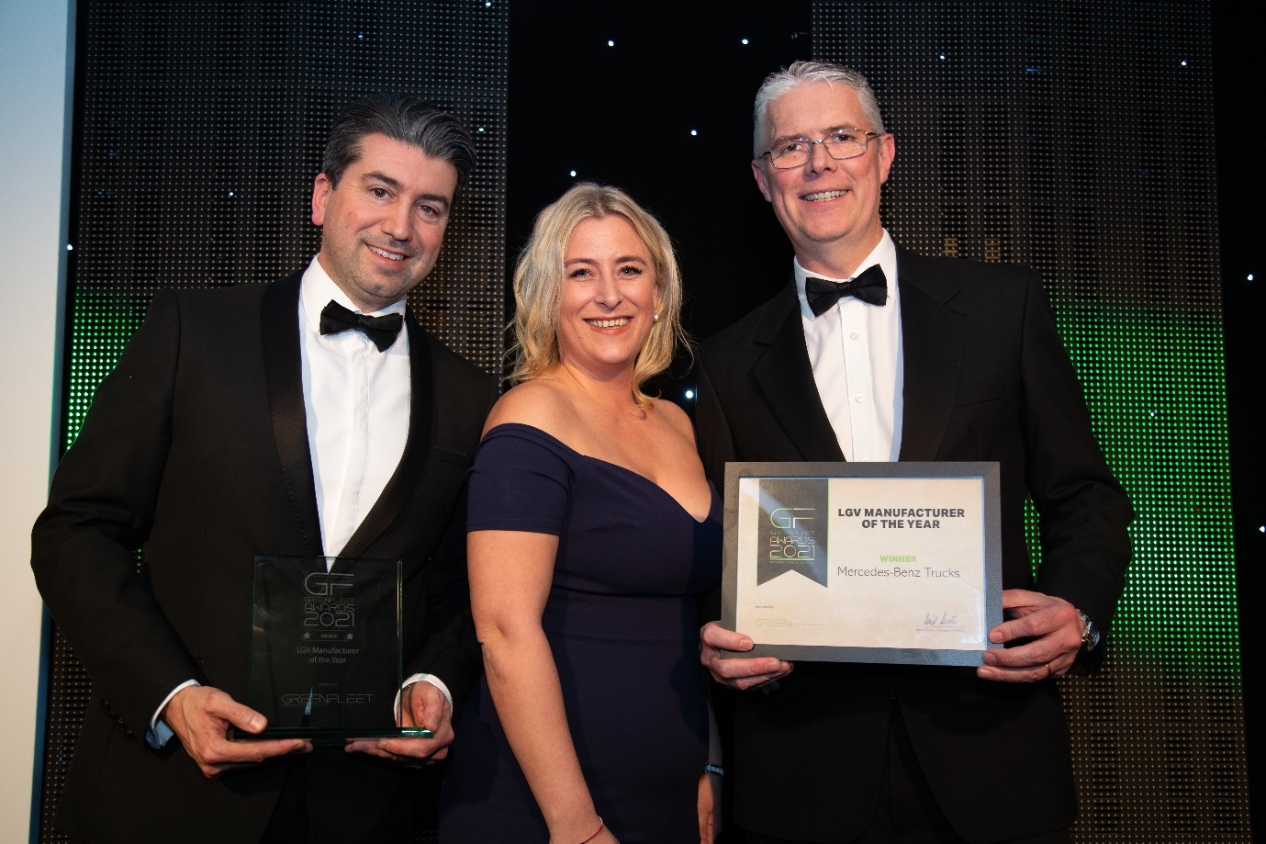

Focused on the future: Head of Special Trucks Ross Paterson, right, and eConsultancy Manager James Venables accepted Mercedes-Benz Trucks’ LGV Manufacturer of the Year award from GreenFleet’s Kylie Glover

Mercedes-Benz Trucks lands a sensational awards double and now sets its sustainability sights on an exciting 2022

Mercedes-Benz Trucks is ending a memorable year in the best possible way, after winning another two prestigious industry accolades.

Just eight days after being named ‘LGV Manufacturer of the Year’ at the 2021 GreenFleet Awards, Mercedes-Benz Trucks took the ‘Most Innovative Product’ honours for the Actros range at Logistics UK’s annual celebration of excellence within the sector.

December’s achievements follow the company’s successes in claiming the ‘OEM (Original Equipment Manufacturer) of the Year’ title at the 2021 Electrical Vehicle Innovation & Excellence Awards in October, and in being named ‘Truck Manufacturer of the Year’ by readers of Commercial Fleet in July.

These coveted awards bring down the curtain on an unforgettable 12 months in which Mercedes-Benz Trucks marked the 125th anniversary of the unveiling by founding father Gottlieb Daimler of the world’s first truck, a vehicle that was then sold to a London-based consortium.

During 2021 the manufacturer has also celebrated the 75 years that have passed since the earliest prototype of the 4x4 Unimog underwent off-road testing, and the 25th birthday of the Actros. The unique Unimog continues to set the standard for all-terrain performance and adaptability to this day, while having ‘broken the mould’ at launch in 1996 the Actros is now in its fifth model generation and – as Logistics UK’s judges clearly recognised – remains the benchmark vehicle for technological innovation.

Its latest achievements have given the Mercedes-Benz Trucks team in the UK the perfect platform from which to embark on an exciting new era. The establishment, also in December, of parent Daimler Truck as an entirely stand-alone business will, according to company chiefs, provide the unrestricted entrepreneurial independence to deliver improved performance and increased profitability.

It also means Daimler Truck is now best placed to master the transformation towards CO₂-neutral transport. Highlights next year will include the arrivals in the UK of the first fully electric eActros and eEconic truck models.

Both were prominent in the minds of the judging panel for this year’s GreenFleet Awards, which showcase environmental excellence within the fleet and transport sector and were announced during a ceremony staged at the British Motor Museum in Warwick.

Series production of the eActros began in October, and right-hand drive versions are now available to order by UK operators as a 19-tonne two-axle, or 27-tonne three-axle truck. The vehicle’s 448 kWh* battery packs provide a range of up to 400 km**. The eActros offers a peak power output of 400 kW (536 hp), while at only 60 dB it is also extremely quiet, so ideally suited to night-time deliveries in built-up areas.

Production of the low-entry eEconic begins next year and will be followed in 2024 by another battery-electric truck, the eActros LongHaul, a 40-tonne articulated tractor unit with 500 km range. Further down the line, the first hydrogen fuel cell-powered Mercedes-Benz GenH2 Trucks will be on UK roads by the end of the decade.

Daimler Truck’s environmental efforts are not restricted to its products. The company’s factories in Wörth, Germany, and Tramagal, Portugal, will be CO₂-neutral from 2022 – Tramagal is where FUSO, winner of the GreenFleet ‘LGV Manufacturer of the Year’ award for 2020, builds the battery-electric eCanter.

Daimler Truck is also collaborating with Shell and OMV on H2Accelerate, phase one of which will see 20 high-capacity hydrogen stations set up in Europe, and has formed a partnership with TRATON and Volvo Group to invest £500 million in a high-performance charging network for heavy-duty trucks.

“Mercedes-Benz is consistently pursuing its technology strategy to decarbonize road transport,” acknowledged GreenFleet magazine Editor Angela Pisanu. “Not only does it want to offer its customers the best locally CO₂-neutral trucks, powered either by batteries or hydrogen-based fuel cells depending on the use case, but it is also leading the way with production and infrastructure.”

Logistics UK, which represents businesses and more than seven million people directly employed in the making, selling and moving of goods, held its gala dinner at the Park Plaza Westminster Bridge. Guests, including Her Royal Highness the Princess Royal, heard that with more than 60 new developments the Mercedes-Benz Actros was a worthy winner of the organisation’s Most Innovative Product award.

Most noteworthy for a range crowned International Truck of the Year 2020 was MirrorCam, the manufacturer’s ground-breaking camera-based replacement for conventional mirrors, which offers significantly improved visibility all round, as well as an aerodynamic advantage that translates to a 1.3% reduction in fuel consumption.

Other core innovations include the Active Braking Assist 5 emergency braking system with enhanced pedestrian recognition and response capability, the radical twin-screen Multimedia Cockpit and the TruckApp Portal, a revolutionary new way for operators to interact with their drivers.

All combine to make this the safest, most efficient and best-connected truck ever. “Logistics UK was delighted to present Mercedes-Benz Trucks UK with the Most Innovative Product of the Year award for its Mercedes-Benz Actros,” said David Wells, Chief Executive at Logistics UK. “The judges were impressed with the vehicle’s innovative features, which result in greater safety for all road users, lower fuel bills for operators, and improved comfort for drivers.”

* Nominal battery capacity based on internal boundary conditions; may vary depending on use case and ambient conditions

** Determined under optimum conditions, including four battery packs after preconditioning in partially loaded distribution traffic without a trailer and at an outside temperature of 20ºC
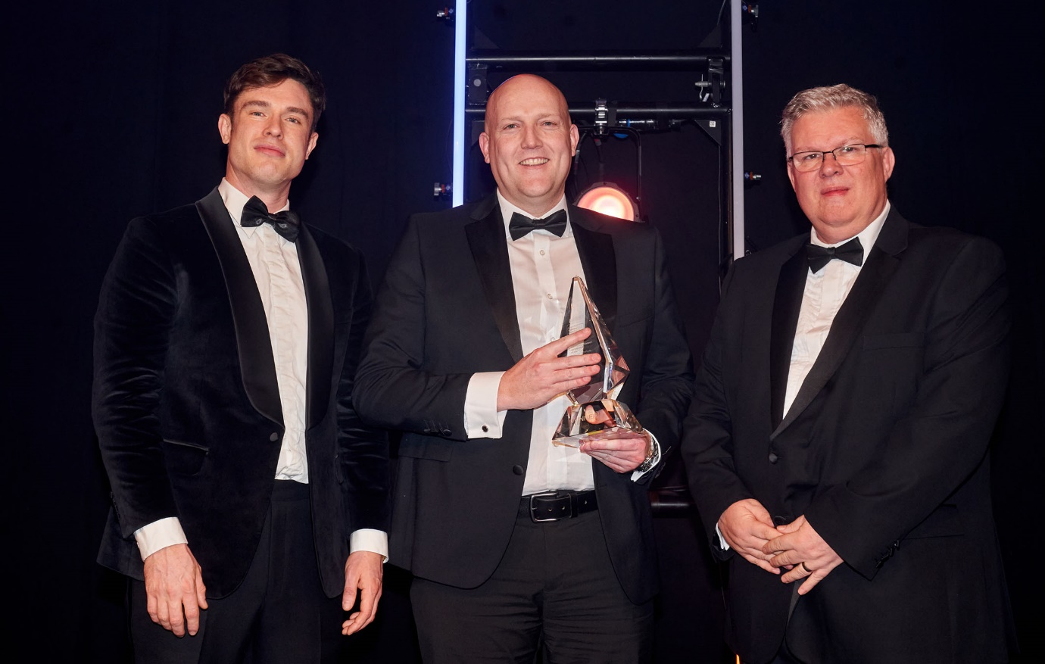

Technological triumph: Peter Dinsdale, Mercedes-Benz Trucks UK’s Head of Technical & Service Support, received the Logistics UK Most Innovative Product trophy from Geoff Lippitt, Chief Commercial Officer of sponsor PD Ports, right, and host, comedian Ed Gamble

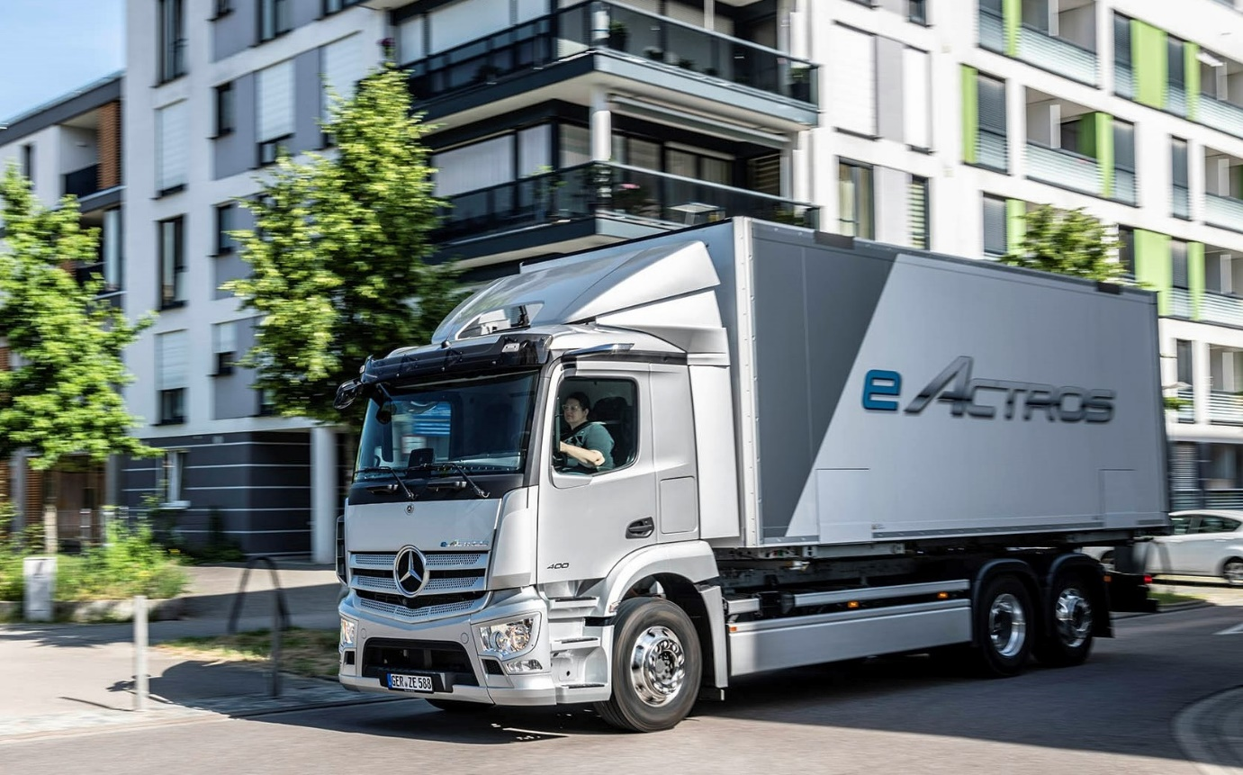

Coming soon: The first battery-powered Mercedes-Benz eActros are scheduled to reach the UK early next year
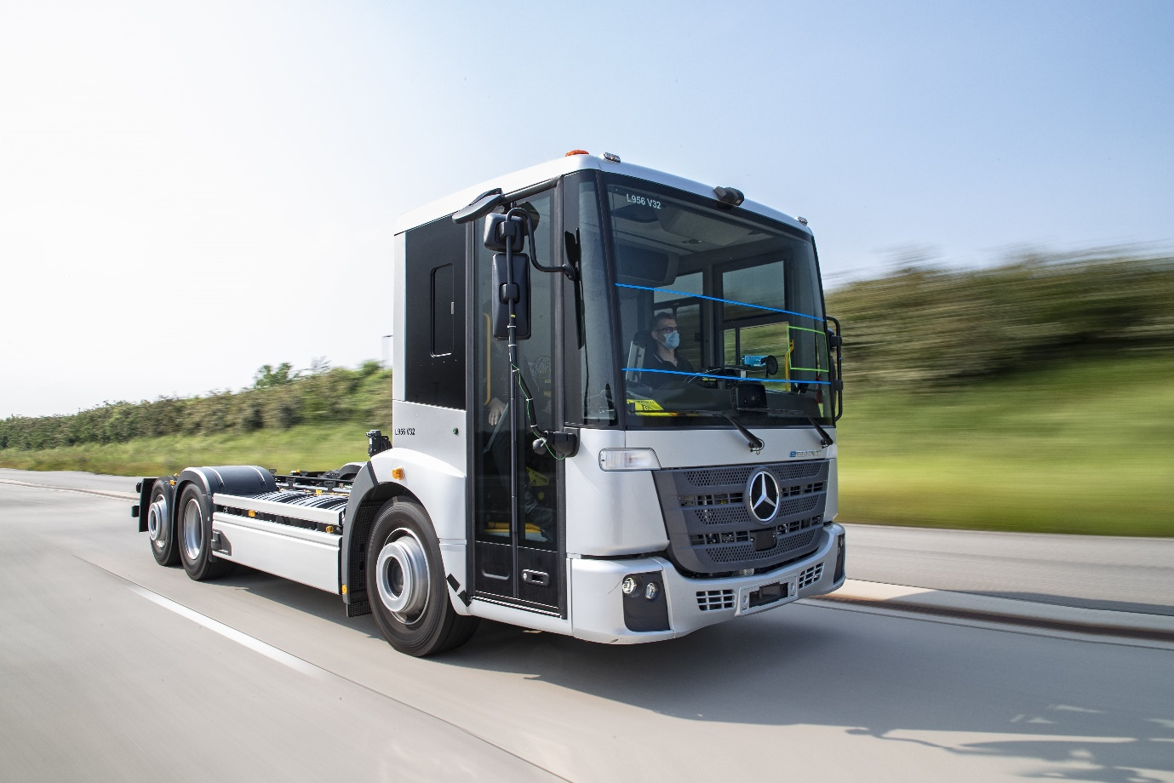

Next in line: Emissions-conscious municipal and other operators are looking forward to the arrival in the UK of the fully electric Mercedes-Benz eEconic

ends

For more information, or to request higher-res image files, please contact:

Jamie Fretwell at Mercedes-Benz Trucks UK Ltd
07712 519230, jamie.fretwell@daimler.com

or

Steve Warren or John Ripley
Impact Communications
Steve: 07770 470251, steve@impactcom.co.uk
John: 07771 484595, john@impactcom.co.uk

