

Date: 21 December 2022

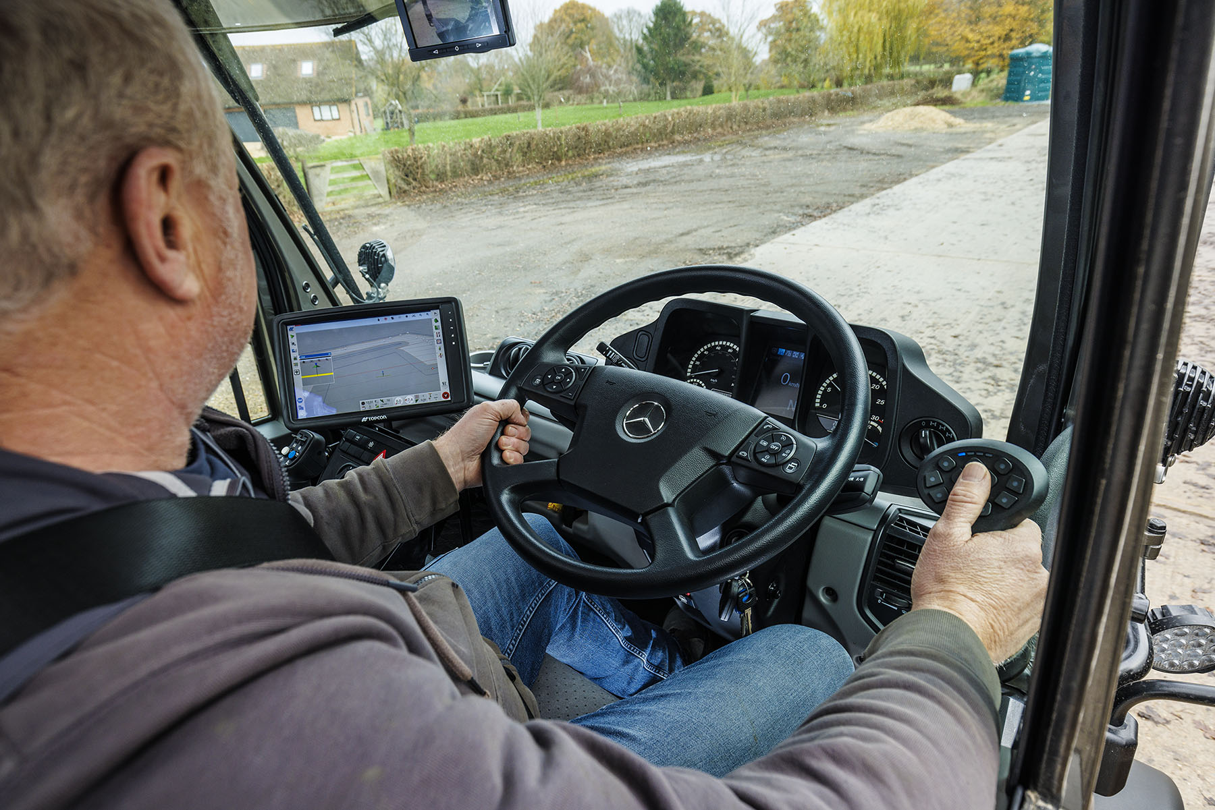

Precision guidance: Home Farm Estates’ new U430 can control itself thanks to its Topcon automated steering system

Home Farm (Charlton) Estates’ Mercedes-Benz Unimog steers straight and true with Topcon RTK GNSS tracking

The all-terrain Mercedes-Benz Unimog is renowned for its ability to tackle a seemingly endless repertoire of tasks – but Home Farm (Charlton) Estates’ latest 4x4 also boasts a highly significant additional talent.

Supplied to the Oxfordshire arable grower by Dealer Arthur Ibbett, the UGE U430 implement carrier is one of the UK’s first Unimogs to be fitted with the manufacturer’s Comfort Steering option.

This ergonomically-efficient electromotive power assistance system reduces steering force required at the wheel. It is capable of adapting automatically to speed and driving conditions, creating an easier and more comfortable drive, even with heavy front-mounted implements and bulky agricultural tyres.

Crucially, the Comfort Steering system’s electronic architecture also means that, for the first time, the Unimog can be integrated with aftermarket RTK GNSS (Real-Time Kinematic Global Navigation Satellite System) automated steering. This allows pinpoint positioning and control of vehicles undertaking tasks such as cultivation, seeding and harvesting.

Ralph Castle is the owner of Home Farm (Charlton) Estates, which grows combinable crops – mostly wheat, barley and oilseed rape – on 175 hectares of land around Wantage. The farm has been in his family for five generations.

Mr Castle traded in his first Unimog, which he’d been running since 2017, when he purchased the new U430 variant. He recalled: “Before placing my order I tried versions with and without Comfort Steering.

“It was immediately apparent that the system would make working with implements on rough ground much easier, but the fact that we could also fit an automated steering package was even more important to me.”

Mr Castle chose the Topcon XD+ system, which was installed by LH Agro, of St Ives, Cambridgeshire. Not only does this offer an automated steering capability, allowing the vehicle to follow a set course to within a margin of two centimetres, it also enables implements such as seed drills to be monitored and controlled with extreme precision via Isobus, using the 12.1in touchscreen console in the cab.

“When you run a Unimog, the more you use it the more you realise there are extra things it can do,” said Mr Castle. “We bought the first one just for transport around the farm – our land is spread across quite a few miles, so we needed a vehicle that would allow us to get around reasonably quickly.

“The Unimog performs very well on the road – it has a much higher cruising speed than a tractor, and it offers far better fuel economy as well. It’s perfectly capable of working in the fields too. At harvest time, for instance, we might use ours to collect a trailer full of grain and bring it back to base much faster than could be done with any other vehicle, so the combine harvester is kept working with fewer interruptions.”

He continued: “The new Unimog offers the same, multiple talents as its predecessor, but can also perform a wide range of arable farming tasks under automated guidance, which gives us the precision and efficient use of materials that modern agriculture requires. It’s a fantastically versatile tool, and will be worked hard all year round throughout the growing cycle.”

Mr Castle’s Unimog was sold by Arthur Ibbett’s Sales Executive Nick Suddes, who previously worked as an agricultural engineer for a leading tractor manufacturer. “So I know the industry well and understand our customers’ requirements,” said Nick.

“As soon as Ralph told me about his operation and the type of work he wanted to do with the Unimog, I realised the Comfort Steering option in conjunction with Topcon guidance would fit the bill exactly. I’m delighted that with the help of LH Agro we were able to deliver a vehicle that’s perfectly specified for Home Farm (Charlton) Estates.”

Ralph Castle added: “I was very impressed by Nick’s knowledge, proactive approach and determination to ensure that our Unimog can do everything we want,” he said. “Of course, it’s possible to retrofit extra systems and equipment to any vehicle, but far better to make sure it has the required capabilities from the outset.”

All Unimogs have 4x4 chassis with single rear wheels, while gross weights vary from 7.5 to 16.5 tonnes. Mr Castle’s 12.7-tonne U430 is powered by a 7.7-litre six-cylinder engine that produces 220 kW (299 hp).

Standard equipment includes the innovative Central Tyre Inflation system, which allows the driver to drop the pressures from the cab when the vehicle is off-road. As well as increasing grip, this also brings an environmental benefit by minimising damage to the ground. Tyres can then be reinflated when back on a hard surface for greater safety and fuel efficiency at normal road speeds.

The Unimog range encompasses gross weights from 7.5 to 16.5 tonnes and is built around two core variants: the UGE implement carrier U219-U535, and UHE extreme off-roader U4023-U5023 that can be fitted with many different types of body.

Ibbetts’ Nick Suddes can be contacted on 07739 091366 or nick.suddes@ibbetts.co.uk

ibbetts.co.uk

 facebook.com/ibbetts.unimog

 instagram.com/ibbetts_unimog

 linkedin.com/in/Arthur-ibbett-8186b019b

 www.twitter.com/ibbettsu

www.lh-agro.co.uk/contact-us/

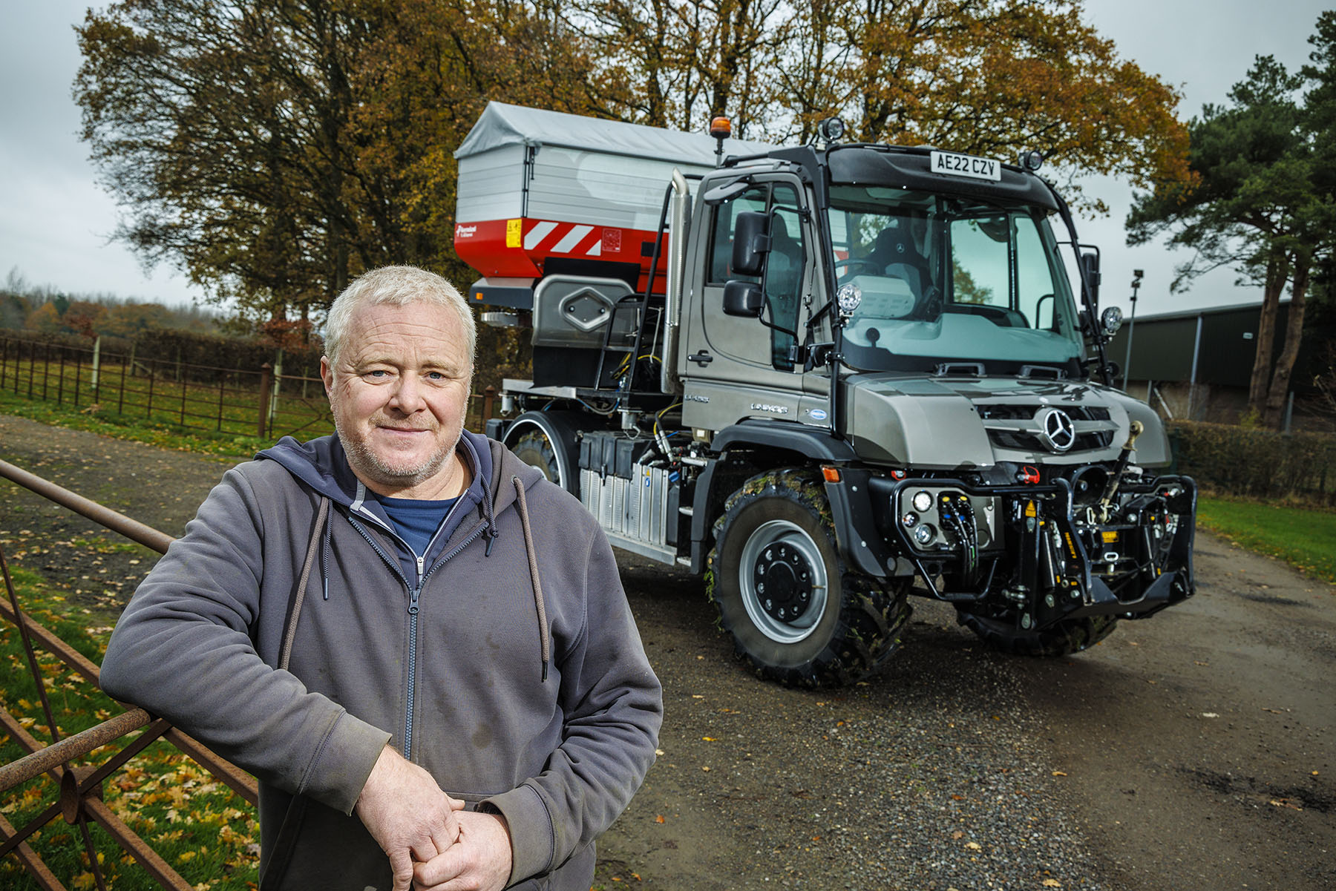

Growing together: Arable farmer Ralph Castle and his new Unimog U430

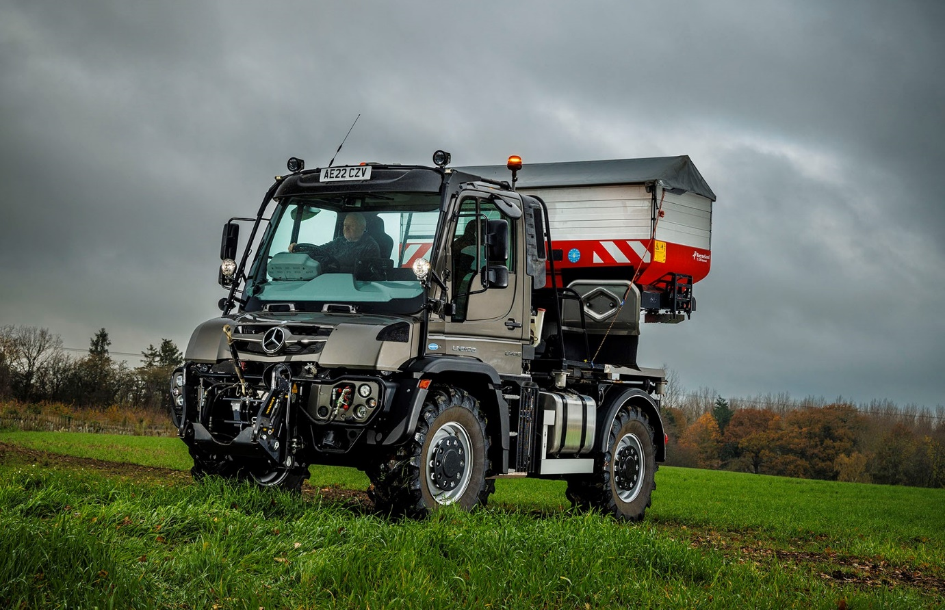

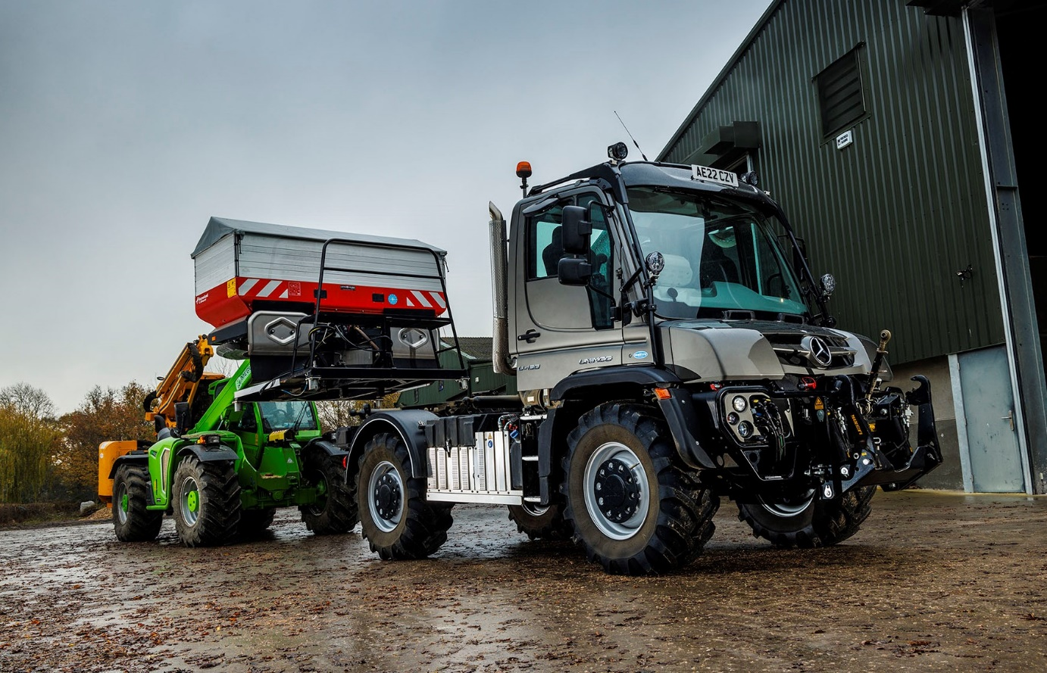

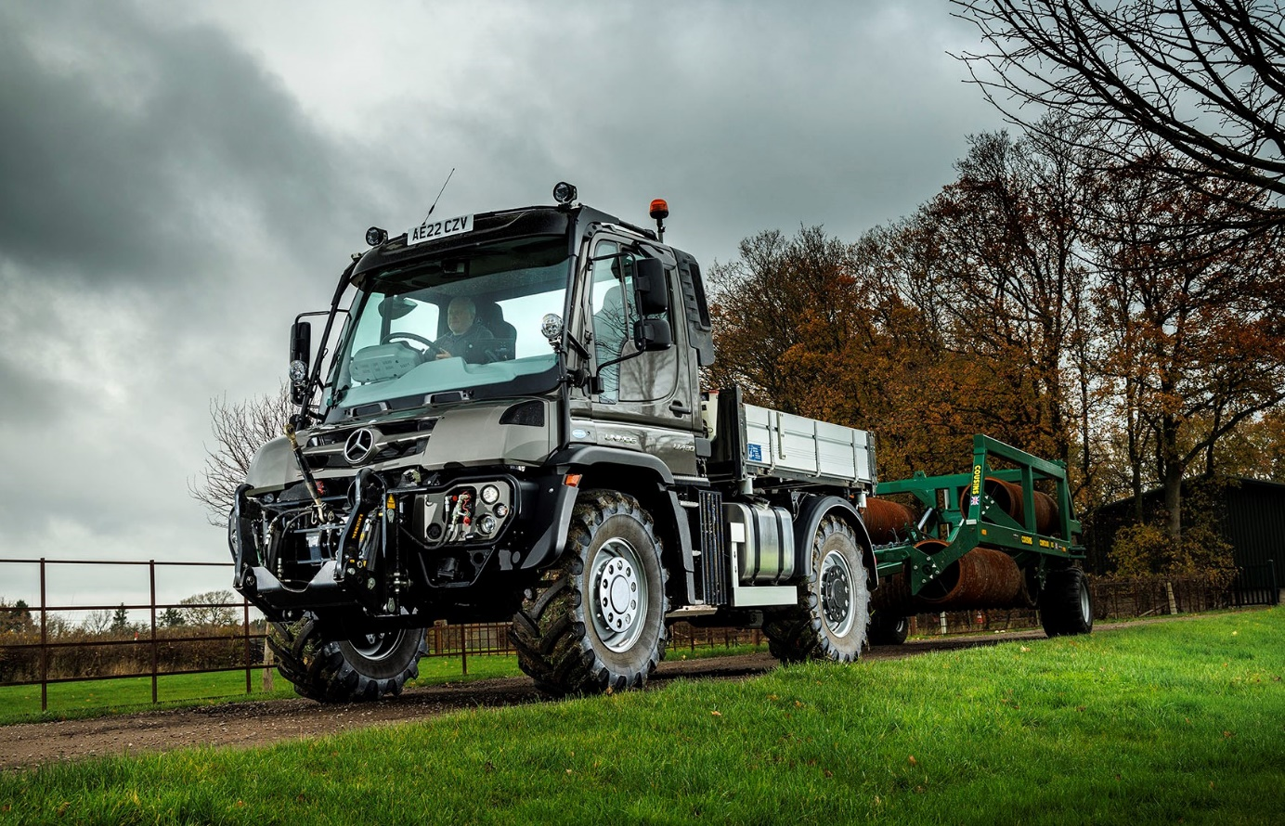

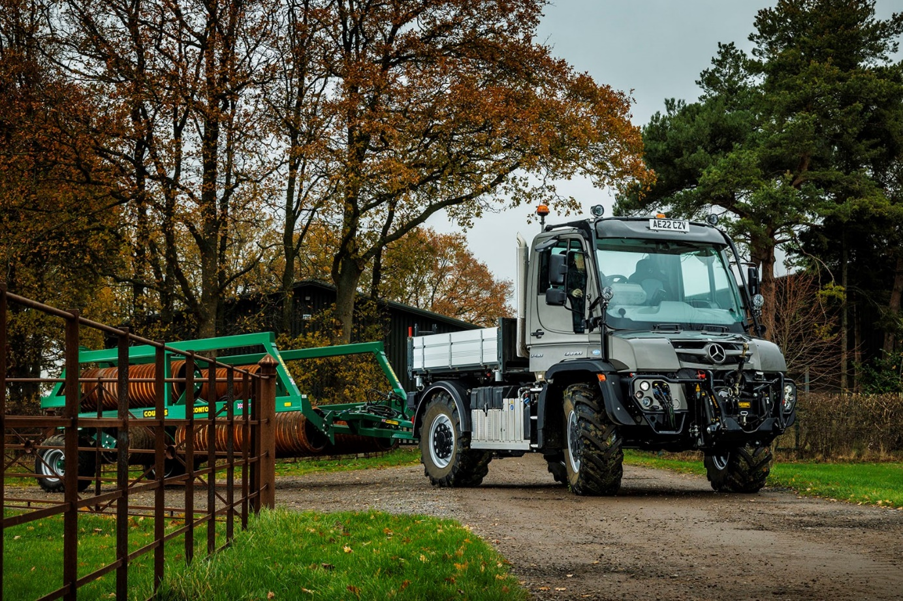

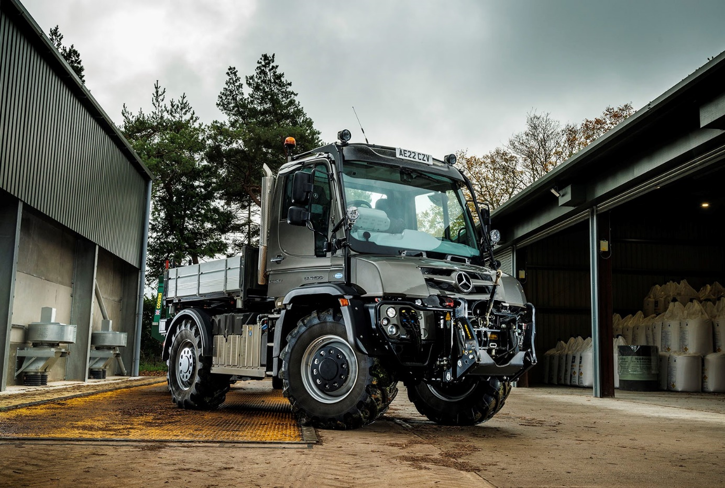

ends

For further information, please contact:
John Ripley or Steve Warren
Impact Communications
John: 07771 484595, john@impactcom.co.uk
Steve: 07770 470251, steve@impactcom.co.uk



