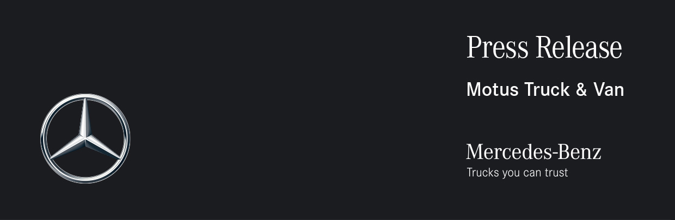

Date: 5 December 2022

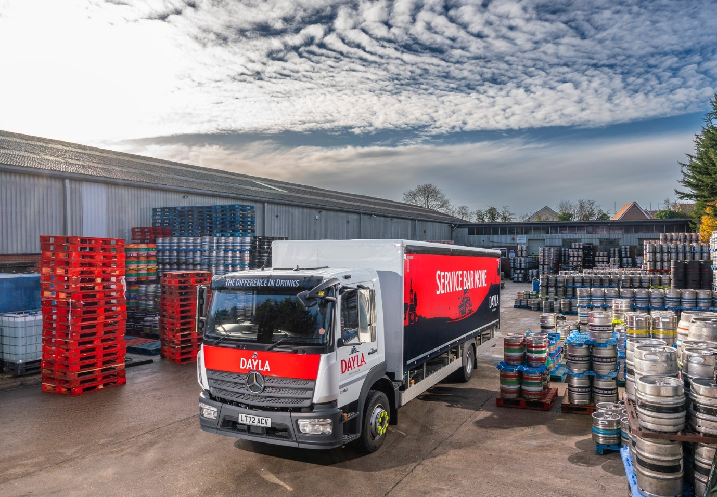

Dayla Drinks raises a toast to the reliability and durability of its Mercedes-Benz Atego

Three new Mercedes-Benz Atego delivery trucks are helping Dayla Drinks get around in the Home Counties, serving up the wholesaler’s range of beers, wines, spirits, soft drinks and snacks to the hospitality industry.

Supplied by Dealer Motus Truck & Van, the latest additions to Dayla Drinks’ expanding fleet will enable it to stay ahead of demand, which has been growing steadily since the country emerged from Covid pandemic lockdowns.

The Aylesbury-based company’s turnover has shot up by almost a third over the last year. As a result, it has been ordering more and bigger trucks, to ensure it continues to fulfil its promise of “service bar none”.

The new arrivals bring to 35, the number of vehicles on the Dayla Drinks fleet. Most are based on Mercedes-Benz or FUSO chassis – both brands are part of the global Daimler Truck family.

The line-up includes Mercedes-Benz Sprinter van chassis cabs at 3.5 and 5.0 tonnes GVW, and 7.5-tonne FUSO Canters. Dayla’s largest-ever vehicle, a Mercedes-Benz Actros 18-tonner, is scheduled for delivery by Motus Truck & Van next spring.

The three new trucks, however, are 13.5-tonne Atego 1318s. They have ClassicSpace S-cabs and 5.1-litre engines that produce 130 kW (177 hp) and drive through six-speed Mercedes PowerShift 3 automated manual transmissions. Their curtainside bodies are by Essex Bodies, of Rayleigh, Essex, with graphics by Aylesbury-based Signum Signs.

Dayla Drinks Head of Operations Dayle Pearson explained: “While we need more compact vehicles for deliveries involving smaller volumes and difficult-to-access locations, and will assign larger consignments to our first Actros, it is the Atego 1318 that forms the backbone of our fleet.

“The 13.5-tonne Atego is a fantastic workhorse, which is why we now run more than 20. It combines a useful payload of around eight tonnes with a manageable footprint and a load platform that’s not too high, which makes for easier unloading. It’s just right for our requirements.”

The Mercedes-Benz Atego range is designed to offer precise handling with exceptional ride comfort, and is renowned for its reliability and durability – qualities which are proven in operation for Dayla Drinks.

“We’ve been running Mercedes-Benz trucks for at least 10 years now,” reported Mr Pearson. “We’ve tried other truck brands from time to time but in our experience none has been as dependable as an Atego.”

He continued: “At Dayla Drinks we pride ourselves on the very high level of service we provide to our customers in the pub, hotel and restaurant trade. For this reason, it is essential that we be able to trust our vehicles not to break down on the way to deliveries.

“The Atego is also popular with those who use it. These colleagues are not just drivers – they’re draymen and the visible face of our business, who offer a comprehensive service that encompasses everything from product support to stock rotation. It’s only right, therefore, that we should give them the best vehicles to work with.”

Mr Pearson has praise for Motus Truck & Van too. “The Dealer’s Sales Executive Steve Thurbon understands our business well and always keeps us informed about vehicle availability and the progress of our orders, which has helped us plan our fleet expansion and replacement programme. Although we use a local service agent we know Motus Truck & Van can always be relied upon to provide technical support, undertake warranty work or manage more serious issues – not that we ever expect there to be a problem with an Atego!”

Family-owned Dayla Drinks can trace its history back over four generations. Founded as a brewery in the late 1800s, the company moved into distribution in the early 20th century and expanded over the ensuing decades by acquiring a series of other small local businesses.

Today, it offers a comprehensive range of cask-conditioned ales, craft and keg beers, ciders, wines, spirits, soft drinks, snacks and related products including cleaning materials, bar-top essentials and dispense gas. Dayla Drinks also provides technical advice on equipment, arranges beer festivals, hosts mobile pop-up bars and even designs menus for its customers.

www.dayladrinks.co.uk

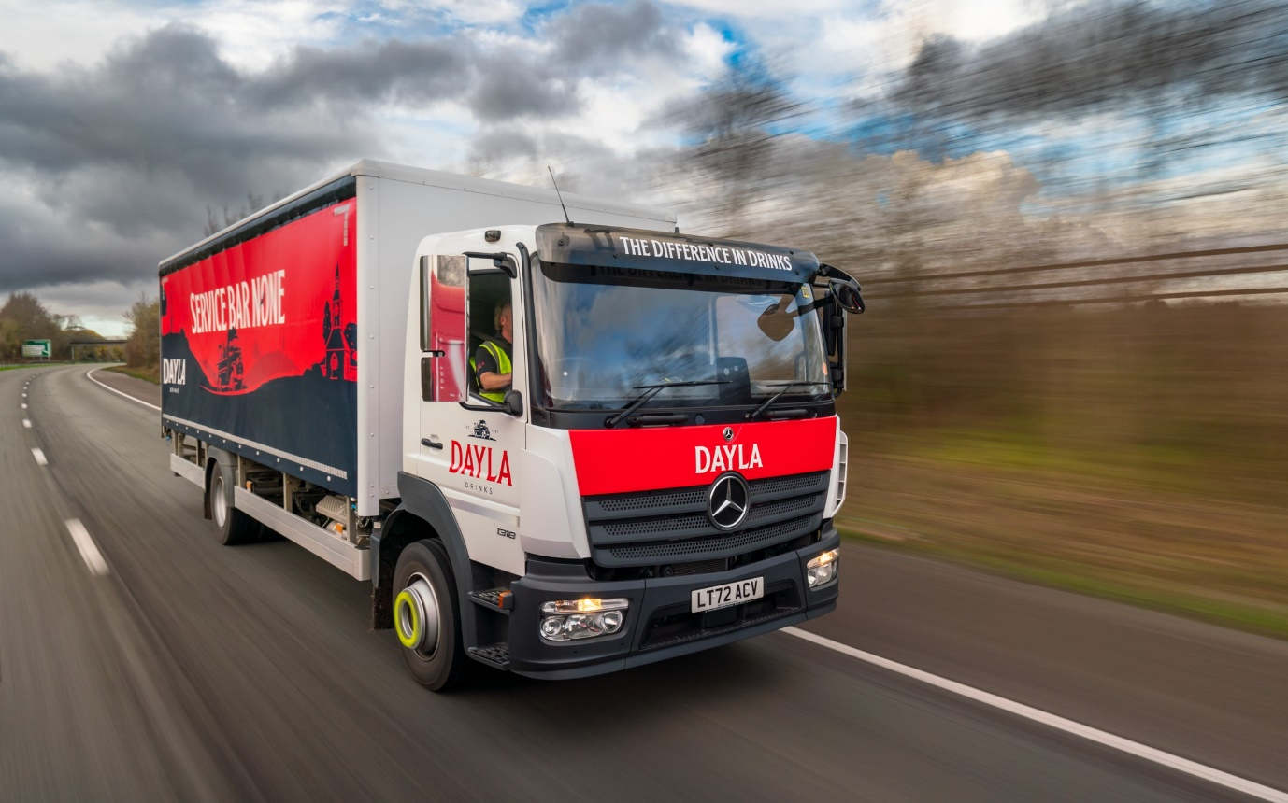

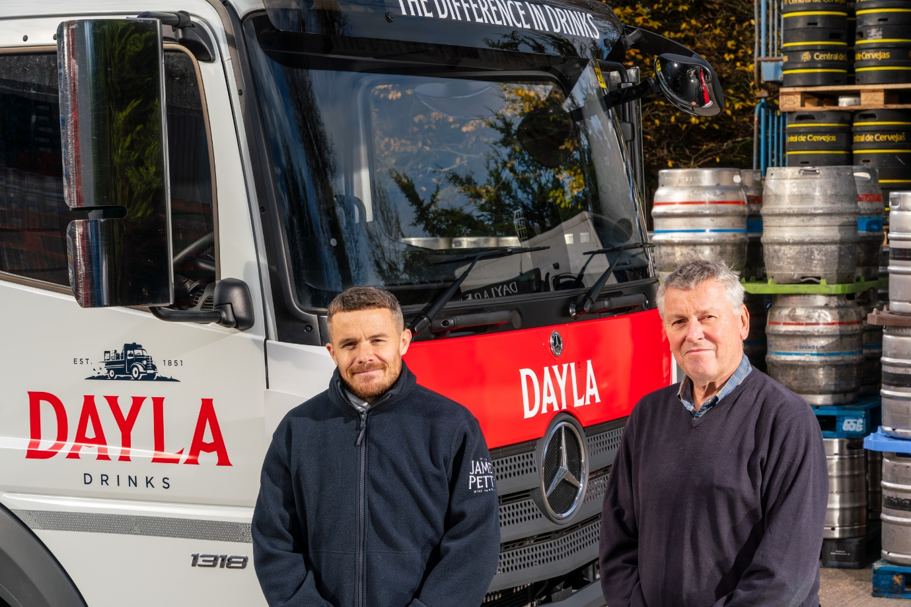

Family values: Dayla Drinks Managing Director Tim Cooper is pictured with his son Sales & Marketing Director Daniel, and one of their new Mercedes-Benz Atego

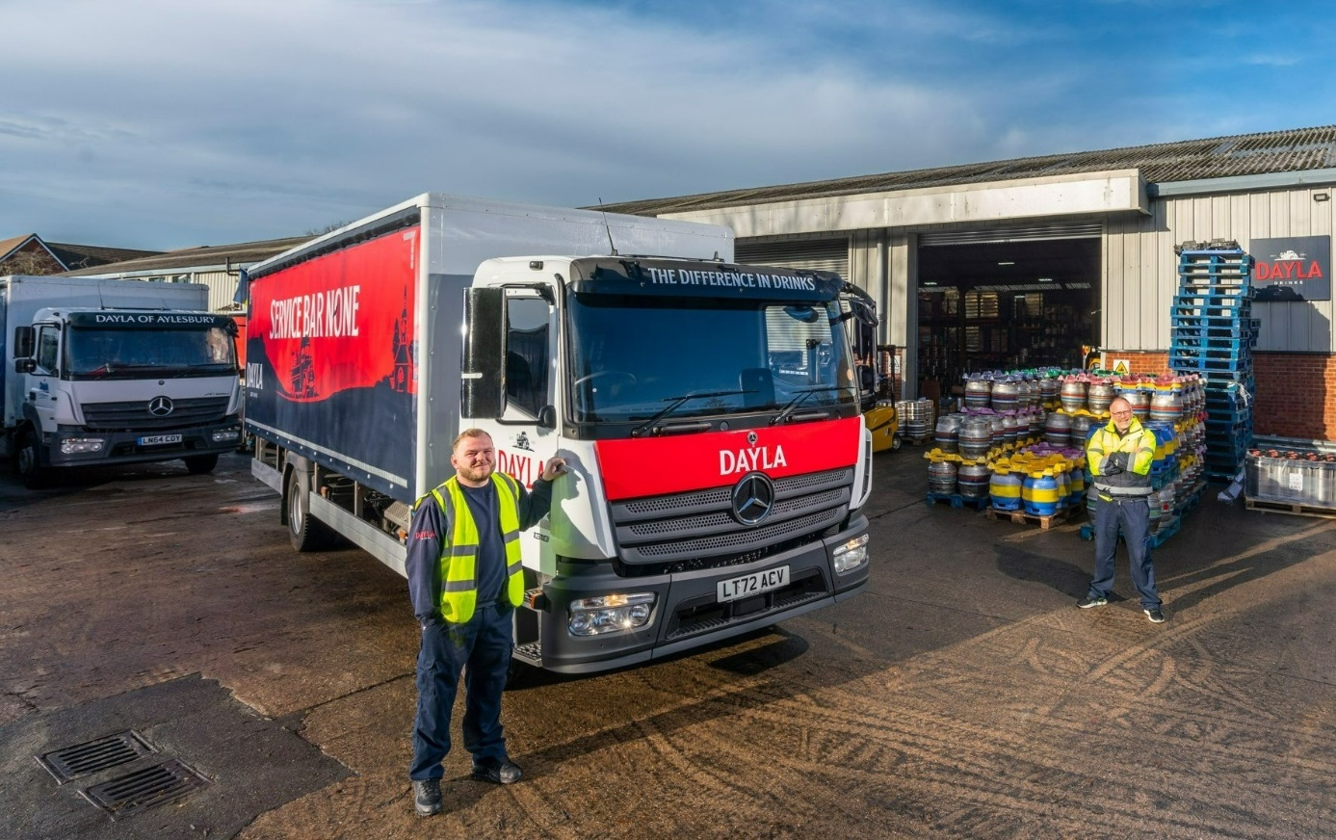

All in a Dayla’s work: Drayman Brett Barnes, left, and Head of Operations Dayle Pearson

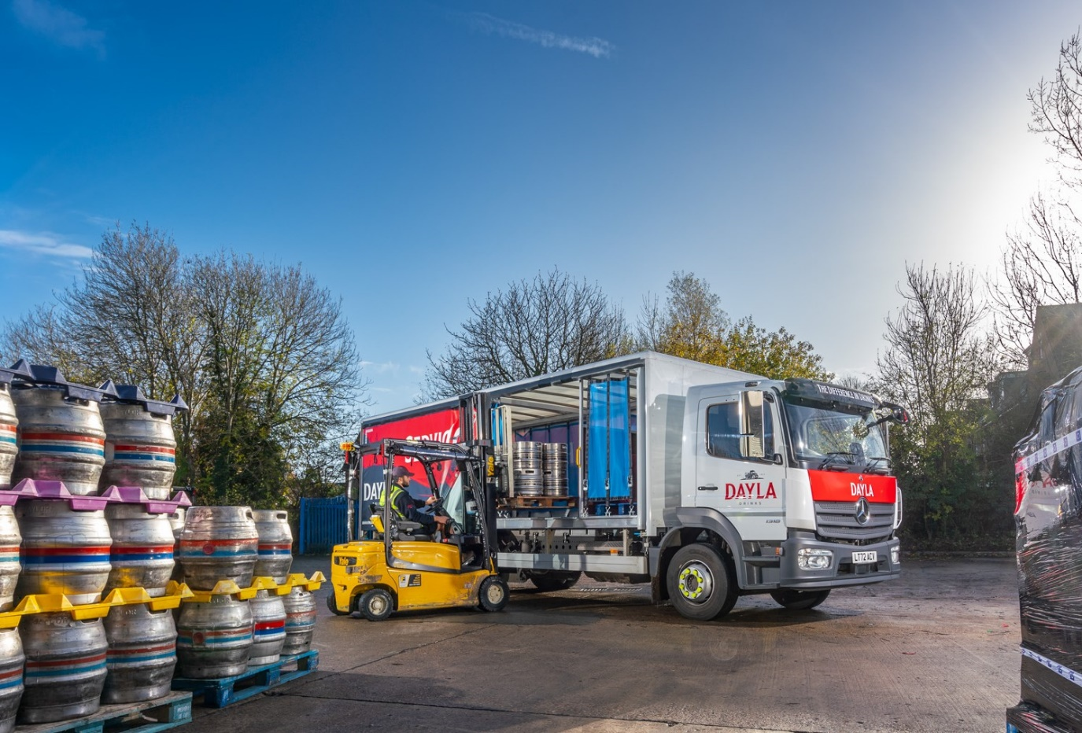

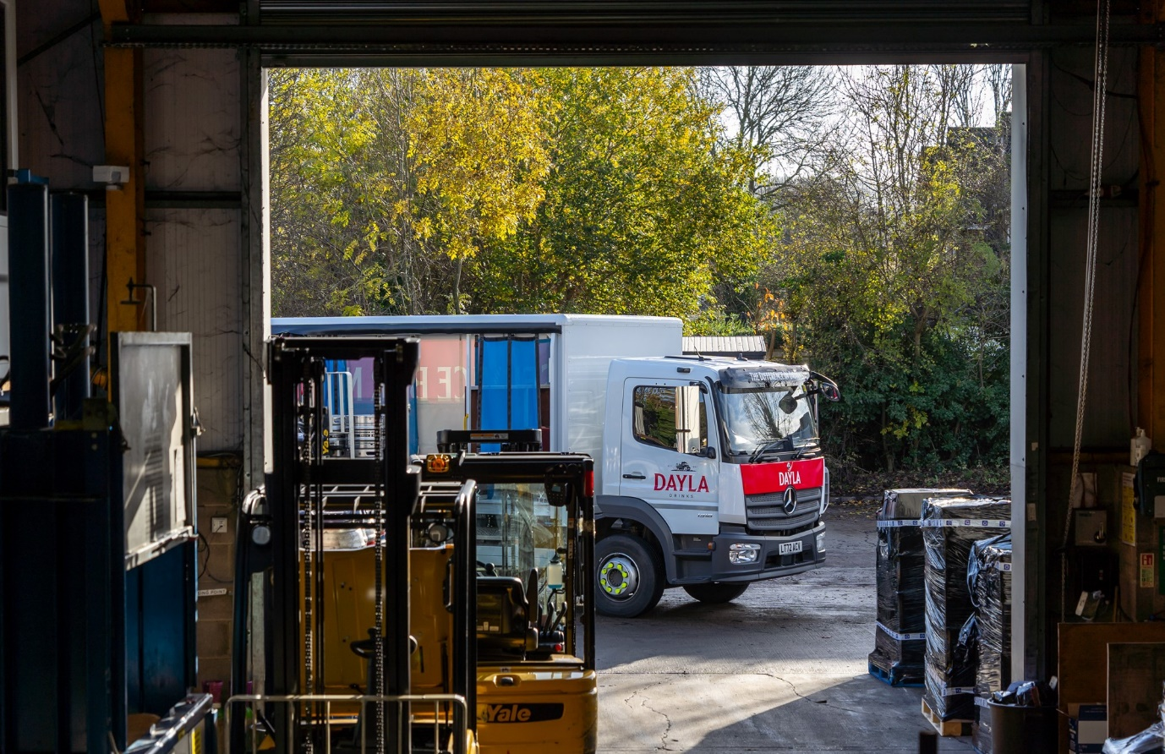

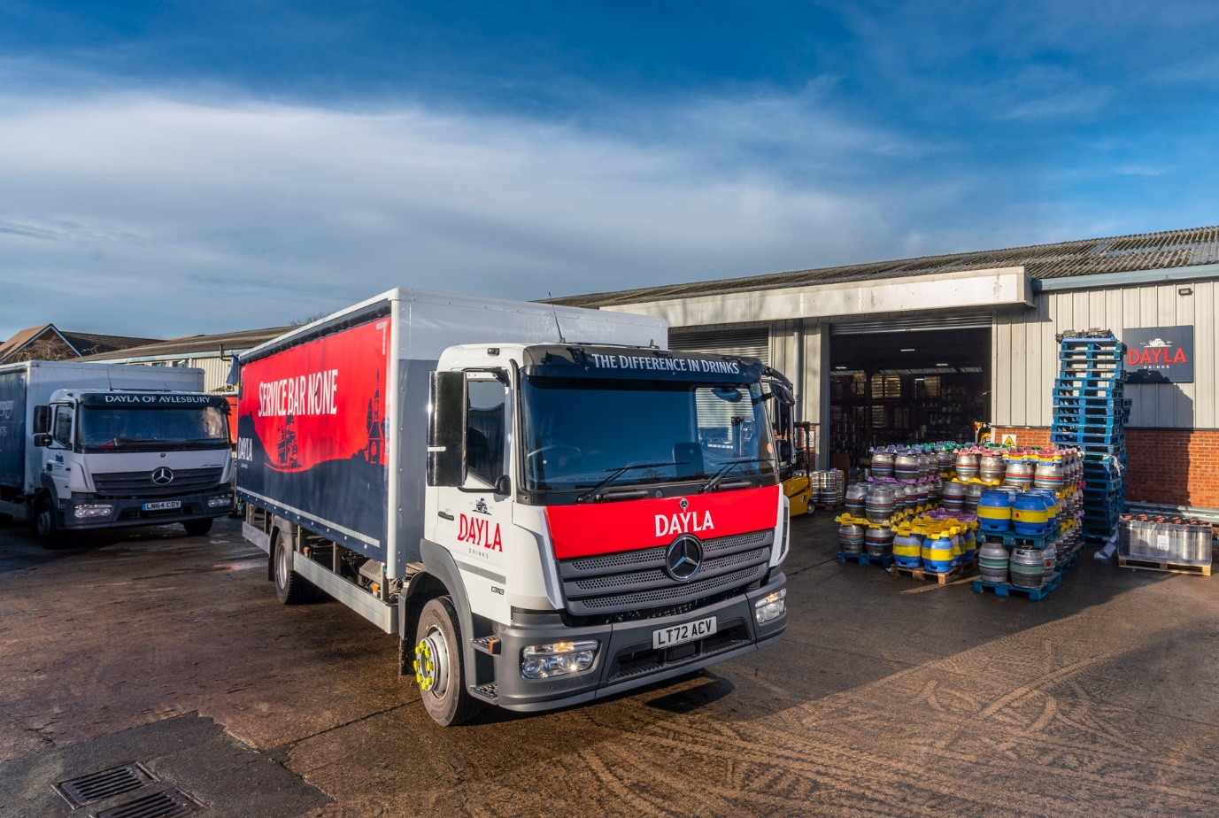

ends

For more information, or to request bigger/higher-res image files, please contact:
John Ripley or Steve Warren
Impact Communications
John: 07771 484595, john@impactcom.co.uk
Steve: 07770 470251, steve@impactcom.co.uk

