

Date: 28 December 2022

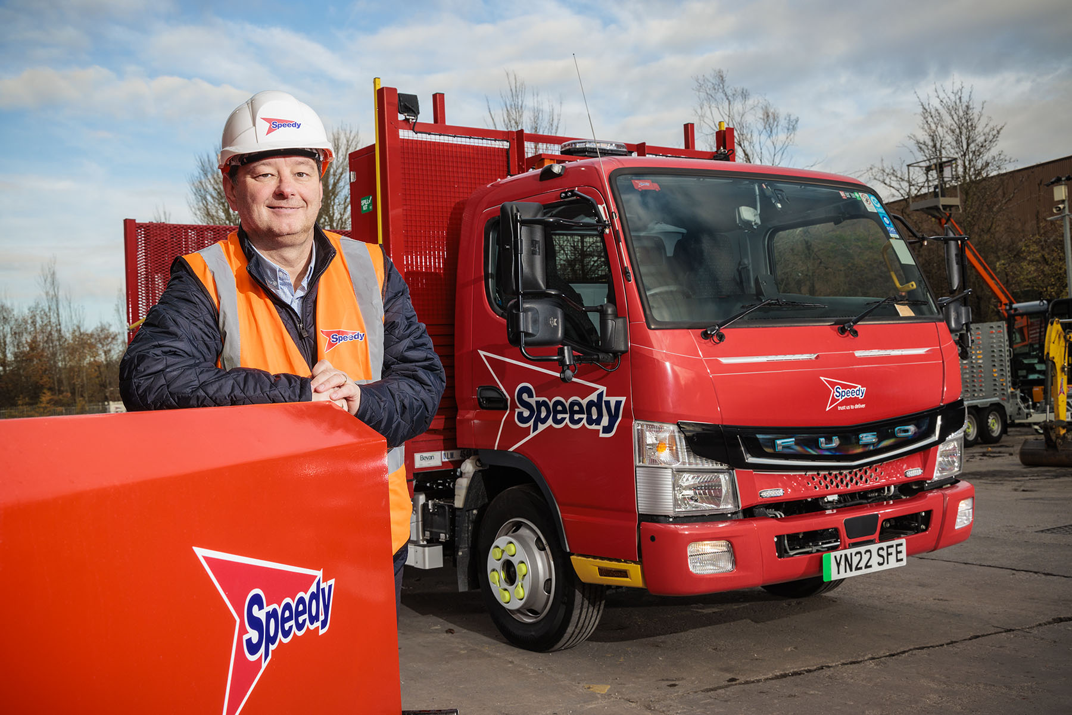

Green leader: Fleet Director Aaron Powell with one of Speedy Services’ first FUSO eCanter electric delivery trucks

Speedy accelerates towards a greener future with battery-electric FUSO eCanters

Leading tool and equipment hire specialist Speedy Services has taken a big step towards a sustainable customer delivery model by commissioning its first two zero-emission FUSO eCanters.

The trucks are now transporting products from the company’s comprehensive range. One is based at a depot near Whitehaven, Cumbria, which supplies contractors working at the Sellafield former nuclear power and fuel reprocessing site. The other works from a branch in Warrington, where it serves a client base comprised largely of building firms.

This vehicle spent its first week of duty on a display stand at Speedy Expo 2022, in Liverpool, where the operator showcased its products and services to customers and suppliers.

Speedy’s Fleet Director Aaron Powell – winner (on 8 December) of the Private Sector Fleet Manager of the Year title at the Greenfleet Awards 2022 – said: “We’re keen to invest in low and zero-emission transport as quickly as is practically possible. We already have around 150 electric vans on our fleet but these eCanters are our first battery-powered trucks at 7.5 tonnes.

“We reviewed the market before settling on the FUSO eCanter. There are battery-electric alternatives available, but these are either aftermarket conversions or vehicles that are very new. The eCanter, by contrast, is a factory-built truck that is already well proven in operation and comes with a bumper-to-bumper warranty.

“Driveline aside, it’s also very similar to the diesel-engined Canters that have been providing reliable and cost-efficient service on our fleet for many years.”

Mr Powell continued: “At Speedy, we strive to be environmentally responsible because we recognise that it’s the right thing to do. But it’s also something that our customers expect from us.

“Increasingly, large corporate customers are demanding that every business in their supply chains should take all available measures to operate as sustainably as possible. In our case, that means investing in electric vans and trucks, so the eCanter is likely to feature prominently in our plans for the future.”

The world’s first fully electric light-duty truck to enter series production, the 7.5-tonne eCanter represents a major advance in the battle to improve air quality in towns and cities.

Its electric drivetrain employs six 13.8 kWh lithium-ion batteries with a total power output of 82.8 kWh (66 kWh usable). The permanent-magnet motor delivers 129 kW (180 hp) via a single-gear transmission in the rear axle. A single charge gives the truck an effective operating range of more than 62 miles (100 km), which is ample for many urban delivery applications.

Speedy’s fleet of more than 1,000 vehicles includes 50 at 7.5-tonnes GVW, more than half of which wear FUSO’s three diamonds badge. The new eCanters are the subject of a contract hire agreement with Daimler Truck Financial Services and fitted with plant-carrying platform bodies by Bevan Group; these have dropsides incorporating the Black Country bodybuilder’s patented Safe-T-Drop system.

“With an exceptionally high body and payload allowance, compact footprint and tight turning circle, the diesel Canter has proved to be well suited to our demands,” continued Mr Powell. “The battery-powered version combines the same advantages with a smooth and quiet electric driveline that requires no gearchanges so is even easier and more comfortable to drive.

“Factor in the impressive build quality, reliability and aftersales back-up we’ve come to expect from the brand, and it’s easy to see why we’re delighted with our first eCanters.”

Speedy has been delivering excellence to its base of more than 50,000 customers for over 45 years. The company offers in excess of 300,000 itemised assets from its network of 200 depots across the UK and Ireland, as well as providing expert training, testing, inspection and certification services.

Speedy already enjoys a strong reputation for sustainability. In 2007 it became the first hire provider to offer bio-fuel generators. A year later it launched the EnviroCabin range of environmentally friendly site accommodation, followed in 2009 by the ‘Greener from the Ground Up’ initiative to help customers reduce waste and improve energy efficiency. A prestigious Green Apple Award, in 2012, is just one of many accolades won by Speedy in recognition of its efforts to operate as responsibly as possible.

www.speedyservices.com

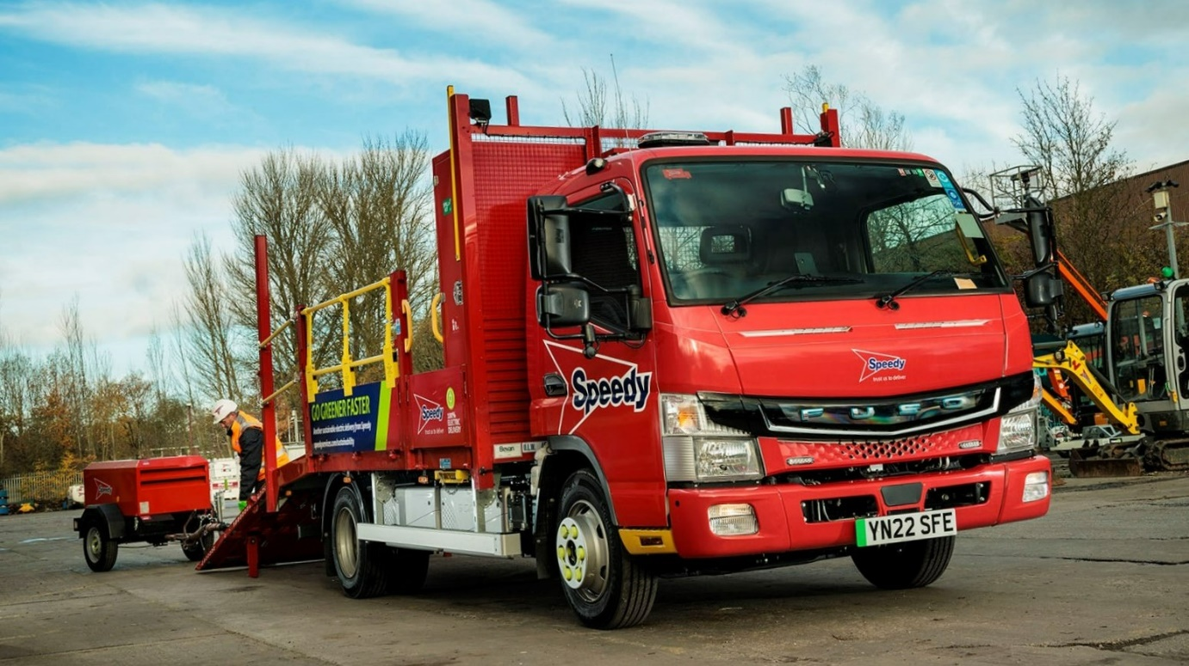

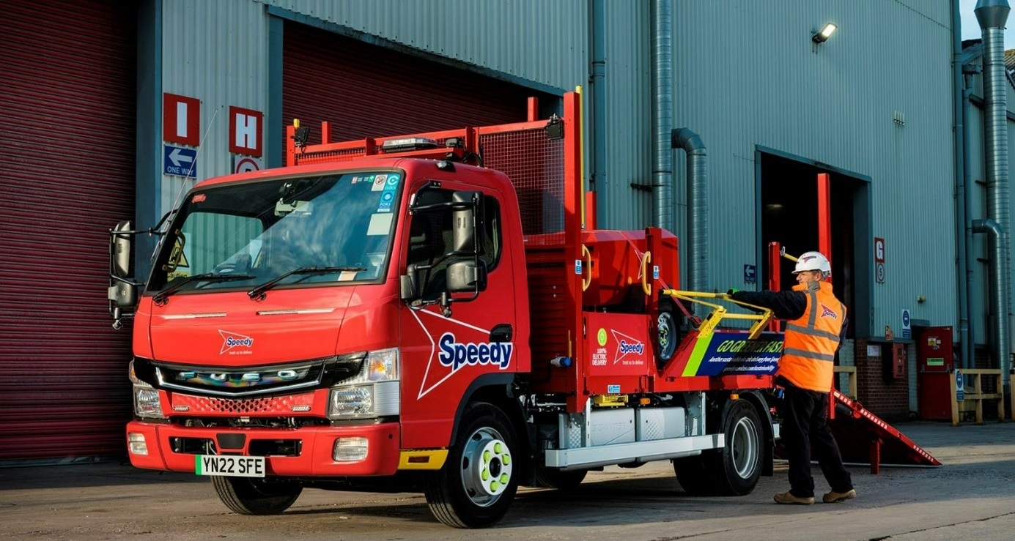
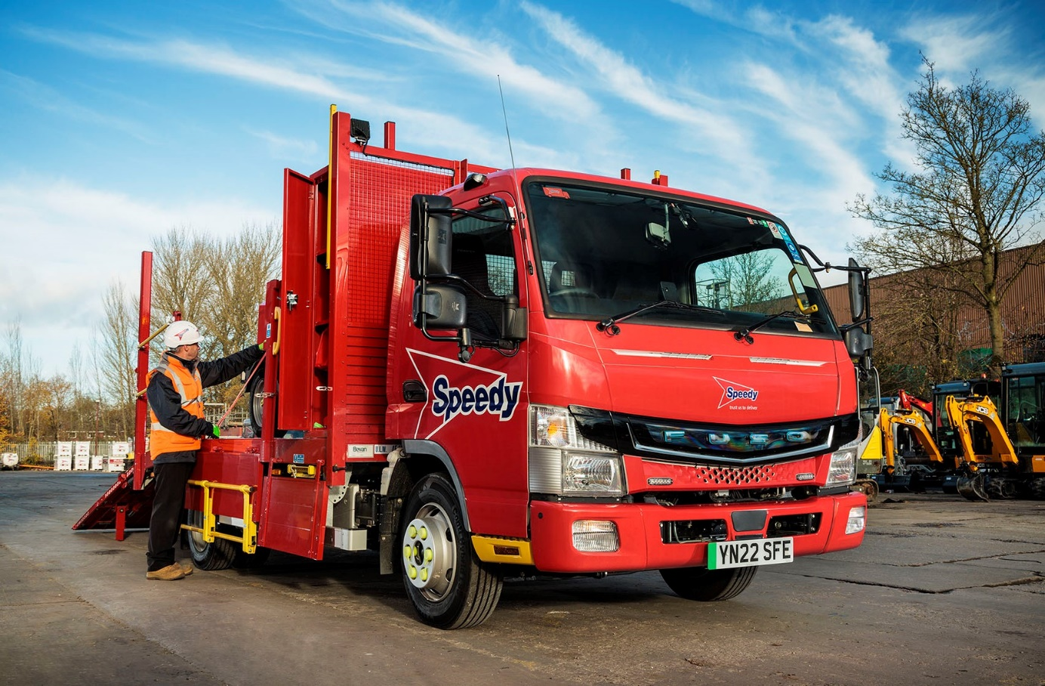

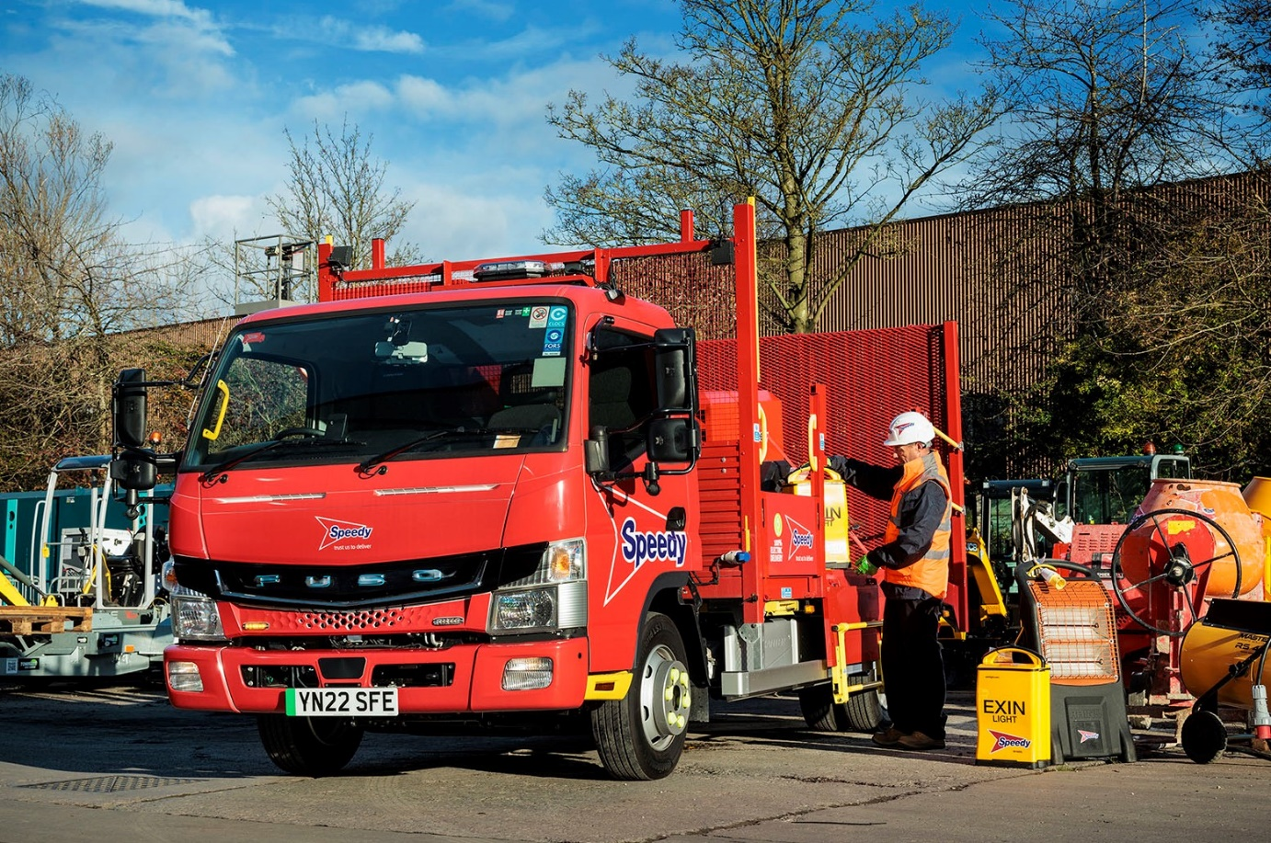

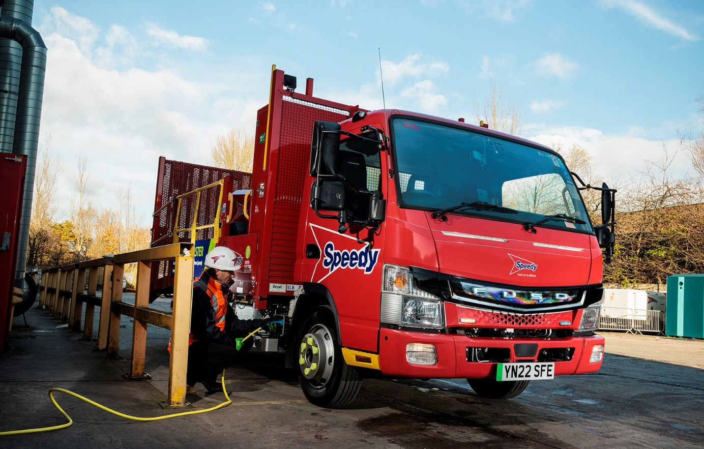

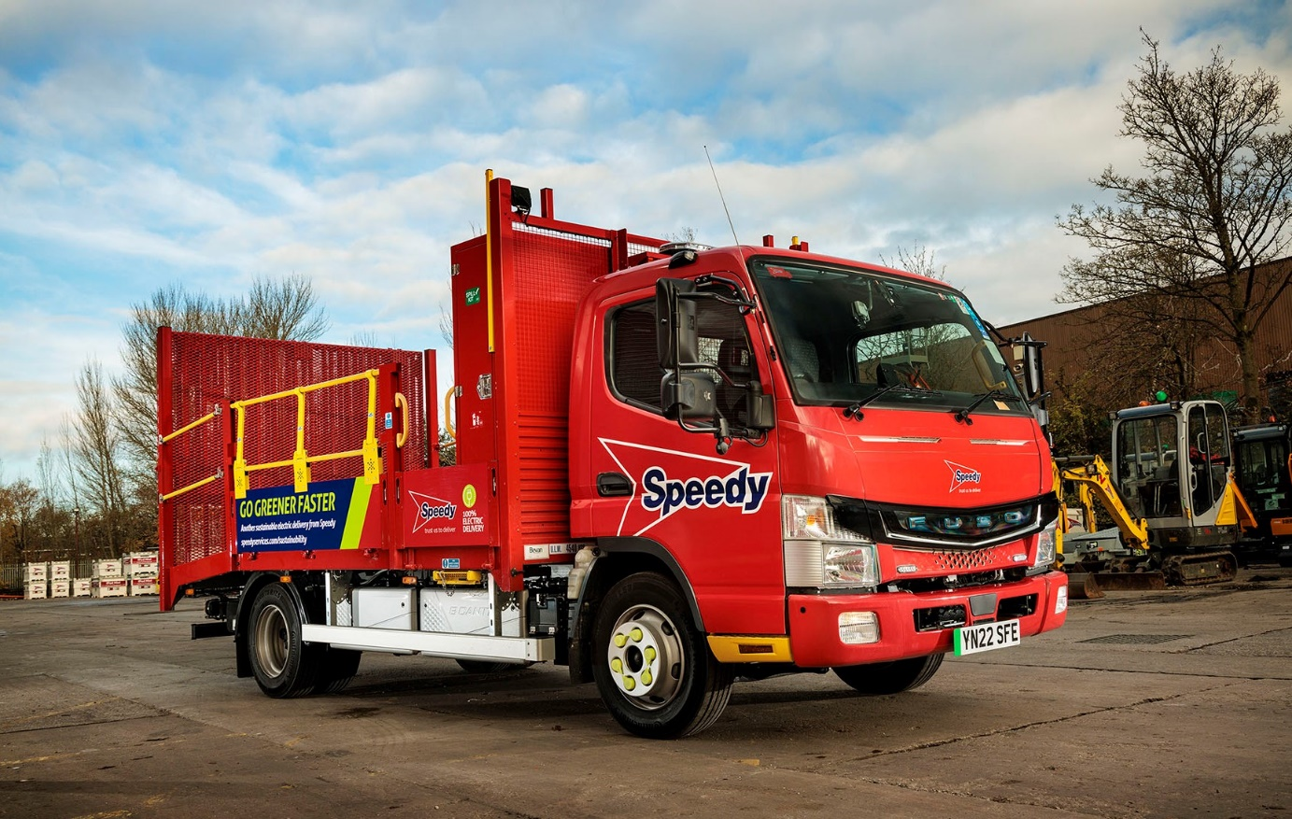

ends

For more information, or to request higher-res image files, please contact:

Jamie Fretwell at Mercedes-Benz Trucks UK Ltd
07712 519230, jamie.fretwell@daimlertruck.com

or

John Ripley or Steve Warren
Impact Communications
John: 07771 484595, john@impactcom.co.uk
Steve: 07770 470251, steve@impactcom.co.uk

