

Date: 30 December 2022

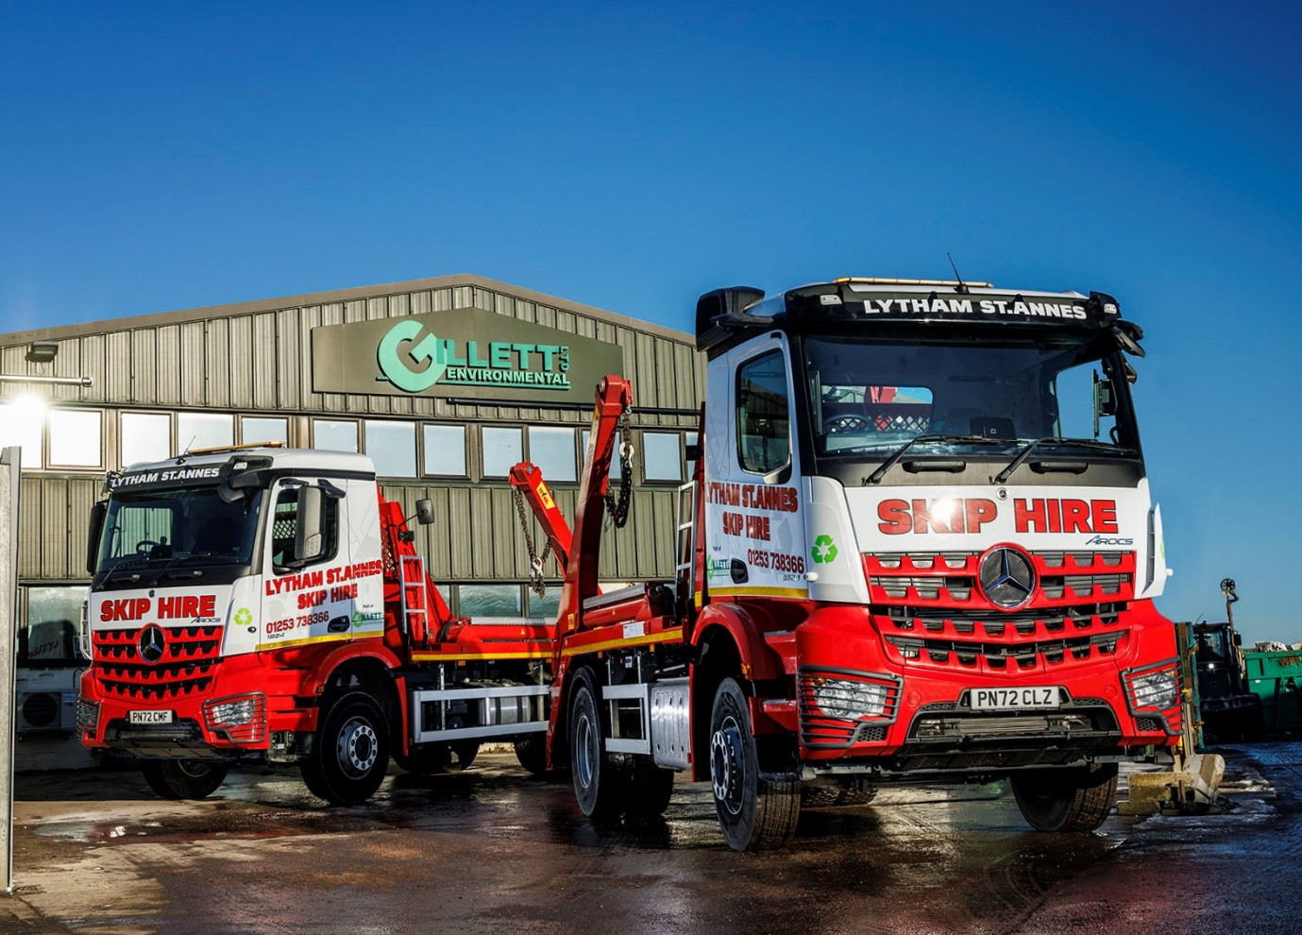

Gillett sharpens its edge with first MirrorCam-equipped Mercedes-Benz from Ciceley Commercials

Lancashire-based waste management specialist Gillett Environmental has commissioned the first two trucks from a clutch of six Mercedes-Benz skiploaders ordered to support its ambitious growth strategy.

The company operates on a national basis but trades locally as Lytham St Annes Skip Hire. Supplied by Ciceley Commercials, its latest Arocs 18-tonners all represent extensions to a fleet in which Mercedes-Benz was already the dominant brand.

This, however, is the first time that Gillett Environmental has sourced vehicles from a member of the manufacturer’s franchised network. Having previously used an independent garage for servicing, it will also be relying for the first time on an official Mercedes-Benz Dealer for aftersales back-up.

Gillett Environmental’s new Arocs are the subject of a Daimler Truck Financial Services contract hire agreement, under which they will be inspected and maintained by the workshop team at Ciceley Commercials’ flagship Blackburn branch.

All are 1824 variants with ClassicSpace M-cabs and twin-screen Multimedia Cockpit dashboards, which are stylishly modern in appearance and intuitively easy to use. The trucks employ 7.7-litre in-line six-cylinder engines produce 175 kW (238 hp) and are paired with eight-speed Mercedes PowerShift 3 automated manual transmissions.

The Arocs range was purpose-designed for construction-related applications and the muscular chassis were additionally specified with factory sun visors and protective headlamp grilles. Their skiploading gear, meanwhile, is being supplied and fitted by Hyva UK, of Stretford, Manchester.

In another first for Gillett Environmental, one of the two Arocs already in service is equipped with MirrorCam, the manufacturer’s ground-breaking alternative to conventional mirrors. Likewise, the final three, which will be delivered early next year.

Director Joe Gillett recalled: “Prior to placing our order we trialled one of Ciceley Commercials’ demonstration units for a couple of weeks and gave it to one of our longest-serving drivers, who loved the Arocs and was very positive about MirrorCam. He was pleasantly surprised at the level of enhanced visibility, as well as the reduced fatigue he felt after a day’s work in the truck.”

Relayed to screens mounted on the A-pillars inside the cab, the images from the roof-mounted cameras remain crisp and clear, even when it’s raining, so drivers no longer have the hassle of wiping water and road debris from standard wing mirrors. Not only do they benefit from greatly improved rear visibility, but the absence of conventional mirror housings also eliminates large, forward-facing blind spots.

As well as providing a professional and efficient hire services covering a full range of skips, Gillett Environmental works with ‘blue chip’ businesses and local authorities to ensure that materials such as plastic, wood, cardboard, plasterboard and hardcore are segregated from mixed waste streams and responsibly reprocessed at its recycling facility in Lytham St Annes.

The family concern was established by Andy Gillett senior in the early 1980s. The founder remains a Director but passed on responsibility for the day-to-day running of the business in 2008 to his sons Joe and Andy junior.

In addition to its latest Arocs Gillett Environmental operates 14 other trucks, most of which also wear three-pointed stars. While 18-tonne skiploaders form the backbone of the fleet, the line-up also includes three 32-tonne hookloaders and a pair of 7.5-tonners.

One of the smaller vehicles – an 814 model first registered in 1995 – is something of an ‘heirloom’. “That truck’s been brilliant!” enthused Joe Gillett. “We’ve had it reupholstered and repainted, and it still sails through its MOT every year.

“Their exceptional reliability and durability go a long way towards explaining why we’ve favoured Mercedes-Benz trucks over the years, and still do so to this day. When issues have cropped up, which you’ll always get with even the best trucks if you work them hard enough, they’ve always been relatively minor and less expensive to resolve than those we’ve experienced with other brands.”

Although Gillett Environmental had not purchased trucks from Ciceley Commercials before, its previous maintenance provider relied on the Dealer for factory-approved GenuineParts. “Ciceley’s delivery service ran like clockwork, which says a lot for its commitment to keeping its customers’ vehicles on the road,” said Mr Gillett.

“We’ve also been impressed with the support provided by Truck Sales Executive Diane Boag and her Dealer Principal Mike Lewis, who have been very responsive and pulled out all the stops to get the new trucks to us as quickly as possible.”

He added: “Our client base continues to expand because we always deliver on our promises, and we do so in a manner that’s 100% compliant. Customers benefit from our extensive social value efforts, as well as our niche 24-hour service guarantee, which ensures their skips are moved when they need them to be and keeps sites flowing as they should. By remaining true to our core family values we’ve also retained the loyalty and respect of our staff, and as we grow, so do they.”
gillettenviro.com

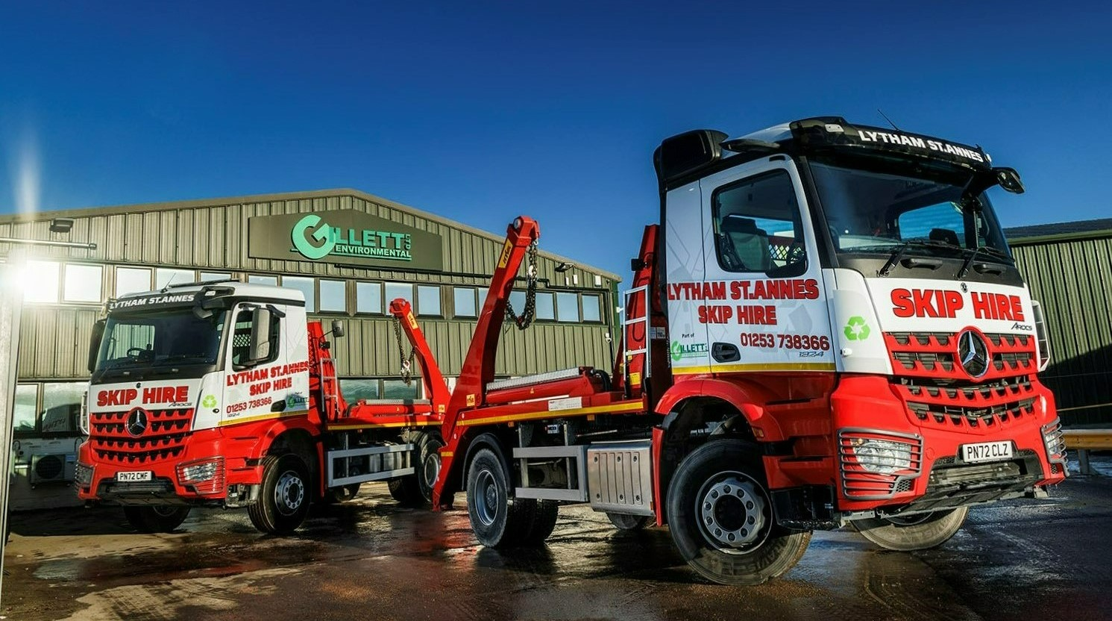
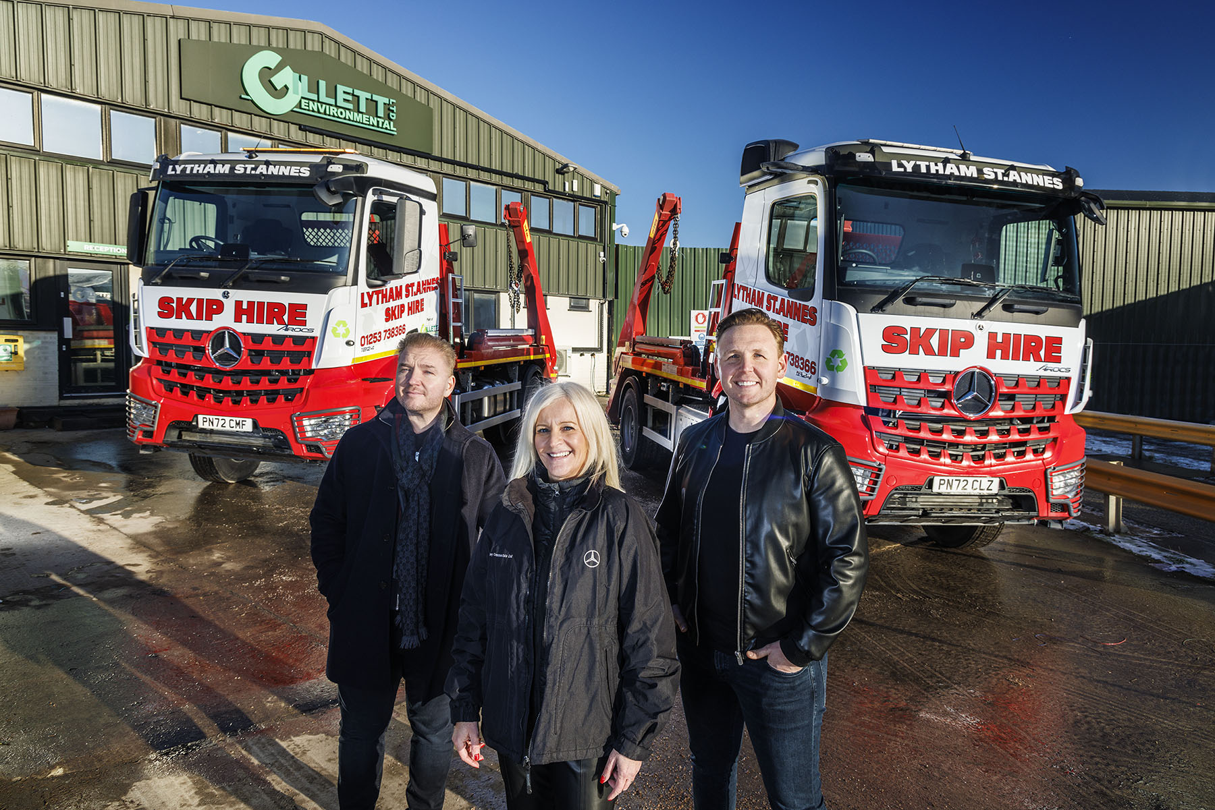

Brand of brothers: Andy, left, and Joe Gillett are pictured with Ciceley Commercials Truck Sales Executive Diane Boag, and their two new Mercedes-Benz Arocs

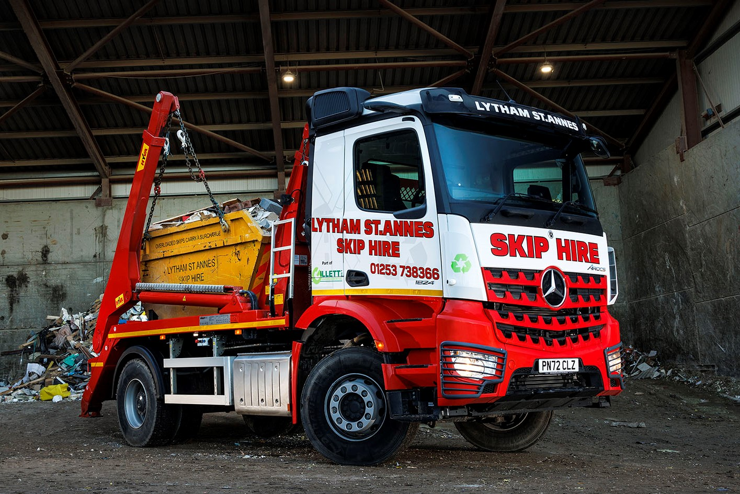

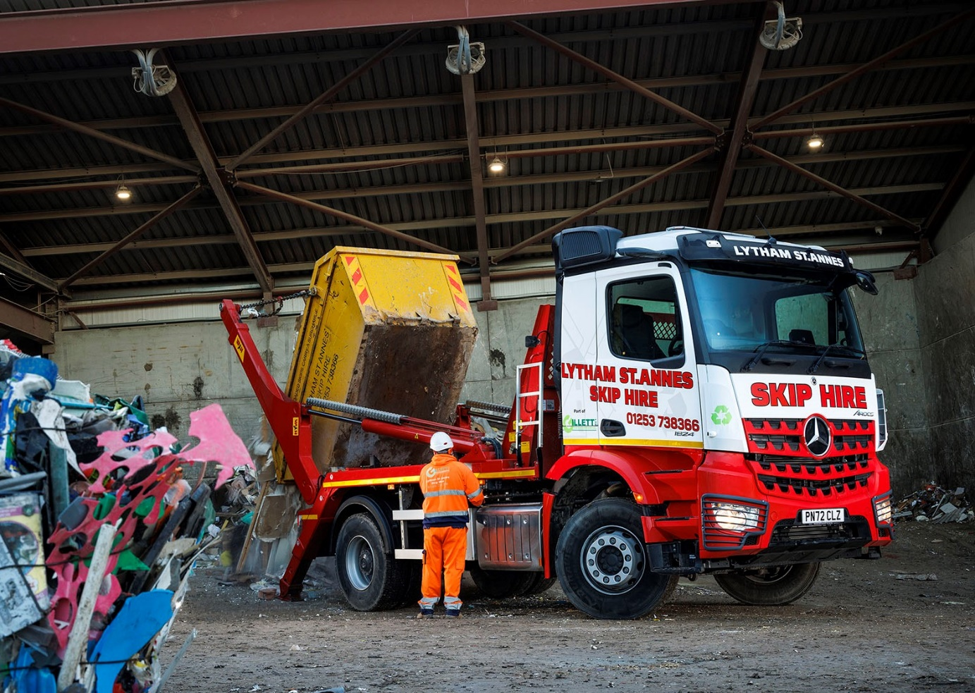

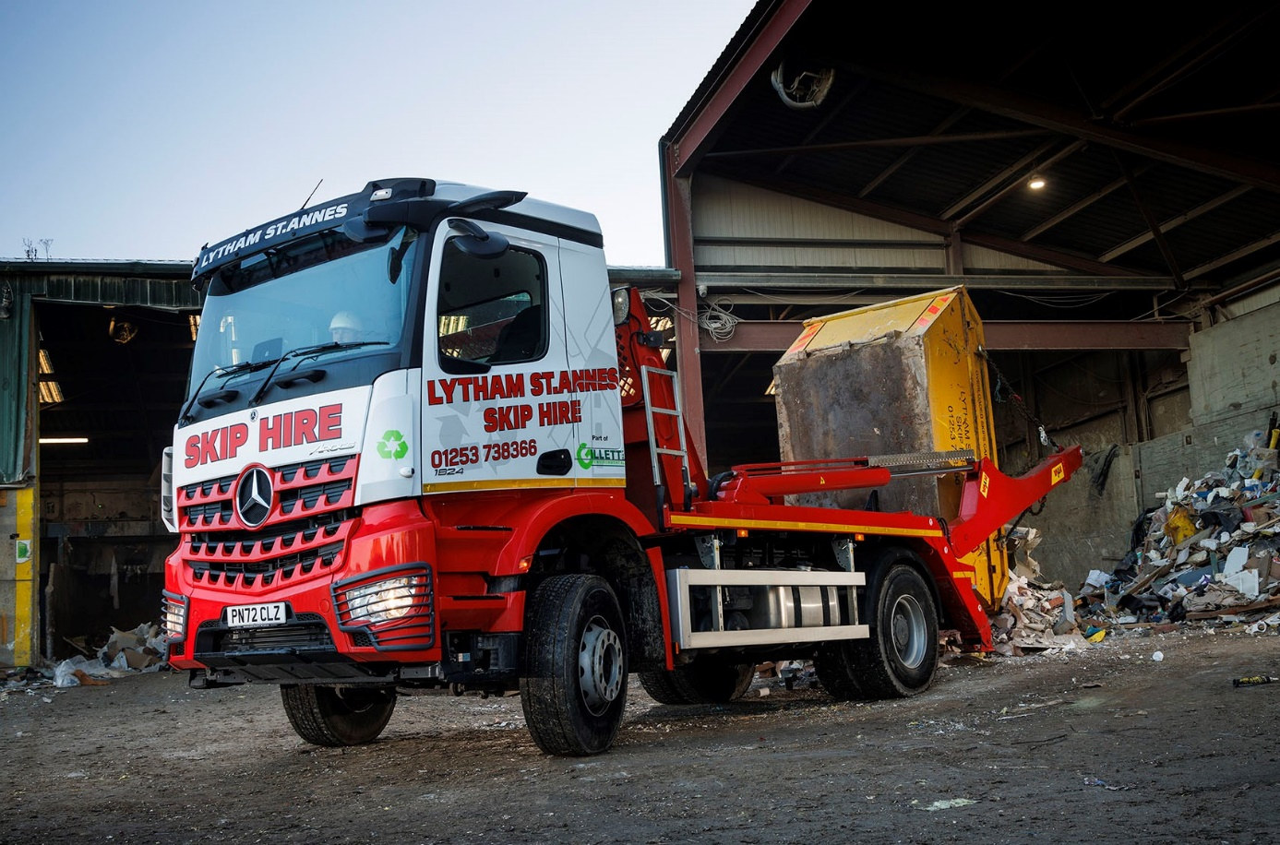

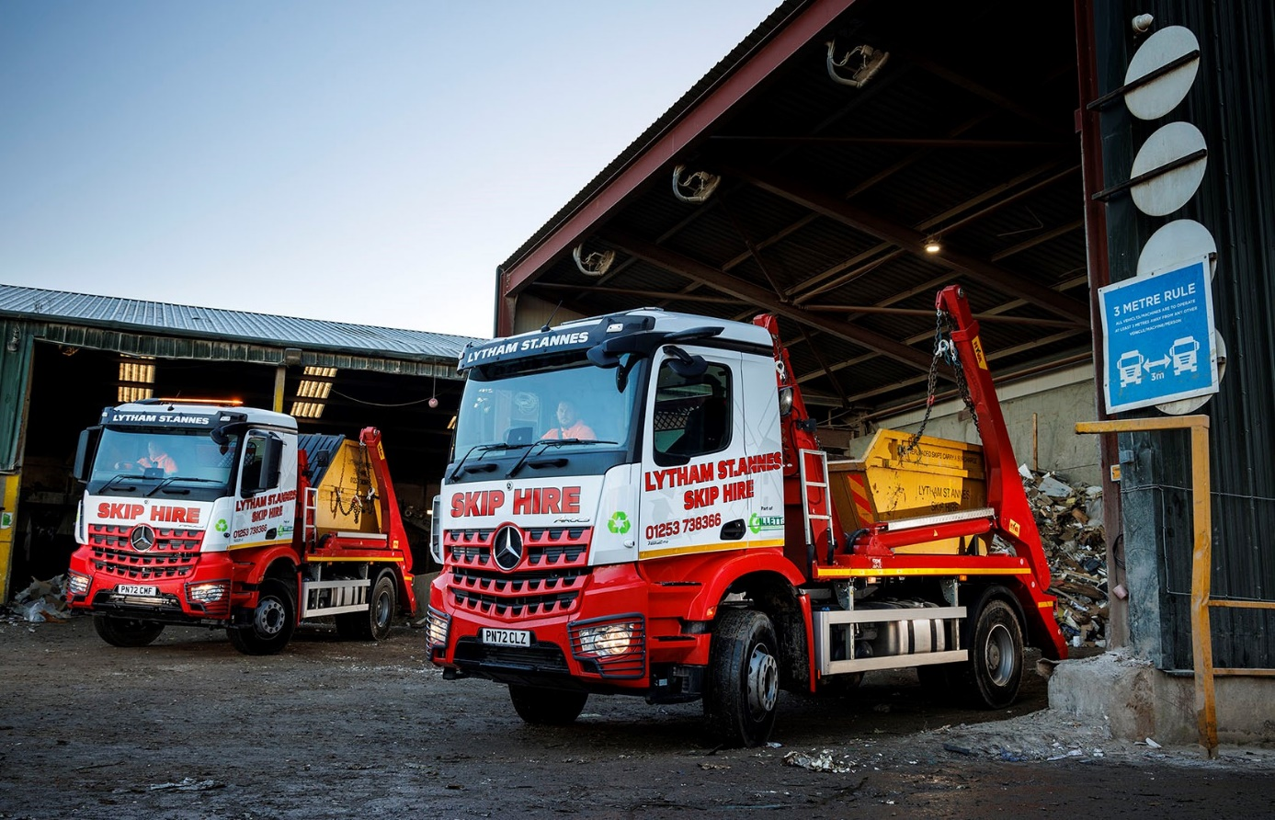



Visibly better: Alan Towle is driving Gillett Environmental’s first MirrorCam-equipped Mercedes-Benz truck

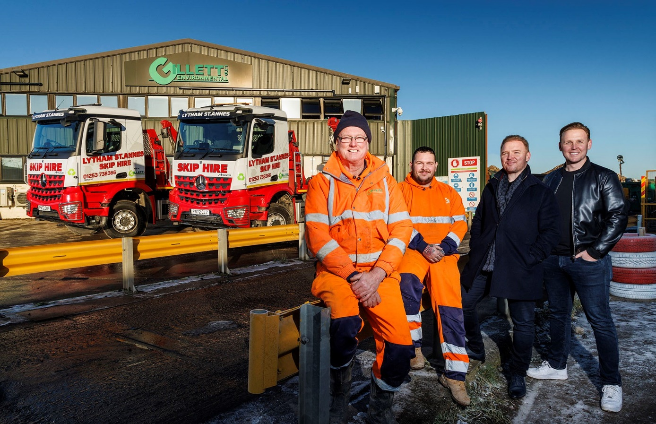

Going for growth: Gillett Environmental Directors Andy, second from right, and Joe Gillett are pictured with drivers Paul Clark and Alan Towle, and their two new Mercedes-Benz Arocs

ends

For more information, or to request bigger/higher-res image files, please contact:
Steve Warren or John Ripley
Impact Communications
Steve: 07770 470251, steve@impactcom.co.uk
John: 07771 484595, john@impactcom.co.uk

