

Date: 9 January 2023

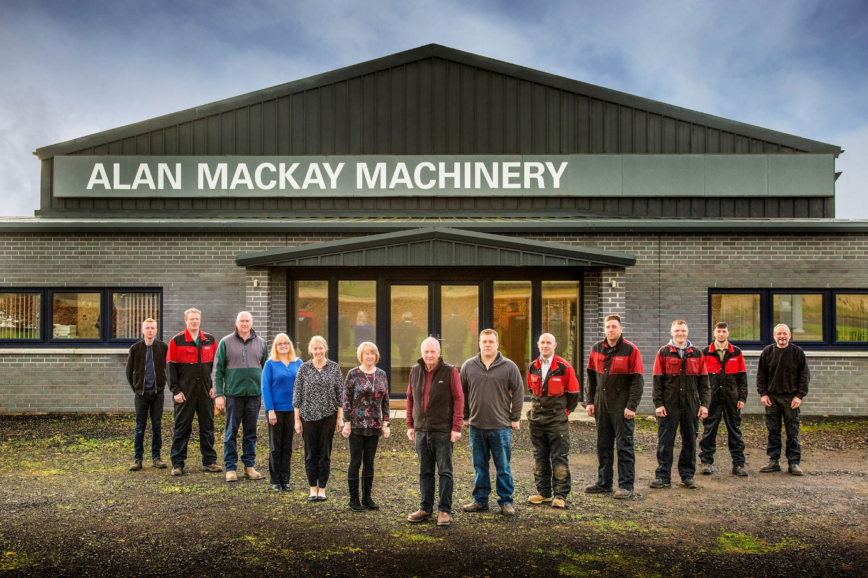

Up to the marque: Managing Director Alan Mackay, centre, and the AM Agri (Alan Mackay Machinery) company team now serving Mercedes-Benz Unimog customers in Scotland

Mercedes-Benz Unimog gains traction in Scotland as AM Agri joins its Dealer network

Mercedes-Benz Trucks UK has announced the appointment of agricultural specialist AM Agri (Alan Mackay Machinery) as its new Unimog Dealer in Scotland.

The Forfar-based company, which also operates from a second branch in Aberdeen, is proud to be adding the legendary 4x4 to the impressive portfolio of farm equipment brands it already represents.

While AM Agri will be selling as well as servicing Unimogs, the manufacturer has also recently added another three names to the roll call of those authorised to provide maintenance, repair and parts back-up for these uniquely capable vehicles.

The appointments of Blackburn’s Ciceley Commercials, Ferndown Commercials, of Wimborne, Dorset, and Rossetts Commercials, of Aldershot, in Hampshire, underscore Mercedes-Benz Trucks’ determination to extend its Unimog network and thereby ensure that operators receive the finest aftersales support.

AM Agri is jointly owned and managed by Alan Mackay and Ross Anderson, who, as Service Director, is also directly responsible for the smooth running of the workshop.

Ross Paterson, Head of Special Trucks at Mercedes-Benz Trucks UK, commented: “We are delighted to be welcoming AM Agri (Alan Mackay Machinery) to the Unimog family. As a highly experienced and trusted supplier to the agricultural community, our new point of representation in Scotland is well placed to grow the Unimog’s share of a key market.

“We now look forward to working with the company team to develop opportunities in some of the other sectors in which the multi-talented Unimog also excels. There will certainly be a focus on forestry, but the Unimog is also ideally suited, for example, to utilities operations, highways management, and special emergency services applications.”

The Unimog range encompasses gross weights from 7.5 to 16.5 tonnes and is built around two core variants: the UGE implement carrier and the UHE extreme off-roader, which can be fitted with many different types of body. Both offer an unrivalled combination of all-terrain performance, on-road speed, fuel-efficiency and flexibility.

The Unimog complements perfectly the array of tractors, cultivators, hay, grass and potato equipment, silage wagons, diet feeders and other miscellaneous farming machinery that AM Agri (Alan Mackay Machinery) already sells and supports.

In line with Mercedes-Benz Trucks’ Dealer standards, which are designed to ensure that franchisees can meet, and indeed exceed, the requirements of the most demanding Unimog customers, the new franchisee has invested heavily in product-specific tooling, parts inventory and technical training. It also looks forward to the imminent arrival of its first demonstrator, a U435 implement carrier.

The area AM Agri covers from Forfar is mainly arable, with wheat, barley, oats, rape and potatoes the predominant crops, while the Aberdeenshire region is home to a more mixed farming regime. Meanwhile, at more than a million hectares Scotland’s conifer woodlands are the biggest in the UK, and the forestry and timber processing industry is vital to the nation’s economy.

Initially, AM Agri will run the Mercedes-Benz franchise from its head office. However, as Managing Director Alan Mackay revealed: “We plan within the next year or so to open at a third location, to the south of Forfar – this will be our Unimog hub, and the base for our dedicated sales executive.”

Mr Mackay approached Mercedes-Benz Trucks UK after being invited to put a customer’s Unimog through its paces. “I was mightily impressed and quickly realised the vehicle’s commercial potential,” he recalled. “If you stand still in business then you’re actually going backwards, so I was keen to grasp the opportunity and contacted the Unimog team to enquire about franchise opportunities.

“Unsurprisingly, given the size of the organisation and its premium brand reputation, Mercedes-Benz Trucks’ representatives are extremely professional – a lot more so than we’ve been used to – and the process has been quite lengthy. Having cleared the final hurdles, though, we’re now a fully-fledged Unimog Dealer and very much looking forward to the next, exciting chapter in the story of our business.”

mercedes-benz-trucks.com/en_GB/brand/unimog-part-of-a-legend/become-part-of-a-legend

alanmackay.co.uk

AM Agri (Alan Mackay Machinery) – key contacts:
- Unimog Sales, Brian Thomson, Sales Manager, 07976 097035, brian.thomson@alanmackay.co.uk
- Unimog Service, Ross Anderson, Service Manager, 07881 652206, ross.anderson@alanmackay.co.uk

 facebook.com/alanmackaymachinery

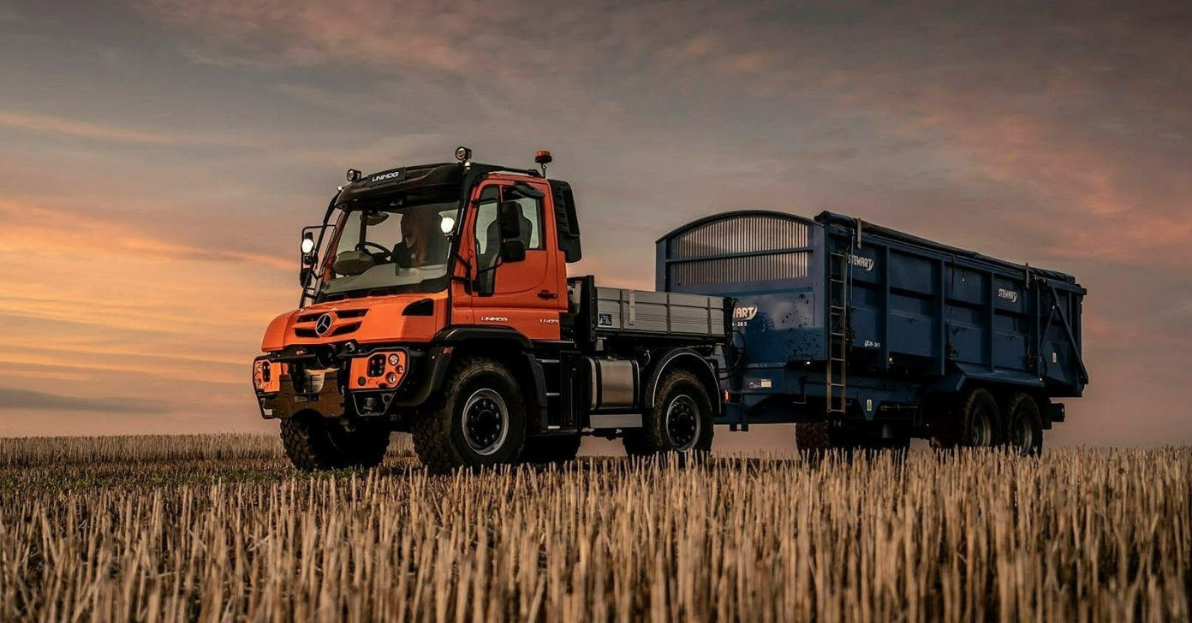

Cream of the crop: The Mercedes-Benz Unimog UGE implement carrier
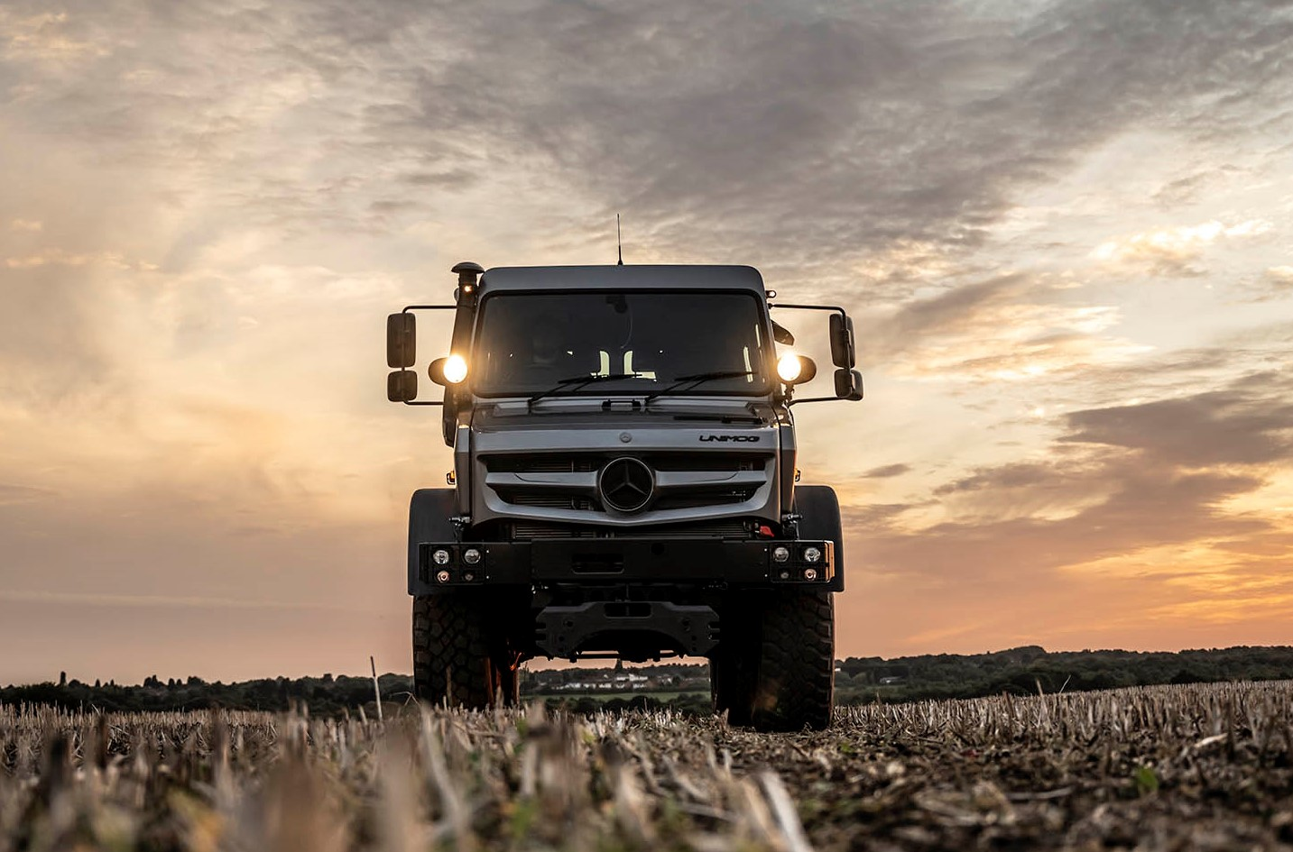

Leading the field: The Mercedes-Benz Unimog UHE

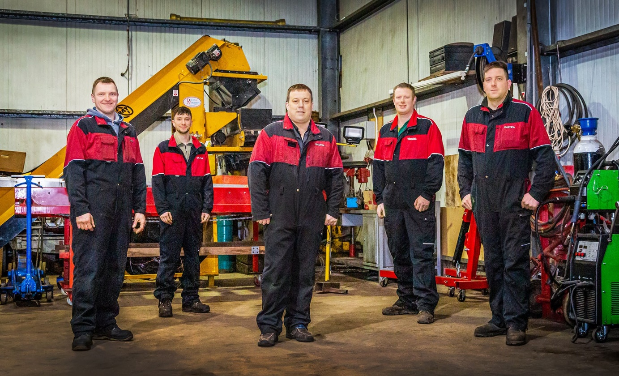

Raring to go: AM Agri co-owner and Service Manager Ross Anderson, centre, is pictured with technicians, from left, from left, Andris Petkevics, Kyle Baillie, Allan Graham and Stuart Taylor. Having undergone Mercedes-Benz training, they now look forward to supporting Unimog customers
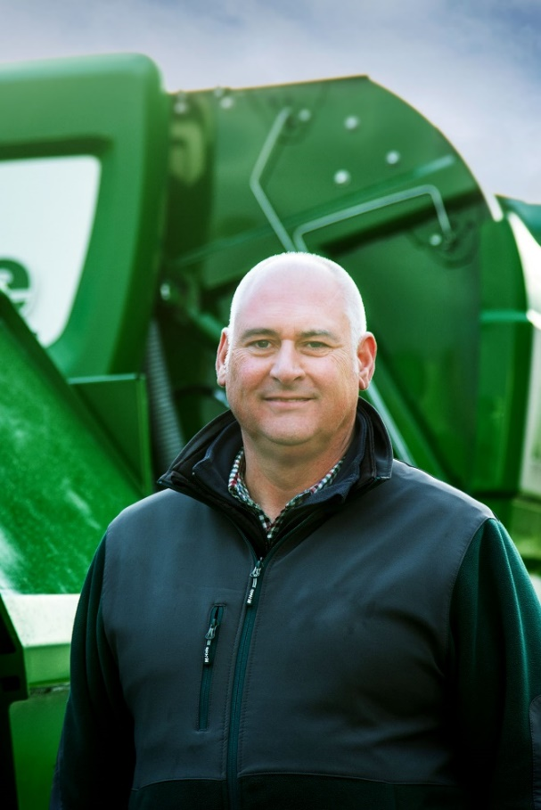

Fresh opportunity: Sales Manager Brian Thomson leads the drive to attract new customers

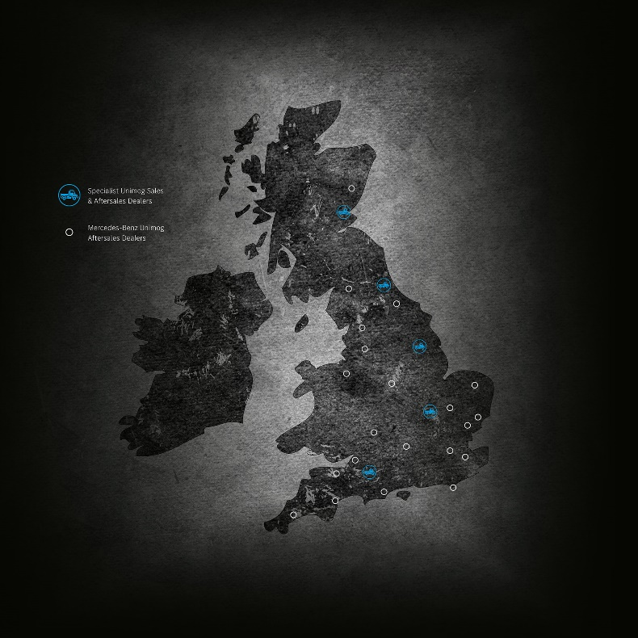

Comprehensive coverage: Scottish Dealer AM Agri is the latest addition to the
Mercedes-Benz Unimog network

ends

For more information, or to request higher-res image files, please contact:

Jamie Fretwell at Mercedes-Benz Trucks UK Ltd
07712 519230, jamie.fretwell@daimler.com

or

Steve Warren or John Ripley
Impact Communications
Steve: 07770 470251, steve@impactcom.co.uk
John: 07771 484595, john@impactcom.co.uk

