

Date: 16 January 2023

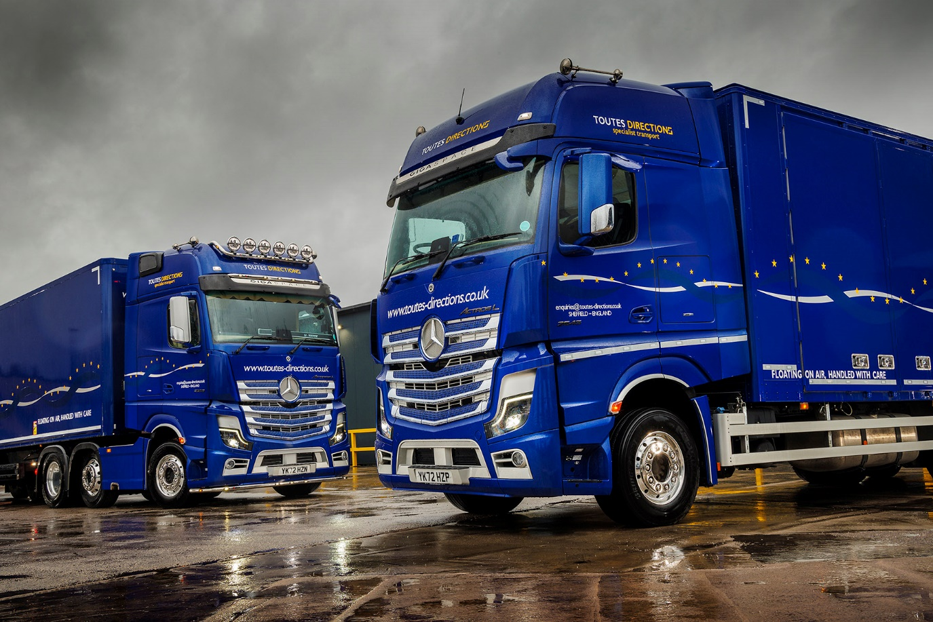

All roads lead to Mercedes-Benz for Toutes Directions

When Sheffield-based haulier Toutes Directions needed a new fleet flagship, a highly specified Mercedes-Benz Actros was the obvious choice.

Plated for operation at a gross combination weight of 68 tonnes, the Actros 2553 arrived via the local branch of Dealer Northside Truck & Van, recently named Commercial Motor’s Dealer of the Year. It has a range-topping, flat-floored GigaSpace cab and is powered by a muscular 390 kW (530 hp), 12.8-litre in-line six-cylinder engine.

The truck also boasts an array of optional upgrades, including the interactive version of the radical, twin-screen Multimedia Cockpit dashboard. Other highlights that really help it to stand out include a StyleLine interior with aluminium-effect and chrome trim, a sliding and tilting electric sunroof, and leather-covered seats and steering wheel. Meanwhile, long-serving driver Peter Molnar also gets automatic climate control, a luxury top bunk, a TV and DVD player, and a pull-out fridge and microwave oven.

“In this case we ticked virtually every box on the extras list, but we always specify our trucks highly,” explained Transport Manager Tom Harrison. “We do so to reward and retain our excellent drivers, not least because around 25% of our work entails long-distance European haulage. If we’re asking the guys to live in the cab for a couple of weeks at a time, it’s only fair that we give them a comfortable environment.”

The latest addition to the company’s fleet of more than 20 Mercedes-Benz trucks will fulfil a variety of roles, including some heavy haulage work. “We have quite an assortment of different trailer types and it could be used with any of them on any given day,” reported Tom.

Peter Molnar previously drove a highly specified 4x2 Actros tractor with 330 kW (450 hp) ‘straight-six’. “It was a great vehicle,” he recalled. “I’d had that truck from new and become very attached to it.

“To be honest, I wasn’t exactly eager to swap, but the new Actros has blown me away. It’s a significant upgrade, and not only in terms of power. The new technology, including Proximity Control Assist and the latest version of Predictive Powertrain Control, makes the vehicle so easy to drive, and it’s a great cab in which to live and work over a long trip.”

In addition to the new tractor unit, Northside Truck & Van has just supplied Toutes Directions with its first 26-tonner. A 6x2 Actros 2545 variant, this also has a GigaSpace cab and is powered by a 330 kW (450 hp) engine. Micra Truck Bodies, of Wakefield, fitted its box body.

“We’ve always operated artics and 18-tonners but this new rigid gives us another option,” said Tom Harrison. “It will be perfect for deliveries that require a bigger vehicle, but for which the access might be a bit too tight for a tractor and trailer. For added flexibility, the body features very wide-opening side doors which combine the best features of a rigid box and a curtainsider.”

Toutes Directions was established by Tom’s father, Mark Harrison in 1978, initially to move catering equipment. However, it quickly carved out a niche for itself as a specialist transporter of mainframe computers. Today, the company delivers and installs all sorts of high-value equipment, for customers from the IT, medical, catering, and other sectors.

Although still involved, Mark has passed responsibility for the day-to-day running of the business to sons Tom and Oliver. A qualified technician who served a Mercedes-Benz apprenticeship with Northside Truck & Van, Oliver runs the workshop in which its vehicles are maintained.

“Our Mercedes-Benz trucks have given us reliable and cost-effective service for almost 30 years now, which is why we keep coming back for more,” said Tom. “Not only are they fuel-efficient, popular with our drivers, and well supported both here in the UK and in Europe, but they also look fantastic and in our metallic blue livery help us to convey the right image of quality and service.

“We’re also delighted with the support we receive from Northside Truck & Van,” he added. “Sales Executive Christian Wordsworth is the best we’ve ever worked with, in terms of the amount of time and effort he puts in to understand the nature of our business and our precise requirements. He also stays in regular contact, irrespective of whether or not we’re in the process of placing an order.”

www.toutes-directions.co.uk

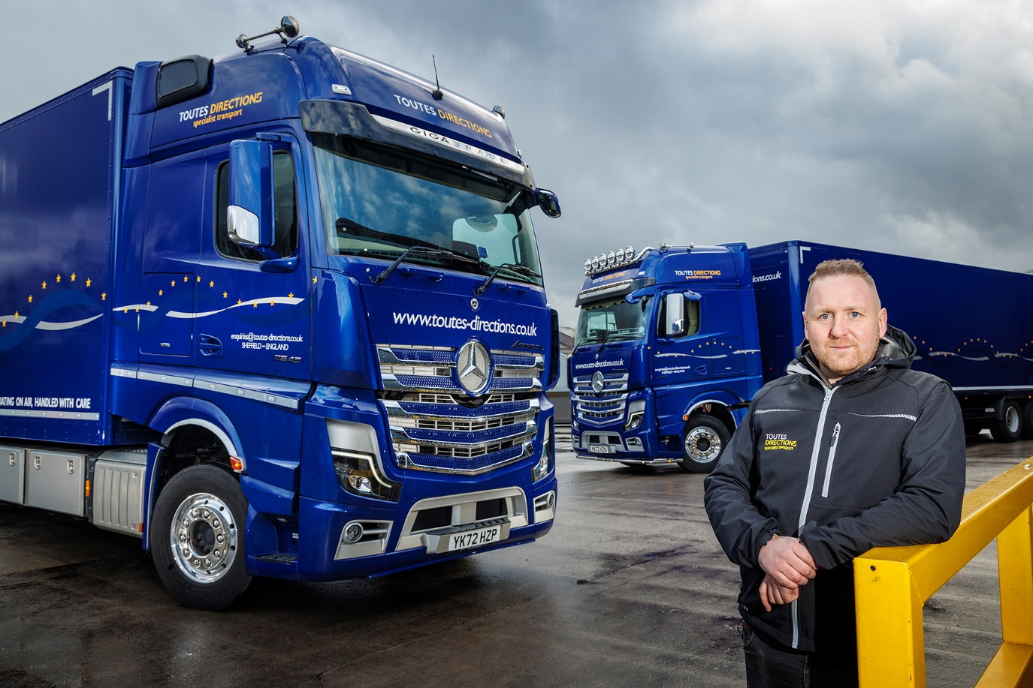

Blue leaders: Transport Manager Tom Harrison is delighted with his latest Actros

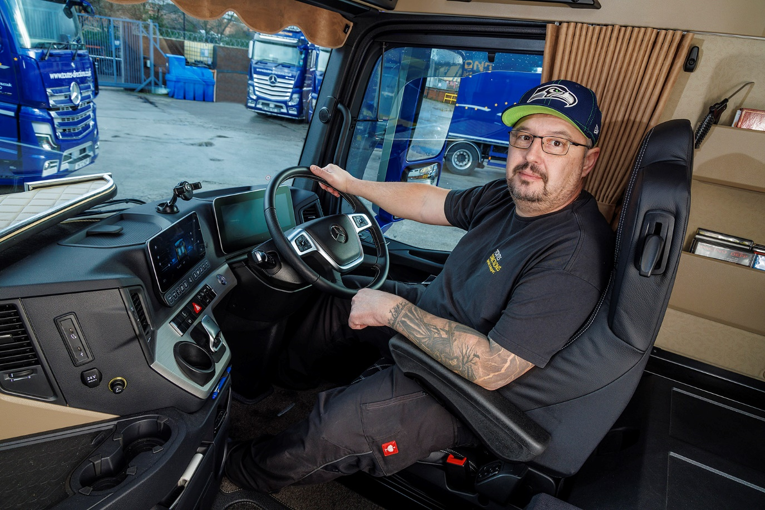

Home from home: Driver Peter Molnar in the luxurious cab of his new Actros 2553

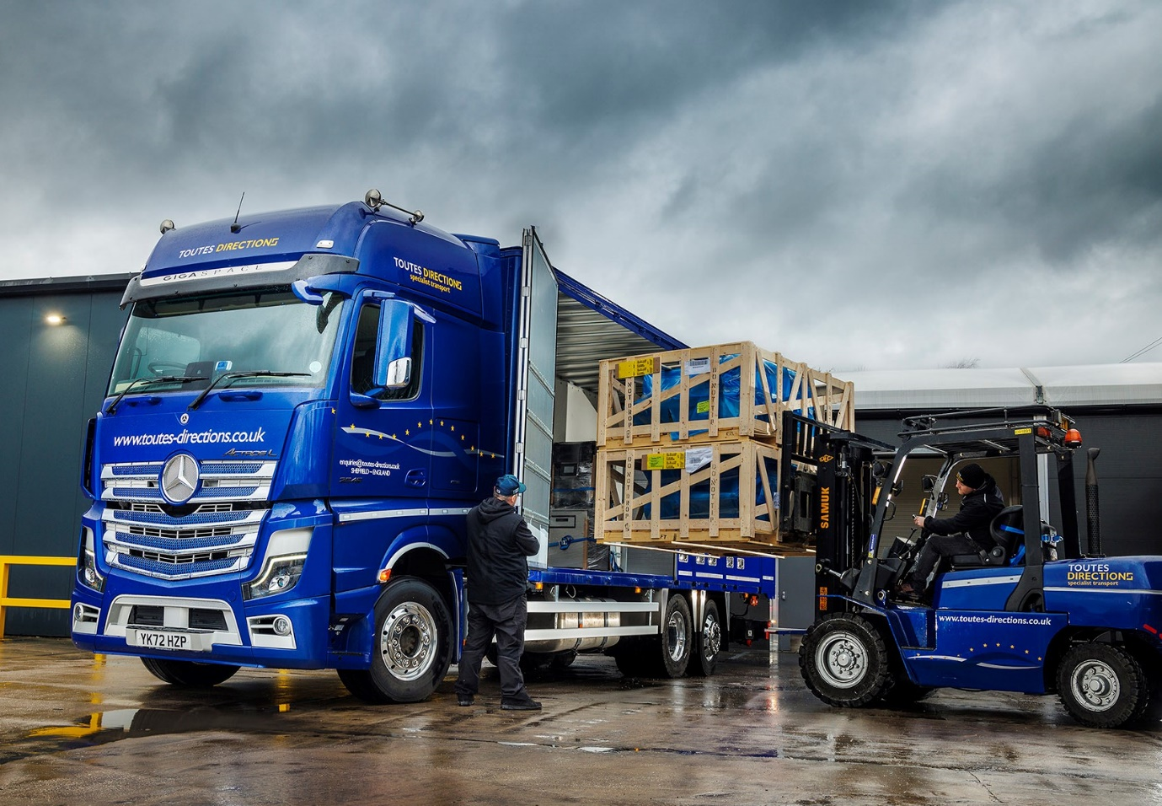

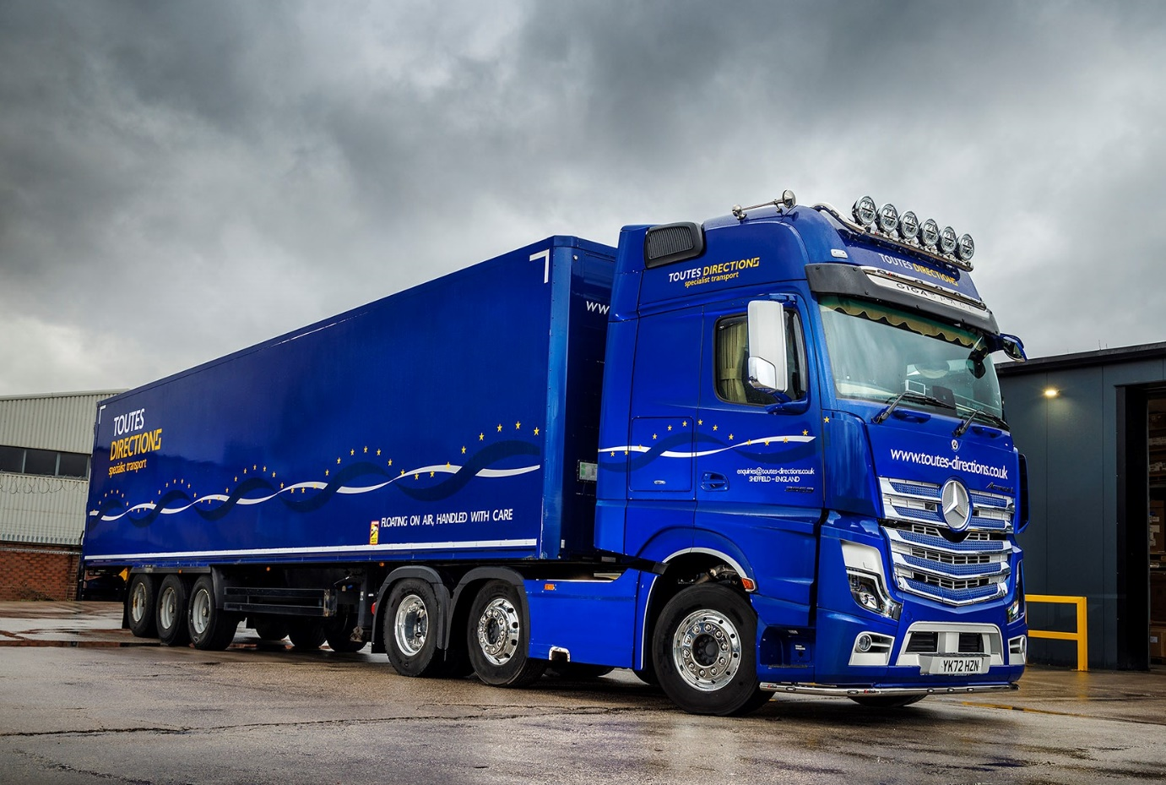

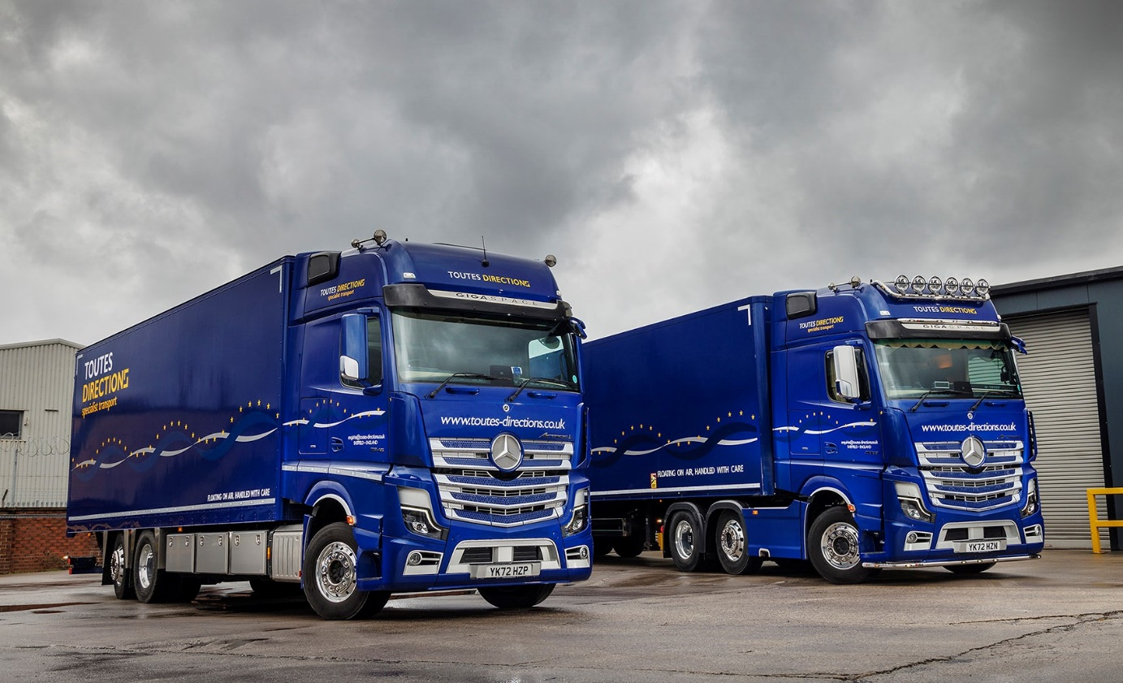

ends

For more information, or to request bigger/higher-res image files, please contact:
John Ripley or Steve Warren
Impact Communications
John: 07771 484595, john@impactcom.co.uk
Steve: 07770 470251, steve@impactcom.co.uk

