

Date: 19 July 2023

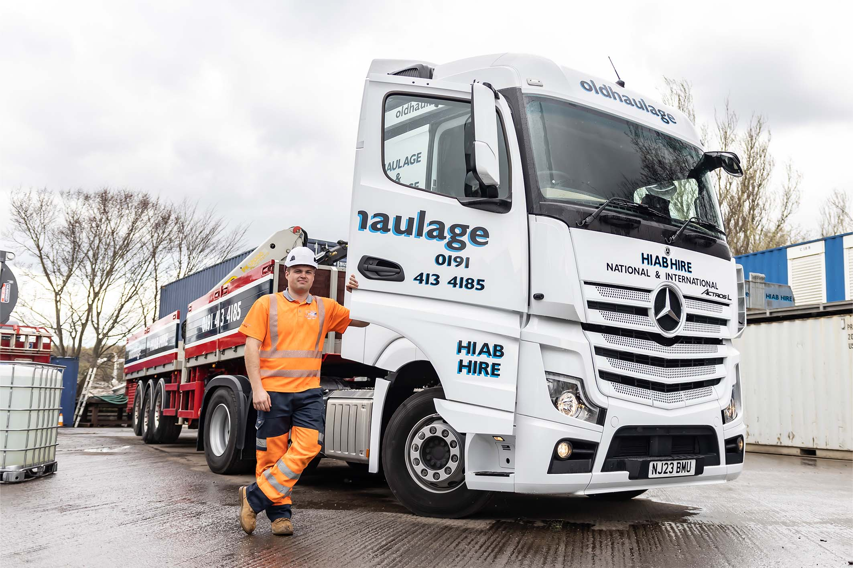

Ready to roll: Driver Shay Wheeler loves his new Mercedes-Benz Actros

Old Haulage takes a new direction with its first Mercedes-Benz tractor unit

Old Haulage’s first Mercedes-Benz Actros has gone to the Tyneside company’s youngest driver – who is delighted with his new truck.

Shay Wheeler is just 22 and joined the company less than a year ago. In his previous job he drove a supermarket home delivery van.

“I always wanted to graduate to bigger vehicles though, so I put myself through HGV driver training and started applying for jobs,” he said. “Luckily I was able to land a position with Old Haulage and to be handed the keys to a new Actros tractor unit so soon afterwards is a dream come true!”

Supplied by Dealer Bell Truck and Van, the Actros 2545 is powered by 12.8-litre in-line six-cylinder engines that produces 330 kW (450 hp), and has a flat-floored StreamSpace cab to which Blaydon-based Old Haulage has added a microwave, fridge and 360-degree camera system – a standard fitment to all the FORS-approved haulier’s fleet.

It has joined a fleet of 12 trucks, traditionally dominated by a Swedish brand. The decision to invest in its first Mercedes-Benz truck for 30 years came after Old Haulage was impressed by a visit from Bell’s Sales Executive, James Walsh.

“James turned up at our depot one day, driving Bell’s Actros demonstrator,” recalled Traffic Planner Chris Wilson.

Chris and Director Amanda Old were given a full demonstration of the Actros and its various high-tech features – including the innovative Multimedia Cockpit with its twin flat screens, and fuel-saving Predictive Powertrain Control, which allows the truck to anticipate the road ahead by linking cruise control and mapping functions.

“I’ve been a driver in the past, and I know the Actros is good on fuel, and very reliable,” he continued. “It’s a popular truck with drivers and it’s easy to see why – the cab is a great place to be.”

Amanda Old added: “James also took us out for a drive and we were both very impressed, with the Actros and his proactive approach. We were not in the market for a new truck at the time, but when one of our older vehicles came up for replacement I had no hesitation in giving James a call.

“Our new Actros is a smart-looking vehicle, and very comfortable. But for operators like us, back-up from the Dealer is just as important as the vehicle itself.

“Bell Truck and Van made all the right promises about support, which is why we were happy to sign up to a five-year Service Contract on this vehicle. The acquisition package, which James arranged through Daimler Truck Financial Services, was highly competitive too.”

Old Haulage can trace its history back to the 1960s. Today it specialises in providing trucks with cranes – including one unit with an 85 tonne/metre HIAB – across the North-East. These are often called on to move heavy machinery, palletised loads, and refrigerated containers, while the run-up to the festive period sees the fleet busy moving Christmas trees. The Actros is paired with an SDC platform trailer, with dropsides and outriggers, and a rear-mounted Palfinger PK 12000 crane.

For much of its life the company was run by Amanda Old’s father, Steven – he still takes an active interest but day-to-day management is delegated to his daughter. “The transport industry might still be male-dominated but I don’t think being a woman in this business is anything special, these days,” she observed. “It doesn’t matter who you are, only how well you do the job.”

www.oldhaulage.co.uk

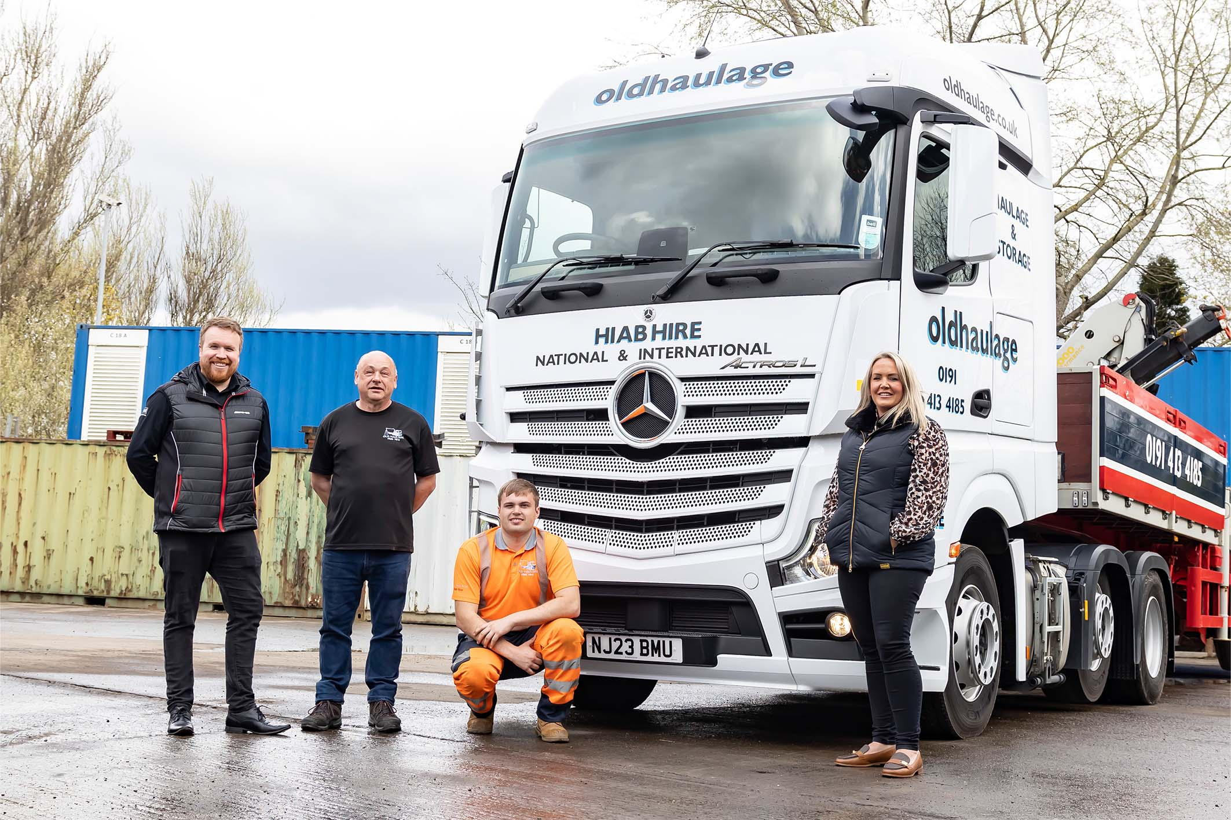

Perfect timing: From left, Bell Truck and Van’s James Walsh with Chris Wilson, driver Shay Wheeler, and Amanda Old

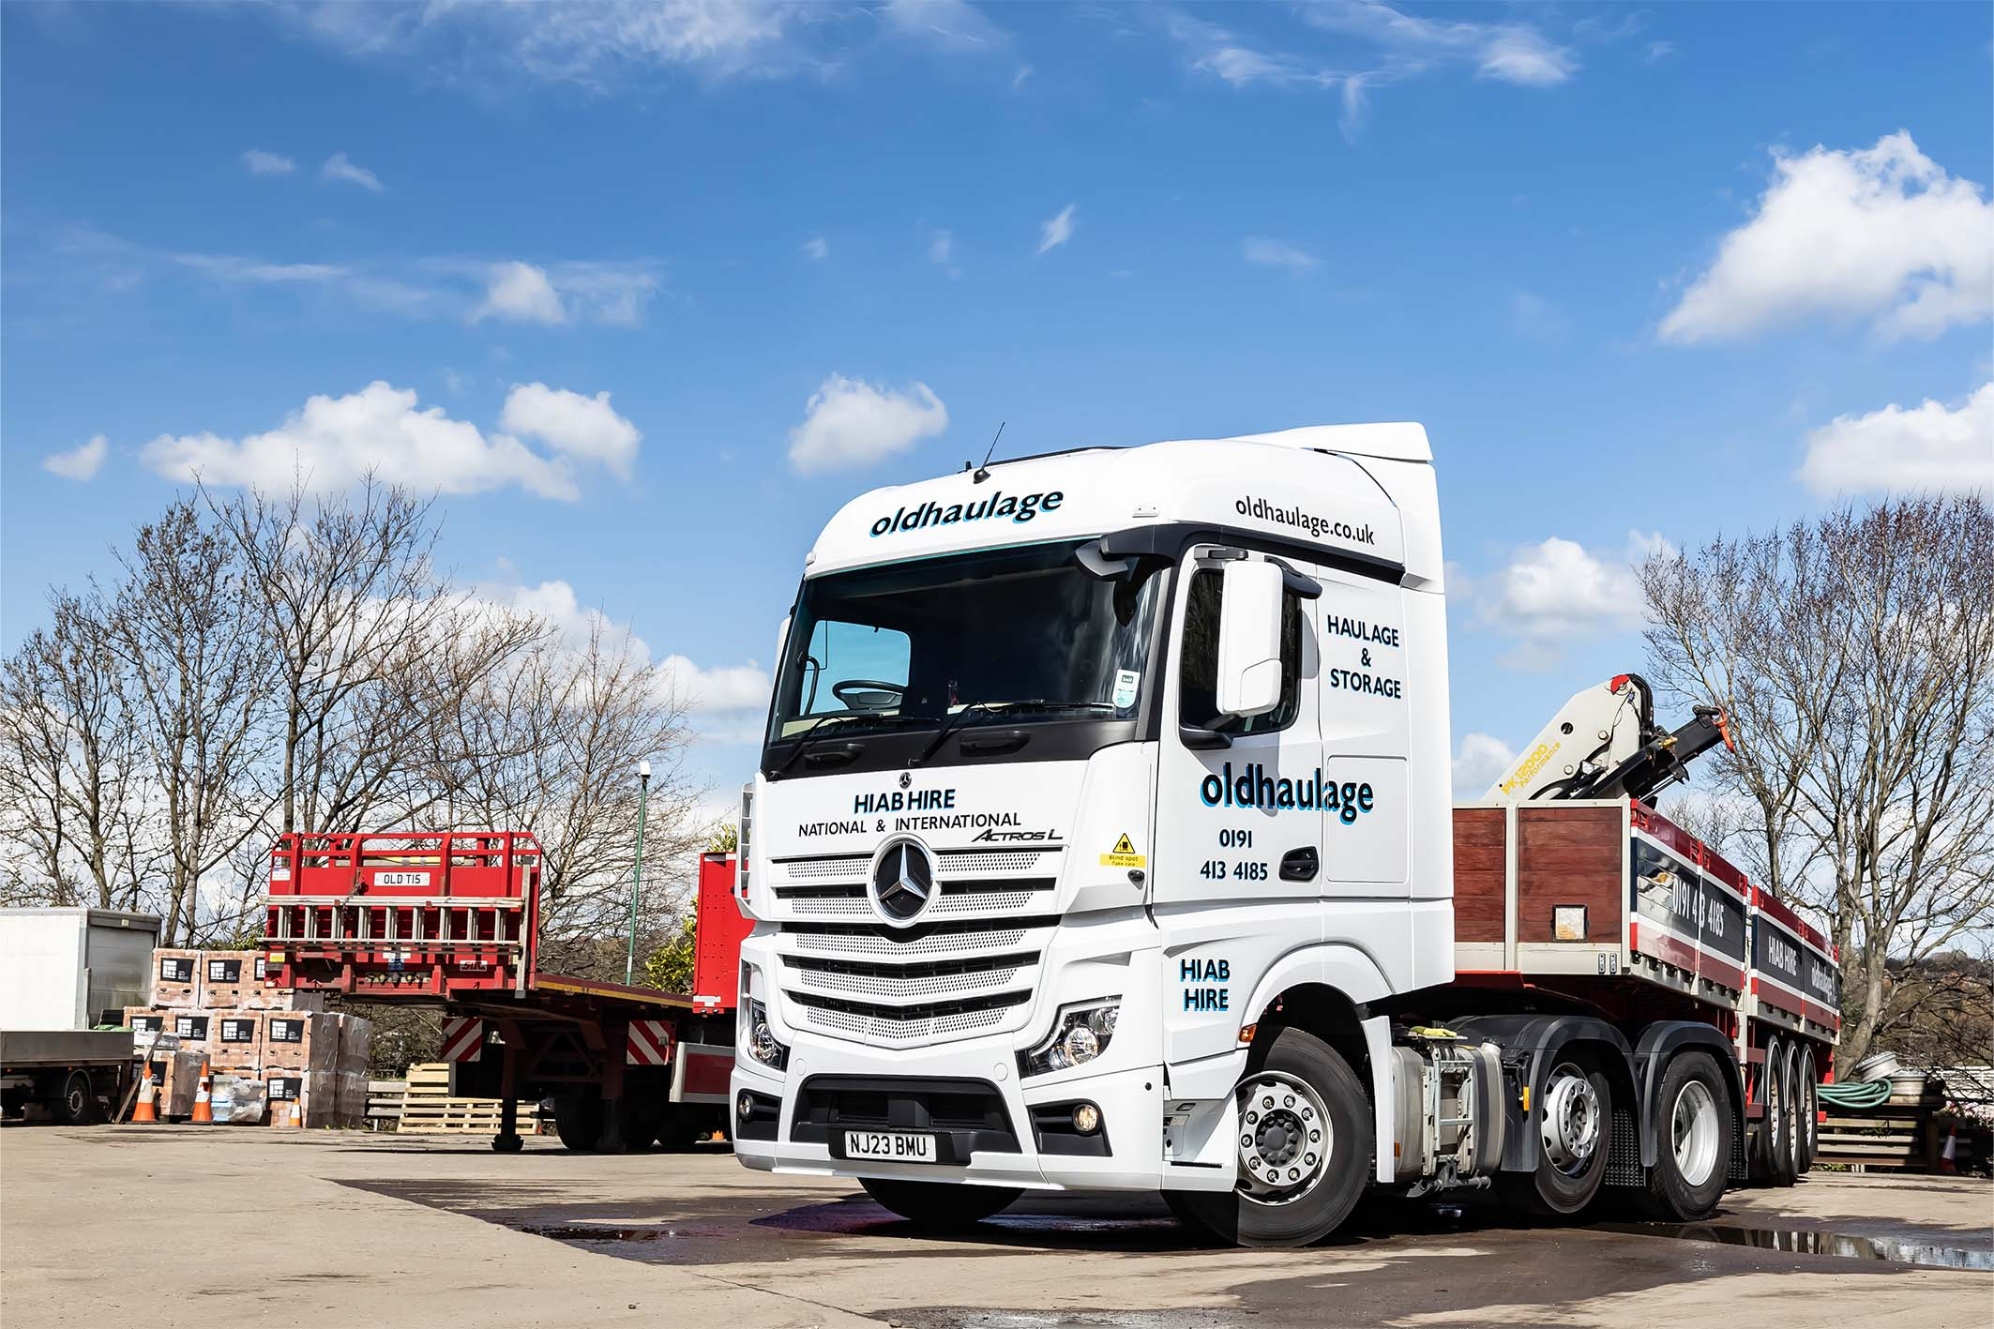

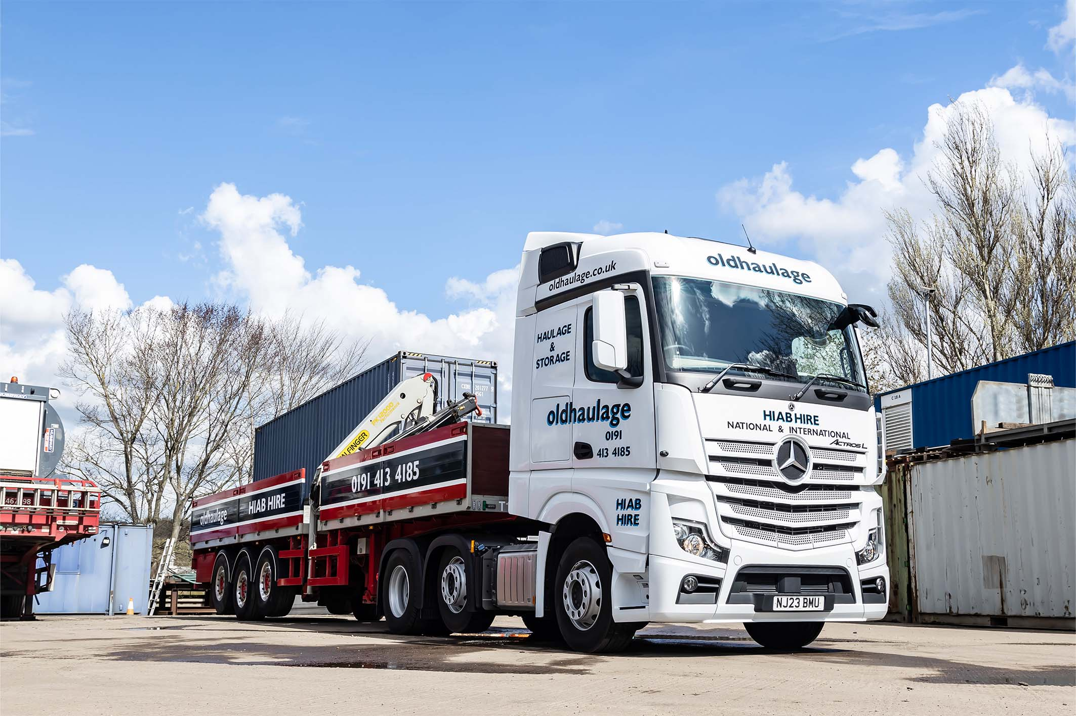

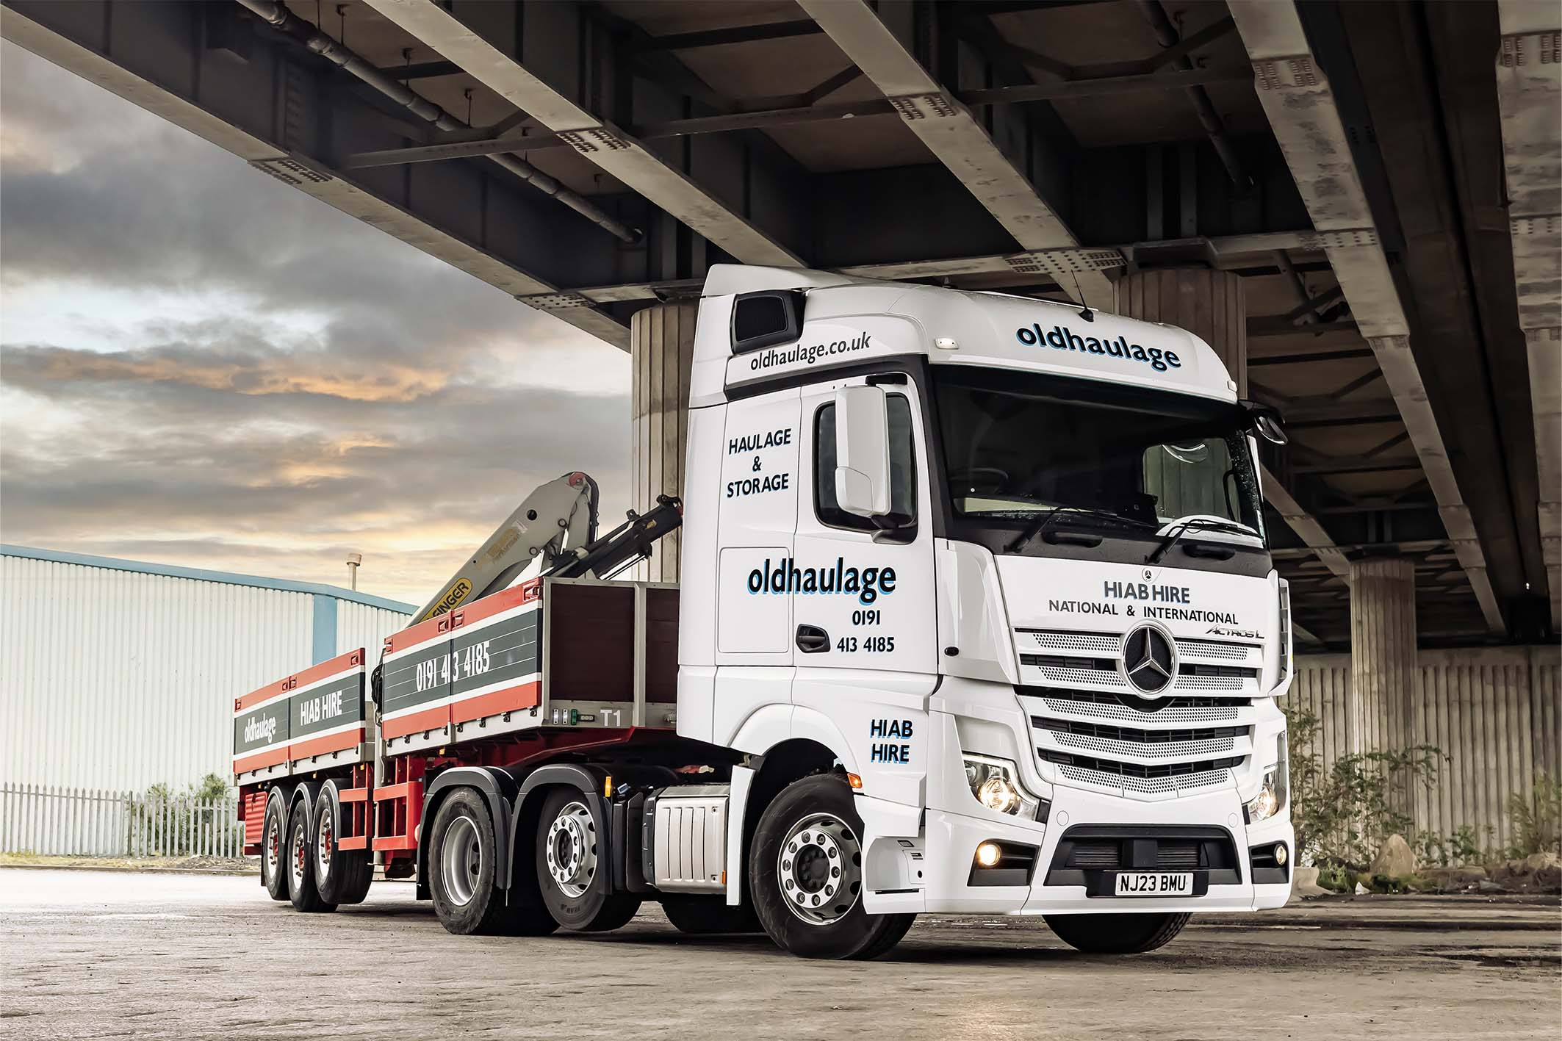

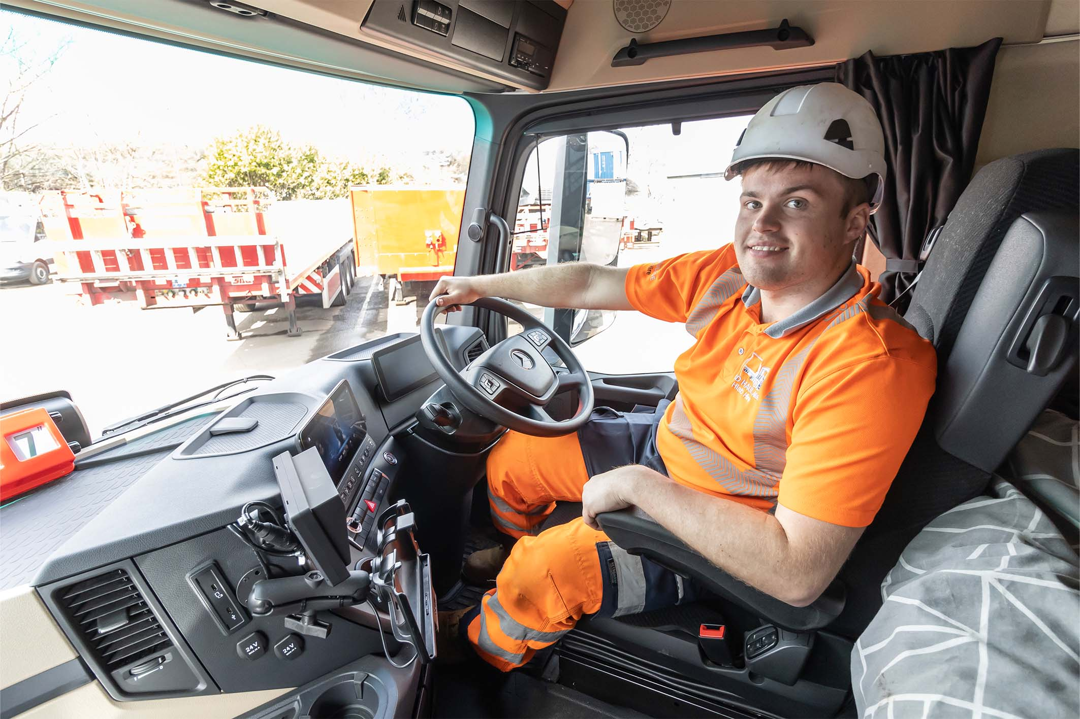

Seat of power: Shay Wheeler in the cab of his first truck – a 450 hp Mercedes-Benz Actros

ends

For more information, or to request bigger/higher-res image files, please contact:
John Ripley: 07771 484595, john.ripley@loopagency.co.uk



