

Date: 17 December 2021

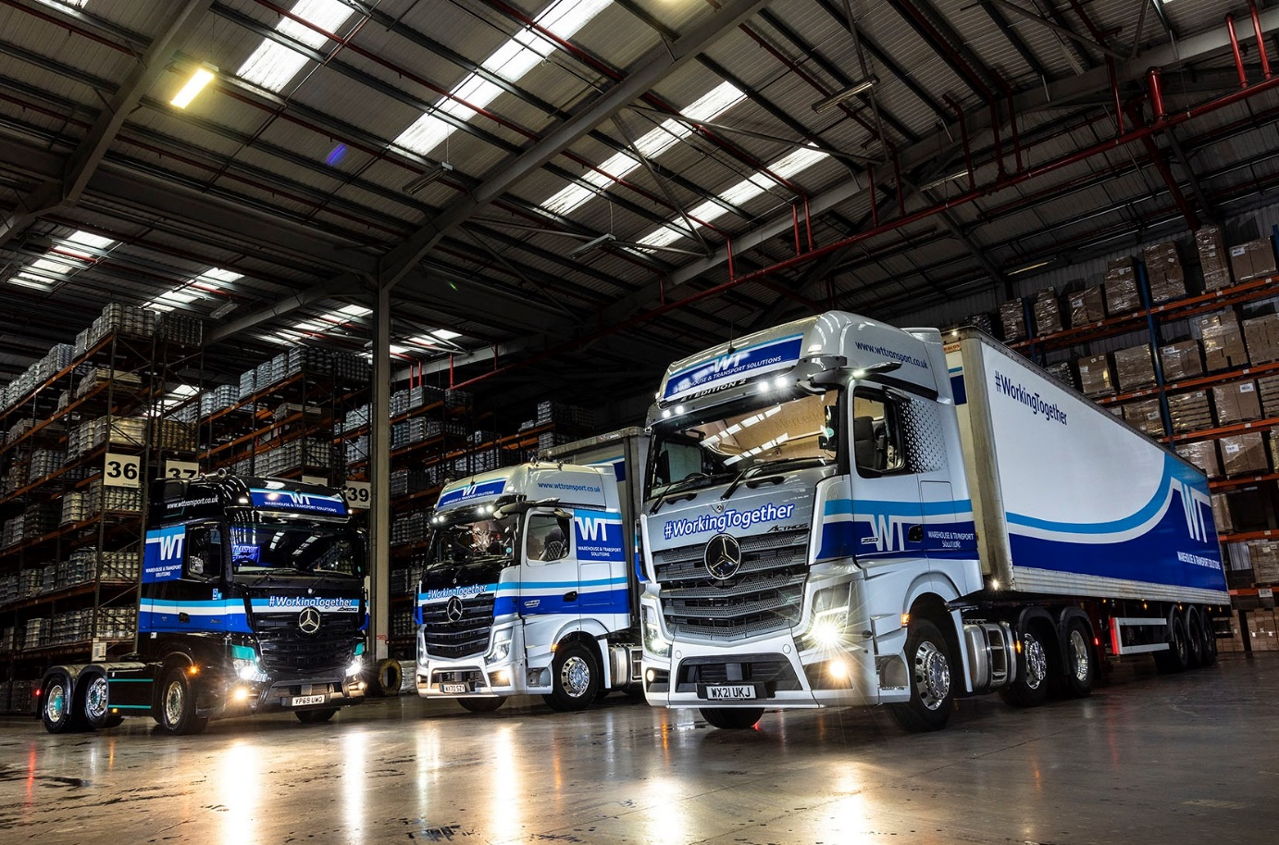

Special issue: One new, one used and one ex-demonstrator… all three of WT Warehouse & Transport Solutions’ limited-edition Mercedes-Benz Actros arrived via City West Commercials

The best just got even better for WT Warehouse & Transport Solutions, with new Mercedes-Benz Actros Edition 2 flagship from City West Commercials

Mercedes-Benz Trucks has introduced three, highly exclusive Actros models over the last four years – WT Warehouse & Transport Solutions’ fleet includes examples of each.

The Northampton-based company has just completed the set by taking delivery of an awesome Edition 2 tractor unit from trusted supplier City West Commercials. Used previously by the Dealer as a demonstrator, the truck had already covered a little over 6,000 miles.

Just 400 Edition 2s were produced and of these only a small handful have reached the UK. WT Warehouse & Transport Solutions’ new flagship is a 2553 variant with range-topping GigaSpace cab and 390 kW (530 hp), 12.8-litre in-line six-cylinder engine.

The truck is finished in Brilliant Silver metallic paintwork and easily recognisable as one of the most exclusive on the road, thanks to its Moonstone Grey grille and sun visor – this incorporating four additional LED headlights – above which is a deep black panel with EDITION 2 lettering.

Other external highlights include an illuminated Mercedes-Benz three-pointed star in dark chrome, with a black closed cover, gloss black trim, stainless steel entrance steps, three more LED headlights behind the cab, and a chassis frame cover.

It has lined-up alongside the two other, limited edition Actros GigaSpace tractor units that WT Warehouse & Transport Solutions acquired from City West Commercials last year. One is an Actros Edition 1 with High-tech Silver metallic paintwork, the other an Actros1 in Obsidian black metallic.

The Edition 1 employs a 460 kW (625 hp), 15.6-litre ‘straight-six, and was purchased from new. The Actros1 was developed by Mercedes-Benz Trucks in the UK, as a showcase for the previous, fourth-generation model range – WT Warehouse & Transport Solutions’ Actros1 shares the same 390 kW (530 hp) powerplant as its Edition 2, and was supplied under the Mercedes-Benz Approved Used banner with 1,000 miles on the clock.

WT Warehouse & Transport Solutions runs a fleet of more than 60 trucks – with the exceptions of four rigid vehicles, every one of them is a Mercedes-Benz or FUSO Canter supplied by Tim Sutcliffe, City West Commercials’ Used Truck Sales Specialist.

The three limited-edition tractor units are the first to wear the operator’s new name and ‘Working Together’ strapline. Having traded as WT Transport since it was established by Warren Tattersall in 1997, the company recently adopted new, more dynamic branding that better reflects the range of services it offers.

WT Warehouse & Transport Solutions covers the Milton Keynes postcodes for TPN – THE Pallet Network, which it joined in 2015. Three years later Mr Tattersall and his team relocated to TPN’s newly-opened, £15-million hub on the Brackmills Industrial Estate.

The limited-edition tractor units, like other highly specified vehicles on the WT Warehouse & Transport Solution fleet, are assigned not to TPN work, but to bespoke contracts with ‘blue chip’ clients.

Mr Tattersall, who runs the family business with his wife and co-Director Sarah, is looking forward to delivery early in the New Year of four new Actros 18-tonners, a 12-tonne Atego and a 7.5-tonne FUSO Canter, all with curtainside bodies. He will also purchase another City West Commercials demonstrator, this an Actros 2548 with BigSpace cab, when its replacement arrives with the Dealer in January.

“We’ve always bought low-mileage, premium quality Approved Used Mercedes-Benz vehicles because they represent such outstanding value for money,” said Mr Tattersall. “With decent stock in such high demand, though, that’s proving more difficult at the moment.”

He reported: “Business is buoyant and the fleet is growing, but we’re also having to contend with the driver shortage. As well as increasing our pay rates by 20% in order to retain good drivers and attract new ones, we’ve also focused on working conditions.

“That’s where the limited-edition Actros come in. Of course, the new technology in which we’ve been investing does translate into less downtime and better fuel-efficiency. Just as importantly, though, I’ll do whatever I can to keep our best drivers happy.

“So providing them with top-quality equipment – trucks they really want to drive – is crucial. In that respect these three fantastic vehicles, but particularly the stunning Edition 2, tick all the boxes.”

Interior features on WT Warehouse & Transport Solutions’ Edition 2 include a sliding and tilting sunroof, eight colours of ambient lighting, and a driver’s suspension seat, while at 900 mm-wide and with its own, cosy topper, the comfort mattress is a dream for any driver. A brushed and polished aluminium badge on the co-driver’s side hails this Edition 2 as “One of 400”.

The truck also comes with a full complement of high-tech aids for increased safety, efficiency and comfort. MirrorCam, Mercedes-Benz Trucks’ pioneering alternative to conventional mirrors, is fitted as standard on all Actros. So, too, is the latest version of Predictive Powertrain Control, which manages gear changes to optimise fuel economy, and Active Brake Assist 5, the emergency braking system that outperforms its rivals, particularly in its responses to pedestrians stepping into the vehicle’s path.

Edition 2 drivers also benefit from the upgraded interactive version of the radical, twin-screen Multimedia Cockpit, which boasts a larger, 12in instrument panel and comes with extra functionality, including satellite navigation, together with Proximity Control Assist, Bi-xenon headlamps with a cleaning system, and LED tail lights.

All of this equipment, and much else besides, is bundled into the Edition 2’s Driving, Comfort, Media, Stowage, Safety and Sight Packages, and ExtraLine design. The result is a vehicle that any professional would be proud to drive.

The WT Warehouse & Transport Solutions maintains the fleet in its own workshop but relies on City West Commercials for technical support. “The Dealer’s Service team are very good and if we ever get stuck we know they’re just a phone call away,” said Warren Tattersall. “Likewise, experience has shown that should we suffer a breakdown the manufacturer’s round-the-clock emergency roadside assistance service will get us up and running again quickly and efficiently wherever possible.”

He continued: “With all the new technology on the latest Mercedes-Benz trucks, City West Commercials’ Handover Specialist Justyn Marshman has also visited and gone through it all with our own Driver-Trainer Darren Fennon. That’s been invaluable, as Darren has since cascaded all that he’s learned down to our drivers.
“As for Tim,” added Mr Tattersall, “we’ve been working together for years now, and Sarah and I think of him as a friend as well as a supplier. Tim and I speak every week. He knows what we need and will always give me a call when something suitable comes along at the right price. It’s a great service.”

wttransport.com

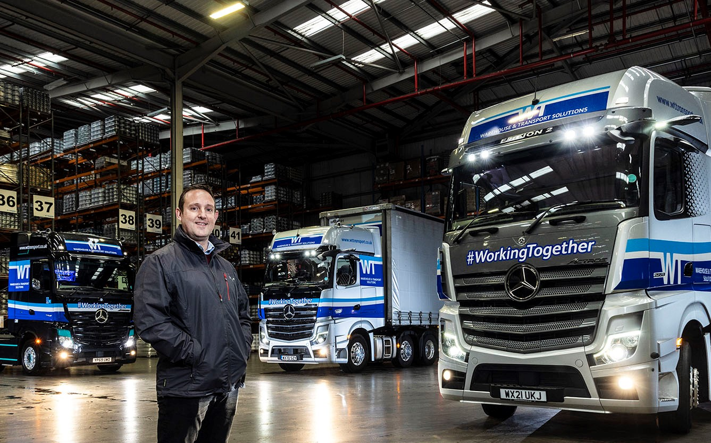

Three-pointed stars in his eyes: Proprietor Warren Tattersall, with WT Warehouse & Transport Solutions’ three limited-edition Mercedes-Benz Actros

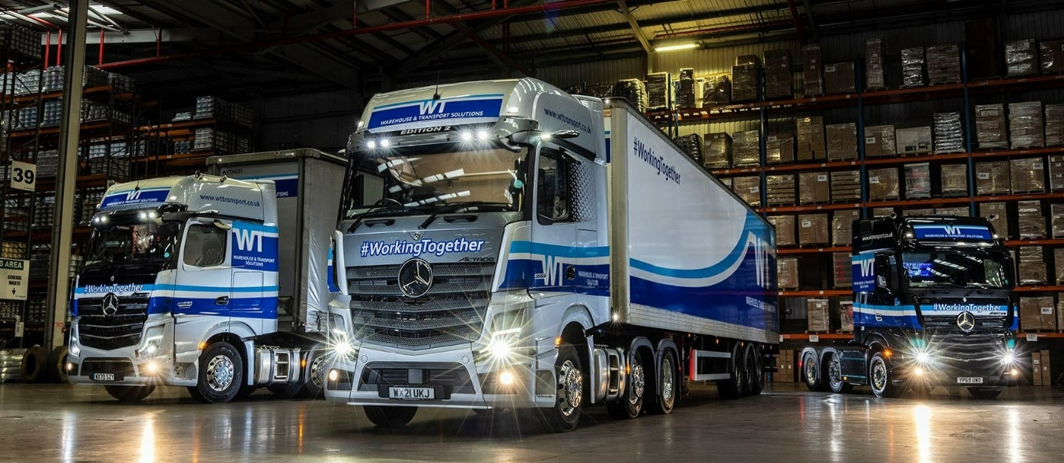

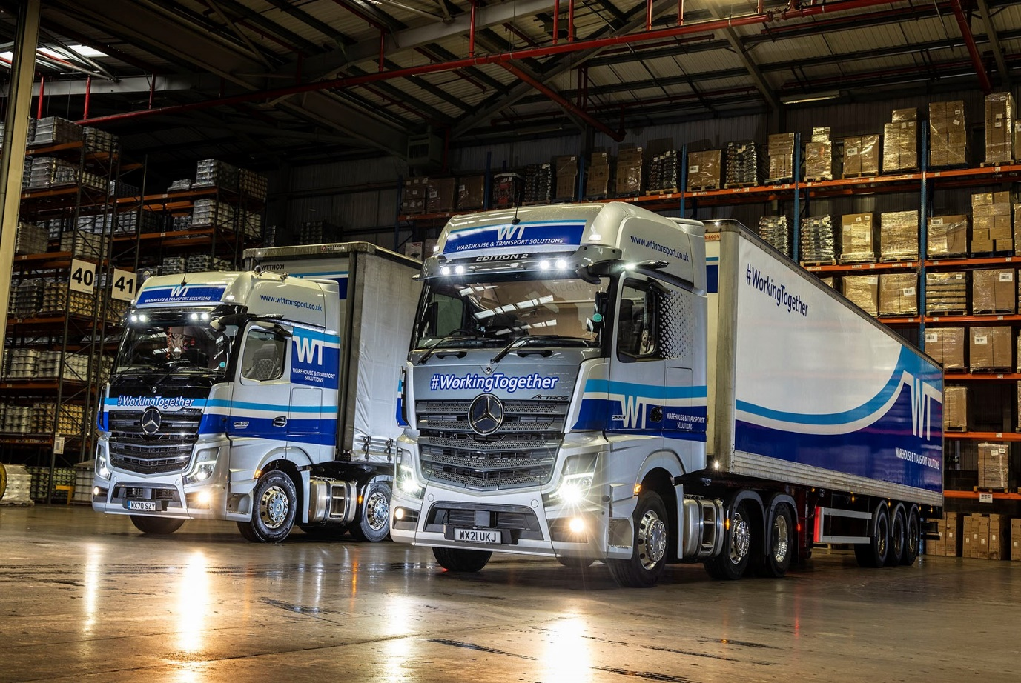

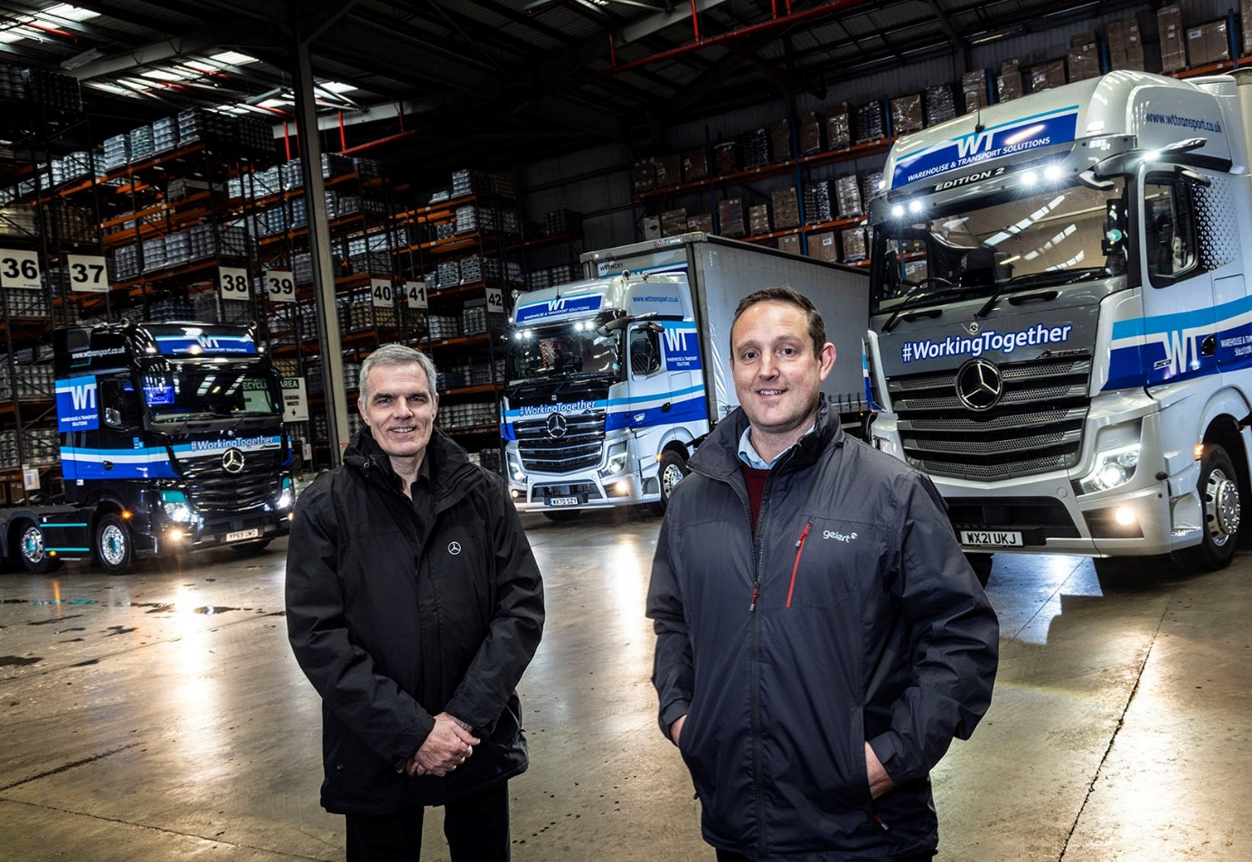

Working Together: WT Warehouse & Transport Solutions’ Warren Tattersall, right, has been buying trucks from trusted supplier Tim Sutcliffe, of City West Commercials, for the last 12 years

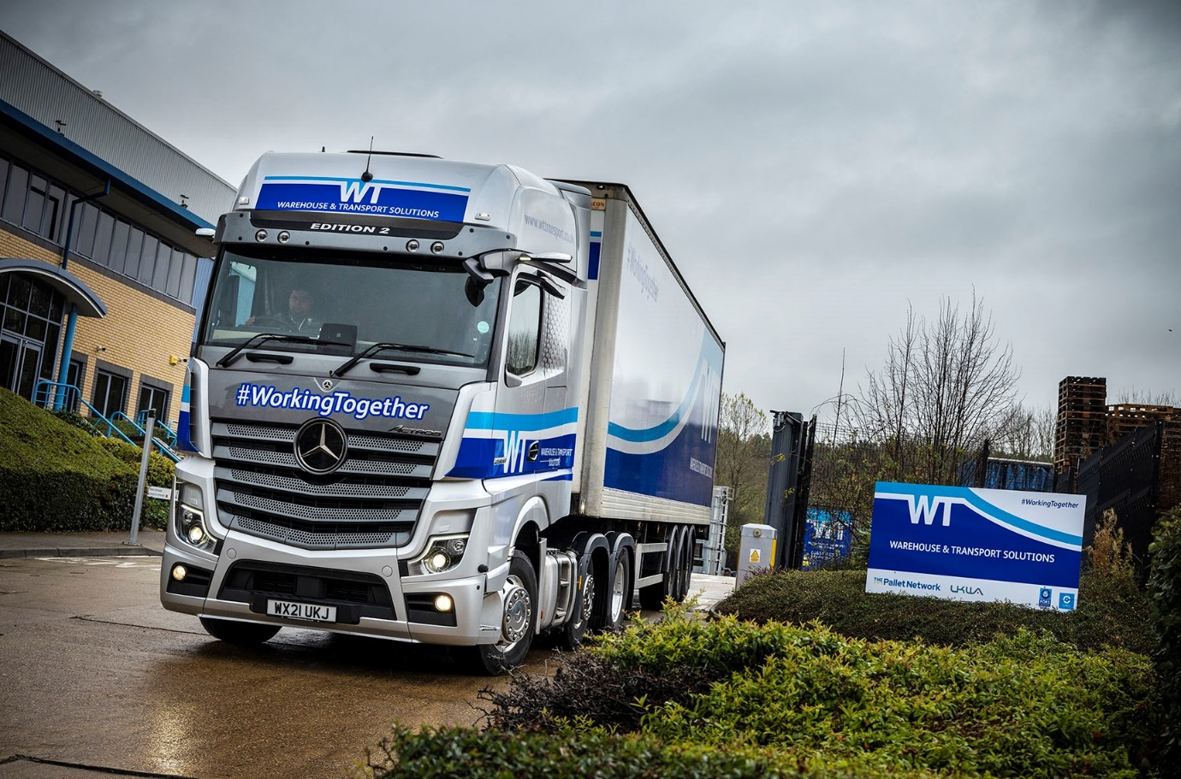

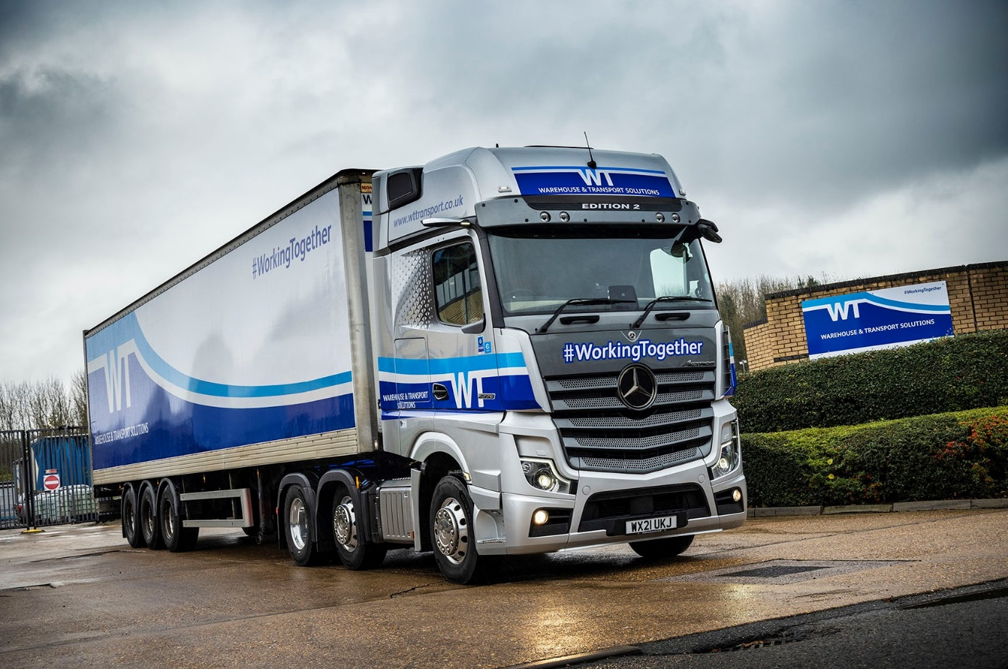

ends

For more information, or to request higher-res image files, please contact:

Jamie Fretwell at Mercedes-Benz Trucks UK Ltd
07712 519230, jamie.fretwell@daimler.com

or

Steve Warren or John Ripley
Impact Communications
Steve: 07770 470251, steve@impactcom.co.uk
John: 07771 484595, john@impactcom.co.uk

