

Date: 28 November 2019

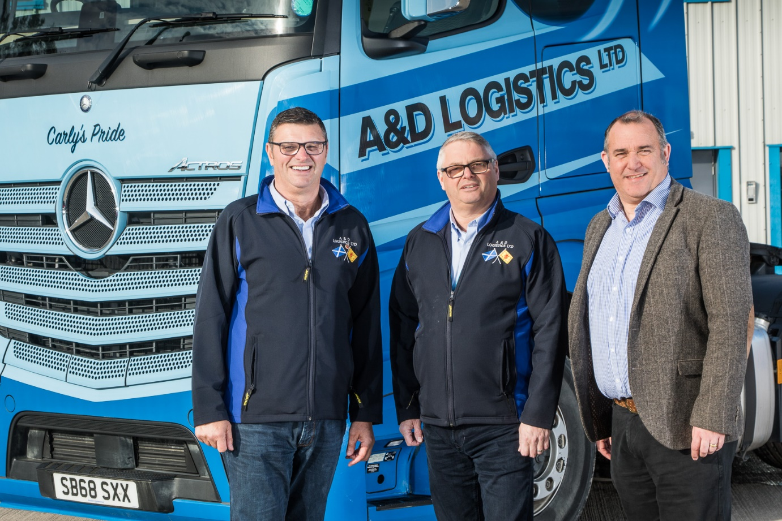

Building a new partnership: Alan, left, and Drew Bolsworth, of A&D Logistics, with Western Commercial’s Paul Mundie

A&D Logistics buys its first Mercedes-Benz after Actros beats the competition ‘hands down’ in trial

Renfrewshire’s A&D Logistics has dropped the chequered flag on its three-cornered truck shootout – and declared the Mercedes-Benz Actros a clear winner.

Western Commercial sent a 350 kW (476 hp) ‘seed vehicle’ smartly finished in the Linwood-based operator’s colours, into battle against similarly specified tractor units by two other manufacturers.

Fast forward six months and not only is the truck bearing the three-pointed star ahead of the rest in terms of fuel-efficiency, but it has also been 100% reliable and scored highly for driver appeal. Completing the picture, the workshop team at the Dealer’s Govan branch have won glowing praise for their flexible and attentive customer service.

A&D Logistics, which moved to its £3.5-million headquarters in 2017, celebrates its 25th anniversary next year. The company’s fleet of more than 90 tractor units is dominated by a Swedish brand, which has been well entrenched for two decades.

So impressed has the high-profile container specialist been with the Actros, however, that it had no hesitation in purchasing its first Mercedes-Benz unit at the end of the trial.

A 2548 model with second-generation 12.8-litre in-line six-cylinder engine and range-topping GigaSpace cab, the truck has now clocked-up some 65,000 km. A&D Logistics adheres as closely as possible to a ‘one driver, one vehicle’ policy, and with Polish-born Martin Urbanczyk at the wheel it is returning an average of 10.5 mpg.

“That’s a good figure, and better than anything else we have right now,” confirmed Alan Bolsworth, co-Director of A&D Logistics with his brother Drew. “The Actros and Western Commercial have both done everything we could have hoped for.

“Mercedes-Benz now has a well-earned ‘foot in the door’, and we’ll certainly be giving its Dealer a chance in 2020, when we come to consider our next round of fleet acquisitions.”

Former driver Eric MacLeod rejoined A&D Logistics last year as its Head of Driver Training & Recruitment, and played a key role in initiating the trial. “The Actros is very competitive on fuel, but just as importantly we’ve not heard a squeak from that motor,” he enthused.

Mr MacLeod praised Western Commercial’s Truck Sales Director Rory Allen and Truck Sales Executive Paul Mundie for their “fantastic support”. As for the Dealer’s Govan Service Manager Brian Cooper: “I couldn’t speak more highly of the guy. Whatever the question, he always has the answer.”

Mr MacLeod continued: “The workshop visits have gone like clockwork. We’ve had one recall, which was attended to while the truck was in for inspection, and all work has been undertaken overnight, at times which have suited us. We couldn’t have asked for more.”

Western Commercial staged a launch event for the fifth-generation Actros range at its truck-dedicated Bellshill branch. Alan Bolsworth and Eric MacLeod both attended, and seized the opportunity to take a fully-laden combination out onto the road.

Mr Bolsworth, who also a guest of the Dealer at the new model’s European launch in Barcelona, hailed some of the vehicle’s new technology – MirrorCam, the Multimedia Cockpit, Active Brake Assist 5 and Active Drive Assist, for example – as “quite amazing”.

MirrorCam does away with door mirrors. Instead, rear-facing cameras in streamlined housings display images of the view down each side of the vehicle on screens inside the cab. As well as enhancing safety by offering a wider and clearer field of rearward vision, MirrorCam eliminates previous blind spots, while its compact, more aerodynamic profile improves mpg returns by reducing wind resistance.

Mr Bolsworth highlighted another potential benefit: “We send a lot of trucks up north and along the west coast where some of the routes are quite narrow and tight. We’ve had a few mirrors banged up there, so the fact that MirrorCam is that much smaller should contribute to a reduction in damage costs.”

Eric MacLeod added: “The high-tech features are very impressive but what really blew me away, coming from a driving background, was the sheer quality of the truck. Fit and finish are exceptional, the driving position couldn’t be better, and the doors shut with a satisfying clunk which tells you this is a vehicle that’s built to last.”

adlogistics.co.uk

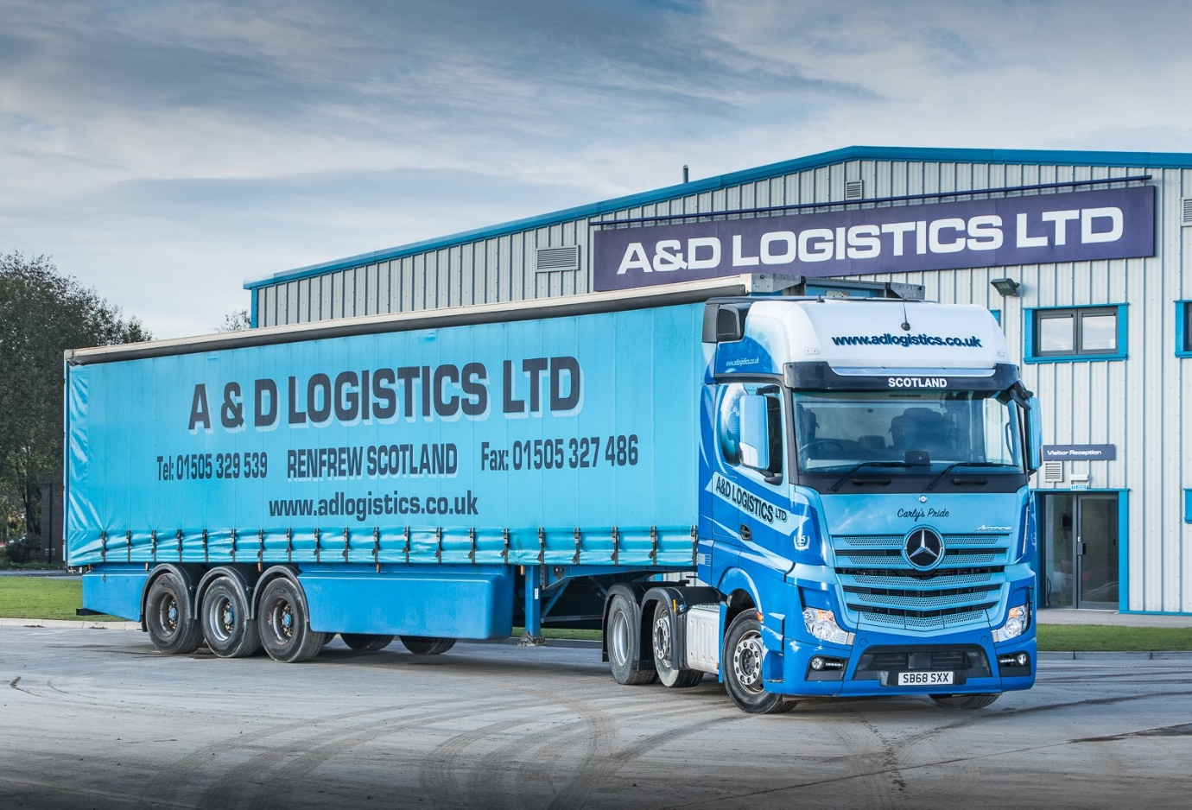

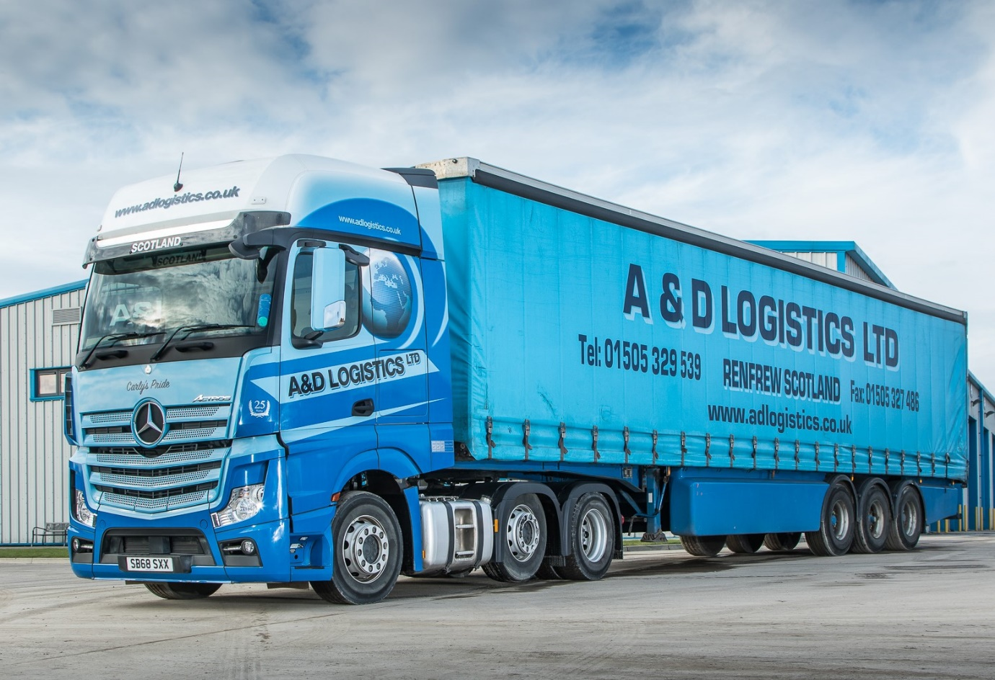

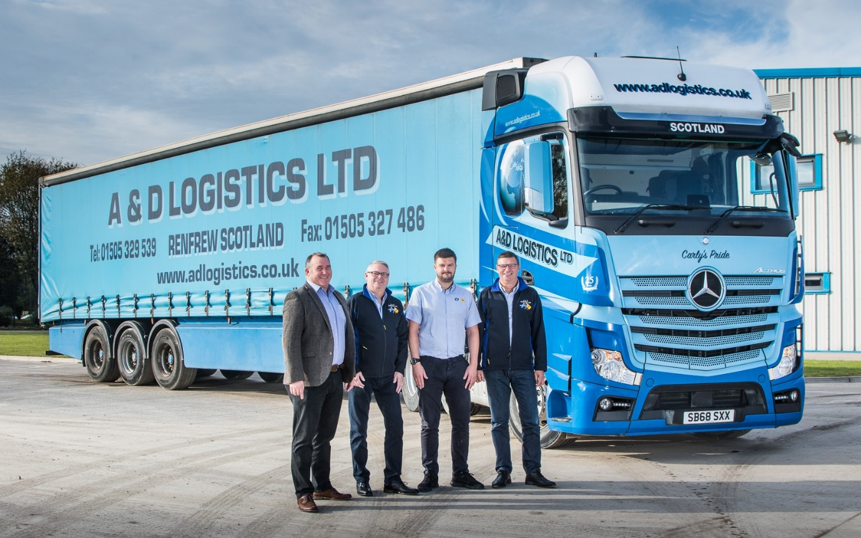

Signed and sealed: Western Commercial’s Paul Mundie, left, completed the sale of A&D Logistics’ first Mercedes-Benz truck to, from left, Drew Bolsworth, Alan Bolsworth Jnr, and Alan Bolsworth

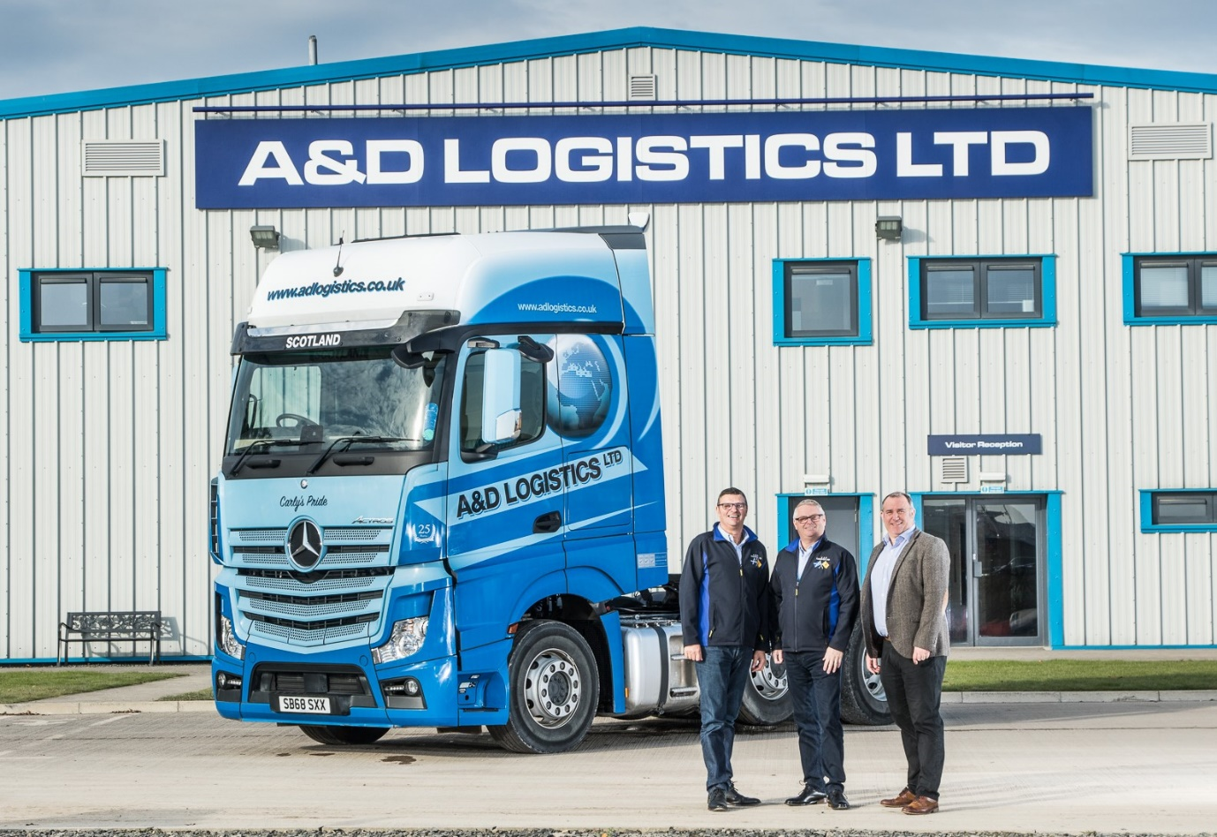

First of the line: A&D Logistics Alan, left, and Drew Bolsworth, with their new
Mercedes-Benz Actros, as supplied by Paul Mundie, of Western Commercial

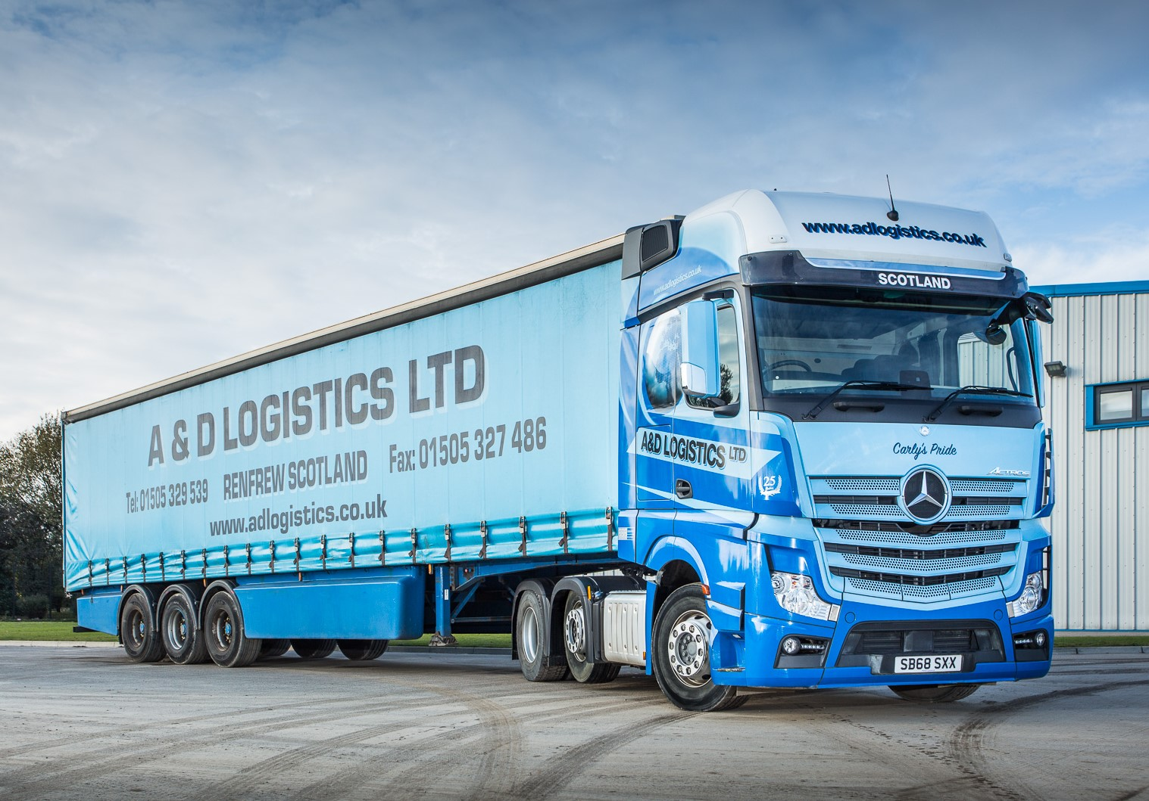

ends

For more information, or to request bigger/higher-res image files, please contact:
Steve Warren or John Ripley
Impact Communications, 01926 842126
John: 07771 484595, john@impactcom.co.uk
Steve: 07770 470251, steve@impactcom.co.uk

