

Date: 2 March 2021

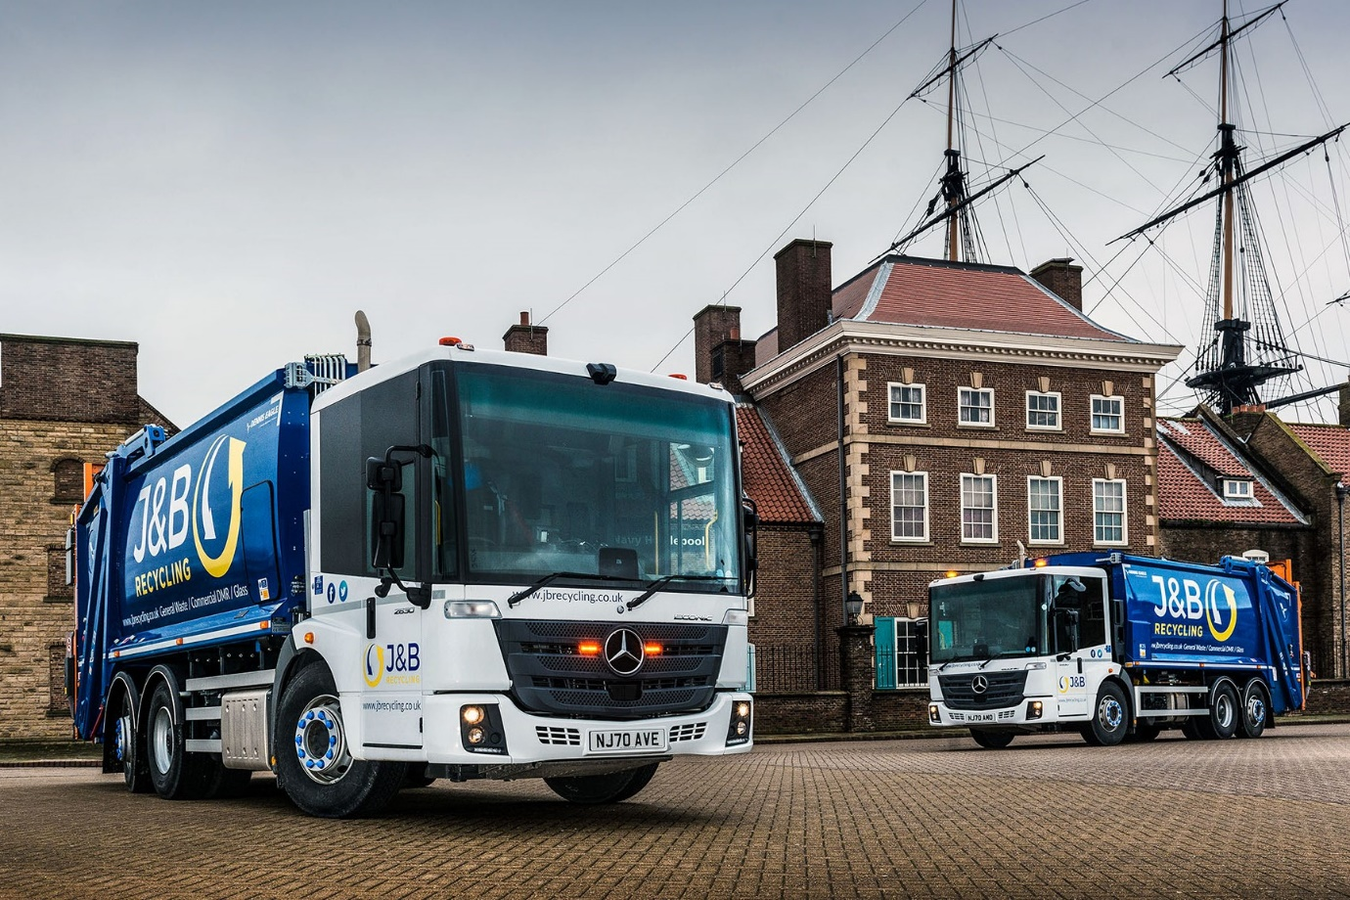

J&B Recycling future-proofs its fleet with ‘safety first’ Mercedes-Benz Econics

Leading North-East independent waste management company J&B Recycling is setting new standards for safety in its sector after commissioning three of the UK’s first low-entry Econics to be equipped with Mercedes-Benz Trucks’ latest accident prevention technology.

The Hartlepool-based operator is now looking forward to the arrival of another two identical 26-tonners, which are due to be delivered in May by Bell Truck and Van. All five will be inspected and maintained under Mercedes-Benz Complete Service Contracts at the Dealer’s Billingham workshop.

Despite the challenges posed by the pandemic, 2020 marked a fourth successive year of growth for J&B Recycling, which has been investing heavily in its infrastructure, process optimisation and automation. The acquisition of its first trucks bearing the three-pointed star has underscored the company’s commitments to customer service and efficiency, as well as to the protection of its employees and other road users.

The Econic 2630 Ls have rear-steer axles that enhance manoeuvrability by significantly reducing turning circles. Their 7.7-litre in-line six-cylinder engines produce 220 kW (299 hp) and are paired with six-speed automatic Allison gearboxes.

The trucks are fitted with refuse bodies by Dennis Eagle and Terberg Matec UK trade lifts – both manufacturers are part of the Terberg RosRoca Group. Dynamic weighing systems relay data on vehicle loadings in real time to J&B Recycling’s head office.

The chassis were among the first to leave the Mercedes-Benz production line after Active Brake Assist 5 was added to the Econic’s standard specification towards the end of last year. First seen in the new-generation Actros, this cutting-edge emergency braking aid employs cameras as well as radar.

Active Brake Assist 5 can detect vehicles ahead and stationary objects in its own lane, at speeds of up to 56 mph (90 km/h). Detection of a dangerous situation triggers a three-stage reaction: first, the system warns the driver with visual and audible alerts; then, if the driver fails to react, it applies partial (approximately 50%) braking; finally, if the driver has still not intervened, it initiates maximum braking to bring the truck to a halt, activating the hazard warning lights to alert drivers behind.

The new sensor fusion has dramatically improved response to moving pedestrians at speeds of up to 31 mph (50 km/h). Active Brake Assist 5 is now capable of applying full braking when encountering pedestrians crossing its path, approaching from the front or walking ahead.

Not only does this remarkable technology increase safety for vulnerable road users and vehicle crews, but it also helps to relieve stress for drivers.

The electronic architecture required for operation of Active Brake Assist 5 means J&B Recycling’s Econics benefit from Electronic Parking Brakes too. The EPB is applied automatically when the engine is switched off. Also, when the truck is at a standstill, after emergency braking for example, the automatic HOLD function prevents unintended rolling away.

Other optional safety features specified by J&B Recycling include Mercedes-Benz Trucks’ own Blind Spot Camera System and Rearguard Assist.

The camera system comprises a monitor, two cameras on the exterior mirrors, and others facing front and back. The front-facing camera replaces the Class 6 ‘blind spot’ mirror and the system automatically selects this view at speeds of up to 10 km/h – the monitor is almost in the line of direct sight for the driver, which helps to make pulling away easier and safer.

Rearguard Assist supports the driver when reversing at manoeuvring speed, by displaying on the instrument cluster the distance from objects being approached. Like Active Brake Assist 5, it provides visual and audible warnings, and can brake the vehicle to a controlled stop when the distance to an object becomes critical.

J&B Recycling processes more than 200,000 tonnes of commercial and general waste each year, 99% of which is recycled. The company operates from four high-tech sites across the North-East, and runs a fleet of 21 vehicles – six of which are assigned to trade waste collections – as well as five trailers.

Operations Director Matt Tyrie commented: “Our fleet replacement programme is designed to avoid service disruption to our clients, while also protecting our business against the risk of spiralling costs. This investment in Mercedes-Benz vehicles will put us in a strong position when lockdown eases and business waste starts to increase, especially in the hospitality sector.”

He continued: “J&B Recycling is committed to investing in the latest technology. We have chosen the Econic because we believe it to be the market’s finest refuse vehicle chassis, one that enjoys an unrivalled reputation for quality and reliability.

“The very high safety specification of these new trucks means they align perfectly with our policy commitments, and their spacious, air-conditioned cabs also provide our staff with an extremely comfortable working environment.”

Mr Tyrie said the valuable data provided by Terberg’s dynamic weighing technology was now being used to drive further efficiencies. “This, coupled with the anticipated reduction in vehicle downtime, will allow us to provide an enhanced service to our customers,” he said.

Bell Truck and Van’s Truck Sales Executive Craig Graham liaised closely with Terberg Matec General Sales Manager Paul Rochester and Dennis Eagle’s Regional Sales Manager Tom Fullerton – between them, they developed the optimum vehicle specification for J&B Recycling.

“Future-proofing our fleet was a key imperative and Craig was a great help in getting this project up and running,” added Mr Tyrie. “Time will tell but if the aftersales back-up from Bell’s Billingham depot comes close to the sales experience, and I’ve every confidence that it will, then the Dealer will be making a very positive contribution to our business.”

J&B Recycling can trace its roots back to the early 1970s, when its parent company was founded by Alan Jackson to provide solid fuels for power stations and steelworks nationwide. Having begun her career with the family concern as a weighbridge clerk, and then served as Transport Manager, Vikki Jackson-Smith took the helm on the retirement of her father and decided to diversify by establishing J&B Recycling in 1998.

In 2014, having secured a £7.5m investment from the Business Growth Fund (BGF), the company embarked on a major expansion and automation upgrade of its facilities. Today, it serves customers throughout the North-East, collecting all types of waste in wheelie bins, skips, bulk containers and bales, and processes commingled recyclables including glass, paper, cardboard, cans and mixed plastic for various local authorities.

jbrecycling.co.uk

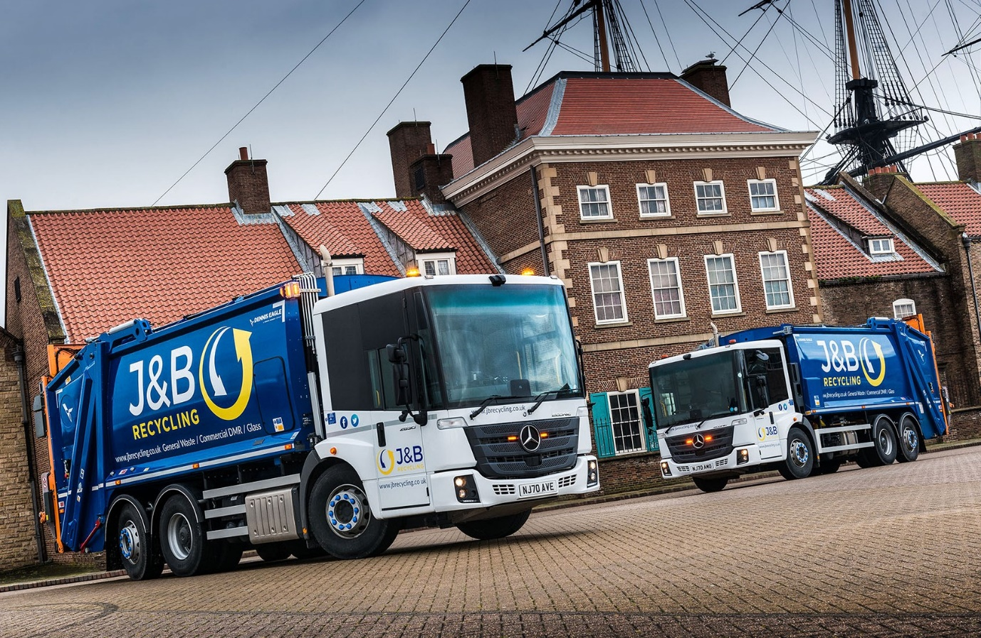

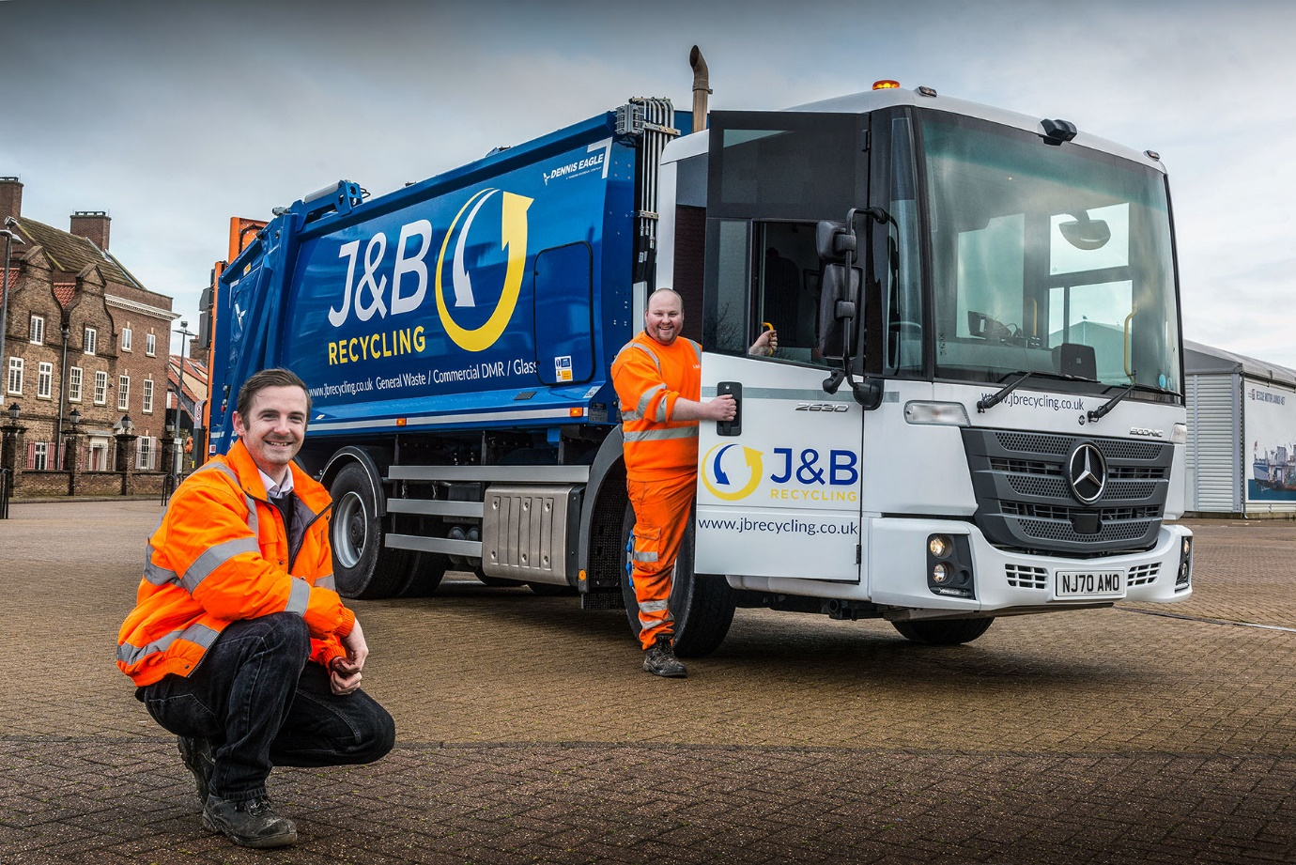

Getting the low-down on safety and efficiency: Transport Manager Peter Dunn, left, and driver Chris Lumley, with one of J&B Recycling’s new Mercedes-Benz Econics
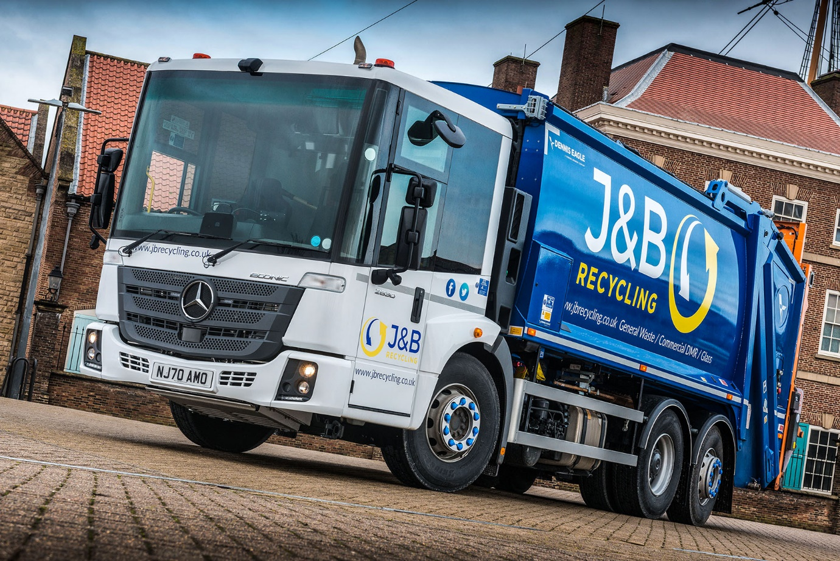

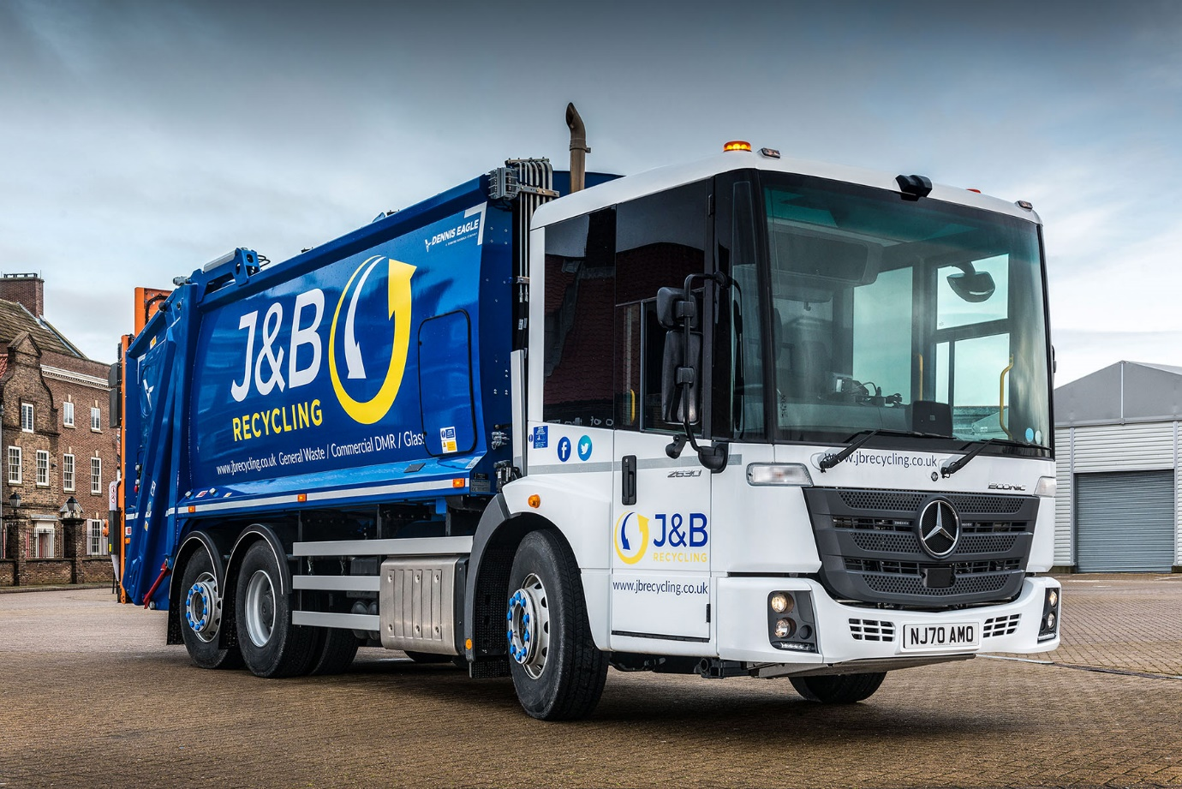

ends

For more information, or to request bigger versions of image files, please contact:
Steve Warren or John Ripley
Impact Communications, 01926 842126
Steve: 07770 470251, steve@impactcom.co.uk
John: 07771 484595, john@impactcom.co.uk

