

Date: 11 June 2020

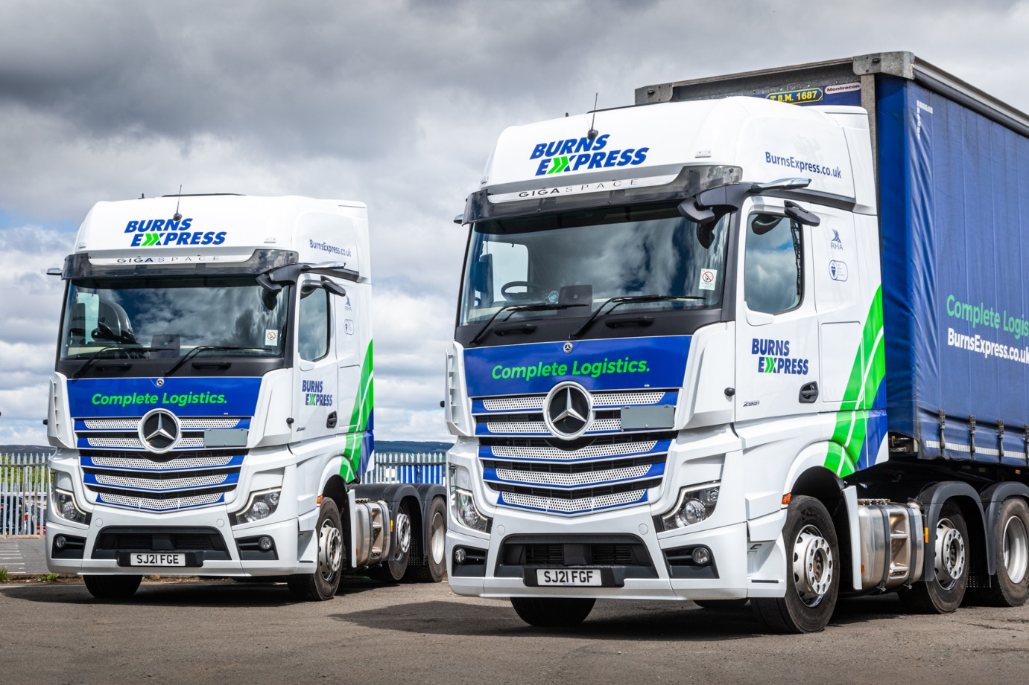

Burns Express carries a torch for latest Actros tractors from Mercedes-Benz Dealer Western Commercial

Glasgow-based Burns Express has embraced the latest cutting-edge technology from Mercedes-Benz Trucks, and is reaping the benefits through improved fuel efficiency and greater safety.

The family-owned operator is now running six new Actros tractor units, which arrived via Western Commercial. All are 2551 variants with GigaSpace cabs and 12.8-litre in-line six-cylinder engines producing 375 kW (510 hp). They are now being inspected and maintained under a Mercedes-Benz Finance contract hire agreement at the Dealer’s Govan branch.

Intensive work schedules entail trunking, double-manned, to the Midlands and North West of England through the night, and making more local collections and deliveries during the day.

“It’s a tough life but we have no concerns,” said Derek Burns, who founded the company with his wife Carolyn in 1993. “We were already familiar with the Actros and it’s proved well able to stand up to the most demanding of regimes, with excellent reliability and only very minimal downtime.”

Burns Express is a long-established Mercedes-Benz operator but the new trucks are its first from the fifth-generation Actros range. As such, they build on the proven dependability of previous model lines with a raft of technological enhancements that make for an even more compelling package.

The most obvious of these – at least in terms of outward appearance – is MirrorCam. This innovative system replaces conventional door mirrors with rear-facing cameras, which relay images to screens mounted inside the cab, on the A-pillars. Not only does MirrrorCam provide drivers with significantly better rear visibility, but the absence of mirrors means it also eliminates large, forward-facing blind spots, thereby increasing safety for vulnerable road users.

“I’m really impressed with MirrorCam,” said Derek. “It has obvious advantages for increased safety but should help improve fuel performance too, as the camera housings are much smaller and more aerodynamic than mirrors. They’re also mounted higher, tucked out of harm’s way, so I’m looking forward to spending less time and money on repairing accidental damage.

“It’s a big change but one that we have no concerns about making. We trialled one of Western Commercial’s MirrorCam-equipped demonstrators for a week and our driver loved it – he was singing its praises from day one.”

The new, enhanced version of Predictive Powertrain Control also contributes to fuel economy. This driver aid, which uses 3D GPS mapping to ‘read’ the road ahead, then responds by managing speed, braking and the transmission, now covers virtually all A roads and many B roads, and takes account not only of topography but also of corners, roundabouts and junctions.

Meanwhile, new Actros leads the market in terms of safety too. The latest Active Brake Assist 5 version of Mercedes- Benz Trucks’ emergency braking system employs a camera in addition to radar and, at speeds of up to 50 kph, can apply full braking automatically when encountering pedestrians crossing its path.

“The new Actros is a fantastic truck,” Derek continued. “The GigaSpace cab offers plenty of space and comfort for a crew of two, and the big, 510 hp engine provides a great combination of power and efficiency. The truck is never short of ‘go’, even on the hills, and average returns are every bit as good as the best we’ve seen from other makes of tractor unit.

“Western Commercial also provided our in-house trainer with a full familiarisation session, so he is now advising colleagues on how to get the very best from all of the new technology on the vehicle. We are delighted to be benefiting from the breakthroughs that Mercedes-Benz has made.

“The Actros makes sound financial sense too. The Mercedes-Benz contract hire rates are competitive and Western Commercial’s workshop team do a great job of keeping our trucks out on the road, where they earn their keep.”

Burns Express runs a fleet of 40 trucks, the majority of which wear three-pointed stars. Although the founding couple still take an active interest in the company’s affairs, its day-to-day management is now the responsibility of their two children, both of whom became Directors in November.

Daughter Gemma achieved an International Business Management degree at Strathclyde University then spent two years with a global logistics provider before joining the family firm. Her brother Michael spent 12 years working his way up through the ranks; he holds national and international CPC qualifications and is also a certified Dangerous Goods Safety Advisor.

In its early days the company concentrated on the air freight industry, but has since added groupage services to Ireland, membership of pallet and hazardous goods networks, and secure warehousing to its portfolio. Today Burns Express offers a complete logistics service to customers across a wide range of sectors throughout the UK, Ireland and Europe.

www.burnsexpress.co.uk

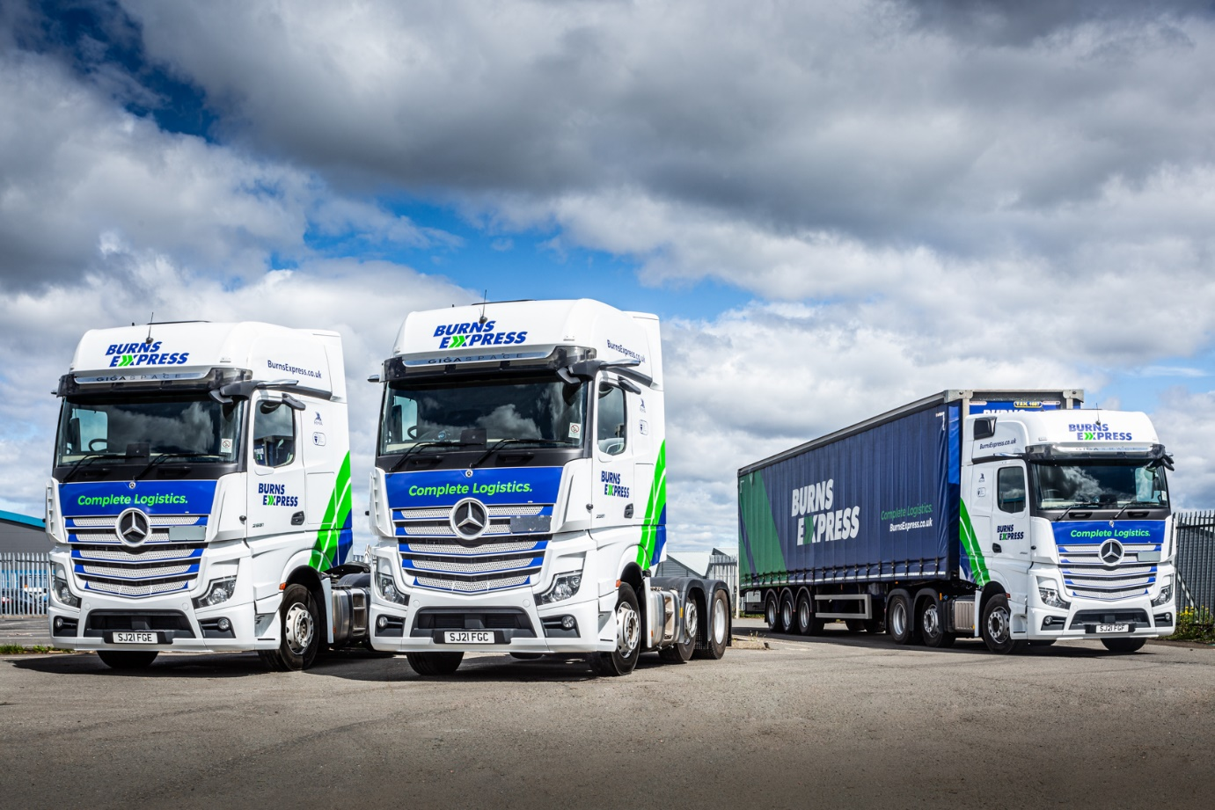

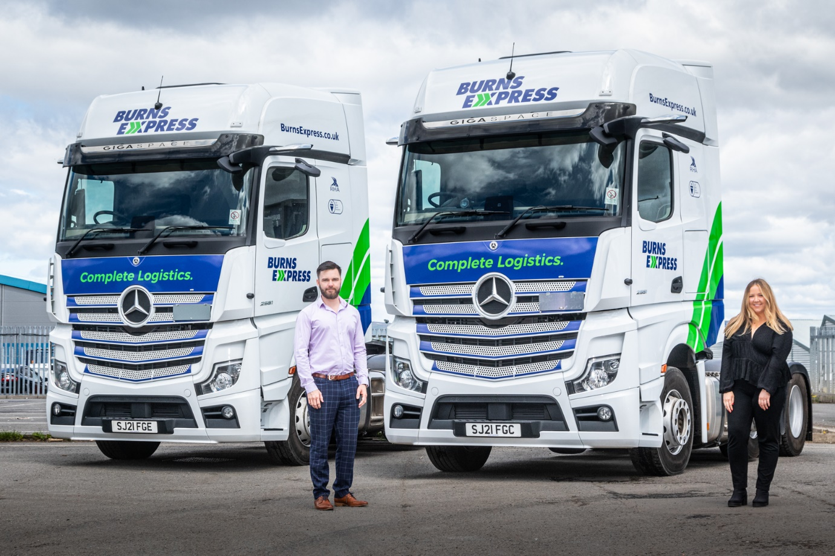

Carrying the fire: Michael and Gemma Burns are now Directors of the firm founded by their parents

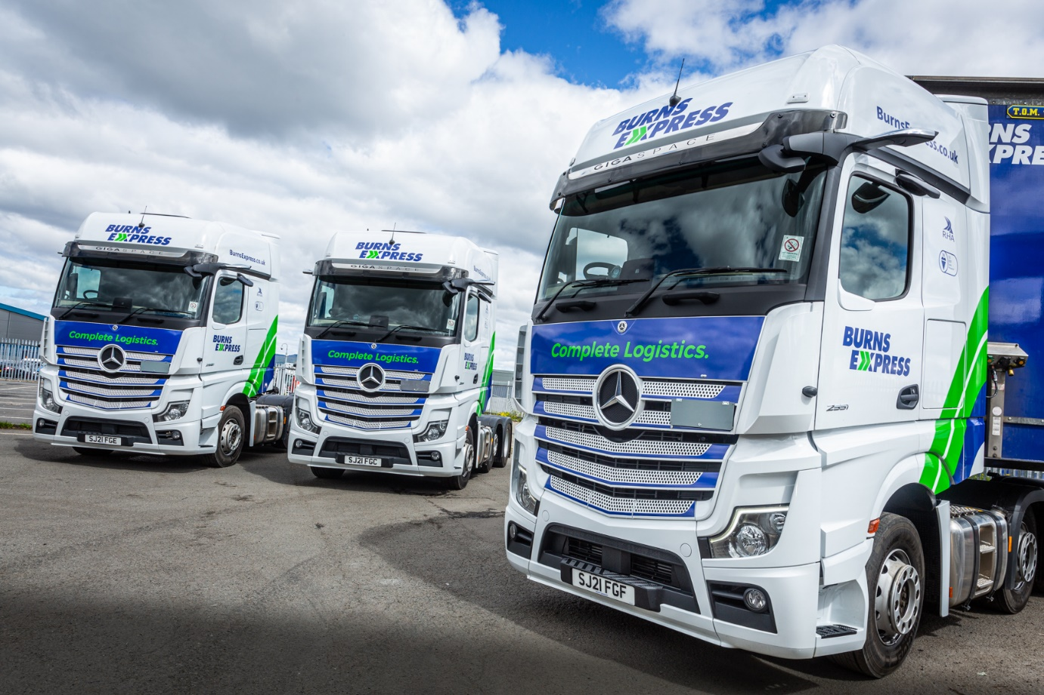

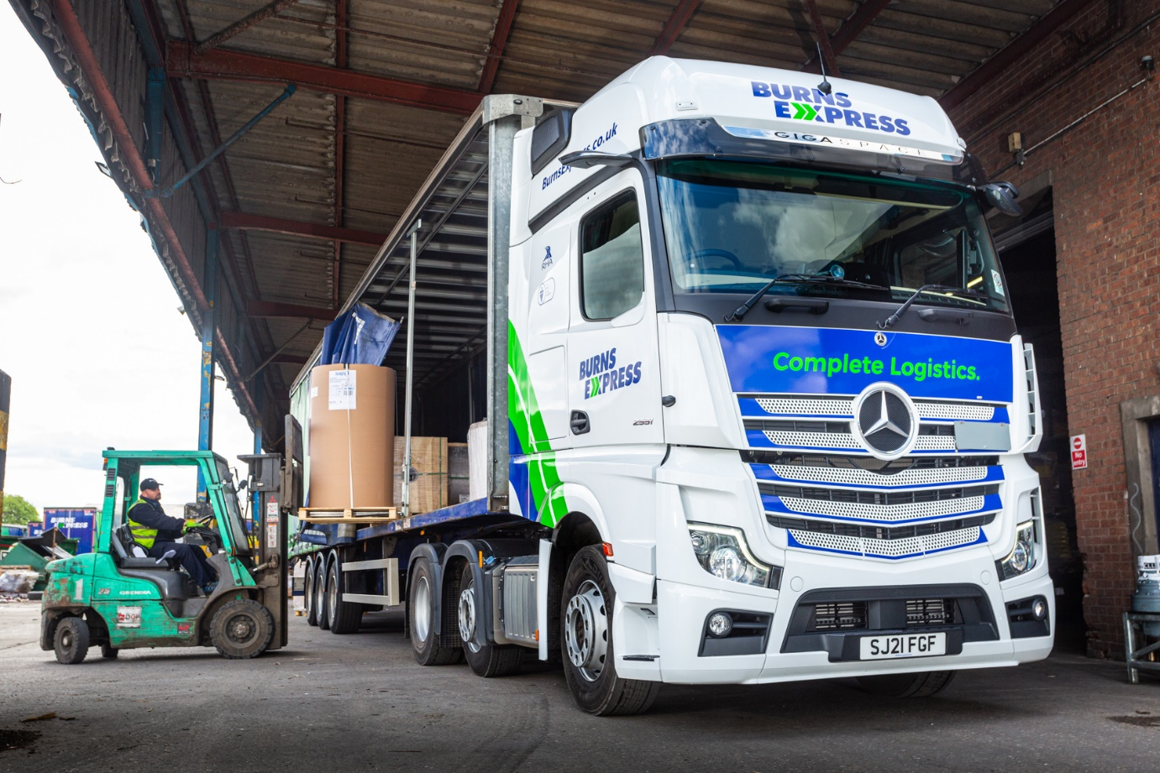

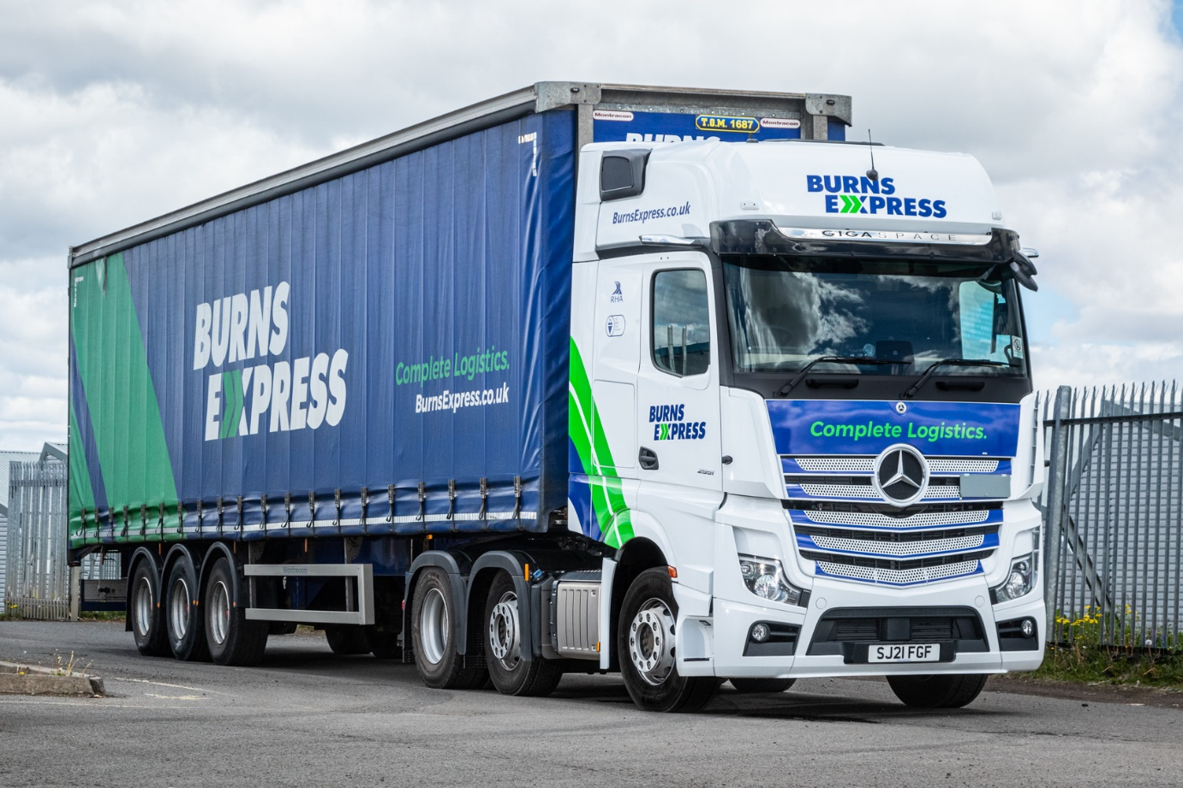

ends

For more information, or to request bigger/higher-res image files, please contact:
John Ripley or Steve Warren
Impact Communications, 01926 842126
John: 07771 484595, john@impactcom.co.uk
Steve: 07770 470251, steve@impactcom.co.uk

