

Date: 20 September 2022

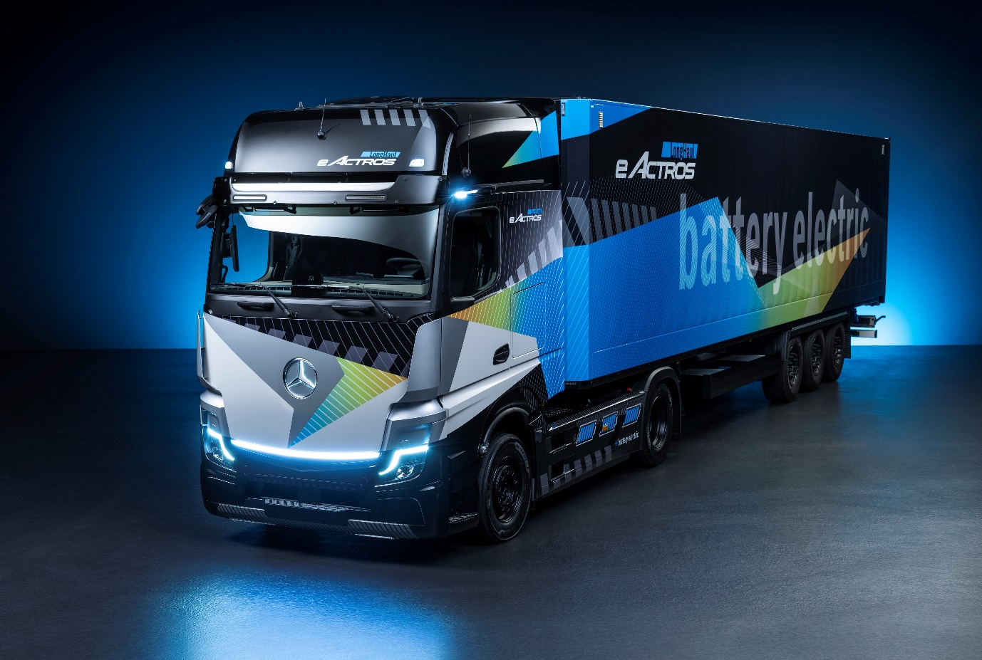

Coming soon: With the electrification of heavy long-distance transport the next milestone on the road to CO₂-neutrality, the eActros LongHaul is due to enter series production in 2024

Charged for tomorrow: Mercedes-Benz Trucks presents the eActros LongHaul for long-distance transport for the first time at the IAA Transportation 2022 in Hanover

- The “concept prototype” of the eActros LongHaul provides a preview of design language of production vehicle planned for 2024.

- The eActros LongHaul will have a range of around 500 kilometres from a single charge.

- Megawatt charging will enable the batteries to be replenished from 20% to 80% in under 30 minutes.

Lithium iron phosphate cell technology (LFP) in batteries ensures long service life and more usable energy.

- Mercedes-Benz Trucks offers customers a holistic transport solution consisting of vehicle technology, consulting, charging infrastructure and tailor-made services.

- Karin Rådström, CEO Mercedes-Benz Trucks: “We are continuously expanding our portfolio of battery-electric trucks. Our focus is on offering clear advantages to our customers. Therefore, our electric trucks are specifically designed for eMobility, giving them better drivability, energy efficiency and durability.”

Stuttgart/Hanover – In terms of payload, distance and routes, heavy-duty long-haul transport is the most demanding segment in road freight transport. At the same time, there is great potential here to reduce CO₂ emissions. Following the market launch of the eActros for heavy-duty distribution transport in 2021, Mercedes-Benz Trucks is now igniting the next stage for battery-powered heavy-duty long-haul transport. The company is presenting the eActros LongHaul, announced in 2020, for the first time at the IAA Transportation 2022 in Hanover. With clear contours and an LED light strip in the front area, the vehicle provides a preview of the design language of the series-production vehicle. The first prototypes have already undergone intensive tests and will next be trialled on public roads this year. In the coming year, near-series prototypes will be sent to various customers for testing.

Karin Rådström, CEO Mercedes-Benz Trucks: “We are continuously expanding our portfolio of battery-electric trucks. Our focus is on offering clear advantages to our customers. Therefore, our electric trucks are specifically designed for eMobility, giving them better drivability, energy efficiency and durability.”

Advantages of the Mercedes-Benz eActros LongHaul

Mercedes-Benz Trucks has also announced additional information on the eActros LongHaul series. Three battery packs provide an installed total capacity of over 600 kWh. Two electric motors, as part of a new e-axle, generate a continuous output of 400 kW (536 hp) and a peak output of over 600 kW (805 hp). In addition to the tractor unit, Mercedes-Benz Trucks will also produce rigid variants of the eActros LongHaul at market launch. This will offer customers numerous other possible use cases in fully electric transport. Development engineers at Mercedes-Benz Trucks are designing the eActros LongHaul so that the vehicle and its components meet the same durability requirements as a comparable conventional heavy long-distance Actros. That means 1.2 million kilometres on the road over a period of ten years.

The eActros LongHaul will be the first all-electric series-production vehicle from
Mercedes-Benz Trucks to be manufactured from start to finish on the existing assembly line at the Wörth truck plant. This includes the installation of all electrical components and putting the vehicle into operation at the end of the line. It enables high-production capacity and the completely parallel production of both conventional and fully electric trucks on the same line. With the eActros 300/400 and the eEconic, on the other hand, electrification has so far taken place in a separate process at the Future Truck Centre in Wörth.

The batteries used in the eActros LongHaul employ lithium-iron phosphate cell technology (LFP). These are characterised, above all, by a long service life and more usable energy. The batteries of the production eActros LongHaul can be charged from 20% to 80% in under 30 minutes at a charging station with an output of about one megawatt. The core of the Mercedes-Benz Trucks concept for battery-electric long-distance transport is to offer customers a holistic solution consisting of vehicle technology, consulting, charging
infrastructure and services. The eActros LongHaul is planned to be the right choice for customers in terms of profitability, sustainability and reliability.

eTrailer for even higher ranges

Electrified trailers can significantly increase the range of electric trucks. For example, the tech company Trailer Dynamics developed the “eTrailer” together with the trailer manufacturer Krone. The core is an e-axle built into the trailer, including batteries, which support the towing vehicle with additional power. Depending on the battery capacity of the eTrailer, ranges of more than 800 kilometres are possible with the series-production version of the eActros LongHaul on one battery charge.

Commitment with partners for charging infrastructure

With regard to public charging for long-haul transport, Daimler Truck, TRATON GROUP and Volvo Group founded a joint venture in July. The joint venture plans to install and operate high-performance charge points for battery-powered heavy-duty trucks and coaches in Europe. The charging network initiated by the three parties will be open and accessible to all heavy commercial vehicles in Europe, regardless of brand. Mercedes-Benz Trucks UK is working with EQUANS on depot charging.

In addition, Daimler Truck participates in the “high-performance charging in long-distance truck transport” (HoLa) project. The goal of this project, under the patronage of the VDA (The German Association of the Automotive Industry), is the planning, construction and operation of a selected high-performance charging infrastructure for battery-electric long-haul trucking. Two high-performance Megawatt Charging System (MCS) charging points will be set up at each of four locations in Germany and tested in real-world use. Various other consortium partners from industry and research are involved in the project.

eConsulting for tailor-made eMobility

Since eMobility is more than just a new technology, Mercedes-Benz Trucks will integrate the eActros LongHaul, like its currently available electric trucks, into a holistic ecosystem that includes consulting services for efficient vehicle use and optimisation of Total Cost of Ownership (TCO). For example, existing routes can be used to determine the most realistic and meaningful application profile of electric trucks for the respective customer in order to determine routes that can be driven with electric trucks. In addition to electrification of the depot, all questions relating to planning, application modalities and implementation relating to the required charging infrastructure, as well as network connection, are also part of the so-called eConsulting, depending on the customer’s requirements.

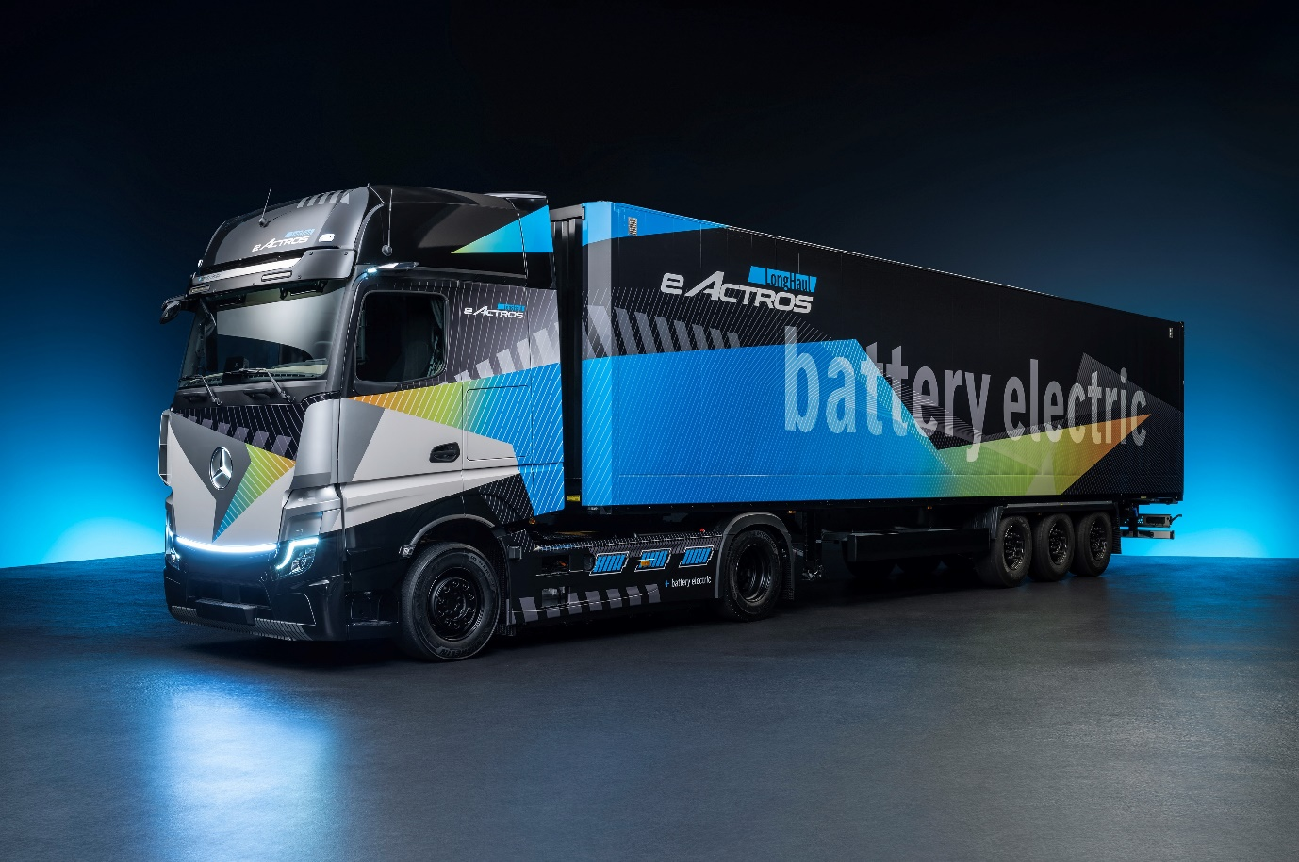

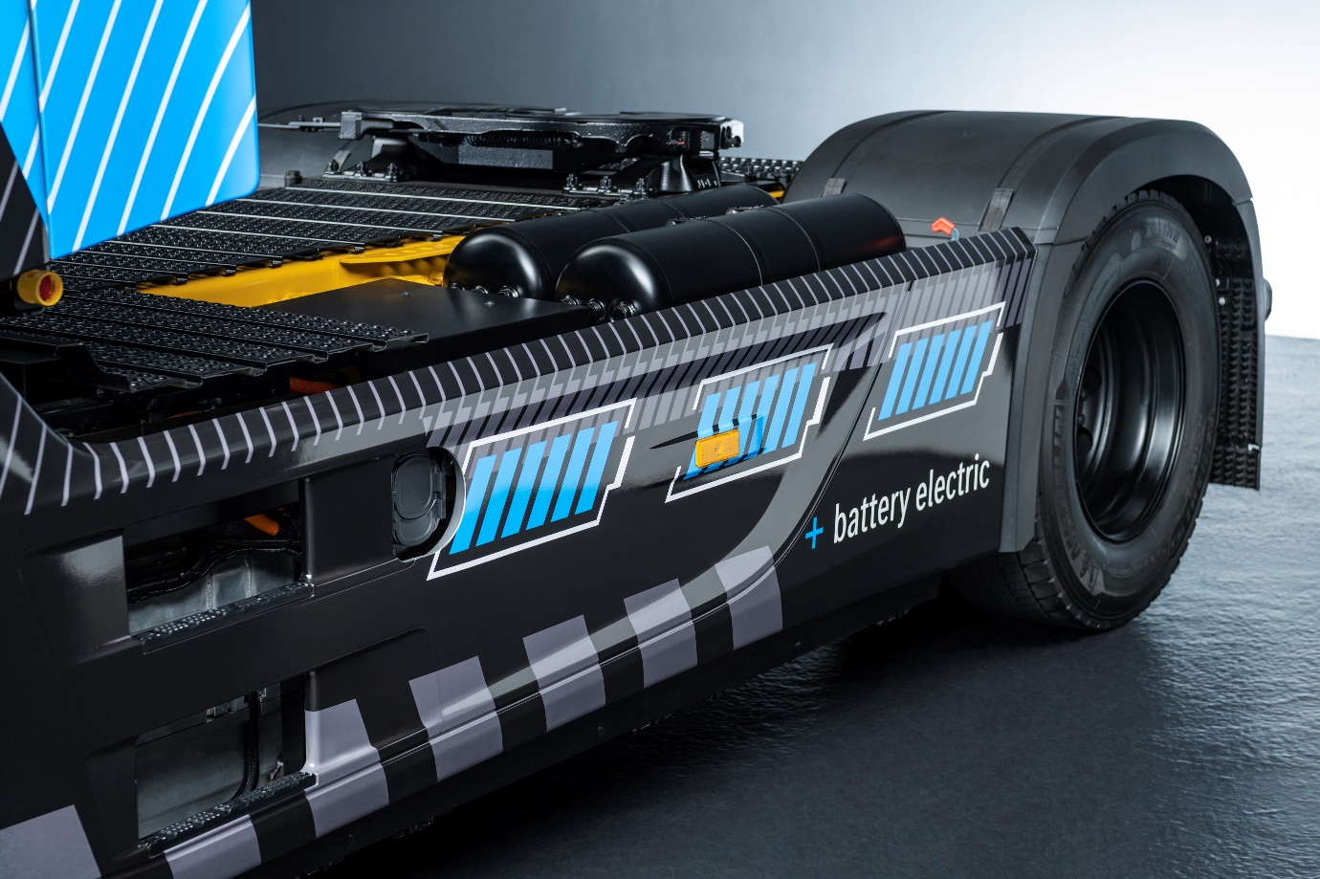

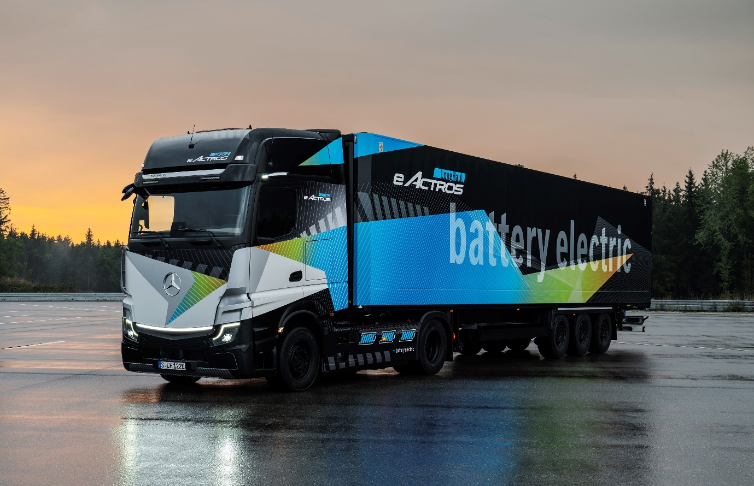

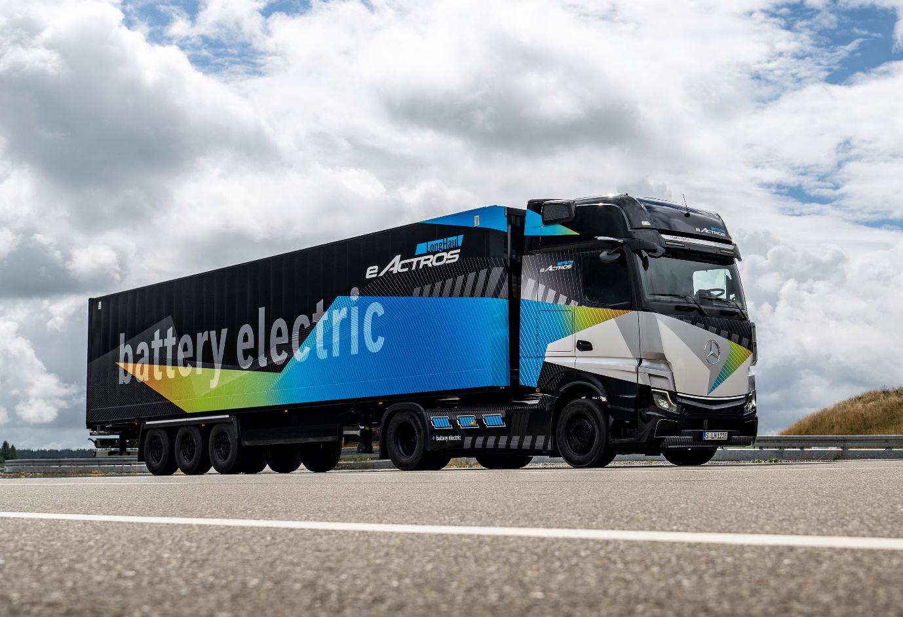

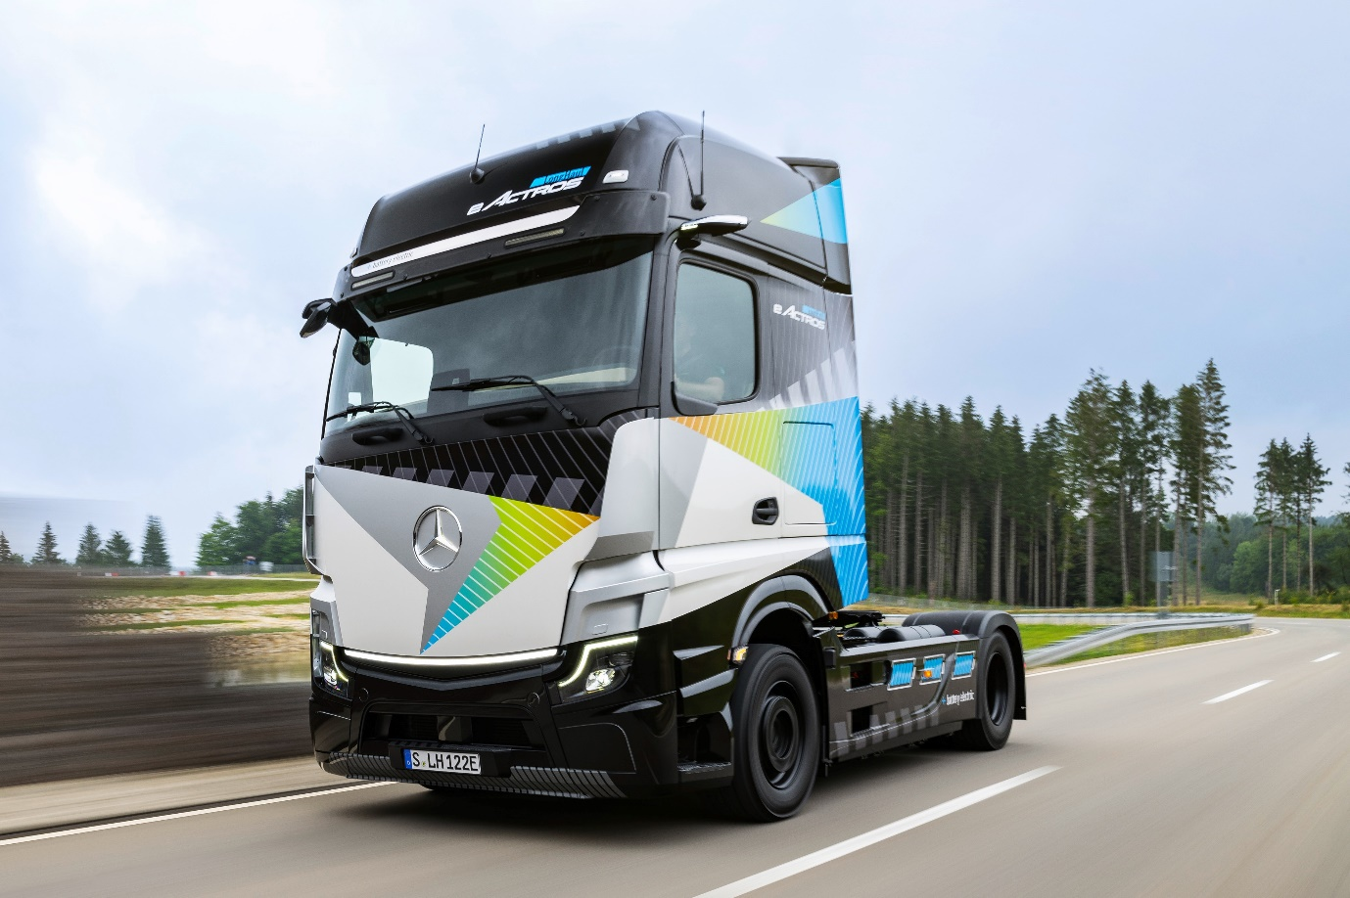

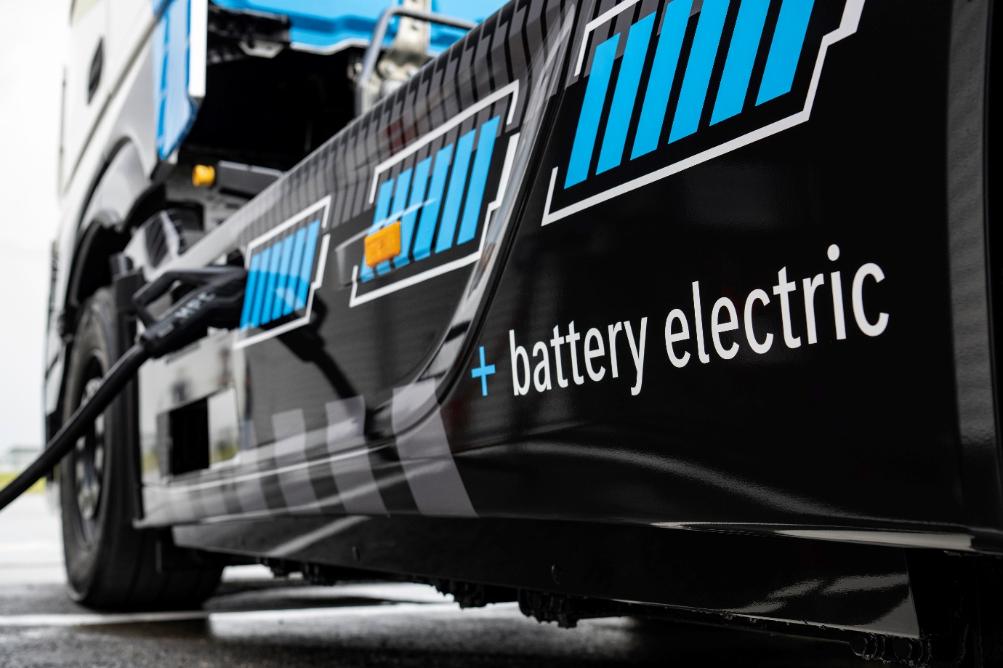

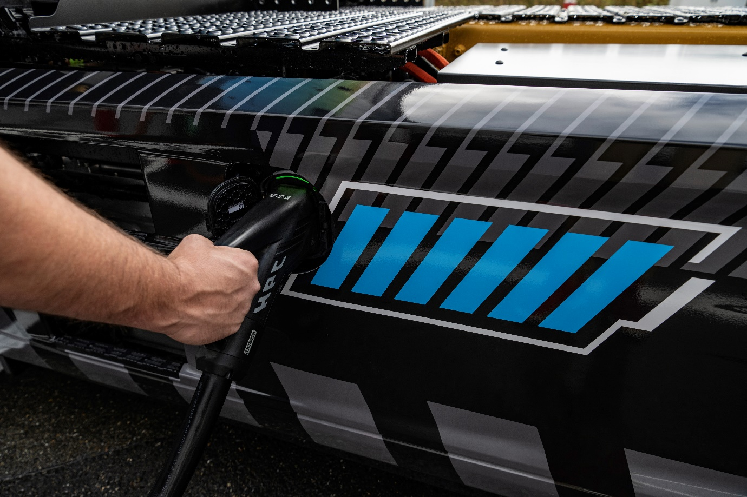

Power point: The eActros LongHaul will have a range of around 500 kilometres from a single charge

ends

For more information, or to request higher-resolution images, please contact:

Jamie Fretwell at Mercedes-Benz Trucks UK Ltd
07712 519230, jamie.fretwell@daimler.com

or

Steve Warren or John Ripley
Impact Communications
Steve: 07770 470251, steve@impactcom.co.uk
John: 07771 484595, john@impactcom.co.uk

or

Ulrike Burkhart, +49 (0) 160 8613757, ulrike.burkhart@daimlertruck.com
Akim Enomoto, +49 (0) 176 30995099, akim.enomoto@daimlertruck.com
Peter Smodej, +49 (0) 176 30936446, peter.smodej@daimlertruck.com

Further information on Daimler Truck is available at:
www.media.daimlertruck.com and www.daimlertruck.com

Forward-looking statements:
This document contains forward-looking statements that reflect our current views about future events. The words “aim”, “ambition”, “anticipate,” “assume,” “believe,” “estimate,” “expect,” “intend,” “may,” ”can,” “could,” “plan,” “project,” “should” and similar expressions are used to identify forward-looking statements. These statements are subject to many risks and uncertainties, including an adverse development of global economic conditions, in particular a decline of demand in our most important markets; a deterioration of our refinancing possibilities on the credit and financial markets; events of force majeure including natural disasters, pandemics, acts of terrorism, political unrest, armed conflicts, industrial accidents and their effects on our sales, purchasing, production or financial services activities; changes in currency exchange rates, customs and foreign trade provisions; a shift in consumer preferences; a possible lack of acceptance of our products or services which limits our ability to achieve prices and adequately utilise our production capacities; price increases for fuel or raw materials; disruption of production due to shortages of materials, labour strikes or supplier insolvencies; a decline in resale prices of used vehicles; the effective implementation of cost-reduction and efficiency-optimization measures; the business outlook for companies in which we hold a significant equity interest; the successful implementation of strategic cooperations and joint ventures; changes in laws, regulations and government policies, particularly those relating to vehicle emissions, fuel economy and safety; the resolution of pending government investigations or of investigations requested by governments and the conclusion of pending or threatened future legal proceedings; and other risks and uncertainties, some of which are described under the heading “Risk and Opportunity Report” in the current Annual Report. If any of these risks and uncertainties materializes, or if the assumptions underlying any of our forward-looking statements prove to be incorrect, the actual results may be materially different from those we express or imply by such statements. We do not intend or assume any obligation to update these forward-looking statements since they are based solely on the circumstances at the date of publication.

Daimler Truck at a glance
Daimler Truck Holding AG ("Daimler Truck") is one of the world's largest commercial vehicle manufacturers, with over 40 main locations and more than 100,000 employees around the globe. The founders of Daimler Truck have invented the modern transportation industry with their trucks and buses a good 125 years ago. Unchanged to this day, the company's aspirations are dedicated to one purpose: Daimler Truck works for all who keep the world moving. Its customers enable people to be mobile and get goods to their destinations reliably, on time, and safely. Daimler Truck provides the technologies, products, and services for them to do so. This also applies to the transformation to CO2-neutral driving. The company is striving to make sustainable transport a success, with profound technological knowledge and a clear view of its customers' needs. Daimler Truck's business activities are structured in five reporting segments: Trucks North America (TN) with the truck brands Freightliner and Western Star and the school bus brand Thomas Built Buses. Trucks Asia (TA) with the FUSO and BharatBenz commercial vehicle brands. Mercedes-Benz (MB) with the truck brand of the same name. Daimler Buses (DB) with the Mercedes-Benz and Setra bus brands. Daimler Truck's new Financial Services business (DTFS) constitutes the fifth segment, the product range in the truck segments includes light, medium and heavy trucks for long-distance, distribution and construction traffic and special-purpose vehicles used mainly in the municipal and vocational sector. The product range of the bus segment includes city buses, school buses and intercity buses, coaches and bus chassis. In addition to the sale of new and used commercial vehicles, the company also offers aftersales services and connectivity solutions.

