

Date: 1 May 2025

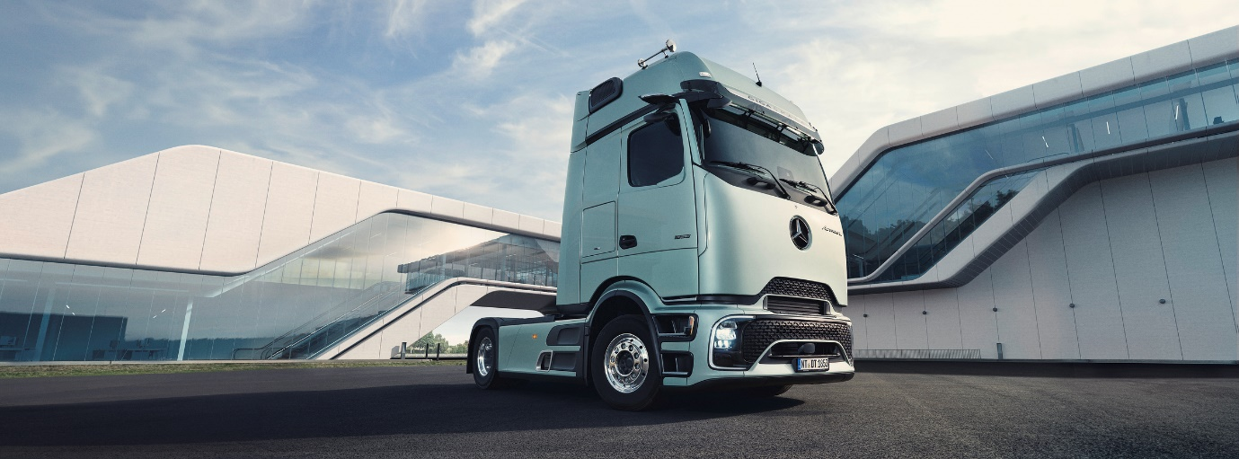

MC Rental signs up for the future with purchase of 100 Mercedes-Benz Actros L ProCabins

Truck hire specialist MC Rental has put pen to paper on a landmark order for 100 Mercedes-Benz Actros L tractor units with the revolutionary ProCabin.

The purchase will be the UK’s biggest yet for the truck with the most distinctive design on the road.

The ProCabin’s smooth front panel gives it a futuristic look that sets it apart from any other vehicle – but it’s not just a visual gimmick, as the cab’s improved aerodynamics also bring a fuel efficiency improvement of up to three percent.

MC Rental has embraced this combination of forward-looking design, with tried-and-tested reliability, performance, efficiency and dependable back-up from Mercedes-Benz and supplying Dealer Bell Truck and Van.

The first of the new trucks is due for delivery in May, with the rest of the order to be completed across the year. All will be Actros L 2553 units powered by muscular 390 kW (530 hp), 12.8-litre in-line six-cylinder engines. Their Giga ProCabins will feature double bunks, premium heated seats, fridges and luxury touches such as ambient lighting and extra USB-C sockets in the side walls.

The fresh design is much more than skin-deep too – Actros L ProCabin trucks all boast a full suite of technological enhancements to boost both efficiency and safety. These include the latest version of Mercedes-Benz Active Brake Assist, now in its sixth generation, as well as Active Sideguard Assist and Front Guard Assist. Together these and other standard systems help the vehicle meet or exceed the latest General Safety Regulations.

Meanwhile driver comfort and efficiency are enhanced by Predictive Powertrain Control and Active Drive Assist functions, and the My TruckPoint platform provides a range of over-the-air services direct to the cab.

The trucks will join MC Rental’s fleet of more than 2,500 commercial vehicles and be offered to customers across various industries, nationwide, via a range of tailored rental solutions.

MC Rental Director of Business Development, Gina Ritrovato, said: “Our investment in these stunning new trucks is part of a combined strategy to both refresh and expand our fleet. Some will replace older models, maintaining our average vehicle age at less than two years old. Others will increase our capacity to cope with growing demand.

“As a rental operator our choice of vehicles is very much driven by what our customers tell us they want,” she continued. “The Mercedes-Benz Actros has consistently been a popular choice due to its exceptional reliability, efficiency, and driver appeal. Some standout features that influenced our decision include:

- Safety and technology – advanced MirrorCam, Active Brake Assist, and Predictive Powertrain Control enhance both driver safety and fuel efficiency.
- Driver comfort – high-spec trim levels, dual bunks, fridges, and premium interiors ensure drivers have the best possible working environment.
- Compliance and future-proofing – these trucks meet the latest GRS2 (DVS) safety standards, with integrated cameras and radar systems for improved visibility and urban safety.
- Low running costs and sustainability – the fuel efficiency and reduced emissions of the Actros align with our commitment to sustainable fleet operations.

“We also love the bold and modern design that makes the Actros L ProCabin really stand out on the road. The sleek aerodynamics and MirrorCam system give it a futuristic look, while the distinctive grille and LED lighting enhance its presence. We believe this visual appeal, combined with its technological advancements, makes the new Actros a fantastic addition to our fleet.”

Ms Ritrovato also paid tribute to the commitment of Bell Truck and Van and Mercedes-Benz to building a successful and ongoing dealer/customer partnership.

“We’ve had an excellent experience working with Group Head of Truck Sales Alex Wordsworth and the team at Bells. Their expertise, support, and commitment to providing the best vehicles for our needs have been outstanding. Mercedes-Benz has always been a trusted manufacturer for us, and this latest investment reinforces our strong relationship with the brand,” he said.

“At MC Rental, we are committed to delivering the highest standards in commercial vehicle hire. Our investment in these latest Mercedes-Benz Actros models is part of our strategy to provide modern, efficient, and safe vehicles to our customers. We look forward to continuing to support businesses with their fleet requirements and helping them stay ahead in a rapidly evolving industry.”

www.mcgroupltd.co.uk

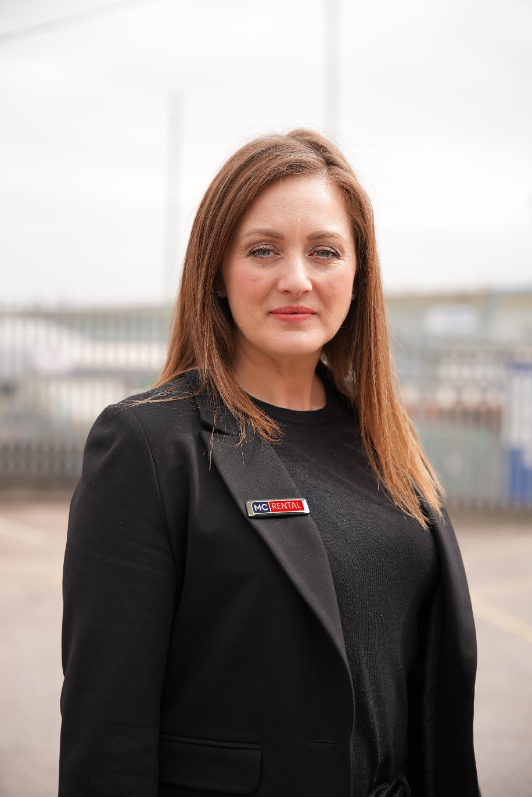

Looking ahead: Actros ProCabin will be “A fantastic addition to our fleet”, says MC Rental’s Gina Ritrovato

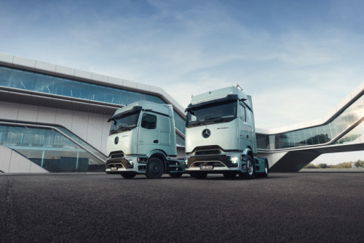

ends

For more information, or to request bigger/higher-res image files, please contact:
John Ripley: 07771 484595, john.ripley@loopagency.co.uk

