

Date: 19 July 2019

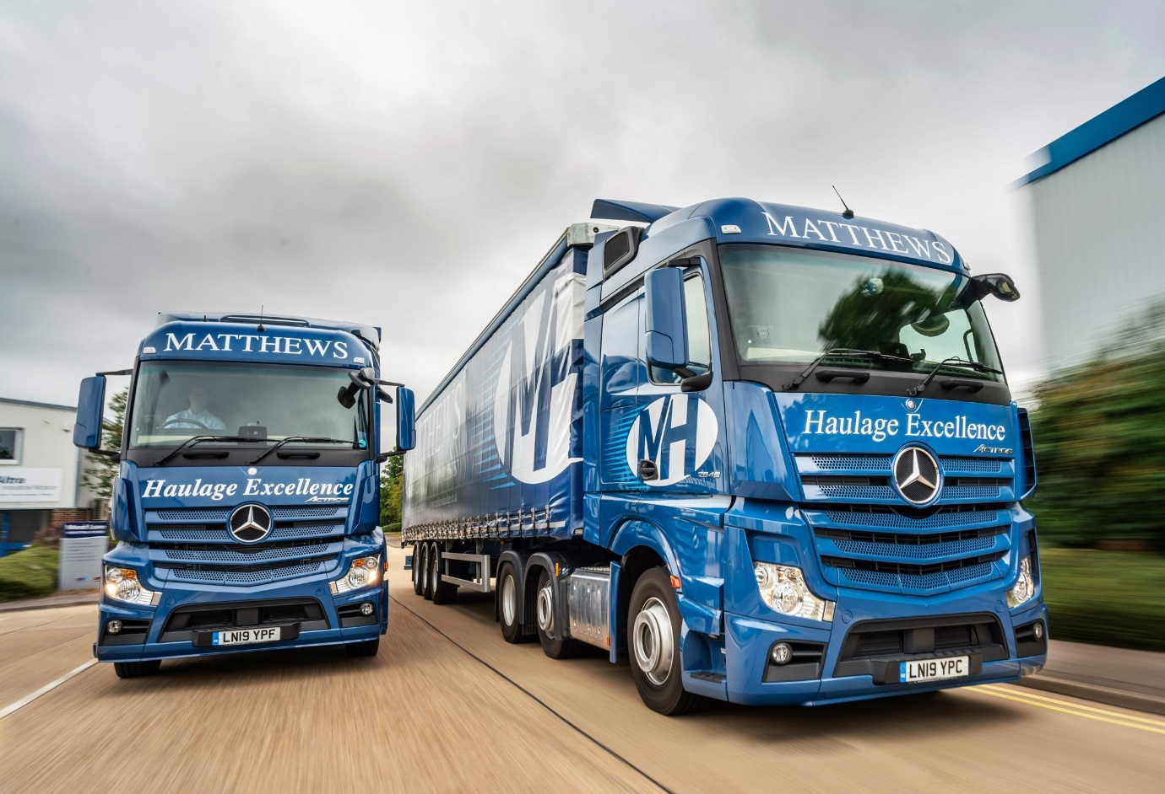

Matthews Haulage chalks up a ‘full house’ of
Mercedes-Benz trucks from S & B Commercials

With the arrivals of its latest four Mercedes-Benz Actros, Matthews Haulage has completed the transformation of its fleet to one in which every truck wears a three-pointed star.

The milestone coincides with the dawn of a new era for the Hertford-based operator, as Managing Director Nick Matthews prepares to retire and hand over the reins to Operations Director Trevor Brown, and Commercial Director Matt Moore, who will be running the business on behalf of the Matthews family.

Matthews Haulage offers a comprehensive portfolio of transport services, but specialises in next-day (including timed) and economy deliveries of everything from a single pallet to a full load, throughout the UK and Ireland. Underlining its commitment to customer service, the company was a proud winner in January – for the third year running! – of the Pall-Ex Group’s prestigious Highest KPI Performer award.

Matthews Haulage’s new trucks were supplied, like its previous Mercedes-Benz vehicles, by local Dealer S & B Commercials, whose timely, efficient back-up has been instrumental in convincing the operator to switch brands.

Three are Actros 2545 tractor units with 2.5m-wide, flat-floored StreamSpace cabs, and second-generation 330 kW (450 hp) 12.8-litre in-line six-cylinder engines. Their comprehensive safety armoury includes the Active Brake Assist 4 emergency braking system with pedestrian recognition capability, Proximity Control Assist, Attention Assist and Lane Keeping Assist.

The fourth is an 18-tonne Actros 1827. It has a 2.3m-wide StreamSpace cab and a 7.7-litre straight-six producing 200 kW (272 hp). The rigid was optionally specified with the fuel-saving Predictive Powertrain Control system, which is standard equipment on roadgoing tractor units. Its curtainsided body, meanwhile, was built in Peterborough by Lawrence David.

As with its other Mercedes-Benz vehicles, the four new trucks are now being inspected and maintained at S & B Commercials’ Hatfield workshop. The tractor units came with two-year Complete Service Contracts, which the operator has extended by a further 12 months; the rigid is also the subject of a three-year agreement.

Smartly finished, with colour-coded bumpers and mirror covers, the Matthews Haulage fleet extends to 15 trucks, eight top-weight tractor units and seven 18-tonners. The company has run 26-tonne curtainsiders in the past, but now considers tractor units and short, urban trailers to be a more flexible and cost-effective alternative.

Established in 1975 by brothers Trevor and Nick Matthews, Matthews Haulage traditionally favoured a Swedish marque, but bought its first Mercedes-Benz trucks – all tractor units – in 2015. “We’ve not looked back since,” said Matt Moore.

“With its current model generation, the manufacturer has really raised its game in terms of both fuel-efficiency and driver appeal. Mercedes-Benz trucks are more economical than our previous vehicles – the tractor units average 9 mpg, which is a figure we’re certainly happy with – as well as being substantially better in terms of reliability.

“Every bit as importantly,” he continued, “our drivers really want to drive these vehicles. In years gone by, Mercedes-Benz trucks might have been lacking a few creature comforts, and very few drivers would have had one at the top of their ‘wish list’.

“Those days are gone, though, because when it comes to style, comfort and equipment levels, Mercedes-Benz trucks are now right up there with the very best. Good drivers are hard to come by, so we can’t just give ours a cheap truck and leave them to get on with it, especially given that some of them are in their cabs all week.

“Instead, it’s only right that we recognise their importance to the success of the company, so we’re prepared to invest and provide them with premium quality trucks in which to do their jobs. Suffice to say, our drivers are very happy to be part of the Mercedes-Benz ‘family’.”

Matthews Haulage is equally pleased with the aftersales support it receives from S & B Commercials. “We cannot afford unplanned downtime, as a truck off the road is likely to cost us a lot of money,” explained Trevor Brown, whose relationship with Mercedes-Benz goes back to the 1980s.

“The Actros is clearly a very sound product mechanically, but when issues do crop up it’s of paramount importance that we get the right level of response from the Dealer. Service Manager Steve Smedley and the team at S & B Hatfield provide an exceptional, customer-focused service – I can’t fault them.”
Trevor Brown added: “This is an important time for Matthews Haulage. We’re very busy and have been investing heavily in new equipment, including another three SDC curtainsided trailers which have also just arrived. Our smart, modern fleet gives us an ideal platform from which to take this business to the next level.”

Nick Matthews concluded: “It’s been a long journey with many ups and downs but I feel we have created something very special here. The company ethos has always been about service, and it’s stronger than ever today. To deliver this service we need reliable trucks, and that’s what we get from Mercedes-Benz.

“Their experience, both in previous employment and with Matthews Haulage, has given me the confidence to hand over the reins to Trevor and Matt, and let them propel the company to even greater heights.”

www.matthewshaulage.co.uk

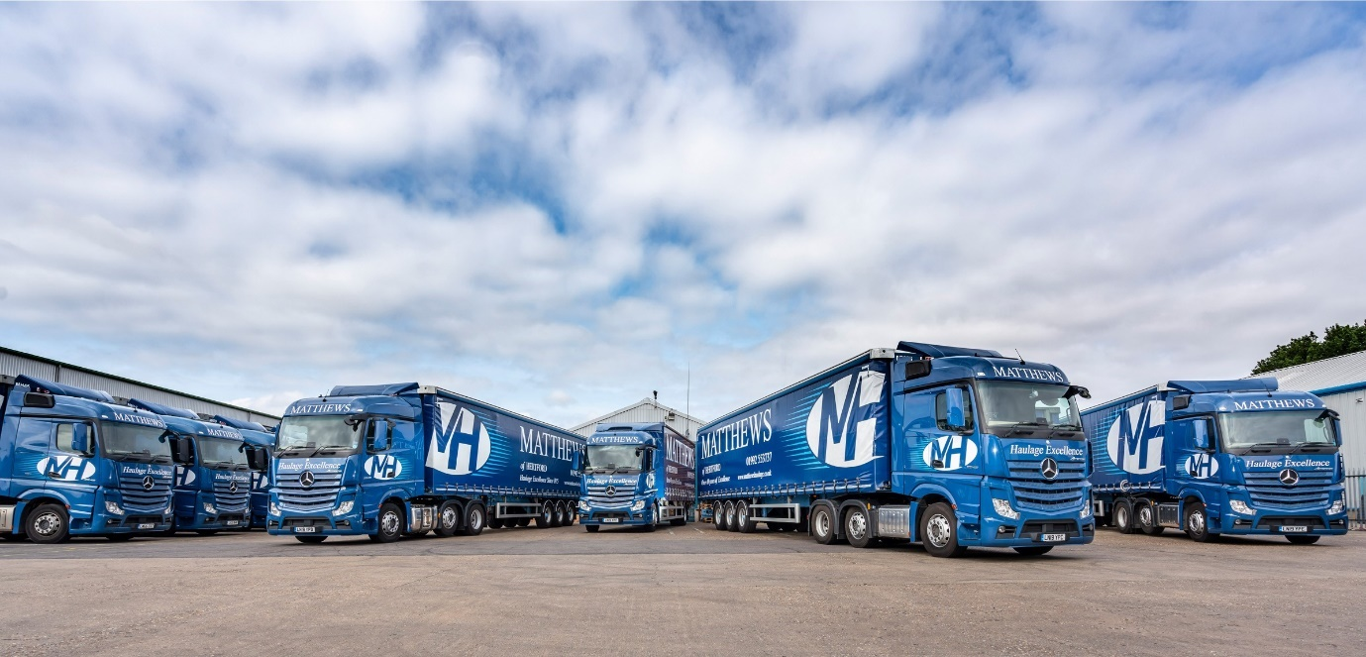
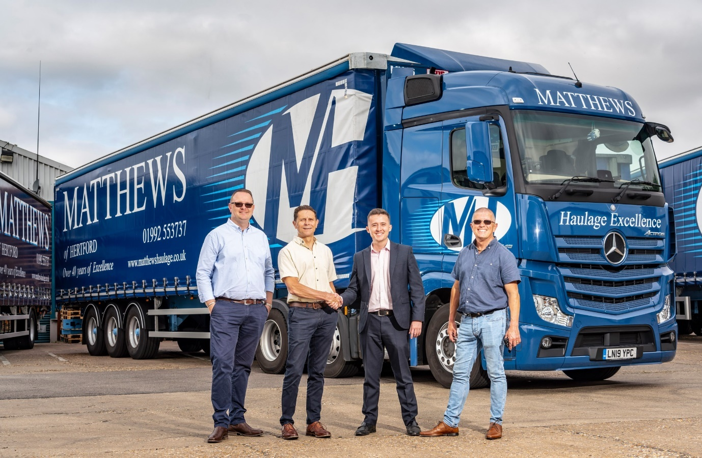

Handover: Managing Director Nick Matthews, second from left, is pictured with Matthews Haulage colleagues Matt Moore, left, and Trevor Brown, right, and S & B Commercials National Fleet Sales Manager Sam Setterfield

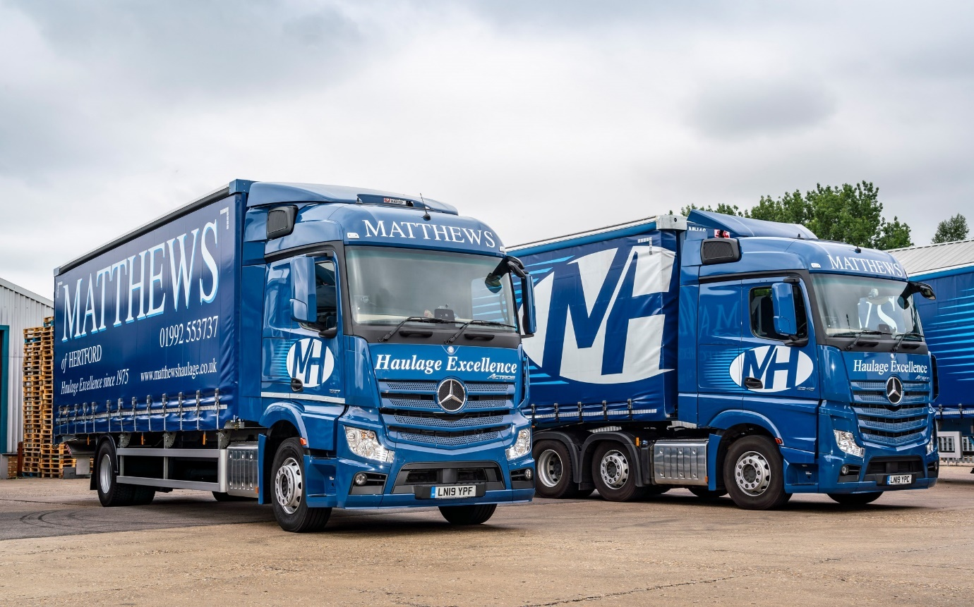

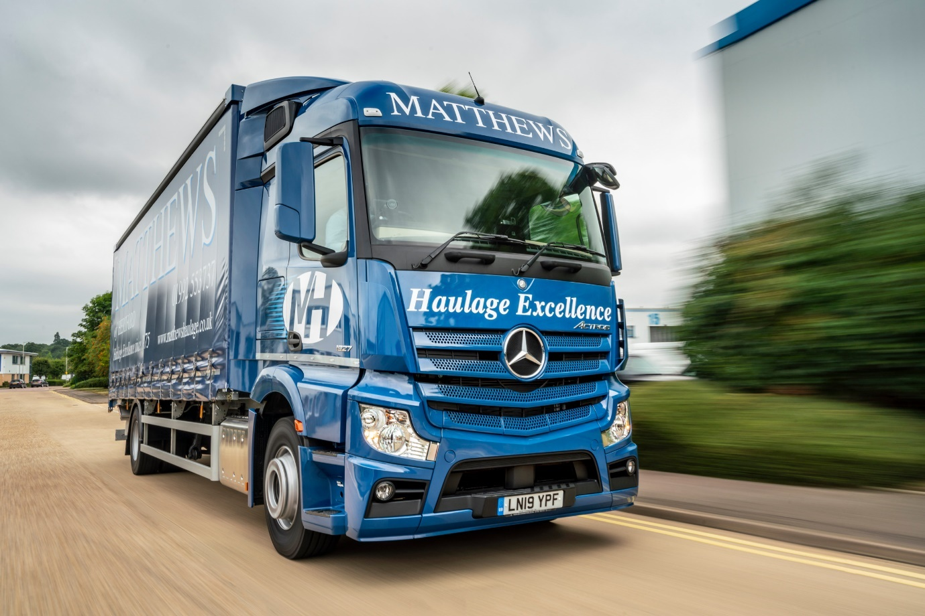

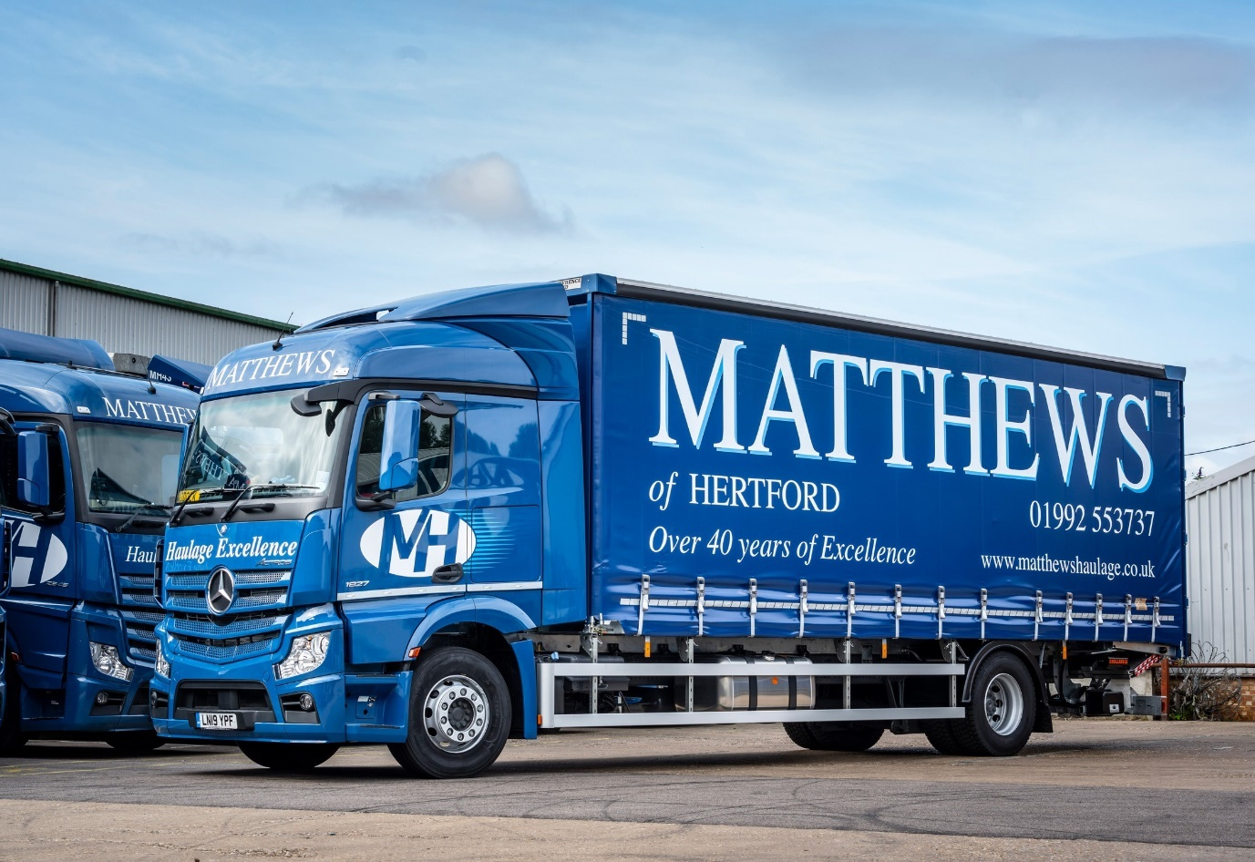

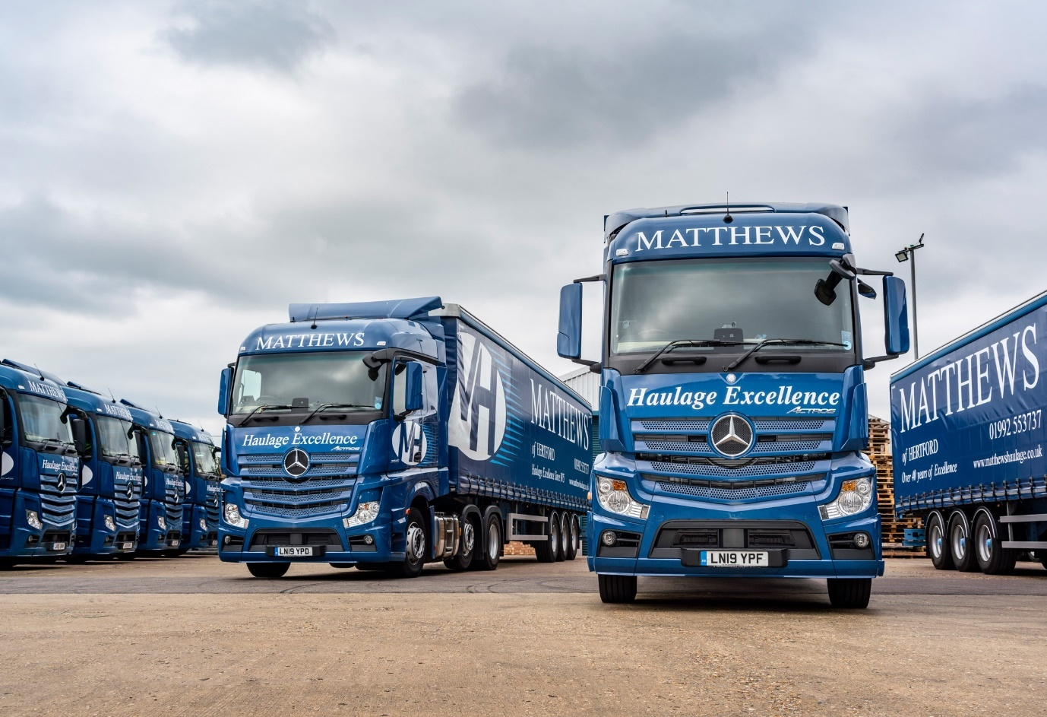

ends

For more information, or to request bigger/higher-res image files, please contact:
Steve Warren or John Ripley
Impact Communications, 01926 842126
Steve: 07770 470251, steve@impactcom.co.uk
John: 07771 484595, john@impactcom.co.uk

