

Date: 4 February 2020

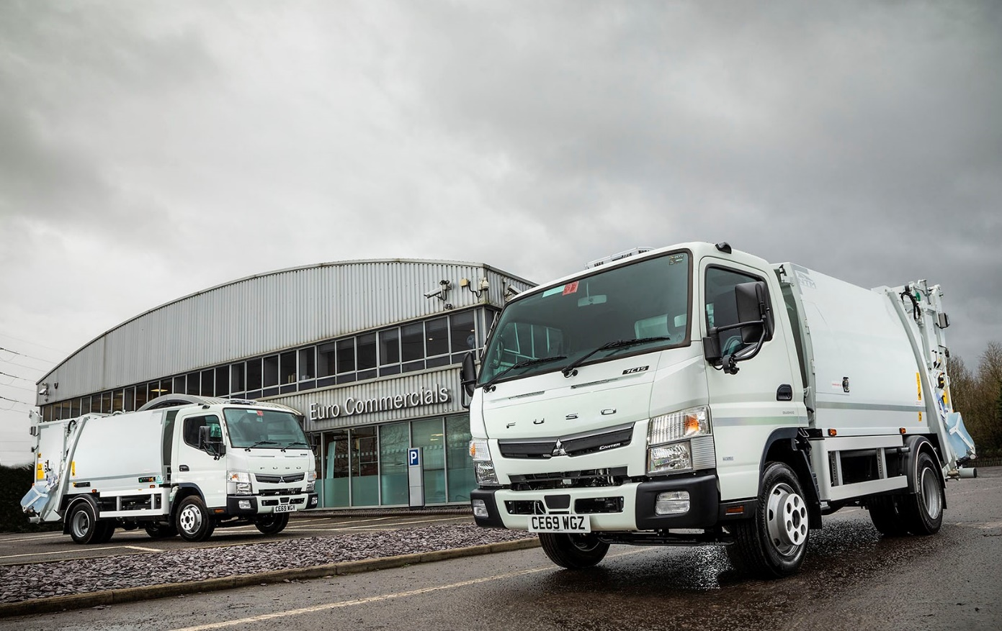

Euro Commercials weighs in with two more FUSO Canters for NTM’s high-payload RCVs

Body manufacturer NTM GB sold its two newest FUSO Canter-based refuse collection vehicles before it had even finished building them!

NTM builds and maintains a comprehensive range of high-quality equipment for waste and recycling applications at the factory in Kidderminster, Worcestershire, to which it moved in 2015.

It will shortly be delivering the new 7.5-tonners to one of the UK’s leading waste management specialists. This well-established customer already operates a number of NTM refuse collection vehicles based on the award-winning FUSO.

The chassis were supplied by South Wales Dealer Euro Commercials, which also sells and supports Mercedes-Benz trucks, and is a leading supplier to the municipal sector. The two companies have forged a highly successful working partnership over recent years.

Under a rolling production programme NTM has pre-built a succession of Canters for immediate delivery to operators. It has also fitted compactor bodies to a number of low-entry Mercedes-Benz Econics, including nine 26-tonne rear-steer models which entered service with Ceredigion County Council last summer. NTM’s demonstration fleet includes a pair of Econics too.

The new FUSOs are both 7C15 variants. In line with its established policy, NTM specified their Comfort day cabs with optional automatic climate control systems. Economical 3.0-litre common-rail diesel engines produce 110 kW (150 hp), offer impressive torque – 370 Nm is available over a broad engine speed range – and drive through smooth-shifting DUONIC dual-clutch automated transmissions.

The trucks have 2.8-metre wheelbases – only one of the six available lengths is shorter – and are the ideal size to accommodate NTM’s K-Series bodywork, which is purpose-designed for domestic collections across the UK; it is particularly viable on routes with restricted access.

Reliable and easy to maintain, the K-Midi body offers high carrying capacities when based on the Canter. This refuse compaction collection vehicle has one of the smallest footprints on the market, yet the available load volume of 4.6m³ is coupled with an outstanding payload allowance of 2.2 tonnes. Standard features include body-mounted beacons and rear LED lights, and a colour rear-view camera, while the latest two vehicles are also fitted with NTM bar bin lifts.

NTM Area Sales Manager Tim Prince confirmed: “The Canter is definitely the most popular 7.5-tonner for our customers, so we regularly build stock vehicles on this chassis. It’s all about payload. The Canter will carry the best part of a tonne more than most trucks in its gross weight segment, and with our K-Midi body offers exceptionally high levels of productivity.

“Even though the FUSO is strong and well built, it is also relatively small in size. This, combined with an extremely tight turning circle, means it is highly manoeuvrable, and ideal for serving those hard-to-reach areas.”
Finnish-owned NTM was founded in 1950 and established its UK subsidiary in 2003. Eight years later it acquired the former LinkTip, a well-known supplier of smaller refuse vehicle solutions, as well as tippers.

Tim Prince continued: “We enjoy working with the team at Euro Commercials as they have a high level of expertise when it comes to the municipal sector. That’s particularly important, for example, when we’re compiling complex tenders and need detailed quotes quickly – Euro’s experts don’t shy away from this kind of technically challenging project.

“The relationship between our two companies is exceptionally strong, and works on a reciprocal basis. Just as we took the chassis order to Euro Commercials after winning an order from Monmouthshire County Council for 13 Econic chassis in 2018, so the Dealer helped us to secure the bodywork when it landed the Ceredigion County Council business.”

www.ntm-gb.com

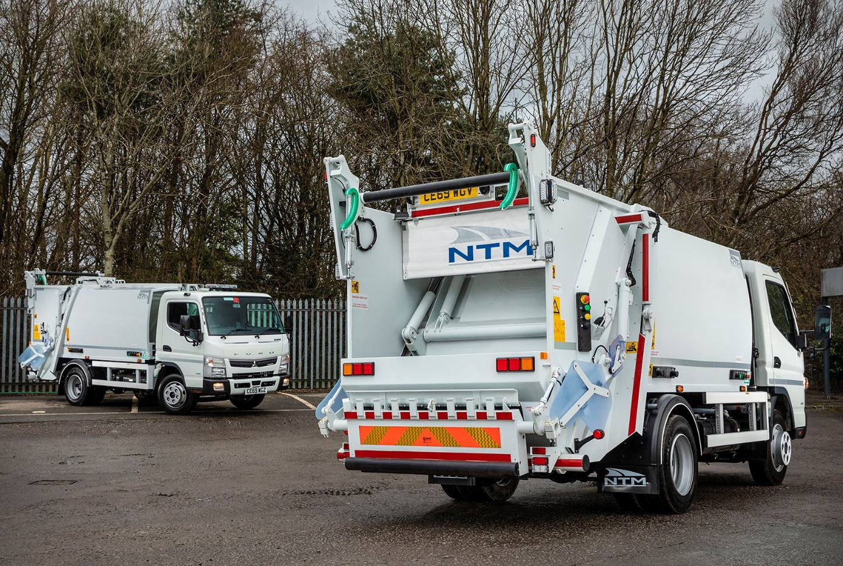

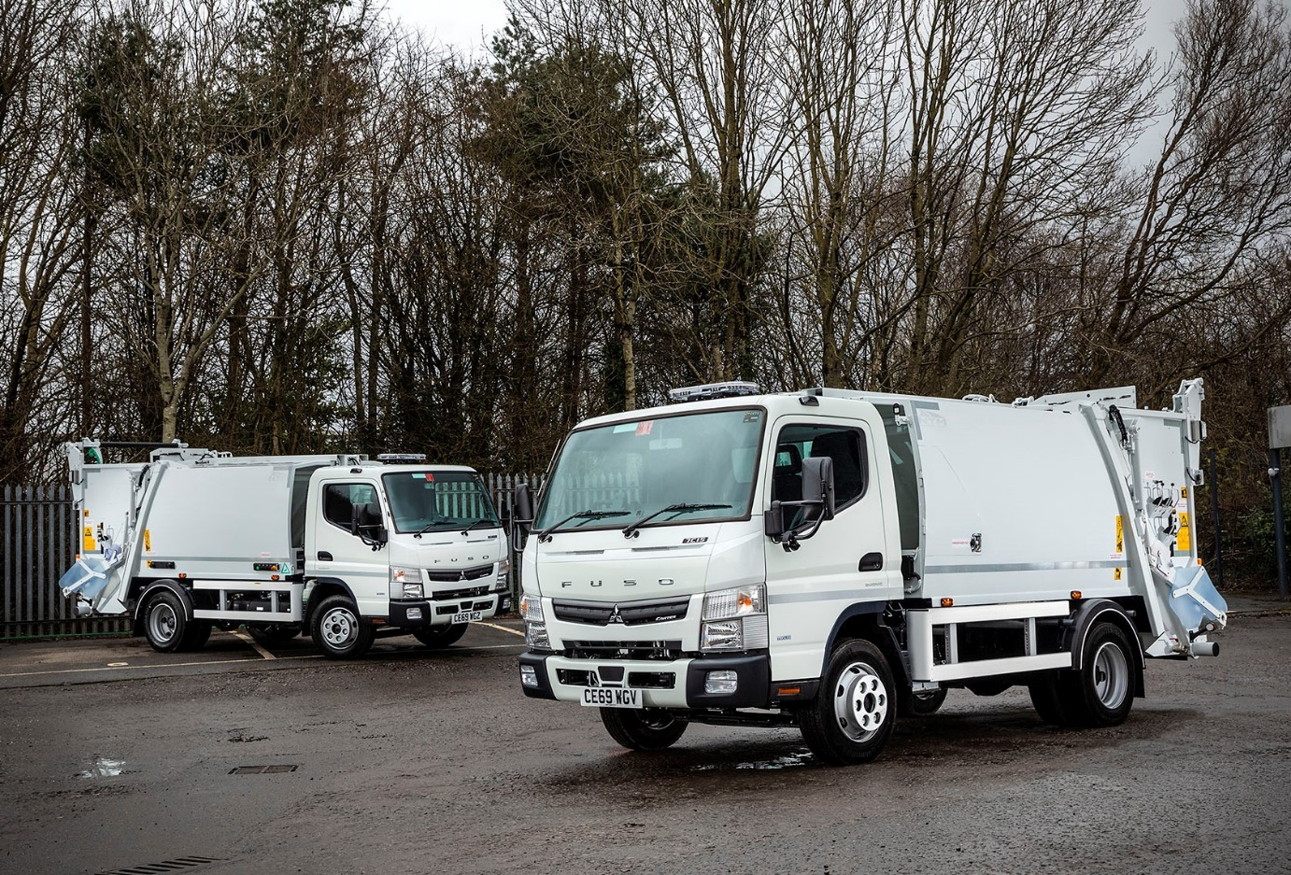

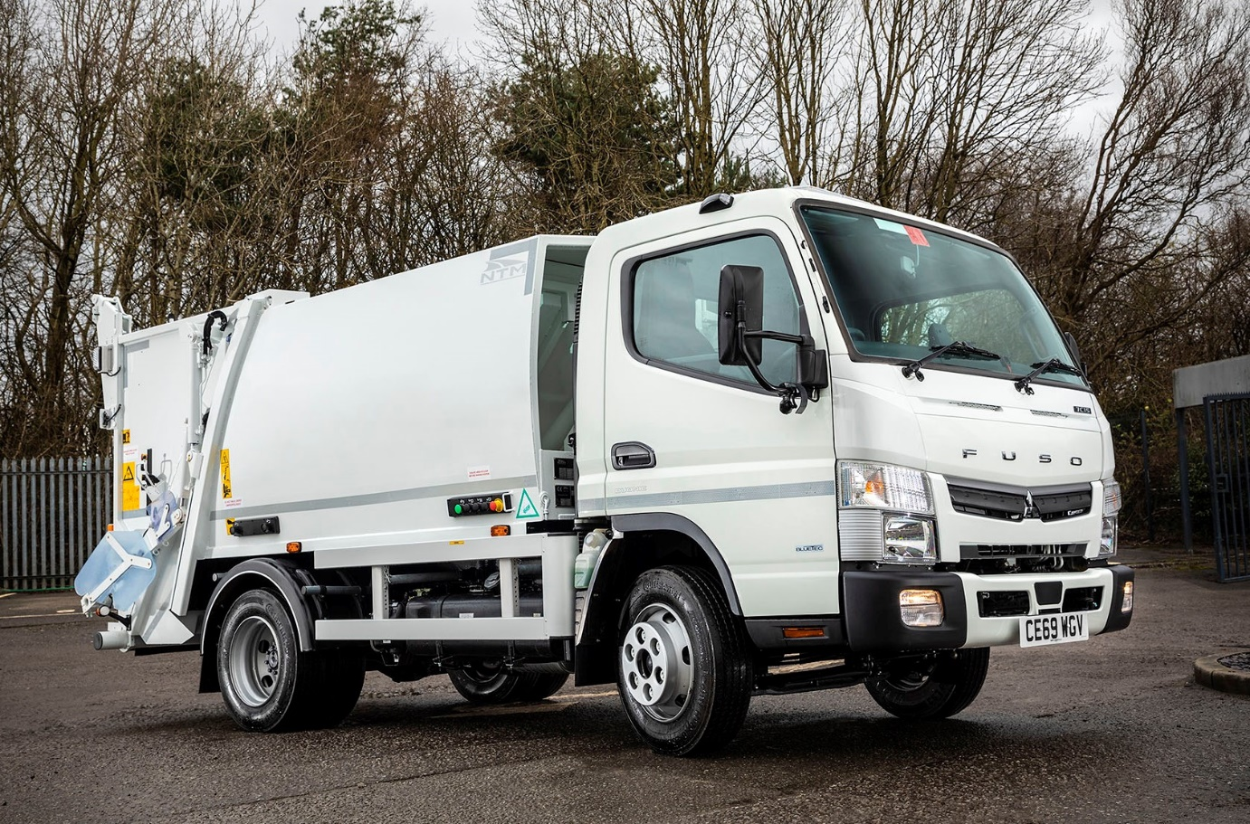

For more information, or to request bigger/higher-res image files, please contact:
Steve Warren or John Ripley
Impact Communications, 01926 842126
Steve: 07770 470251, steve@impactcom.co.uk
John: 07771 484595, john@impactcom.co.uk

