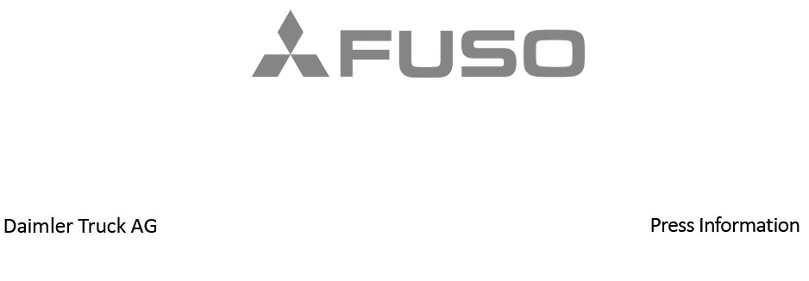

Date: 20 September 2022

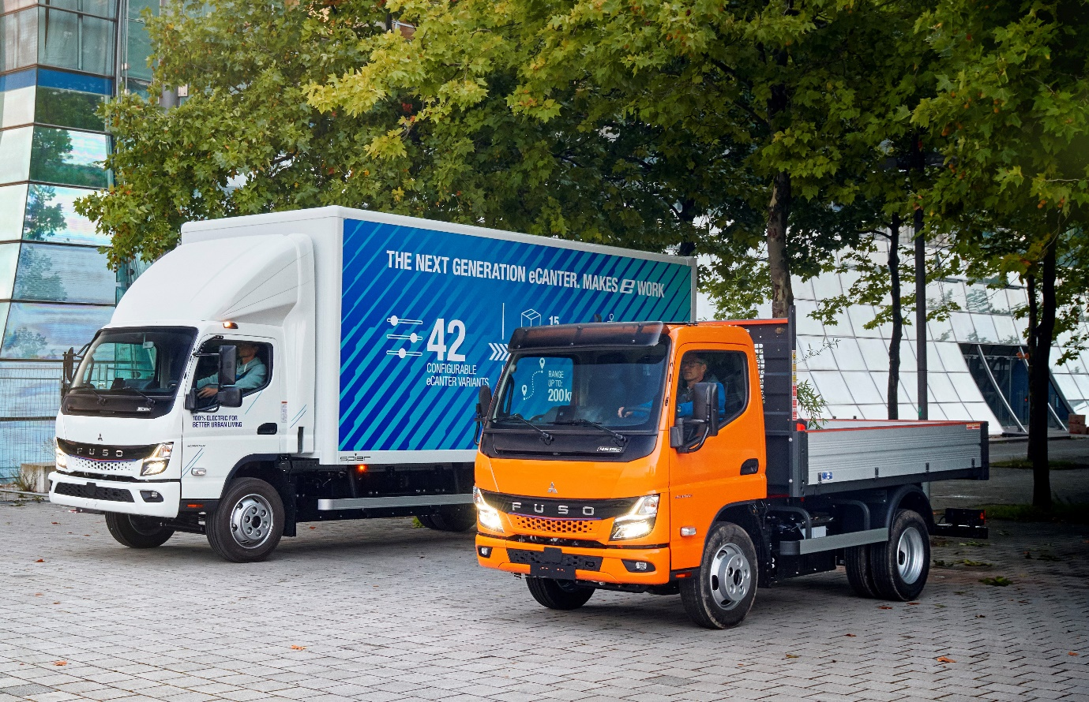

Extending choice: Whereas its ground-breaking predecessor was only available with a gross weight of 7.49 tonnes, the Next Generation eCanter can also be specified at 4.25, 6.00 and 8.55 tonnes GVW

Pioneer and frontrunner in electric trucks: Daimler Truck celebrates the European premiere of FUSO’s Next Generation eCanter at IAA Transportation 2022

- FUSO’s Next Generation eCanter is tailored to inner-city distribution transport and the requirements of the last mile.

- Three different battery packs enable ranges of between 70 and 200 kilometres.

The charging unit supports charging with both alternating and direct current.

- The Next Generation eCanter is now available in a total of 42 variants with six wheelbases and gross weights from 4.25 to 8.55 tonnes.

- Karl Deppen, Member of the Board of Management of Daimler Truck Holding AG, responsible for Truck China and the regions Japan and India with the brands FUSO and BharatBenz: “The Next Generation eCanter is the development result of around five years of eCanter experience gained with our customers around the globe. Compared to the previous eCanter, the significantly broader vehicle portfolio covers most of today’s common applications and makes an even greater contribution to locally emission-free inner-city transport than before.”

Stuttgart/Hanover – More powerful, more efficient, more range, and a wide variety of applications: This is the essence of the Next Generation eCanter from FUSO, presented at the IAA Transportation 2022. Since the introduction of the eCanter in 2017, FUSO, the Japanese subsidiary of Daimler Truck, has been regarded as a pioneer and frontrunner in electric trucks and is consistently working on the implementation of sustainable, CO₂-neutral transport solutions. Currently there are more than 450 FUSO eCanters in daily customer operation in Europe, Japan and the United States, as well as in Australia and New Zealand. The total distance covered by the global eCanter fleet in all-electric and thus locally emission-free mode is now over six million kilometres – equivalent to about 150 circumnavigations of the globe. The Next Generation eCanter is now taking this success story to a new level.

Karl Deppen, CEO Daimler Truck Asia: “At FUSO, we are frontrunners in the electrification of commercial vehicles. Since the introduction of the small-series FUSO eCanter five years ago, we have gained extensive experience and valuable feedback from customers running the trucks in daily operations. With the Next Generation eCanter, we are now offering our customers tailor-made eMobility solutions for a broad range of applications. By taking the next step, extending our product portfolio and entering large scale production we continue to lead the sustainable transportation of the future.”

Ready for an even more ecological and economical operation

In order to meet customer requirements even more, FUSO has made several adjustments to the Next Generation eCanter. While the current electric truck was previously only available as a 7.49-tonner with a wheelbase of 3,400 millimetres, customers now have a choice of six wheelbases between 2,500 and 4,750 millimetres and a permissible gross vehicle weight of 4.25 to 8.55 tonnes. The load capacity of the chassis is up to 5.0 tonnes. The Next Generation eCanter is powered either by a 110 kW (150 hp) electric motor in variants with gross weights of 4.25 and 6.0 tonnes, or a 129 kW (180 hp) electric motor in variants with gross weights of 7.49 and 8.55 tonnes. This optimised driveline delivers 430 Nm of torque; the maximum speed is 89 km/h.

Depending on the wheelbase, three different battery packs are available: S, M and L. The batteries use lithium iron phosphate (LFP) cell technology. These are characterised above all by a long service life and more usable energy. The battery pack in the S variant has a nominal capacity of 41 kWh and enables a range of up to 70 kilometres. In the M variant, the nominal capacity is 83 kWh and the range is up to 140 kilometres. The L variant, as the most powerful package, offers a nominal capacity of 124 kWh and a range of up to 200 kilometres. This is far more than the distance usually covered per day in light distribution traffic. Recuperation can increase the range even further, which at the same time minimises charging breaks. By comparison: Until now, the eCanter only had a battery option with a nominal capacity of 81kWh and a range of up to 100 kilometres.

As far as battery charging is concerned, the Next Generation eCanter is compatible with all main voltages in the major markets. The charging unit supports charging with both alternating current (AC) and direct current (DC). The Combined Charging System CCS is the charging standard, and charging is possible with up to 104 kW. DC fast charging to 90% of capacity is possible in approximately 36 minutes (S), 44 minutes (M) and 75 minutes (L), depending on the battery pack. AC charging (11kW and 22 kW) takes between four and six hours, depending on the battery pack.

Competent advice for tailor-made eMobility

As eMobility is more than just a new drive, FUSO integrates the Next Generation eCanter into a business ecosystem that also includes tools and consulting services for high vehicle utilisation and optimisation of the Total Cost of Ownership. Through a special analysis of the total cost of ownership, FUSO dealers can offer each customer a completely individual calculation for operating the eCanter. With the help of the Daimler Truck Incentive Tool, it is also possible to get an overview of incentives and benefits such as specific government subsidies for vehicles or charging infrastructure as well as tax reductions or toll waivers. Through a strategic partnership with EQUANS, customers can also obtain comprehensive advice on the subject of DC charging infrastructure and receive a complete service package. From charging technology and installation to coordination with the network operator.

Versatile, comfortable and safe

The Next Generation eCanter, which is available in two cab variants (Standard of 1.7 metres width and Comfort at 2.0 metres wide), is characterised not only by its overall ecological and economic concept but also by its versatility. The electric truck from FUSO is compatible with many body applications, which makes it the ideal companion for a wide range of applications – whether for the delivery of general cargo over short distances and for e-commerce orders, for beverage and industrial gas transport, for towing services, refuse collection, the construction industry or horticulture.

Numerous features and devices ensure a high level of comfort for the driver and road safety for all involved. Standard highlights include the multifunction steering wheel with buttons for controlling the fully digital LCD instrument cluster, LED headlights that are 30% brighter than halogen models for increased visibility, the Autolight function for controlling the headlights depending on lighting conditions, and Intelligent Highbeam Assist.

In terms of safety, the batteries are mounted under the vehicle’s chassis frame with a highly rigid steel bracket that also serves as impact protection for the battery in the event of a frontal or side crash. In the event of an accident, a crash sensor automatically deactivates the high-voltage system. To ensure the vehicle is more easily heard by pedestrians or cyclists, for example, the Next Generation eCanter is equipped with an external Acoustic Vehicle Alerting System (AVAS) as standard. For greater safety when turning left, Active Side Guard Assist is also fitted as standard. In addition, the fifth-generation Active Brake Assist with pedestrian detection, which is also standard, can reduce the risk of a collision in longitudinal traffic.

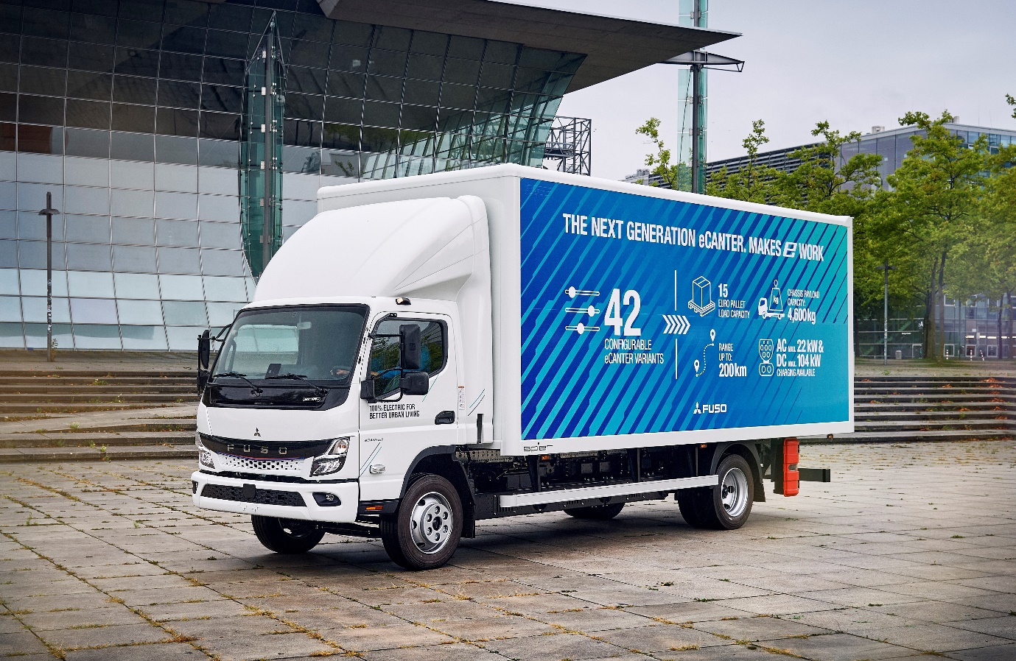

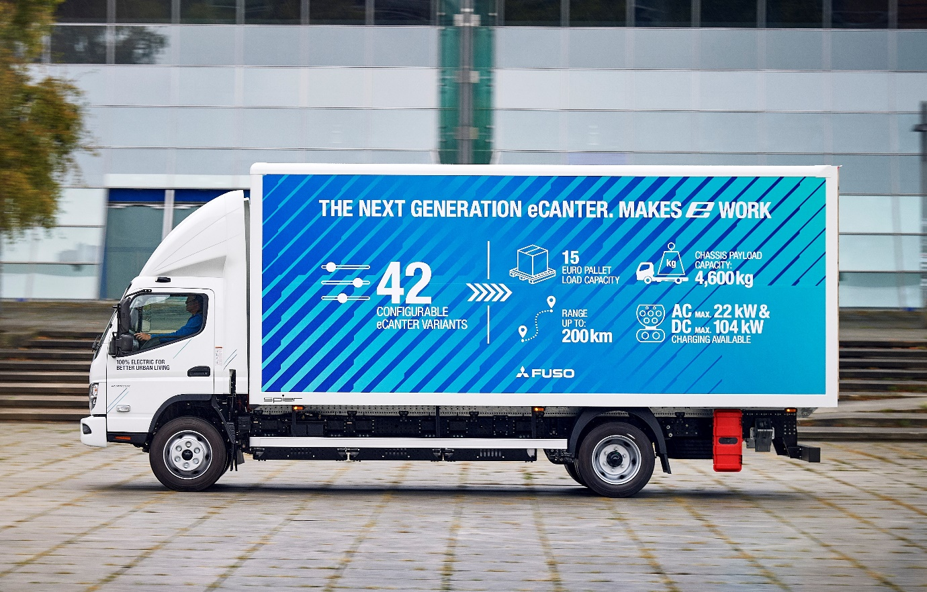

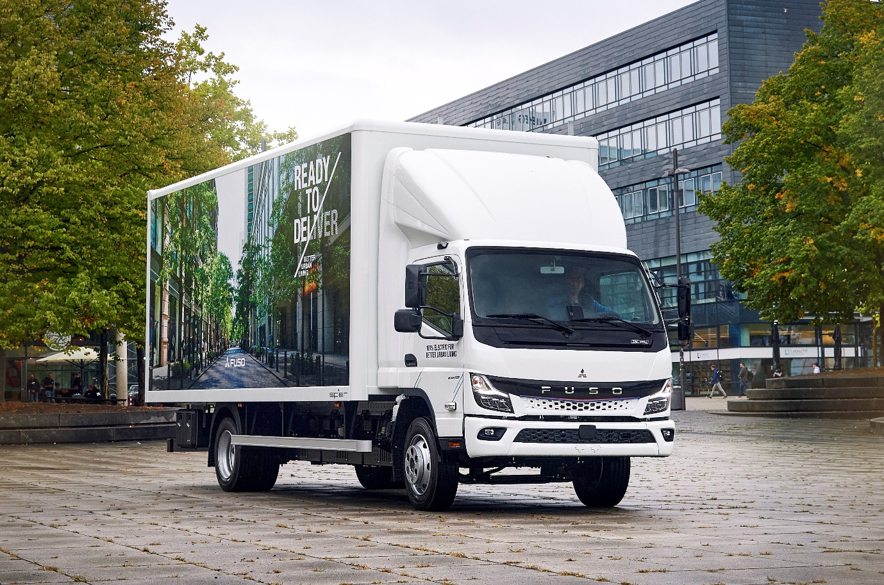

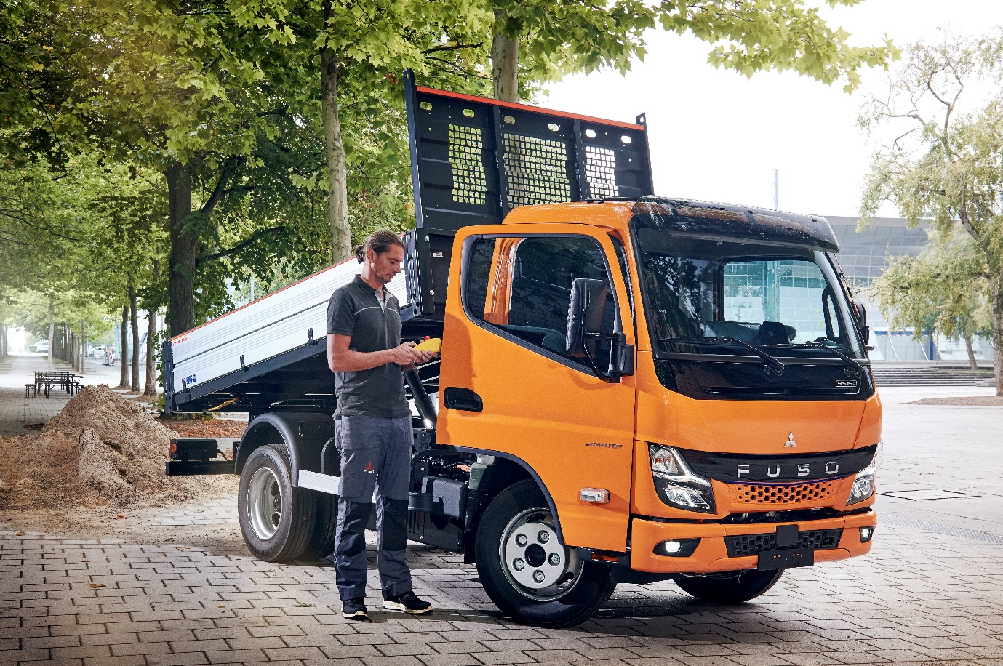

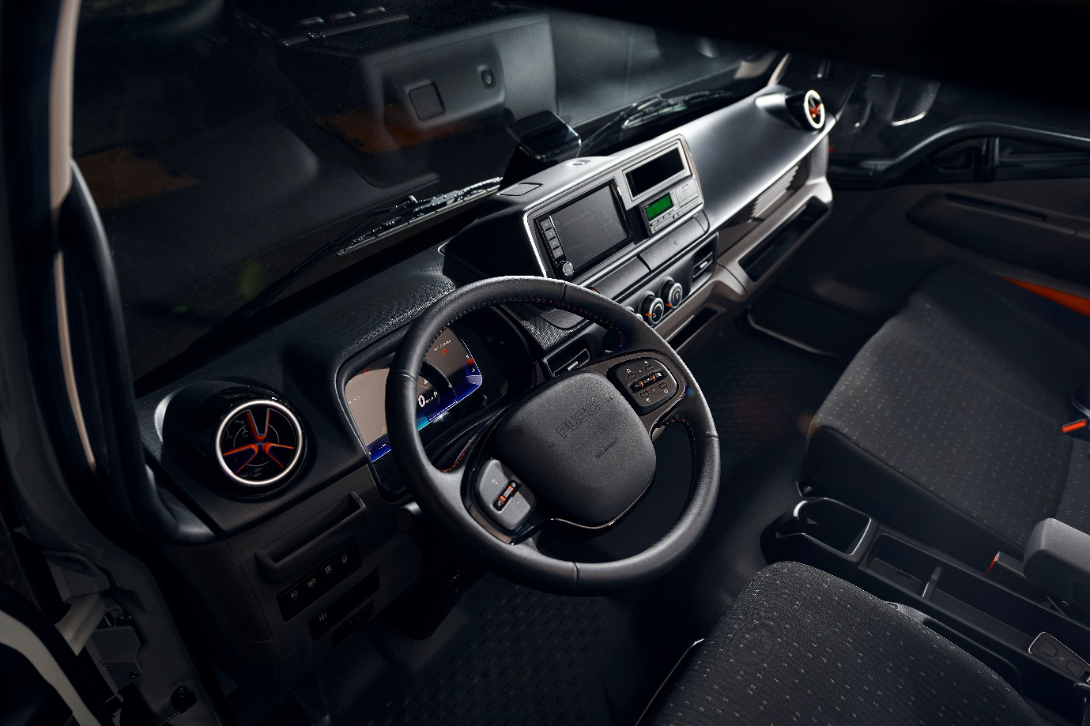

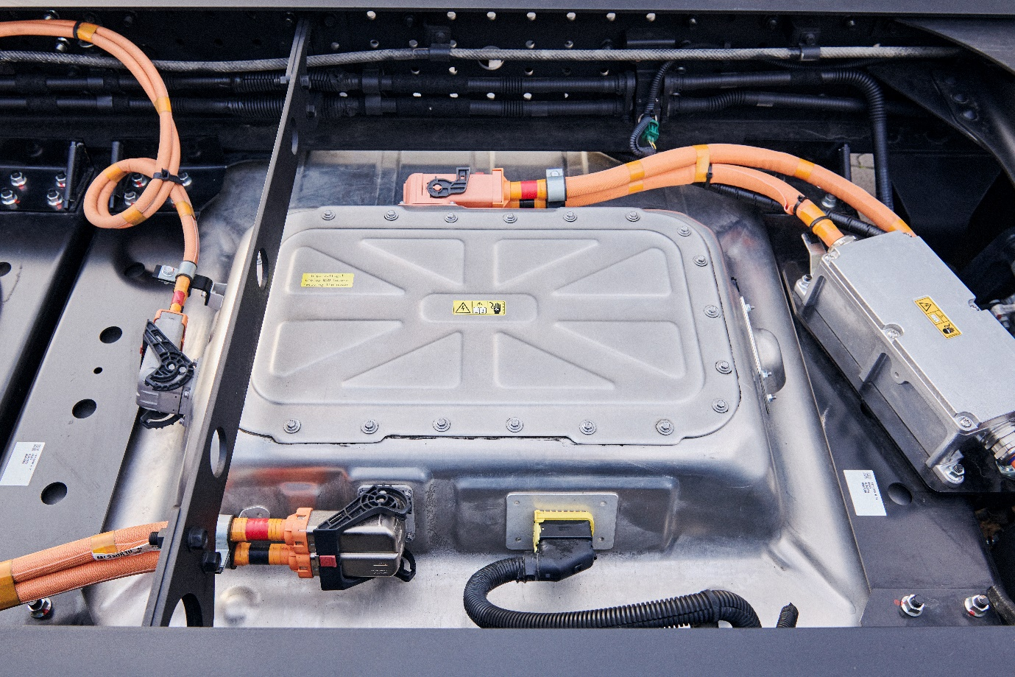

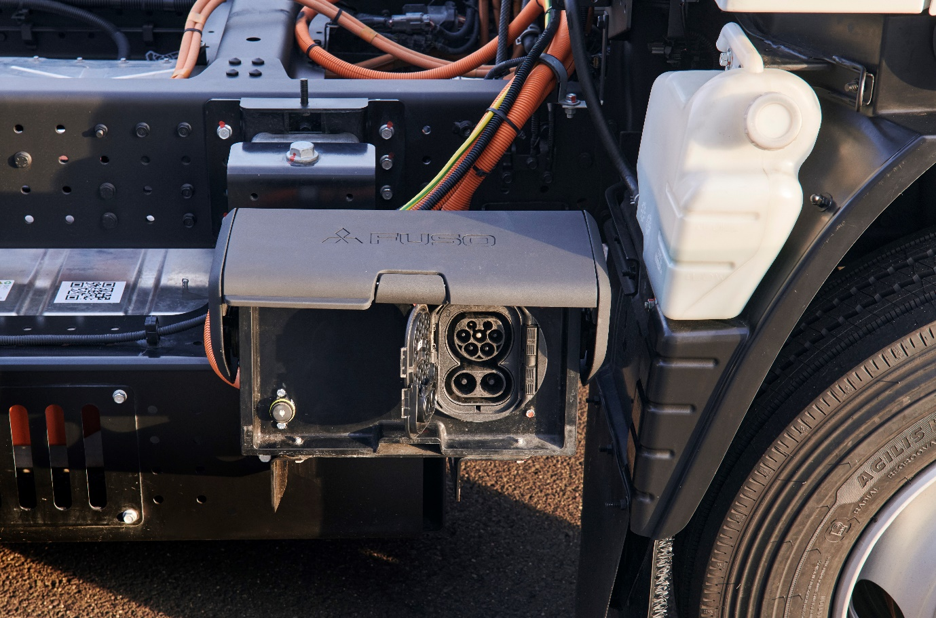

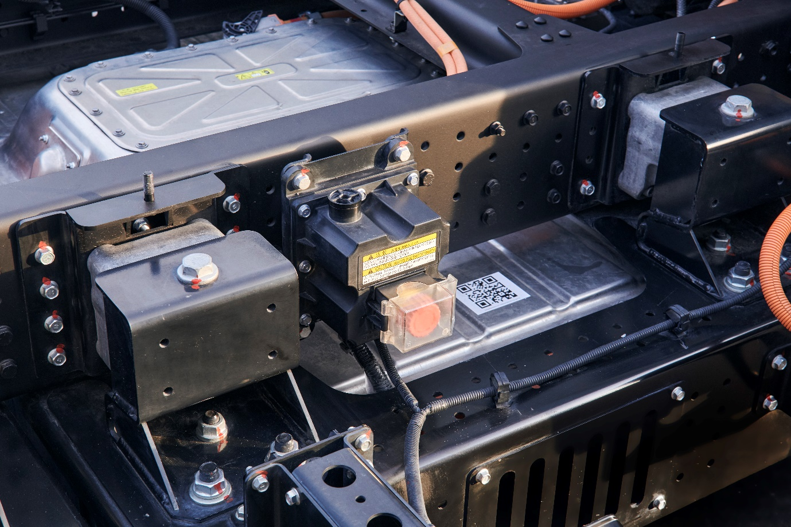

ends

For more information, or to request higher-resolution images, please contact:

Jamie Fretwell at Mercedes-Benz Trucks UK Ltd
07712 519230, jamie.fretwell@daimler.com

or

Steve Warren or John Ripley
Impact Communications
Steve: 07770 470251, steve@impactcom.co.uk
John: 07771 484595, john@impactcom.co.uk

or

Maximilian Splittgerber, +49 (0) 160 860 71 24, maximilian.splittgerber@daimlertruckcom
Carolin C. Fritze, +49 (0) 160 864 13 54, carolin.c.fritze@daimlertruck.com

Further information on Daimler Truck and FUSO is available at:
www.media.daimlertruck.com, www.daimlertruck.com and www.fuso-trucks.com

Forward-looking statements:
This document contains forward-looking statements that reflect our current views about future events. The words “aim”, “ambition”, “anticipate,” “assume,” “believe,” “estimate,” “expect,” “intend,” “may,” ”can,” “could,” “plan,” “project,” “should” and similar expressions are used to identify forward-looking statements. These statements are subject to many risks and uncertainties, including an adverse development of global economic conditions, in particular a decline of demand in our most important markets; a deterioration of our refinancing possibilities on the credit and financial markets; events of force majeure including natural disasters, pandemics, acts of terrorism, political unrest, armed conflicts, industrial accidents and their effects on our sales, purchasing, production or financial services activities; changes in currency exchange rates, customs and foreign trade provisions; a shift in consumer preferences; a possible lack of acceptance of our products or services which limits our ability to achieve prices and adequately utilise our production capacities; price increases for fuel or raw materials; disruption of production due to shortages of materials, labour strikes or supplier insolvencies; a decline in resale prices of used vehicles; the effective implementation of cost-reduction and efficiency-optimization measures; the business outlook for companies in which we hold a significant equity interest; the successful implementation of strategic cooperations and joint ventures; changes in laws, regulations and government policies, particularly those relating to vehicle emissions, fuel economy and safety; the resolution of pending government investigations or of investigations requested by governments and the conclusion of pending or threatened future legal proceedings; and other risks and uncertainties, some of which are described under the heading “Risk and Opportunity Report” in the current Annual Report. If any of these risks and uncertainties materializes, or if the assumptions underlying any of our forward-looking statements prove to be incorrect, the actual results may be materially different from those we express or imply by such statements. We do not intend or assume any obligation to update these forward-looking statements since they are based solely on the circumstances at the date of publication.

Daimler Truck at a glance
Daimler Truck Holding AG ("Daimler Truck") is one of the world's largest commercial vehicle manufacturers, with over 40 main locations and more than 100,000 employees around the globe. The founders of Daimler Truck have invented the modern transportation industry with their trucks and buses a good 125 years ago. Unchanged to this day, the company's aspirations are dedicated to one purpose: Daimler Truck works for all who keep the world moving. Its customers enable people to be mobile and get goods to their destinations reliably, on time, and safely. Daimler Truck provides the technologies, products, and services for them to do so. This also applies to the transformation to CO2-neutral driving. The company is striving to make sustainable transport a success, with profound technological knowledge and a clear view of its customers' needs. Daimler Truck's business activities are structured in five reporting segments: Trucks North America (TN) with the truck brands Freightliner and Western Star and the school bus brand Thomas Built Buses. Trucks Asia (TA) with the FUSO and BharatBenz commercial vehicle brands. Mercedes-Benz (MB) with the truck brand of the same name. Daimler Buses (DB) with the Mercedes-Benz and Setra bus brands. Daimler Truck's new Financial Services business (DTFS) constitutes the fifth segment, the product range in the truck segments includes light, medium and heavy trucks for long-distance, distribution and construction traffic and special-purpose vehicles used mainly in the municipal and vocational sector. The product range of the bus segment includes city buses, school buses and intercity buses, coaches and bus chassis. In addition to the sale of new and used commercial vehicles, the company also offers aftersales services and connectivity solutions.

