

Date: 5 May 2021

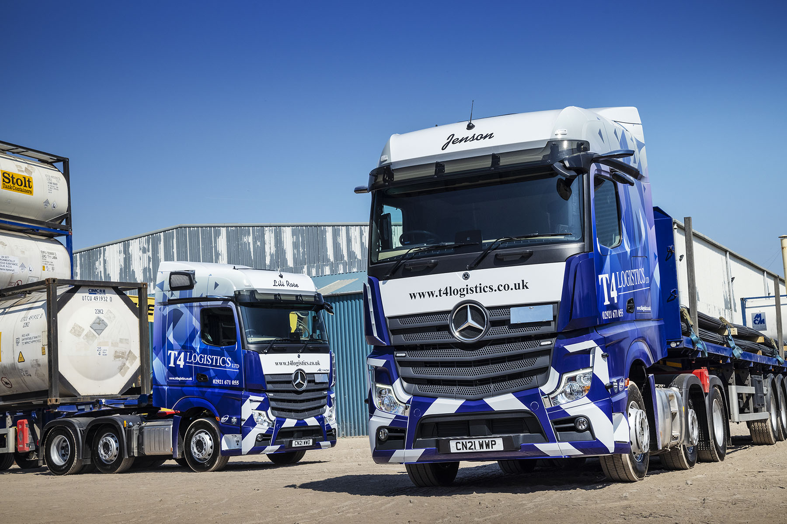

T4 Logistics homes in on another four reliable, driver-friendly Mercedes-Benz Actros

A brief experience with trucks by another manufacturer was all it took to convince T4 Logistics that its interests are best-served by the three-pointed star of Mercedes-Benz.

The Cardiff-based operator’s latest four Actros arrived via South Wales Dealer Euro Commercials. Acquired with competitive funding support from Mercedes-Benz Finance, they have flat-floored BigSpace cabs and, as 2548 variants, are powered by 12.8-litre ‘straight six’ engines with 350 kW (476 hp) outputs.

The Actros dominates T4 Logistics’ line-up of 22 tractors, which includes vehicles previously operated by three recently acquired local companies. The operator flirted briefly with four trucks from a rival brand, but the move that has not been repeated.

“Those units gave us more problems than we anticipated,” explained T4’s Transport Consultant Mark Rees. “The Actros, by contrast, has an excellent track record in our fleet – they’ve been highly dependable and cost-effective to operative.

“For our latest order we therefore had no hesitation in returning ‘home’ to Euro Commercials and re-establishing our relationship with Truck Sales Manager Gary Clark and his team, who have always provided excellent customer service. As ever, our new Actros were delivered without delay and in perfect condition.”

Managing Director David Butler established T4 Logistics with a single truck in 2013. Rapid expansion meant it was soon running a dozen, and the company, which is ISO 9001 and SQAS (Safety & Quality Assessment for Sustainability) certified, has continued to grow steadily. Its tractor units carry a range of loads, including 20- and 40-foot shipping containers and demountable tanks on skeletal frame trailers, and steel on flatbeds.

“We’re still a relatively young business but as individuals we’re all steeped in the transport industry,” said Mr Rees. “Within our head office team we have a total of well over 100 years’ experience.”

T4 Logistics’ latest trucks are its first from the fifth Actros model generation, and instantly recognisable as such due to the absence of conventional door mirrors. Instead, the innovative MirrorCam system employs roof-mounted, rear-facing cameras that relay their images to screens mounted inside the cab, on the A-pillars.

As well as enhancing safety by providing much-enhanced all-round visibility, MirrorCam cuts diesel costs by an estimated 1.5% because the cameras’ compact, streamlined housings create less wind resistance.

Standard safety equipment also includes Active Brake Assist 5 technology, the emergency braking system that now employs cameras in addition to radar. At speeds of up to 50 kph, Active Brake Assist 5 can apply full braking automatically when encountering pedestrians crossing its path.

Technology is also helping to optimise fuel efficiency. New Actros models are equipped with an enhanced version of the proven Mercedes-Benz Predictive Powertrain Control system, which uses digital 3D mapping and GPS data to scan the road ahead, then manages gear changes and ensures that full use is made of the Mercedes PowerShift 3 transmission’s Eco Roll function to maximise fuel-efficiency and reduce emissions.

PPC now makes an even more substantial contribution to economy by covering virtually all A roads, as well as many B roads, and taking account not only of topography but also of corners, roundabouts, junctions and traffic signs.

T4 Logistics’ drivers, meanwhile, benefit from the optionally upgraded interactive version of the stylish and functional twin-screen Multimedia Cockpit. In addition to a bigger, 12in central display, this offers extra functionality. Features include Android Auto and Apple CarPlay, as well as the Mercedes-Benz Truck App Portal, an open platform that enables fleet managers easily to assign apps to individual vehicles, which drivers can then see and use to increase efficiency and comfort.

The operator has also added camera systems and side sensors to warn drivers of the presence of vulnerable road users, particularly cyclists, as well as audible left-turn warning indicators that alert other road users in the case of a manoeuvre towards the nearside.

“As well as its proven reliability the Actros has always been a popular truck with our drivers,” added Mark Rees. “The latest developments on these new models only make it more so. MirrorCam, in particular, is clearly the way forward in vehicle design. Overall, we’re delighted with our new Mercedes-Benz trucks.”

www.t4logistics.co.uk

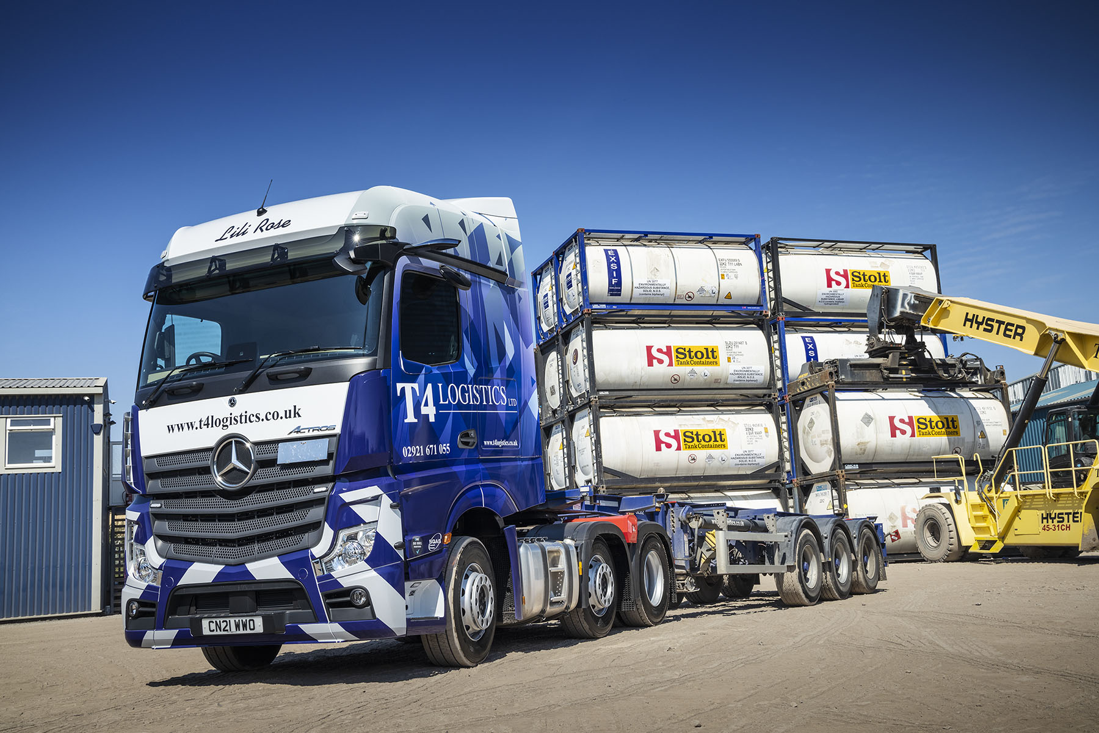

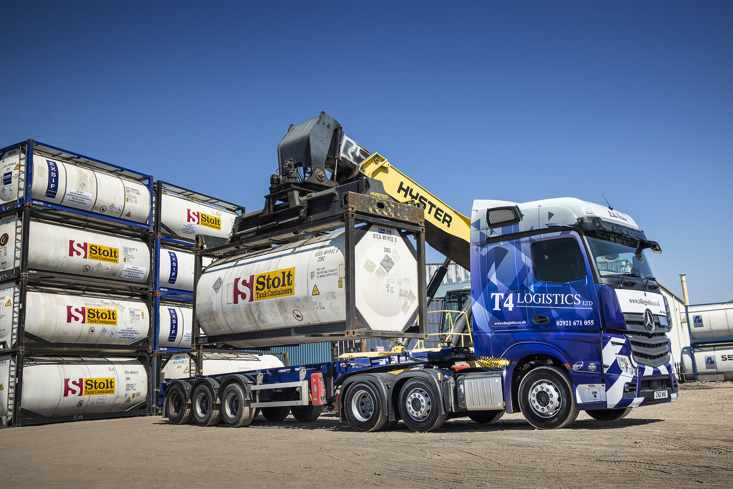

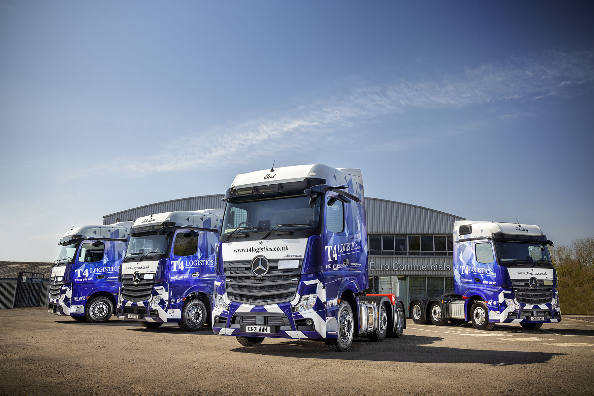

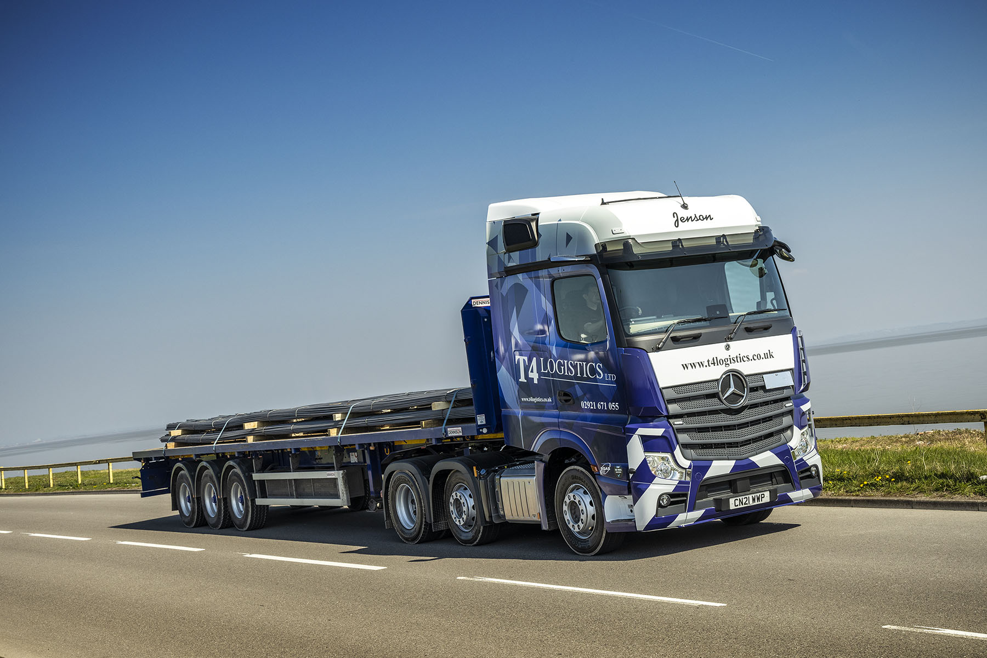

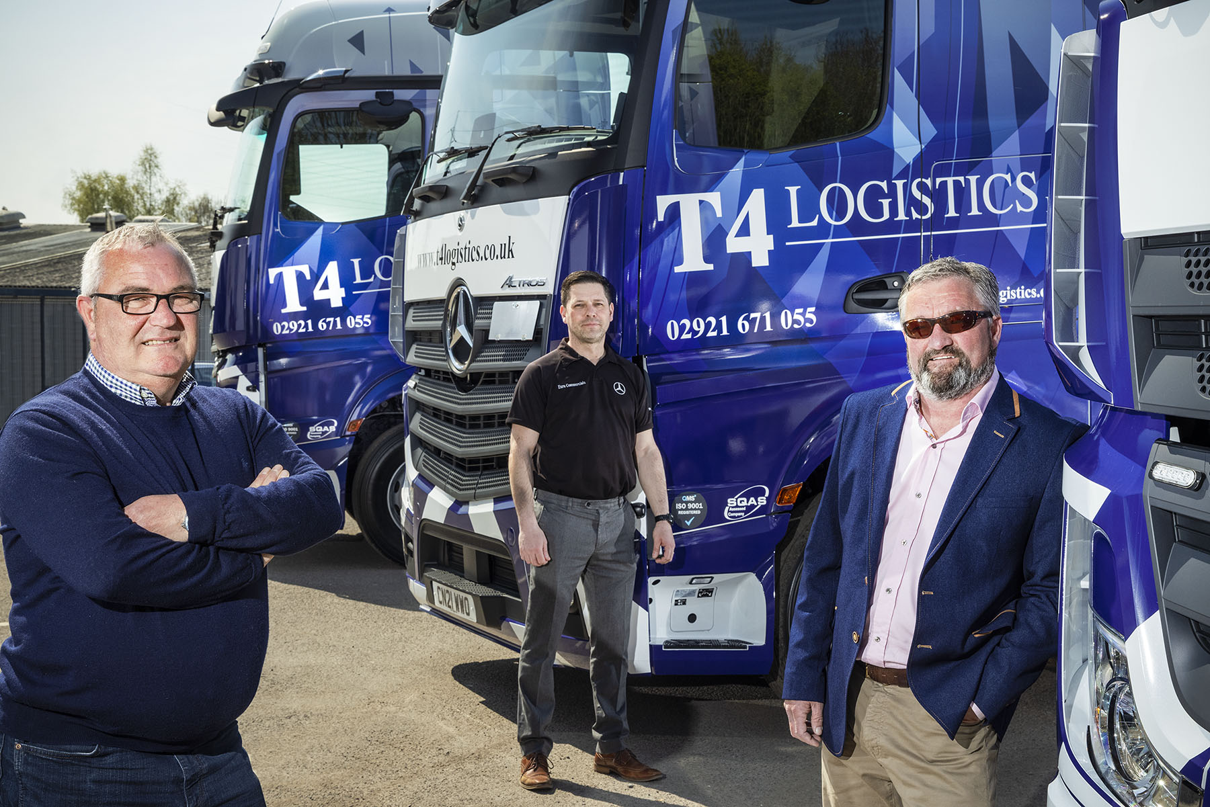

Into the blue: T4 Logistics’ Mark Rees, left, and David Butler, right, with Gary Clark of Euro Commercials, and their smart new Mercedes-Benz Actros tractor units

ends

For more information, or to request bigger/higher-res image files, please contact:
John Ripley or Steve Warren
Impact Communications, 01926 842126
John: 07771 484595, john@impactcom.co.uk
Steve: 07770 470251, steve@impactcom.co.uk

