

Date: 20 January 2022

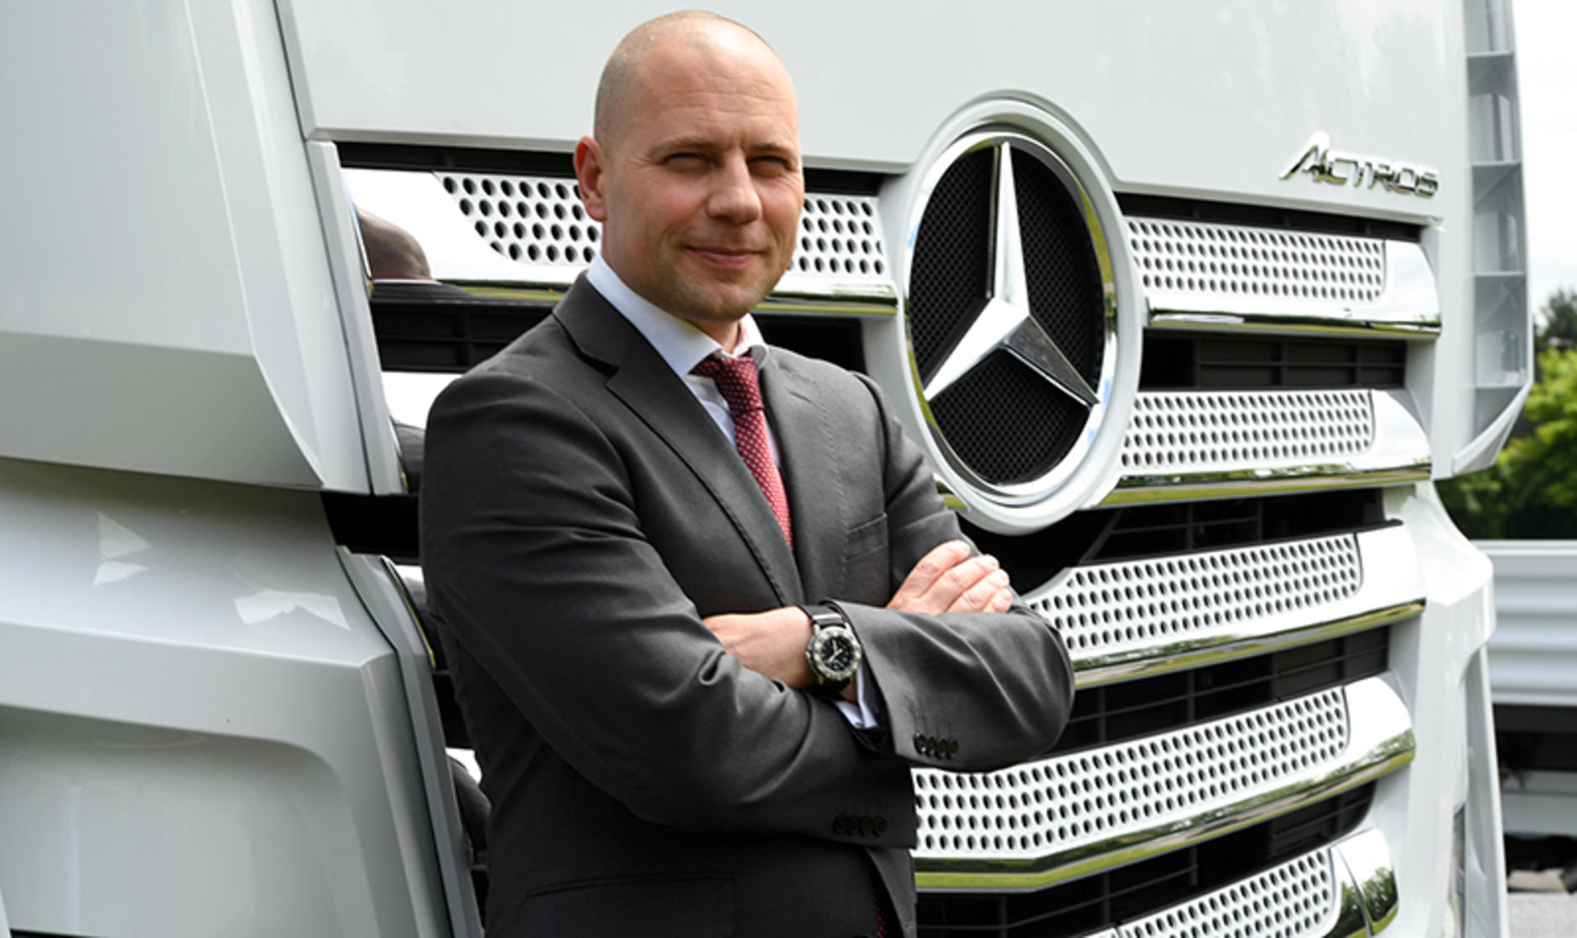

Return of an established executive: Experienced Heiko Selzam is returning to the UK following success as CEO of Mercedes-Benz Trucks Austria

Mercedes-Benz Trucks UK appoints Heiko Selzam as Managing Director

Heiko Selzam is preparing to take on the job of Managing Director at Mercedes-Benz Trucks UK, effective from 1 April 2022.

He succeeds Wolfgang Theissen, who passed away in September.

Heiko is a familiar face within the global Daimler Truck family, having joined what was then Daimler Benz AG in 1996 as Sales Executive for Commercial Vehicles. Since then he has taken on multiple assignments in the Middle East, Luxembourg and Austria, gaining experience across sales and service.

In his current role, Heiko has established the new Mercedes-Benz Trucks Austria GmbH, and as CEO he has taken the company through full independence with the separation of the Daimler Group companies Mercedes-Benz AG and Daimler Truck AG.

Heiko’s UK appointment will see him return to the business with which he spent two years as Sales Director, from 2017 to 2019. In this position, in addition to the new and used truck business, he was responsible for truck training and sales operations, as well as sales of telematics services.

As a result, he feels well prepared for the job of Managing Director: “Through my previous role as Sales Director in the UK, I am very familiar with the structure of the company,” he said. “I already know many employees, customers and business partners, and I am very much looking forward to working with them again. There are some challenges to overcome in our industry, but I am confident that the excellent team will combine and we’ll accomplish all our tasks.”

In a statement, Head of Sales Europe Jean-Marc Diss, said: “Heiko’s extensive business experience and strong leadership skills are two significant assets which will support our business success in the UK. We would like to thank him for his continuous commitment and achievements, and we wish him the utmost success in his new role as Managing Director of Mercedes-Benz Trucks UK.”

ends

For more information, please contact:

Jamie Fretwell at Mercedes-Benz Trucks UK Ltd
07712 519230, jamie.fretwell@daimler.com

Steve Warren or John Ripley
Impact Communications
Steve: 07770 470251, steve@impactcom.co.uk
John: 07771 484595, john@impactcom.co.uk

