

Date: 27 February 2023

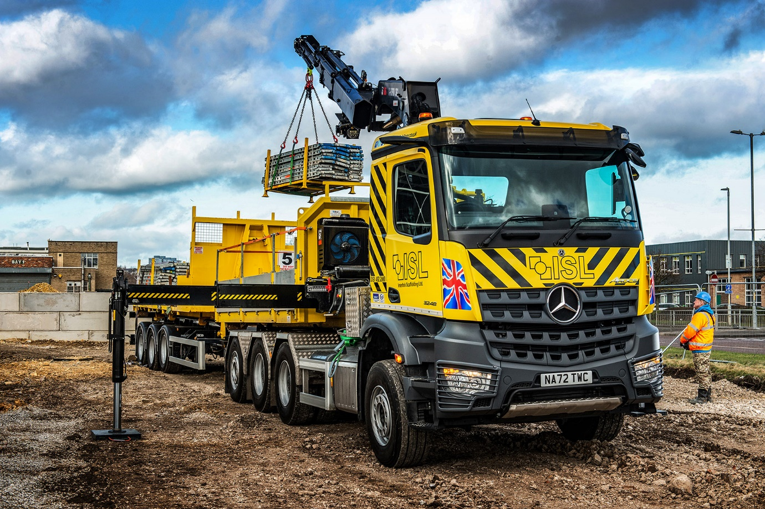

Mercedes-Benz Arocs puts Interlink Scaffolding in pole position for efficient deliveries

Interlink Scaffolding is saving time and restricting its labour costs after commissioning an eight-wheeled Mercedes-Benz Arocs with a highly unusual, demountable crane body.

The operator, which is commonly known as ISL and currently celebrating its 20th anniversary, is based in Birtley, Tyne & Wear. Its new flagship arrived via local Dealer Bell Truck and Van.

The Arocs 3248 ENA has a single front steer axle and lifting, rear-steer axle, both of which are uprated to 9.0 tonnes and fitted with ‘super single’ tyres. The 12.8-litre ‘straight six’ engine’s 350 kW (476 hp) output is smoothly transmitted to the double-drive bogie via a 12-speed Mercedes PowerShift 3 automated manual gearbox.

The ClassicSpace M-cab has a rest bunk and boasts a full complement of advanced technology. Highlights include MirrorCam, Mercedes-Benz Trucks’ revolutionary alternative to conventional mirrors, and Multimedia Cockpit, interactive, the optionally upgraded version of its intuitively-operated twin screen dashboard – in addition to a larger, 12in instrument panel, this comes with extra functionality, such as satellite navigation.

The Arocs was fitted by Notterkran in Switzerland with a Multilift Ultima Z tilt and slide hooklift and a demountable split dropside body with integral stabilisers on which is mounted a remote radio-controlled 33.5 tonne/metre Hiab X-HiPro 362 EP5 crane capable of lifting 1,860 kg at a distance of 15.1 metres.

Other features include a winch, for lowering scaffolding over the sides of bridges or down wells (Northumbrian Water is an important ultimate client), and a VBG drawbar coupling which allows the truck to pull a tri-axle trailer.

ISL undertakes housing, commercial building, civil engineering and industrial projects throughout the North East, and serves the rail infrastructure sector on a national basis.

Its first 32-tonner has joined a fleet of 16 trucks in which two other manufacturers are represented. The line-up includes a pair of pre-owned 18-tonne Axors that have provided outstanding service since 2018.

The company was already running four 26-tonne Multilifts that work with demountable bodies which can be left on site for unloading and loading without delaying the truck. “The demountable concept is ideal for our operation, but we realised that a crane would provide valuable extra flexibility,” reported Director Mark Eddy.

“The Hiab will reach to the back of the drawbar trailer and allows us to lift a tonne-and-a-half pack of scaffold tubes 16 metres in the air, so the lads don’t have to handball it all up. Not only does that save a lot of costly time and effort, but it also provides health and safety benefits.”

By moving to a 32-tonne chassis, ISL has ensured that despite the heavy crane the Arocs offers a 12-tonne payload, which is on a par with its six-wheelers. “One or two of our drivers who’d seen 8x4 tippers struggling to get out of tight spots expressed concerns about manoeuvrability but thanks to its ENA configuration the new Mercedes-Benz is every bit as agile as our 26-tonners,” said Mr Eddy.

He continued: “We might only use the crane a couple of times a week and there’s no point in carrying all that weight around when it’s not required. At such times we’ll send the truck out with one of our standard, much lighter bodies, and take advantage of the increased carrying capacity.”

Commenting on the decision to place its prestigious order with Mercedes-Benz, Mr Eddy explained: “We were able to specify an Arocs built to N3G (off-road) specification, whereas our established supplier could only offer a standard N3 (on-road) chassis.

“We also put it to our drivers. Bell’s Sales Executive Alex Wordsworth provided us with a demonstrator and the feedback after the two-week trial was entirely positive. The guys quickly took to MirrorCam but what really impressed them about the Arocs was its high ground clearance – we’re often on rough sites and up to our axles in mud, so that’s going to be a big advantage.”

Just as important was the major investment being made by Bell Truck and Van in an impressive new Dealership. Currently under development on a seven-acre site on the Team Valley Trading Estate, this facility will triple the Dealer’s workshop capacity and allow it to provide an enhanced experience for customers and colleagues alike.

ISL has signed-up to a five-year Mercedes-Benz Complete Service Contract under which its new eight-wheeler is currently being inspected and maintained, together with the two Axor 18-tonners, at Bell Truck and Van’s Billingham branch.

“As soon as it’s opened, though, we’ll switch to the Team Valley dealership, which is just four miles from our head office so could scarcely be more convenient,” said Mr Eddy, whose company has now been engaged to provide scaffolding services on the project.

He added: “Alex kept us regularly updated on progress throughout the build process while the aftersales service looks to be ‘spot on’, so we have high hopes for our new relationship with Bell Truck and Van.”

islscaffolding.co.uk

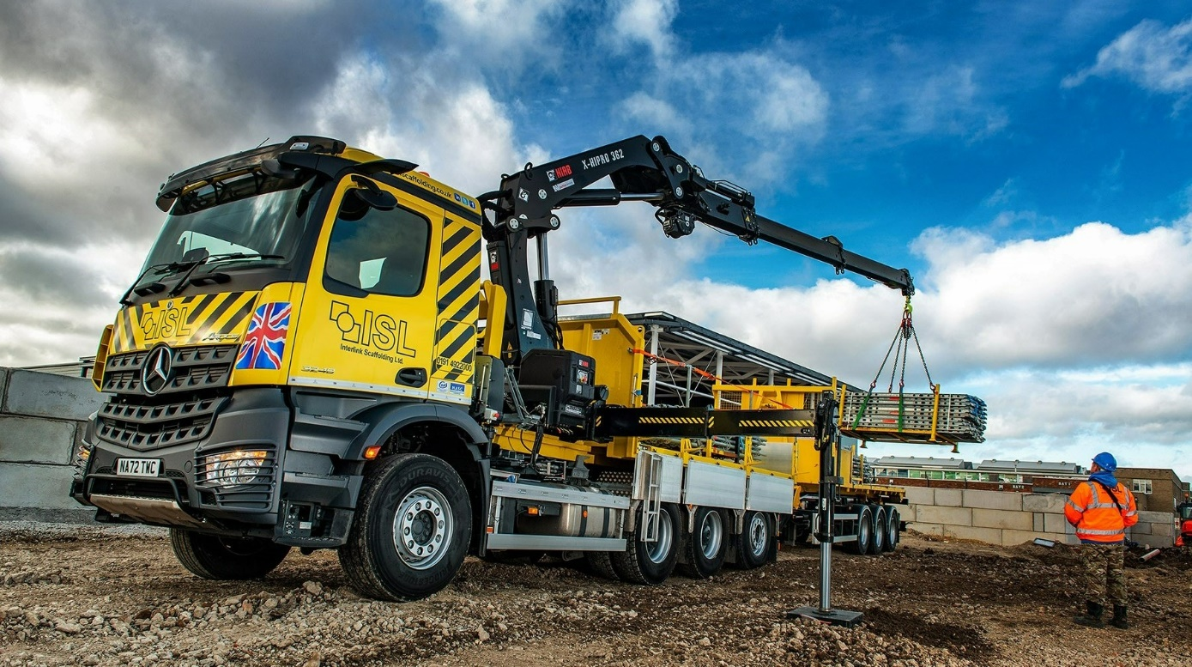

Out and back: Within days of its delivery by Bell Truck and Van, Interlink Scaffolding’s new Arocs was hard at work on the Dealer’s Team Valley Trading Estate construction project
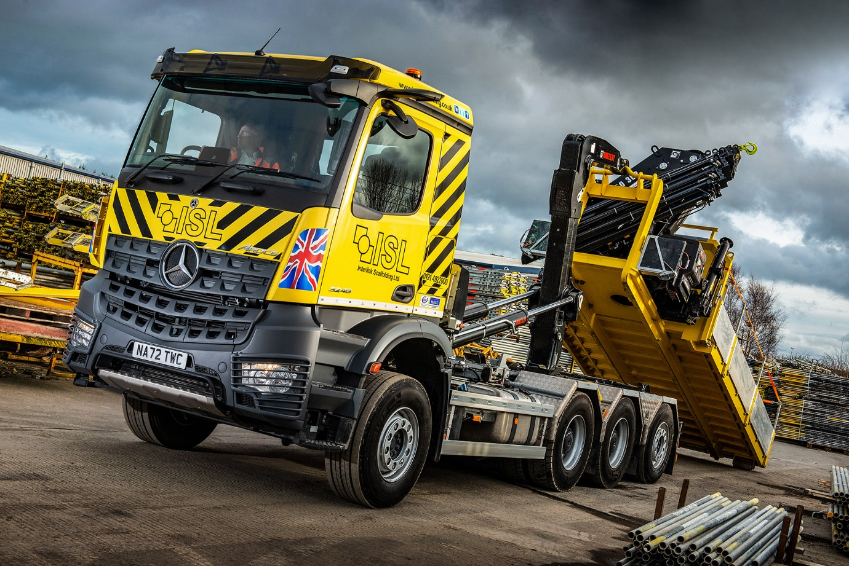

Hooked on efficiency: Its use of demountable bodies allows Interlink Scaffolding to maximise productivity from its trucks

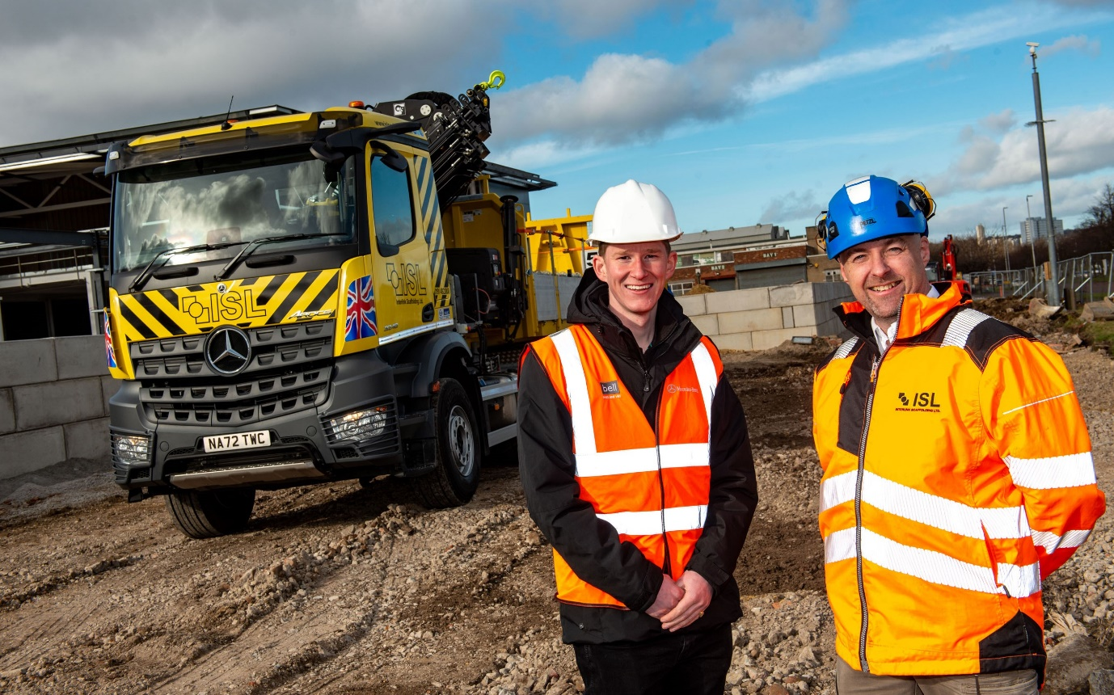

Working in partnership: Interlink Scaffolding Director Mark Eddy is pictured, right, with Alex Wordsworth of Bell Truck and Van
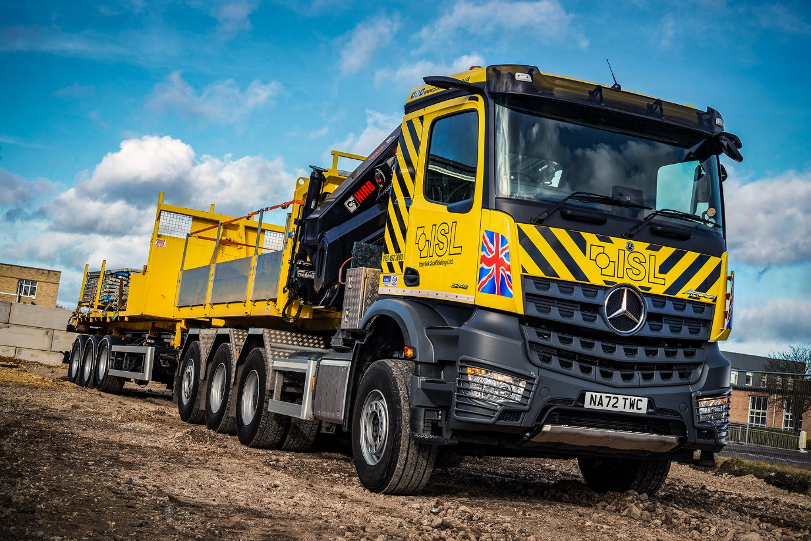

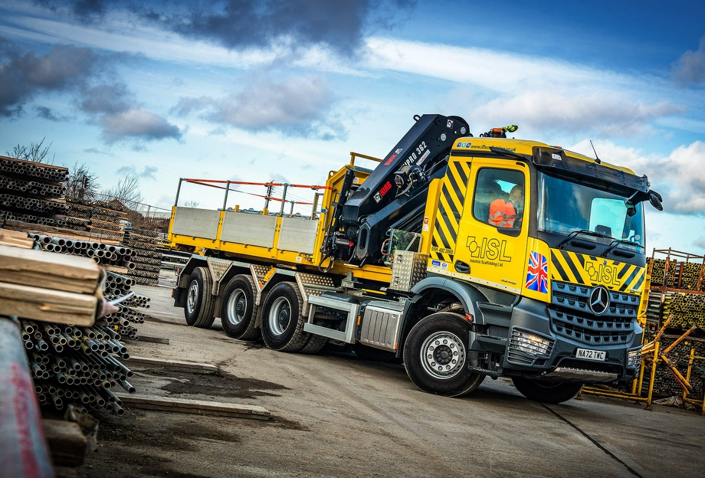

Agile Arocs: Its ENA configuration with rear-steer axle means the new 8x4 Mercedes-Benz is every bit as manoeuvrable as Interlink Scaffolding’s established six-wheelers

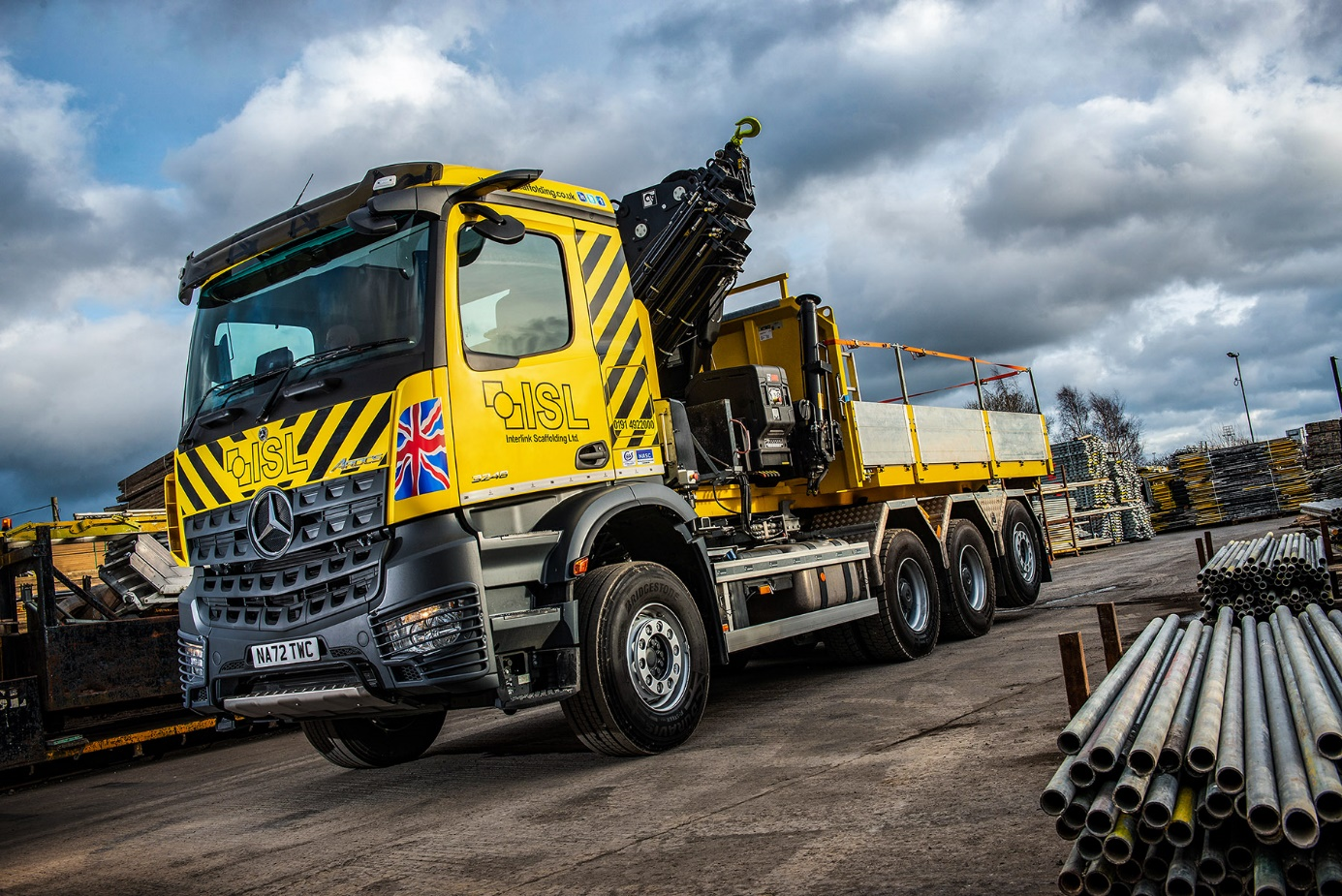

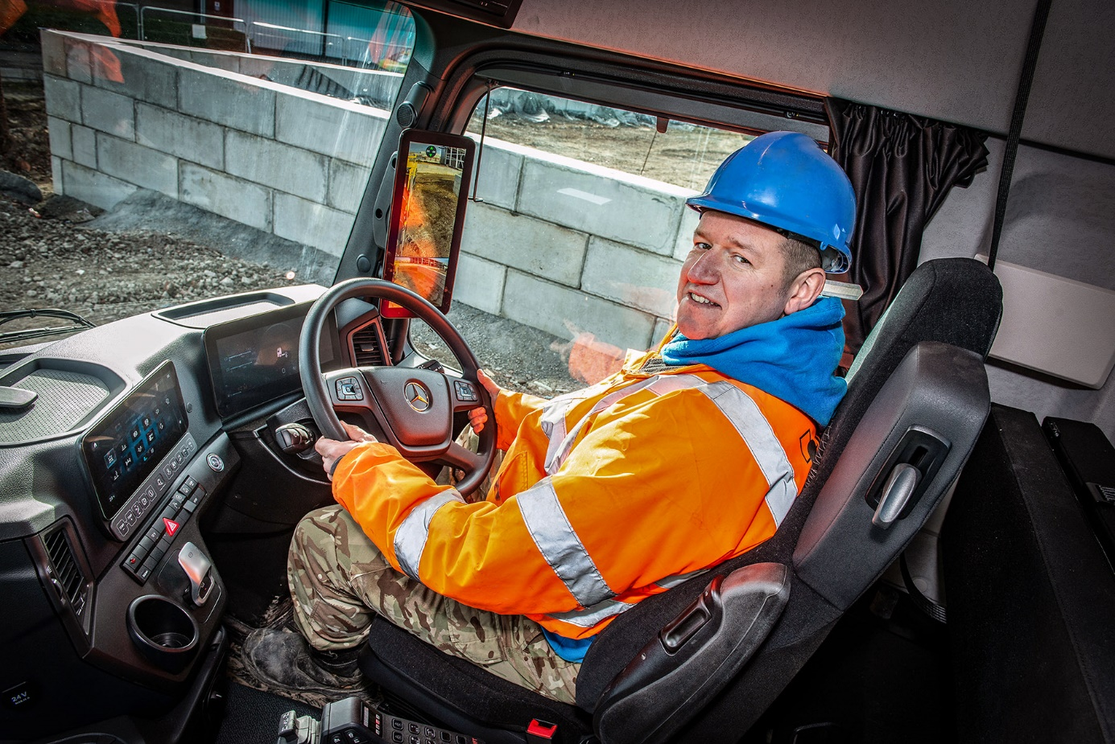

Seat of power: Interlink Scaffolding operates a ‘one man, one truck’ policy and the new Arocs has gone to experienced driver Graeme Carter

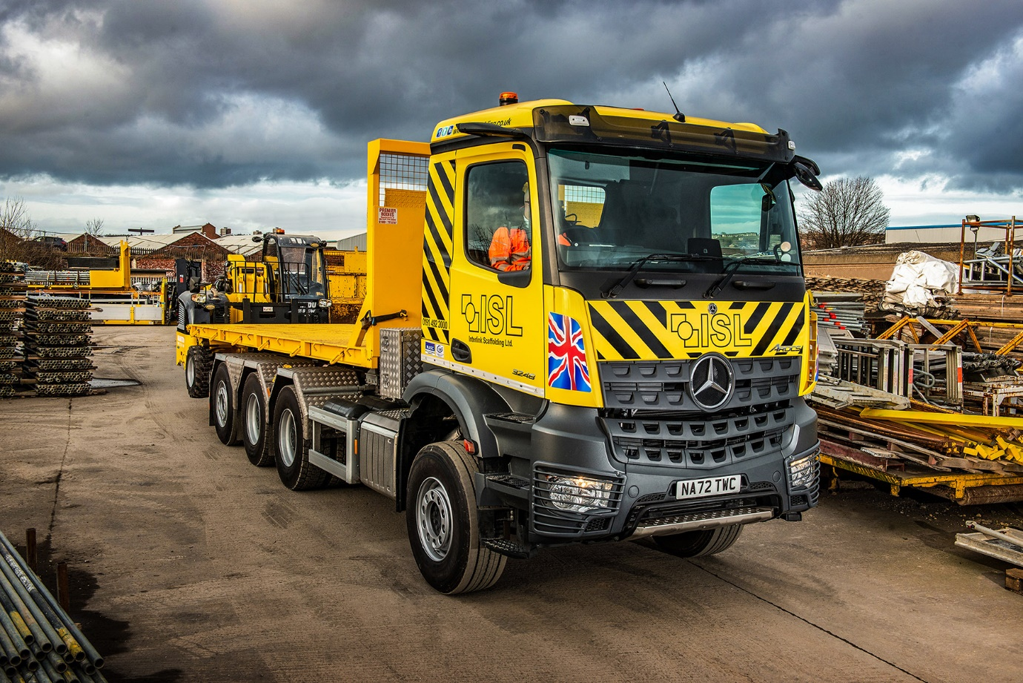

Switch back: When the crane is not required the new truck can also work with one of Interlink Scaffolding’s standard demountable bodies, which are able to carry rear-mounted Manitou telehandlers

ends

For more information, or to request bigger versions of image files, please contact:
Steve Warren or John Ripley
Impact Communications
Steve: 07770 470251, steve@impactcom.co.uk
John: 07771 484595, john@impactcom.co.uk

