

Date: 28 February 2022

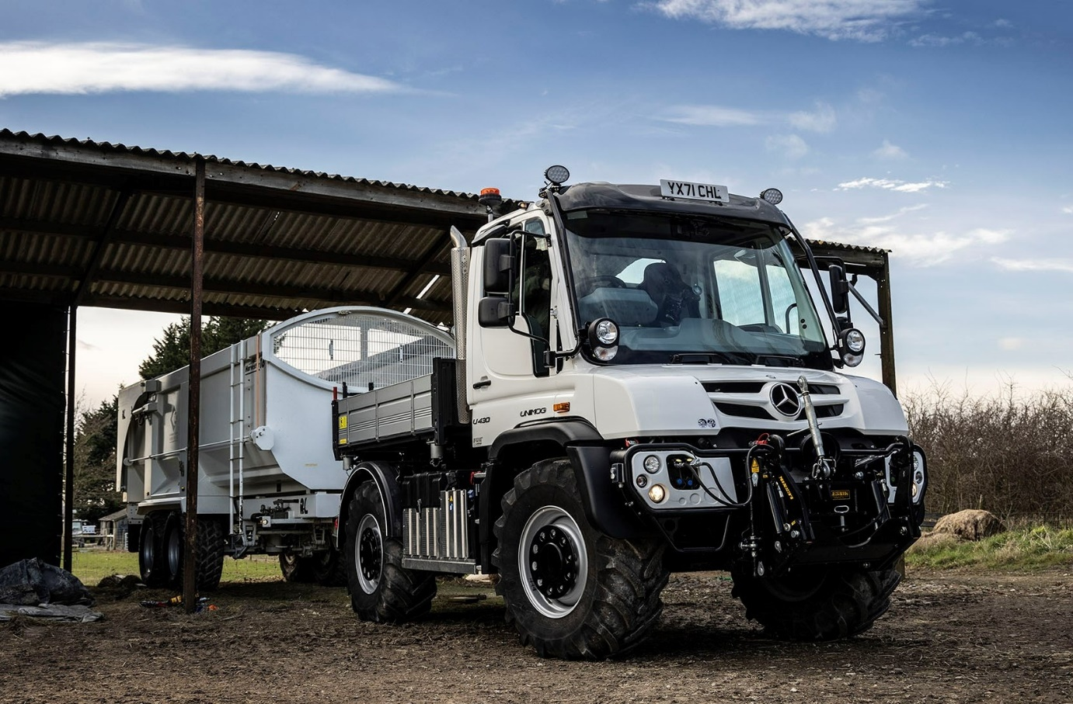

Ex-soldier Ian calls up a Mercedes-Benz Unimog from South Cave Tractors for work on the family farm

Pig rearing for Ian and Rebecca Chick has become a lot more efficient since they replaced their agricultural tractor with a new, and very highly specified Mercedes-Benz Unimog.

The couple established the Lincolnshire Pig Company shortly after buying their 100-acre farm at Scredington, near Sleaford. So high are their commitments to quality, animal welfare standards and regulatory compliance that they now supply two of the country’s best-known premium brand food retailers.

A 12.7-tonne U430 implement carrier, the Unimog arrived via South Cave Tractors and is fitted with a factory-built, three-way tipping body. The vehicle is already proving its worth in a variety of roles – in addition to their 2,000 pigs, Ian and Rebecca keep some 340 sheep, the majority of them Herdwicks, and cut their fields for hay and silage.

Although the Unimog enjoys an unrivalled reputation as the ultimate off-roader, its impressive on-road performance was also a crucial factor behind the couple’s purchasing decision.

Ian explained: “Rebecca’s from an agricultural background and she has relatives in the area with their own farming ventures. Using a 16-tonne Larrington Harvester trailer, we supply them with farmyard manure from the pigs – they produce more than 1,300 tonnes of the stuff each year – and bring back straw for bedding.

“One regular run involves a 14-mile round trip which, once you factor in the tipping and loading, was taking me over an hour with the tractor. Because the Unimog is so much quicker on the road I’m now able to complete the task in little more than half the time. I’m invariably juggling several jobs at once, so that makes a big difference.

“The Unimog is significantly more fuel-efficient than the tractor, and there are safety benefits too,” he observed. “I no longer get cars coming up close behind then cutting in front of me after they’ve overtaken.

“Also, that regular route involves crossing a main A-road. The fact that the cab was towards the rear of the tractor meant that I had to edge out very slowly indeed. In the Unimog, by contrast, you sit at the front of the vehicle and visibility is excellent, so getting to the other side is a lot less stressful.”

A career soldier who saw action in theatres all over the world, the former Parachute Regiment Warrant Officer retired from active service in 2009. “Rebecca and I make a great team, each bringing our own skill sets to the business,” said Ian.

“While her focus and expertise is in animal welfare, my military background has given me a real appreciation of efficiency. I like clean straight lines, paperwork squared and capable, productive equipment that’s designed and built to the highest standards, so can always be relied upon.

“The Unimog fits the bill perfectly. There are so many jobs around the farm for which it can be used, from cutting, raking and carting hay, to hedge trimming, fencing… I even use it to run a hydraulic pressure washer. The list is practically endless but this ‘Swiss Army knife’ of a vehicle can do it all. What’s more, our six-year-old daughter Trinity absolutely loves it!”

The short U430 is powered by a 7.7-litre six-cylinder engine that produces 220 kW (299 hp) and is paired with an optional EAS automated manual version of the standard gearbox, which has eight forward and six reverse gears – this allows drivers to switch between manual gear shifting and automatic mode at the press of a button. Ian also specified the popular working and crawler gear range, which provides a maximum of 24 forward ratios and up to the same in reverse.

Highlights on the lengthy list of options are Central Tyre Inflation (CTI) technology, which can be used to quickly and easily lower tyre pressures, thereby minimising damage to particularly soft ground, and Vario Pilot, which enables drivers to switch the steering wheel from one side of the vehicle to the other in around 30 seconds; a left-hand drive set-up is ideal for verge cutting and hedge trimming operations.

Other optional Mercedes-Benz features include an electric heated windscreen and driver’s seat, and front- and rear-facing cameras; South Cave Tractors also fitted additional, aftermarket camera to provide Ian with full 360-degree coverage.

The vehicle underwent extensive pre-delivery modification in the workshop at South Cave Tractors’ base in Brough, East Yorkshire. The Dealer designed, manufactured and fitted its integrated towing hitch and lifting system with external controls, which allows Ian to make finely-tuned adjustments when hooking up implements to the Unimog’s hydraulic systems.

The lifting and towing capacity now available at the back of the vehicle also necessitated a heavy-duty sub-frame, which South Cave Tractors built and installed. To complete the job, the Dealer refitted the factory body to the new sub-frame and added extra LED working lights.

Ian and Rebecca part-funded the acquisition of their Unimog with competitive support from Mercedes-Benz Finance, and have taken out an extended manufacturer’s warranty, under which the cover runs for five years or 450,000 km.

All Unimogs have single rear wheels that follow the track created by the front wheels. The range encompasses gross weights from 7.5 to 16.5 tonnes and is built around two core variants: a UGE implement carrier and a UHE extreme off-roader that can be fitted with many different types of body.

South Cave Tractors celebrated its 50th anniversary last year and has been supporting the unique Unimog brand since it opened for business. Added Ian Chick: “The service I’ve received from Sales Executive Ben Middleton and his colleagues has been first class from start to finish, while the Unimog is exceeding all my expectations.”

South Cave Tractors’ Ben Middleton can be contacted on 07498 619190 or 01430 424233, ben.middleton@southcavetractors.com

southcavetractors.com

 facebook.com/southcavetractors

 instagram.com/southcavetractors

 linkedin.com/company/south-cave-tractors-ltd/

 twitter.com/sctunimog

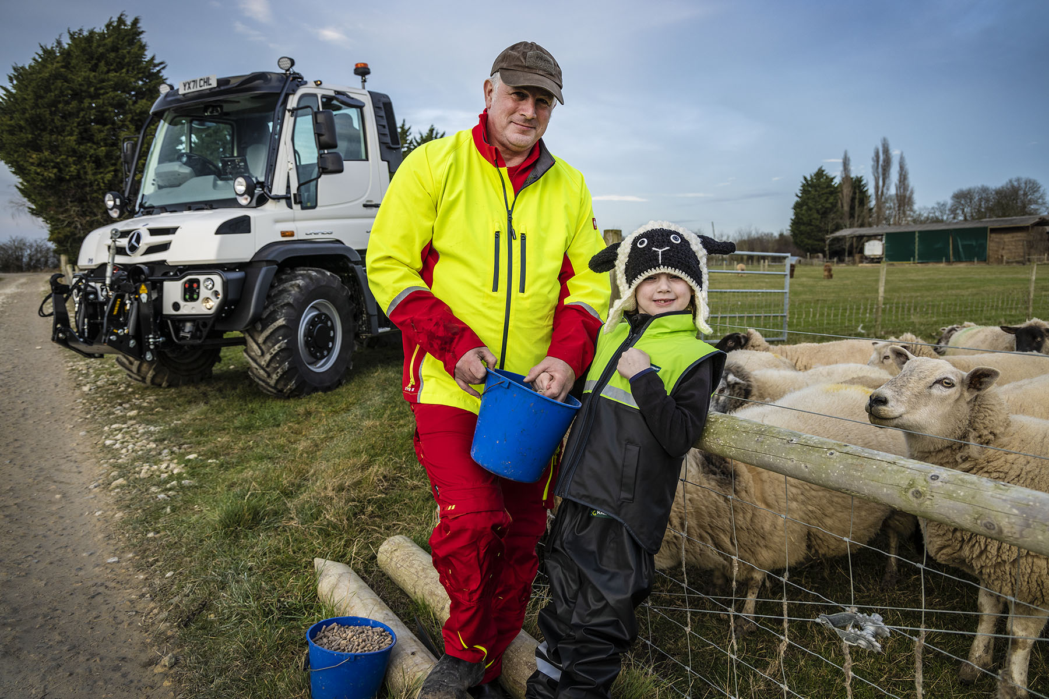

Field of dreams: Ian Chick is pictured with daughter Trinity, and the new Unimog that is more than living up to its promise

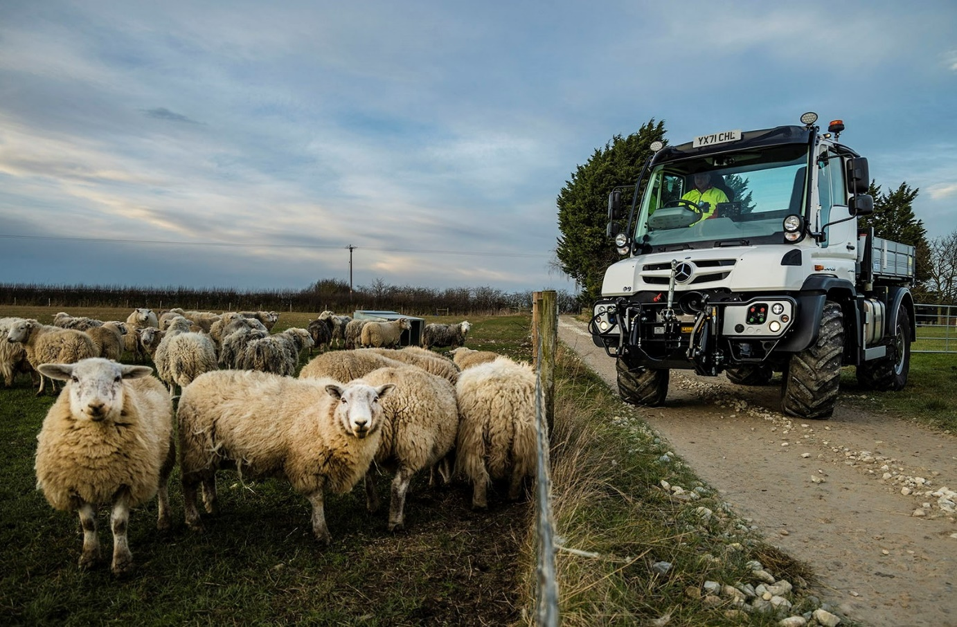

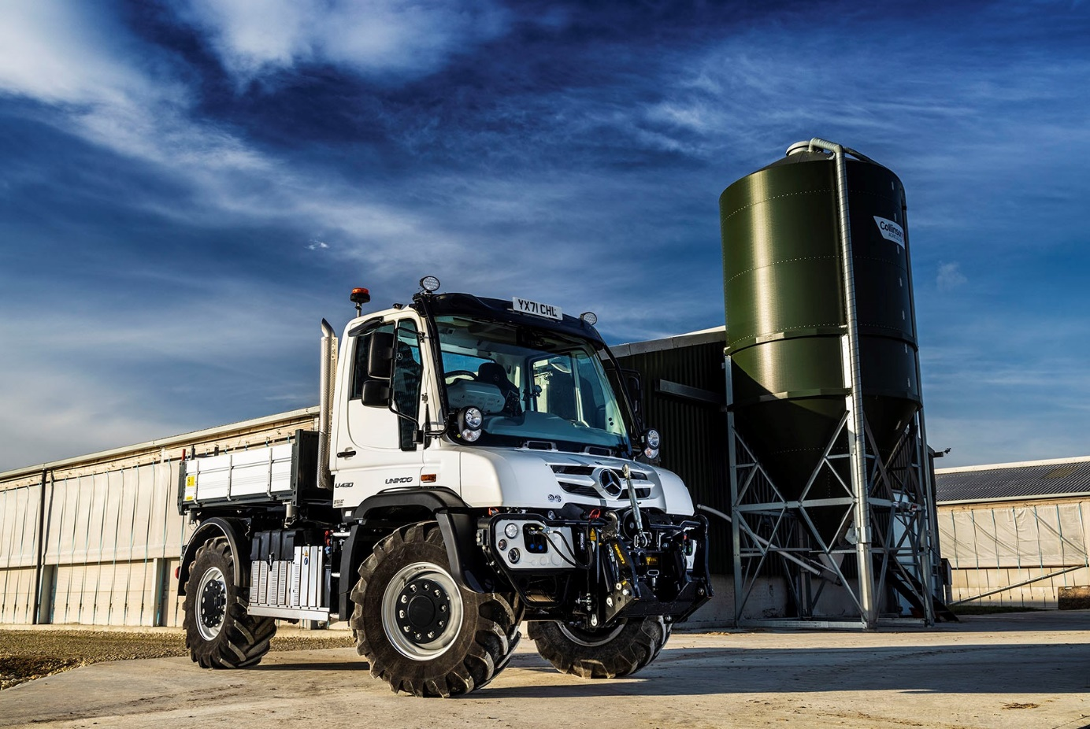

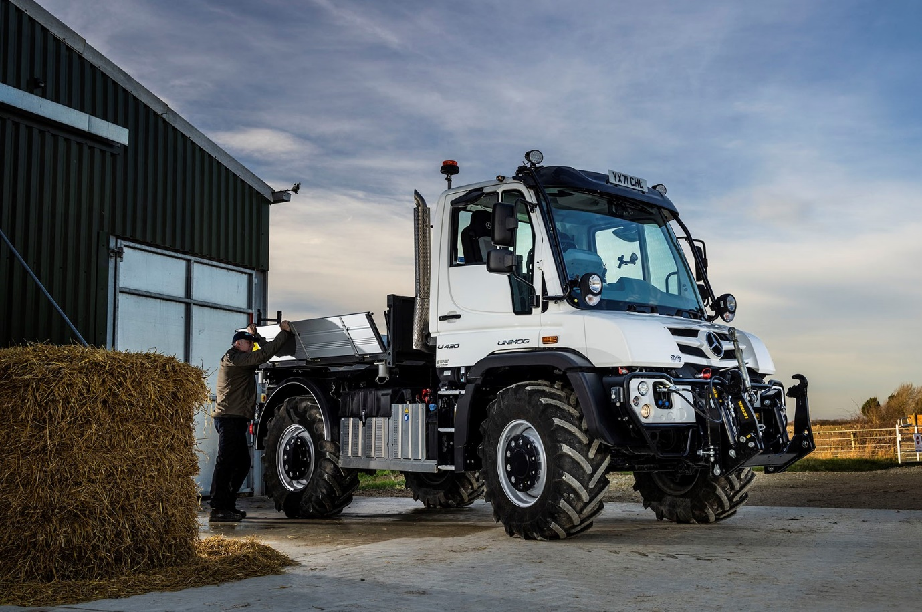

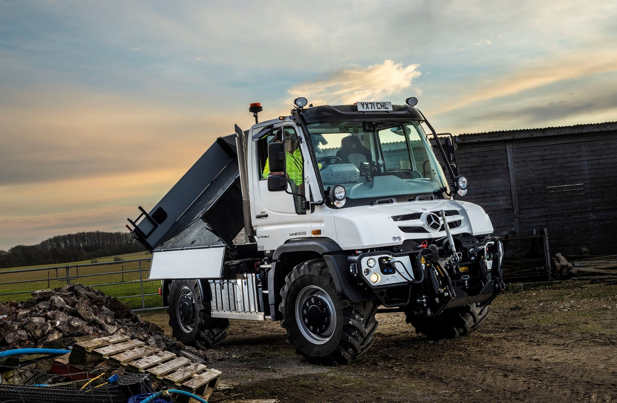

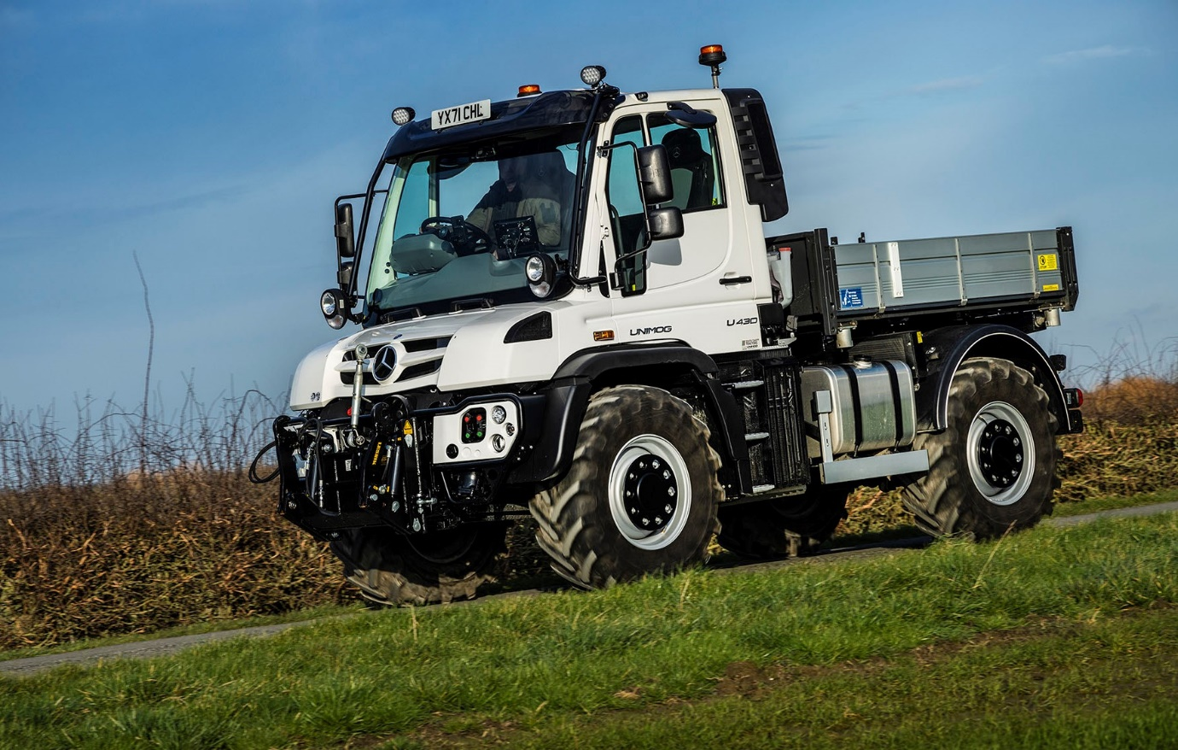

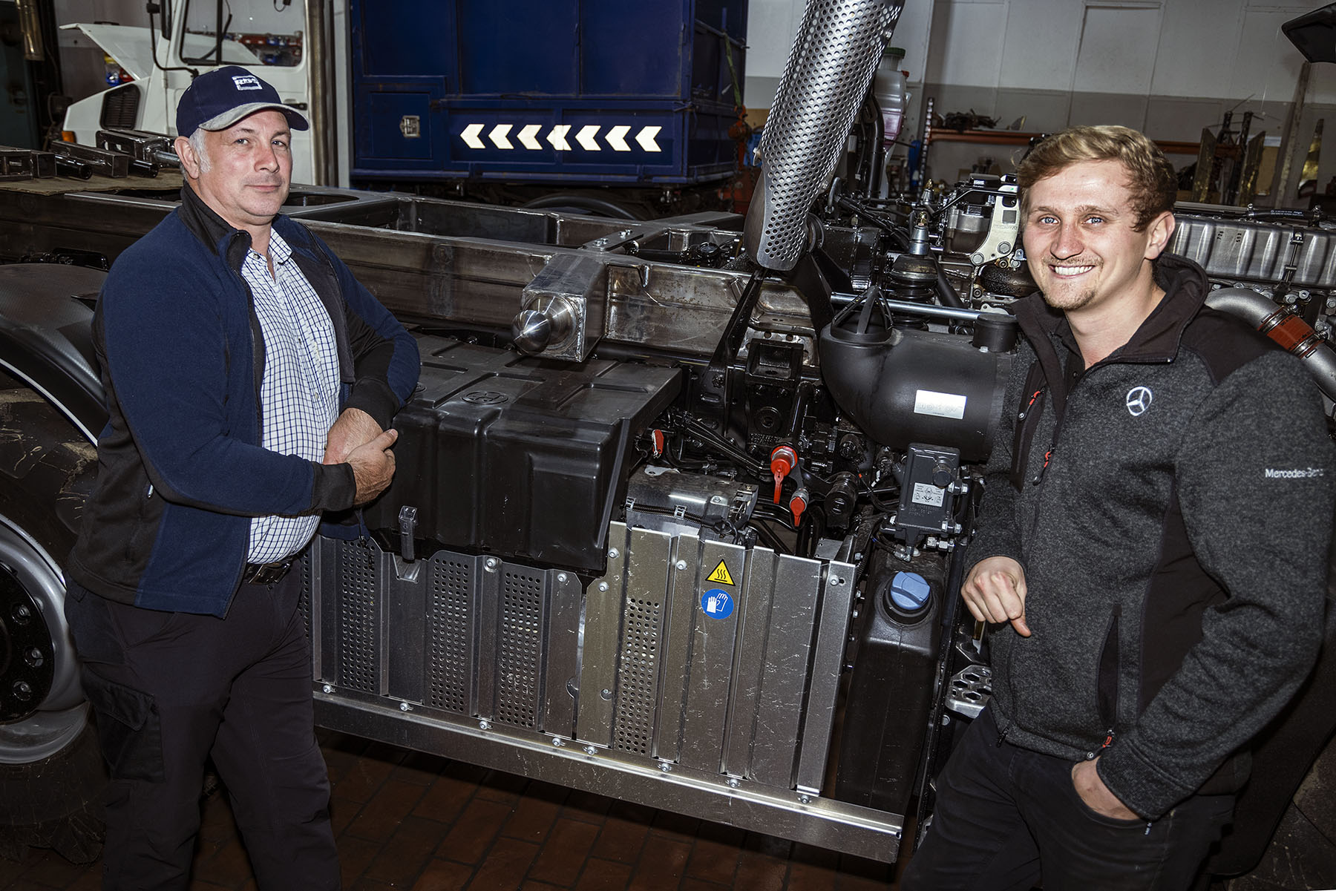

A job well done: Ian Chick is pictured, left, with his soon-to-be-finished Unimog and South Cave Tractors’ Ben Middleton – the vehicle underwent modifications in the Dealer’s workshop prior to delivery

ends

For more information, or to request bigger/higher-res image files, please contact:
Steve Warren or John Ripley
Impact Communications
Steve: 07770 470251, steve@impactcom.co.uk
John: 07771 484595, john@impactcom.co.uk



