

Date: 16 December 2020

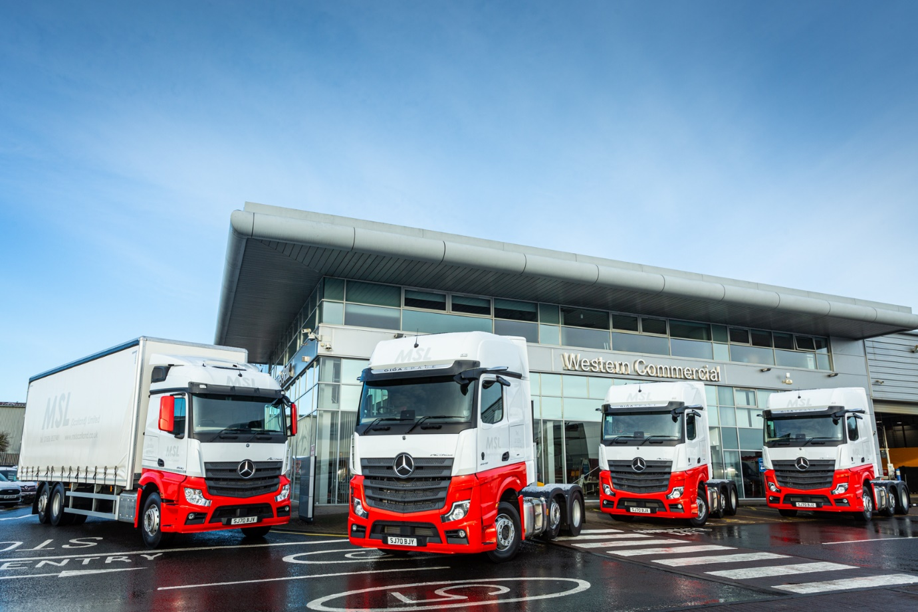

MSL looks to the future with MirrorCam from Mercedes-Benz Dealer Western Commercial

Haulier MSL Scotland has been operating an all-Mercedes-Benz fleet for four years now – but its latest trucks represent a step in a new direction.

The three Actros tractor units supplied to the Broxburn-based operator by near neighbour Western Commercial are its first with the revolutionary MirrorCam system.

MirrorCam is the most highly visible of a raft of technological updates on the latest Actros range. It replaces traditional door mirrors with rear-facing cameras that relay their images to screens mounted inside the cab, on the A-pillars.

As well as enhancing safety by providing much-enhanced all-round visibility, not least through the elimination of forward-facing blind spots caused by conventional mirrors, the system cuts diesel costs by an estimated 1.3% because the cameras’ compact, streamlined housings create less aerodynamic drag.

MSL Director Dave Sharp recalled: “Western Commercial supplied a demonstration unit with MirrorCam, which I assigned to one of our experienced drivers. He’d never seen anything like it and was initially apprehensive, but within a few miles was fully converted.

“Everyone who has since tried the system – myself included – has reached the same conclusion: once you’ve seen the improved visibility it offers, especially down the blind side when making tight turns, you would not want to go back to old-style mirrors. MirrorCam is definitely the way forward.”

MSL acquired its first Actros tractor units in 2013, and within three years had converted its entire fleet to Mercedes-Benz. It now runs 18 trucks. Most are tractor units, but the line-up also includes three 26-tonne curtainsiders with rear-mounted forklifts.

The new tractor units have range-topping GigaSpace cabs and, as 2548 models, are powered by 350 kW (476 hp) 12.8-litre in-line six-cylinder engines. They are the subject of a competitively priced contract hire agreement with Mercedes-Benz Finance.

Western Commercial has also just delivered another 26-tonne Actros, a 2530 with StreamSpace cab and 7.7-litre ‘straight-six’ producing 220 kW (300 hp). Its curtainside body is by Truckcraft, of Stalybridge.

“We put all our eggs in the Mercedes-Benz basket four years ago because the Actros had proved to be extremely fuel-efficient and very popular with our drivers, while Western Commercial’s back-up was exemplary,” recalled Mr Sharp.

“Since then our relationship with the Dealer has gone from strength to strength, and we now have a great rapport with its team. As for the trucks, they just get better at the pumps. At 480 hp the demonstrator we trialled represented a step up in power from our established 450s, but it still produced average mpg returns that were comfortably into the 10s, and the early indications suggest that our new tractors will do every bit as well.”

He continued: “We’re up against some big hauliers in this part of the world, so have had to carve our own niche. We focus on providing the best possible customer service, and to deliver on that promise we make a big effort to recruit and retain the best drivers.

“That’s why we choose the biggest cabs and high specifications – the guys are away from home all week and if they’re in a comfortable, well-designed vehicle they’re much better able to work safely and efficiently.”

MSL has managed to remain busy throughout the pandemic, in part because it was already working for customers whose work was vital to keep the country moving. As well as trunking between mail and parcel delivery depots, its trucks have been involved in carrying Covid-19 testing kits to and from an NHS testing hub in the Midlands.

“Purely by accident, it’s been a very busy year,” said Mr Sharp. “We’re proud to have played a small part in the important work our customers undertake, and that our Actros fleet helps us to provide them with the reliable service they need.”

www.mslscotland.co.uk

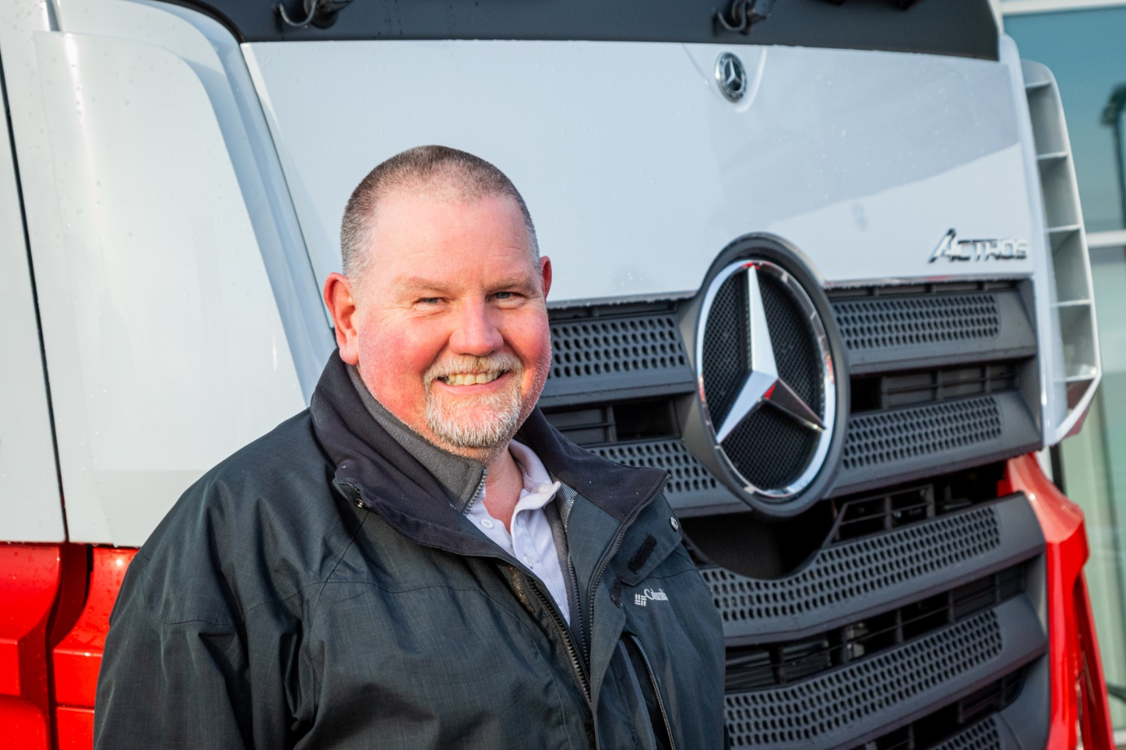

Everybody needs good neighbours… and in Western Commercial, Director Dave Sharp says MSL Scotland has one of the best
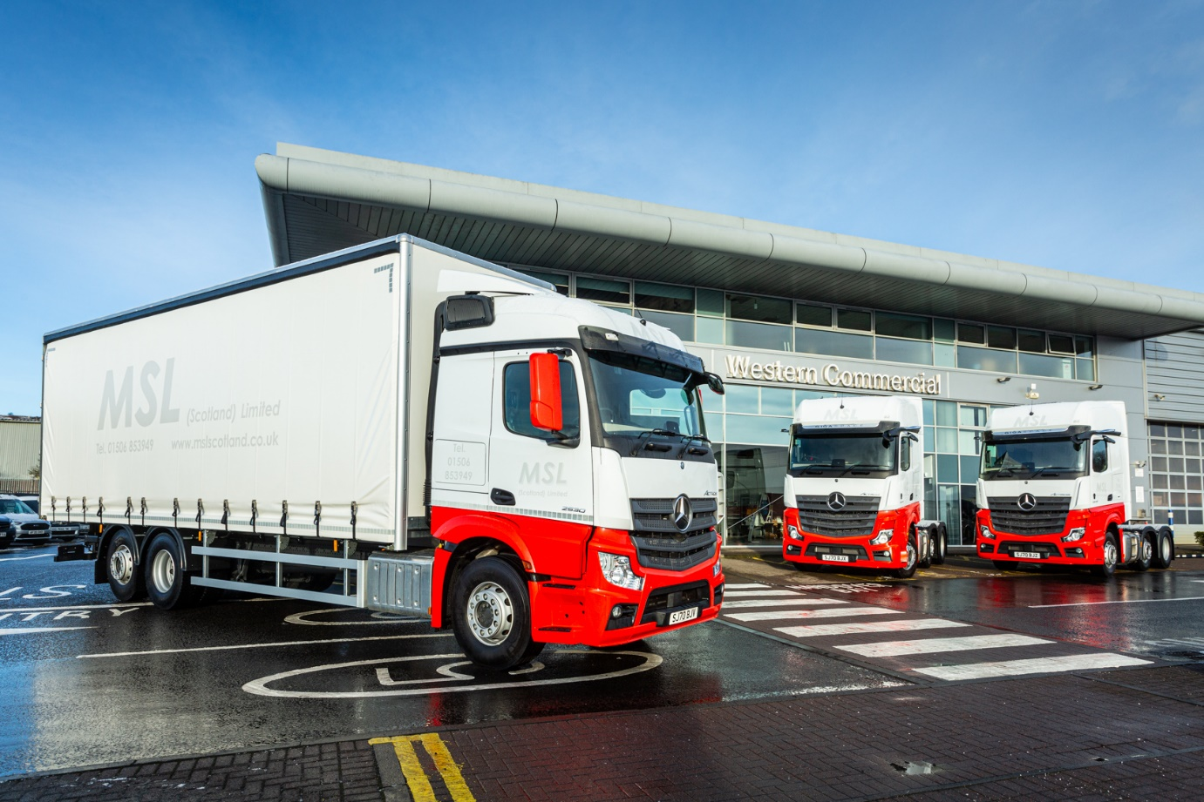

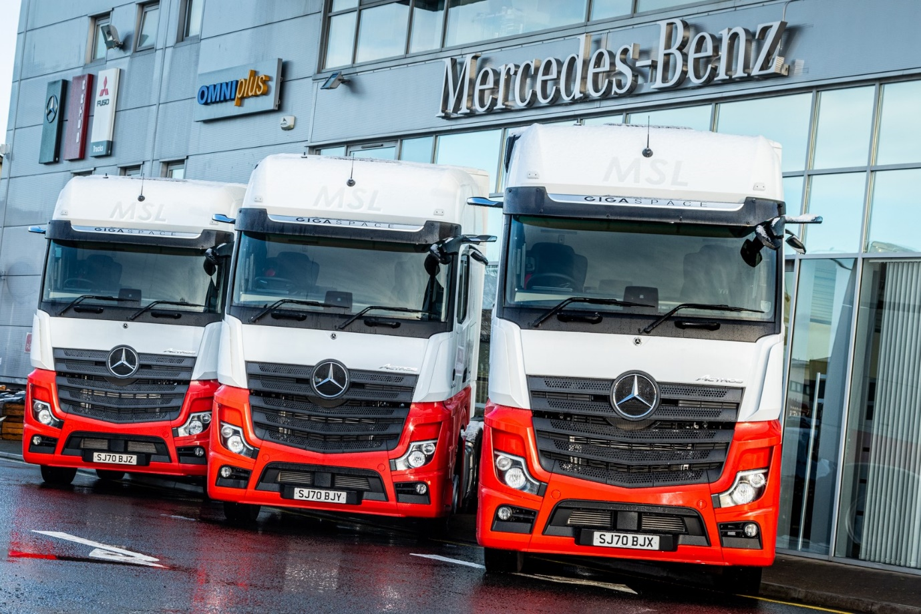

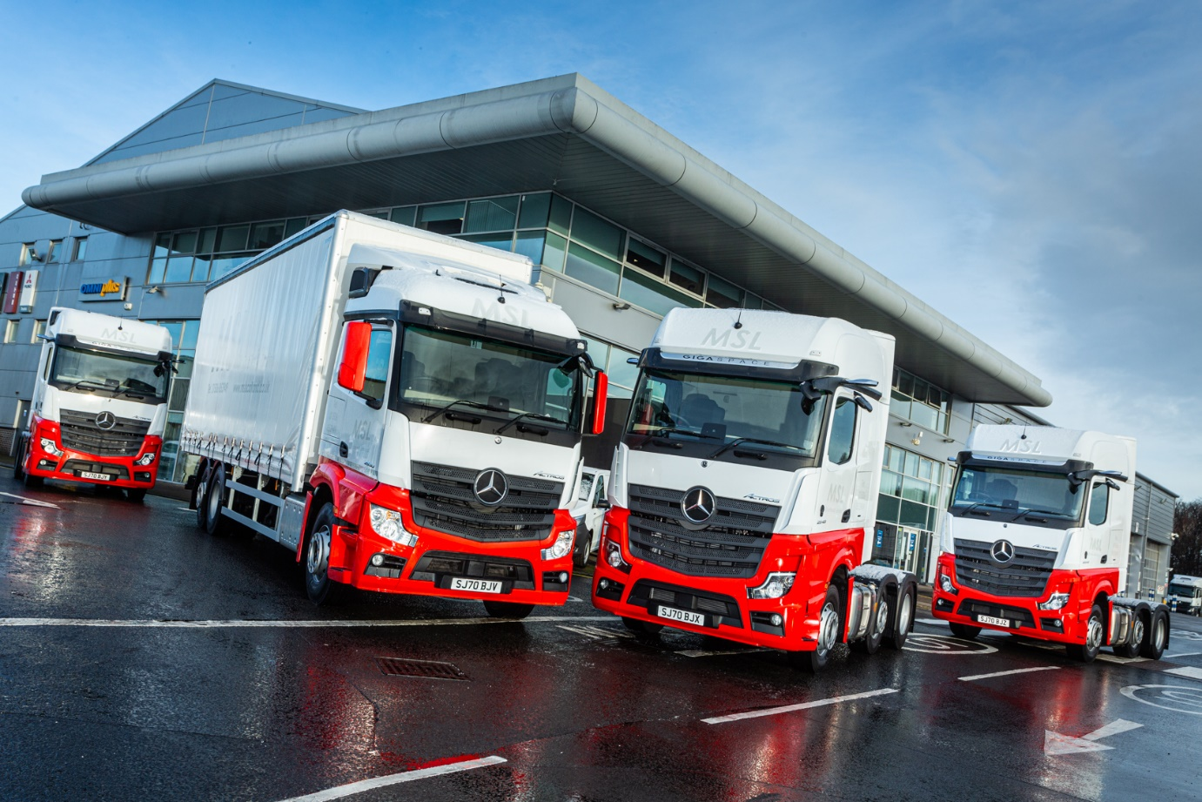

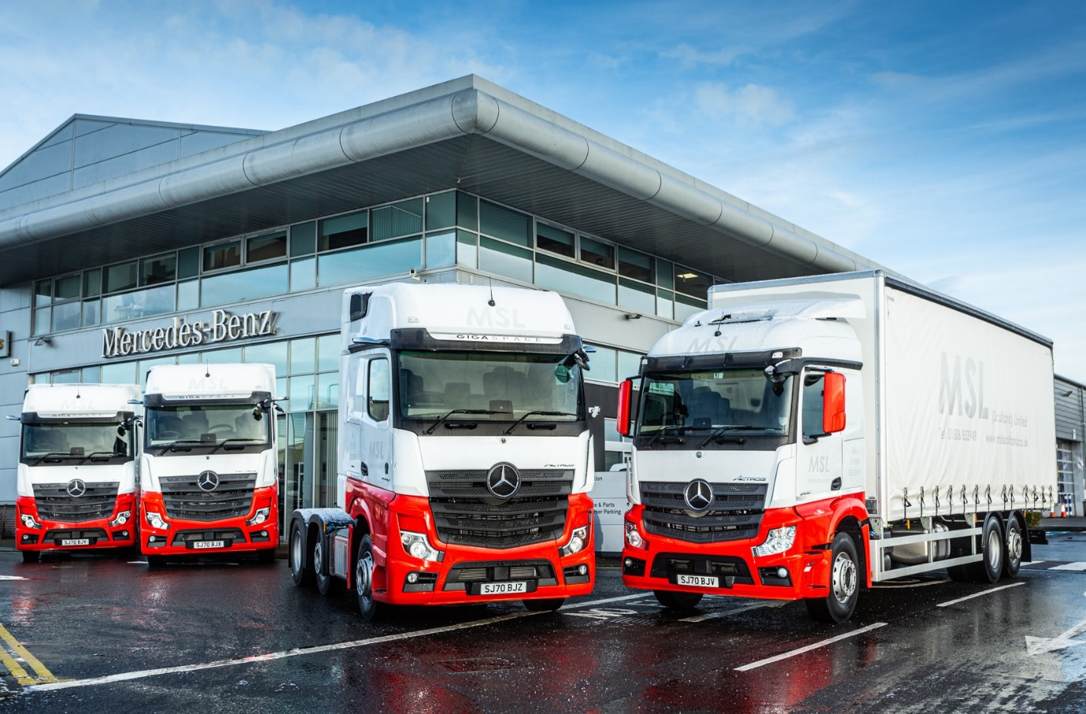

ends

For more information, or to request bigger/higher-res image files, please contact:
John Ripley or Steve Warren
Impact Communications, 01926 842126
John: 07771 484595, john@impactcom.co.uk
Steve: 07770 470251, steve@impactcom.co.uk

