

Date: 14 July 2022

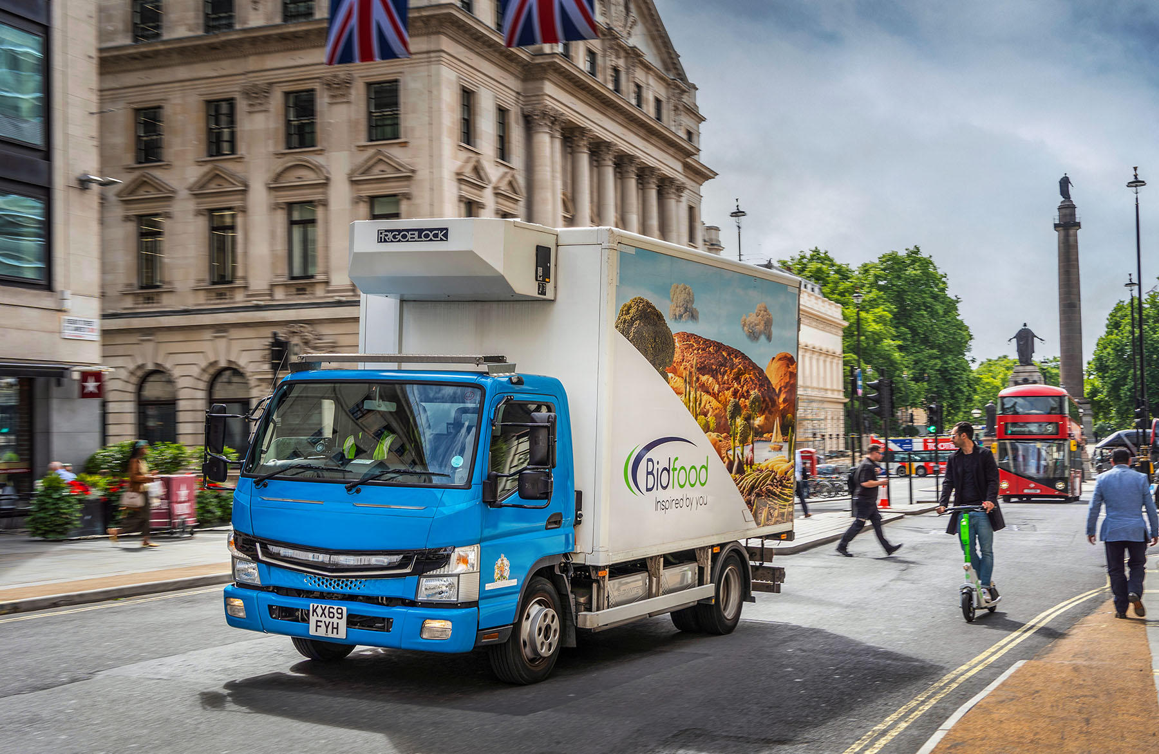

Bidfood gets a taste of electric transport by entrusting central London deliveries to FUSO eCanter

Foodservice wholesaler Bidfood is preparing for the advent of battery-powered truck technology with the help of its first zero-emission FUSO eCanter.

The high-profile company is keen to pave the way for future changes to its delivery operation by gaining early experience of electric vehicle operation.

The world’s first fully electric light-duty truck to enter series production, the 7.5-tonne eCanter represents a major advance in the battle to improve air quality in towns and cities.

Examples are in service in a variety of applications across the UK but Bidfood’s is the first to be fitted with a temperature-controlled body. This was built by Gray & Adams and is cooled by a Frigoblock eutectic refrigeration system which chills the insulated twin-compartment box as the eCanter’s main drive batteries are being recharged, rather than draining them of energy while the vehicle is on the road.

Bidfood took delivery of the eCanter in 2020 but plans to put it to work were curtailed by the onset of Covid-19, subsequent lockdowns, and then ‘fall out’ from the pandemic. It has now been assigned to the company’s depot in Battersea, from where it delivers to customers throughout central London, typically covering 60-70 km each day.

Depot Manager Jon Stansfield said: “Like all transport operators working in London we face the reality of emissions-based restrictions. These are only going to get stricter, with similar regimes becoming more widespread throughout the country.

“Battery technology is still in its infancy and obviously an electric vehicle cannot compete with a diesel-engined truck in terms of range, especially when fitted with a heavy fridge body.

“The eCanter offers other attributes, though. Of course, from a business perspective it’s important that we ‘future-proof’ our operation against further regulations. There is also a moral dimension to this issue – the fact that electric vehicles like the eCanter are so much cleaner and quieter means they can only benefit the wider community, and not just our company and customers.”

He continued: “We were keen to trial an electric truck and get a true picture of how it would fit our requirements. The eCanter was an obvious choice – it’s already well proven in operation and is backed by a major manufacturer in Mercedes-Benz Trucks.

“Given its environmental credentials, the eCanter has the potential to make an important contribution to Bidfood’s overall sustainability strategy.”

The eCanter’s electric drivetrain employs six 13.8 kWh lithium-ion batteries with a total power output of 82.8 kWh (66 kWh usable). The permanent-magnet motor delivers 129 kW (180 hp) via a single-gear transmission in the rear axle. A single charge gives the truck an effective operating range of more than 62 miles (100 km), which is ample for many urban delivery applications.

Bidfood has been a leading supplier of fresh, frozen and ambient food, beers, wines and spirits, catering essentials and equipment to customers in a range of sectors across the UK for more than 20 years, and runs a fleet of more than 800 trucks at 7.5-tonnes and above.

Last September Bidfood became the first UK foodservice wholesaler to sign up to a net-zero carbon goal with the Science-Based Targets initiative, a partnership of international climate leaders including CDP (Carbon Disclosure Project), the United Nations and World Wide Fund for Nature. Bidfood has committed to a target date of 2045 and will be focusing heavily on emissions not only across its own operations, but also working in collaboration with customers and suppliers to explore ways of reducing overall carbon footprints together.

www.bidfood.co.uk

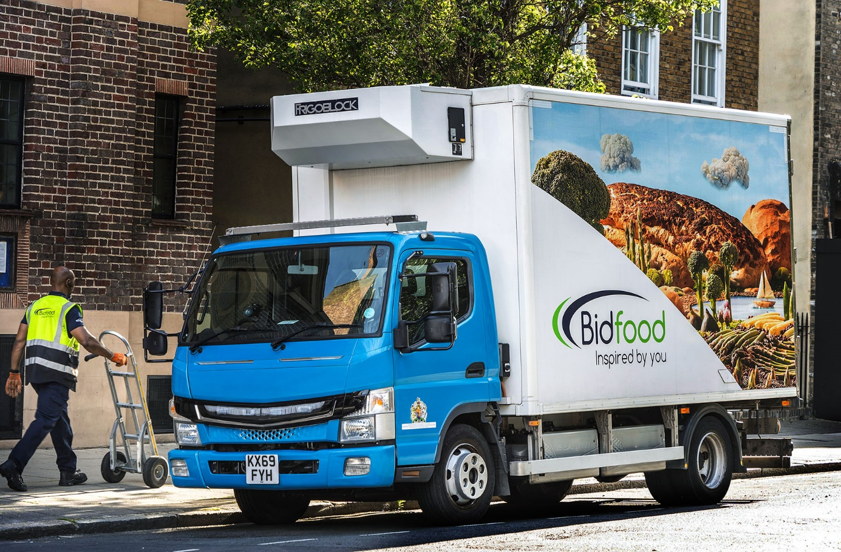

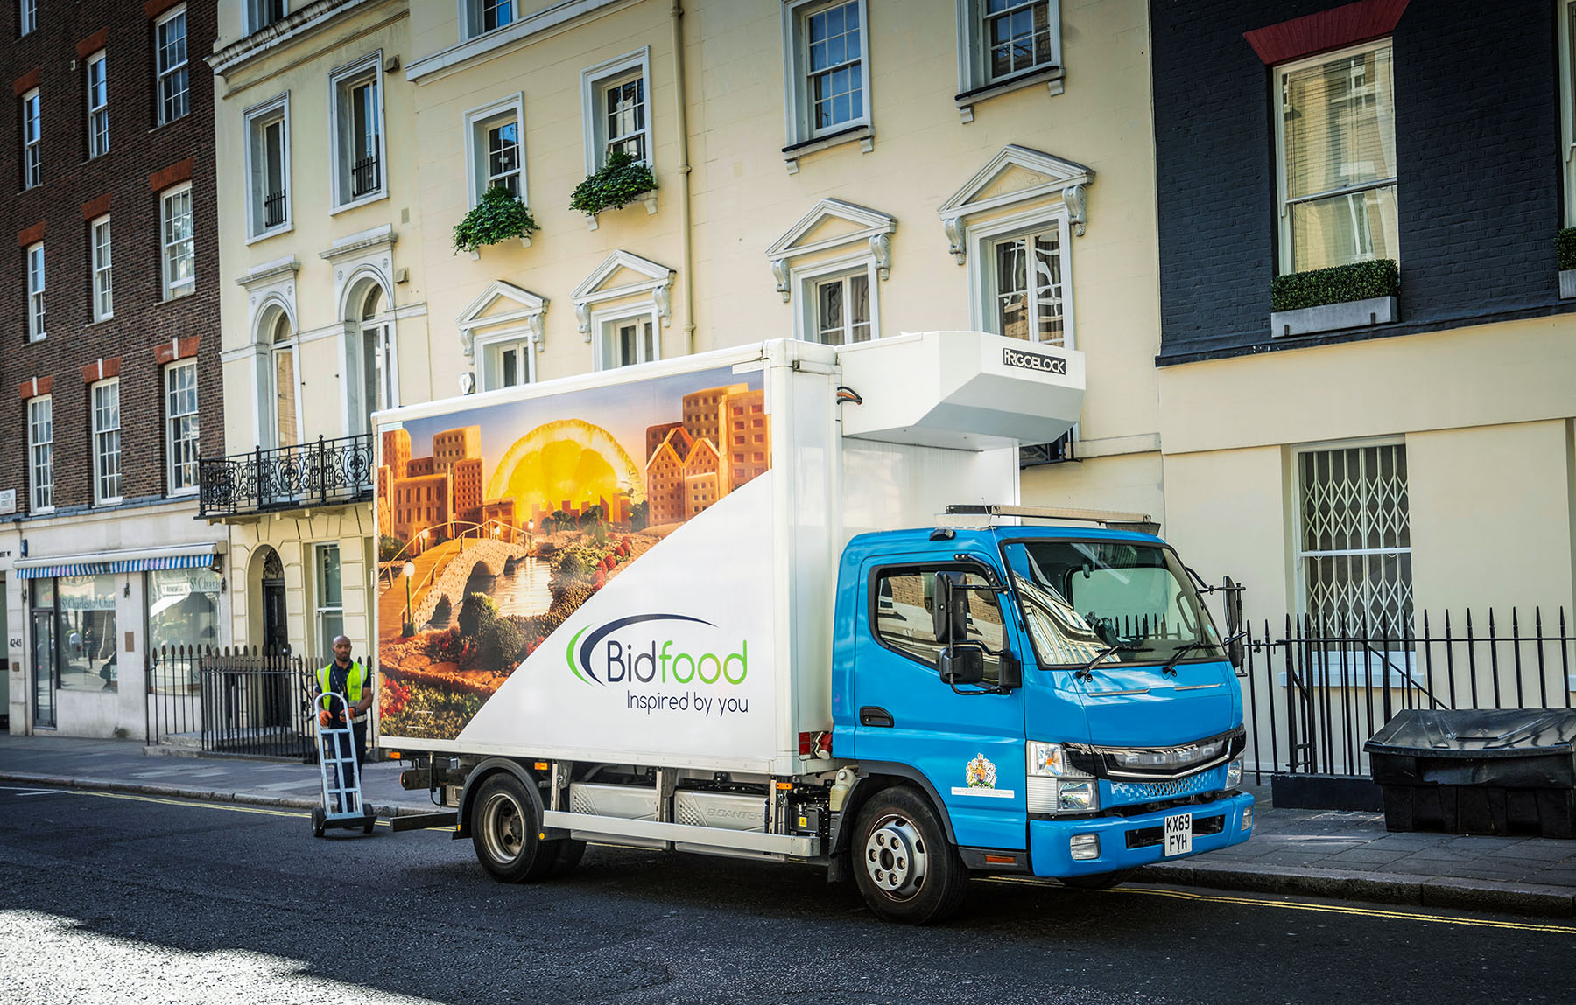

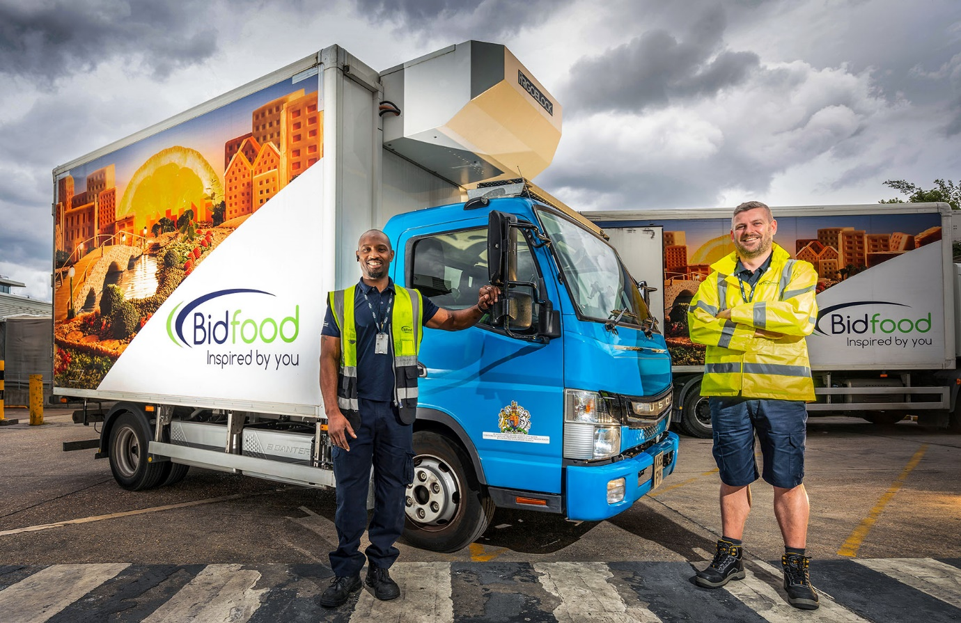

Taking charge: Battersea Depot Manager Jon Stansfield, right, and Driver Marc Blackman

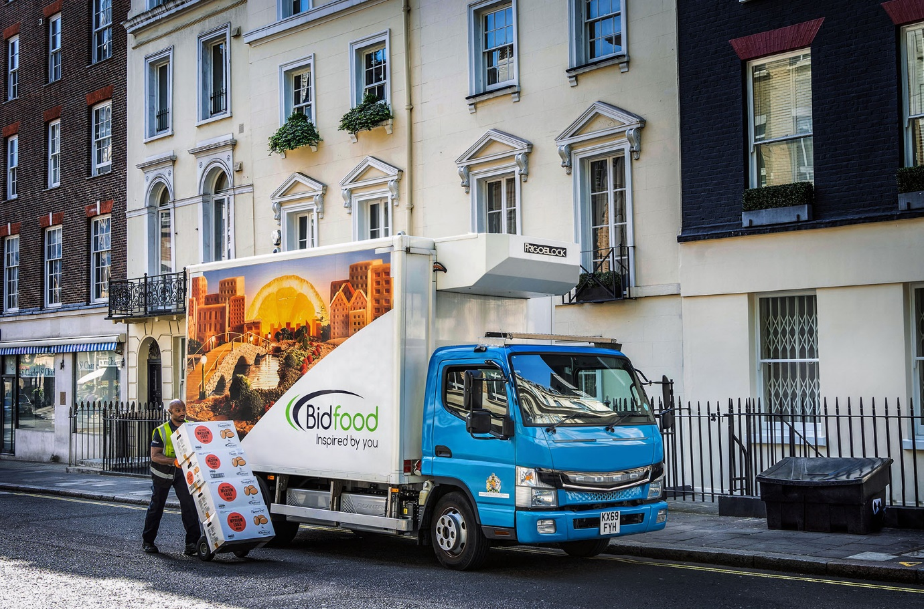

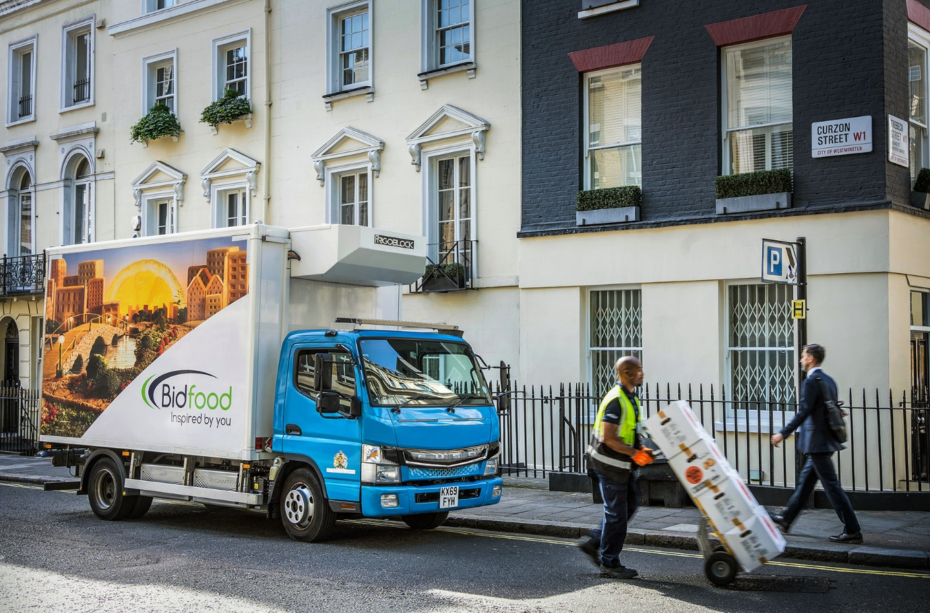

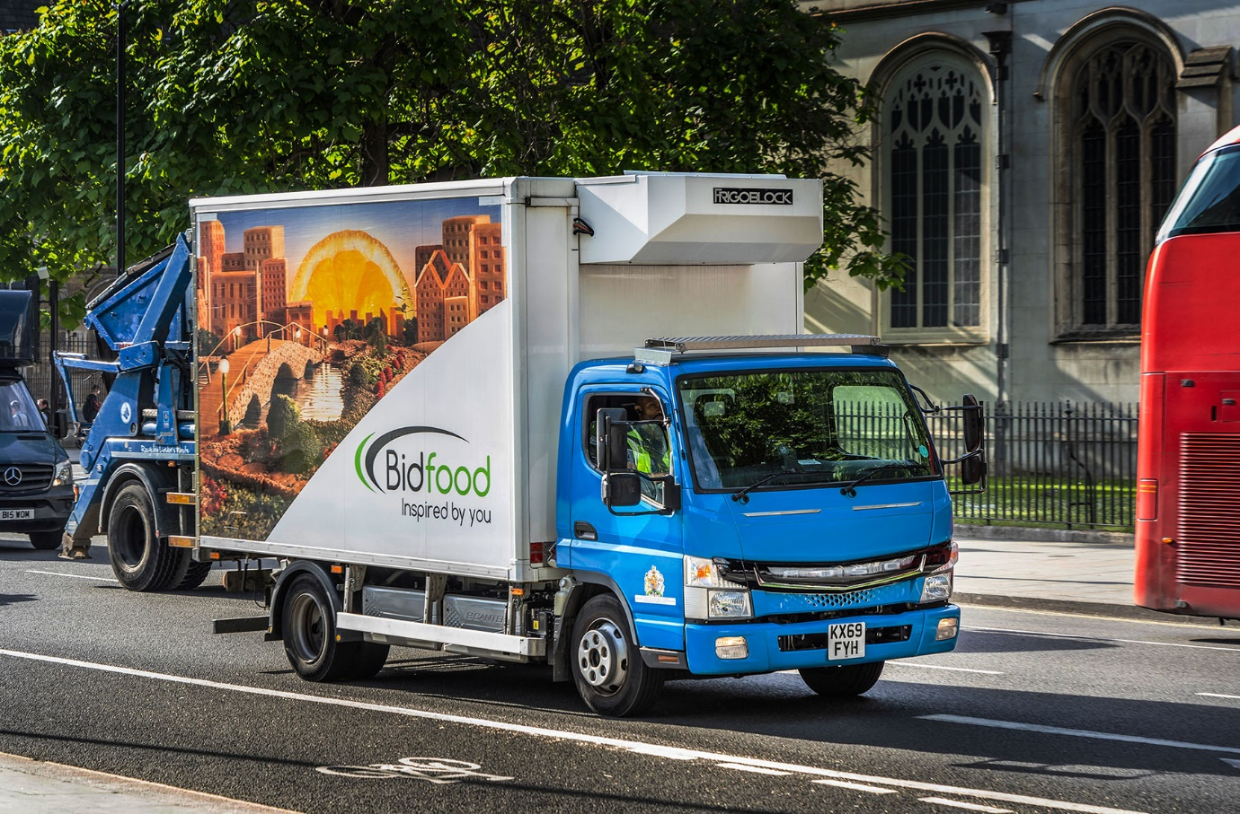

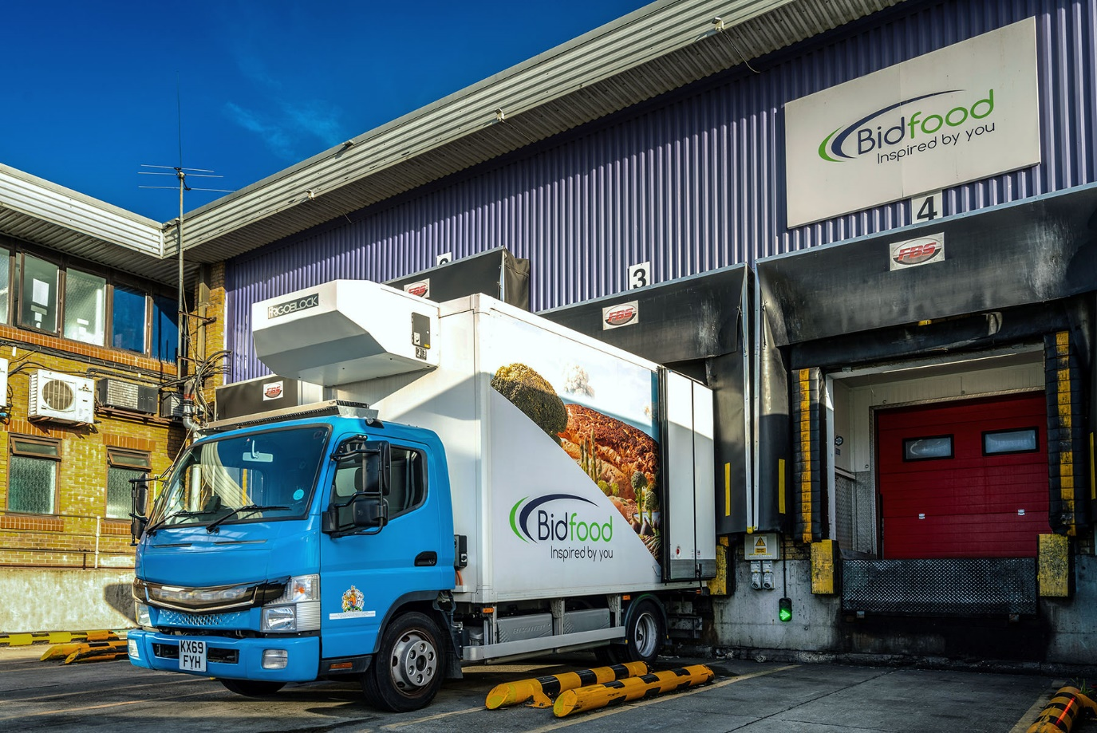

ends

For more information, or to request higher-res image files, please contact:

Jamie Fretwell at Mercedes-Benz Trucks UK Ltd
07712 519230, jamie.fretwell@daimler.com

or

Steve Warren or John Ripley
Impact Communications
Steve: 07770 470251, steve@impactcom.co.uk
John: 07771 484595, john@impactcom.co.uk

