

Date: 10 March 2025

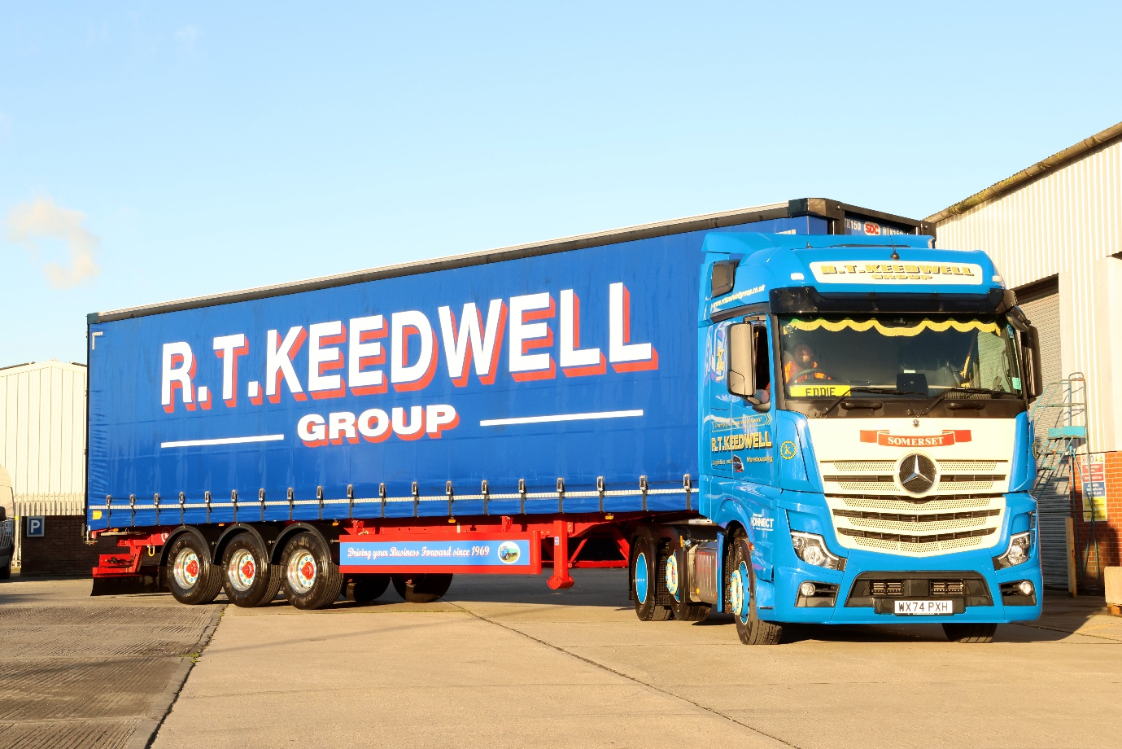

‘Unbeatable’ Actros L from City West Commercials the only choice for Keedwell

History shows one indisputable fact for leading haulier RT Keedwell – when it comes to fuel efficiency, the Mercedes-Benz Actros just keeps getting better.

The Somerset-based operator has been running Actros tractor units as a mainstay of its fleet of more than 400 trucks since 2012, and has seen consistent improvements from each generation.

“Our first Actros proved to be superbly reliable and their fuel returns were easily as good as our fleet average at the time – but when we added units from the following generation they showed an immediate 10 per cent mpg increase,” recalled Chairman Stuart Keedwell.

“That trend has continued. Our latest 480 hp tractors, even with just a few weeks on the road, are already matching the figures of the next-newest 450 hp vehicles we run.”

Those most recent additions are 15 Actros L 2548 models with roomy BigSpace cabs, powered by 12.8-litre engines from the third-generation OM 471 family, which is engineered for optimum driving dynamics and efficiency.

“The 450 hp Actros is a great truck from a fleet operator’s perspective because it’s so cost-efficient and reliable,” said Mr Keedwell. “With the 480 hp version though, we get all of the same benefits with the added bonus of a useful boost in power, which makes them more popular with our drivers.”

The new trucks were delivered by Dealer City West Commercials, which has developed a strong relationship with its customer since handing over the first Keedwell Actros 13 years ago. As Actros L models they came with a full complement of well-proven Mercedes-Benz technology to maximise efficiency, safety and comfort.

Highlights include sophisticated aerodynamics, quieter cabs with extra heat insulation, and a lower, more comfortable driving position that also provides improved visibility.

“City West has become a trusted partner over the years and when they told us there would be no fuel penalty from upgrading to the 480 hp engine, we trusted their word,” continued Mr Keedwell. “The evidence has proved they were correct.

“The Actros L cab is a great step forward too – the seating position and quality of the fixtures and fittings make it a real driver’s truck, and the gearbox is the best yet.

“We have vehicles from other manufacturers so we’re always comparing but our experience shows that – especially when you’re talking about a large fleet with a lot of different drivers – the Mercedes-Benz Actros is unbeatable for consistently high average mpg returns.”

The RT Keedwell Group was founded in 1969 with a single truck by Mr Keedwell's father Ray. In addition to its 22-acre headquarters in Highbridge the company operates from 10 other locations across the UK, and provides a comprehensive portfolio of services from traditional general haulage to specialised logistics and freight distribution.

www.rtkeedwellgroup.co.uk

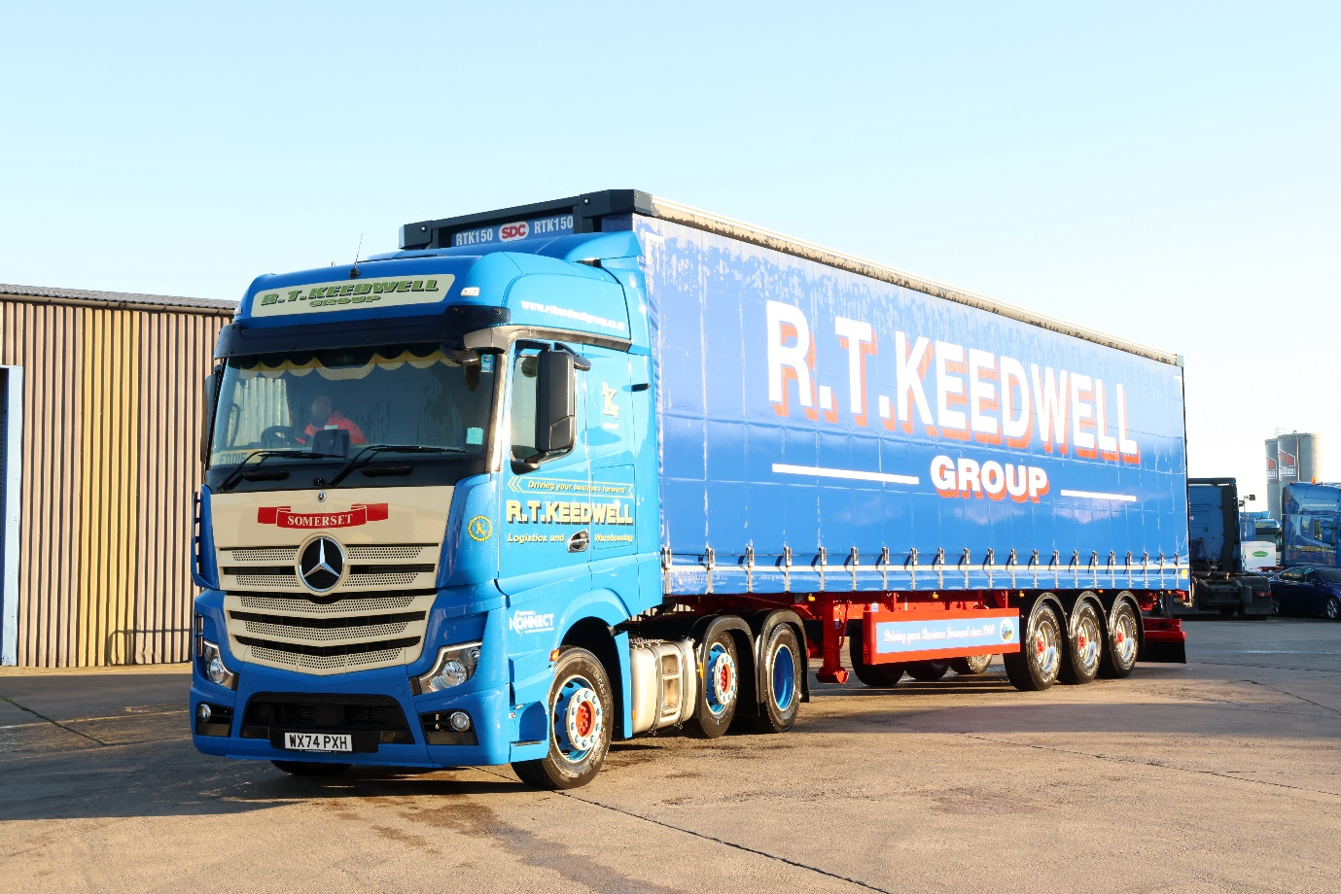

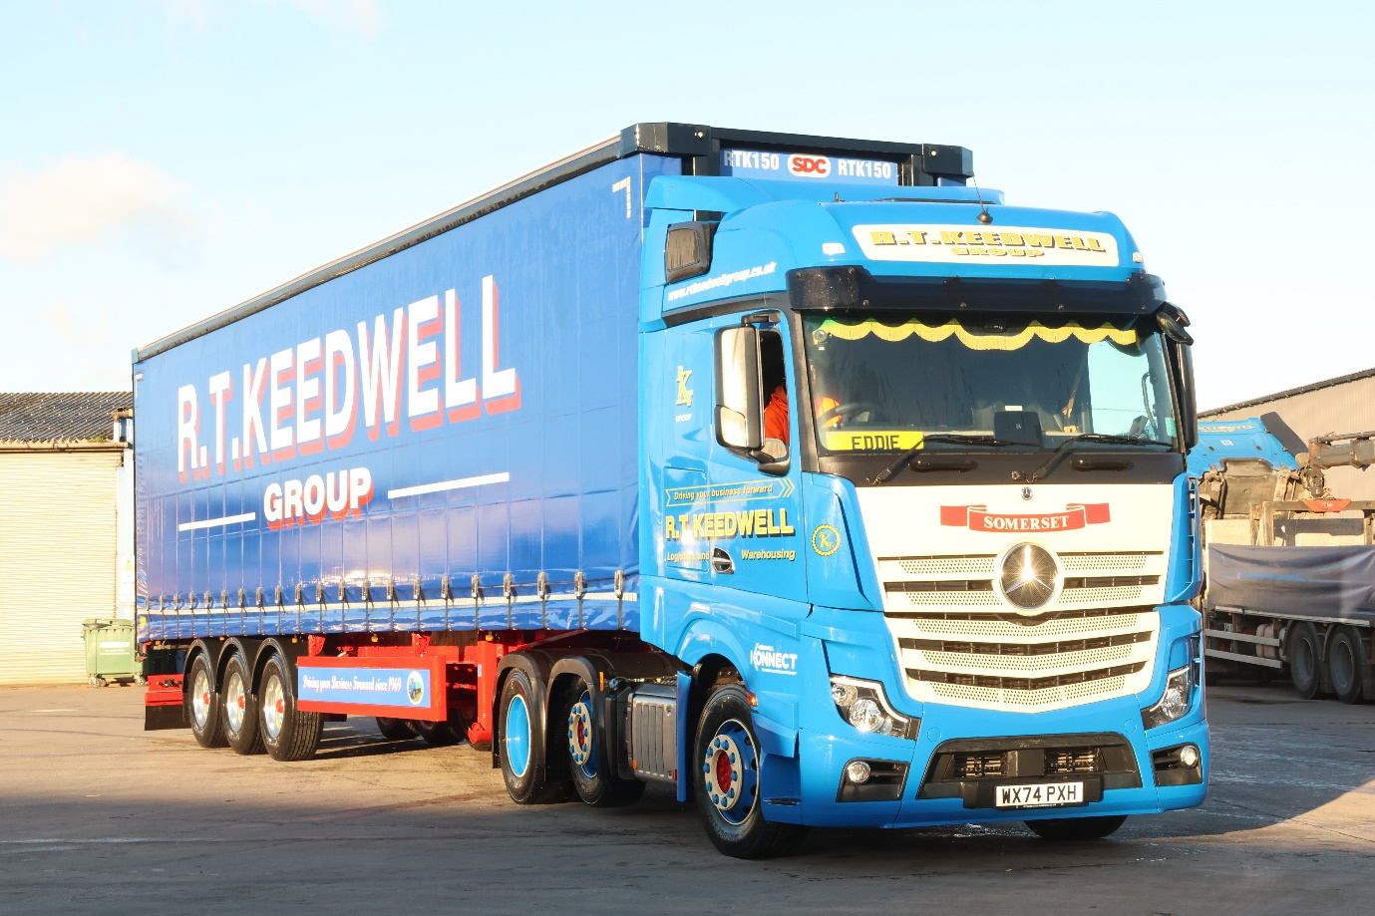

ends

For more information, or to request bigger/higher-res image files, please contact:
John Ripley: 07771 484595, john.ripley@loopagency.co.uk



