

Date: 4 May 2022

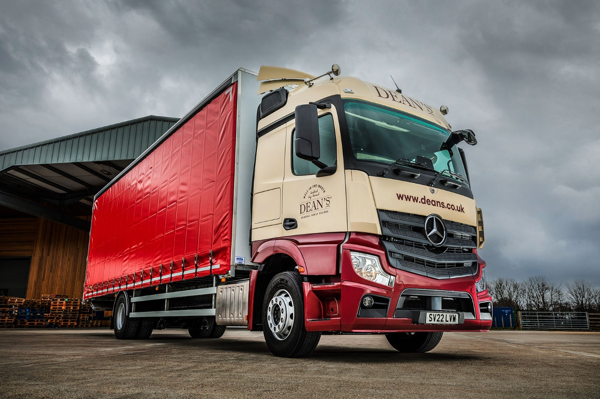

Mercedes-Benz Trucks delivers premier shortbread producer’s new Actros recipe for success

When crunch time came for its previous 18-tonner, shortbread manufacturer Dean’s of Huntly turned to Mercedes-Benz Dealer BLS Truck & Van for the perfect replacement.

This is the first time the family-owned, Aberdeenshire-based company has acquired a commercial vehicle bearing the three-pointed star.

Smartly finished in a recently revised version of Dean’s livery, with colour-coded bumper, the Actros 1830 has an aerodynamic StreamSpace sleeper cab which, at 2.3m wide, is the narrower of the two sizes available.

The 7.7-litre in-line six-cylinder engine produces 220 kW (300 hp) and drives through an eight-speed Mercedes PowerShift 3 automated manual transmission, while the vehicle’s curtainside body is by Micra Truck Bodies, of Wakefield.

Features include the manufacturer’s radical new Multimedia Cockpit, which replaces traditional switchgear with intuitively-operated twin tablet-style screens – the optionally upgraded interactive version specified by Dean’s boast a larger, 12in instrument panel and comes with extra functionality, including satellite navigation.

Recognised internationally as the leading premium quality shortbread brand, Dean’s of Huntly is a household name in Scotland and, thanks to the melt-in-the-mouth taste and texture of its products, is becoming increasingly popular with consumers south of the border. It also exports to more than 30 countries, including Australia, China and the USA.

With new recruit Mike Kelman at the wheel, the company’s only truck is now delivering shortbread to retail customers, including supermarket RDCs, cash & carries, garden centres and gift shops, the overwhelming majority of them in Scotland. Wider distribution is undertaken by a third-party supplier.

Dean’s resolved to purchase the Actros following successful trials of a demonstration unit provided by BLS Truck & Van. Warehouse & Transport Team Leader Silas Woodward recalled: “Our last three trucks were by the same manufacturer, and before that we used another brand. Given its excellent reputation for reliability and durability, we were keen to investigate what Mercedes-Benz could offer.”

He continued: “We like the design of the Actros, which looks really good in our colours – branding is important to our business, so that’s a big ‘plus’.

“Mike is also delighted with his new truck. He’ll typically spend a couple of nights in the truck each week, and says it has plenty of space as well as being very easy and comfortable to drive.”

The vehicle is now being inspected and maintained under a four-year Mercedes-Benz Complete service contract, at BLS Truck & Van’s Aberdeen workshop. “Ultimately we’ll be judging the new truck on its running costs and reliability,” added Silas Woodward.

“First impressions of the Dealer are entirely positive, though. Sales Executive Chris Dyer was very helpful when it came to arranging the demonstration and specifying the vehicle, and I’ve every confidence his Service and Parts colleagues will provide the aftersales support we need.”

The Dean’s of Huntly story dates back to the mid-1970s, and Helen Dean’s kitchen in the small town of Huntly. Her husband Bill, a Drum Major, thought her shortbread so delicious that he decided to sell it to help raise funds for the local Huntly pipe band. As the band toured, so the reputation of Helen’s light and crumbly shortbread spread.

Today, with the couple’s son Bill at the helm as Managing Director, Dean’s continues to produce shortbread at the purpose-built bakery in Huntly to which it moved in 1992, using Helen’s original recipes and traditional, hand-crafted methods.

www.deans.co.uk

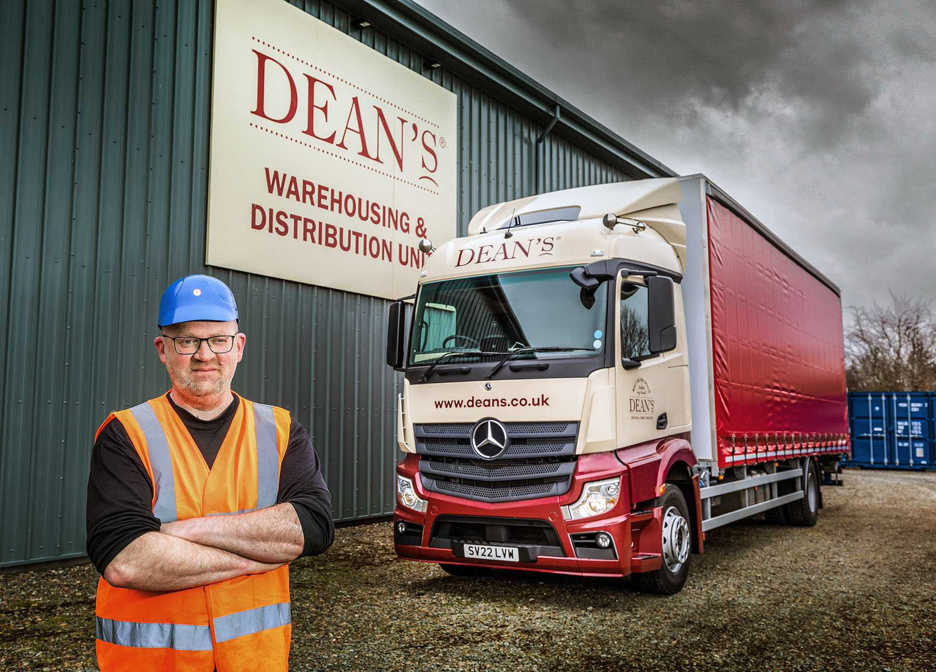

Silas Woodward: “We like the design of the Actros, which looks really good in our colours”
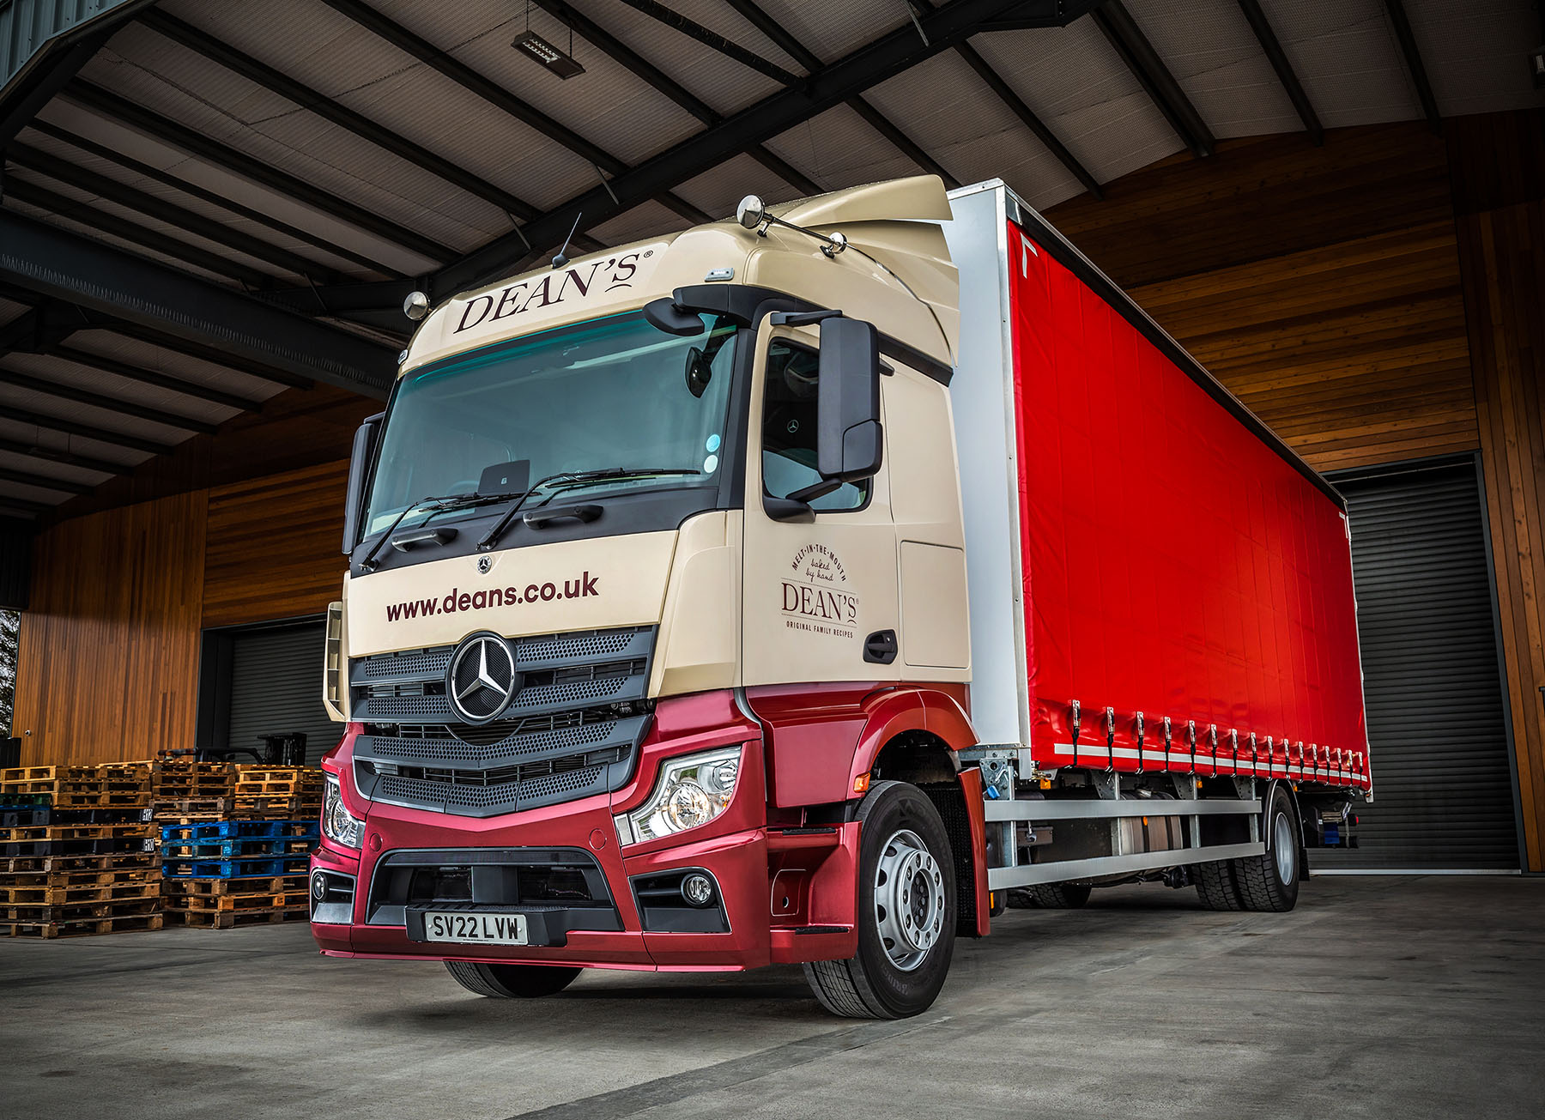

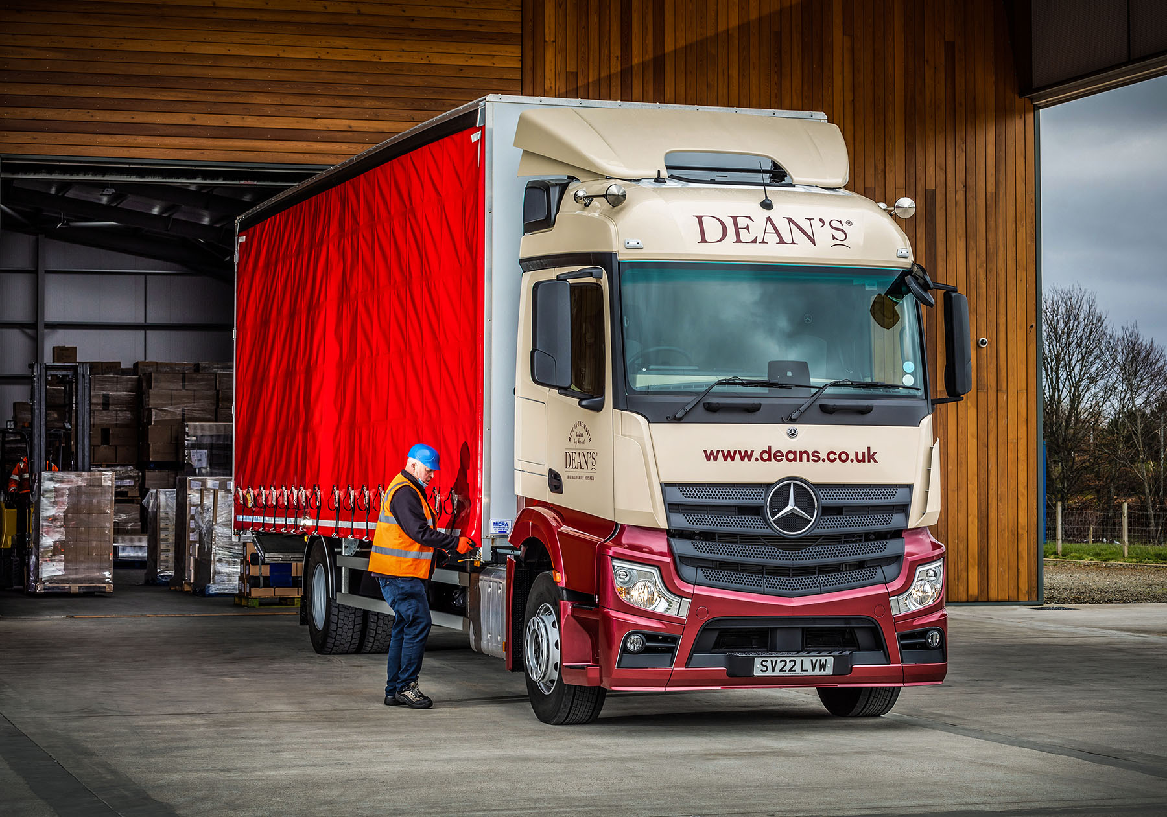

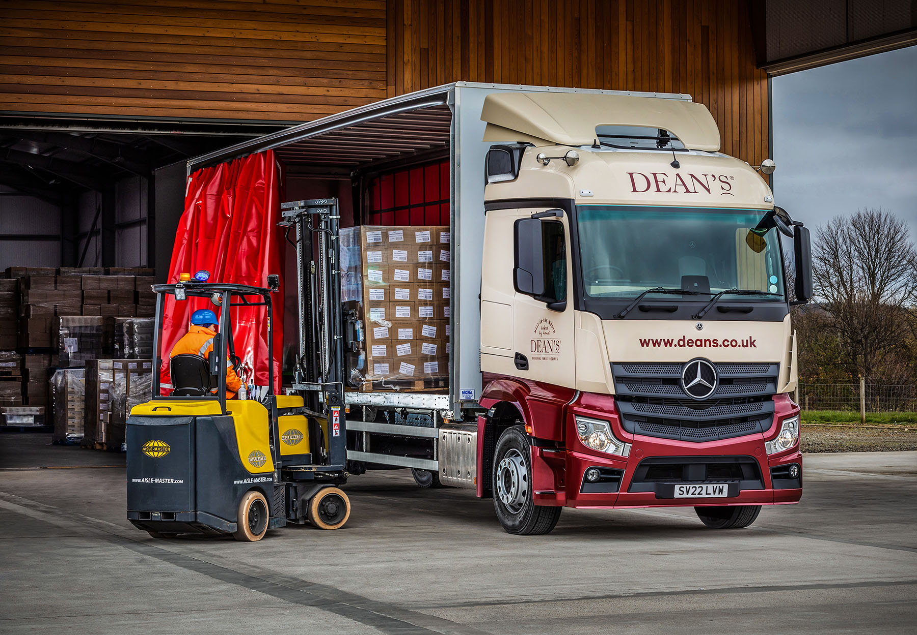

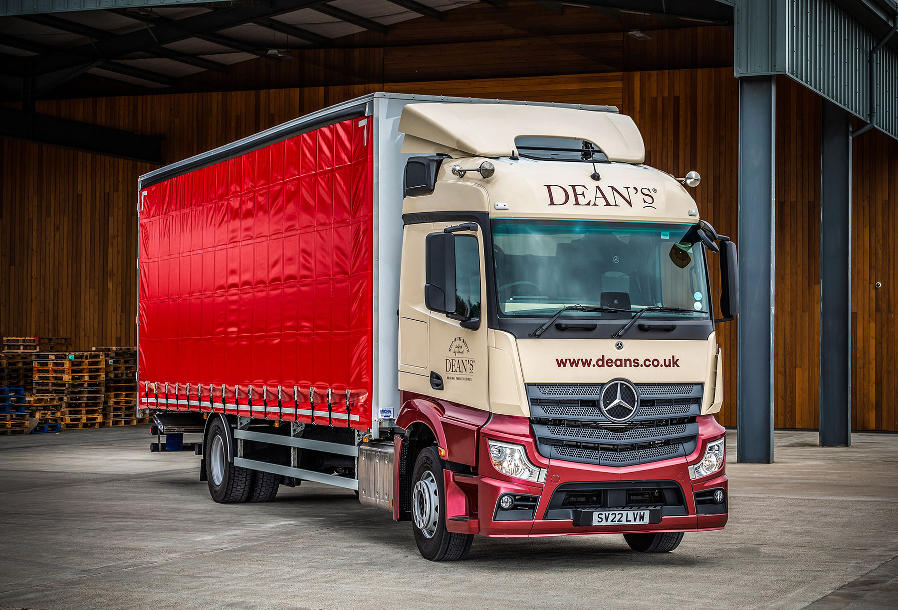

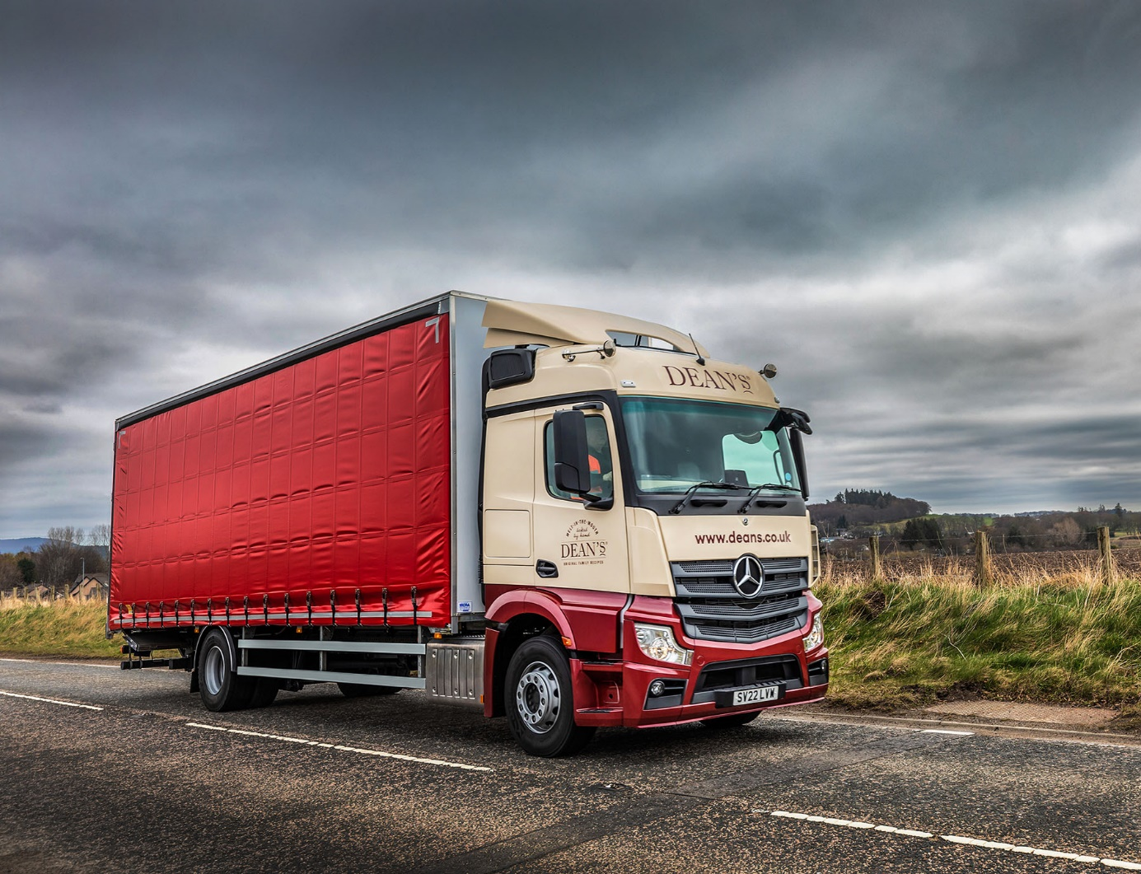

ends

For more information, or to request bigger versions of image files, please contact:
Steve Warren or John Ripley
Impact Communications
Steve: 07770 470251, steve@impactcom.co.uk
John: 07771 484595, john@impactcom.co.uk



