

Date: 30 November 2020

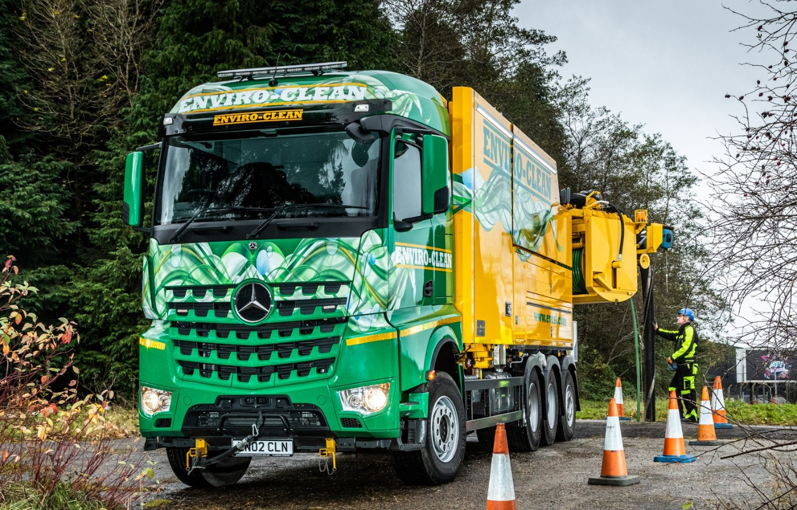

Enviro-Clean gives ‘green light’ for another efficient Mercedes-Benz Arocs from Western Commercial

Enviro-Clean Scotland’s latest, eight-wheeled Mercedes-Benz sewer-cleaning truck is a ‘green giant’ in more than one sense – as well as sporting the company’s distinctive verdant colour scheme, it is also reducing both water and diesel consumption.

Supplied by Dealer Western Commercial, the high-riding Arocs 3258 is equipped to save up to 15 million litres of clean drinking water every year, and capable of doing the job of two or more trucks.

The vehicle’s muscular 425 kW (580 hp) 15.6-litre ‘straight six’ engine provides the ‘grunt’ needed to drive its powerful jetting and suction gear, which was built and fitted by German specialist Wiedemann. The 8x4 ENA chassis has a single front axle, a double-drive bogie and a steering axle at the rear, and offers a level of manoeuvrability comparable to a six-wheeler.

Enviro-Clean Operations Manager Mark Donaghy said: “Fuel consumption is difficult to measure in a meaningful way for a truck like this, as the engine’s PTO (power take-off) also runs the auxiliary equipment. However, the powertrain of this Arocs makes it one of the most efficient vehicles we’ve ever had.

“The steered back axle helps the driver to get in and out of tight spots, and means the truck can access locations at which a standard 8x4 would struggle. The Arocs is also very driver-friendly, with a comfortable and well-designed StreamSpace cab.”

East Kilbride-based Enviro-Clean has been providing waste management and cleaning services for domestic, commercial and industrial customers across Scotland and northern England for more than 20 years.

Its fleet of 90 vehicles includes tractor units, tippers and vans kitted out for drain jetting or remote camera inspections, as well as DISAB suction loaders and vacuum tankers, RSP suction excavators and Muller recycler jetting units. The line-up includes five Arocs at 32 tonnes GVW. “It’s now our eight-wheeled chassis of choice,” confirmed Mr Donaghy.

Although the operator has its own workshop, it now relies on Western Commercial to inspect and maintain these vehicles under Mercedes-Benz Complete Service Contracts. “The Dealer’s Bellshill workshop does an excellent job and we know from experience that its team will always do their best to work around our own operational commitments,” Mr Donaghy continued.

The new Arocs is fitted with a 15,000-litre stainless steel tank. Its Wiedemann KW4500 liquid ring vacuum pump has a suction capacity of 4,500 m³ per hour, which can be deployed across a 180-degree range via a main boom and reel holding 20 metres of six-inch diameter suction hose. Further reels offer suction hoses of two- and three-inch bore.

For jetting, the truck has a highly efficient and automatic continuous water recycling system and a URACA P4 pump capable of delivering a massive 541 litres per minute at pressures of up to 175 Bar. Delivery is via 240 metres of 1¼ -inch hose, or a secondary 100-metre line with half-inch diameter.

All of this equipment can be operated and monitored via a touchscreen panel or by remote radio control. The truck is also set up for use in all weathers – it can work at temperatures as low as -10ºC and features a full set of operating lights and heated clothing locker, as well as hot water handwashing facilities.

Crucially, the jetting system’s recycling capability allows the operator to reuse water pumped from a sewer, rather than feeding directly from the drinking water supply. As well as substantially reducing water consumption, this cuts the volume of waste water emptied back into the drainage network.

“Assuming full usage it’s estimated that this could save up to 15 million litres of water per year, and eliminate the carbon footprint of the industrial process that would be needed to replace that loss,” said Mr Donaghy. “Given that its capacity and power allows the Arocs to do the work of two or more vehicles, the potential for reducing the impact of our operations on the environment is considerable.”

evcsl.com

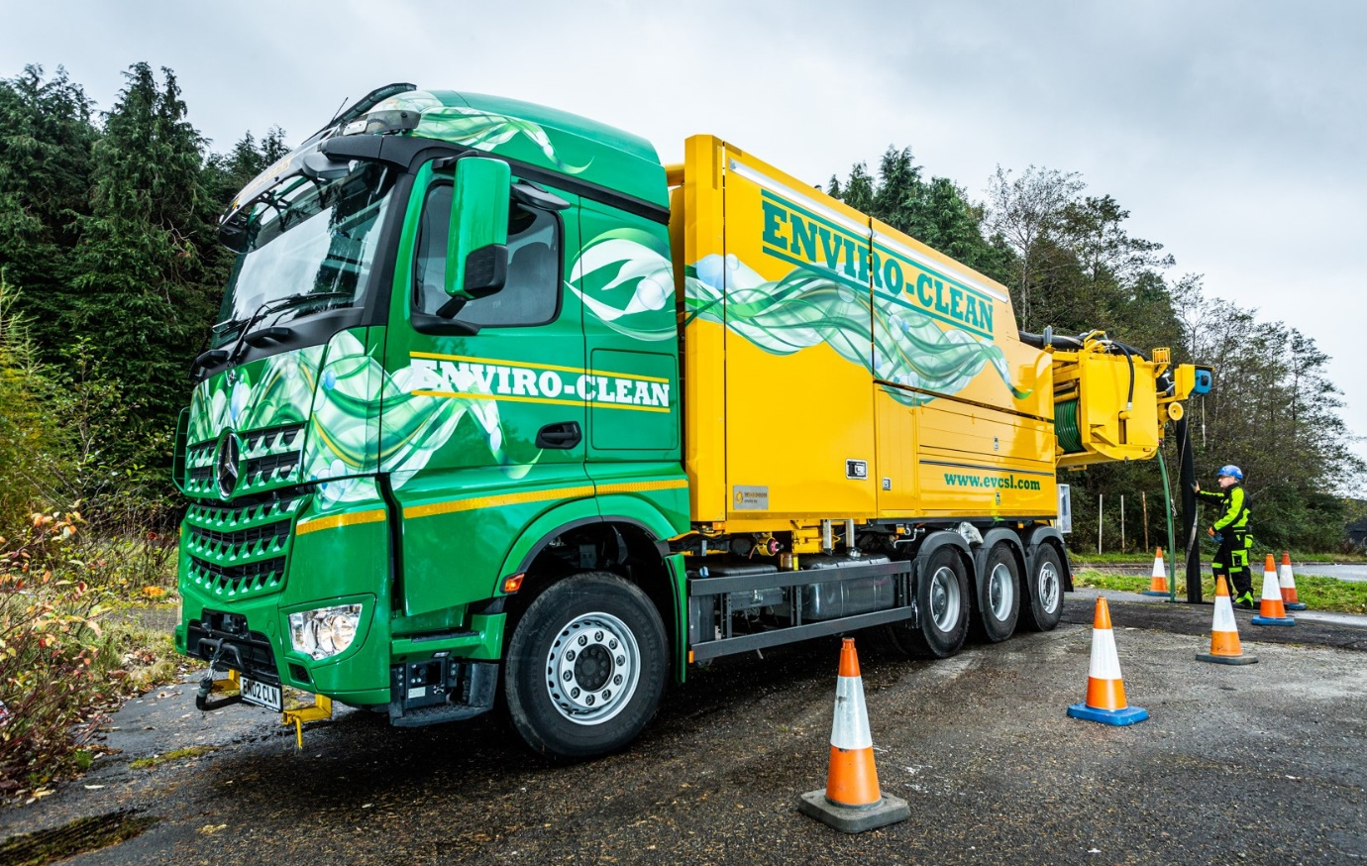

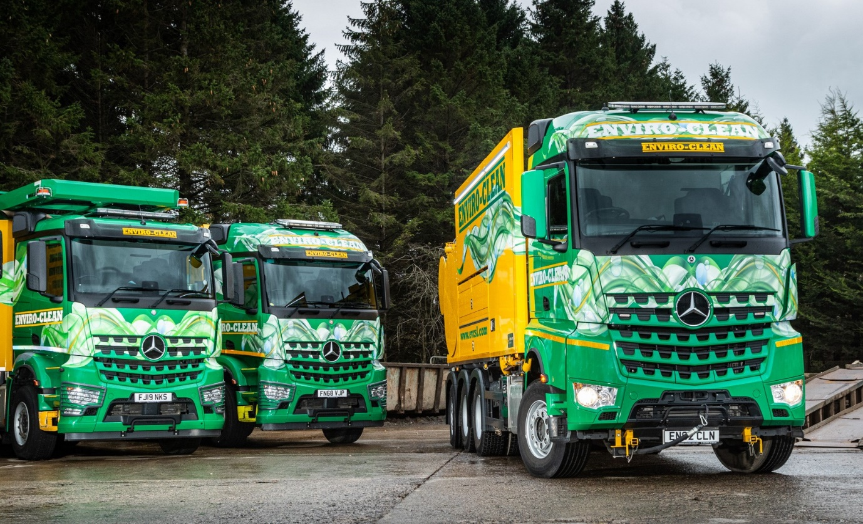

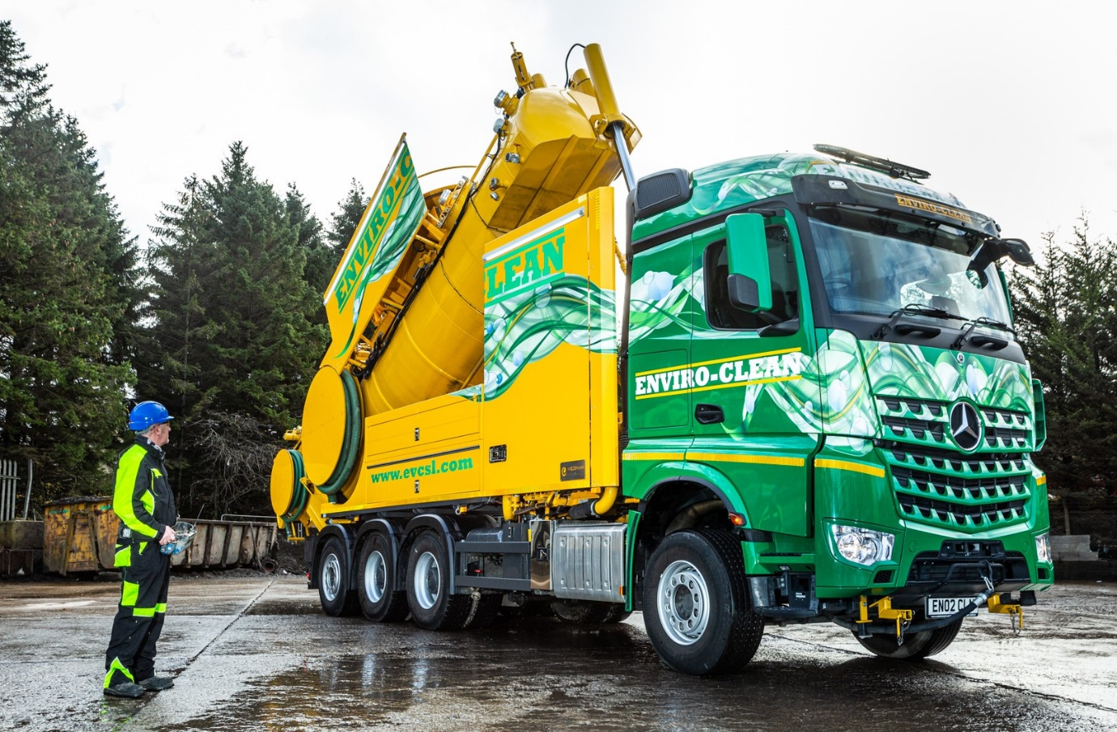

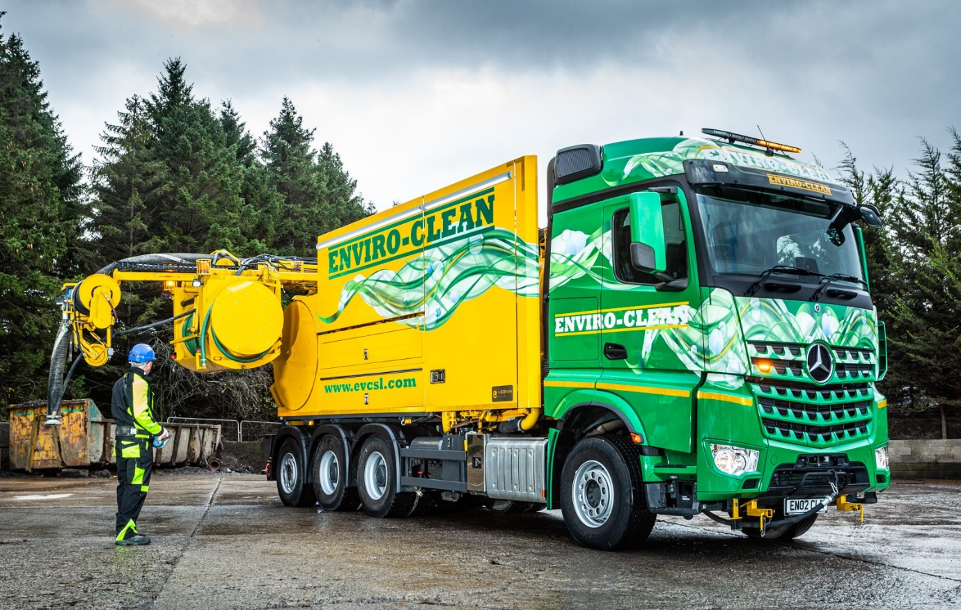

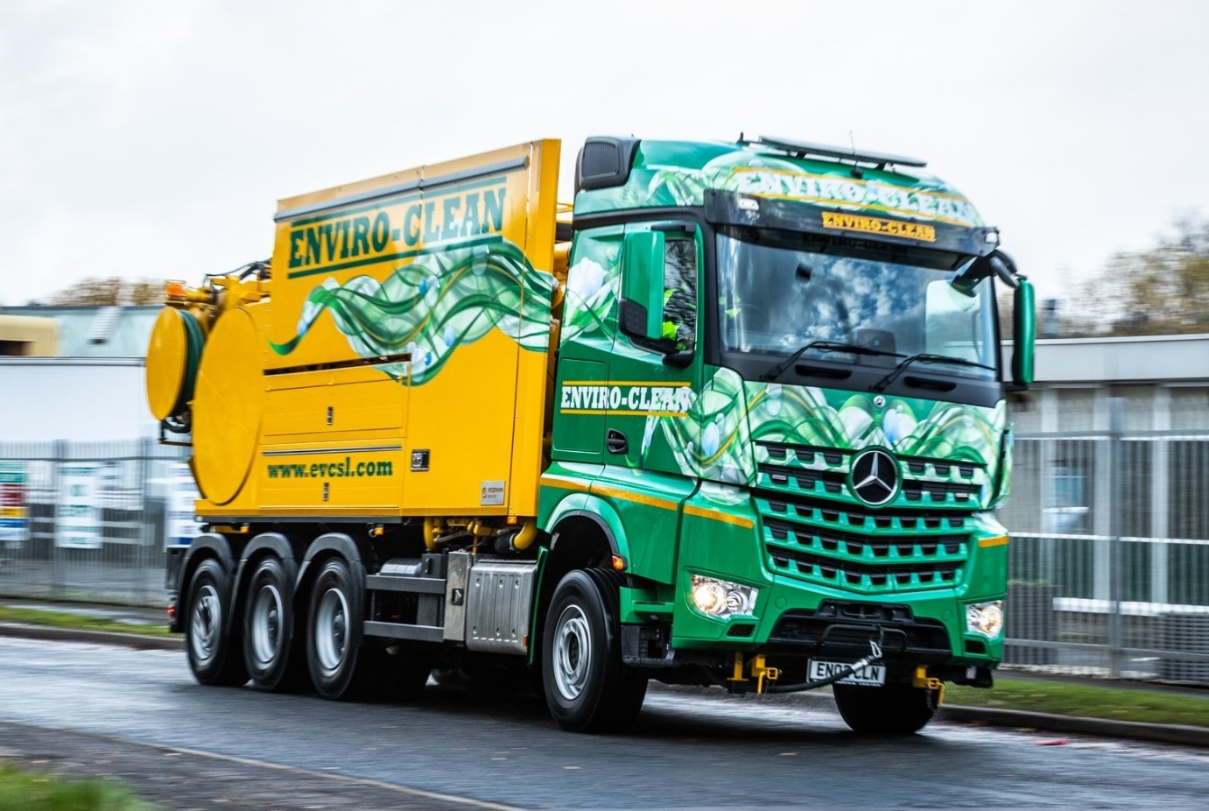

ends

For more information, or to request bigger versions of image files, please contact:
John Ripley or Steve Warren
Impact Communications, 01926 842126
John: 07771 484595, john@impactcom.co.uk
Steve: 07770 470251, steve@impactcom.co.uk

