

Date: 12 October 2023

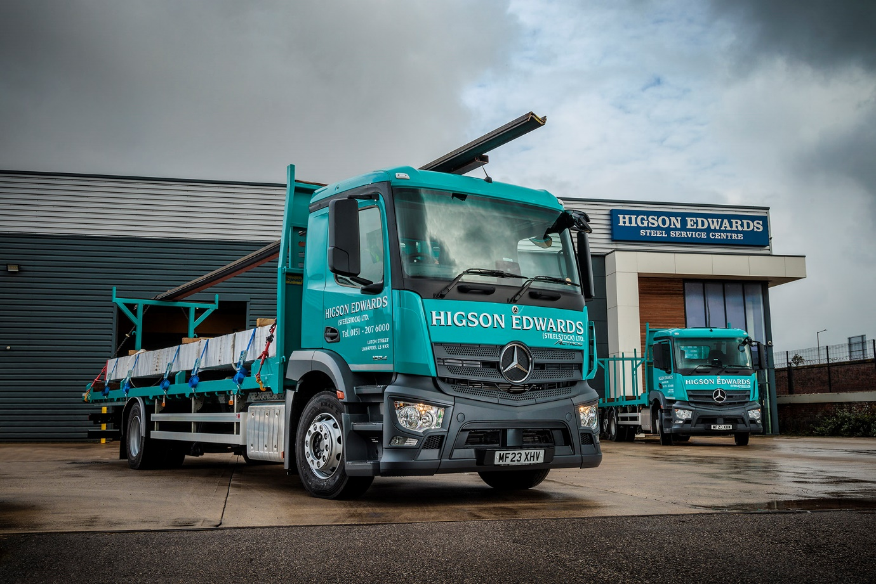

Mercedes-Benz Actros is the solid option for steel supplier Higson Edwards

When steel stockholder Higson Edwards needed to expand its delivery fleet, a pair of Mercedes-Benz Actros rigid trucks matched the job profile perfectly.

The Liverpool-based operator’s new trucks were delivered by local Dealer eStar Truck & Van, and bring the fleet strength to 14 class 2 vehicles. One is an 18-tonne 1824 model, with a 7.7-litre ‘straight six’ engine generating 175 kW (238 hp). The other is an Actros 2530, rated at 26 tonnes and powered by a 220 kW (300 hp) version of the same powerplant.

Both have ClassicSpace extended day cabs with 320 mm engine humps – which allow for a lower floor and driving position, improving both vision and ease of access for their drivers.

The chassis are fitted with 8.8-metre platform bodies to Higson Edwards’ own design by Fitzgerald Vehicles, of Ormskirk. These have raised frames at both front and rear to allow longer profiles to be carried overhead. The trucks were acquired via a contract hire package from Daimler Truck Financial Services, which includes full maintenance to be carried out at eStar’s 24-hour workshop in Knowsley.

Higson Edwards runs a fleet of nine 18-tonne trucks and five 26-tonners, which deliver its range of steel bar, rod, profile, plate and related products to customers including fabricators and construction contractors across the North-West.

The company’s cut-to-length service is supported by fully automated saws that are capable of cutting single pieces of bundles of steel quickly, and to extremely precise tolerances. Sections are stocked in multiple lengths to enable orders to be cut with little or no scrap element.

Transport Manager Seam Madden said: “These are additions to our fleet became necessary as we continue to expand our sales area, to ensure we maintain our next day delivery service.

“Our Liverpool site works 24 hours a day so the vehicles are typically loaded overnight. Our consignments can be anywhere from a few hundred kilos to a full load, which means drivers could be making a single big delivery or a series of multiple drops – regardless of the size or weight of the order, though, all customers are treated equally and our promise of trustworthy next-day delivery is paramount to our reputation.”

Higson Edwards has chosen Mercedes-Benz trucks in the past but more recently it has opted for other brands. “We still run two rigids from Mercedes-Benz that have proved very reliable, though, and we maintain a good relationship with eStar,” said Mr Madden. “After looking at models from other manufacturers and taking quality and cost into consideration, we felt the new Actros ticked all the boxes.

“The vehicles are clearly built to the high quality standards we would expect from Mercedes-Benz, the contract hire rates are competitive and the ordering from start to finish was very straightforward. Sales Executive Richie Rainford was always available and kept us fully informed throughout the process, delivering two vehicles that we know will be reliable. We have always benefited from a good service from eStar and have had very few issues with any of our Mercedes-Benz trucks over the years.”

He concluded: “We have built our brand on the reliability of our service and for this we need trucks that are dependable whenever required, with first-class service and backup. We believe that’s exactly what Mercedes-Benz can offer.”

www.higsonedwards.co.uk

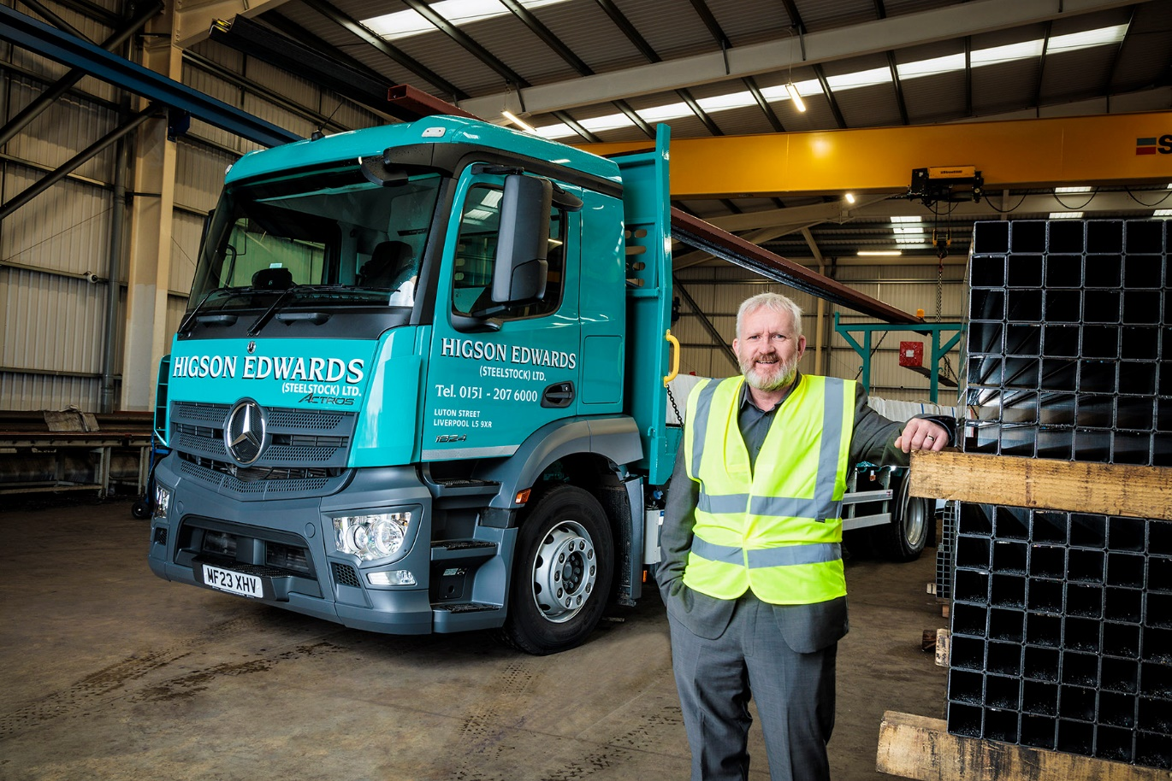

“Dependable trucks with first class service”: that’s why Sean Madden of Higson Edwards turned to Mercedes-Benz

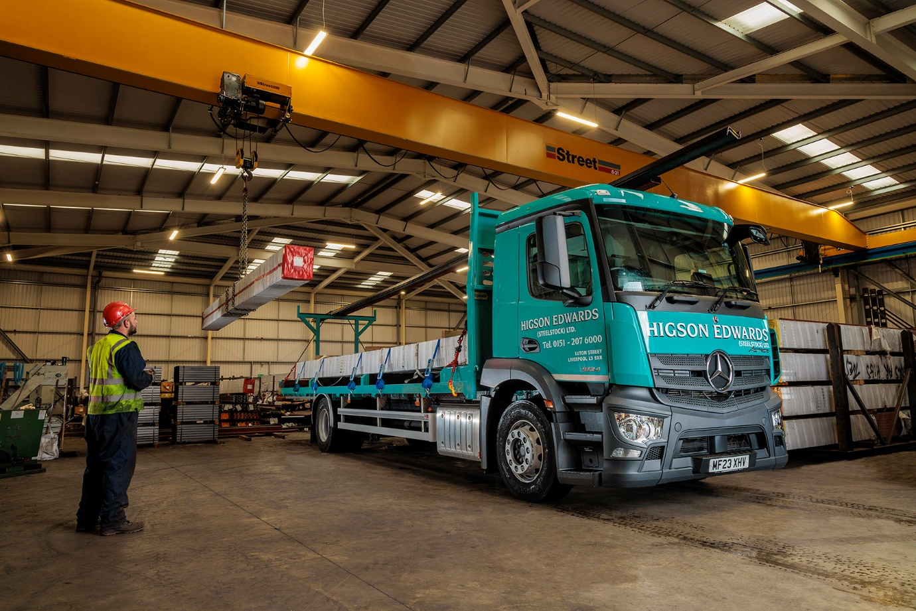
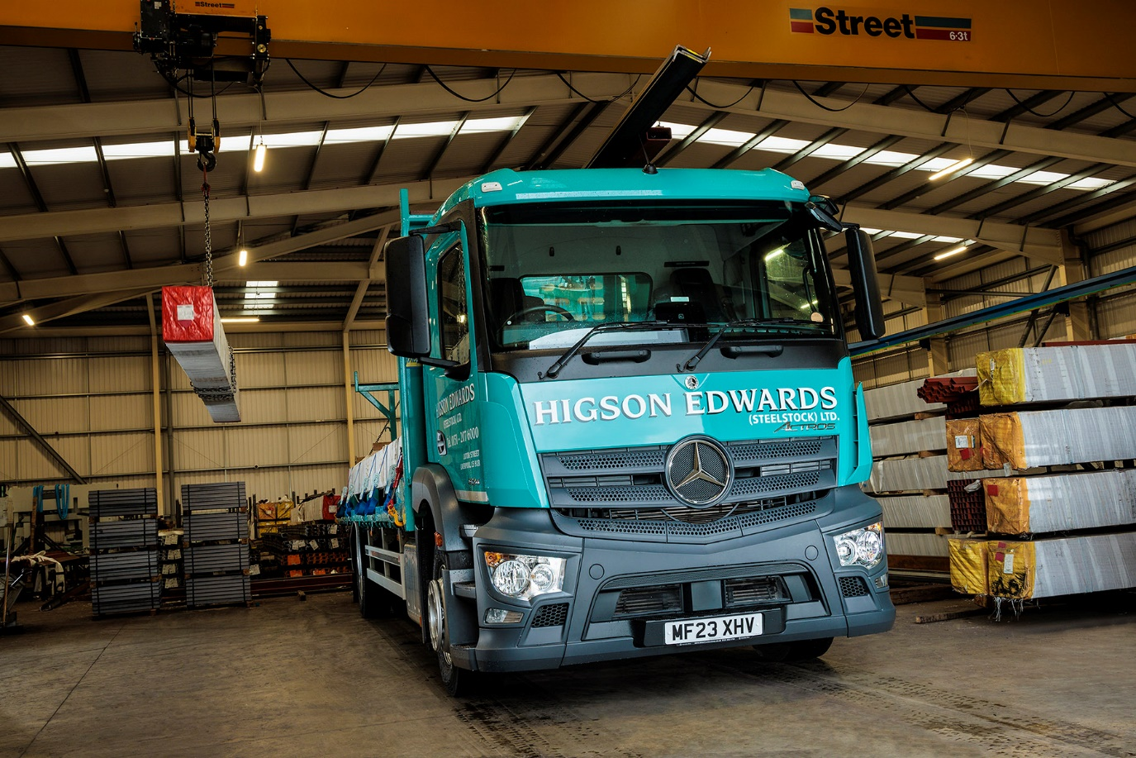

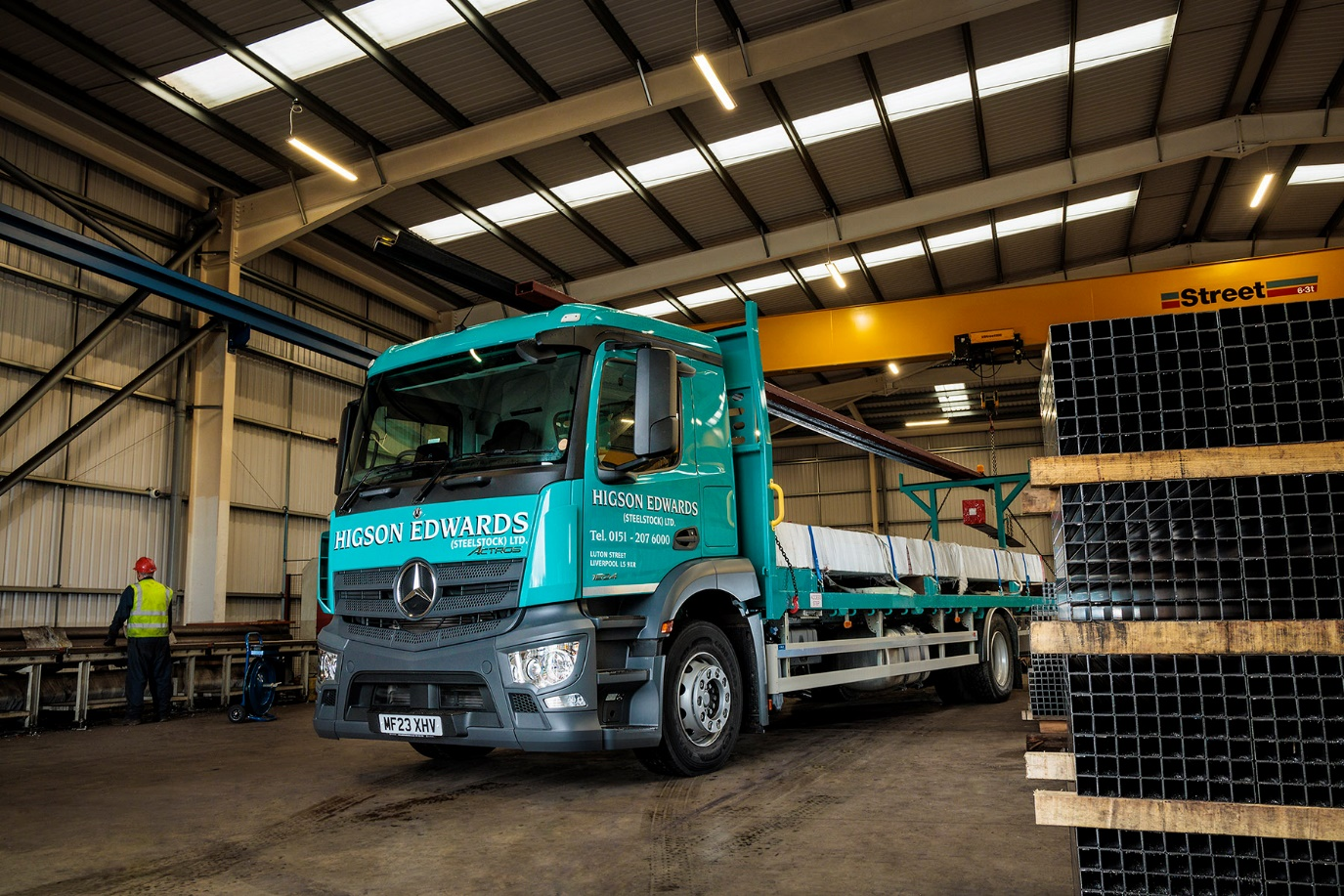

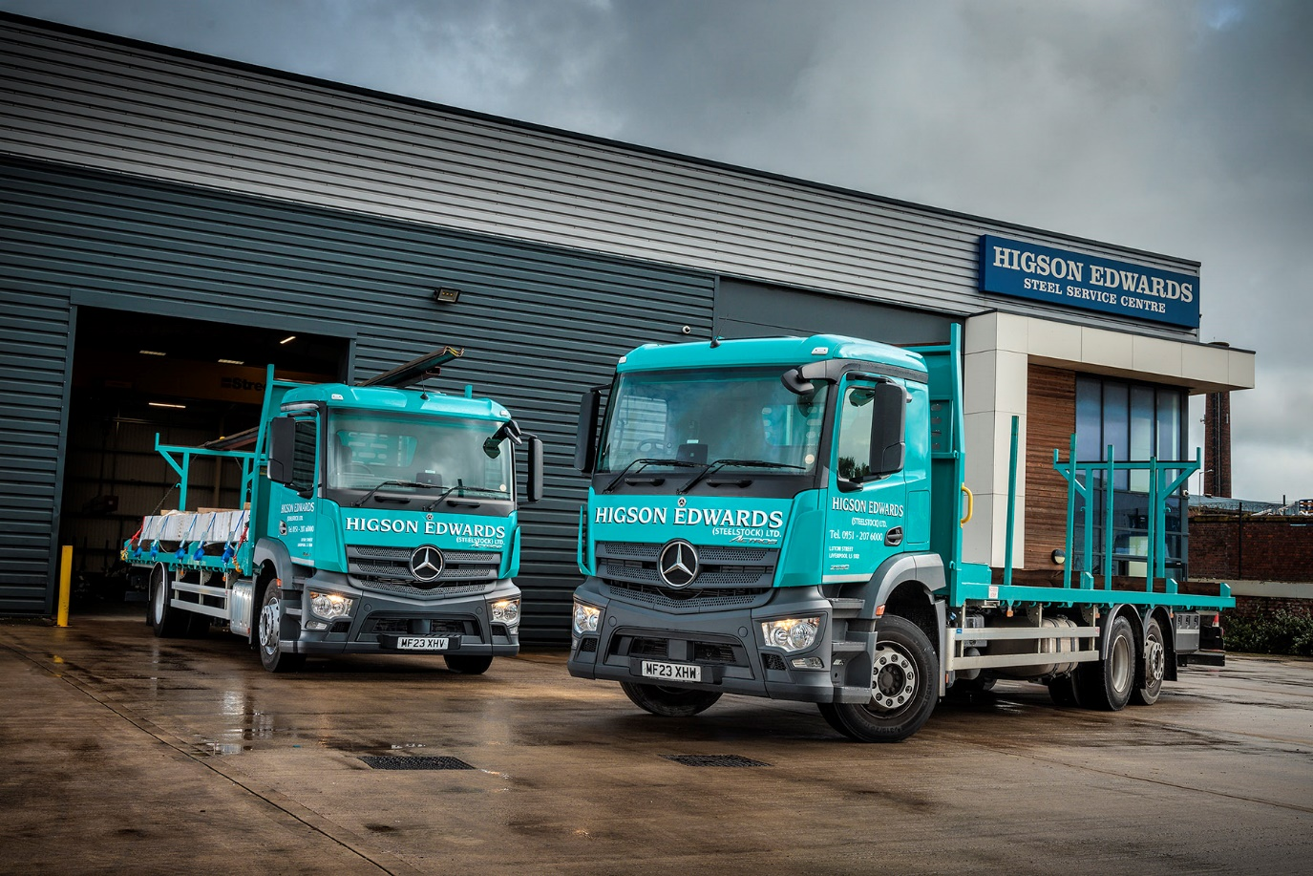

ends

For more information, or to request bigger/higher-res image files, please contact:
John Ripley: 07771 484595, john.ripley@loopagency.co.uk

